Professional and Career development

Task 3 – Reflective portfolio

Student name: Nicola Mattis
Student Number: 1913560
Module: BMSW4005
Lecturer: Abdi Rahman

Introduction
A reflective portfolio refers to the summary of the learner’s experience (Nambiar, 2018). It provides a brief insight into the practical assignments which the learner have gone through. This portfolio helps to assess the student’s engagement with their fieldwork as well as their ability for using the theoretical knowledge in the actual setting. In the same context, this paper provides a discussion and analysis of my personal skills is critical for the determination of the strengths as well as weaknesses (MacCallum & Casey, 2017; Ahmed, & Schwind, 2018). This helps me to devise measures to overcome these weaknesses for more rapid and concrete development.

Personal Audit
For the personal audit, the tool that has been applied is that of the SWOT Analysis. This tool is used for the analysis of my strengths (S), weaknesses (W), opportunities (O), and threats (T). Various researches have advocated it as an effective tool for the audit of the individual himself (Phadermrod, Crowder, & Wills, 2019; Sarsby, 2016).

Strengths
My relationship with my profession to develop as a competent leader in the managerial position requires me to have adequate mental capabilities as well as psychological competences. This follows the use of the skills to reach out creative as well as novel concepts related to the brand, which will allow the organisation in showing a powerful market image. The existences of the highly intellectual and interactive expertise have permitted me to make vigorous participation in the continuing debate which support me in creating a powerful and bonding association with the customers in the organisational context (Sarsby, 2016). Further, I owe an ability, and the expertise that will help the organisation in the creation of the productive association with the customers beside with operational tactics for the promotion of the organisation offered facilities and brand with the clients, and in the similar period attaining advantages from the defined strategies for marketing. This expertise not simply support in the combination of the proficient performs at the office, which not simply improvise the productivity of the company operational matters besides the formation of the optimistic corporate picture in the industry.

Weaknesses
Numerous challenges are there which are linked with a changed corporate part; each one has an impact on the operational productivities in a diverse manner (Phadermrod, Crowder, & Wills, 2019; Sarsby, 2016). The prime challenge encountered is the preparation that influences my performing abilities and the period, which influences corporate productivity as well. The outcome of this strategic scarcity in me generally frustrates the active that I can perform in an organisation. Furthermore, the self-confidence which I have reduces as the gathering begin larger, influencing the efficient knowledge liberation to the client critical to the client. Furthermore, I easily come under pressure which restricts my effectivity and productivity, which could have performed timely. Furthermore, the enhanced assignment influences the productivity pace too.

Opportunities

Numerous opportunities were created by the firm in the form of the learning plans or the small virtual courses to improve the specialist’s information. It is authoritative as it may be impacting the corporate outcome normally. In these learning and development plans, the moderators have numerous exposures which will support me in recognising the background and improvising the skills sets I have, that will help me in achieving my personalised objectives and purpose that are planned much effectively (Phadermrod, Crowder, & Wills, 2019; Sarsby, 2016).

Threats
The threat is the new recruitment that has happened in the organisation. These fresh recruitments' have informed expertise besides the specialised education, which improvises their views of much broader hands-on knowledge (Phadermrod, Crowder, & Wills, 2019). These applicants pose a risk to the part that I am operating beside them as they are more capable as compared to me. Further, the corporate holds the fewer amount of workforces posturing my workload, which influences the operational tactics and effectivity of attaining the decided objectives of the company.

Personal Development Plan
Priority | Competence | Capabilities (At present) | Target Capabilities | Opportunities for Developmental | Success Measurement | Evidence
One | Leadership | Capable enough to contract with the team members and efficiently observe the scheme map but lacks in supervising the team projects | A professional leader who can execute efficiently and supervise every assignment in team proficiently | Undertaking the training programs to buff the skills | Evaluate and keeping all the team works in line. Team Contentment and their accord to work in the same surroundings | HOD Appreciations and administration
Two | Interpersonal or Communication | Good communication skills when dialoguing with the professional | Conquer all the nervousness | Contribute to a weekly presentation to improve the skillet | Efficiently convey knowledge to the participants | The incentive to convey more presentations
Three | Time Management along with Stress Management | Sufficiently supervise time in an overload of work as stress is mostly associated with every type of work | Handle the fears that are causing the stress at the time is not efficiently managed | Undertaking more work that is deadline-oriented, as well as indulge in challenging projects | All tasks have been completed on or before time without any pressure | Successfully completing all tasks.

Learning and development training methods for your new employees
The new employees that have been recruited in the firm belong to the following position;
- Human Resource (HR) Officers
- Maintenance Supervisor

Lecturers
This method is the traditional method which is used for the training of the employees. The main purpose of using the lecturers is that it helps to learn about the technicalities of the job. In it, the senior management part of the maintenance unit can be included for the deliverance of the training. In this method, the junior staff learns under senior management or leaders so that important skills can be developed. For roles of senior leadership/executive, programs for more formal learning are utilized (Maskálová, Urbanová, Bašková, & Kvaltínyová, E. (2018). There must be aware of time asset in this method of teaching, and also there is one-on-one teaching model's narrower funnel. However, this can be ineffective in case the personality of the trainer is rigid and not accommodating. Also, these at times become inconvenient where the individual has to sit throughout the lecture. This can lead to discouragement among the trainee at times.

Demonstration
Demonstration development will be a useful method for those employees who took some of the basic training related to technical skill, including the new machine's operating system's learning or new financial analysis methods' learning. The senior personnel perform the tasks and carries all the necessary practices that are required for the performance of the tasks. This also includes the material information required for performing a job, such as a sheet, tools, and more. The training method is effective as it helps to enhance the individual understanding related to the complex skills as well as practices (Oluwaseun, 2018). Accordingly, it is effective for drawing more attention, interest, along with the learning process. Here, the use of a different sense allows the development of the permanent knowledge. As a result of it, when employees are in the process of finishing their assigned tasks, they apply the methods or learn how to utilise something. It is the method which has taken a huge amount of fame in developing the employees because firms do not possess enough time for training an individual on single skill particularly when advanced or specific knowledge is not needed by that skill.

Role-playing
The role-playing enables the learner to assume the role or the tasks for the job through practising or stimulating the actual working conditions (Kim, 2019). The main objective is to role play in order to learn through skill development as necessary for a specific position. To utilise the new skills in the place of work, roles can be rotated by the employees with colleagues on a team or shift. As a process for employees, job sharing can also be encouraged by employers, and it is for those employees who intend to attain some of the practical experience so that some additional skills can be developed (Othlinghaus-Wulhorst, Mainz, & Hoppe, 2019). The main objective is tasks as well as roles rotation so that something new can be learnt or those skills can be practised, which were learnt previously. We are not able to put stress on the significance to assist employees polishing their skills via coaching when we talk related to several development methods of employees and their advantages. In this, senior employees help those who have less experience than them. It has the ability to improve understanding of an employee in relation to many topics, but this method is time taking and provides subject’s clone-like knowledge against the way in which an employee learns according to his or her own way or learn from mentors or coworkers.

Computer Based Training
Normally known as CBT, computer-based training (also referred to as computer-based learning or computer-based instruction) is a collaborative instructor-less learning procedure. Essentially, beginners interrelate with multiple sorts of training stuff via computer. Computer-based training options come in diverse outlines and systems. This includes the use of the multimedia-enhanced literature, lessons, and exercise training or even micro-world imitations. The training modules used in computer-based training software packages (Kim, PHoman, & Metzer, 2016). To approach and attend these lessons, beginners are required to have info to operate this software. The rationale for the use of this training method is that it is effective in terms of cost. For instance, computer-based learning is affordable, where predevelop learning methods are accessible, and multiple can be modified for your organisational requirements. Apart from those early arrangement costs, computer-based learning can offer your organisation with a 24-hour instructor that has online unrestricted synchronised pupil capability (Kim, PHoman, & Metzer, 2016). Computer-based training permits the beginners to perform at their individual teaching momentum and method; a slight adjustment is required at both side to meet the personal requirements of each learner. Computer-based learning is non-threatening and easygoing while offering an urgent response as the learning grows. The instant collaborative response of the computer based teaching method permits the learner to analyse divisions of the module as regularly as required, confidentially and deprived of sensing ashamed by errors. However, the disadvantages of online computer-based learning include that trainees who lack the enthusiasm to develop might get bored, and eventually skip some modules effective for their learning. Also, in case the lessons have a monotonous arrangements of an outdated lesson, pupils might get diverted or confused related to modules’ actions and timelines. The trainer might not continuously be accessible when trainees are reviewing or require assistance. Likewise, the poor internet connection or out dated personal computers might make retrieving module elements difficult.

Seminars and conferences
Conferences help in attaining network and assist in gaining the exposure to a huge amount of knowledge related to outside industries and interdisciplinary studies as one can say they are like committees and workshops. In an organisation, specified sessions are there to enhance relevant topics' training as well as awareness, and employees can select as well as pick a format of their own interest.

Simulations
Simulations are gaining popularity because they are effectual as well as engaging. In the simulation, a skill is being role-played like an employee is made ready to react to an emergency situation, or they are being taught that how confrontational and an irate client is diffused in person. If we consider the highest level of simulations, virtual worlds can be involved by simulations including flight training or fire rescue and here the skills can be learnt by the employees which are needed in the non-consequential setting. This method helps in the application of textbook or conceptual knowledge to the real world scenario and such a way; employees will be comfortable and exposed to handle these kinds of tasks.

Reflection (Self-Awareness)
The course has been extremely effective in the development of my skills. The course has helped me learn about the different aspects concerning my motivation for development, both professionally as well as personally. I started this course with a strong motivation to develop my management skills by using the different resources available. The main and ideal form of learning for me was to continuously reflect on my development, which I ensured and which was also emphasised throughout this course. This technique was extremely effective to discover new tools and techniques for assessing my progression. The earlier research of Hamric et al. (2013) has presented that the good course and instructor is the one that helps the learners to commit to the development. As a part of my self-awareness, the tool that I used includes the personality test (Appendix). I feel my motivation for becoming the manager is increasing, which has further been progressed as a part of this course.
Leadership motivational assessments are performed for the analysis. The test was conducted to analyse the leadership capabilities that I perform and has developed with the learning activities. This skill is critical for motivating the team to achieve the targeted goals (Aarons et al., 2017). The leadership test shows that I am highly motivated and that I enjoy practising my abilities and skills. The leadership test majorly indicates that I have a high competence reveals about my competence level, my ability to assimilate others within the group and give my best to ensure that effective and collaborative work practices are followed. The emotional intelligence test is critical to assess, recognise as well as regulate the emotions in an effective manner (Mayer, Caruso, & Salovey, 2016). This shows that I have an adequate level of emotional competence, which depict my ability to regulate my emotions in an effective manner. I also performed the decision making test as a part of my self-awareness. The test reveals that I undergo extensive research before finalising my decision. I believe this is due to the critical thinking approach that I have learnt as a part of this course. Initially, I was not so critical and did not have the ability to effectively interpret, but by completing the different tasks assigned as a part of this course, I was able to effectively interpret, synthesis, critique, response, along with the use of the material other than the quotations, paraphrasing of the content, and summary. I believe that this skill has helped me to polish and diligently work towards my goal of achieving my position as a manager in a well-reputed firm. In addition to it, I have used the outside material in my other tasks as well, which demonstrate my ability to extract information and idea to support the incorporated information.
I performed this test to assess the listening capacity of the individual. The score provides that I have active listening skills. The primary reason to assess this is to analyse my ability to listen as a manager. Roebuck et al. (2016) has also provided that the listening skills are essential to make everyone in the team feel valued. This has also helped me to overcome the misunderstanding prospects and the potential conflicts that might emerge as a result of ineffective listening. The results depict that I might sometimes fail to acknowledge the listening. This indicates that I need to work on my motivation skills. I believe that listening and directing attention to every task and its minor details is what is similar to the listening skills. This can be reflected on the completion of my assignments, where I was able to derive the relevant information, listen to what the instructor wanted us to incorporate, as well as become a more improved version of myself.

Conclusion
The report presents an analysis of my skills, my self-awareness as well as the efforts that I need to deploy for achieving my personal development goals. The analysis is formed with an objective to achieve the proficient objectives and purposes which are decided as a part of my personal development. The strategies will not simply help in improvising the organisational productivity and refine the strategies for its lasting sustainment by arranging objectives. The methodologies for assisting conclusion support in assessing the development in the soft expertise which influence the performance productivity in the corporate. The time-fixed objectives and purpose in the achievement of the objectives timely. As one of the apprehension is improvising my skillset, thus it is vital that to undergo changes and achieve the relevant expertise for bridging the professional loopholes. This is likely to help me become a more improved version of myself, in both personal and professional roles.

References
Aarons, G. A., Ehrhart, M. G., Moullin, J. C., Torres, E. M., & Green, A. E. (2017). Testing the leadership and organisational change for implementation (LOCI) intervention in substance abuse treatment: a cluster randomised trial study protocol. Implementation Science, 12(1), 29.
Ahmed, N., & Schwind, J. K. (2018). Supporting the wellbeing of inner-city middle-school students through mindful and creative reflective activities. Reflective Practice, 19(3), 412-425.
Hillson, D. (2019). Capturing Upside Risk: Finding and Managing Opportunities in Projects. CRC Press.
Hollis, C., Hall, C. L., Guo, B., James, M., Boadu, J., Groom, M. J., ... & Walker, G. M. (2018). The impact of a computerised test of attention and activity (QbTest) on diagnostic decision‐making in children and young people with suspected attention deficit hyperactivity disorder: single‐blind randomised controlled trial. Journal of Child Psychology and Psychiatry, 59(12), 1298-1308.
Kim, P., Homan, J. V., & Metzer, R. L. (2016). HOW LONG DO EMPLOYEES REMEMBER INFORMATION SECURITY TRAINING PROGRAMS? A STUDY OF KNOWLEDGE ACQUISITION AND RETENTION. Issues in Information Systems, 17(4).
Kim, S. (2019). Role-playing game for training a design process of startup company compensation plan. International Journal of Game-Based Learning (IJGBL), 9(2), 40-54.
Lent, R. W., Ireland, G. W., Penn, L. T., Morris, T. R., & Sappington, R. (2017). Sources of self-efficacy and outcome expectations for career exploration and decision-making: A test of the social cognitive model of career self-management. Journal of Vocational Behavior, 99, 107-117.
MacCallum, J., & Casey, S. C. (2017). Enhancing skills development and reflective practise in students during their programme of study. New Directions in the Teaching of Physical Sciences, (12).
Maskálová, E., Urbanová, E., Bašková, M., & Kvaltínyová, E. (2018). Experience of lecturers with simulation training in midwifery education in Slovakia. Midwifery, 59, 1-3.
Mayer, J. D., Caruso, D. R., & Salovey, P. (2016). The ability model of emotional intelligence: Principles and updates. Emotion review, 8(4), 290-300.
Nambiar, V. (2018). Reflective practice with e-portfolio. Malaysian Journal of ELT Research, 13(1), 43-54.
Oluwaseun, O. O. (2018). EMPLOYEE TRAINING AND DEVELOPMENT AS A MODEL FOR ORGANIZATIONAL SUCCESS.
Othlinghaus-Wulhorst, J., Mainz, A., & Hoppe, H. U. (2019, September). Training Customer Complaint Management in a Virtual Role-Playing Game: A User Study. In European Conference on Technology Enhanced Learning (pp. 436-449). Springer, Cham.
Phadermrod, B., Crowder, R. M., & Wills, G. B. (2019). Importance-performance analysis based SWOT analysis. International Journal of Information Management, 44, 194-203.
Sarsby, A. (2016). SWOT analysis. Lulu. com.
Wu, Z., & Xu, J. (2016). Managing consistency and consensus in group decision making with hesitant fuzzy linguistic preference relations. Omega, 65, 28-40.

Appendix
Test of Leadership Motivation for Leading
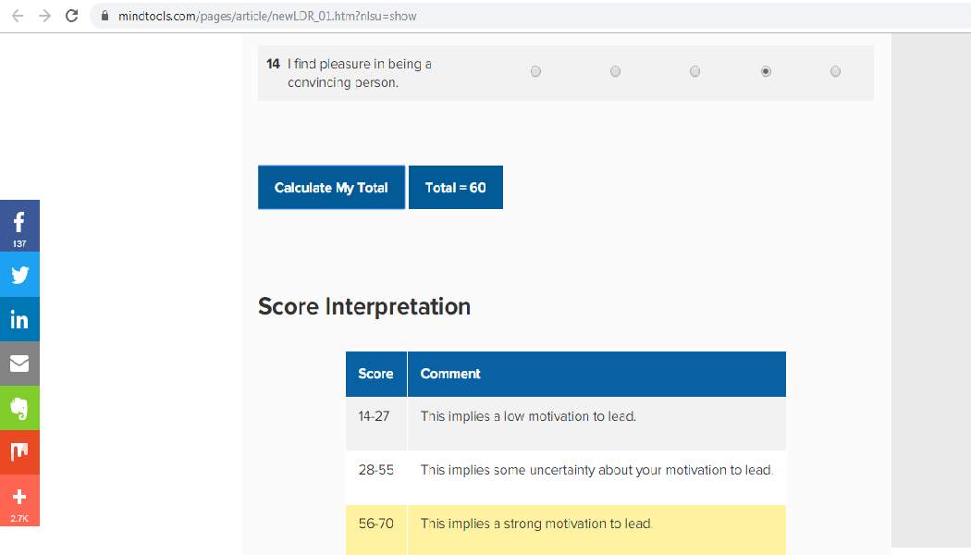
Test for Emotional Competence
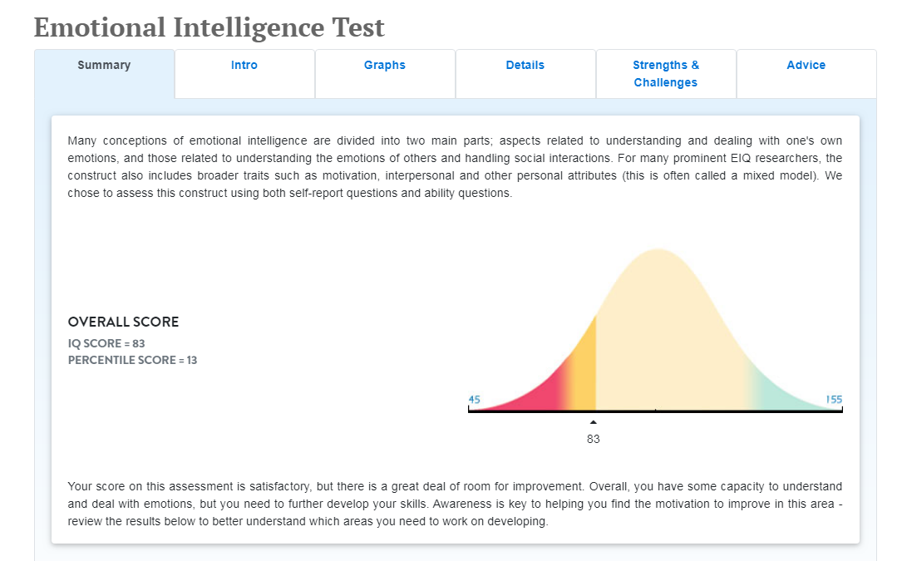

Test for Decision Making
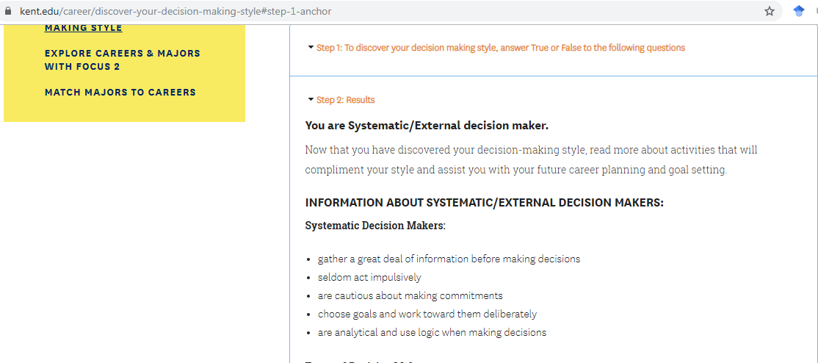
Test for Listening Skills


