Five

Flooring!
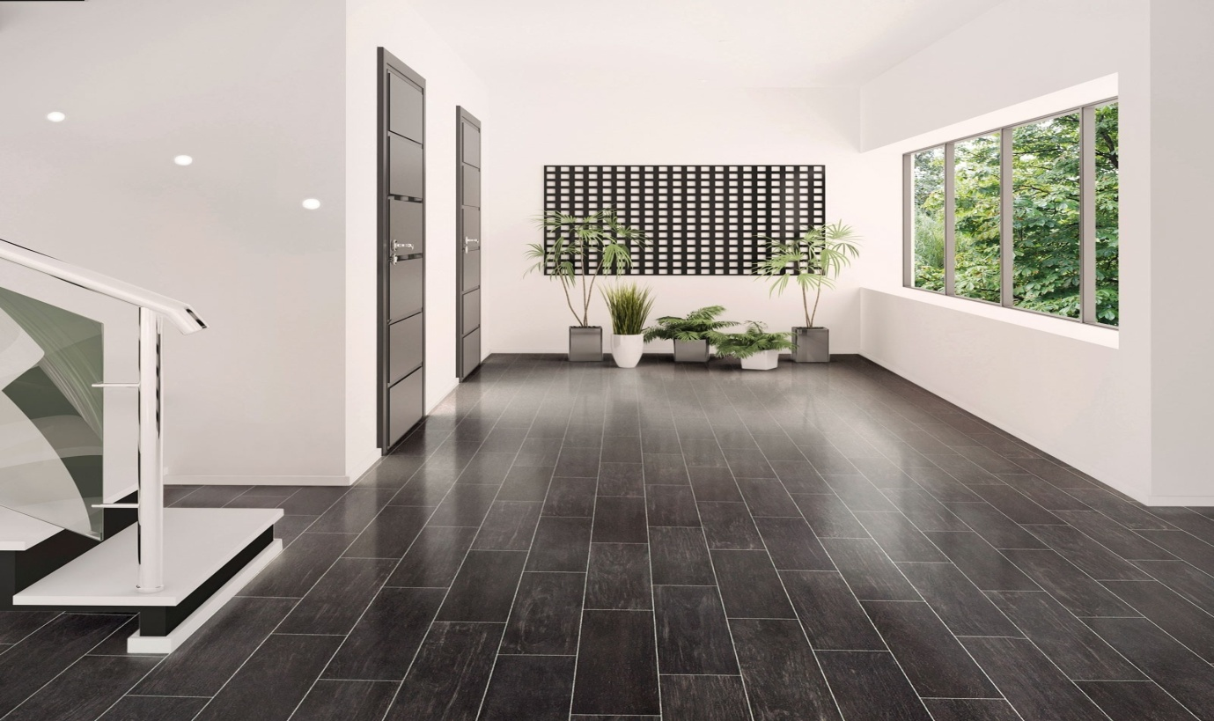

Business proposal created by
Savannah Davies, Mohamed Akbor, Shahana Begum, Rusina Begum and Reena Ali.
Business Summary
It is our aim to become a leading flooring store in the Cross Hands area. We aim to create a store that will be sector leading and well established. As a partnership, we will help to bring our customers visions to reality, be it to supply the smallest of rooms to fitting entire homes and developments. We will grow the business through Specializing in high quality solid wood, engineered wood flooring and via offering outstanding customer service, quality and care.

Mission statement
Beautiful flooring brings together consumers and retailers that are inspired by the “ordinary” and the “extraordinary” in flooring. Our mission is to provide the consumer with complete commercial and residential floor covering products, quality services and expertise.

Our keys to success
To enable our company to grow on large scale we acknowledge that we must use a variety of different marketing and advertising methods to target a large number of customers for example radio, face book, leaflets and Google adds. Our stores must have knowledgeable well trained and friendly employees that offer excellent customer service during the sale and after the products are bought. We will pride ourselves in buying good quality products that will offer value for money and look stunning in your home.

Our unique selling points
Our business has two unique selling points that set us apart from your average flooring stores.
- We will supply consumers with unique flooring styles direct to them, Products that have only been available to traders in the past. Therefore leaving out the middle man and offering the savings direct to the customer.
- Knowledge,” knowledge is power” the fact that both the partners have an in-depth knowledge of the trade is always going to be a bonus, one partner has previously worked as a manager in other flooring stores, so he already knows a lot of the product and installation information, customers usually like advice on what products would best suit their needs, if you have a new staff member who has no information on such things a customer may be put off.

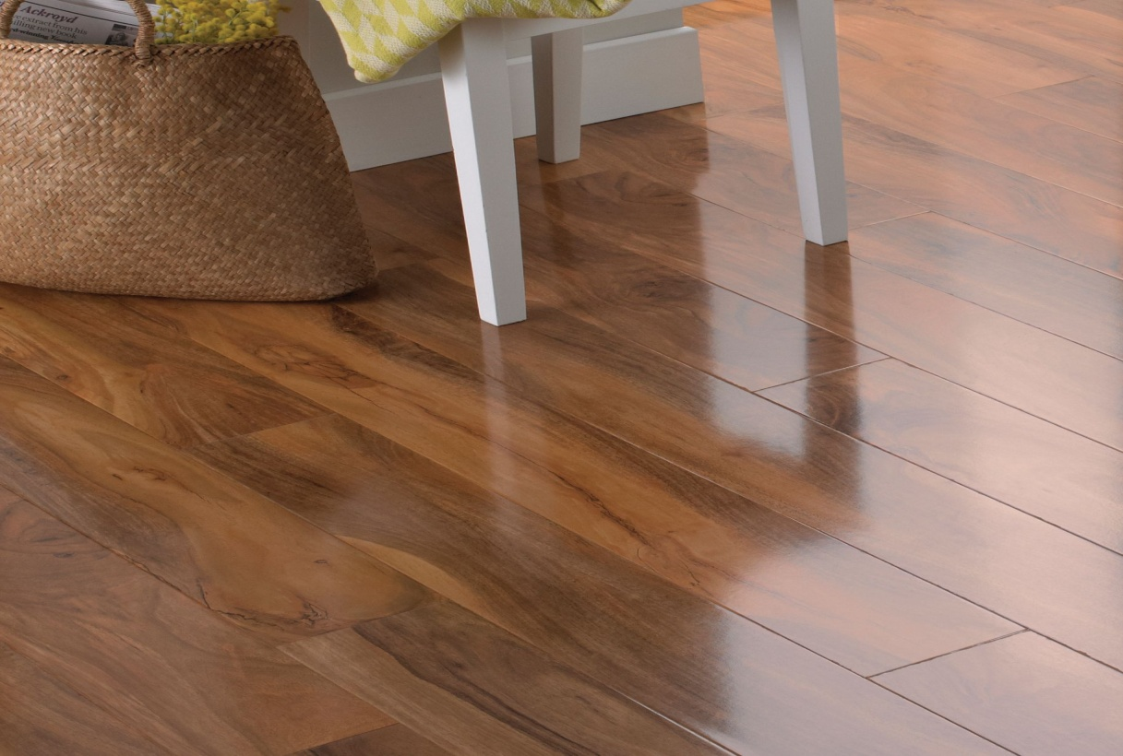

Business structure

5 Star flooring is a general partnership between 2 people. The reason we have chosen to do partnership in this business is because each Partnership will have unlimited liability for the debts and have equal right of the losses and profits of the company. The benefit of going into partnership is that the business doesn’t have to pay income tax as this will be done individually. The partners can also share workload and the rewards of the business success. Partners will also have equal rights in the management of the business. Being in a partnership can bring more knowledge, skills and contacts for the company.

Marketing and promotions

The company has advertised the services on social media such as Face book. As the business is new, social media has been a good marketing tool as there are few or no costs. This is also a way for us to promote offers, giveaways and flash sales to followers or attract customers. If the product is received well by the consumers, then bloggers would further promote the product through social media platforms (Lovering, 2018).
We used primary research methods and created a questionnaire. The marketing questionnaire was aimed at people of all ages, so we could have a good knowledge of consumer’s interests. The questionnaire included a mix of closed questions - yes and no answers, multiple choice questions and scaling questions. The questionnaire will enable us to adjust and improve the products based on the customer’s feedback. We then compiled the results into pie charts and bar charts to analyse. (Dudovskiy, 2018).
According to the market research, most people would like wood flooring in their homes. 60% of people replace their flooring after6 years, and 40% would be willing to spend over £500.
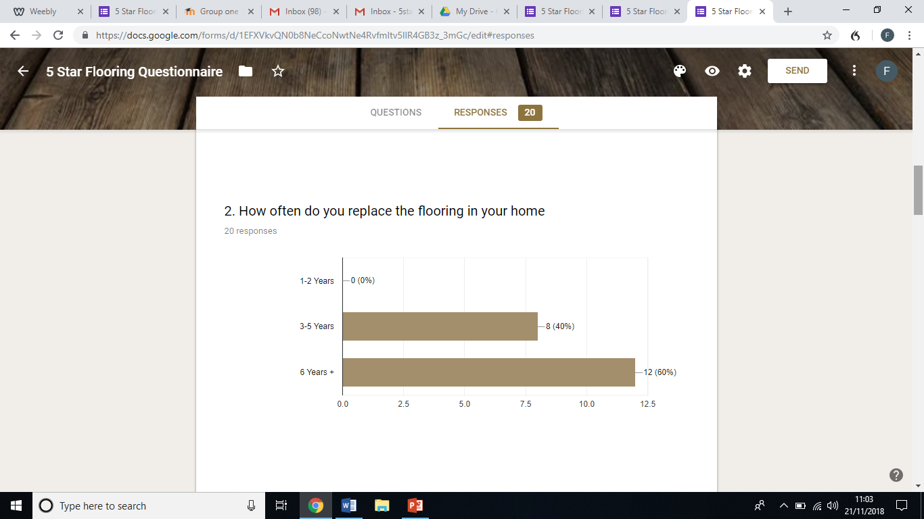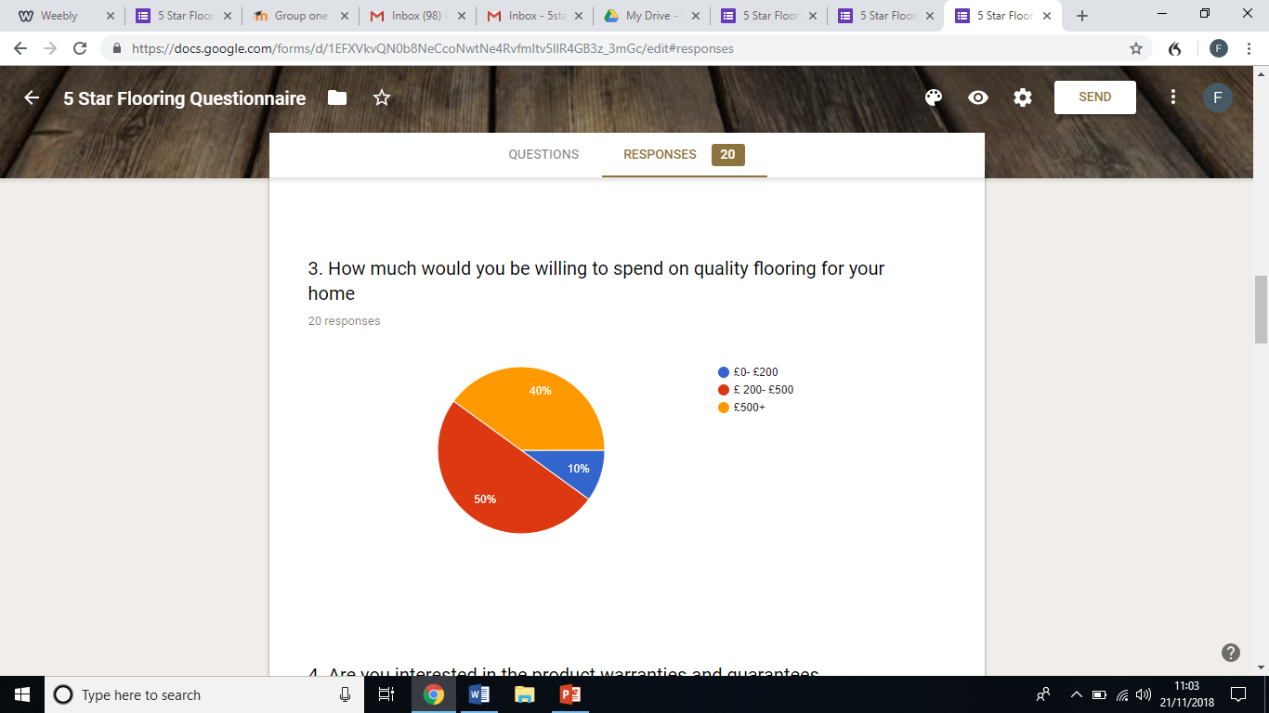

80% of people want to have a warranty with their flooring, as shown below.
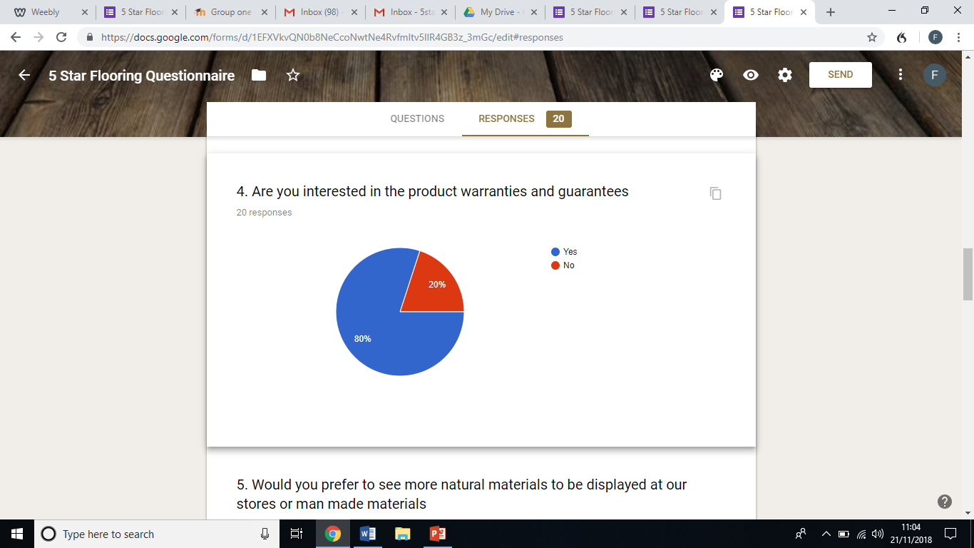

The most popular flooring in the survey is flooring made by natural material and most people popular place to install the flooring in a home is the living room. Beauty, durability, quality and budget were all important factors to almost all participants of the survey. 75% of participants have children under the age of 16 in their home. This finding suggests that the most likely target audience would be families. Almost all participants said they would be interested in the promotional offers of 10% days, free underlay and free fitting. The questionnaire shows that there is an interest and consumer market for the company with 75% participants saying they would buy from 5-star flooring. We will use the findings from the survey to create a report and ensure the most popular products e.g using natural materials is implemented in our products. The graph below shows that 75% of people prefer wood flooring.
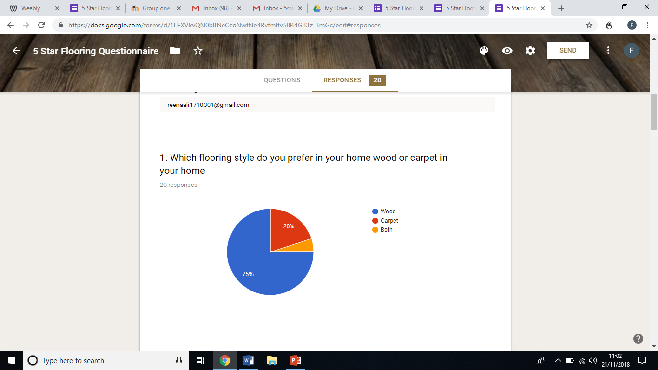

Promotional activities
As the product has been advertised on social media, we will also use Face book’s Audience Insights which allows the businesses to advertise to certain audiences that are in line with the brand by selecting boundaries, such as demographics. Through our market research, we know 75% of the participants had children under the age of 16 and therefore we will ensure we target those with young families as well as consumers who are older. We will advertise to existing customers through paid ads via vlogger/bloggers and popular social media accounts. The social media followers will then have discount through using a promotion code advertised by the social media promoter. (Jones. K, 2018)
As well as using online advertising, we will use radio advertising and specifically advertise during times when our consumers are most likely to listen for example, when parents are most likely to do the school runs. We will also ensure we create leaflets to promote the products which include pictures of flooring in living rooms and advertise them through door to door sales and through linking in with other companies such as builders so they can promote the business to attract new customers. Another way of attracting new customers is event sponsorship, to advertise the three promotional offers of 10% days, free underlay and free fittings. Lastly the company will ensure that all products have 1 year warranty and factor this in to all the marketing and promotion (Lovering, 2018).

Human resources
Between the two partners they have a varied skill set that covers most aspects of running a store. The one partner already has previous experience in running a flooring store as a manager therefore has great knowledge on the products we aim to sell and how to source them at a great price. This partner also knows how to use the till systems and booking diary. The other partner has many years experience in running his own carpentry business therefore having gained a great knowledge of the products as he has fitted them before, he also is very good at organisation and customer service he will also be responsible for the fitting service offered. The partners will take a 20% cut from the profit. We will also employ one part time sales staff and a part time delivery driver.
All staff will be trained to handle questions and queries, to give advice on which is the best suited for the rooms needed, if need be advice on a budget. There will be options for delivery only if needed, free measuring service and after care advice.
We offer all our customers 3 years guarantee and the option of purchasing after care solutions for example wood or laminate cleaners and advice leaflets. After the sale has been made we will look at customer reviews and deal with complaints appropriately to do better in future
Pricing strategies
For the market research my team has put together a questionnaire to gain information about our flooring. It included questions about fitting, flooring, price strategy etc. From the research we got an idea of what type of targets we need to meet for our customers. Our 5starflooring is not aimed at anyone in particular by character or age in fact it is for everyone. This is because 5starflooring is all about good customer service and we offer reasonable prices to the best of our ability to the customers. In our store we sell different type of flooring such as the material and texture is different. Our pricing strategy varies for the type of flooring for example our laminate flooring would be cheaper and the wood flooring and marble would be more expensive. We offer sales and discounts throughout the year occasionally during Christmas and Easter. From all the research that we have gathered we came to this product and pricing strategy. Also due to the fact we get our product in bulks straight from the warehouse from all around the UK and it’s at a discounted price as we tend to buy a bulk.
Financial resources
Each partner will invest £20,000 this will be made up of funds from personal saving accounts, a joint business loan, funding from start up loans and grants provided by Business Wales. Both partners have done the relevant checks to ensure their eligibility. Both the partners will invest £5000 each from their personal savings; £15000 is covered by a start up grant from business Wales and the outstanding £15000 is provided by a bank loan that the partners have joint responsibility for repaying. We arrived at the start up figure of £40,000 by looking at the cost of renting a unit and utilities in the area, getting quotes for shop fitting, finding information and pricing on van leasing and we had quotes for buying our stock in bulk. we have also allowed ourselves some breathing room buy having enough money in the bank to cover any losses we may make in the first few months or to cover any unforeseen costs.
5star flooring 12 month projection /cash flow
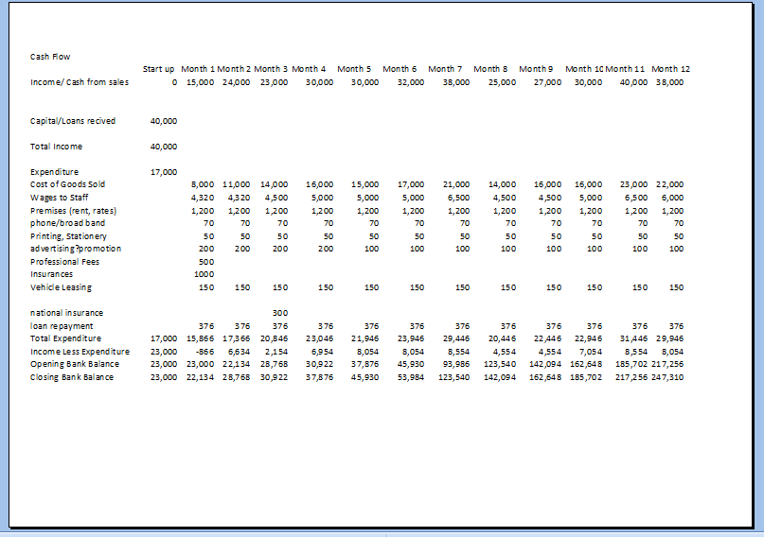
Business Location
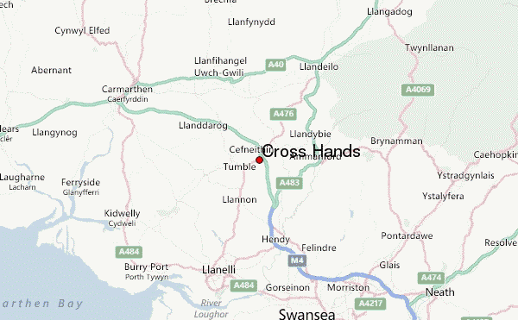
Cross Hands is based just off A48 and serves a vast area of potential customers. Cross hands is a growing residential and employment area and includes the established Cross Hands Food Park to the south west of the A48. A new business park - the Cross Hands Business Park is being developed to the northwest A48 making this an ideal location.

Physical resources
We will hire a shop fitting team and all interior is dealt with and fitted prior to management of the store the upkeep and layout will be kept at a high level of cleanliness and standard. Displays boards will be made to show case a range of floors. A van will be required for deliveries, this can also be used to advertise the business if we have logos put on the van and the shop free phone number.
The premises have the ability to house and display a range of wood and laminate as well as a carpet section which will optimize the choice for the customer and therefore enable a higher ratio of sales to be successful.

Operations
Our products will be ready made from varies parts of the U.K warehouses. We believe British made materials are better quality which is worth paying for, “if I know that a product is made in Britain I would consider paying more for it” (Hills, 2018). We will buy in bulk when needed after the customer has chosen the type of flooring they want, as we won’t stock every item in our stock, therefore we can offer discount when we purchase in bulk.
Our plan will be for customers to come into the store to look at the samples or look online for different flooring, then one of our partners who is also qualified as a fitter which is a bonus for the company will go and measure the floors. Our company policy is to go out to the customers within 10 days and from the first visit another 10 days for sales. After measuring the customers will need to make a 10% deposit, before fitting pay balance in full in store. There will also be free delivery option if customers don’t need fittings. Our plan also involves guiding customers to the right quality of flooring depending on the rooms.

Physicals resources
In store we will have a customer service desk for customer queries and to look at samples, also there will be separate sections for different types of floors and various prices from the higher end to cheaper laminates to suit each customer. The store will have up to 2hrs free parking space.
As we will fit different types of flooring we will need various tools for example
· Fitter (one of the partners)
· Car
· Power mitre saw
· Hand saw, power jigsaw, door Jam saw, circular, Ten on
· Claw hammer
· Nail punch
· Screws
· Measuring tape
· Chalk line and chalk
· Safety glasses or goggles
· Utility knife
· Universal Installation Kit
· Broom and Dustpan
· Scissors
· Carpenters square and level
· Sand paper
· Double faced flooring tape
· Moisture meter
· Glue
· Pull bar and tapping block
· Wood chisel
(Winter,2018)

Conclusion
Swot
Strength
- Experiences
- Colleagues have previous experience in running a flooring store before therefore, the company is able to expand and do better as the staff has enough knowledge on how to run a flooring store. Furthermore, there are other staffs that also have knowledge on different tasks within the flooring store company and so, they have the capacity to run the flooring store in a adequate way.
- Prices
- Our pricing strategy is for our entire customer base. Our prices will to all budgets. we cater to appeal to customers who are willing to spend more for a premium product we also have budget friendly flooring

Weakness
- Unknown site
- Weakness is that not many people will be able to attend the company due to the company being in a location where people may not go. Another weakness could be marketing the company on different websites people may not have access to. Another weakness could be the location being in a busy location may affect people living around them.
- 10 days
- We only have 10 days to supply our goods which means we have less time to get the stock from the warehouse

Opportunities
- 100% customer focus
- The company focuses a lot on how to impress the customers and how to attract them to trust the flooring company. Flooring Store Company will allow staff to do different tasks which would enable them to expand on their knowledge and gain new skills. Another opportunity is that this company will allow customers to pick their own flooring and enable them to join the company if they want…

Threats
- Competition
- There could be a competition between the flooring companys on who does better. One company may have better finance than the other or better products than the other. One company could be bigger and better than the other.

SWOT Analysis
STRENGTHS  Experience  Fresh store with scope  Cross hands is up and coming  Fantastic location  High footfall | WEAKNESSES  Unknown site  No existing customer base
OPPORTUNITIES  Outreach  New site  100% customer focus (blank canvases) | THREATS  Leeks  Tops tiles  D G Heath Pontarddulais  Wood house Llanelli

Gannt chart

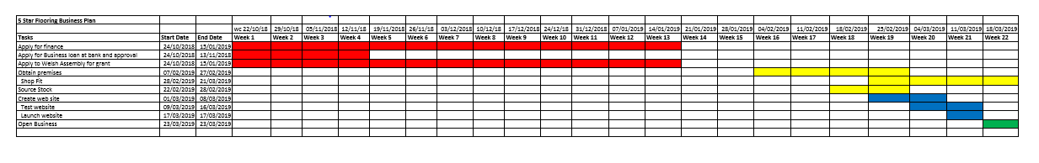

Appendix

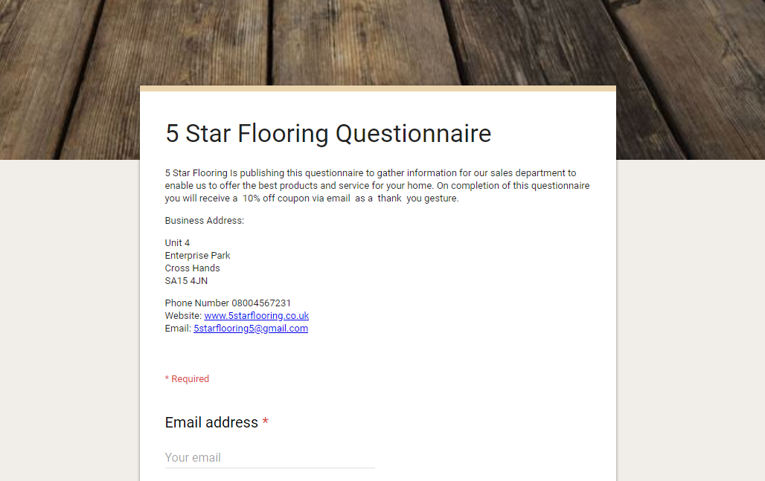

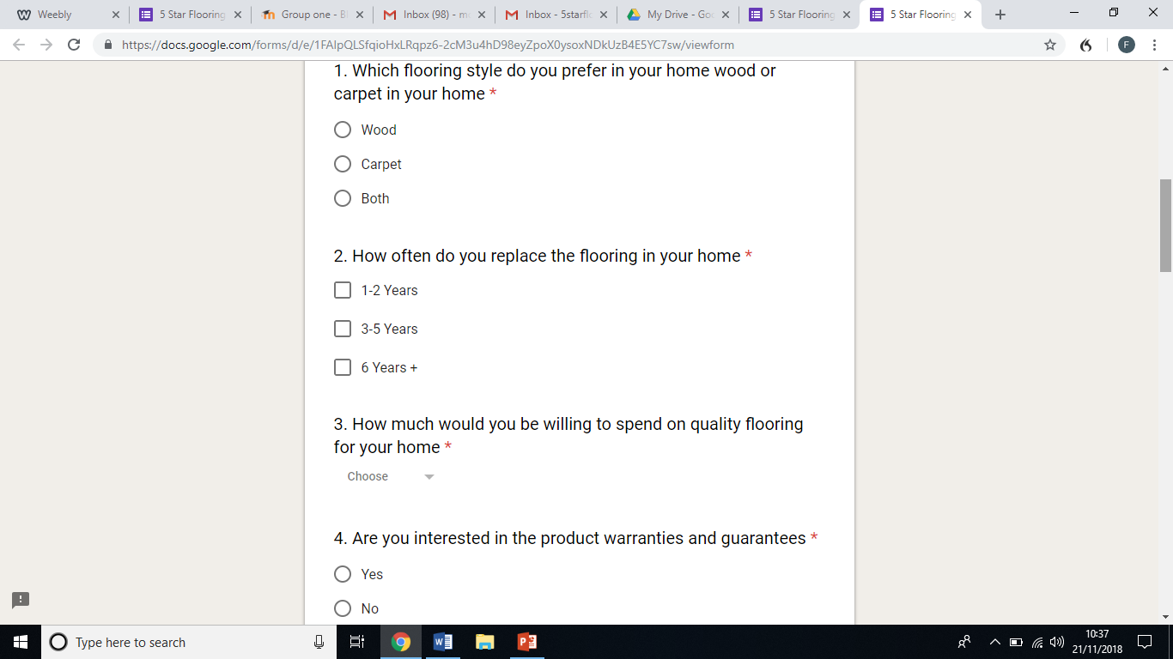
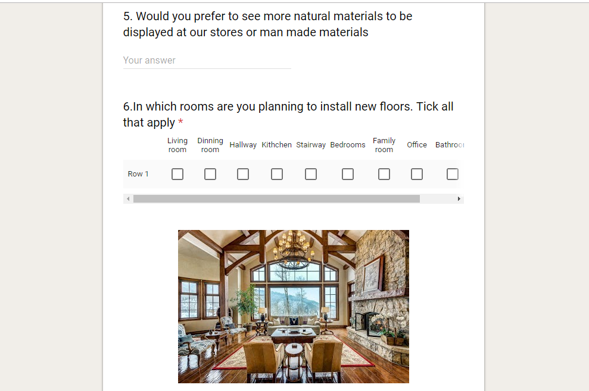

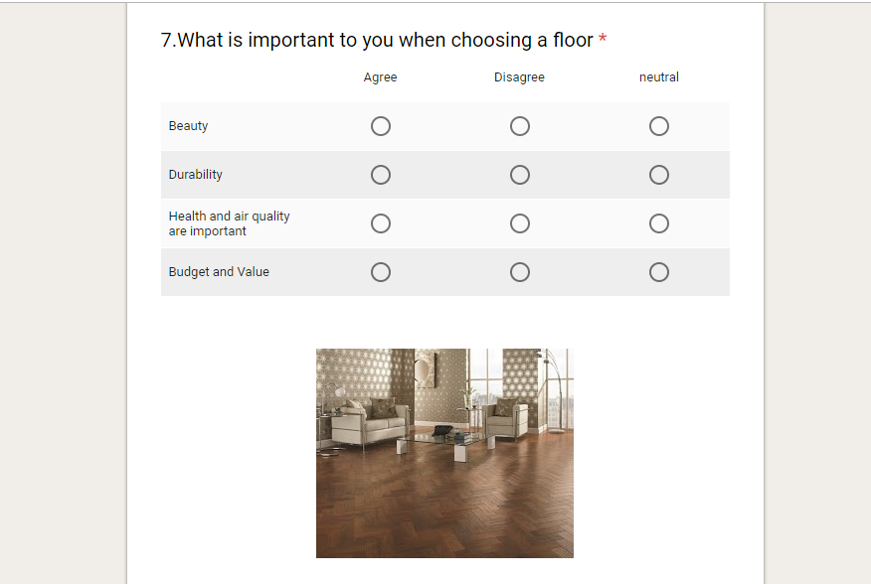

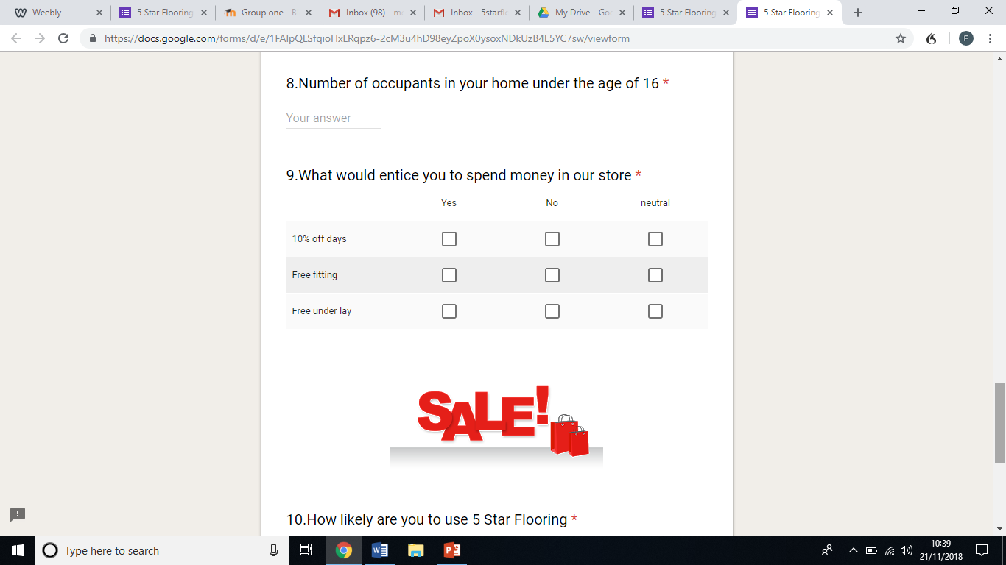

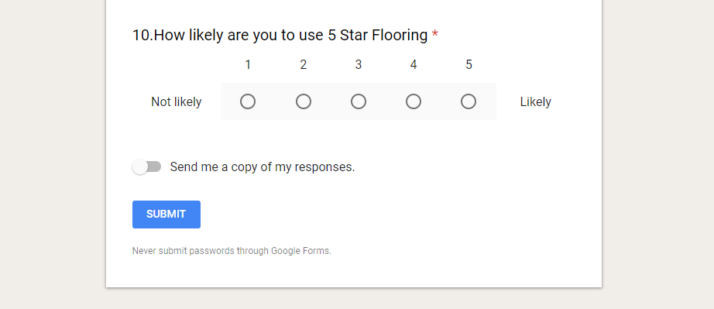

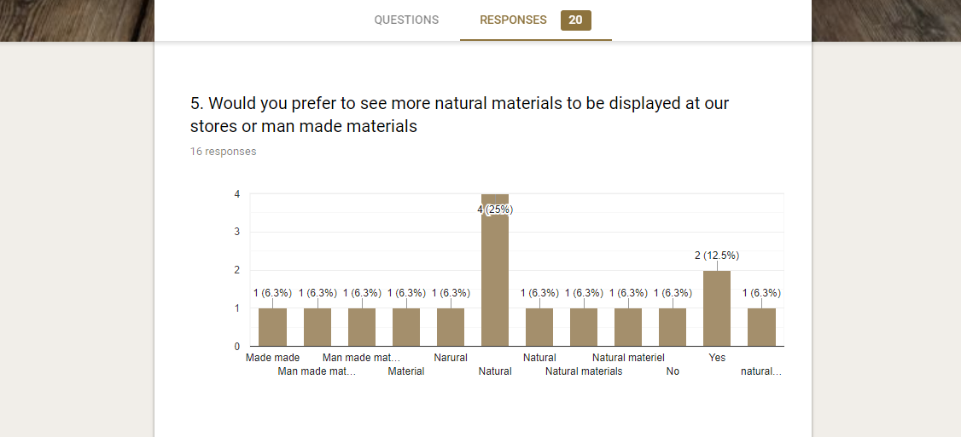
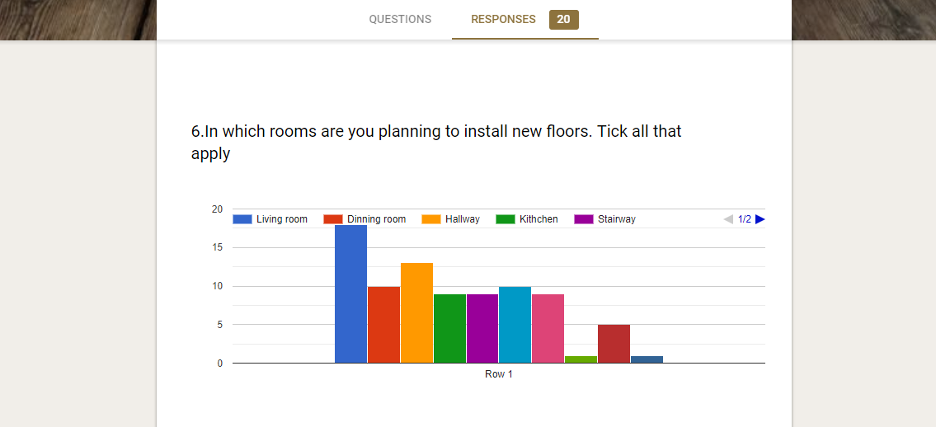
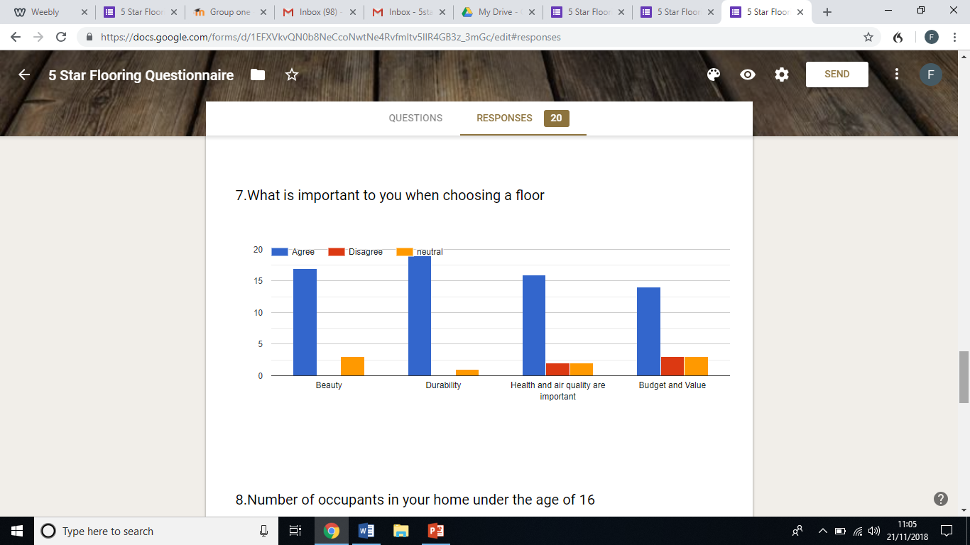
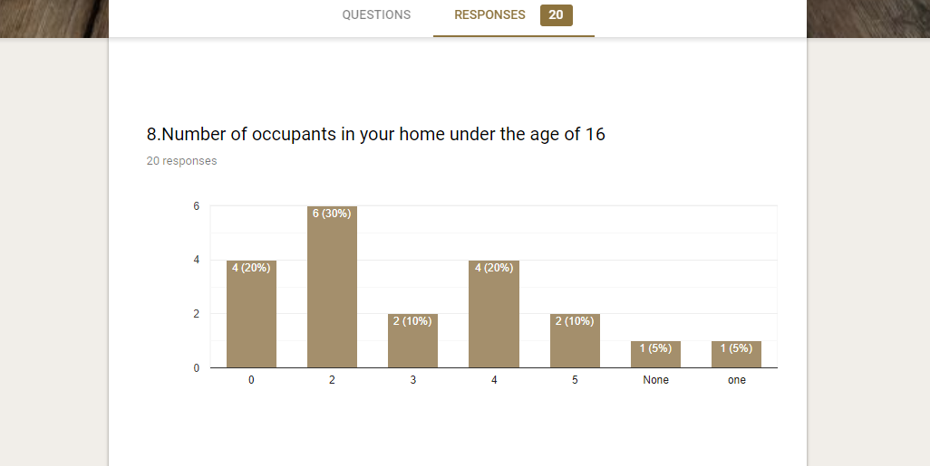

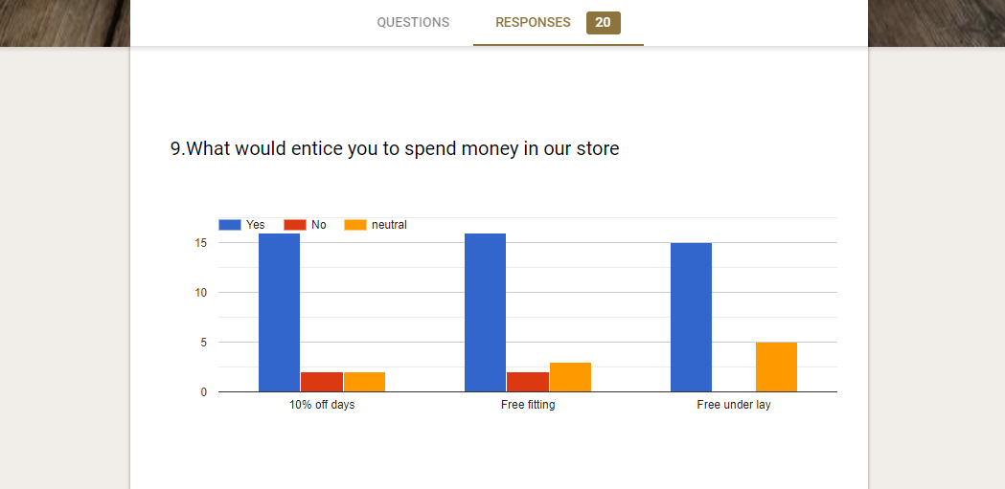

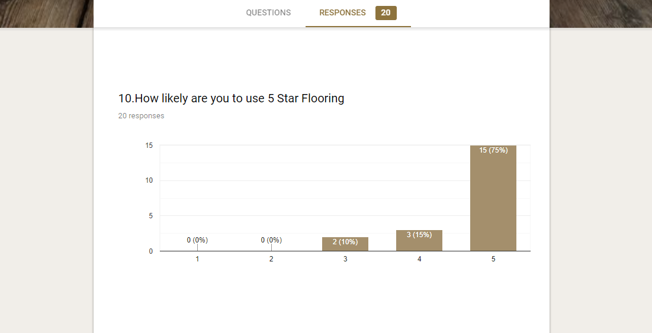

Reference list
1. Donovan, N (2018) MARKETING THEORIES – THE MARKETING MIX – FROM 4 PS TO 7 PS, Available at: https://www.professionalacademy.com/blogs-and-advice/marketing-theories---the-marketing-mix---from-4-p-s-to-7-p-s (Accessed: 31st October 2018).
2. Webfinance Inc (2018) what is partnership. available at: www.businessdictionary.com/definition/partnership.html (Accessed: 30th October 2018)

3.Investorswords (2018) Partnership. Available at: www.investorwords.com/3609/partnership.html (Accessed: 30th October 2018)

4. Keuilian, B. (2016) Partnership in business (video). Available at: https://youtu.be/fG_NBTeNN2s(Accessed: 30th October 2018)
5.(2017) Businesswalse, Available at: https://businesswales.gov.wales/businessfinance/types-finance-and-how-apply(Accessed: 2/11/18).
6.Dudovskiy, J. (2018) Questionnaires, Available at: https://research-methodology.net/research-methods/survey-method/questionnaires-2/ (Accessed: 27th November 2018).
7.Jones, K. (2018) 7 marketing and promotion tactics to get your content discovered, Available at: https://searchengineland.com/7-marketing-and-promotion-tactics-to-get-your-content-discovered-293734 (Accessed: 27th November 2018).

8.Lovering, C. (2018) 8 Different Ways to Advertise Products and Services , Available at: https://smallbusiness.chron.com/8-different-ways-advertise-products-services-19274.html (Accessed: 27th November 2018).
9.Hills, K, 2018, Made in British. Available at: https://makeitbritish.co.uk (Accessed; 1 December 2018)

10.W.Richard, 2018, How to install laminate floorings. Available at:https://home.howstuffworks.com/home-improvement/home-diy/flooring/install-laminate-flooring1.htm (Accessed: 1 December 2018)

Presentation slides.

