NAME: JAYDIP RAMANI
STUDENT NUMBER: 2131580
LECTURER: TUSHARA BALENDRAN
COURSE: MBA GENERAL MANAGEMENT
MODULE CODE: LCMB7001
MODULE NAME: MARKETING MANAGEMENT
ASSIGNMENT 1
ASSINGMENT TITLE: MARKETING MANAGEMENT OF UNILIVER

Executive Summary
The assessment helps in analysing the various marketing tools that have helped in development of Unilever. A critical discussion of the communication and the brand equity models have been presented here. In this study the detailed discussion of the customer journey map has also been presented. Furthermore, a brief discussion on the customer touchpoints have been provided as well. Overall, the total management model of Unilever has been discussed in detail as well.
Table of Contents
1. Introduction 5
2. Background Study of Unilever 5
3. Communication Models and Marketing 7
3.1. Defining communication 7
3.2. Berlo’s Model of Communication 7
3.3. Communication Channels Used by Unilever 8
4. The Different Promotional Strategies of Unilever 9
5. Brand equity models and implementation in Unilever 11
5.1. Defining Brand Equity 11
5.2. Aaker Model of Brand Equity 11
5.3. Implementation of Aaker Model in Unilever 12
5.4. Pros and Cons of Aaker Model concerning Unilever 13
6. Customer Journey 14
6.1. Defining Customer Journey 14
6.2. Stages of the Journey 14
6.3 Customer Touchpoints 15
Pre-purchase Touchpoints 16
Purchase Touchpoints 16
After-purchase Touchpoints 17
6.4 Customer Journey Map of Unilever 17
6.5 Opportunities and Threats of Unilever’s Customer journey map 18
7. The Total Engagement Model of Unilever 19
8. Conclusion and Recommendation 20
References 21

1. Introduction
Customer experience has always been considered to be one of the most important aspects of the business. The main aim of the study is to focus on the communication channels and the customer journey provided by the company. The study has helped in critically appraising Unilever Plc and has shown the various innovative strategies and creation of brand awareness. A customer journey map has been depicted in the study showing the ways in which the customer experience is met.

2. Background Study of Unilever
Unilever is a consumer goods company that aims at making living sustainable. At present, the company is spread over 190 countries and a total of 3.4 billion people are seen using the products of the company. In 2021, the company showed a turnover of €52 billion with about 58% of the emerging markets (Unilever.com, 2022). The company has been observed to have built its name by establishing a market with over 400+ household brands. Among them, it has been observed that over 13 brands had a turnover of more than €1 billion in 2021. It has been observed that the company has shifted towards implementing sustainable strategies. The statistics state that 53% of the plastic packaging that is used by the company is reusable (Unilever.com, 2022). Additionally, a reduction in scope 1 and scope 2 of the greenhouse gas emissions has been observed by about 64% since 2015.
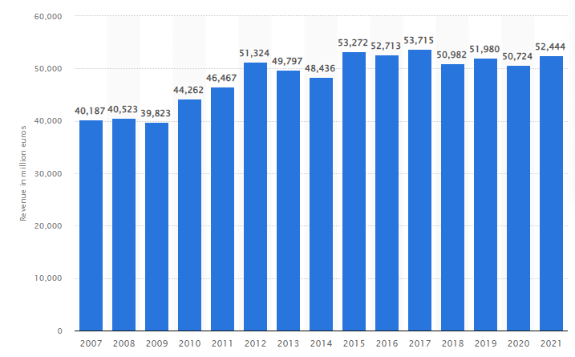
Figure 1: The Revenue of Unilever Group
(Source: Statista.com, 2022)
From the image above it has been observed that the revenue of the Unilever Group has increased over the years as well. Furthermore, from the image below it can be stated that as of 2018 the mentioned company contributed to 23% of the European market among the total 59% of the emerging markets (Masterinvestor.co.uk, 2019). It has been observed that the market of Unilever is divided into three strong divisions of home care, foods and refreshments, and personal care and beauty products.
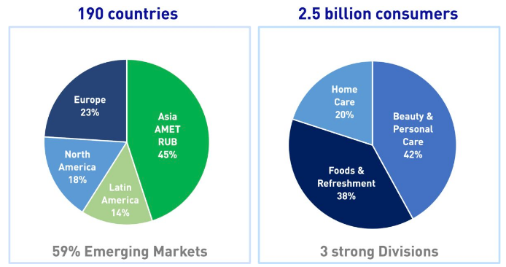
Figure 2: The emerging market of Unilever and the product segments
(Source: Masterinvestor.co.uk, 2019)
Furthermore, it has been observed that the market of Unilever has a higher stock price and is on the rise constantly. Additionally, the studies of Sinha (2021), have stated that the markets of Unilever have gained higher profitability in recent years owing to its gain in customers. The image below has helped in showing the increasing stock and share price of the mentioned company.
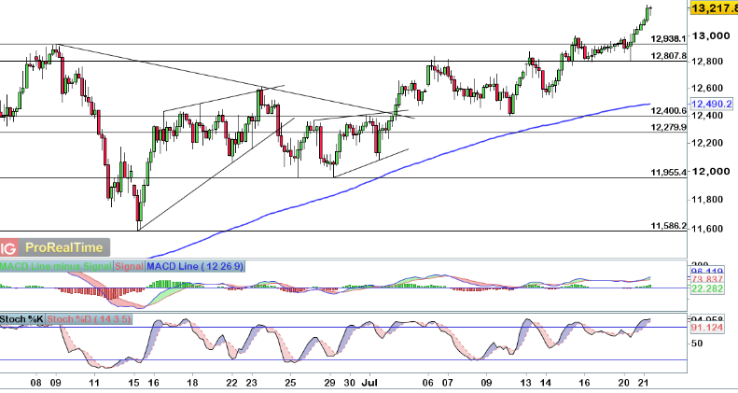
Figure 3: The emerging market of Unilever and the product segments
(Source: Ig.com, 2021)

3. Communication Models and Marketing

3.1. Defining communication
The act of communication is referred to as the act of receiving, giving, or sharing information. According to Sarbini et al., (2021), communication is also defined as the key process in the maintenance of a dynamic activity that helps in establishing a better understanding of an organization or any form of leadership.

3.2. Berlo’s Model of Communication
In this model of communication, the forms of communication take into account the emotional aspect of the message delivered. The research of Riley et al., (2021), has expressed that this model of communication is dependent on four aspects: Source, Message, Channel and Receiver (SMCR). The image below has helped in showing the SMCR model in detail.
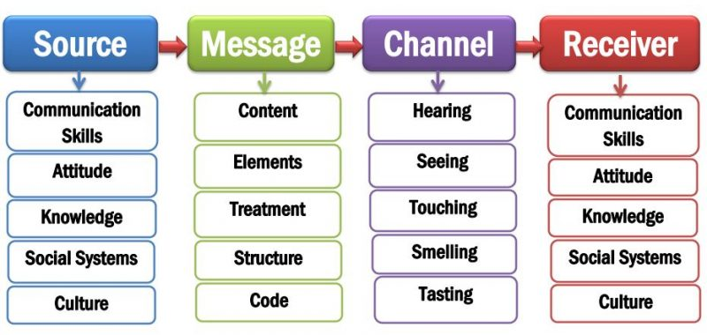
Figure 4: Berlo’s SMCR model
The Source in the model depicts the sender and or the originator of the message. Mangan et al., (2022), have opined that the source should have proper communication skills and attitude while developing the message. The sender of the message should have a thorough knowledge of the social systems and cultures to communicate fluently. When encoding the message, it can be mentioned that the elements and the contents of the message determine the number of followers. Furthermore, Rosenthal (2020), has voiced that the channel of the message generally refers to the medium of information flow. The receiver end of the message depicts the decoding stage of the message. It can be mentioned that following all the steps of Berlo’s model helps in the development of a fool proof communication system that helps in ensuring a strong and dynamic presence of the message.

3.3. Communication Channels Used by Unilever
The communication channels that are mostly implemented by the mentioned company involve communication through product labels, leaflets, telephone conversations, email communications, and other forms of open communications (Unilever.com, 2018). According to Zalnieriute (2019), it can be mentioned that the introduction of the “inter-media digital age” has played a major part in changing the forms of communication. A beautiful amalgamation of the “Customer Engagement theory” and the “Berlo’s communication model” has been presented by Unilever to gain customers. From a detailed evaluation of the various social media communications of Unilever, it has been observed that marketing and communicating through Facebook has helped them in gaining 0.07% of consumers. Furthermore, the report shows that the 72 tweets of the company have gained 579 retweets overall. The average customer engagement of the company gained through Instagram is nearly 176 (Unmetric.com, 2022).
Following Berlo’s Model of Communication, it has been seen that the communication method adopted by the mentioned company is focused on breaking stereotypes. The research of Batat, W., and Addis (2021), has expressed that the company has adopted the strategy of linking their brands with real life for the promotion of products as it would capture the emotional side of the consumers. Instances such as “Dove's Campaign for Real Beauty” has helped in promoting a positive attitude development in women and making them feel comfortable in their skins (Unilever.com, 2018). The other campaigns such as “Omo/Persil's 'Dirt is good' campaign” or the “Comfort One Rinse’s campaign” have created a positive impact in the minds of the customers.
Other communication channels such as event sponsorship and gifting practices have been implemented by the mentioned company as well. Introducing price drops and advertising them through various advertisement channels have led to the establishment of effective communication between the company and the consumers. Since these forms of communicating with the consumers involve the promotion of the products they are also referred to as promotional tools. The image below has helped in representing the successful frequency of the communication methods used by the company.
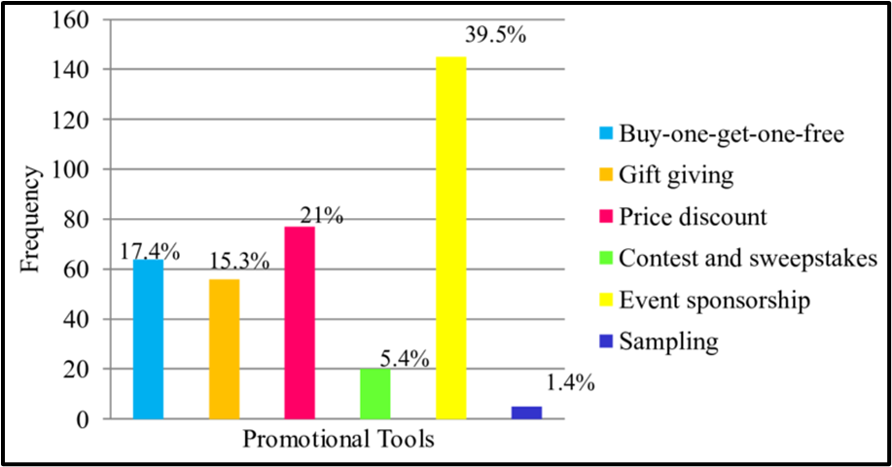
Figure 5: Frequency of consumer engagement achieved through the various communications
(Source: Researchgate.net, 2018)
Overall, it can be mentioned that the communication channels that are implemented by the mentioned company are based on the development of the positive brand model of the company. Following Berlo’s Model of communication has helped the company in covering the social aspect of communicating to the consumers.

4. The Different Promotional Strategies of Unilever
The different promotional strategies that are implemented by the mentioned company involve both online as well as offline promotions. However, it can be mentioned that the promotion of the products by the mentioned company involves the opening of subsidiaries in different countries. It has been observed that the major theme of promoting the products by the mentioned company involves capturing the local essence (Thestrategystory.com, 2021). For instance, the Unilever subsidiary in India, “Hindustan Unilever” has been observed to make a permanent place in Indian households by valuing middle-class values and holding onto the old-fashioned essence of culture. Thus, it can be mentioned that the promotion of the products by Unilever is based on the culture and values of the consumers making them one of the most loved brands. Moreover, Thijssen et al., (2019), have stated that this company has kept the values of sustainability at the heart of its development. Since consumers in the present times have become more environmentally conscious, they are bound to get attracted to these products overall. The mentioned company by implementing these strategies has been able to achieve a higher operating profit.
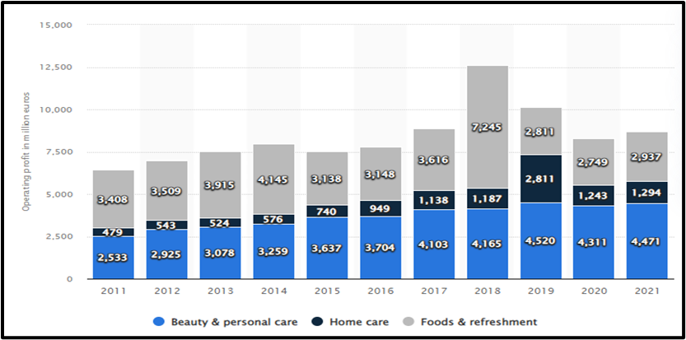
Figure 6: Operating profit of Unilever
(Source: Statista.com, 2022)
According to Nath and Saha (2021), Unilever is one of the most common brands in every household worldwide, advertising products on televisions and in newspapers have formed the primary basis of communication. Sales promotions and discounts help in gaining the attraction of consumers. For instance, sometimes Dove soaps are offered as a pack of three thus offering lucrative discounts to the people. The offline promotional strategy of the company involves direct marketing and personal selling of the products in collaboration with the retailers. In other words, Sassi et al., (2018), have mentioned that the pricing strategy of the company also helps promote the products. Offering discounts and incentives on the purchase of the products also pave the way in influencing the customers to buy the products of a particular brand.

5. Brand equity models and implementation in Unilever

5.1. Defining Brand Equity
Brand equity can be defined to be a marketing term that helps in describing the brand value in detail. According to Górska-Warsewicz (2020), the brand value is determined based on the perception of the consumers and the experience of the brand. It can be mentioned that in case the consumer perception of the brand is high the brand equity is determined to be positive for the brand as well. The image below helps in representing the various aspects of brand equity.
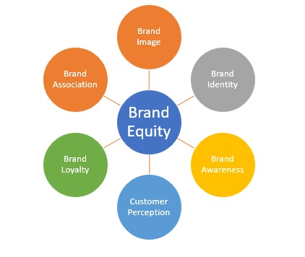
Figure 7: Brand Equity Aspects
(Source: Created by the Author)

5.2. Aaker Model of Brand Equity
The Aaker model views brand equity as a combination of brand loyalty, awareness, and associations. Shariq (2018), has mentioned that brand equity in this model can be defined as the set of the brand assets and the liabilities which are linked to the brand. This model mainly suggests that companies having a high brand awareness can positively put brand visibility to increase the revenue of the company (Hategan et al., 2021). With the implementation of this model in the development of brand equity, the customers can be valued in a better manner and hence help in influencing the customers to buy services from the company.
The various aspects of Aaker's brand equity model involve the following:
- Brand Loyalty
- Brand Awareness
- The Perceived Quality
- Brand Associations
- The proprietary assets
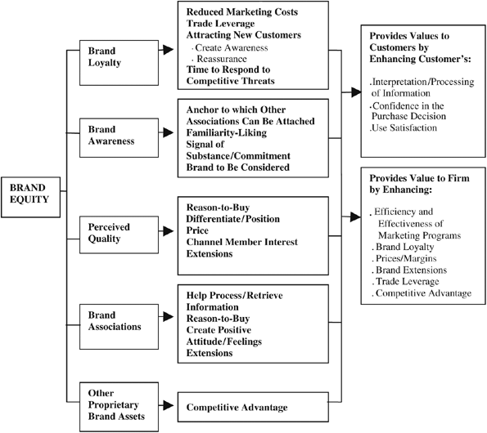‘
Figure 8: Aaker’s Brand Equity Model
(Source: Researchgate.net, 2018)
The image below helps in showing the links between the five aspects of the model. The value perceived by the customers from this model has also been illustrated in the image as well.

5.3. Implementation of Aaker Model in Unilever
The Unilever brand reaches billions of people every day and helps in capturing the way in the best possible manner. According to Ishaq and Di Maria (2020), following Aaker’s model has helped the company in developing a high brand image, It is through this model that the brand has been able to link its products with the daily life of the consumers. This has helped the company in increasing the perceived value of the brands in the views of the customers. Additionally, the report has expressed that following the views of almost 74% of the consumers globally, Unilever has adopted a greater inclusion strategy that helps in portraying that the customers are of high value to the company (Unilever.com, 2022). The creation of a brand association has led to the development of unstereotyping the marketing processes and provoking diversity and equity in the marketing process.
Furthermore, as per a report it has been observed that the FMCG giant is focusing on the establishment of sustainability in the business processes to boost brand equity (Warc.com, 2018). Setting up targets to reduce greenhouse emissions has helped in making the company adopt green practices. Additionally, it can be mentioned that this process has helped the company in gaining a greater position in the market and has helped it in maintaining its position in the market.

5.4. Pros and Cons of Aaker Model concerning Unilever
Pros of the Aaker Model
- Helps in better positioning of the brand thus helping Unilever to capture and hold the best position in the market.
- Helps in adding value to the products thus helping to increase customer satisfaction (Keller and Brexendorf, 2019)
- Adds quality to the products following which Unilever would be able to influence the purchasing behaviour of the consumers.
Cons of the Aaker Model
- Requires a high investment for promotional campaigns that would help in increasing the customer base of the company.
- Acquiring the brand equity requires promotions in such a manner which would help eventually end up acquiring a common pace in the market.

6. Customer Journey

6.1. Defining Customer Journey
The customer journey is referred to as the path of the interactions that help in offering the individuals with the brands and services. As per the studies of Tueanrat et al., (2021), customer journeys can be considered as a map of the unique path which helps in achieving the marketing touch points in a better manner. However, each and every customer journey is different from one another.

6.2. Stages of the Journey
The customer journey is referred to as the collective interactions of the consumer with the brand. The image below helps in showing the stages of the customer journey.
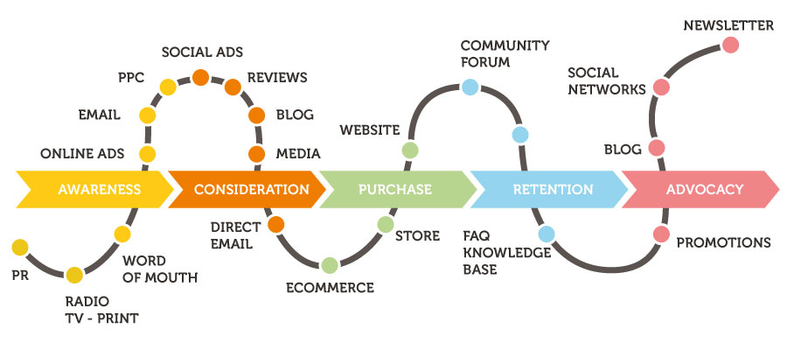
Figure 9: Stages of Customer Journey
(Source: Preciesmark.nl, 2018)
Overall, there are five phases of the customer journey as follows:
- Awareness: In this phase, the consumer is made aware of the products and looks for information on the particular item. About 81% of the consumers carry out online research of the product while 61% focus on the reviews of the item before considering buying it (Adweek.com, 2022).
- Consideration: After conducting informative research it has been seen that in most cases the consumers weigh the pros and cons of the product and then consider buying it. According to Rana et al., (2021), in this phase, the products are generally compared with those of the other brands in respect to their price and quality and then chosen.
- Purchase: After gathering all the necessary information and comparing the products it has been observed that the customers buy the products in this phase.
- Retention: This stage can be considered to be the most crucial step for the company. This is mainly because after purchasing the product if the consumers are not satisfied then they would shift to other brands. Thus, the retention phase helps in testing consumer loyalty and increases the customer base of the company (Gao et al., 2020).
- Advocacy: In this phase, it has been observed that the customer generally advocates the brand. The studies of Rusthollkarhu et al., (2021), have helped in showing that in this phase the consumer generally has developed huge faith in the company which helps in making them confident about spreading the brand among their friends and family.

6.3 Customer Touchpoints
Customer touchpoints refer to the various points or stages at which the brand is seen to be interacting with the customers from the beginning end to the end. From the studies of Eckert (2022), it can be mentioned that the customer touchpoint helps in capturing the encounters of the customer and the brand thus helping the company to identify the pros and cons of the interactions.
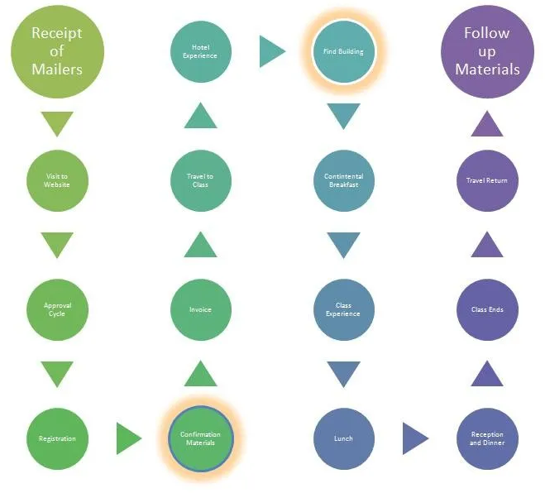
Figure 11: Customer Touchpoints Map
(Source: Created by the Author)

Pre-purchase Touchpoints
The prepurchase touchpoints for the mentioned company should be designed in such a manner that it helps in shaping and heightening brand awareness. For instance, customer D wants to buy household products such as soaps or pastes. The first brand in that case that comes into the mind of the customer is Unilever since it offers both. Thus, the customer would look for the review of the products and then decide to order the products.

Purchase Touchpoints
Customer D is seen going into a supermarket to buy grocery items and wants to get all the required products. Within the store, she is assisted by a salesperson who offers D all the products he needs from the same brand. Thus, customer D is turned into a potential and permanent customer for the brand since Unilever would be able to provide him with all the world-class products under one brand name.

After-purchase Touchpoints
After a few days of the purchase, Customer D comes across an email sent to her by the company letting him know about the various upcoming offers. In this manner, Customer D is shown that the customer is valued to a great extent. Thus, the customer is bound to be pleased with such after-sales behaviour. Thus, customer D would become a potential carrier of the message regarding Unilever and its products.
From the above example, it can be mentioned that the customer touchpoints play a major role in making retention of a customer.

6.4 Customer Journey Map of Unilever
The customer journey map helps in showing the journey of the customers from viewing an advertisement to purchasing the products. The image below has helped in showing the detailed representation of the customer journey in buying the dove soap manufactured and marketed by Unilever. All the stages of marketing have been presented in detail on the map. The start of the journey is through discovering the ad from a social media website regarding the product and then looking up the offers and discounts provided by the company. After the discovery phase, the products are then purchased by the customers. The quality of the products and the experience of the consumers play a major role in turning the customers into advocates for the brand.
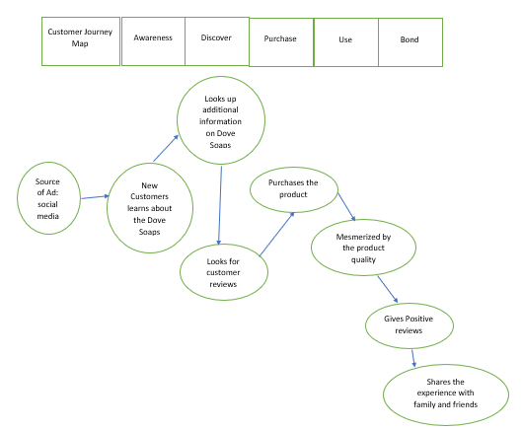
Figure 10: Customer Journey Map for Dove
(Source: Created by the Author)
From the customer journey map, it can be mentioned that all the touchpoints have been met. As per the journey map it can be mentioned that the major reason for the purchase of the products involve the product quality. It can be stated that the customers have been observed to be greatly inspired and satisfied with the product quality. Hence, it can be mentioned that the company has paid greater attention to the satisfaction of the customers as a major criteria for increasing the industrial gains.

6.5 Opportunities and Threats of Unilever’s Customer journey map
From the customer journey map, it can be mentioned that the major opportunities for the company lie in the fact that all the products manufactured by the company are of very high quality. Moreover, Rahmayati (2021), has mentioned that the pricing strategy of the products offered by the company is quite competitive in comparison to the surrounding market hence it helped in the better development of the customer base. Moreover, the communication methods of promoting positive messages among the consumers have helped in creating brand loyalty among the customers. Thus, it can be mentioned that the customer journey of Unilever has quite a positive impact on the employees. The major strengths identified from the customer journey map involve taking in reviews from the customers. Thus, it would help the company in focusing on the ways of improving the quality of the product further.
The major threats that have been identified in the customer journey map are the increasing number of competitors in the field of FMCG goods. Moreover, the product segmentation followed by Unilever has become quite common through nit as vast as Unilever which acts as a threat to the position of the mentioned company.

7. The Total Engagement Model of Unilever
The total engagement model is mainly focused on developing an efficient and effective system for the development of a better relationship between the development team and the client. In the case of Unilever, it can be mentioned that the customer satisfaction is maintained at the highest level. According to Kirkbride et al., (2021), it has been seen that Unilever believes in the implementation of the “Direct-To-Consumer Business Model” for gaining better insights into the needs of the employees.

Figure 12: The Total Engagement Model
(Source: Created by the Author)
Taking into consideration the studies of Guiné et al., (2020), it can be mentioned that the main focus of the company has been to develop its products in such a way that it contributes to the development of a positive attitude among the customers. Moreover, the management of Unilever is focused on bringing about product innovation. It can also be stated that the customer engagement model of the company helps in engaging and building better relationships. In turn it helps in building of a greater revenue per customer and hence helps in better customer retention. Thus, it helps the company in fulfilling its mission and vision in a better manner. Overall, it needs to be mentioned in this context that the management model of the company has been quite ideal for the development of the company so far.

8. Conclusion and Recommendation
Conclusion
The report has helped in concluding that the implementation of several marketing tools has helped in making the company quite competitive. Moreover, it can also be concluded that the development of the market based on customer loyalty has been quite high for Unilever. The study has shown that the company has focused on providing the customers with an increased level of satisfaction through excellent product quality. Moreover, it can be mentioned that the study has identified that for the promotion of the products the company has adopted the strategy of blending in with the local culture for the promotion of their products. The various customer touchpoints provided by the company to the consumers have also been provided in the study.
Recommendations
- It is recommended that the company needs to introduce better strategies for bringing about innovation in product development.
- Adoption of technology such as AI and Big Data Analytics is highly advised for the company to gain thorough market knowledge.
- It is advised that the company needs to sponsor more events and introduce more varieties of food products to attract “health-conscious consumers”.
- Focus on improving the customer services further so that distinct customer journey maps of various customer segments can be analysed in detail.

References
Adweek.com, 2022. 81% of Shoppers Conduct Online Research Before Buying [Infographic]. Available at: https://www.adweek.com/performance-marketing/81-shoppers-conduct-online-research-making-purchase-infographic/#:~:text=Eighty%2Done%20percent%20of%20shoppers,stores%20before%20making%20their%20purchase. [Accessed on 09-08-2022]
Batat, W. and Addis, M., 2021. Designing food experiences for well-being: a framework advancing design thinking research from a customer experience perspective. European Journal of Marketing.
Eckert, C., Neunsinger, C. and Osterrieder, K., 2022. Managing customer satisfaction: digital applications for insurance companies. The Geneva Papers on Risk and Insurance-Issues and Practice, pp.1-34.
Gao, L., Melero, I. and Sese, F.J., 2020. Multichannel integration along the customer journey: a systematic review and research agenda. The Service Industries Journal, 40(15-16), pp.1087-1118.
Górska-Warsewicz, H., 2020. Factors determining city brand equity—A systematic literature review. Sustainability, 12(19), p.7858.
Guiné, R.P., Florença, S.G., Barroca, M.J. and Anjos, O., 2020. The link between the consumer and the innovations in food product development. Foods, 9(9), p.1317.
Hategan, C.D., Pitorac, R.I., Hategan, V.P. and Imbrescu, C.M., 2021. Opportunities and Challenges of Companies from the Romanian E-Commerce Market for Sustainable Competitiveness. Sustainability, 13(23), p.13358.
Ig.com, 2021. Unilever shares on course to exceed Barclays target price. Available at: https://www.ig.com/uk/news-and-trade-ideas/unilever-shares-on-course-to-exceed-barclays-target-price-200721 [Accessed on 10-08-2022]
Keller, K.L. and Brexendorf, T.O., 2019. Measuring brand equity. Handbuch Markenführung, pp.1409-1439.
Kirkbride, L., Humphries, L., Kozielska, P. and Curtis, H., 2021. Designing a Suitable Stability Protocol in the Face of a Changing Retail Landscape. Cosmetics, 8(3), p.64.
Mangan, J., Rae, J., Anderson, J. and Jones, D., 2022. Undergraduate paramedic students and interpersonal communication development: a scoping review. Advances in Health Sciences Education, pp.1-26.
Masterinvestor.co.uk, 2019. Unilever’s beautiful future. Available at: https://masterinvestor.co.uk/equities/unilevers-beautiful-future/ [Accessed on 10-08-2022]
Nath, S. and Saha, B., 2021, January. A Review: Representation of Women in Commercial Advertising and Impact in Indian Society. In International Conference on Research into Design (pp. 641-653). Springer, Singapore.
Oehmen, J., Günther, A., Herrmann, J.W., Schulte, J. and Willumsen, P., 2020, May. Risk management in product development: risk identification, assessment, and mitigation–a literature review. In Proceedings of the Design Society: DESIGN Conference (Vol. 1, pp. 657-666). Cambridge University Press.
Preciesmark.nl, 2018. How To Measure The Customer Buying Journey. Available at: https://preciesmark.nl/how-to-cut-your-customer-buying-journey-in-measurable-pieces/ [Accessed on 09-08-2022]
Rahmayati, R., 2021. Competition Strategy In The Islamic Banking Industry: An Empirical Review. International Journal Of Business, Economics, And Social Development, 2(2), pp.65-71.
Rana, J., Gaur, L., Singh, G., Awan, U. and Rasheed, M.I., 2021. Reinforcing customer journey through artificial intelligence: a review and research agenda. International Journal of Emerging Markets.
Researchgate.net, 2018. Aaker’s Brand Equity Model. Available at: https://www.researchgate.net/figure/Aakers-brand-equity-model-Source-Aaker-1991-270_fig1_317952494 [Accessed on 09-08-2022]
Researchgate.net, 2018. Investigation into Consumer Response to Sales Promotional Activities: The Case of Unilever Ghana Limited. Available at: https://www.researchgate.net/figure/Types-of-promotional-tools-used-by-Unilever-Ghana-Limited_fig2_276242347 [Accessed on 09-08-2022]
Riley, R., de Preux, L., Capella, P., Mejia, C., Kajikawa, Y. and de Nazelle, A., 2021. How do we effectively communicate air pollution to change public attitudes and behaviours? A review. Sustainability Science, 16(6), pp.2027-2047.
Rosenthal, S., 2020. Media literacy, scientific literacy, and science videos on the internet. Frontiers in Communication, 5, p.581585.
Rusthollkarhu, S., Aarikka-Stenroos, L. and Mero, J., 2021. B2B Customer Journey: Axioms and Actor Roles. In Proceedings of the 50th European Marketing Academy Conference, EMAC 2021. European Marketing Academy.
Sarbini, N.N., Ibrahim, I.S., Abidin, N.I., Yahaya, F.M. and Azizan, N.Z.N., 2021. Review on maintenance issues toward building maintenance management best practices. Journal of Building Engineering, 44, p.102985.
Sassi, F., Belloni, A., Mirelman, A.J., Suhrcke, M., Thomas, A., Salti, N., Vellakkal, S., Visaruthvong, C., Popkin, B.M. and Nugent, R., 2018. Equity impacts of price policies to promote healthy behaviours. The Lancet, 391(10134), pp.2059-2070.
Shariq, M., 2018. Brand equity dimensions-a literature review. International Research Journal of Management and Commerce, 5(3), p.312.
Sinha, E., 2021. Circular economy—A way forward to sustainable development: Identifying conceptual overlaps and contingency factors at the microlevel. Sustainable Development.
Statista.com, 2022. Global operating profit of Unilever Group from 2011 to 2021, by product segment. Available at: https://www.statista.com/statistics/254206/global-operating-profit-of-the-unilever-group-by-product-segment/ [Accessed on 09-08-2022]
Statista.com, 2022. Revenue of Unilever Group worldwide from 2007 to 2021. Available at: https://www.statista.com/statistics/269190/global-revenue-of-the-unilever-group-since-2007/ [Accessed on 10-08-2022]
Thijssen, D.H., Bruno, R.M., van Mil, A.C., Holder, S.M., Faita, F., Greyling, A., Zock, P.L., Taddei, S., Deanfield, J.E., Luscher, T. and Green, D.J., 2019. Expert consensus and evidence-based recommendations for the assessment of flow-mediated dilation in humans. European heart journal, 40(30), pp.2534-2547.
Tueanrat, Y., Papagiannidis, S. and Alamanos, E., 2021. Going on a journey: A review of the customer journey literature. Journal of Business Research, 125, pp.336-353.
Unilever.com, 2018. Advertising and marketing. Available at: https://www.unilever.com/planet-and-society/responsible-business/advertising-and-marketing/ [Accessed on 09-08-2022]
Unilever.com, 2022. Transforming our brands, transforming our advertising. Available at: https://www.unilever.com/planet-and-society/equity-diversity-and-inclusion/transforming-our-brands-transforming-our-advertising/ [Accessed on 10-08-2022]
Unilever.com, 2022. Unilever at a glance. Available at: https://www.unilever.com/our-company/at-a-glance/ [Accessed on 10-08-2022]
Unmetric.com, 2022. A deep dive into the social media habits and performance of Unilever Available at: https://unmetric.com/brands/unilever [Accessed on 09-08-2022]
Warc.com, 2018. Unilever goes green to boost brand equity. Available at: https://www.warc.com/newsandopinion/news/unilever-goes-green-to-boost-brand-equity/en-gb/27513 [Accessed on 10-08-2022]
Zalnieriute, M., 2019. The Necessity for Binding Human Rights Obligations for Private Actors in the Digital Age: A Submission to the UN Human Rights Council on New and Emerging Technologies. UNSW Law Research Paper, (19-81).

