Electrical and Electronic Principles L4 EES
ACDA4006

Resonance

Caitlin Lonsdale
2306892

Word Count: 2300

Contents

Abstract……………………………………………………………………………………………………………………………………...….…1

Introduction………………………………………………………………………………………………………………………………………2

Resonant Circuit Theory…………………………………………………………………………………………………………………….2
  - Capacitance and Inductance
  - Resistance and Voltage Dividers
  - Reactance and Impedance
  - Attenuation and Q-Factor

Circuit Simulation………………………………………………………………………………………………………………………………5
2.1 Circuit Design
2.2 Proteus Simulation
2.3 Simulation Results

Circuit Testing……………………………………………………………………………………………………………………………………8
3.1 Circuit Implementation
3.2 Laboratory Results
3.3 Discussion
3.4 Model Refinement

Conclusion……………………………………………………………………………………………………………………………………….11

References……………………………………………………………………………………………………………………………………….12

Figure 1 – RLC Circuit Diagram………………………………………………………………………………………………………..…5
Figure 2 – Proteus Circuit Simulation…………………………………………………………………………………………………6
Figure 3 – Simulation Graph for Resonant Frequency………………………………………………………………………..6
Figure 4 – Simulation Graph for Lower Cut-off Frequency………………………………………………………………...7
Figure 5 – Simulation Graph for Upper Cut-off Frequency…………………………………………………………………7
Figure 6 – Circuit Testing Laboratory Set-up………………………………………………………………………………………8
Figure 7 – Breadboard RLC Circuit……………………………………………………………………………………………………..8
Figure 8 – RLC Circuit Measurements………………………………………………………………………………………………..9
Figure 9 – RLC Circuit Frequency Graph……………………………………………………………………………….…………….9
Figure 10 – Proteus Adapted Circuit…………………………………………………………………………………………………11

Abstract
This paper sets out the theory of an RLC (Resistor-Inductor-Capacitor) circuit and its resonant response through a range of tested frequencies, which can be achieved by both computer simulation and laboratory testing. We observe the behavioral responses of both, and differentiate the results through graphing and theoretical relationships. It is seen that both have similar responses, explored in greater detail, but there is a greater attenuation in a real-life response. The disparity is evaluated through bandwidth and Q-factor calculations, then explained by the losses of a real-life circuit. Since these losses are not automatically taken into account by the computer simulation, suggestions are made to improve the accuracy of the model. These adaptations involve adding resistors in series with the impeding components, in addition to adapting the inductive values to account for component tolerances.

Introduction
Resonant circuits are a fundamental concept in electronic design, with a variety of types and use cases. An example of its use can be given by audio amplifiers, where they can be used to control audio tone [1]. This report explores the design and test results of an RLC circuit, which combines a resistor, capacitor and inductor to form a passive filter. This is done through a computer simulation, followed by an implementation of the circuit on breadboard and laboratory testing. These results can then be compared and evaluated in order to demonstrate and understand the circuit activity.

Resonant Circuit Theory

  - Capacitance and Inductance
In the parallel portion of the circuit there is a 1µF capacitor. A capacitor is a passive electronic component that stores energy in an electric field [2]. Capacitance is the ability to store electric charge, and is calculated in Farads (F) by:
$$Capacitance (C)=\frac{Charge (Q)}{Voltage (V)}$$

In parallel with the capacitor is a 1mH inductor – a passive component that stores energy in a magnetic field. Inductance is the tendency of an electric conductor to oppose the change in the current flowing through it, due to the magnetic field induced. It is calculated in Henrys (H) by:
$$Inductance (L)=\frac{Voltage (V)}{di/dt}$$
where di/dt denotes the rate of change of current with respect to time

  - Resistance and Voltage Dividers
The parallel portion of the circuit is in series with a 1kΩ resistor, which forms a voltage divider circuit [3]. This means that the same current flows through the parallel portion of the circuit and the resistor.

Since the resistor is also a passive component, we can determine that the circuit is passive – since it contains no active components [2]. Since the circuit is passive, energy will be stored and attenuation will be observed (see 1.4) [4].

  - Reactance and Impedance
Similarly to resistance, reactance is the opposition of the change of flow of current in a circuit [2]. It is an AC (alternating current) only property, and can be either inductive, capacitive, or both. They are given by the following equations:
$$Inductive Reactance \left(XL\right)=2πfL$$

$$Inductive Capacitance (XC)=\frac{1}{2πfC}$$

Impedance (Z) is a vector quantity which combines the total reactance and resistance, taking phase into account. For the RLC circuit we first examine the impedance of the LC parallel component [5]:
$$\frac{1}{ZLC}=\frac{1}{ZL}+\frac{1}{ZC}=\frac{1}{jωL}-\frac{ωC}{j}=j\left(ωC-\frac{1}{ωL}\right)$$

Therefore: $ZLC=\frac{j}{\left(\frac{1}{ωL}\right)-ωC}$

As above in 1.2, the resistor in series forms a voltage divider circuit. Due to this, the maximum impedance (infinity) of the LC parallel component is achieved at the resonant frequency as given:
$$fres= \frac{1}{2π\sqrt{LC}}$$

  - Attenuation and Q-Factor
Following the equation above in 1.3, we can explore the parallel resonance that takes place in the circuit [6]. This can be graphed in a frequency-response curve, as appears below (see sections 2 and 3). The curve will show the system bandwidth – the range of frequencies over which it can operate efficiently. In a resonant circuit just as this, the bandwidth is the range between the upper (f2) and lower (f1) cutoffs; they are the points at which attenuation is 3dB, and amplitude is halved as such. It can be independently calculated by:
$Attenuation=20log10(\frac{Vout}{Vin}$)

The quality factor (Q-factor) is the ratio of the current through the parallel branches of the resonant circuit, meaning it is equal to current magnification at resonance. It is calculated by:
$$Q=\frac{1}{R}\sqrt{\frac{L}{C}}= \frac{fres}{f2-f1}$$

Circuit Simulation

2.1 Circuit Design
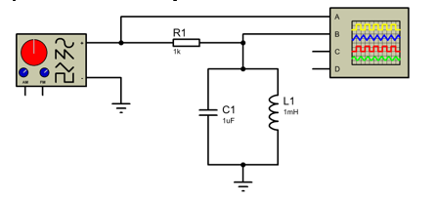
Figure 1 - RLC Circuit Diagram
As set out in section 1, the resonant circuit has a 1uF capacitor and 1mH inductor in parallel [2]. This portion is then connected in series with a 1kΩ resistor. The signal input is provided by a signal generator; with all elements connected to ground. The oscilloscope is then connected, as above, in order to take readings of the inputted and outputted circuit signals.

2.2 Proteus Simulation
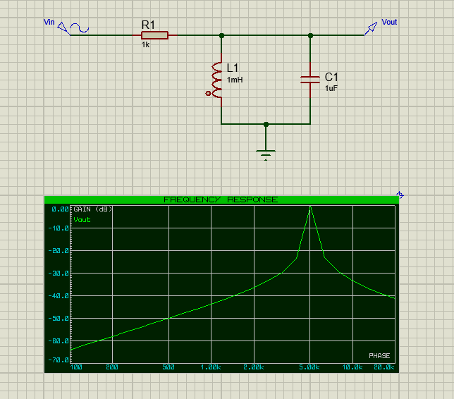
Figure 2 - Proteus Circuit Simulation
Above is shown the Proteus simulation of the resonant circuit, with its frequency response curve. The input signal is set at 2V pk-pk, ranging in frequency from 100 Hz to 20kHz. This is plotted on a logarithmic scale against gain (dB).

2.3 Simulation Results
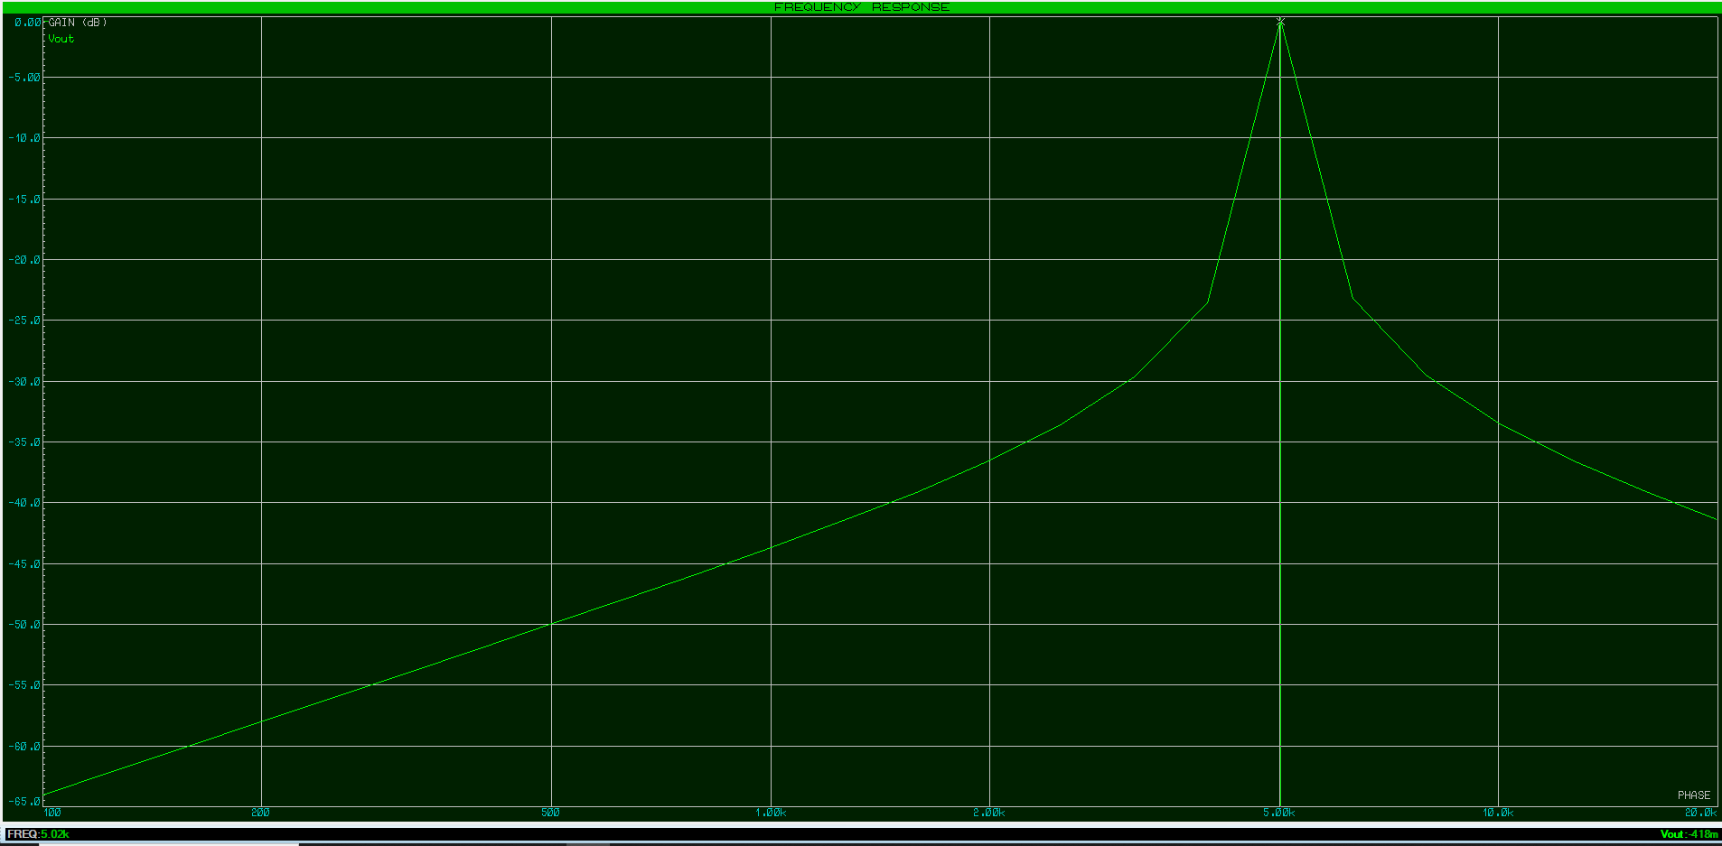
Figure 3 - Simulation Graph for Resonant Frequency
At the peak frequency, which can be defined as the resonant frequency, there is the maximum gain (alternatively referenced as minimum attenuation). From this graph we can take the resonant frequency as 5.02 kHz, where attenuation tends towards 0 dB. This aligns with the theoretical equations set out in 1.3, where resonant frequency is calculated as:
$$fres= \frac{1}{2π\sqrt{0.001×0.000001}}=5032.92 Hz=5.03 kHz$$
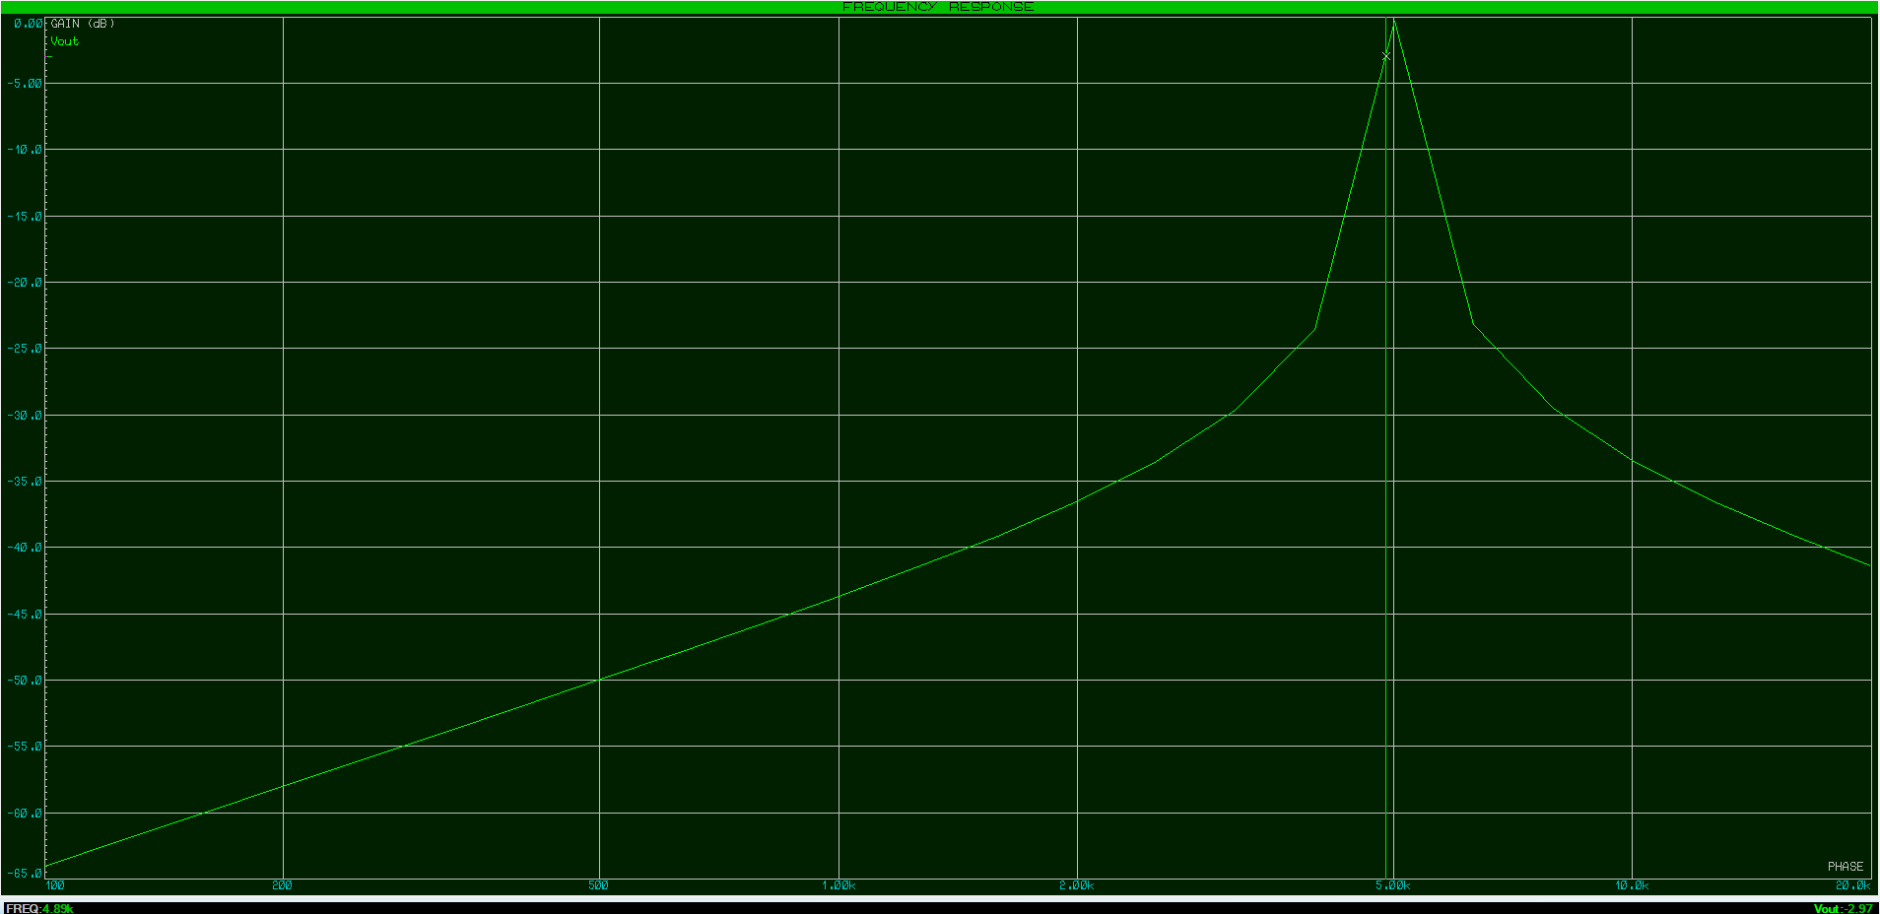
Figure 4 - Simulation Graph for Lower Cut-off Frequency
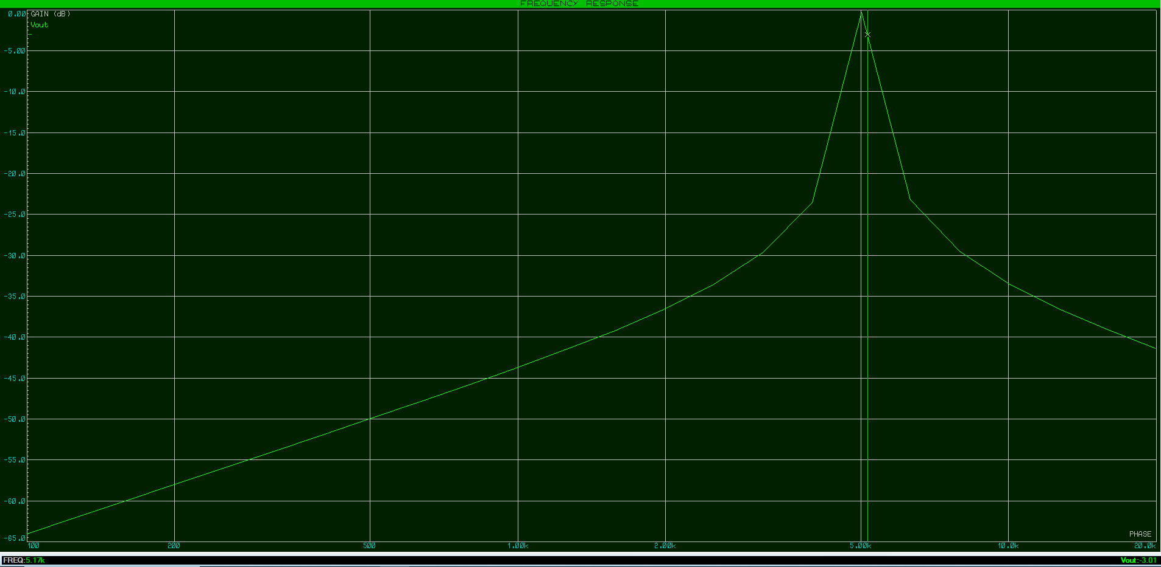
Figure 5 - Simulation Graph for Upper Cut-off Frequency
Readings can also be taken at -3dB gain to measure the f1 and f2 values, as explored in 1.4. f1 is given as approximately 4.9 kHz, and f2 as 5.2 kHz. From these values we can calculate the Q-factor:
$$Q= \frac{5.02}{5.17-4.89}=17.93$$

Comparing again to the theoretical equation from 1.4, the Q-factor is calculated as:
$$Q=\frac{1}{1000}\sqrt{\frac{0.001}{0.000001}}=0.0316$$

Before proceeding, it is key that we take the above comparison into account. The magnitude of the disparity, between the calculated theoretical Q-factor value and the simulation, is large. This means that, whilst the simulation doesn’t consider any real-life discrepancies of the circuit, it cannot be considered an entirely accurate depiction of theory either.

Circuit Testing

3.1 Circuit Implementation
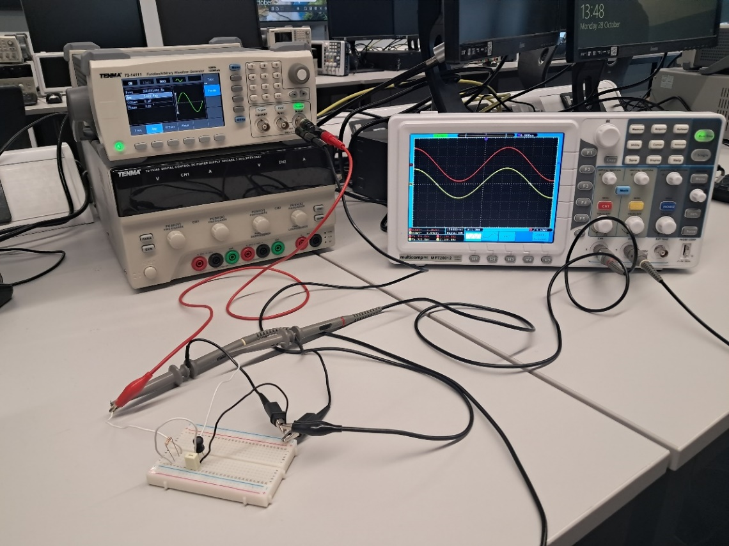
Figure 6 - Circuit Testing Laboratory Set-up
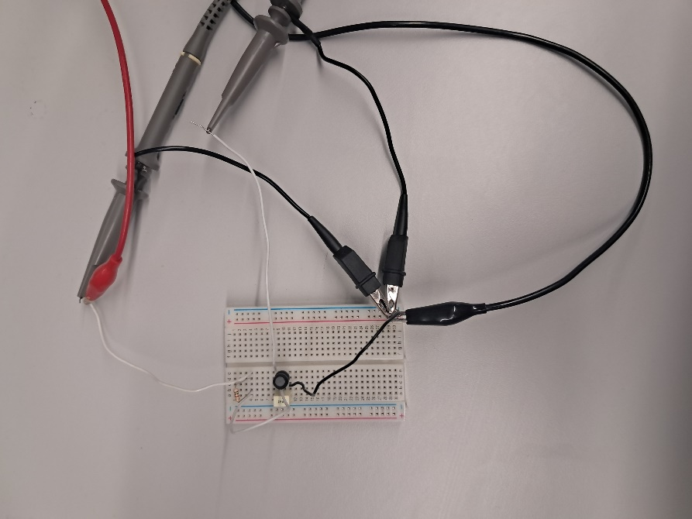
Figure 7 - Breadboard RLC Circuit
The above images show the building of the resonant circuit on breadboard, and its connection to the laboratory signal generator and oscilloscope. This entire setup follows the model given in section 2, including setting the oscilloscope to 2V pk-pk, and taking frequency readings in the range of 100 Hz to 20 kHz.
3.2 Laboratory Results
Using the oscilloscope, measurements for the voltage supplied (Vin) and voltage out (Vout) of the circuit are taken at defined frequency values. Using the equation in 1.4, we can use the values to calculate the attenuation at each of those frequencies. These can be plotted on a logarithmic graph to produce a frequency response curve, just like that produced by the Proteus simulation in 2.2.

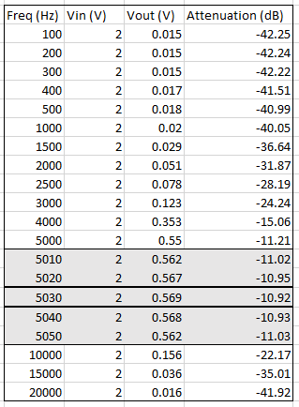
Figure 8 - RLC Circuit Measurements

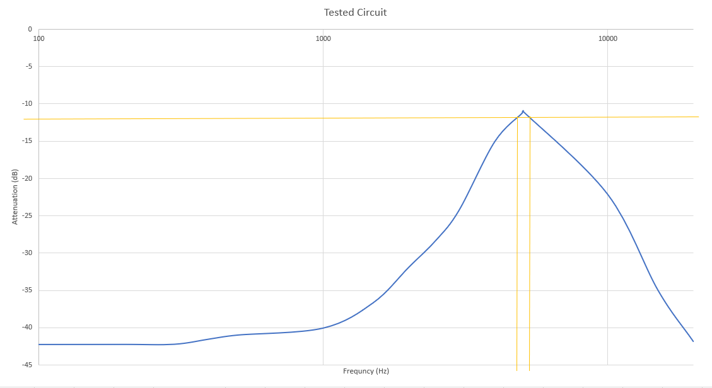
Figure 9 - RLC Circuit Frequency Graph
The graph shows a peak frequency of 5030 Hz, at an attenuation of 10.92 dB. Since the peak at 0 dB is not reached, this has to be taken as the measurement of resonant frequency. Hence, the cutoff points (see 1.4) used must be taken at approximately -13 dB on the graph to account for this. As a result, we find that:
$$Q=\frac{5.03}{5.4-4.5}=5.59$$
3.3 Discussion
When comparing the simulation and laboratory graphs, there is a noticeable difference in the results. Firstly, there is less accuracy in the measurement of frequency between the theoretical value and that given by the laboratory testing. The comparative values are 5032.92 Hz for theoretical (see 2.3) and 5030 Hz for the tested circuit (see 3.2). This is because the accuracy of the value of frequency in the tested circuit is affected by the accuracy of the measuring equipment, specifically the oscilloscope in this case. This could be improved by using more accurate equipment - a higher quality scope with greater resolution.

Secondly, we can identify differences in the peaks by comparing the shapes of the graphs of the Proteus simulation and the laboratory breadboard testing. Whilst both have the similar PERT distribution [7] – peaking at the resonant frequency, with attenuation magnitude exponentially decaying either side of that peak – the graph for the tested circuit appears flatter. This appearance is due to the shallower peak at resonant frequency for the tested circuit. This can be numerically defined; first by examining the bandwidths of the two graphs. As set out in 1.4, the bandwidth is the difference between the upper (f2) and lower (f1) cutoff frequencies, both taken at -3dB. The bandwidth of the simulated graph is 280 Hz, whereas it is 900 Hz for the tested circuit. Hence, since the tested circuit has a greater bandwidth than the simulated graph, it is proven numerically that the peak at resonant frequency is shallower.

Furthermore, upon calculation of the bandwidths, we can also compare the Q-factors of both graphs. For the simulated circuit, the calculated Q-factor is 17.93 (see 2.3), whereas its value for the tested circuit is much smaller at 5.59 (see 3.2). Again, this confirms that the tested circuit results graph has a shallower peak compared to the simulated graph. This is because capacitor and inductor losses in a real-life circuit will reduce the sharpness of the peak [5]. In the case of the capacitor, these losses are due to the series resistance, produced by the component’s physical structure, and may appear as a function of frequency [8]. There also may be cases where series inductance occurs due to the capacitor. Alternatively, in the case of the inductor a leakage inductance may result in a voltage drop, or greater circuit resistance by the winding or core losses [9].

Increased voltage drop and resistance (according to Ohm’s Law [2]) will decrease the output voltage value of the circuit. Following the calculation equation for attenuation (see 1.4), as output voltage decreases the gain ratio will increase. This means that the magnitude of attenuation will increase as the circuit losses, defined above, also increase. This will give a greater attenuation loss at peak frequency for the tested circuit, even with the same resonant frequency as the simulated response, as observed. This is due to the real-life losses that the breadboard circuit exhibits, which are not represented in the simulated circuit.

Lastly, following from above - it is clear not only from the tested circuit readings table, but by comparing both graphs, that there is a smaller attenuation magnitude for all corresponding frequencies for the breadboard circuit. As aforementioned, this is proven by the calculated bandwidths and explained by the real-life losses of the tested circuit, a behavior not exhibited by the simulated circuit. This means that adaptations involving these losses must be made to the simulated model in order to more accurately predict the behavior of a real-life RLC circuit. This will be discussed below in part 4 of section 3.

3.4 Model Refinement
As discussed in 3.3, the simulated model must be adapted to include circuit losses in order to more accurately simulate the resonant response of the RLC circuit. Firstly, we know that one of the main causes of loss for the capacitor is a series resistance caused by the physical make-up of the component. As a result, a small resistor could be added in series with the capacitor in the model, to represent this response. An example is shown below.

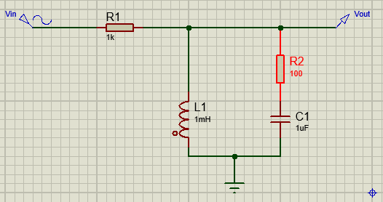
Figure 10 - Proteus Adapted Circuit
Moreover, we can simulate the increased impedance of an inductor by taking its inductance to its maximum value within tolerance range for the component. This will maximise the loss due to the inductor (see 1.3), and increase the accuracy of the simulated model. For example, if we take the tolerance as ±10% [4], then the inductance will become 1.1mH. These adaptations could be tested and further refined, taking measures such as additional resistors or even low inductance inductors.

Conclusion
In conclusion, we have observed the resonant response of an RLC circuit; specifically, one that has a parallel capacitor and inductor, in series with a resistor. Its behavioral response has been examined through a simulated Proteus circuit, compared with an assembled and tested breadboard circuit. The graphing of both sets of results demonstrates their differentiation. It has been observed that whilst the resonant frequency is approximately the same for both – and there is a similar relationship for all other frequencies – there is much greater magnitude of attenuation for a real-life response.

The explanation for this disparity has been explored by setting out the smaller bandwidth and therefore greater Q-factor of the simulated circuit (compared to the circuit tested on breadboard), which correlates to a greater attenuation. This was also used to explain the shallower response graph of the tested circuit. It has been set out that the reduced attenuation of the simulated circuit is due to the lack of consideration of losses in a real-life circuit due to the capacitive and inductive components. Following this, it was discussed how the simulated model could be adapted in order to more accurately represent the real-life response of an RLC circuit. There were suggestions made to add resistors in series with the impeding components, in addition to adapting the inductive values to account for component tolerances. Additionally, it was acknowledged that there is also the potential to explore this line of work further, and to perfect the simulated model adaptations.

References
[1] | Electronics Tutorials, "Passive Band Pass Filter," 2024. [Online]. Available: https://www.electronics-tutorials.ws/filter/filter_4.html. [Accessed 02 12 2024].
[2] | UWTSD, Electrical and Electronics Principles, School of Computing, 2024.
[3] | Electronics Tutorials, "Voltage Divider," 2024. [Online]. Available: https://www.electronics-tutorials.ws/dccircuits/voltage-divider.html. [Accessed 02 12 2024].
[4] | ES Components, "Active & Passive Components," 31 07 2019. [Online]. Available: https://www.escomponents.com/blog/2019/7/31/active-amp-passive-components-what-is-the-difference-between-the-two. [Accessed 02 12 2024].
[5] | W. H. Paul Horowitz, in The Art of Electronics Third Edition, New York, Cambridge University Press, 2015, pp. 52-53.
[6] | W. H. Paul Horowitz, in The Art of Electronics Third Edition, New York, Cambridge University Press, 2015, p. 392.
[7] | Real Statistics, "PERT Distribution," 2021. [Online]. Available: https://real-statistics.com/binomial-and-related-distributions/pert-distribution/. [Accessed 05 12 2024].
[8] | W. H. Paul Horowitz, in The Art of Electronics Third Edition, New York, Cambridge University Press, 2015, p. 28.
[9] | W. H. Paul Horowitz, in The Art of Electronics Third Edition, New York, Cambridge University Press, 2015, pp. 30-31.

