Student name: Yanislav Georgiev

Individual Report
Marketing Process Tesco
Student ID: 2219323
Module Code: LCBB4004
Lecturer: Dr. Piymika Gamage
Assignment 2
Marketing Fundamentals

Table of Contents
Introduction: 2
Marketing Process 3
Main Stages in marketing process: 3
Macro Environment: PESTLE Analysis 5
Definition of PESTLE Analysis: 5
Analyzation of each factor: 6
Mix of favourable and unfavourable macro-environmental factors for TESCO: 8
Industry Analysis: Porter's Five Forces 8
Definition of Porter’s Five Forces: 8
Evaluating the level of each force: 9
Advantages and Disadvantages of Porter's Five Forces Model: 11
Advantages: 11
Disadvantages: 11
Future Recommendations: Ansoff Matrix Strategies 12
Introduction to the Ansoff Matrix: 12
Selected Ansoff Matrix Strategies for TESCO 12
Implementation of Recommended Strategies and Justifications: 13
Conclusion: 15
References: 16

Introduction:
TESCO was founded by Jack Cohen in 1919 and has grown to become a leading multinational retail corporation. The company is headquartered in the United Kingdom and specializes in grocery and general merchandise retailing. TESCO has expanded its operations to countries across Europe and Asia, including Ireland, Poland, Hungary, Thailand, and Malaysia. The company's success can be attributed to its diverse range of products and services, which cater to various customer needs. TESCO's mission is to continually improve its offerings and serve customers better by providing high-quality products at affordable prices. This customer-centric approach has contributed to TESCO's significant market share in the retail industry (Tesco PLC, 2021). Marketing, as defined by the American Marketing Association (2017), is a multifaceted activity that encompasses the creation, communication, delivery, and exchange of value-added offerings. The marketing process is a systematic approach that involves understanding customers' needs, developing and promoting products and services that address these needs, and fostering long-term relationships with customers. The primary goal of marketing is to ensure sustainable business growth by satisfying customers and creating a strong brand reputation (Kotler and Armstrong, 2018).
Marketing is crucial for TESCO as it drives the company's competitive advantage, customer satisfaction, and overall growth. TESCO's marketing process involves a series of interconnected steps, beginning with situational analysis to understand the external business environment. This analysis informs the company's marketing objectives, which guide the formulation of marketing strategies. TESCO then implements these strategies through marketing programs designed to reach and engage its target audience. Finally, the company evaluates its marketing performance to ensure that its efforts are delivering the desired results (Kotler and Armstrong, 2018). By employing effective marketing strategies, TESCO can identify and capitalize on market opportunities, address potential threats, and better serve its customers, ultimately maintaining its position as a leading retail organization.

Marketing Process
The marketing process is a systematic approach that enables organizations to identify, target, and engage customers by understanding their needs and delivering value-added offerings (Kotler and Armstrong, 2018). The marketing process can be visualized as a series of interconnected stages, as shown in the diagram below:
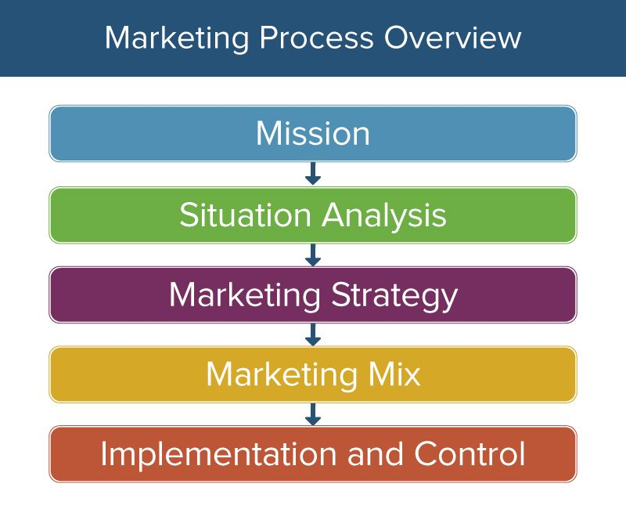

Main Stages in marketing process:

- Situational Analysis: The first stage in the marketing process involves assessing the current market environment, including the internal and external factors that influence an organization's performance. This analysis enables businesses to identify opportunities and challenges in the market and provides a foundation for informed decision-making. For TESCO, situational analysis involves examining the retail industry's competitive landscape, consumer trends, and macro-environmental factors such as political, economic, social, technological, legal, and environmental aspects (PESTLE) (Kotler and Armstrong, 2018).
- Objectives: Based on the situational analysis, organizations set marketing objectives that outline the desired outcomes of their marketing efforts. These objectives should be Specific, Measurable, Achievable, Relevant, and Time-bound (SMART) to ensure effective implementation and evaluation (Doran, 1981). TESCO's marketing objectives may include increasing market share, improving customer satisfaction, expanding product offerings, or entering new markets.
- Strategy: With clear objectives in place, organizations develop marketing strategies that outline the overall approach and tactics to achieve their goals. These strategies are typically based on market segmentation, targeting, and positioning (STP) to ensure that marketing efforts resonate with the intended audience (Kotler and Armstrong, 2018). TESCO's marketing strategies might involve targeting specific customer segments, emphasizing the company's unique selling points, and implementing promotional activities that communicate its value proposition.
- Implementation: The implementation stage involves executing the marketing strategies through various marketing programs, such as advertising campaigns, public relations initiatives, and sales promotions. This stage requires effective coordination, communication, and resource allocation to ensure successful execution (Kotler and Armstrong, 2018). TESCO's marketing implementation might include launching new product lines, rolling out targeted promotional campaigns, or enhancing its in-store and online customer experience.
- Control: The final stage in the marketing process is monitoring and evaluating the performance of marketing efforts against the predefined objectives. This stage allows organizations to measure the effectiveness of their marketing programs, identify areas for improvement, and make data-driven decisions to refine their marketing strategies (Kotler and Armstrong, 2018). TESCO's marketing control may involve tracking key performance indicators (KPIs) such as sales revenue, market share, customer satisfaction, and brand awareness to assess the impact of its marketing initiatives.
TESCO's marketing process follows a structured approach to understand its market environment, set clear objectives, develop targeted strategies, implement marketing programs, and evaluate the performance of its efforts. By adhering to this process, TESCO can effectively engage with its customers and maintain its competitive advantage in the retail industry.

Macro Environment: PESTLE Analysis

Definition of PESTLE Analysis:
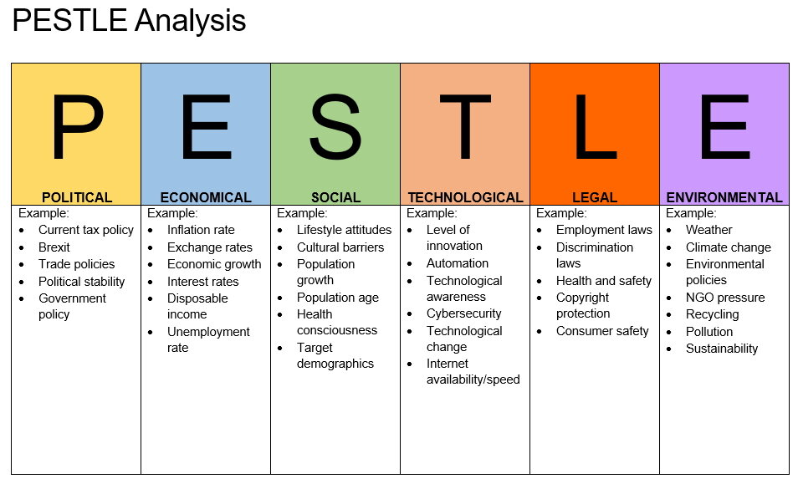
PESTLE analysis is a strategic tool used to identify and assess the impact of macro-environmental factors on an organization's performance. These factors include Political, Economic, Social/Cultural, Technological, Legal, and Environmental aspects, which can influence a company's operations, decision-making, and overall success (Johnson, Scholes and Whittington, 2008). This section examines the relevance of each PESTLE factor for TESCO and evaluates their favourability.

Analyzation of each factor:

- Political Factors: Political factors refer to the extent and impact of government policies, regulations, and political stability on an organization's operations. TESCO operates in various countries, making it susceptible to political changes that could impact its business, such as trade policies, taxation, and labour laws (Tesco PLC, 2021). For instance, Brexit has created uncertainties and challenges for TESCO, including potential supply chain disruptions and increased costs (Bamford, 2021). Therefore, political factors are currently unfavourable for TESCO, as they may hinder the company's growth and profitability.
- Economic Factors: Economic factors encompass macroeconomic indicators, such as inflation, interest rates, exchange rates, and economic growth, that can affect a company's performance. In times of economic downturn, consumers may prioritize low-cost options, benefitting TESCO's value-oriented strategy (Tesco PLC, 2021). However, economic factors can also pose challenges, such as currency fluctuations, impacting TESCO's overseas operations and financial performance (Tesco PLC, 2021). Thus, economic factors present both favourable and unfavourable aspects for TESCO, depending on the specific indicators and their influence on consumer behaviour and spending.
- Social/Cultural Factors: Social and cultural factors involve demographic trends, consumer preferences, and societal values that shape the market environment. TESCO has adapted its offerings to cater to evolving consumer preferences, such as the growing demand for healthier, organic, and ethically sourced products (Tesco PLC, 2021). Moreover, TESCO's commitment to diversity and inclusion aligns with the changing societal values and expectations (Tesco PLC, 2021). Overall, social/cultural factors are favourable for TESCO, as the company has demonstrated adaptability and responsiveness to changing consumer demands and societal trends.
- Technological Factors: Technological factors refer to the impact of technological advancements, innovations, and digitalization on an organization's operations and competitiveness. TESCO has embraced technology, investing in e-commerce, mobile applications, and data-driven decision-making to enhance customer experience and streamline operations (Tesco PLC, 2021). By leveraging technology, TESCO can improve efficiency, offer personalized shopping experiences, and stay competitive in the digital era. Therefore, technological factors are favourable for TESCO, as the company can capitalize on technological advancements to drive growth and innovation.
- Legal Factors: Legal factors encompass the regulatory framework, industry-specific regulations, and legal requirements that organizations must comply with to operate successfully. TESCO is subject to various legal regulations, such as food safety, labour, and environmental laws, which may impose additional costs and obligations on the company (Tesco PLC, 2021). While compliance with legal requirements is essential, it can also be resource-intensive, making legal factors unfavourable for TESCO in terms of cost and complexity.
- Environmental Factors: Environmental factors relate to the impact of ecological and sustainability concerns on a company's operations and reputation. TESCO has demonstrated its commitment to sustainability by setting ambitious goals to reduce carbon emissions, minimize waste, and promote sustainable sourcing (Tesco PLC, 2021). By addressing environmental concerns, TESCO can enhance its reputation, attract eco-conscious consumers, and mitigate potential regulatory risks. Thus, environmental factors are favourable for TESCO, as the company can leverage its sustainability initiatives to differentiate itself and create a competitive advantage in the market.
The PESTLE analysis reveals a mix of favourable and unfavourable macro-environmental factors for TESCO. While social/cultural, technological, and environmental factors present opportunities for the company to adapt and grow, political, economic, and legal factors pose challenges that could impact TESCO's performance and profitability. By closely monitoring and strategically responding to these external forces, TESCO can navigate the complex business environment, capitalize on opportunities, and mitigate potential threats.

Mix of favourable and unfavourable macro-environmental factors for TESCO:

Social/cultural factors have emerged as favourable for TESCO due to the company's adaptability and responsiveness to changing consumer preferences and societal values. Technological factors also present favourable opportunities for TESCO, as the company has proactively embraced digital transformation to improve efficiency and customer experience. Environmental factors are another area where TESCO can capitalize on favourable opportunities. By setting ambitious sustainability goals and implementing initiatives to reduce carbon emissions, minimize waste, and promote sustainable sourcing. TESCO must remain vigilant of the challenges posed by political, economic, and legal factors, which can have a significant impact on its operations and financial performance. Political uncertainties, such as Brexit and changing trade policies, can disrupt supply chains and increase costs. By closely monitoring these external forces and strategically adapting its business practices, TESCO can navigate the complex business environment, capitalize on opportunities, and mitigate potential threats. By doing so, the company can maintain its competitive edge, drive growth, and ensure long-term success in the ever-changing retail industry.

Industry Analysis: Porter's Five Forces

Definition of Porter’s Five Forces:
Porter's Five Forces model is a widely recognized framework for analyzing the competitive forces within an industry, which helps organizations to understand their competitive position and develop effective business strategies (Porter, 2008). The model consists of five forces: the threat of new entrants, the bargaining power of suppliers, the bargaining power of buyers, the threat of substitute products or services, and the intensity of competitive rivalry. This section applies Porter's Five Forces model to TESCO, evaluating the level of each force and providing justifications.
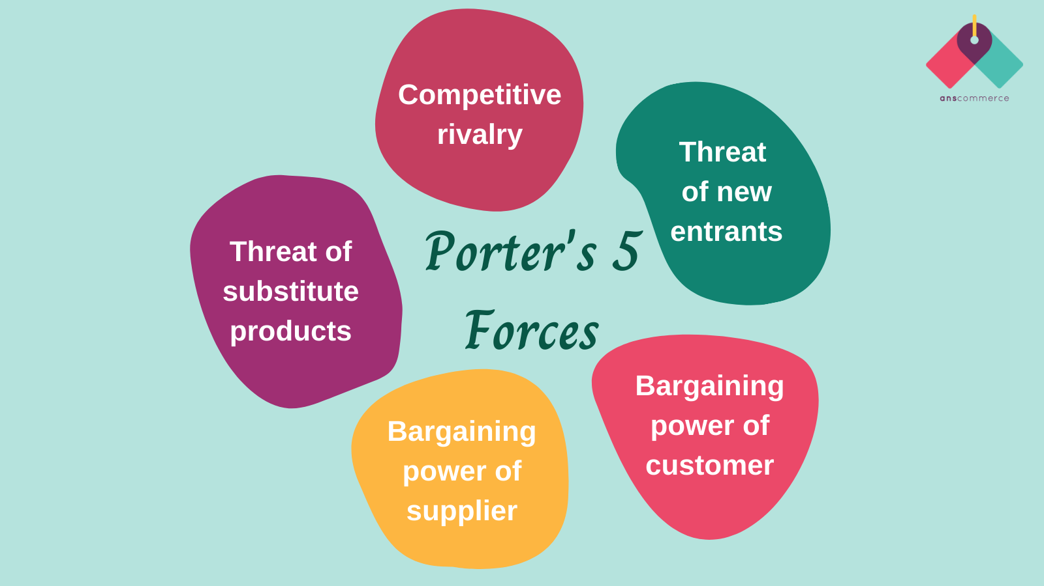

Evaluating the level of each force:
Threat of New Entrants (Low): The threat of new entrants in the retail industry is relatively low, primarily due to the significant barriers to entry, such as high capital requirements, established brand loyalty, and economies of scale enjoyed by large players like TESCO (Mintel, 2021). Moreover, TESCO's extensive distribution network, strong supplier relationships, and efficient operations create additional barriers for potential entrants. While online retailers and discount stores might pose a challenge, the overall threat to TESCO from new entrants remains low.
Bargaining Power of Suppliers (Medium): The bargaining power of suppliers in the retail industry is generally moderate. TESCO has a vast network of suppliers, which reduces its dependency on any single supplier and allows the company to negotiate favourable terms (Tesco PLC, 2021). However, suppliers of unique or high-demand products may have increased bargaining power, and regulatory changes, such as those related to sustainable and ethical sourcing, could impact TESCO's negotiations with suppliers (Smithers, 2019). Overall, the bargaining power of suppliers is moderate, as TESCO's size and scale provide leverage, while certain factors may still influence supplier negotiations.
Bargaining Power of Buyers (High): The bargaining power of buyers in the retail industry is high, as customers have various options when it comes to purchasing groceries and other consumer goods (Mintel, 2021). The rise of e-commerce and the growth of discount retailers have further intensified competition, providing consumers with more choices and price comparison opportunities. Additionally, the prevalence of social media and online reviews has empowered consumers, who can quickly share their experiences and opinions about a brand (Helm and Tolsdorf, 2013). Consequently, TESCO must continuously focus on delivering exceptional value and customer experiences to maintain customer loyalty and mitigate the high bargaining power of buyers.
Threat of Substitute Products or Services (Medium): The threat of substitute products or services in the retail industry is moderate. While TESCO competes with other grocery retailers, it also faces competition from alternative channels such as online retailers, convenience stores, and specialty shops (Mintel, 2021). Furthermore, the growth of meal delivery services and meal kit providers offers consumers alternative ways to access food products (Nielsen, 2021). Although these substitutes might not replace TESCO's core offering entirely, they can still impact the company's market share and revenues. Therefore, the threat of substitute products or services for TESCO is medium.
Intensity of Competitive Rivalry (High): The intensity of competitive rivalry in the retail industry is high, as TESCO faces fierce competition from both large supermarket chains and discount retailers (Mintel, 2021). Competitors, such as Sainsbury's, Asda, and Aldi, continuously strive to improve their offerings, prices, and customer experiences, which intensifies the competitive landscape (Mintel, 2021). Moreover, the rise of e-commerce and changing consumer preferences add to the competitive pressure, requiring TESCO to constantly innovate and adapt to maintain its market position.


Advantages and Disadvantages of Porter's Five Forces Model:

Advantages:
- Comprehensive Framework: Porter's Five Forces model provides a comprehensive framework for analysing an industry's competitive landscape, allowing organizations to gain a holistic understanding of their competitive position and the factors influencing their industry (Porter, 2008).
- Strategic Insights: The model enables organizations to identify opportunities and threats within their industry, informing strategic decision-making and helping companies to develop effective competitive strategies (Porter, 2008).
- Dynamic Analysis: Porter's Five Forces model encourages organizations to regularly assess their industry, ensuring that they stay updated with the latest trends and developments, and adapt their strategies accordingly (Porter, 2008).

Disadvantages:
- Static Snapshot: While the model provides valuable insights into an industry's competitive landscape, it captures a static snapshot of the market and may not fully account for rapidly changing market conditions, such as technological advancements and shifting consumer preferences (Grant, 2016).
- Limitations in Quantification: The model focuses on qualitative analysis, making it difficult to quantify the impact of each force on an organization's competitive position and profitability (Grant, 2016).
- Oversimplification: The model may oversimplify complex industry dynamics, and organizations must be cautious not to rely solely on the Five Forces analysis for their strategic decision-making (Grant, 2016).
Porter's Five Forces analysis of TESCO indicates a highly competitive retail industry, characterized by high bargaining power of buyers and intense competitive rivalry. The threat of new entrants is low due to significant barriers to entry, while the bargaining power of suppliers and the threat of substitute products or services are moderate. By understanding these competitive forces, TESCO can develop effective strategies to maintain its competitive advantage, capitalize on opportunities, and mitigate potential threats.

Future Recommendations: Ansoff Matrix Strategies

Introduction to the Ansoff Matrix:
The Ansoff Matrix, developed by Igor Ansoff in 1957, is a strategic planning tool that helps organizations determine their growth strategies by assessing potential product and market combinations (Ansoff, 1957). The matrix consists of four growth strategies: market penetration, market development, product development, and diversification. These strategies vary in terms of the degree of risk and potential for growth, allowing companies to select the most suitable approach based on their objectives and market conditions (Ansoff, 1957).

Selected Ansoff Matrix Strategies for TESCO
Based on the Ansoff Matrix, this report recommends that TESCO pursue the following two growth strategies:
a) Market Development: TESCO could explore opportunities for expansion into new geographical markets, particularly in emerging economies with growing middle-class populations and increasing demand for modern retail experiences. By entering new markets, TESCO can further diversify its revenue streams and capitalize on untapped growth potential.
b) Product Development: TESCO can invest in the development of new products and services, particularly in areas with high growth potential, such as private label offerings, health and wellness products, and e-commerce services. By expanding its product portfolio, TESCO can cater to evolving consumer preferences, enhance its value proposition, and differentiate itself from competitors.

Implementation of Recommended Strategies and Justifications:

a) Market Development: To implement the market development strategy, TESCO should consider the following steps:
i) Market Research: Conduct comprehensive market research to identify suitable target markets, considering factors such as demographic trends, economic growth, regulatory environments, and competitive landscapes (Kotler and Keller, 2016). This research will enable TESCO to make informed decisions about market entry and prioritize markets with the highest growth potential.
ii) Market Entry Mode: Evaluate different market entry modes, such as joint ventures, acquisitions, franchising, or greenfield investments, to determine the most suitable approach for each target market (Hill, 2020). TESCO should consider factors such as local market conditions, regulatory requirements, and the company's resources and capabilities when selecting an entry mode.
iii) Localization Strategy: Develop a localization strategy to adapt TESCO's offerings, store formats, and marketing efforts to the specific needs and preferences of each target market (Hollensen, 2017). This may involve sourcing local products, customizing store layouts, and adjusting pricing and promotional strategies to cater to local tastes and preferences.
iv) Partnering with Local Stakeholders: Establish partnerships with local suppliers, distributors, and other stakeholders to facilitate market entry, ensure a reliable supply chain, and gain valuable local insights (Hollensen, 2017). Collaborating with local partners can help TESCO build trust and credibility in new markets, as well as navigate potential regulatory and cultural challenges.
b) Product Development: To implement the product development strategy, TESCO should consider the following steps:
i) Market Research: Conduct market research to identify consumer trends and preferences, assess the competitive landscape, and uncover potential gaps in the market that TESCO can fill with new products or services (Kotler and Keller, 2016). This research will help TESCO make informed decisions about product development priorities and ensure that new offerings resonate with consumers.
ii) Product Development Process: Implement a structured product development process that involves cross-functional teams and emphasizes innovation, quality, and speed to market (Ulrich and Eppinger, 2015). This approach can help TESCO streamline the development of new products and services, reduce time to market, and ensure that offerings meet customer needs and expectations.
iii) Collaboration with Suppliers and Partners: Collaborate with suppliers, partners, and other stakeholders to develop new products and services, leveraging their expertise and resources to create innovative, high-quality offerings (Ulrich and Eppinger, 2015). Building strong relationships with key partners can help TESCO gain access to new technologies, knowledge, and capabilities, enhancing its product development efforts.
iv) Marketing and Promotion: Develop targeted marketing and promotional campaigns to create awareness and generate demand for new products and services (Kotler and Keller, 2016). TESCO should leverage its existing marketing channels, such as in-store promotions, online advertising, and social media, to reach its target audience and communicate the benefits and features of its new offerings.
v) Monitoring and Evaluation: Monitor the performance of new products and services, collecting customer feedback and tracking key performance indicators (KPIs) to assess the success of product development efforts and make data-driven improvements (Kotler and Keller, 2016). By closely monitoring product performance, TESCO can identify areas for improvement, adjust its strategies, and ensure the long-term success of its product development initiatives.
Implementing market development and product development strategies can help TESCO capitalize on new growth opportunities, diversify its revenue streams, and enhance its competitive position. By carefully planning and executing these strategies, TESCO can navigate the challenges of the rapidly evolving retail landscape, meet the needs of its customers, and drive sustainable growth.

Conclusion:
In conclusion, this report has provided a critical analysis and evaluation of TESCO's external business environment, focusing on macro-environmental factors through a PESTLE analysis, industry forces using Porter's Five Forces model, and potential growth strategies based on the Ansoff Matrix. The key findings from the analysis are as follows:
PESTLE Analysis: The PESTLE analysis revealed a mix of favourable and unfavourable factors for TESCO. Social/cultural, technological, and environmental factors offer opportunities for TESCO to adapt and grow, while political, economic, and legal factors pose challenges that could impact the company's performance and profitability. By closely monitoring and strategically responding to these external forces, TESCO can navigate the complex business environment, capitalize on opportunities, and mitigate potential threats (Hill, 2020).
Porter's Five Forces: The industry analysis using Porter's Five Forces model highlighted the competitive dynamics of the retail sector. The level of rivalry among existing competitors is high, and the bargaining power of suppliers and buyers is moderate. The threat of substitute products is also moderate, while the threat of new entrants is low. TESCO must continue to differentiate itself from competitors, enhance its value proposition, and maintain strong relationships with suppliers and customers to sustain its market position (Porter, 2008).

Ansoff Matrix Strategies: The report recommends two growth strategies for TESCO based on the Ansoff Matrix: market development and product development. By expanding into new geographical markets and developing innovative products and services, TESCO can diversify its revenue streams, cater to evolving consumer preferences, and enhance its competitive advantage (Ansoff, 1957).
The findings from the external analysis and evaluation underscore the importance of marketing and adapting to external forces for TESCO's continued success. Marketing plays a crucial role in helping TESCO understand its customers, competitors, and the broader business environment, enabling the company to make informed decisions about its growth strategies and marketing efforts (Kotler and Keller, 2016). By leveraging effective marketing processes and tools, TESCO can identify and capitalize on market opportunities, mitigate potential threats, and enhance customer satisfaction and loyalty, driving sustainable business growth (Kotler and Armstrong, 2018). In light of the rapidly changing retail landscape, TESCO must remain agile and responsive to external forces, continuously adapting its marketing strategies and tactics to stay ahead of competitors and meet the evolving needs of its customers. The growth goes from low to high.

References:

- AMA (2017) 'Definition of Marketing', American Marketing Association, available at: https://www.ama.org/the-definition-of-marketing-what-is-marketing/ (accessed 25 April 2023).
- Kotler, P., and Armstrong, G. (2018) Principles of Marketing, 17th Edition, Pearson.
- Tesco PLC (2021) 'About Us', Tesco PLC, available at: https://www.tescoplc.com/about-us/ (accessed 25 April 2023).
- Doran, G. T. (1981) 'There's a S.M.A.R.T. way to write management's goals and objectives', Management Review, 70(11), pp. 35-36.
- Kotler, P., and Armstrong, G. (2018) Principles of Marketing, 17th Edition, Pearson.
- Bamford, C. (2021) 'Tesco stockpiles food as Brexit looms', The Grocer, available at: https://www.thegrocer.co.uk/brexit/tesco-stockpiles-food-as-brexit-looms/658295.article (accessed 26 April 2023).
- Johnson, G., Scholes, K., and Whittington, R. (2008) Exploring Corporate Strategy: Text and Cases, 8th Edition, Pearson Education.
- Tesco PLC (2021) 'Annual Report and Financial Statements 2021', Tesco PLC, available at: https://www.tescoplc.com/media/759533/tesco_ar_2021.pdf (accessed 26 April 2023).
- Grant, R.M. (2016) Contemporary Strategy Analysis: Text and Cases Edition, 9th Edition, Wiley.
- Helm, R., and Tolsdorf, J. (2013) 'How Does Corporate Reputation Affect Customer Loyalty in a Corporate Crisis?', Journal of Contingencies and Crisis Management, 21(3), pp. 144-152.
- Mintel (2021) 'Supermarkets - UK - October 2021', Mintel, available at: https://reports.mintel.com/display/1055346/ (accessed 26 April 2023).
- Nielsen (2021) 'Global Meal Kit Market to Reach $19.92 Billion by 2027', Nielsen, available at: https://www.nielsen.com/eu/en/press-releases/2021/global-meal-kit-market-to-reach-19-92-billion-by-2027/ (accessed 26 April 2023).
- Porter, M.E. (2008) 'The Five Competitive Forces That Shape Strategy', Harvard Business Review, 86(1), pp. 78-93.
- Smithers, R. (2019) 'UK Supermarkets Step Up Efforts to Reduce Plastic Waste', The Guardian, available at: https://www.theguardian.com/environment/2019/apr/29/uk-supermarkets-step-up-efforts-to-reduce-plastic-waste (accessed 26 April 2023).
- Tesco PLC (2021) 'Annual Report and Financial Statements 2021', Tesco PLC, available at: https://www.tescoplc.com/media/759533/tesco_ar_2021.pdf (accessed 26 April 2023).
- Ansoff, H. I. (1957) 'Strategies for Diversification', Harvard Business Review, 35(5), pp. 113-124.
- Hill, C. W. L. (2020) International Business: Competing in the Global Marketplace, 12th Edition, McGraw-Hill Education.
- Hollensen, S. (2017) Global Marketing, 7th Edition, Pearson.
- Kotler, P., and Keller, K. L. (2016) Marketing Management, 15th Edition, Pearson.
- Ulrich, K., and Eppinger, S. D. (2015) Product Design and Development, 6th Edition, McGraw-Hill Education.
- Ansoff, H. I. (1957) 'Strategies for Diversification', Harvard Business Review, 35(5), pp. 113-124.
- Hill, C. W. L. (2020) International Business: Competing in the Global Marketplace, 12th Edition, McGraw-Hill Education.
- Hollensen, S. (2017) Global Marketing, 7th Edition, Pearson.

