
Assignment Title: Assessment Component: 2 Marketing Strategies Portfolio

Module Name: Marketing Management
Module Code: LCMB7024

Student Name: Tania Sultana
Student ID: 2516332
Word Counts: 2500
Submission Date: 01.05.2026

Lecturer’s Name: Laila Maazouz

Table of Contents
1. Element 1: Brand Extension Poster Presentation 3
2. Element 2: Develop a Segmentation, Targeting, Differentiation, and Positioning (STDP) Analysis for Apple Smart Ring 4
2.1 Segmentation 4
2.2 Targeting 5
2.3 Differentiation 5
2.4 Positioning 6
3. Element 3: Marketing Mix (7Ps) 8
3.1 Product 8
3.2 Price 9
3.3 Place (Distribution) 9
3.4 Promotion 10
3.5 People 10
3.6 Process 10
3.7 Physical Evidence 11
4. Element 4: Reflection 12
4.1 Strengths in Brand Development 12
4.2 Weaknesses in Analysis Skills 12
4.3 Action Plan for Improvement 13
5. Reference List 14

1. Element 1: Brand Extension Poster Presentation
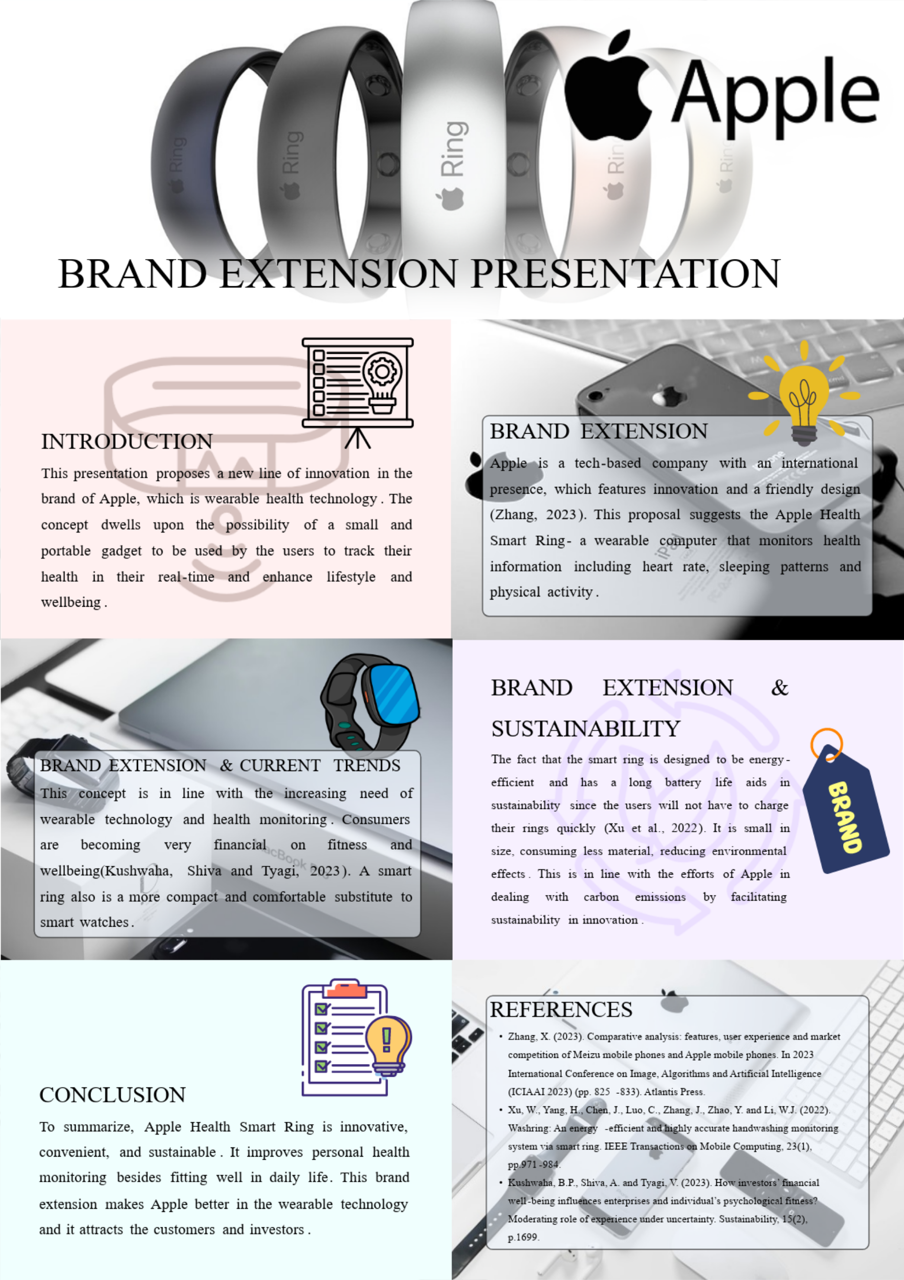

2. Element 2: Develop a Segmentation, Targeting, Differentiation, and Positioning (STDP) Analysis for Apple Smart Ring
The Apple Smart Ring is a brand extension that responds to demand to have miniature continuous health monitoring and using the STDP framework as a tool to assess its competitive positioning in the wearable technology market.

2.1 Segmentation
Market segmentation categorizes consumers into groups sharing common features to learn more about their requirements. In the case of the Apple Smart Ring, segmentation is done based on geographic, demographic, psychographic, and behavioural variables (Tavor, Gonen and Spiegel, 2023).
Table 1: Market Segmentation for Apple Smart Ring
Segmentation Type | Variables | Description
Geographic | Region, urbanisation | Developed regions such as US, UK, Europe, and Asia-Pacific urban markets
Demographic | Age, income, occupation | Individuals aged 25–45, middle to high income, professionals
Psychographic | Lifestyle, values | Health-conscious, tech-savvy individuals valuing innovation and convenience
Behavioural | Usage, benefits sought | Users seeking continuous health tracking and integration with devices
The developed and urban markets are given priority based on the greater purchasing power and the speed at which they embrace innovative technologies. These areas are also highly interested in digital health solutions. Demographically, the target group is 2545-year-old because this age group is economically active and more inclined to invest in high-quality devices (Biga et al., 2024).
Psychographic segmentation emphasizes the consumers who believe in contemporary living, practicality and easy incorporation of technology in their daily life. These people like functional and appealing products. Focusing behaviourally, it targets users that already use wearable technology or want to track their health in a more practical and less noticeable manner. This segmentation is to make the product be in line with the present consumer trends and expectations.

2.2 Targeting
Targeting is the process of choosing the most appealing segments that were determined in the process of segmentation. The differentiated targeting strategy is likely to be embraced at Apple, targeting several consumer groups.
The main target market is urban professionals aged between 25 and 45 years old and with medium to high-income levels. These people have hectic schedules and want effective ways to take care of their health. They are also technologically conscious and are already used to using Apple products, so they will readily embrace the Smart Ring.
The secondary target market consists of consumers interested in fitness and health-aware consumers who are keen on monitoring their wellbeing. These people are already extremely active in wearables and might want to have a more subtle option to smartwatches (Zahrt et al., 2023). Apple Smart Ring fulfills this requirement through the provision of convenience and constant monitoring.
The reason behind the effectiveness of this targeting strategy is that it will be based on the already developed customer base of Apple, in addition to attracting new users, who are interested in innovation related to health.

2.3 Differentiation
The strategic value of differentiation is necessary to develop a competitive advantage in the market of wearable technologies. Apple Smart Ring will be differentiated in terms of design, integration with the ecosystem, and brand strength.
To begin with, the product will be in a smaller and discreet design, unlike the bigger wearable devices like smartwatches. This will enable uninterrupted usage without any inconvenience especially during sleeping or during daily routine (Hosseini et al., 2023). The ease of a compact and wearable device increases the user experience and promotes the use over time.
Secondly, the integration of the ecosystem is an added benefit to Apple. The smart ring can easily be linked to other Apple products like the iPhone and Apple Watch, which will result in a cohesive and effective user experience. Such integration enhances customer loyalty and the switching cost.
Moreover, Apple has a good brand equity which helps to increase trust and perceived quality. Apple is linked to innovation, reliability, and privacy by its consumers, and it is especially crucial when handling sensitive health information (Zou, 2023). This confidence gives a competitive advantage over lesser known or smaller brands.
Lastly, the innovative health monitoring functionalities, which include heart rate monitoring and sleep analysis, make the product to be of real value. Together with the sustainability-oriented approach of Apple, the product will attract contemporary buyers who are concerned with the functionality and environmental friendliness.

2.4 Positioning
Positioning establishes the attitude of the product in the consumers’ minds. Apple Smart Ring is being marketed as a high-priced, innovative, and life-style wearable item.
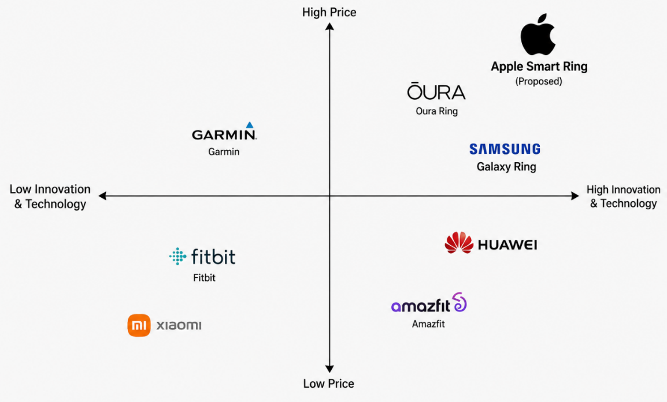
Figure 1: Positioning map – wearable devices market
Source: Own
The approach is centered on quality, superior technology, and convenience. Maintaining a high-quality image, Apple strengthens the brand image as well as attracting consumers who care about the functionality and design (Zhang and Hu, 2024).
Positioning Statement:
The Apple Smart Ring is a high-end, unobtrusive wearable product that appeals to health-conscious and tech-focused customers who need to be constantly monitored in terms of health and be able to do so seamlessly in their daily life.
This is indicated in the analysis of the STDP, which reveals that Apple Smart Ring is poised to emerge successfully. By engaging in good segmentation, targeting and differentiation, Apple will be able to enhance its competitive advantage and address the dynamic needs of the consumers.

3. Element 3: Marketing Mix (7Ps)
The marketing mix offers a systematic approach to marketing strategy implementation through matching product offerings with the needs of customers. In the case of the Apple Smart Ring, the 7Ps framework will be applied to support the positioning of the device as a high-end, innovative, and lifestyle-oriented wearable device. All these are factors that will ensure that the Apple brand extension strategy is enhanced in the competitive wearable technology market.
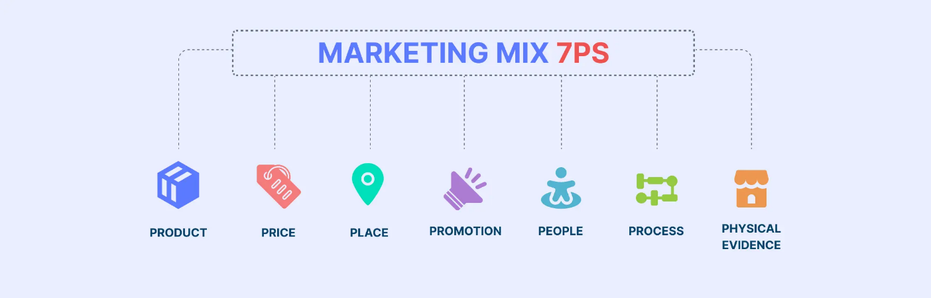
Figure 2: Marketing Mix (7Ps)
Source: (Athuraliya, 2024)

3.1 Product
The Apple Smart Ring is a wearable device that is a compact, lightweight gadget that offers comprehensive health monitoring, heart rate, sleep, and activity tracking. The ring is a more secretive and comfortable alternative to the traditional wearable devices like smartwatches that increase usability and convenience.
Strategically, the product has fit the innovation strategy of Apple, as it has created a new category in its wearable ecosystem. It can be enhanced by the integration with the Apple Health and other devices to provide a convenient user experience. Kotler et al. (2024) suggest that to be successful, products should provide both functional and emotional value. Here, the Smart Ring meets both functional needs, in terms of precise health data, and the wish of consumers to own the product, which is fashionable and minimalistic in design.
Moreover, the product will be sustainable since, possibly, it uses recyclable materials and energy-saving technology. This does not only boost brand perception but also is in line with the rising consumer demand of environmentally responsible products.

3.2 Price
The Smart Ring will be priced as a premium product of about £299-399 (350-450). This would be in line with the current wearable products offered by Apple, including the Apple Watch, which retails between 349-799. This kind of pricing supports the brand image of quality, innovation, and exclusivity of Apple.
Premium pricing enhances perceived value and helps in achieving profit margins of approximately 35-40. It focuses on consumers that are less price-elastic and can afford to purchase advanced technology. The increased prices, however, can decrease the availability of the product to lower-income groups, preventing mass-market use.
The price of the Smart Ring is justified by the integration of the ecosystem, high-level health functions, and image. Oura Ring competitors such as the Oura Ring cost between 299 and 349, which means that it is in high demand. Apple can employ psychological pricing like the price of 349 to make it seem like it is more affordable.

3.3 Place (Distribution)
The distribution is very important in availability and accessibility of the product. This is where Apple has a strong business case, as it has an existing distribution channel. The Smart Ring would be sold in Apple stores, the official Apple online shop, and several authorised retailers.
This multi-channel distribution process facilitates both in-store and online customer experience. Apple Stores have a high-end retailing experience in which the customer can touch and feel the product and get professional advice. In the meantime, online channels are convenient and reach the entire world (Bahri, Susan and Gunawan, 2023).
Strategically, selective distribution is in line with the premium positioning of Apple. This ensures consistency in the brands and a high-quality customer experience since Apple can control the place and way it sells its product. This will also minimize the risk of brand dilution that might be experienced in case of mass distribution.

3.4 Promotion
Apple Smart Ring promotion would be aimed at building a brand awareness and emotional connection. The approach of Apple usually involves product launch events, online marketing, and influencer partnerships to create buzz.
Keynote talks are significant in conveying innovation and creating excitement. Digital media provides the opportunity to communicate specifically, especially to health-conscious, tech-friendly consumers (Jeremias and Zhang, 2025). The promotional strategy adopted by Apple is not focusing on the technical specifications, but on simplicity and usability which makes the brand easier to emotionally relate to.
Importantly, there should be no concealed messages in promotional messages, particularly when they are related to health-related features. Trust is a key factor to success in the long run, especially in wearable health technology market.

3.5 People
The people factor is all the people who are in the process of providing the customer experience. The retail team and customer support teams of Apple are crucial in disseminating the Smart Ring value and assisting customers.
Trained employees can increase customer satisfaction through offering expert advice and by making the buying experience as hassle free as possible. This will be consistent with the customer-focused strategy of Apple whereby service quality is one of the differentiators (Shang, 2025). Strategically, employee training is worth investing in as it helps in maintaining a steady brand delivery and enhancing customer relationships.

3.6 Process
Process is the systems and procedures that facilitate product delivery and utilization. In the case of Apple Smart Ring, this process should be made easy and effective.
The device would go hand in hand with iPhones, enabling users to easily establish and view health data via the Apple Health app. Automated monitoring and customised insights decrease the effort of users, making it more convenient and engaging in the long term (Machorro-Cano et al., 2023).
Simplicity is a key element in the wearable technology since complexity may decrease users’ adoption. Its emphasis on simplicity makes sure that the product is in accordance with its brand values and it provides a good user experience.

3.7 Physical Evidence
Physical evidence is the material that surrounds the product and has an impact on the customer perceptions. In the case of Apple Smart Ring, this will be the product design, packaging, and retail environment.
The minimalist design philosophy of Apple would carry over to the design of the ring, which would be made of high-quality materials and a smooth finish. The packaging would be high-end and sustainable to reaffirm the brand image and sustainability.
Another physical evidence is offered by Apple Stores that create a clean, modern and interactive environment. These features produce the powerful initial impression and facilitate the customer experience.
Theoretically, physical evidence is important in perceived risk reduction especially in new products. The quality of design and presentation is an indicator of reliability and value that consumers need to be confident (Handoyo, 2024).
The 7Ps marketing mix demonstrates the ways the Apple Smart Ring could be successfully placed in the wearable market. All these factors promote the high-end, innovative strategy of Apple. Matching product, price, place and promotion to consumer expectations enhances competitive advantage and people, process and physical evidence ensure a high quality and consistency of customer experience.

4. Element 4: Reflection
This reflection appraises my experience in creating the Apple Smart Ring brand extension and creating and presenting the poster. It explores the major skills and knowledge acquired during the process, strengths and weaknesses. It also provides a course of action to enhance my future academic and professional performance.

4.1 Strengths in Brand Development
The ability to find a relevant and original brand extension in line with the prevailing trends in the wearable technology and health monitoring was one of my main strengths. This showed that I can identify the opportunities in the market and implementing marketing theories like the marketing mix and STDP in a real-life situation. I could relate theory to practice, and this reinforced the quality of my work strategy.
The other strength was the ability to remain consistent with the brand image of Apple. The Smart Ring idea was an expression of Apple premium positioning, its innovation focus and integration of its ecosystem. This guaranteed the extension was feasible and did not contradict the current strategy of the company (Das, Vijaykumar and Vui, 2025). Moreover, I demonstrated good visual communication abilities in my poster preparation. I created an organized and simple design which was based on the minimalist design.
I was confident and managed my time well during the presentation. I managed to describe the idea and its worth in the specified time frame clearly, which is indicative of good preparation and organisation.

4.2 Weaknesses in Analysis Skills
Despite these advantages, some aspects could have been improved. Among the weaknesses, the extent of critical analysis in my written work was a critical error. Certain parts were more descriptive than analytical, and I could have made my arguments stronger by referring more to academic sources and assessing other possible strategies. This restricted the profundity that was supposed to be at postgraduate level.
Another issue was time management since I did not have time to review and refine my work (Pamuji et al., 2025). This influenced the clarity and coherence in some parts. Regarding poster preparation, I struggled to maintain a balance between the visual appeal and the detailed content of the poster, thus some of the ideas were not clearly explained.
In the presentation, I was confident; however, I would have done more to engage the audience with the use of more persuasive language and interactive delivery strategies. This would have enabled the presentation to be more effective and compelling.

4.3 Action Plan for Improvement
To enhance my performance in the future, I will pay more attention to the development of stronger critical analysis and reviewing the academic literature and assessing various positions more efficiently. This will add depth and quality to my work. My time management will also be enhanced by developing a time schedule with specific deadlines so that it will have enough time to revise and redefine it.
Moreover, I would like to enhance my poster design by having a more balanced visual design and content clarity. I will also be practicing presentation skills, which will involve audience engagement and persuasive communication strategies. These enhancements will help me in not only developing academically but also as a professional, so that I am able to work better in the future projects.

5. Reference List
Athuraliya, A. (2024). What are the 7 Ps of Marketing and How to Use Them | Creately. [online] Creately. Available at: https://creately.com/guides/7ps-of-marketing/
Bahri, R.S., Susan, M. and Gunawan, T. (2023) ‘Exploring the Influence of Omnichannel Experience on Trust and Repurchase Intention in Retail Companies: Evidence from Indonesia’, Journal of Law and Sustainable Development, 11(2), p.e631. Available at: https://doi.org/10.55908/sdgs.v11i2.631
Biga, R., Nottebaum, S., Kozlakidis, Z. and Psomiadis, S. (2024) ‘Digitalization of Healthcare in LMICs: Digital Health and the Digital Divide Based on Technological Availability and Development’, in Sustainable Development Goals Series, pp.185–193. Available at: https://doi.org/10.1007/978-3-031-62332-5_18
Das, M., Vijaykumar, P. and Vui, Dr.C.N. (2025) ‘Apple Inc.: A Case Study on Marketing Excellence and Sustainable Innovation in a Dynamic Market’, International Journal of Current Science Research and Review, 8(4). Available at: https://doi.org/10.47191/ijcsrr/v8-i4-31
Handoyo, S. (2024) ‘Purchasing in the digital age: A meta-analytical perspective on trust, risk, security, and e-WOM in e-commerce’, Heliyon, 10(8), p.e29714. Available at: https://doi.org/10.1016/j.heliyon.2024.e29714
Hosseini, M.M., Hosseini, M., Karim Qayumi, Hosseinzadeh, S. and Saba, S. (2023) ‘Smartwatches in healthcare medicine: assistance and monitoring; a scoping review’, BMC Medical Informatics and Decision Making, 23, p.248. Available at: https://doi.org/10.1186/s12911-023-02350-w
Jeremias, A. and Zhang, L. (2025) ‘Research on Apple’s Social Media Marketing Strategies Focus on the Improvement of the iPhone 15 Launch’, Open Access Library Journal, 12(6), pp.1–22. Available at: https://doi.org/10.4236/oalib.1113641
Kotler, P., Keller, K.L., Brady, M., Goodman, M. and Hansen, T. (2024) Marketing Management. European edn. Harlow: Pearson
Machorro-Cano, I., Olmedo-Aguirre, J.O., Alor-Hernández, G., Rodríguez-Mazahua, L., Sánchez-Morales, L.N. and Pérez-Castro, N. (2023) ‘Cloud-Based Platforms for Health Monitoring: A Review’, Informatics, 11(1), p.2. Available at: https://doi.org/10.3390/informatics11010002
Pamuji, S., Ni’mah, T., Baharuddin, K.M., Novianto, A.Y., Wibowo, E.P. and Kasmin, K. (2025) ‘Time Management: The Key to Success in Managing Complex Projects’, International Journal of Multidisciplinary Approach Research and Science, 3(01), pp.124–134. Available at: https://doi.org/10.59653/ijmars.v3i01.1234
Shang, S. (2025) ‘Apple Customer Care Apocalypse: Strategy Evaluation and Suggestions for Improvement’, Highlights in Business Economics and Management, 48, pp.198–209. Available at: https://doi.org/10.54097/daac7j97
Tavor, T., Gonen, L.D. and Spiegel, U. (2023) ‘Customer segmentation as a revenue generator for profit purposes’, Mathematics, 11(21), p.4425. Available at: https://doi.org/10.3390/math11214425
Zahrt, O.H., Evans, K., Murnane, E., Santoro, E., Baiocchi, M., Landay, J., Delp, S. and Crum, A. (2023) ‘Effects of Wearable Fitness Trackers and Activity Adequacy Mindsets on Affect, Behavior, and Health: Longitudinal Randomized Controlled Trial’, Journal of Medical Internet Research, 25, p.e40529. Available at: https://doi.org/10.2196/40529
Zhang, R. and Hu, L. (2024) ‘Research on Apple’s Competitive Advantage’, Frontiers in Business, Economics and Management, 17(2), pp.64–66. Available at: https://doi.org/10.54097/9enesd13
Zou, Y. (2023) ‘Apple’s Brand Marketing Strategy: A Case Study on Brand Image and Customer Engagement’, Highlights in Business Economics and Management, 23, pp.712–715. Available at: https://doi.org/10.54097/sbcggy69

