

Assessment 1 – Reading Task Template
PART 1: Upload your photo of your A3 in-class notes here:
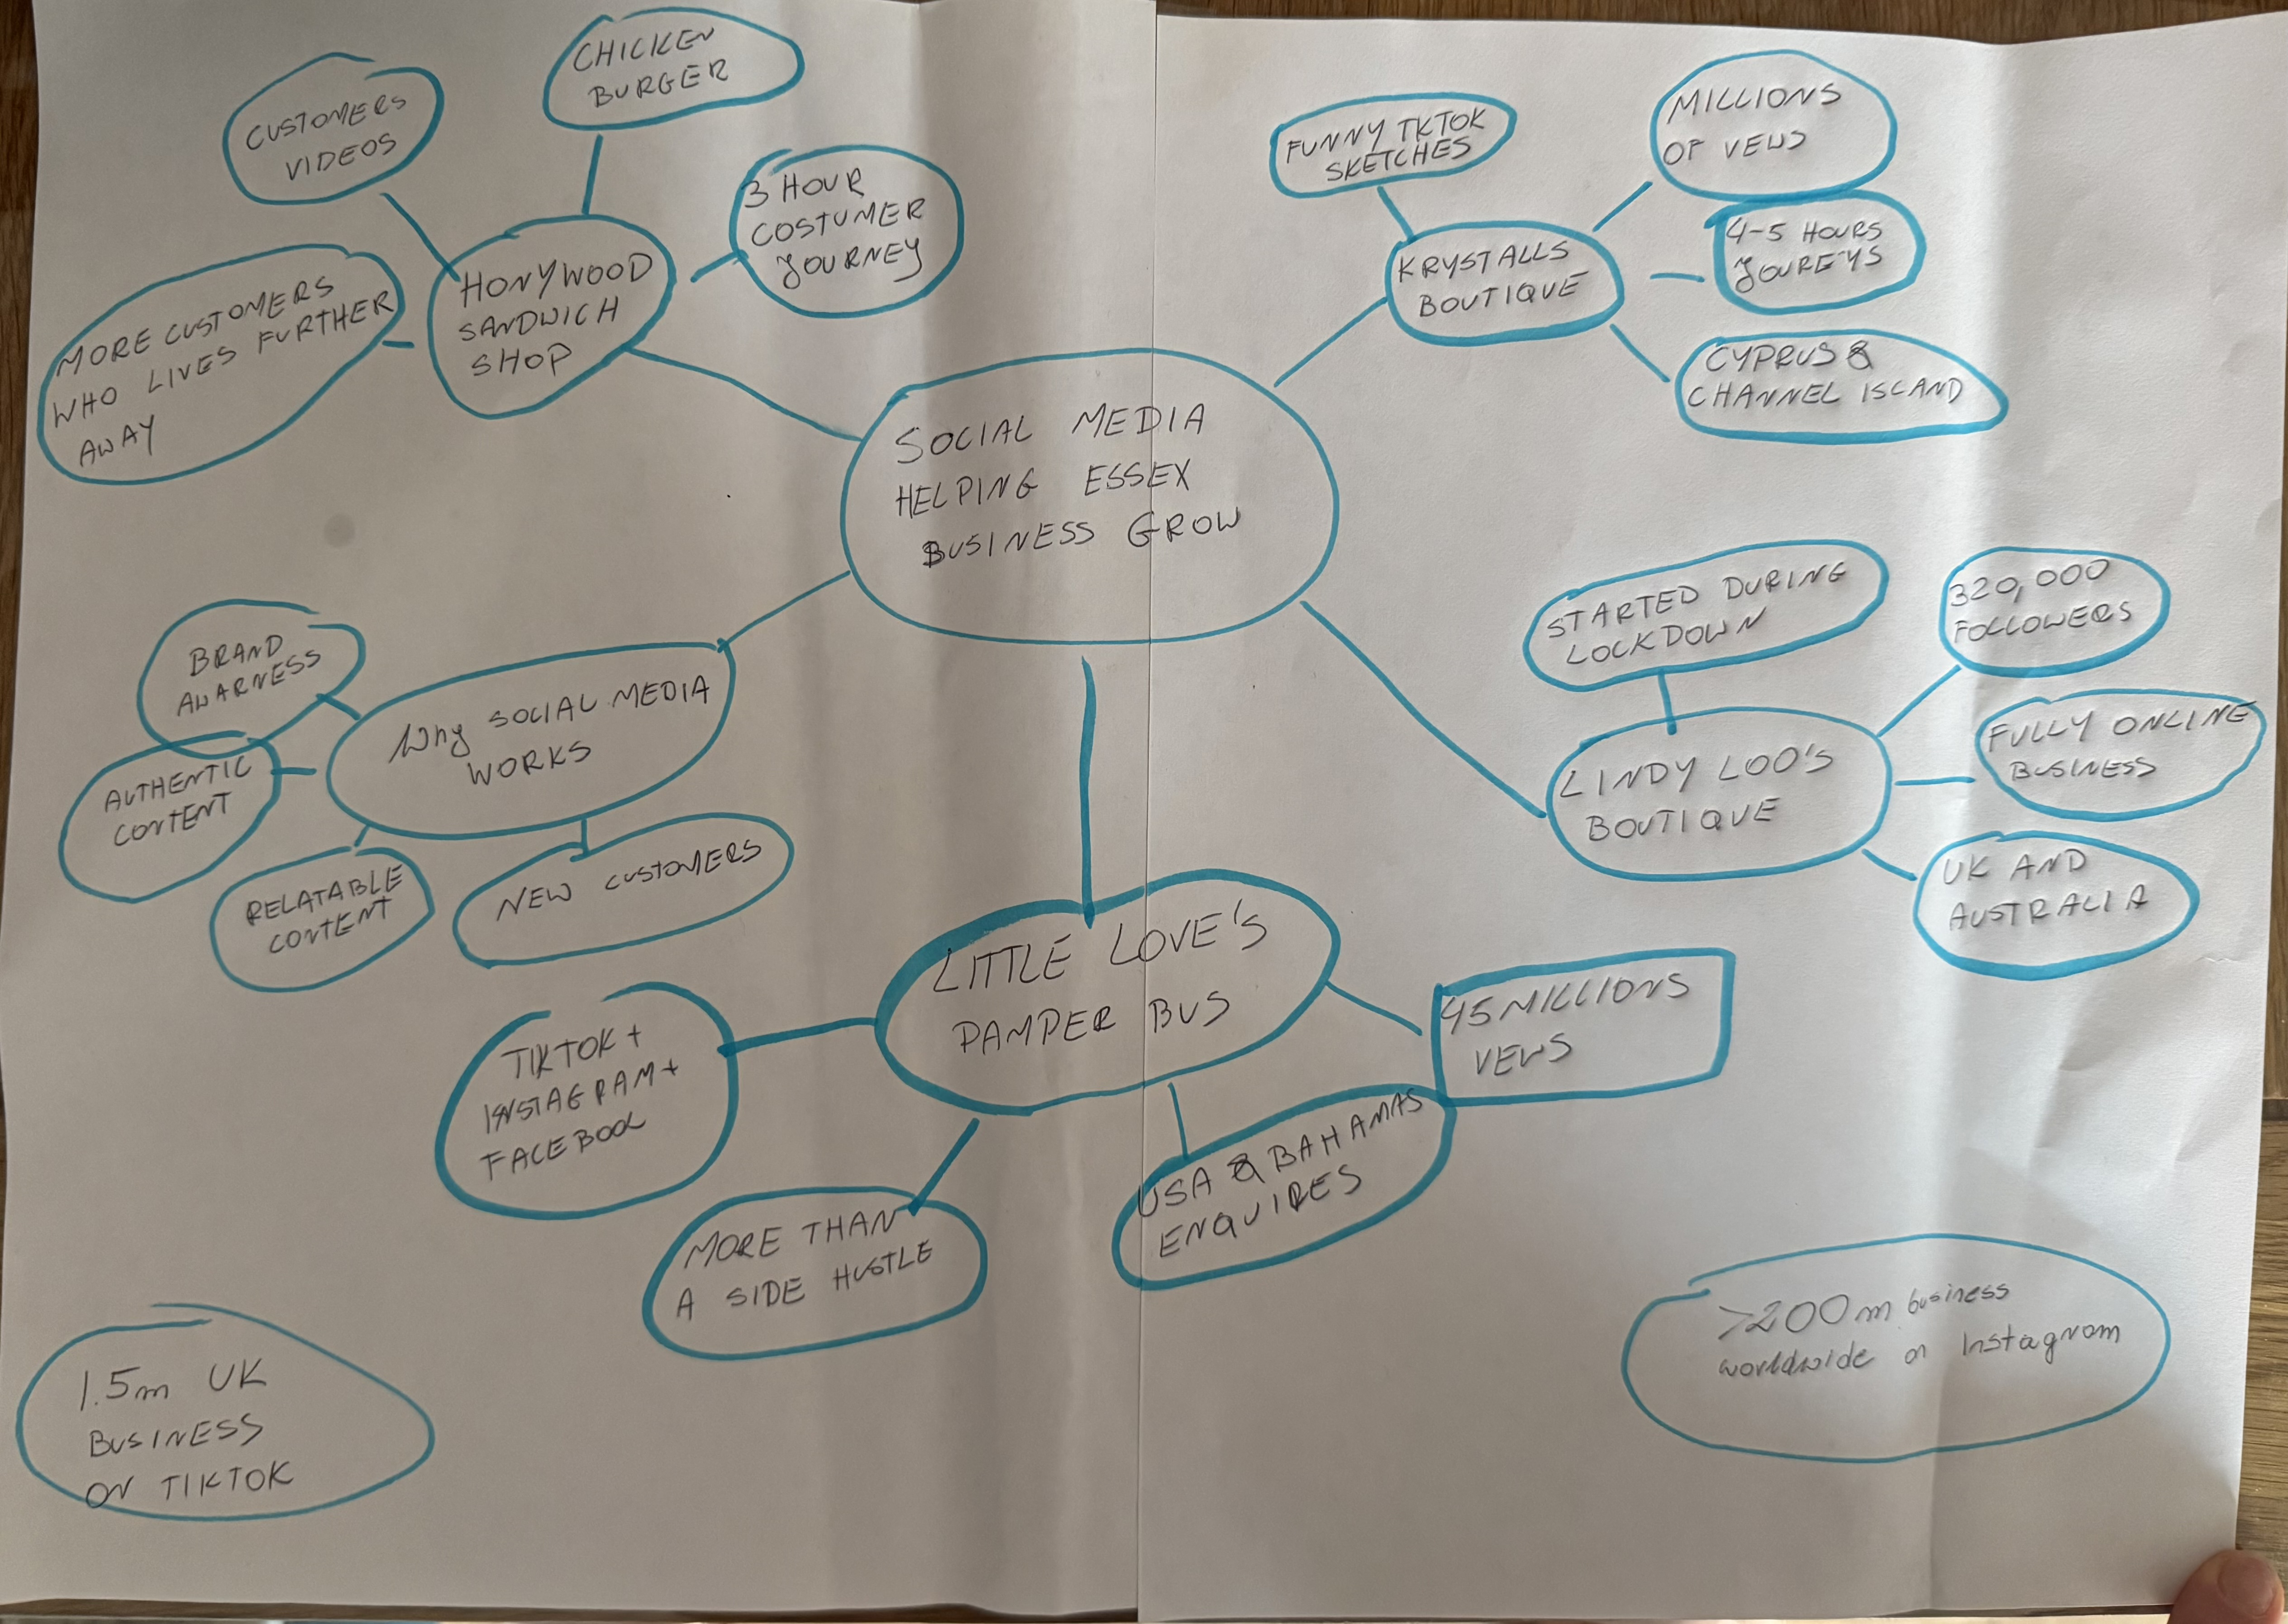

- The text is about business that became popular on TikTok and Instagram. Social media helps these businesses get more customers and become well known. The text shows how important social media is for small local businesses

- One key point is that social media can help local businesses get more customers. For example, the text talks about an Essex business that became popular after people shared it on TikTok. This shows that social media can make a small business famous.

- Another key point is that social media can help businesses reach people outside their local area. For example, the text describes Essex businesses getting attention from people who saw their videos online. This shows that TikTok and Instagram can help local businesses attract new customers.

- I think the most important part is how social media helps small business become popular. It is important because more people can see their products and visit their business. This shows that TikTok and Instagram can have a big effect on local businesses.

I found the text interesting because it shows how social media is changing the way small business attract customers. What stood out to me was how quickly a business can become well known when people share its content online. I think platforms like TikTok and Instagram can create opportunities for businesses that would otherwise be difficult to get notices. Overall, the text made me realise how strongly social media can influence the success of a local business.

- I found it difficult to organise the information from the article into a diagram in class. There were many details in the text, so it was sometimes hard to decide which information was the most important. I also found it challenging to connect the main idea with the different examples from the articles. However, making the diagram helped me understand the text better.

- The diagram we made in class helped me organise the information from the article. It made it easier to see the main idea and connect it with the key points and examples. Discussing the article in class also helped me understand parts that I found confusing. This made it easier for me to answer the questions.

