Student Name: Stanimira Yuliyanova Dimitrova
Student Number: 1909125
Lecture Name: Adesewa Ajayi
Module Name: Introduction to Physiology
Module Code: BMHP 5003 (LON)
Assessment Component 1

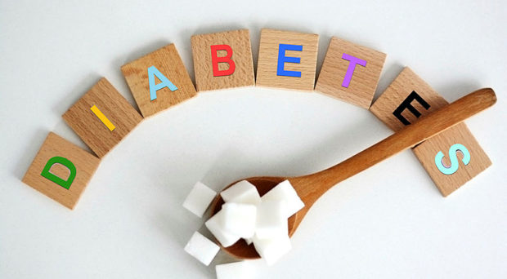

Type 2 diabetes mellitus

Miss X is born with a genetically determined level of insulin resistance. If there is not requited enough attention to nutrition and physical activity there is a high chance of developing type 2 Diabetes Mellitus. In this type of disease, the body's cells do not absorb glucose, this is necessary for their vital activity and normal functioning. In type two diabetes, the pancreas produces insulin but does not react with the body at the cellular level.

According to Harreiter and Roden, (2019) diabetes mellitus is an increase in the concentration of glucose in the blood. This increase is affected by a group of heterogeneous disorders. Diabetes is a chronic disease in which the pancreas does not produce enough insulin. That causes the body to have insulin resistance. When the blood sugar remains elevated in the body occurs hyperglycemia.

(Cambridge, 2019).

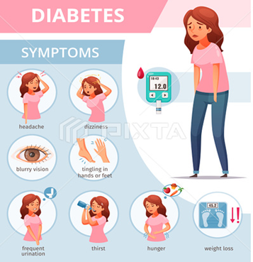

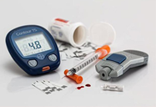

(Pinnacle Care, 2018).
According to Chatterjee et al., (2017) type 2 diabetes is the reason why many patients have microvascular and macrovascular complications. These complications have psychological and physical stress. They also affect an individual's health systems.

An indicator of whether a person suffers from type 2 diabetes can be the following symptoms: frequent urination even at night, constant thirst, hunger, weight loss, constant feeling of fatigue and dizziness, itching in the groin, slow wound healing, blurred vision, headache, tingling in hand or feet (NHS Choices, 2020).
(Macro vector, 2020).

According to Diabetes.co.uk. (2019) some of the factors that predispose to diabetes can be prevented. Being overweight is one of the most significant risk factors. A sedentary lifestyle combined with an unhealthy diet also affects whether Miss X will develop type 2 diabetes. High cholesterol and high blood pressure are also at risk both can be a sign of a pre-diabetic condition. Some ethnic groups are more prone to disease as well as aging.
Risk factors

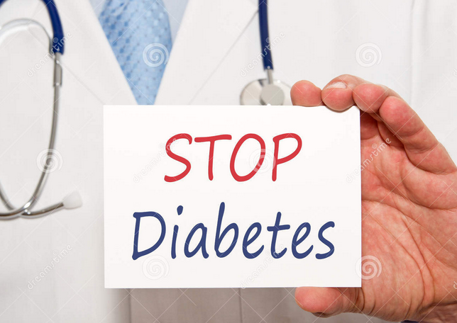

(Dreamstime, 2000-2021).

References:

Cambridge, R.P.E. at B.C. studied N.S. at the U. of, July 2013, joined B.C. in and registry, now holds the position of D.E. for the I. (2019) Take a fresh look at diabetes research for UK Diabetes Week [Online] On Medicine Available at: https://blogs.biomedcentral.com/on-medicine/2019/06/06/take-a-fresh-look-at-diabetes-research-for-uk-diabetes-week/
(Accessed 05 November 2020).

Chatterjee, S., Khunti, K. and Davies, M.J. (2017) Type 2 diabetes. The Lancet [Online] 389(10085), pp.2239–2251. Available at: https://pubmed.ncbi.nlm.nih.gov/28190580/
(Accessed 10 April 2021).

Diabetes.co.uk. (2019) Diabetes Risk Factors [Online] Available at: https://www.diabetes.co.uk/Diabetes-Risk-factors.html.
(Accessed 11 April 2021).

Dreamstime (2000-2021) Stop diabetes stock image. Image of closeup, card, health - 40378523. [Online] Available at: https://www.dreamstime.com/stock-photos-stop-diabetes-hand-doctor-stethoscope-holding-sign-image40378523
(Accessed 11 April 2021).

Harreiter, J. and Roden, M. (2019) Diabetes mellitus – Definition, Klassifikation, Diagnose, Screening und Prävention (Update 2019). Wiener klinische Wochenschrift, [Online] 131(S1), pp.6–15. Available at: https://link.springer.com/article/10.1007%2Fs00508-019-1450-4.
(Accessed 10 April 2021).

NHS Choices (2020) Symptoms - type 2 diabetes [Online] NHS. Available at: https://www.nhs.uk/conditions/type-2-diabetes/symptoms/.
(Accessed 11 April 2021).

Pinnacle Care (2018) Could You Have Undiagnosed Diabetes? [Online] Available at: https://www.pinnaclecare.com/highlights/blog/undiagnosed-diabetes/ (Accessed 05 November 2020).

