
Skills for the Workplace
Module Assignment Submission
Student Name: | Laurentiu Corodescu
Student Number: | 2024420
Module No: | BMSK4005
Module Title: | Professional Career Development

Statement of Confirmation of Authenticity
By the act of making this submission, the student declares that this is the work of the student named above. The work has not, in whole or in part, been knowingly presented elsewhere for assessment, or where assessment has been built on a previous assessment, this has been identified. Where materials have been used from other sources it has been properly acknowledged. If this statement is untrue, the student acknowledges that an assessment offence has been committed.
Attention is drawn to the plagiarism and unfair practice policies of both the University and of ILM.

Table of Contents
Section 1: Know how to identify development needs 2
1.1 Identify learning styles for self and another 2
1.2 Use a simple technique for identifying development needs for self & another 2
1.3 Identify potential barriers to learning for self and another. 2
1.4 Explain how these barriers to learning can be overcome. 2
Section 2: Know how to develop self & others to achieve organisational objectives 2
2.1 Analyse learning/development options to meet needs of self & another. 2
2.2 Identify support mechanisms for the development of self & another 2
2.3 Prepare development plans for yourself and another person 2
2.4 Method used to monitor the development of self & another. 2
Section 3: Know how to prepare for the recruitment process 2
Reflection on the recruitment process 2
3.1 Description 2
3.2 Feelings 2
3.3 Evaluation 2
3.4 Analysis 2
3.5 Conclusion 2
3.6 Action Plan 2
References 2
Appendix A 2
Appendix B 2
Appendix C 2
Appendix D 2

Section 1: Know how to identify development needs

Identify learning styles for self and another

Sha Drena (Drena, 2017) believes that every person learns in their own way, which makes it vital for managers to detect each person’s learning type. There are numerous schools of thought on this topic, but it is a useful tool to use cautiously. After all, whether an employee is obviously a more perceptible, auditory, or visual learner will decide the most efficient training procedures to use. Omission to do so may possibly result in underutilizing or omitting aptitude that are present in the interior of the organization. By deciding the best types of training procedures, teams decrease training period, fully exploit available talent, and prime the pump for long-term achievement.
Drena shares some helpful ways to distinguish the three separate learning styles of a team members:

The Kinesthetic Learner
Kinesthetic learners achieve expertise through direct involvement and exercise. They like to plunge right into an example project and learn by cooperating with the subject matter. Kinesthetic learners recognize the value of semblances and walk-throughs, but less so lectures or other one-way teaching styles. They take less advantage from others revealing their skills than other styles of learners. Given their predisposition to discover, kinesthetic learners habitually take more chances than other learners, which makes for an important team member. However, they may demand more means for extremely efficient training. It is vital to take risks with the training procedures and practices to keep them on their toes.

The Auditory Learner
Auditory learners take in knowledge best when it is given out loud, so even conventional training procedures can work reasonably well for them. They learn foremost from talks, theorises, or one-on-one coaching. Auditory learners may talk their way through a crisis or recap data verbally to assist in recollection. They significantly profit from dialogues and learn more by discussing about what they know with different individuals. However, this poses a lot of requisitions when it is not feasible to clearly communicate information through words alone, or if there is not much room for discussion in the training structure.

The Visual Learner
The Social Science Research Network states that 65 percent of individuals fall into this group. Visual learners absorb information when it is offered as an illustration. They learn best when information is parted out into obvious structures or methods and is produced in formats such as graphs, charts, diagrams, and text. They are efficient visualizers and work well with self-instruction scenarios. However, they frequently find auditory learning unproductive and may be unable to pay attention during conversations or speeches. On-the-job training techniques have a tendency to work well for them if organised adequately.

SWOT Person 1

STRENGTHS  - Time management abilities  - Drive and determination | WEAKNESSES  - Absence of persistence  - Jumping to assumptions  - Communication abilities
OPPORTUNITIES  - Enhancing the degree of learning abilities  - Using drive and determination to change weaknesses into strengths | THREATS  - Loosing enthusiasm to persist with self-development
  - Use a simple technique for identifying development needs for self & another

SWOT Person 2

STRENGTHS  - Enthusiasm  - Ability to work well in a team | WEAKNESSES  - Lack of skills on independent work  - Poor time management ability
OPPORTUNITIES  - Workplace offers resources to improve time management and communication abilities | THREATS  - The following achievement review may not go well if time management abilities do not get better

According to Paul (Boag, 2018) it exists two methods of addressing the weaknesses and threats from a SWOT analysis. These are to match and convert. Matching requires taking the strengths and finding out if they fall into line with any of the opportunities.
The other method is to look for possibilities to convert weaknesses and threats into opportunities or strengths. That is simple to say but not so straightforward to do. It is not on all occasions feasible to convert a weakness or threat into an opportunity. Where it is not possible, the option is to diminish its impact.

1.3 Identify potential barriers to learning for self and another.

According to iEduNote (iEduNote, 2021) barriers to learning are obstacles or circumstances that preclude learners from gaining access to programs, make it challenging for learners attend classes or make it arduous for learners to focus and learn.
7 barriers to learning are:
- Presentation dilemma.
- Another barrier to learning is altering the prospect of a new philosophy.
- Learners do not get suitable assistance.
- Employment-related problems.
- Occasionally individuals cannot focus appropriately.
- The financial issue can be an impediment to learning.
- The political pressure can be an obstacle.

Presentation dilemma
The presentation dilemma is one of the major impediments to learning. At times individuals cannot comprehend the significance of a subject if it is given orally without using any form of visual means of presentation.
In this case, often it comes to be very challenging for the learner to comprehend.

Learning is altering the prospect of a new philosophy
Another barrier to learning is altering the prospect of a new philosophy. If individuals go to a new culture, often they do not get the anticipated atmosphere and it obstructs the learning development.
In this case, initially they have to learn the new culture within a very short period, and it is very challenging for every person.

Learners do not get suitable assistance
When the learners do not get suitable assistance from the people and the company, they cannot learn the details appropriately.

Employment-related problems
Employment-related problems can be a very big issue in the learning development.
Individuals cannot learn if there is no good connection with their upper-level or subaltern. Not only that, if there is no corroboration associated to the outcomes of learning, individuals cannot be driven in accomplishing a good outcome from it.

Occasionally individuals cannot focus appropriately
Occasionally individuals cannot focus appropriately on the learning development because of their family, private or administrative issues. There are some of the learning classes that involves a sum of money.

Financial issue can be an impediment to learning
Certain individuals have financial difficulties and because of that, they cannot join the learning development. Financial issues can be an obstacle to learning.
For not sufficient money, people cannot learn anything appropriately.

The political pressure can be an obstacle
If the political nature is in favour of the learners, it develops an opening for the learner. If the habitat is not favourable, then they encounter many issues because of political pressures.
If there is any issue with the individual who will give evidence to the learners, then it comes to be very challenging for the people to learn.
There may have so many issues with the coach like- lack of abilities, language barrier, lack of information, lack of willingness, etc.

1.4 Explain how these barriers to learning can be overcome.

According to the same iEduNote (iEduNote, 2021) there are 10 approaches of overcoming the impediments of learning:
- Environment.
- Routine.
- Verbal Instructions.
- Respect.
- Non-curricular Activities.
- Improving Communication Skills.
- Giving ICT and Presentation Facilities.
- Give Concentration.
- Learn the New Culture before Going There.
- Provide Effective and Timely Feedback.

Environment
The environment is a significant point for the company.
In a loud environment, learning would be challenging for the learner. The administrative environment have a duty to be soundless.
Moreover, the administration must use visual effects, motions and/or a signing system to strengthen spoken and written language, make a visual schedule, and eradicate unnecessary noise as far as possible.

Routine
This is very important to relieve uncertainty and offer individuals a sense of safety.
When habits have to be disrupted, make certain that individuals are ready whenever possible and that somebody addresses what is going to come about.

Verbal Instructions

Communication should be brief and accurate. The coach should make certain that learners understand he/she is referring to them, not someone else.

One training should be offered at a time. He/she have to speak evidently, at a natural pace and ensure that the learner can see the face of the coach.

Respect
Young individuals should not be forced to work in pairs or groups if they are nervous in that position.
Esteem should be demonstrated for distinctions and be mindful of the social networks of the room where the learning session will be performed.

Non-curricular Activities
When the meeting will be operating issues often occur at break time, lunchtime, at the bus stop or any other irregular time of the day.
It is in the course of these times when computer organizations, planned games, and trainers present significant assistance and can also deliver some training in social skills that will help students to deal with new circumstances.

Improving Communication Skill
Good communication skills can be improved to comprehend no matter what. In this case, the coach must use the speech which is comprehensible by the students.
For clearer understanding, it has to be enhanced the communication abilities straight away.

Giving ICT and Presentation Facilities
For effectively organising the learning phase, the coach or the association should use the ICT and graphic demonstration services.
It inspires the students to learn matters in a brief interval.

Give Concentration
All of the students should focus on the learning phase.
Though the association organises such type of meeting for developing the abilities of the individuals, he or she should focus on learning to thrive in the line of work.
From time to time it is prepared for informing the individuals about the procedure of doing their duties. So, if they disregard these things, they will not carry out their tasks appropriately.

Learn the New Culture before Going There
Though the philosophy of different country even different associations in the same country are different, before going to a new culture the student should learn about the new culture and study it for adapting there.

Provide Effective and Timely Feedback
This is vital for any kind of studying. Make the coach’s existence known in a debate forum by getting engaged early and raising questions that keep the debate going.
Students should also be conscious of their development throughout the program.
It has already been contended that impediments can be found within the learner, within the centre of learning, within the education system and within the broader social, economic and political environment.
These difficulties reveal themselves in various ways and only grow to be evident when learning analysis arises when learners abandon the scheme or when the omitted come to be evident.
Sometimes it is likely to recognize permanent obstacles in the student or the structure which can be tackled through facilitating structures and methods.
However, obstacles may also occur during the learning process and are seen as temporary. These may necessitate different involvements or approaches to avoid them.
If the above matters should be respected at the time of organising a different meeting, the association will be effective.

Section 2: Know how to develop self & others to achieve organisational objectives

2.1 Analyse learning/development options to meet needs of self & another.

According to hr-guide (hr-guide.com, 2021) today's employment situation involves individuals to have abilities in executing complex tasks in an effective, profitable, and safe way. Training is required when individuals are not achieving a specified level. The disparity between the factual level of performance and the required level of performance implies a need for training. The recognition of training needs is the initial step in a process of instructional design.
An effective training will recognize those who need training and what kind of training is required. It is ineffective to offer training to people who do not require it or to offer the improper kind of training. A Training Needs Analysis helps to put the training solutions to good use.

2.2 Identify support mechanisms for the development of self & another

Changing Minds (ChangingMinds, 2021) presents a practical way to understand why developing yourself to grow the individual one wants to be is an impressive task and one that many individuals assume in order to develop new substance and fulfil their lives. It is about taking accountability for oneself, one’s beliefs and one’s pursuits, understand how one think and changing oneself beneficially.
Furthermore, Pachamama (Pachamama, 2021) defines personal growth and development is an interchanging method, in which reformations are made in one’s physical, emotional, intellectual, spiritual, social, and/or financial state.
This method is frequently sparked by a crucial life experience that motivates to enhance and enable oneself by determining where the full capability is. The outcome is a more rewarding and purposeful life, which is distinct in the interactions, workplace, self-image and self-confidence.

2.3 Prepare development plans for yourself and another person

Part 1: Personal Analysis
See SWOT Analysis in 1.2

Part 2: Setting Goals

What do I want to learn? | What do I have to do? | What support and resources will I need? | How will I measure success? | Target Date for Review
Learn something new | Choose a new skill, topic or take a class | Meditation, affirmations | By how much time is spent doing what is desired | April 2022
Improve communication skills | Improving English language, learning conversation techniques | Coaching and continuing classes | By confidence when interacting with others | December 2022

Part 3: Personal Objectives

Short Term Goals (next 12 months)
Visit family in both countries
Medium Term Goals (2-3 years)
Build different streams of income

Long Term Goals (3-5 years)
Owning a property management company

2.4 Method used to monitor the development of self & another.

Richard (Richard, 2018) states that according to jobs.ac.uk, there are 3 main areas to carrying out a personal development plan. These are:
- allocating time to deliberate and examine
- being methodical, creating a plan and consistently assessing it
- delegating at least one individual who can act as a ‘critical friend’
However, there is considerably more to executing an effective personal development plan that just these three fields.
When planning personal development, supervisors need to look at an individual’s prior familiarity, existing conditions, and what might be essential for them to improve and organize training, advising actions or own learning plans in agreement with the companies goals.
According to Lucidchart (Lucidchart, 2021) a performance development plan is an instrument for enhancing an individual’s performance. The PDP practice assists managers and individuals pinpoint areas for advancement, establish goals, evaluate improvement, and define an approach to accomplish those goals.
Performance development planning is typically held quarterly, permitting individuals and their managers to pursue improvement and make corrections as needed.
Michelle (Putter, 2021) shows what the advantages of a PDP are:
- It sets obvious aspirations.
- It assists pinpoint strengths and weaknesses.
- It powers employability.
- It boosts performance.
- It enhances motivation.
- It assists track the development.
- It serves the sense of purpose.
- It improves mental wellbeing and lowers stress.
In general, a PDP offers the greatest possible opportunity for accomplishment and increases capability.

Section 3: Know how to prepare for the recruitment process

Reflection on the recruitment process

One of the best reflection models is undoubtedly Gibbs Cycle of Reflection.
According to Fahri (Karakas, 2020) Gibbs Cycle of Reflection was created by Graham Gibbs in 1988 to deliver a tool for learning from events. It proposes a cyclical framework for analysing events, facilitating learning and planning from what that did or did not go well. Fahri brings to attention some of the benefits of reflection and says that can help to:
- improves the skills to assess circumstances and create action plans for future success,
- re-evaluate the events to turn them into knowledge and deeper learning,
- improves self-awareness and emotional intelligence,
- develop problem-solving abilities,
- improve on creative answers to the disputes faced, and
- assess the urgency for change and start the approach of constructive change.

Gibbs Cycle of Reflection
Description
What happened?

Action plan
If it arose again, what would you do?
Feelings
What were you thinking
and feeling?

Conclusion
What else could you have done?
Evaluation
What was good and bad about the experience?

Analysis
What sense can you make of the situation?

3.1 Description

An application for a new job has been submitted and regrettably the qualifications were not entirely corresponding to the position. The position was requiring extended work experience in a specific area.

3.2 Feelings

The initial feeling was that the work experience is not coinciding and there is a lack of abilities.

3.3 Evaluation

Looking at how everything went so far, it has been realised that there is confidence to start something despite the lack of abilities, as long as there is willing to do hard work consistently and practice more.
Although, the thoughts are that it could have been done a better preparation for that particular job considering the abilities required.

3.4 Analysis

The whole experience looked like a challenge to do not miss on a new opportunity and brought motivation to work smarter to fulfil that aspiration.

3.5 Conclusion

Sometimes just believing in the existing skills and showing up for the interview is just about enough to take the opportunity and make that big step towards bigger achievements.

3.6 Action Plan

Finally, a prep list has been planned to prevent this kind of situation in the future. Also, it has been added to improve skills on self-awareness as a fortnight routine.

References

Boag, P., 2018. Website SWOT analysis: A ‘How To’ Example of Best Practice. [Online]
Available at: https://boagworld.com/digital-strategy/swot-analysis/
[Accessed 6 December 2021].
ChangingMinds, 2021. Self-Development Methods. [Online]
Available at: https://www.changingminds.org/techniques/self-development/self-development.htm
[Accessed 11 December 2021].
Drena, S., 2017. Learning Your Team: Identifying Learning Styles for Better Training. [Online]
Available at: https://www.lessonly.com/blog/learning-your-team-identifying-learning-styles-for-better-training/
[Accessed 28 November 2021].
hr-guide.com, 2021. Needs Analysis: How to determine training needs. [Online]
Available at: https://hr-guide.com/Training/Determining_Training_Needs.htm
[Accessed 11 December 2021].
iEduNote, 2021. Learning Barriers and Overcoming Barriers to Learning. [Online]
Available at: https://www.iedunote.com/learning-barriers
[Accessed 6 December 2021].
Karakas, F., 2020. How to Apply Gibbs Cycle of Reflection And Why This is Useful for Your Learning and Personal Development. [Online]
Available at: https://medium.com/an-idea/how-to-apply-gibbs-cycle-of-reflection-f56026a2558
[Accessed 11 December 2021].
Lucidchart, 2021. A step-by-step guide to the PDP process. [Online]
Available at: https://www.lucidchart.com/blog/performance-development-planning-pdp-process
[Accessed 11 December 2021].
Pachamama, 2021. Personal Growth and Development—A Transformational Journey. [Online]
Available at: https://www.pachamama.org/personal-growth-and-development
[Accessed 11 December 2021].
Putter, M., 2021. What is a personal development plan?. [Online]
Available at: https://cpdonline.co.uk/knowledge-base/business/what-are-personal-development-plans/
[Accessed 11 December 2021].
Richard, 2018. Understand How to Implement and Monitor a Personal Professional Development Plan. [Online]
Available at: https://gloopa.co.uk/understand-how-to-implement-and-monitor-a-personal-professional-development-plan/
[Accessed 11 December 2021].

Appendix A

2 | 7 y | 1 | 5 y
4 y | 13 y | 3 y | 9 y
6 | 15 y | 8 y | 11
10 | 16 y | 12 | 19 y
17 | 25 y | 14 y | 21 y
23 | 28 y | 18 y | 27 y
24 y | 29 y | 20 y | 35 y
32 y | 31 y | 22 y | 37
34 y | 33 y | 26 y | 44
38 | 36 y | 30 y | 49
40 y | 39 y | 42 y | 50 y
43 | 41 y | 47 | 53 y
45 | 46 y | 51 y | 54 y
48 | 52 y | 57 y | 56 y
58 | 55 y | 61 y | 59 y
64 y | 60 y | 63 y | 65 y
71 y | 62 y | 68 y | 69 y
72 | 66 y | 75 y | 70
74 | 67 y | 77 | 73 y
79 y | 76 y | 78 y | 80
Total: 8 | Total: 20 | Total: 16 | Total: 14
ACTIVIST | REFLECTOR | THEORIST | PRAGMATIST

Appendix B

Submit & Print Submit
UK Employment Application

AN EQUAL OPPORTUNITIES EMPLOYER
Enterprise Rent-A-Car is an Equal Opportunities Employer, and has a nondiscriminatory policy in conformity with the law and will not discriminate on any basis as defined by applicable laws. We are proud of our equal opportunities policies and we intend to comply with not only the letter, but with the spirit of these laws. Prospective employees will receive consideration without discrimination because of race, age, gender, disability, part-time status, sex, sexual orientation, marital or civil partnership status, religion or belief or any other characteristic protected by law.
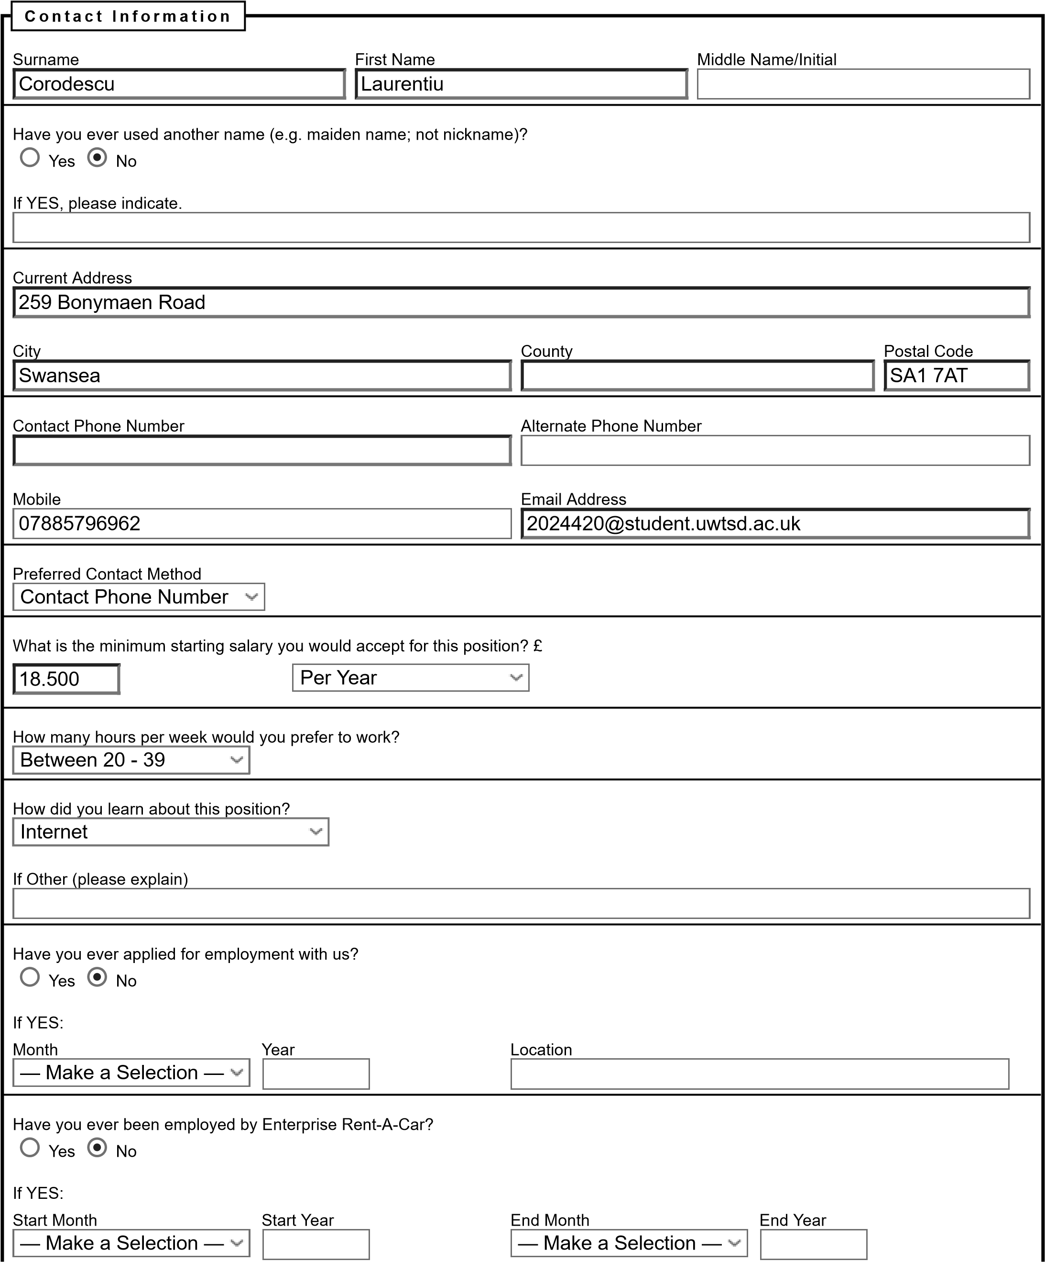
Location

When will you be able to begin work?

Month

Jan

Year

2022
Do you have the legal right to live and work in the United Kingdom?

Yes

No
What adjustments will you need to participate in the recruitment process?

NOTE: Enterprise Rent-A-Car will consider employment, without regard to disability, a disabled applicant who satisfies the requisite skill,
experience, education, and other job-related requirements of the job and is capable of performing the essential requirements of the job
with or without reasonable accommodation.
Regular attendance is an essential job function and is required of all Enterprise Rent-A-Car employees.

Will you be able to meet this job requirement?

Yes

No
none
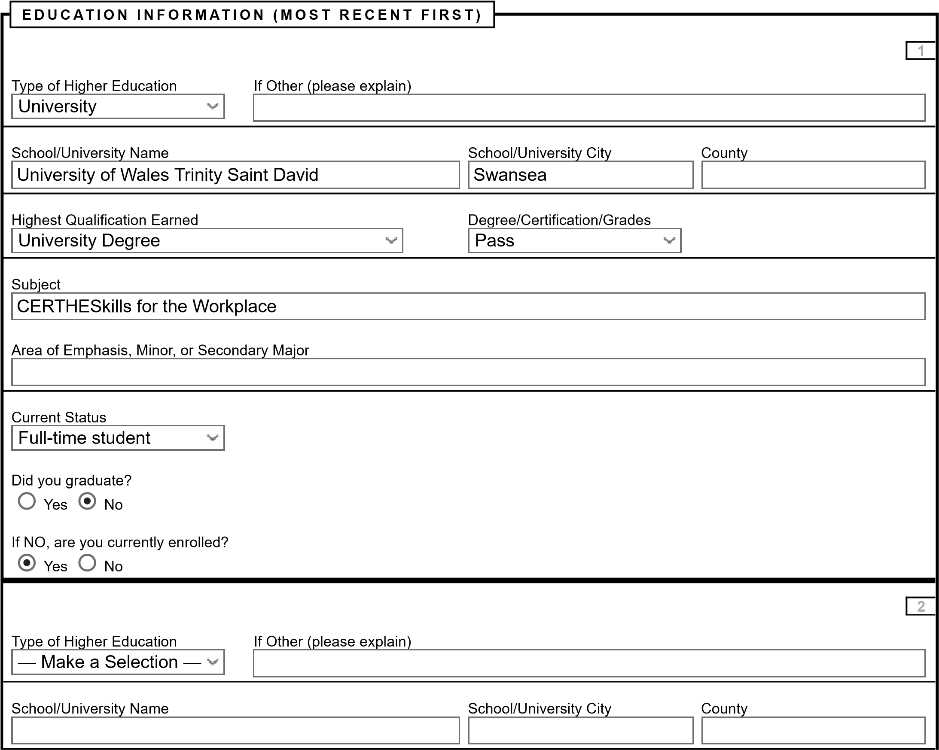

Highest Qualification Earned Degree/Certification/Grades
— Make a Selection — — Make a Selection —
Subject
Area of Emphasis, Minor, or Secondary Major
Current Status

— Make a Selection —
Did you graduate?

Yes

No
If NO, are you currently enrolled?

Yes

No
 | Show More (Education) | (EDUCATION INFORMATION — COLLEGE/UNIVERSITY)
Please give accurate, complete full-time and part-time employment record.
Start with present or most recent employer.
1
May we contact this employer?
Yes

No
Job Title

Holiday Lets Property Management/ Maintenance
Company Name

Sparkle Lab

Telephone

07599275455
Address

259
Bonymaen Road, Swansea, SA1 7AT
Name and Title of Supervisor

Marzena Malinowska
Are you still employed here?

Yes

No
Primary Responsibilities

EMPLOYMENT INFORMATION
-
managing all aspects of assigned properties

-
inspecting and arranging maintenance to meet standards

-
handling maintenance requests and repairs

-
performing audits after cleaning and disinfection

Reason for Leaving (if applicable)
n/a

May we contact this employer?  No  Yes |  |  |  | 2
Job Title
Avon Sales Leader
Company Name

Avon Cosmetics Ltd

Telephone

07738878166
Address
Nunn Mills Road, Northampton, NN1 5PA
Name and Title of Supervisor
 | Sue Bullock
Are you still employed here?
No
Yes

Primary Responsibilities
Reason for Leaving (if applicable)
 | Show Less (Employment) | Show More (Employment) | (EMPLOYMENT INFORMATION)

Please explain all periods of unemployment between jobs within the past five years.
no gaps

Have you ever been asked to resign from a job or were discharged for reasons other than workforce reduction?
Yes

No
If YES, please explain.

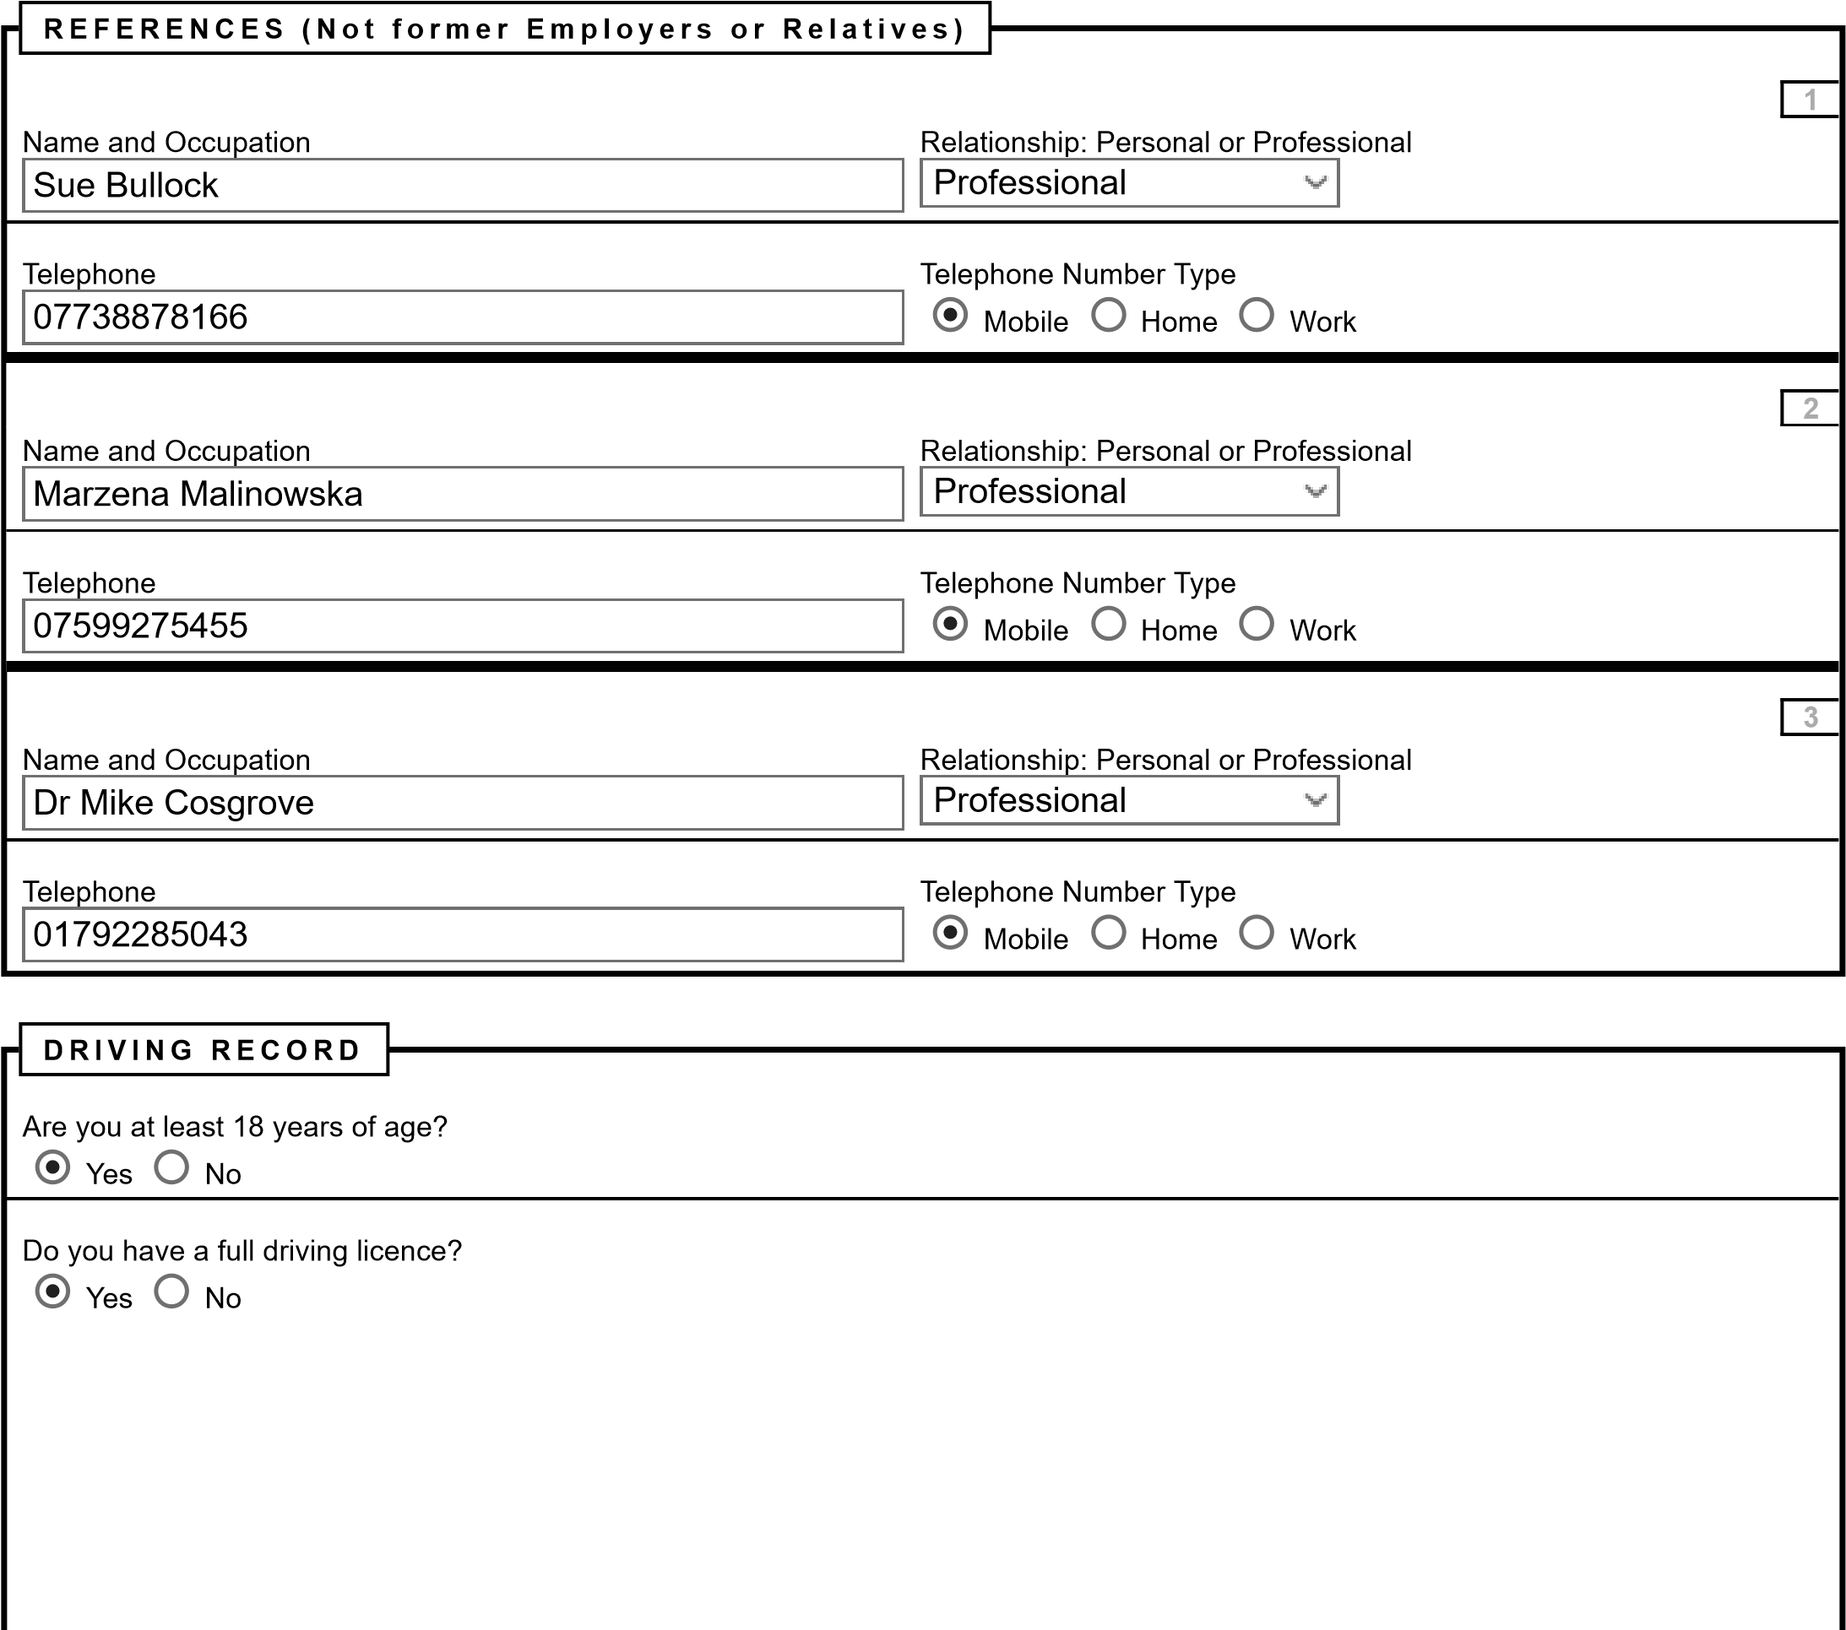
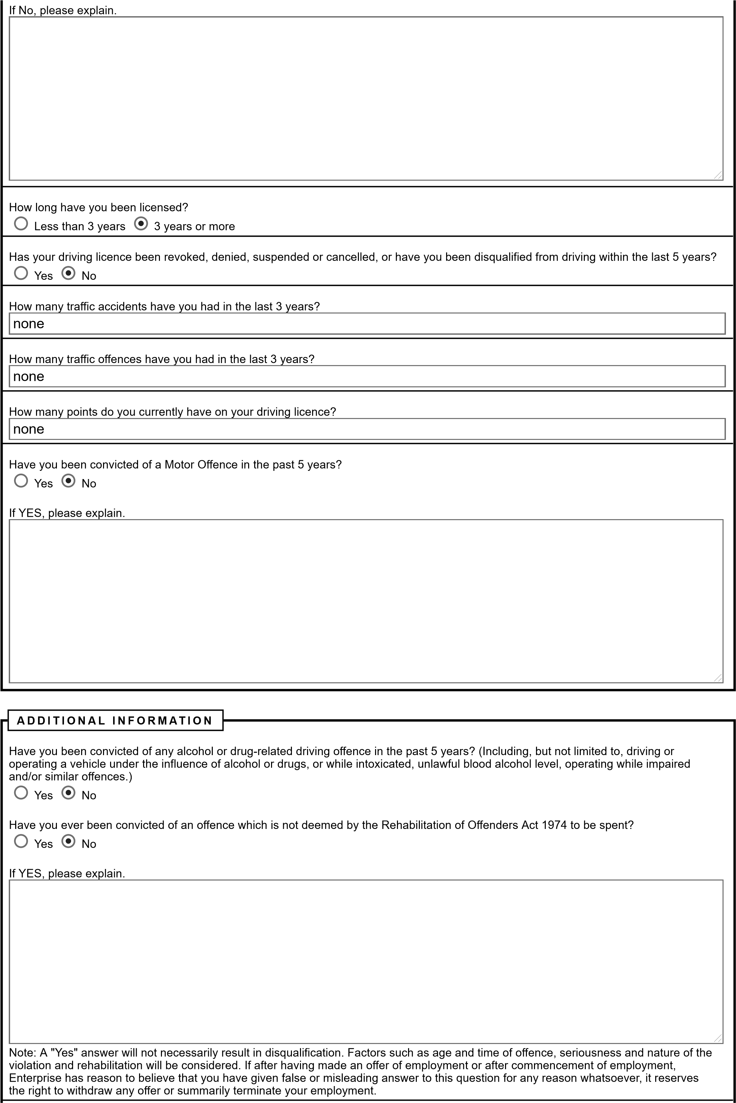
Apart from absences for religious observance, are you available for full-time work?
Yes

No
If NO, what hours can you work?

List any honours and/or awards that you have received. *
-President Club Award (higher sales achievement) 2018
List any special training that you have received and/or skills that you possess (include technical and/or computer skills).
-
Level 2 Drylining

-
Trainings: Manual Handling, Mental Health
List your current interests, activities, and/or hobbies. *
-
Metaverse

-
Self-awareness

-
Management
* You may exclude any honours, activities, interests or hobbies that indirectly or directly disclose race, age, gender, sex, religion or belief or any other protected characteristics.
APPLICANT'S CERTIFICATION FOR ENDORSEMENT
PLEASE READ CAREFULLY
I hereby certify that the facts set out in this Application for Employment are true and complete to the best of my knowledge and belief. I understand that if, after Enterprise has made a firm offer of employment to me or after commencement of my employment it should come to Enterprise's attention that any statement on this application form constitutes a misrepresentation whether fraudulent, negligent, or otherwise, Enterprise reserves the right to terminate my employment or to retract any offer of employment forthwith. I agree to cooperate with Enterprise, in any investigation concerning my suitability to work as an employee of Enterprise. I agree to conform to the rules and regulations of Enterprise, whether contained in my contract of employment or elsewhere.
I further agree that because of the nature of its business, Enterprise at its discretion, may require me to submit at any time (whether as an applicant or an employee) to a drug or alcohol test to establish whether I use or may have used controlled drugs, drugs which may reduce my ability to drive or operate machinery safely or to establish whether I may have an alcohol-related problem. I accept that my refusal to undergo such a test may constitute sufficient ground for summary dismissal on the part of Enterprise. I agree that Enterprise may require
such testing as a condition of employment (although such testing is only compulsory for promotions to levels II, III and IV). I agree to abide by the requirements of Enterprise concerning drug or alcohol testing and/or use.
The personal information you give to Enterprise on this form is processed and used by Enterprise to assess your application for the "position desired" nominated on this form. [If your application is unsuccessful, Enterprise will retain this information on file for 6 months in order to consider you for future vacancies. If you object to the retention of your data for this purpose, please indicate this in the space provided below.] During the assessment process, your information may be disclosed to our recruiter for the purpose of assessment. If you subsequently enter into an employment contract with Enterprise, the personal information on this form and other information Enterprise collects from you from time to time will form part of Enterprise's personnel files and may be transferred to the head office in the United States for the purpose of processing and managing the file on the behalf of Enterprise in the United Kingdom. The United States does not have the same data protection safeguards as the United Kingdom, but Enterprise will take steps to ensure that your rights are adequately protected.
Enterprise is hereby authorised to take up references from my previous employers, educational institutions, bankers or others.
I agree that Enterprise may seek information about me from any source and I agree to waive any claims I may have against Enterprise, and the source supplying such information, which result or may result from the request for and the provision of such information.
If employed I authorise Enterprise to supply information about me to any entity with whom I might hereafter seek employment and I agree to waive any claims that I may have against Enterprise in relation to the provision of such information.
[Please tick this box if you object to the retention of your details on our files if this application is unsuccessful].
I Accept
(By checking this box, I am agreeing to the above and confirming my signature via electronic format.)
Submit & Print Submit

