nmP


My daughter, Rosie, 17 months.

BLOG 1: WHAT IS EMOTIONAL DEVELOPMENT?

I started off my academic year at Trinity Saint David with no knowledge of what child development meant. Let alone the deep impact that each stem of development can have from early childhood through to adult life. As a mother of a young toddler, I found myself intrigued by many ideas and theories throughout my studies, and then horrified to learn that each interaction I made with my daughter could leave lasting negative impacts on her. I found that simple phrases and commands I would use daily; ‘don’t climb that, you’ll fall!’ ‘don’t cry, you’re being silly.’ Were damaging to her sense of self, sense of curiosity and her emotional, social and even physical development. Learning about childhood development in depth has allowed me to apply a more care-free parenting approach with my daughter. Her emotional and social skills (and sadly her independence from me!) have blossomed as a result.
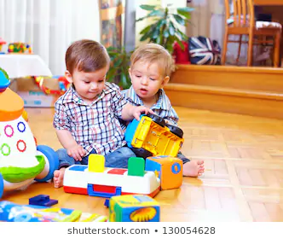
I found the concept of emotional development interesting as it is truly amazing to see a young person learn new skills daily and adapt their behaviours to gain positive praise from those around them. It is essential that children develop emotionally in order to be an active, involved member of society, to be able to cooperate with others, to follow direction and to demonstrate self-control and pay attention. A person who has positive emotional development will be able to empathize with others, be confident in themselves and can handle personal stress. (Greenway, 2014). Emotional and social develop link and overlap with one another. Positive emotional development will foster positive social development and vice versa.
(Shutterstock, 2020)

Emotional and social development is the process of learning to understand the feelings of others, to be able to form friendships with other children, to have control over his or her own feelings and behaviours and to build relationships with adults. ((What is Social & Emotional Development? | dmh.mo.gov, 2020)
BLOG 2: WHY IS EMOTIONAL AND SOCIAL DEVELOPMENT IMPORTANT AND LINKS TO THEORY.
The development of personal, emotional and social skills (PSED) has been noted as the building blocks for a successful, happy future. The national strategies for early years practitioners describe these skills as allowing children to:
- ‘Personal development (Being me) – how we come to understand who we are and what we can do, how we look after ourselves.
• Social development (Being social) – how we come to understand ourselves in relation to others, how we make friends, understand the rules of society and behave towards others.
• Emotional development (Having feelings) – how we come to understand our own and others’ feelings and develop our ability to ‘stand in someone else’s shoes’ and see things from their point of view,referred to as empathy.’ (The National Strategies early years, 2008)
These skills are essential throughout life, impacting life at home, school, work and in the community. Building on positive emotional and social development as a child will lead to seeking out these relationships as adults.
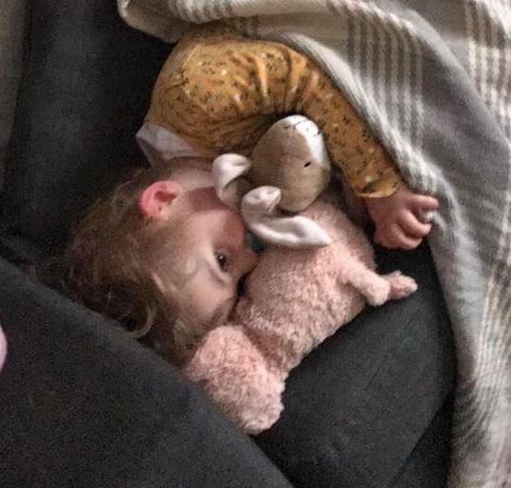
An example of development being shown through theory is Martin Hoffman’s Development of Empathy Theory (1982). He found that infants may match emotions displayed around them. Showing that they begin to develop a sense of awareness of emotions at a very young age, and even begin to mimic it. He notes in his study that babies will develop Egocentric empathy at 12 to 18 months old. Meaning that if they notice a person is upset they will offer what they would find comforting in that situation. This is considered egocentric as they notice the emotions of another person and aim to ‘cure’ them but can only think of what they would find soothing or comforting in that situation. In my personal experience, if my 17-month-old daughter sees someone feign upset, she will offer her teddy pig or bunny for comfort, as it is what she sleeps and cuddles close to throughout the day. This is, of course, a sweet offering but she does not understand that what she finds comforting would not be the same for everybody. This proves Hoffman’s theory (1982) of Egocentric empathy. He also discovered that between the ages of 2/3 and 11 is when empathy begins to be shown in non-egocentric ways as well as empathy for another person’s living situations, environment or personal struggles. Aswell as the ability to put oneself in ‘another person’s shoes’. Hoffman clearly shows that understanding and displays of emotional will develop through age and experience.
Rosie with her toy pig and bunny.
In my studies, I found John Bowlby’s attachment theory to be incredibly thought provoking. Bowlby discusses the link between positive attachments as a child and positive life experiences as well as the implications that negative or poor attachments would have as an adult. Attachment is said to be formed after a strong emotional bond takes place. As a visual learner myself, I found this YouTube animation pleasing and interesting to watch as it allowed me to better understand the link between secure or insecure attachments and adult personality formation.
https://www.youtube.com/watch?v=WjOowWxOXCg&t=315s
According to Bowlby, attachment is what allows a baby to live as it is what connects a mother and child. The parent is their only source of need fulfilment. (Sincero, 2012). As positive attachments form from positive emotional bonds between the primary caregiver in young childhood, what attachment is formed from negative emotional development or bonds?
Attachments can be categorized into four groups:
1. Secure Attachment
When children are securely attached to their primary caregivers (parents), the child is happy when they are with them and are upset when separated. Whilst the child is distressed when left alone, they are secure in knowing that their parent/ caregiver will return soon.
2. Ambivalent Attachment
A child who is ambivalently attached becomes incredibly upset when separated from their parent, the child will feel that they cannot rely on their caregiver when in need.
3. Avoidant Attachment
Avoidant attachments mean that a child will not be close to their parents, both emotionally and in proximity. They will not seek comfort in their presence and will avoid them. Studies show that this may be because of abusive or neglectful parenting.
4. Disorganized Attachment
This is when the child may show no clear sign of attachment or mixed signs of some. This can be caused by turbulent parenting who can act both reassuring and apprehensive at different times. The child may be confused by their emotional bond, leading to this attachment.
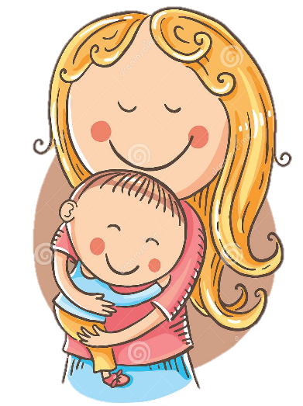
BLOG 3: WHY IS YOUR ATTACHMENT AS A CHILD SIGNIFICANT AND DEVELOPMENT IN THE MODERN WORLD.
(dreamstime, 2012)
- Research shows that securely attached children will become confident, trusting and optimistic with a positive self-image as an adult.
- Children who display ambivalent attachments can often be described as ‘unpredictable’ or ‘moody’ they will also have a less positive self-image.
- Avoidant attached children will often continue their strategy of hiding their feelings to avoid conflict into adulthood, finding it hard of them to enter healthy relationships, adults who have been avoidant attached their whole lived will have a poor self-image.
- Lastly, those with a disorganised attachment will find themselves unworthy of positive relationships and are very unhappy and anxious individuals with very negative self-image. (Sprouts, 2018) This shows us that the very first emotional attachment a child makes with their primary caregiver will shape their future selves, propelling them to a happy or unhappy life.
‘The childhood internal working model becomes the model for the adult’s social emotional and cognitive competence’ (Bowlby, 1969)
As a mother and as a person who wants to work to better children’s life experience, it is obvious that it is secure attachments that we want to strive towards each child having. Securely attached children are more sociable, well-behaved individuals, more empathetic towards others, more mature emotionally, more independent in a school environment, less disruptive and less aggressive. ( Boyd and Bee, 2012, p.277). These are qualities that we want to foster in the youngest generation.
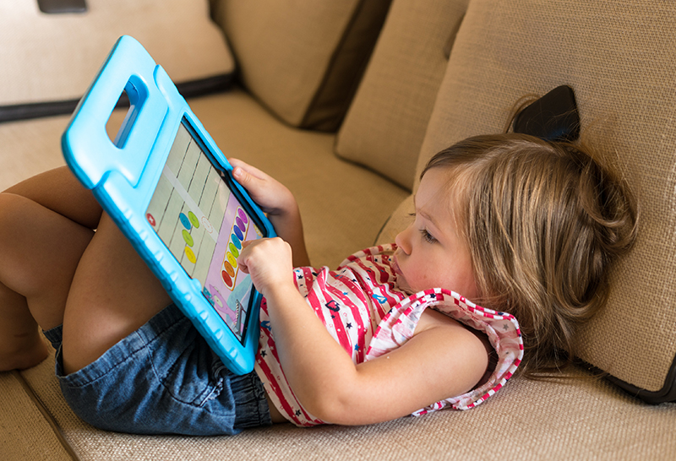
A MODERN WORLD
We are in an ever-changing world and society is dramatically different to what it was even 100 years ago. Our innate biology has not evolved as rapidly as our technology or culture has. What negative impact can this pose developmentally?
I will be the first to admit that technology and television is an easy first choice to entertain your child, especially when you have an assignment to complete and a toddler who loves to be cuddled. Palmer refers to this as ‘the electronic babysitter’. It may seem that too much screen time does not impact much on their development. Unfortunately, it does. Sue Palmer states in her book Toxic Childhood, 2008, that overexposure to technology at such significant developmental years damages children’s ability to think, learn and behave. It damages their social development as, to put it simply, children are not socialising anymore. They do not play together with toys but rather through a screen. They are missing that face-to-face socialisation and emotional development. They are not learning to recognise body language or facial expressions, meaning that they can find it difficult to interpret emotions in real-life. Not developing these essential communication skills can lead to delays in speech or even misdiagnosis of autism or ADHD as children have not matured in a way to sit still and listen to absorb information. Attention spans are shorter and their need for immediate gratification greater. A classroom does not adhere to these needs.
(mother&baby, 2020)
An additional way in which the modern world can affect a child’s emotional development is through equalising the sexes. It is now not the norm for the father to be the breadwinner of the household. It is much more common for both parents to work and both contribute to the household. This is a stark difference to years ago when mothers were housewives and expected to do the entirety of the childcare. This can impact a child’s emotional development as they may not have a singular primary caregiver, but spend equal time with the mother, father, grandparents or childcare. This may make it more difficult for the child to form strong, positive attachments with their mother as they do not spend the entirety of their time with them forming bonds. However, it could be argued that this modern dynamic offers positive outcomes in terms of emotional and social development for children. Firstly, a mother who works compared to a stay-at-home mother is less likely to be depressed. This would allow the mother to bond more positively with their child as they are in a positive mental space. Additionally, parents on two incomes have more disposable income to do activities such as visit farms, museums etc.. this is itself can enhance a child’s social and emotional development as they are exploring the world around them and interacting with people and things.

BLOG 4: HOW DOES ATTACHMENT AND SOCIAL & EMOTIONAL DEVELOPMENT IMPACT SCHOOL LIFE?
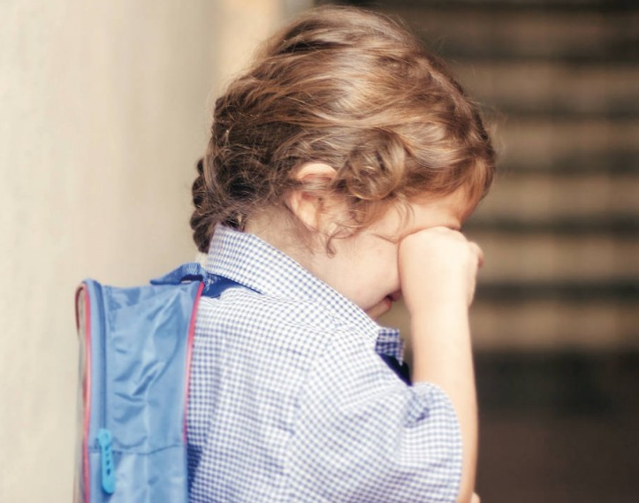
It is no secret that those whose career involves children are often faced with challenges. Children are so individual and diverse that it is hard to label and categorize them. Children can develop in vastly different ways compared to someone of the same age. This is what makes issues of emotional and social development difficult to deal with in a school environment as children are categorized by age and expected to mature at the same pace as their peers. Schooling does not take often into consideration the individual development of a child’s emotional or social needs or factors which can minimise their development (such as Adverse Childhood Experiences, ACEs) are not largely considered when assessing a child’s development.
(Getty Images, 2019)
A child who has not developed emotionally or socially will suffer academically. A child who has not developed emotionally to understand and control their behaviours, will have difficulties sharing in school and being more considerate of another child’s feelings. They may find it overwhelming to be surrounded by so many people if they have not matured enough emotionally. Additionally, if a child has not developed their social skills, they would find it difficult to communicate with others, especially those with differing points of view. (Greenway, 2014). This would be problematic in an inescapable school environment. Children who have not developed in these ways will struggle in a formal school environment, they will struggle to pay attention or show correct behaviours, they will struggle to make friends and they will struggle to keep up academically. Even from the beginning of school at age 4, their day will be focused largely on curriculum and learning outcomes in the UK. This differs from more Scandinavian schooling in which there is more of a focus on developing a child’s social and emotional needs. I cannot help but think this would largely benefit children in the UK, allowing them to flourish as individuals and as a collective before staring to ‘learn.’ It allows children to be children for just that little bit longer. (Griffiths, 2020)
Social and emotional development is now beginning to be incorporated more in education as it heavily impacts behavioural outcomes. (as previously stated, those with a secure attachment are less disruptive, less argumentative and more confident) It is important for practitioners to try and bridge the gap between emotionally and socially developed children and those who are not as developed.
POLICY AND PRACTICE
One way in which practitioners aim to make a child feel safe through thinking, feeling, communicating and behaving is PACE. (Playfulness, Acceptance, Curiosity and Empathy). Practitioners (perhaps teachers, learning support staff, social workers etc.) would use PACE with children who have negative attachments or delayed emotional development. The aim of PACE is to establish trust with a child, allow them to feel safe so that they can explore themselves and their world. It mimics natural, positive behaviours between parent and child.
This policy allows practitioners to have a better understanding of approaches which would have significance on children. PACE means:
- Playfulness. This entails having an atmosphere of interest and lightness. It is important that the child feels listened to and that the person who is speaking to wants to interact with them. This mimics the relationship between a parent and child who feel happy and secure in company with each other and want to get to know one another. Playfulness aims to help a child be more open and to be more accepting of positive life experiences. Troubled children may reject affection such as hugs or positive affirmations, they may also have trouble regulating their feelings as they haven’t matured enough to understand them; anger can turn to rage, terror or sadness. Having a playful approach can lead the child to mimic these positive, playful attitudes, to explore fun and have hope in themselves and their future.
- Acceptance. For a child to feel truly comfortable and safe it is importance that they feel unconditionally accepted. Acceptance is about actively communicating to the child that you accept the wishes, feelings, thoughts, urges, motives and perceptions that are underneath the outward behaviour. It is important that the child feels valued in their feelings and actions and that they are not condemned by them. This will lead the child to know that while behaviour may be criticised and limited, this is not the same as criticising the child’s self.
- Curiosity. In response to negative behaviour, it is often useful to adopt a curious tone and questioning in order for the child to explain their motivations behind said inappropriate behaviour. A child will often know that they have done or behaved wrongly but may not know how to express their motivations to an adult. If asked ‘why did you do that’ in an angry tone will immediately lead to the child being defence and shutting down emotionally. However, if you simply seek to know why the child felt the way they did in order to react that way, they are more likely to open up emotionally.
- Empathy. Empathy is important to be shown to children as often children’s feelings are invalidated as being over reactions or tantrums. Even if a child has overreacted to a situation. They are still feeling upset, anxious, angry or confused. Showing the child that you understand they are suffering and going through a difficultly will allow the child to feel that they can explore their emotions openly, rather than the worry that their feelings will be invalidated. Showing empathy will also communicate strength, love and commitment, with confidence that sharing the child’s distress will not be too much. Together they will get through it. (What is meant by PACE? - DDP Network, 2020)

In summary, I chose to explore the singular topic of emotional and social development for my academic blogs. I found the topic incredibly stimulating in lectures and decided to expand my knowledge of emotional development in greater detail. I found that the initial years of life and the emotional connections and development that takes place subconsciously stays with us into adulthood and shapes our personality and our entire prospects and outlook on life. It is important that we strive towards encouraging a supportive emotional bond between children and caregivers, their friends, their extended family, and teachers and practitioners that they interact with.

REFERENCE LIST
- dreamstime, 2012. Mother And Child Hugging Cartoon. [image].
- Getty Images, 2019. Child Crying In School Uniform. [image] Available at: <https://www.todaysparent.com/kids/what-to-do-if-your-preschooler-wont-stop-crying-at-drop-off/>
- Griffiths, H., 2020. Emotional Development - Attachment.
- mother&baby, 2020. Child On Ipad. [image] Available at: <https://www.motherandbaby.co.uk/baby-and-toddler/toddler/looking-after-your-toddler/toddler-ipad-addicted-screen>
- Shutterstock, 2020. [image].
- Sincero, S., 2012. Bowlby Attatchment Theory. [online] Explorable.com. Available at: <https://explorable.com/bowlby-attachment-theory>
- Sprouts, 2018. The Attachment Theory: How Childhood Affects Life. [video] Available at: <https://www.youtube.com/watch?v=WjOowWxOXCg&t=315s>
- The National Strategies early years, 2008. Nottingham: DCSF Publications, pp.1-23.
- DDP Network. 2020. What Is Meant By PACE? - DDP Network. [online] Available at: <https://ddpnetwork.org/about-ddp/meant-pace/>
- Dmh.mo.gov. 2020. What Is Social & Emotional Development? | Dmh.Mo.Gov. [online] Available at: <https://dmh.mo.gov/healthykids/parents/social-emotional-development>

