International Hotel Management
Marketing Essentials

STUDENT NAME: Ionut Alexandru Dumitru
STUDENT ID: 2232734
MODULE NAME: Marketing Essential BMIH4005
TUTOR NAME: Ruth Tailor

Table of Contents

Component A: Marketing Analysis 3
Introduction 3
Situation Analysis 3
Objectives 5
Strategy 6
Tactics 6
Action 7
Control 7
Conclusion 8
Component B: PowerPoint Presentation 9
Slide One: Cover Page 9
Slide Two: Introduction 9
Slide Three: Company aims and objectives 10
Slide Four: Identification of market, competition and Target Customer 11
Slide Five: Marketing goals and implementation of marketing strategy 12
Slide Six: Marketing budget 13
Slide Seven: Conclusion 13
Slide Eighth: References 14
References 15

Component A: Marketing Analysis

Introduction
The purpose of the marketing plan is to generate a social media strategy that helps in directly communicating with consumers all over the world. It is prepared for customers that are looking for affordable hotels and provides them with the best service. The following assignment will go through a marketing plan that eradicates the issue of Communication for Premier Inn.

Situation Analysis
5 C's
This is an analysis that frameworks the market environment of an organisation (Jobber and Ellis-Chadwick, 2020). It generally consists of certain factors like the company, collaborators, customers, competitors and the context in which the organisation is operating and is being exposed to various environmental factors.
Company: SWOT analysis
Strength
The organisation has fame and a reputation that positively impacts the operations of the business.
Weakness
The organisation has certain aspects like increased competition and less global presence in the international Hotel Salem business.
Opportunities
Due to the expansion of the business, it has started tying up with different partners that help in providing more opportunities for them in the marketplace.
Threats
There are many micro and macroeconomic factors that possess a threat to the organisation.
Customers: STP
Segmentation
Premier Inn has targeted a customer segment that is mostly families and entrepreneurs that are able to afford the hotels (Smith and Zook, 2020). It has understood and evaluated the commercial attractiveness of each customer segment.
Targeting
The organisation clearly targets its audience based on geographical, behavioural and psychological approaches.
Positioning
The organisation has positioned its marketplace in the United Kingdom, the US, Europe and many more countries around the globe for getting maximum customer attention.
Competitors: Perceptual positioning map and Bowman's strategy clock
It is a graphical representation of the consumers perceiving certain services provided by the organisation. It generally measures the perceived traits and compares certain points of premier with its competitors (Kotler et al., 2020). It also indicates the actual services provided by Premier Inn.
Bowman's strategy clock analyses benefits and prices that make premier compete with its competitors in the marketplace. It tends to make positive decisions that are a big concern related to strategic positioning. McDonald hotel, Travelodge hotels Limited, Edinberg collection and Hyatt corporation are the major competitors of Premier Inn.
Collaborators
Premier Inn is a big business chain that needs business partners and commercial alliances that help in expanding the business worldwide (Chaffey and Ellis- Chadwick, 2019). The organisation has recently undergone a strategic partnership between Emirates group and white bread plc. These two are global corporations that have a clear interest in the travel, tourism and hotel industries.
Climate: PESTLE
Political
The organisation has faced many political factors while expanding its business (Blythe and Martin, 2019). There are certain text forms identified by the government that reduce as well as increase taxes and implement certain strategies or regulations that are on behalf of the business.
Economic
There are a lot of investors in the hotel business (Fahy and Jobber, 2019). It positively influences consumer spending and promotes cheaper and more affordable hotels.
Social
The organisation positively impacts the society in which it operates. It offers new employment opportunities and raises donations for non-profitable organisations and charities.
Technological
Advanced technology has positively impacted organisational success. It created an online platform and also focused on social media channels to directly communicate with the consumers.
Legal
These are important factors that negatively and positively impact the revenue of the organisation. Premier Inn faces certain legal obligations that make it difficult for it to operate in certain places.
Environmental
Premier Inn has focused on using sustainable items the decreased waste of natural resources.

Objectives
The aim and objectives of the marketing plan for the premier inn are to increase the responsibility of social media and digital marketing in the hotel industry. It is important to specify an accurate marketing plan to directly communicate with consumers on different platforms of social media (Pyper et al, 2020). It requires an implementation of the plan that will help the organisation attract more customers to the business. The multinational company has more than 700 hotels around the globe that can be promoted with the use of digital marketing and database management. It will help in achieving the process required for good market growth and inculcating value within the customer experience.
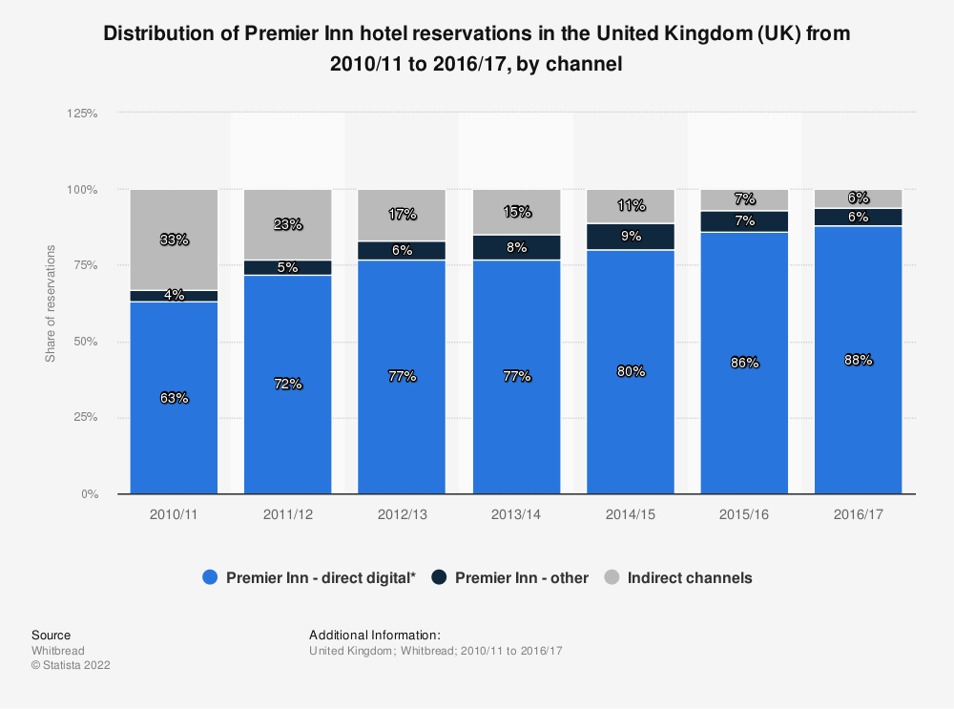
Figure 1: Distribution of Premier Inn hotel reservations
(Source: 2022)

Strategy
Premier Inn has a unique value proposition which helps in providing affordable accommodation for visitors. It guarantees extreme comfort and quality service in its hotels. The organisation is more concerned with attracting businessmen, customers and families that are looking for budget accommodation in the nearby area. It provides a positive culture in the work environment of the business. The organisation rewards its employees for good customer service and said certain targets reveal the potential growth of the business. It specifies the merits of positive services provided to guests (Stone et al., 2020). It builds the strongest experience and has a unique selling proposition that stands on the brand value and creates a competitive advantage for the market. Value proposition benefits targeting and positioning of the business in connection to customers and opening the hotel in a particular marketplace. It is crucial for Premier Inn’s success and helps in directly communicating with customers for establishing a great foundation for creating a difference between Premier Inn and its competitors.

Tactics
Marketing mix
Product
Premier Inn offers a wide range of rooms and services for its customers. It interconnects and categorises the products and services offered by the organisation to its customers. There are many interconnecting rooms that attract families (Czinkota et al., 2021). They also offer TV, free Wi-Fi and essential elements like tea and coffee for their visitors. Premier Inn also indulges in the transport business by offering bikes to its consumers.
Place
The business organisation has expanded in more than five countries and consists of 800 hotels (Kazemian et al., 2021). Customers are able to book their accommodation from their online website. It prefers online booking for tester offers and deals that attract more customers. Customers can easily find their hotels by simply searching on the internet.
Price
Premier Inn has followed different pricing strategies for its customers. It includes low pricing, flex and standard rates that allow great value for money. The business organisation pursues a wide range of discrimination strategies by providing the lowest rates on rooms on certain days (Stone et al., 2020). The organisation also focuses on maintaining affordable prices for increased profit margins and taking concern about family customers.
Promotion
The hotel invests a lot of money in marketing and promotion of the business. It uses different platforms like radio, and magazines and recently opted for digital and social media for enhanced growth and development. According to market research, the premier inn has been aiming to invest €20 million for expanding the digital reach of the business.

Action
There are different types of approaches implemented by the premier in order to provide customers with quality accommodation and great value for money. It has started embracing its hotels on Google to reach new customer segments. It has increased the traffic on its official website and is focusing on engaging more customers in its business. It enhanced Hotel revenue also creating a strong brand essence throughout (Fahy and Jobber, 2019). There are many online travel agencies and meta-search websites that allow customers to book their accommodations online. It has started creating a transient social media strategy to achieve the goals and objectives of the organisation.

Control
Premier Inn is becoming a strong hotel chain business that has its own brand position and a competitive advantage over all its competitors. It has started offering affordable accommodations to its customers that positively impact the revenue of the business. The organisation has made €307 million in profit in 2022 (Statista, 2022). Many new customers have started knowing the brand which created A great impact on the overall revenue. It generated a 13.61% of net profit margin that increased the current and last quarters' estimates. The key performance indicator measured the ultimate success of the business after integrating market opportunities and increasing the number of sales after the pandemic.
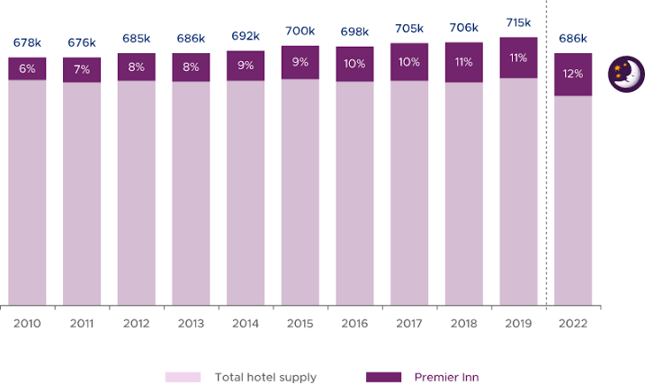
Figure 2: Reason for investment
(Source: Jobber and Ellis-Chadwick, 2020)

Conclusion
According to the above Study, it can be concluded that the implementation of the marketing plan will face certain challenges that need to be eradicated with a perfect plan. Premier Inn can evaluate the importance of social media and digital marketing in the hotel industry for gaining attention from new customers to the business.

Component B: PowerPoint Presentation

Slide One: Cover Page
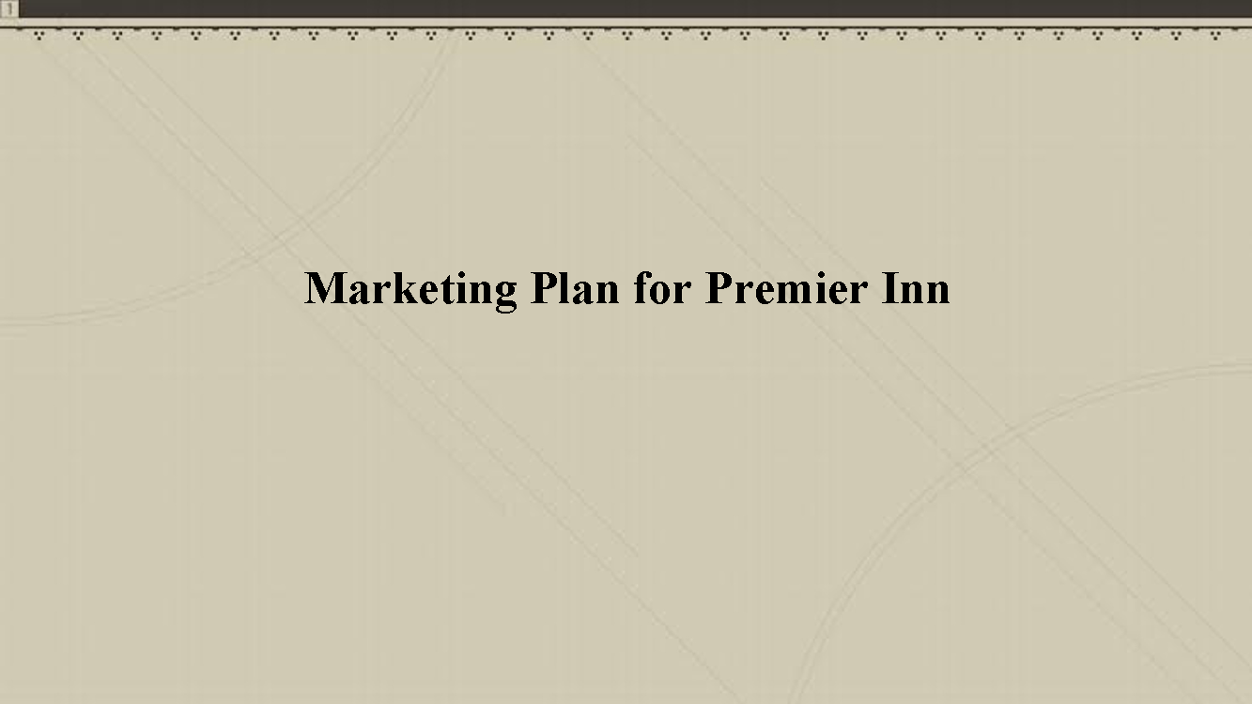

Slide Two: Introduction
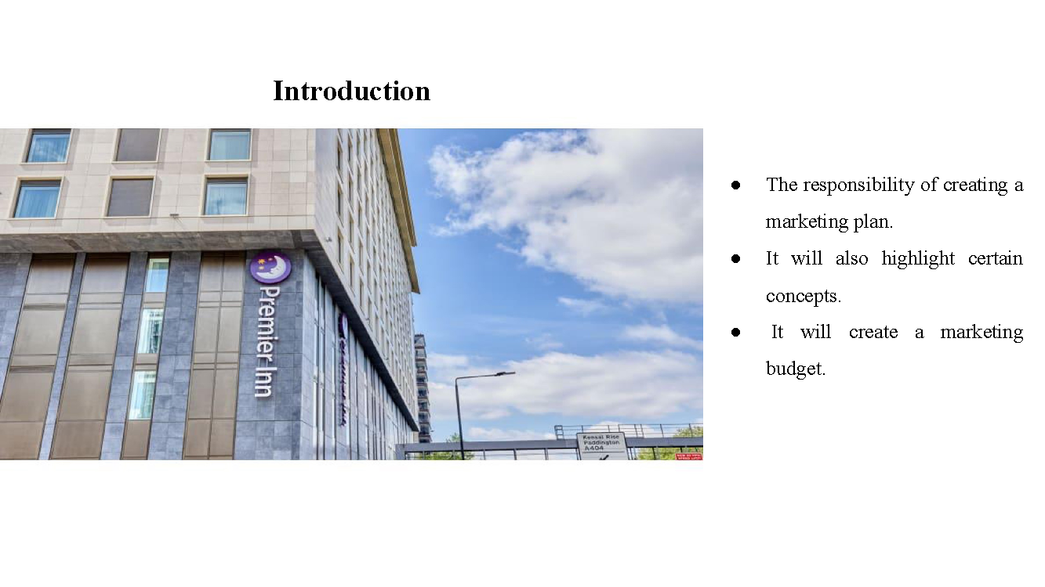
Notes: The following presentation will undertake the responsibility of creating a marketing plan for the Premier Inn. It will also highlight certain concepts and ideas that are required for attracting different customer segments. It will create a marketing budget required for the implementation of the marketing strategy.

Slide Three: Company aims and objectives
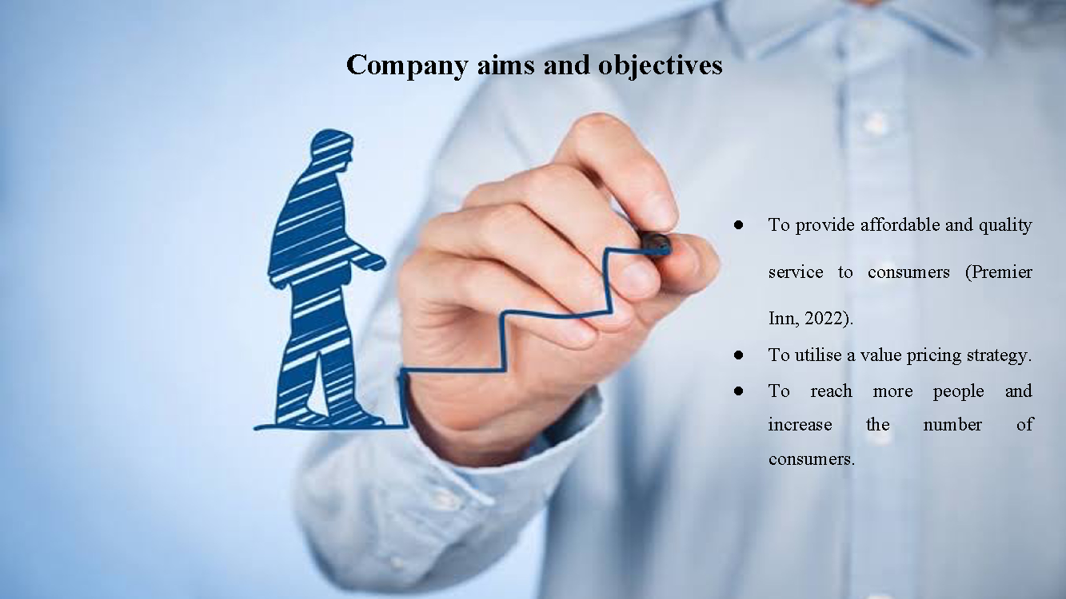
Notes: The objective is to deliver affordable and superior services to clients. A value pricing strategy is employed to ensure that customers receive value for their money. Social media and digital marketing strategies are implemented to boost profitability and overall revenue. The aim is to reach a wider audience and increase the number of clients.

Slide Four: Identification of market, competition and Target Customer
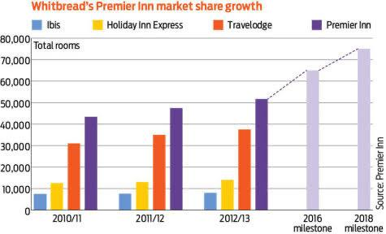
Notes: Premier Inn generally targets family and business entrepreneurs as their consumers with affordable as well as high prices. It generally uses a unique value pricing strategy that is perceived by a wide range of consumers. The competitors of Premier Inn in the hotel business are Edinberg collection, Thistle hotels Limited, McDonnell hotels and Jurys Inn.
The target customers for premier inn are travellers and backpackers that travel around the world. It is positioned as one of the best hotels in the United Kingdom and the globe. It generally focuses on families that are looking for budget accommodation while they are travelling there favourite places and destinations. Tour groups and individual tourists are also on their radar.

Slide Five: Marketing goals and implementation of marketing strategy
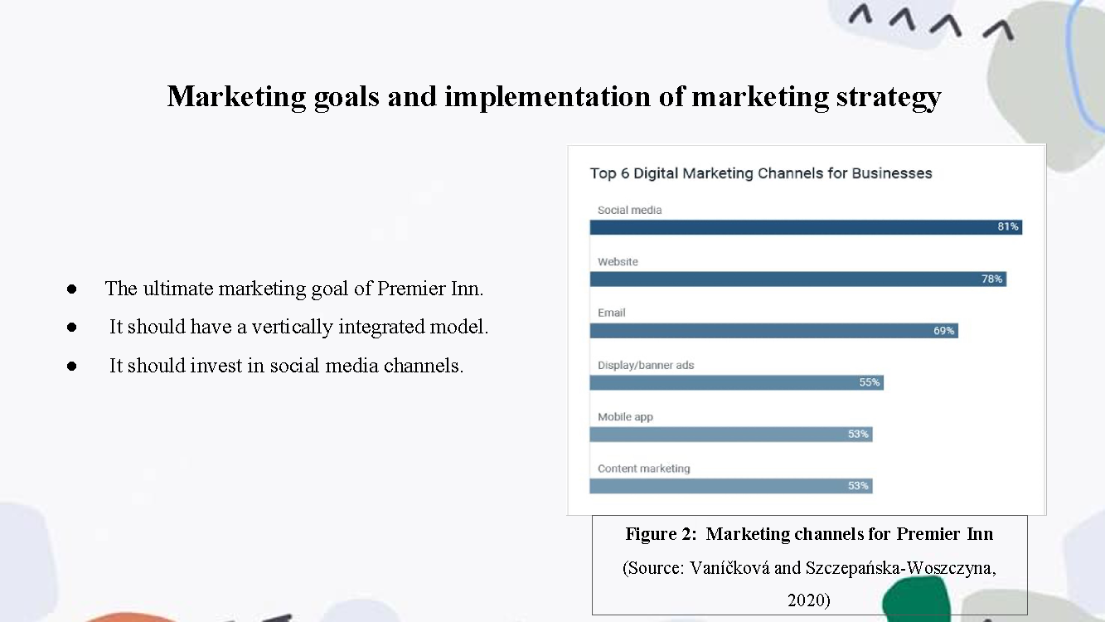

Notes: The ultimate marketing goal of Premier Inn is to create a brand strategy that Hopefully enhances its profit margin and overall revenue. The organisation has also been focusing on reinforcing and investing in social media platforms to effectively communicate with customers. It should have a vertically integrated model that widens its sales activity and provides its guests with rewards and achieves the maximum results possible.
Premier Inn has set realistic expectations which identify resources required for enhancing the workflow. It should invest in social media channels and digital marketing that manage marketing projects efficiently. It should operate a project planning software that undertakes practical tasks and duties in order to achieve organisational aims and objectives. It should define particular metrics and publish a plan to conduct proper research on the marketplace.

Slide Six: Marketing budget
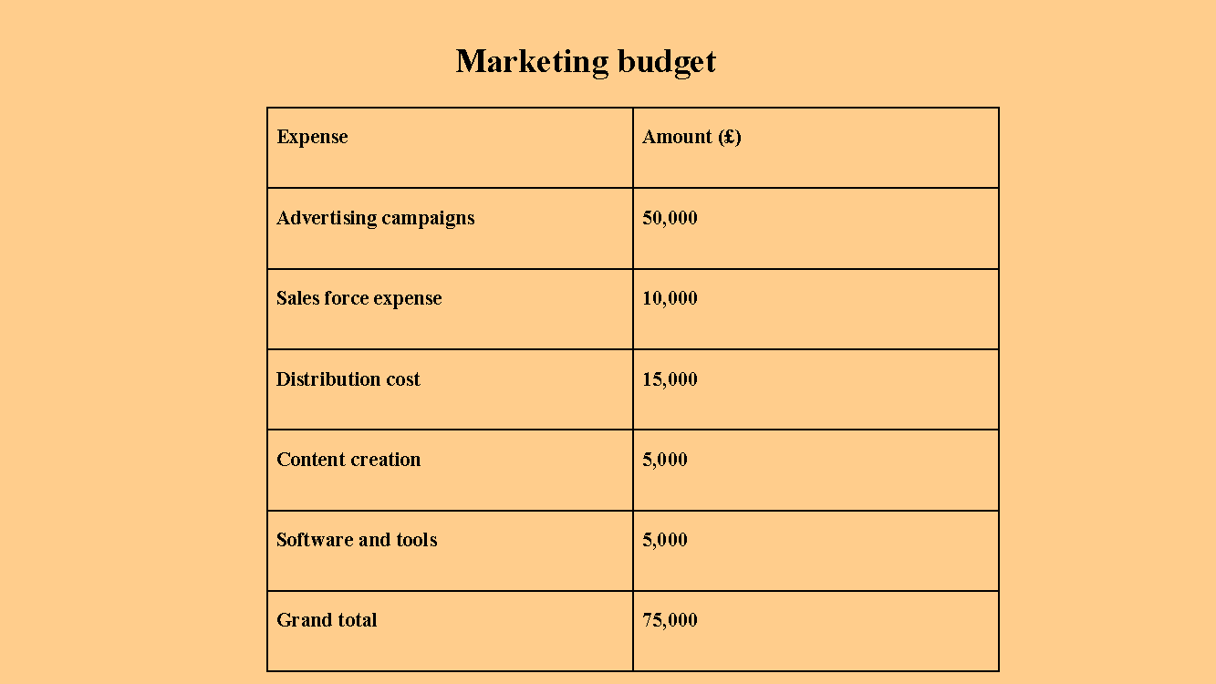

Slide Seven: Conclusion
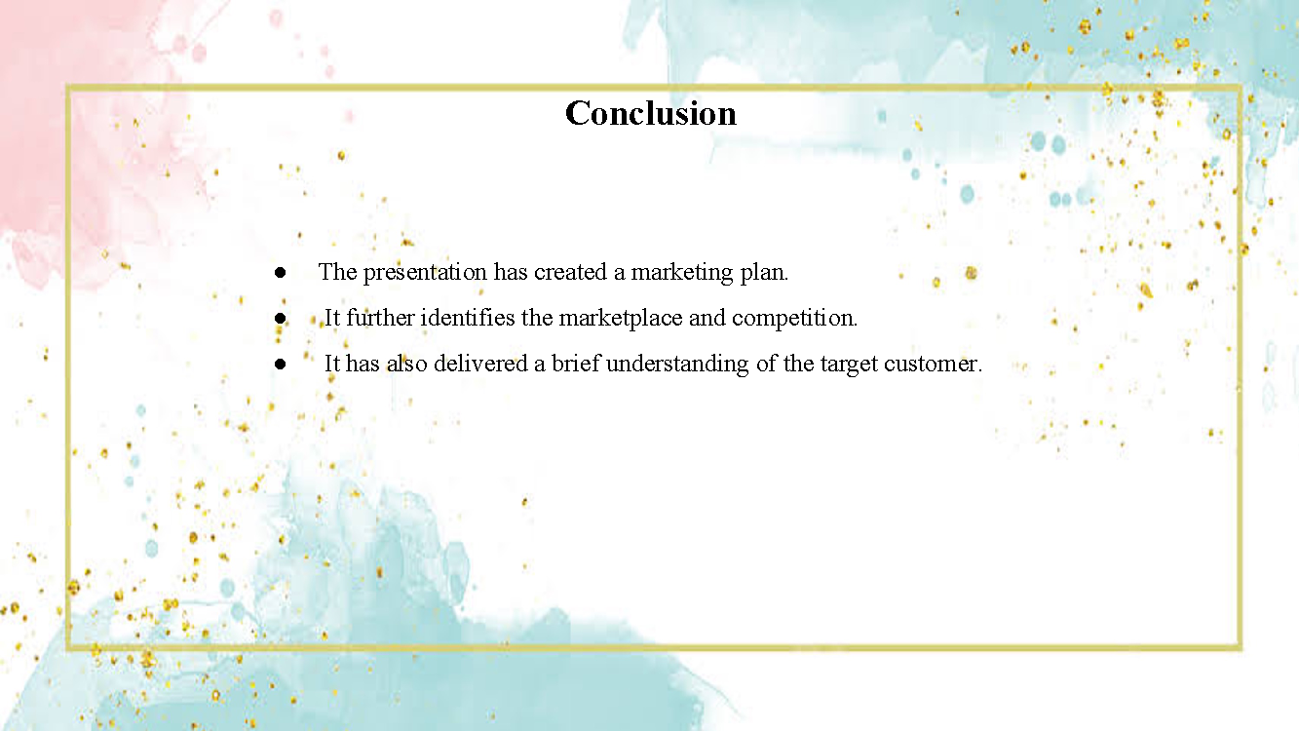
Notes: The presentation has created a marketing plan for Premier Inn It has identified certain aims and objectives of the organisation. It further identifies the marketplace and competition. It has also delivered a brief understanding of the target customer and marketing goals of the organisation.

Slide Eighth: References
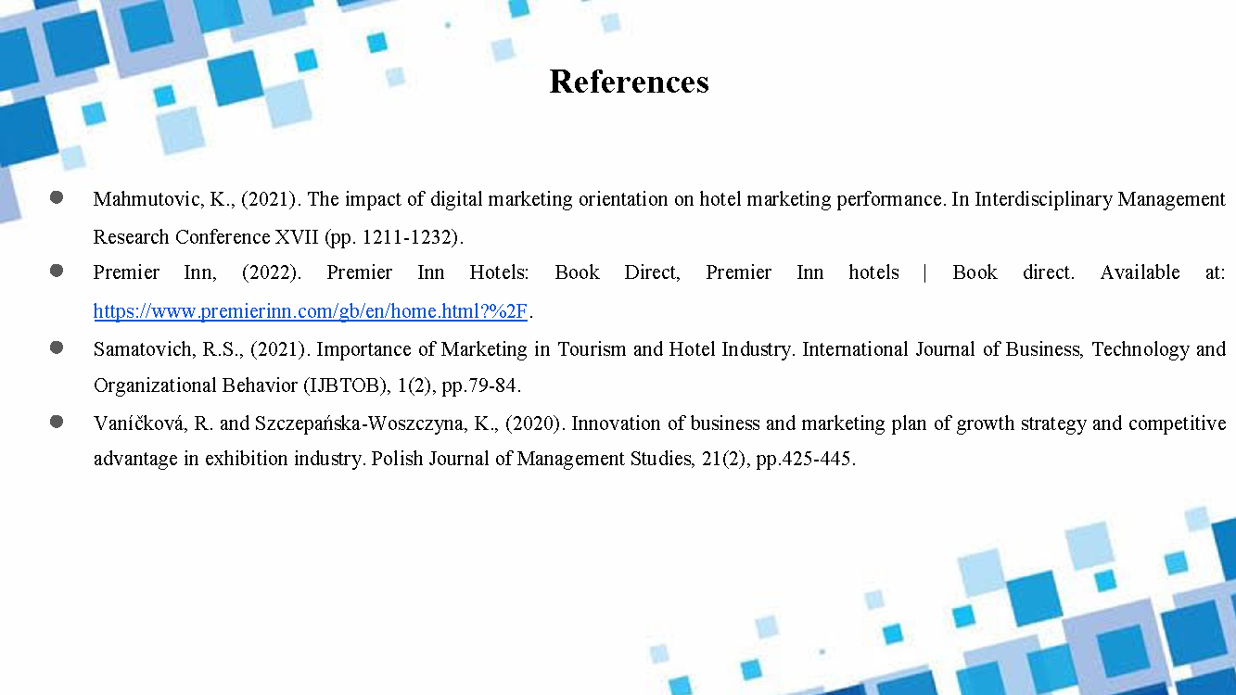

References
Blythe, J. and Martin, J., (2019). Essentials of marketing. Pearson UK.

Chaffey, D and Ellis- Chadwick, F. (2019) Digital Marketing. 7th ed, Pearsons, London.

Czinkota, M.R., Kotabe, M., Vrontis, D., Shams, S.R., Czinkota, M.R., Kotabe, M., Vrontis, D. and Shams, S.R., (2021). Marketing Planning. Marketing Management: Past, Present and Future, pp.43-90.

Fahy, J. and Jobber, D., (2019). EBOOK: Foundations of Marketing, 6e. McGraw Hill.

Jobber, D. and Ellis-Chadwick, F (2020), Principles and practice of marketing. 9th ed. London:

Kazemian, S., Djajadikerta, H.G., Said, J., Roni, S.M., Trireksani, T. and Alam, M.M., (2021). Corporate governance, market orientation and performance of Iran’s upscale hotels. Tourism and Hospitality Research, 21(3), pp.344-357.

Kotler, P., Armstrong, G., Harris, L. and He, H., (2020). Principles of marketing. 8th European ed, London: Pearson Education Limited.

Mahmutovic, K., (2021). The impact of digital marketing orientation on hotel marketing performance. In Interdisciplinary Management Research Conference XVII (pp. 1211-1232).

Premier Inn, (2022). Premier Inn Hotels: Book Direct, Premier Inn hotels | Book direct. Available at: https://www.premierinn.com/gb/en/home.html?%2F.

Pyper, K., Doherty, A.M., Gounaris, S. and Wilson, A., (2020). Investigating international strategic brand management and export performance outcomes in the B2B context. International Marketing Review, 37(1), pp.98-129.

Premier Inn, (2022). Premier Inn Hotels: Book Direct, Premier Inn hotels | Book direct. Available at: https://www.premierinn.com/gb/en/home.html?%2F.

Smith, PR. and Zook ZE (2020) Marketing Communications. 7th ed, Kogan Page, London
Statista, (2022). The Statistics Portal, Statista. Available at: https://www.statista.com/.

Stone, M., Aravopoulou, E., Ekinci, Y., Evans, G., Hobbs, M., Labib, A., Laughlin, P., Machtynger, J. and Machtynger, L., (2020). Artificial intelligence (AI) in strategic marketing decision-making: a research agenda. The Bottom Line, 33(2), pp.183-200.

Samatovich, R.S., (2021). Importance of Marketing in Tourism and Hotel Industry. International Journal of Business, Technology and Organizational Behavior (IJBTOB), 1(2), pp.79-84.

Vaníčková, R. and Szczepańska-Woszczyna, K., (2020). Innovation of business and marketing plan of growth strategy and competitive advantage in exhibition industry. Polish Journal of Management Studies, 21(2), pp.425-445.

