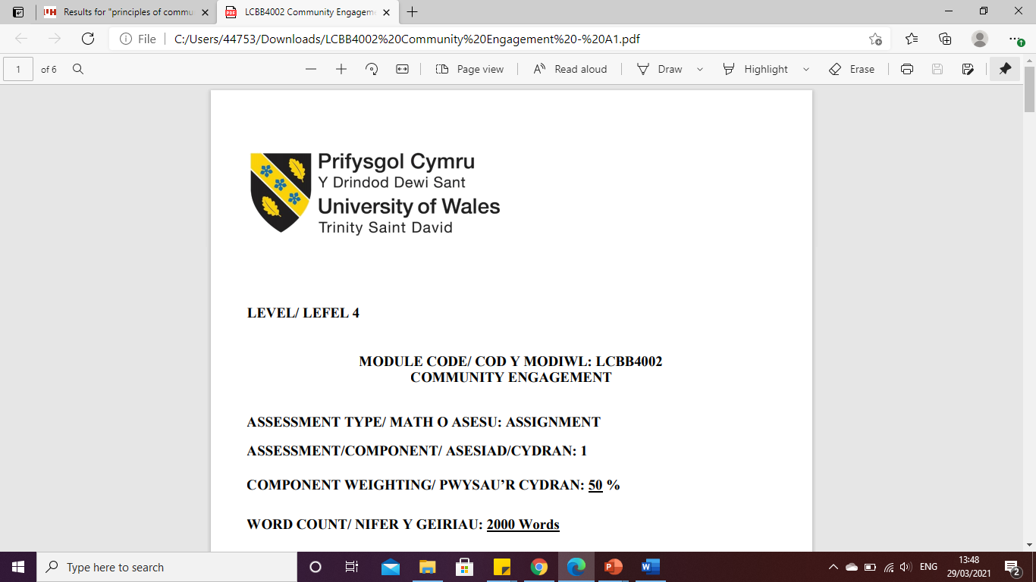

LEVEL 5

Cross Rail Project
MODULE CODE: LCBB5005
PROJECT MANAGEMENT

ASSESSMENT TYPE: ASSIGNMENT
ASSESSMENT/COMPONENT: 2
COMPONENT WEIGHTING: 50%
WORD COUNT: 2 463 Words
SUBMISSION DETAILS:
Name: Cosmin Adrian Mitu
Student Number: 2021613

Table of Contents

1. Introduction 3
2. Concrete Experience 3
3. Reflective Observation 4
4. Abstract Conceptualization 5
5. Active Experimentation 6
6. Conclusion 8
7. Recommendations 8
8. Action plans 9
References 11

Introduction

Self-analysis is considered an approach that is associated with the level of preparation for the improvement of performance by identification of the strengths, weaknesses and abilities of actions that have been done in the past. On Assessment 1 the project I worked on the effectiveness of the Crossrail Project (Elizabeth Line) and its benefit on London. Crossrail is known as a railway construction project of Central London, where the Elizabeth line connects Paddington and Abbey Wood with a turn of 42km with a South East to West. While analysing the project, different skills have been reviewed which resulted in both positive and negative manners. Further, in this project application of Kolb's reflective cycle would be done to make the analysis of strengths and weaknesses in my project based on the identification of the improvement strategies. Application of the model would also make me understand the ability to be a project manager and the importance of their role in order to handle cost, structure, outcome, scheduling and quality of the project. Kolb's reflective cycle will make the analysis based on four stages, Concrete Experience, Reflective Observation, Abstract Conceptualization and Active Experimentation. Based on the mentioned stages, an analysis regarding the effectiveness of the participation of the author in the project can be analysed.

- Concrete Experience

During the analysis of The Crossrail project (Elizabeth Line) project, I witnessed both the positive and negative impacts of the operations in the London Railway system. In terms of the positive side of the project, the Elizabeth Line project can increase London's rail capacity by 10% with a capacity of 30 trains per hour across the network (Railway-technology, 2022). This is considered to be a positive side of the Crossrail project which helps to reduce the traffic across London and make the journey from the Southeast to the West more feasible. One of the major negative sides of the construction operation of the Crossrail project (Elizabeth Line) project is that the project faced major time delays which are almost equivalent to 4 years of delay. There are certain project management constraints that have been witnessed by the project, one of which is associated with the Time management factor. Aeon et al. (2021) have exhibited that the aspect of time management is associated with an effective decision-making ability which is associated with major 3 approaches including structuring, protecting, and adapting to every project.
The Crossrail project (Elizabeth Line) has confronted time management challenges due to various reasons. One of the major reasons which causes the delay of the Crossrail project is known as the covid-19 pandemic. This causes over three years of delays with an increasing cost of £4bn. In addition to this, a slower rate of construction is one of the major reasons for delaying final completion and handover. One of the major reasons for slower construction operations is the electrical transformer explosion at east London station, which has delayed the operations by several days (Railway-technology, 2018). Workers cut off is another reason for slowing operations of the Elizabeth Line project. This happens due to the project budget increases of over £14.8bn which affected the paying salary of the staff of the project (Bbc, 2022). This perspective of the Crossrail project has demonstrated that assurance of proper project management approaches is essential to handle superior delivery of the needs that have been designed during initiation.

- Reflective Observation

In the analysis of the project, I observed that the cross-rail project (Elizabeth Line) is associated with major project management decision issues. Those issues are associated with budget estimation, time management and staff handling abilities. Thus, it can be ensured that the project manager lacks an analytical mindset development which resulted in issues with proper assessment of time and the budget requirements on the project. It has been seen that the project is established to carry over 200 million passengers in a year, which increases transportation ability by 10% across London (Ndtv, 2022). Although, based on the expected size the project manager does not plan their expenses for design, which causes a major delay in the delivery of the construction.
During the analysis of the project, UI has seen that there are different types of advanced technologies also associated with the Crossrail project (Elizabeth Line) which helps to handle signalling and monitoring of the train movements. As exhibited by Muruganandan et al. (2022) have exhibited the system of Crossrail helps to maintain interdependent interactions of multiple subsystems during the design, construction, testing, and handover phases. This represented disciplined flexibility in the operations. Although, there is a major management concept gap present in the operation which affects the dynamic process of balancing stability and change.
Through this situation, I have observed that along with the intervention of innovation, a creative mindset is essential to establish an effective execution of the system in real-life operations. Shi et al. (2020) have demonstrated that Effective creativity skills would help to understand perceived behaviour control and subjective norms to handle different innovations across projects. A lack of this among the project managers has resulted in issues of delay in the integration of digital systems across the Elizabeth Line operations. In the evaluation of the project, I also observed a major gap in the promotion of an Open-sharing ecosystem which resulted in difficulty in providing responses to the learnt lessons during the time of difficulties. Thus, the project manager has to witness different challenges in relation to Elizabeth line services and resulting in a timeline of issues.

Abstract Conceptualization

Based on the analysis of the project, I have developed an understanding of different areas of a project. Such as costing aspects of every project, which is essential to meet the completion of the project in a projected amount. Ronald and Lumbantoruan (2019) have demonstrated that the costing of the project is also known as Project cost management; this is associated with cost budgeting and cost control by inclining on baseline performance. This process helps to monitor costs by valuing techniques that help to compare planned performance with actual performance. I have witnessed that there is a major budgeting and costing gap witnessed by the project managers of the Crossrail Elizabeth Line project. The project was planned to accomplish under a cost of £14.8bn the time period of December 2018, whereas the final cost was £ 4 billion more than originally planned. Thus, a lack in the budgeting aspects has been witnessed by the project team, which causes a higher rate of overrun. In order to fully accomplish the project, Crossrail will further require a £1.1 billion extra cost to finally operate the full operation on the Elizabeth line.
Through the intervention of the project, I have also understood the impact of Project Iron Triangle which is based on three different manipulating variables which can be a major constraint on every project. As exhibited by Pollack et al. (2018), the project Iron Triangle is also known as Triple Constraint which is considered a fundamental aspect of driving success in projects. Time is considered a main constraint in the project iron Triangle, which is positively associated with time overruns and project complexities. In the project, Iron Triangle is considered a critical aspect that makes the project simple, unambiguous, and reassuring. It has been seen that the Crossrail project has been delayed over 4 years which is a major challenge for the project. The time constraint is associated with the major issues due to a lack of focus on understanding the quality needs and requirements of the project.
Hence, I have created an understanding that projects are crucially associated with greater analysis and supportive behaviours from the managers. The responsibility needs to be accomplished in a proper manner while planning the project, which might help to eliminate project disruptions in future work processes. In future, as a project manager, I have to be more aware of these aspects which would help to maintain a greater understanding of the project and help to accomplish the tasks easily. I have witnessed that construction projects are associated with different criteria, which provided a greater understanding of planned risk approaches. Further, I am having a greater loophole in an understanding of the cost overrun issues where proper budgeting might be necessary to meet the demand of proper budgeting aspects. During the analysis, I have witnessed that in construction projects an understanding of different budget methods and quality management aspects needs to be considered. This helps to meet the expected demands based on the understanding of the quantity and materials needs. Further, an analysis of the needed skill development and present knowledge is done in the “Active Experimentation” in a further section.

- Active Experimentation

In terms of being active in the project management operation, I have to be more aware of the different constraints of the project which are necessary to be established before making the project successful. In terms of big project management, a manager needs to ensure the project needs and its understanding, which might ensure it meets certain factors relatable to the operation. A project management operation is based on majorly focusing on three major areas including cost, time and budgeting. Proper budgeting knowledge is associated with inventory ideas, cash flow understanding and an analytical mindset. Through the development of my project management skill, I am being creative from my mindset, which is essential for being a successful project manager. This might help to reduce delays in the project operations and helps to accomplish every task in a time-oriented manner. Further, with a delay of 4 years, the Crossrail project could be completed by 93% which moreover needs an extended deadline to meet the project needs. A cost burden is a major challenge of this project, which represents that budget is considered to be a major challenge that tends the project to fail at a certain rate.
Alshammari et al. (2020) have demonstrated that effective communication ability, negotiation skill, Leadership ability, Time Management and Risk Management skills are considered to be effective knowledge that helps to lead projects to success. Further, I have analysed a major lack of an understanding of the technical areas which are associated with the project. This helps to achieve the project scope by focusing on portfolio management across the operation with the skills of project managers. In terms of large infrastructure projects, a certain rate of complexity is always found which makes the project delayed and results in project failure. The complexities are associated with a multitude of possible interrelations and decision-making processes with different aspects. The complexities would help to reinforce different knowledge that helps to push volunteers on the project at a certain level so that they are able to achieve the needed goals. Along with this, I have to develop a risk management approach which would help to make an understanding of future challenges which the project might face.
de Araújo Lima et al. (2021) have demonstrated that risk Management across projects is considered an important approach, which helps to utilise the resources properly by attaining a certain level of engagement. Thus, analysis of different risks by measurement of certainty needs to be done, which provides an understanding of the control method on the project operation. In order to develop an effective risk strategy, I have to be more serious about the necessary activities and their subordinates which might allow investigation in a better manner based on analysis of the needs. Further, a conclusion and action plan are also provided based on the necessary skills which might be required to make my project management abilities more effective. Based on the planning, I might be able to handle different challenges in my future projects.

Conclusion

In concussion, it can be assumed that the Crossrail project of the Elizabeth line is considered to be a success in terms of increasing the transportation abilities of London. The project is considered to be one of the effective transportation mediums in London which make a direct connection between the west of London to Abbey Wood and Shenfield in the east. This helps to increase the ability of London transportation by 10%. Although, the project has several challenges in terms of project planning and controlling. In view of successful project managers, the project is associated with challenging budget and time management approaches. The project has been delayed for 4 years, and still it is 93% completed. This has also resulted in a cost overrun and excess time problems on the project, which further surges the cost by £14.8bn to £15.4bn in the further fiscal years.

Recommendations
In terms of the above analysis, it can be recommended that there are certain project management gaps present as a manager that needs to be effectively handled while executing the project operation. The following recommendations for the project are,
- A proper understanding of budgeting methods is necessary by the project handlers, which might ensure a proper understanding of the resources needs and the expected cost.
- The project operations need to be properly analysed by using different risk management methods, which would make identification of the future challenges that the project might face.
- In a successful project, the managers have to be more agile so that they can deal with certain challenges such as labour issues and resourcing problems. An agile behaviour of managers might ensure an alternative plan to meet the project outcome.
- In terms of making a project successful, the managers have to be more cautious about the movement which might ensure an understanding of the needed resources in the project along with additional requirements of the changes. A change management plan is found to be missing in this project, which further needs to be developed in order to manage the big rate of projects.

Action plans

Skills | Development need | Development Process | Time
Risk management ability | needed to be developed, as I have witnessed to be inactive in properly analysis of the risks which are associated with projects | to ensure the stages of the chosen project based on perceiving the knowledge of their final outcome. Based on this I have to be more active to make the analysis of the future challenges which the project can face in future.  I have to make review existing project relatable to this situation which can make a better understanding of the types of risks that the particular project face. | 6 Months
Situation analysis | I need to develop my situation analysis abilities as this is helpful to make agile behaviour in uncertain challenges. | I have to be more aware of the scope of the project which needed to be achieved. Based on this I might be able to organise the project required in challenging situations and might reduce the chances of project failure. | 3 months

Table 1: Action plan
(Source: Self-Developed)

References

Aeon, B., Faber, A. and Panaccio, A., 2021. Does time management work? A meta-analysis. PloS one, 16(1), p.e0245066.
Alshammari, F., Yahya, K. and Haron, Z.B., 2020. Project Manager’s Skills for improving the performance of complex projects in Kuwait Construction Industry: A Review. In IOP Conference Series: Materials Science and Engineering (Vol. 713, No. 1, p. 012041). IOP Publishing.
Bbc, 2022. “Elizabeth line: What is it and when will it fully open?” [Online] Available from: <https://www.bbc.com/news/uk-england-london-61505172> [Accessed on 1 December 2022]
de Araújo Lima, P.F., Marcelino-Sadaba, S. and Verbano, C., 2021. Successful implementation of project risk management in small and medium enterprises: a cross-case analysis. International Journal of Managing Projects in Business.
Muruganandan, K., Davies, A., Denicol, J. and Whyte, J., 2022. The dynamics of systems integration: Balancing stability and change on London's Crossrail project. International Journal of Project Management, 40(6), pp.608-623.
Ndtv, 2022. “This Is London's $24 Billion Crossrail Named After Queen Elizabeth II” [Online] Available from: <https://www.ndtv.com/world-news/london-crossrail-this-is-londons-24-billion-crossrail-named-after-queen-elizabeth-ii-3003135> [Accessed on 1 December 2022]
Pollack, J., Helm, J. and Adler, D., 2018. What is the Iron Triangle, and how has it changed?. International journal of managing projects in business.
Railway-technology, 2018. “Crossrail: what’s the hold-up with London’s long-awaited line?” [Online] Available from: <https://www.railway-technology.com/analysis/crossrail-delay-rail/> [Accessed on 1 December 2022]
Railway-technology, 2022. “The Elizabeth Line is a success: so what about Crossrail 2?” [Online] Available from: <https://www.railway-technology.com/analysis/the-elizabeth-line-is-a-success-so-what-about-crossrail-2/> [Accessed on 1 December 2022]
Ronald, A.M. and Lumbantoruan, H., 2019, April. Analysis of project cost management indicators at residential buildings (Case study: Building construction project in Rusun Penggilingan Jakarta). In IOP Conference Series: Materials Science and Engineering (Vol. 508, No. 1, p. 012044). IOP Publishing.
Shi, Y., Yuan, T., Bell, R. and Wang, J., 2020. Investigating the relationship between creativity and entrepreneurial intention: the moderating role of creativity in the theory of planned behavior. Frontiers in Psychology, 11, p.1209.

