Mental health conditions and PTSD in police officers and Police staff.

Introduction – Research Background.
Recent research has shown that one in five Police Officers and police staff within the UK have or have had symptoms of PTSD, also known as Post traumatic stress disorder, but over two thirds of them were unaware that they were suffering from it.
The University of Cambridge received funding by Police Care UK to allow a team of sociologists to complete a survey force wide that would concentrate on police wellbeing and giving the option for screening of mental health disorders. During the research 16,857 police officers and police staff participated in “The Job, The Life” survey which was carried out across England, Wales, Scotland and Northern Ireland (University of Cambridge, 2022).
The research showed that 90% of police workers had experienced trauma and of these one in five had said to have had either PTSD or Complex PTSD experiencing sleep disturbance, irregular heartbeats, sweats and difficulty regulating their emotions and two thirds of candidates that completed the survey confirmed that they had suffered from mental health problems that had been caused from police work (University of Cambridge, 2022).
Research states that during the study undertaken in 2014 PTSD rates in police officers and police staff were almost five times higher than the levels of the general population in the UK which was estimated to be 4.4% (University of Cambridge, 2022).
Even though above research reflects a very high number of police officer and staff suffering from mental health issues refer to accessing help as the “postcode lottery” and only 16% had been given support via their police force whilst the majority had to seek help themselves (University of Cambridge, 2022).

Research rationale.
When looking into the issue on mental health its clear from information gathered above that mental health within police officers and police staff is at an all-time high. The research conducted so far is nationwide and my research will look closer at the mental health with Gwent Police. What mental health conditions officers have or are suffering with, when they developed the symptoms and how easy it has been accessing help and support via the force, what’s working well, what could be improved and is it sustainable long term?

Research mythology.
To gain the best and most relevant information for my study I believe quantitative research best to gather and evaluate information I need.
Quantitative research is defined as “a systematic investigation of phenomena by gathering quantifiable data and performing statistical, mathematical, or computational techniques” (QuestionPro, 2022). Quantitative research collects information from people willing to engage in the study, using methods such as online surveys, online pols and questionnaires. The results can then be depicted into numerical form to create and different understanding and set up of collected information and data (QuestionPro, 2022).
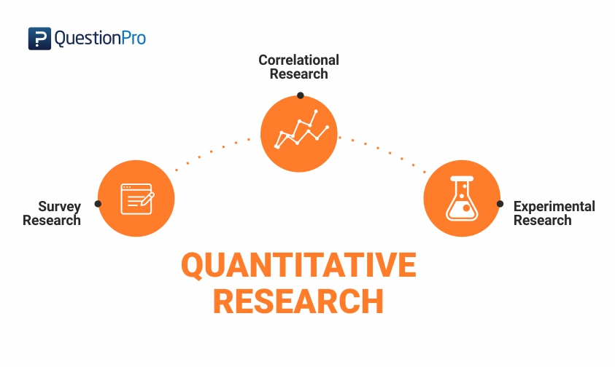
(QuestionPro, 2022).
The method best used to collect the data for this piece of work is going to be a survey sent out to officers across Gwent police force.
This will allow myself to gather data in a larger quantity which can them be examined closely and combined into numerical data.
Due to the volume of information I am looking to gather quotative research is best suited to my research.
521 Words.

University of Cambridge. 2022. Police workforce almost one in five suffer with a form of PTSD. [online] Availibe at: https://www.cam.ac.uk/policeptsd
University of Cambridge: Police Care Uk. 2022. Trauma Resilience in UK Policing. [online] Available at:https://www.policingtrauma.sociology.cam.ac.uk/survey?_gl=1*1qsnkcz*_ga*MTMyNzEwMTY2Ni4xNjUyNjA5MTI0*_ga_P8Q1QT5W4K*MTY1MjYwOTEyNC4xLjEuMTY1MjYwOTE0Mi4w [Accessed 23 May 2022].
QuestionPro. 2022. Quantitative Research: Definition, Methods, Types and Examples. [online] Available at: https://www.questionpro.com/blog/quantitative-research/ [Accessed 23 May 2022].

