Stress Analysis and Dynamics

Analysis and Simulation of a Centrifugal Clutch

Taylor Davies

6/11/2023

Contents
Introduction 3
Task A 4
Historical Development of Centrifugal Clutches 4
Advantages and Disadvantages of Centrifugal Clutches 7
Electromagnetic Clutches 8
Task B 9
Question 1 9
Question 2 9
Question 3 10
Question 4 11
Question 5 12
Question 6 13
Question 7 14
References 15

Introduction

Centrifugal clutches are a staple in smaller applications such as motorbikes and go-karts. The centrifugal clutch is a type of clutch that works on the idea of creating centrifugal force. It is typically regarded as one of the smoothest clutch types since it gradually applies the load to the engine, allowing it to reach its ideal torque range before handling any loads (on, 2018). This report discusses the development of the centrifugal friction clutch and typical applications and operating conditions; this will involve the fundamental principles of the operational factors, materials used in centrifugal clutches and typical applications where centrifugal clutches are used in several industries and equipment. By examining the centrifugal clutch, the aim is to discuss all the advantages and disadvantages that come with the use of the clutch. In addition, this report will discuss the current application of electromagnetic clutches in the modern automation of manufacturing processes (Crane, 2003).

Centrifugal clutches are essential to many mechanical systems because of their performance and design, which facilitates the smooth transfer of torque between the driven and driving shafts. The functionality of the given centrifugal clutch system is greatly impacted by the intricate interactions between several critical parameters, including the mass and structure of the shoes, the stiffness of the linear mechanical spring, the coefficient of friction, and the size of the clutch components. By completing task B, we can explore the inner working of the centrifugal clutch and how each component effects the performance of the clutch.

Task A

Historical Development of Centrifugal Clutches

Early Developments

Until 1858, centrifugal clutches were seen on railway locomotives, and an 1899 patent referred to them in relation to electric motors. In the US, he received patent protection in 1898 for his automobile centrifugal clutch (for an electric car). Thomas Fogerty is the man who is credited for the invention of the centrifugal clutch which is used in balloon catheters (Academic Accelerator, 2022).

On driven rotating machinery, a mechanical component called a centrifugal clutch is employed. The clutch, which is most frequently employed in conjunction with a combustion engine, can immediately transfer torque from the drive to the driven equipment, enabling a "soft start" without the need for load engagement. The speed at which the mechanically driven shaft engages may be adjusted by utilising this kind of clutch between the drive and the driven equipment. The mechanical drive will engage as soon as the engine speed reaches or exceeds the centrifugal clutch's predetermined engagement speed. This allows the engine to attain its ideal torque before encountering load by enabling the operator to run the engine at a specified idle speed without operating the equipment ((Lancereal, 2019).

Design Principles

Its driving elements, such as an engine or motor, must produce all the centrifugal force necessary for it to function. Utilising this centrifugal force, the clutch is engaged with the driven shaft. The sliding shoes move outward when the engine rotates because of the centrifugal force it produces. This in turn initiates the motion of the drum by connecting the inner surface to the friction lining of the shoes. Since the driven shaft is connected to the drum, power is transferred from the engine shaft to the gearbox shaft, which in turn drives the load (IndustrialFriction, 2022).

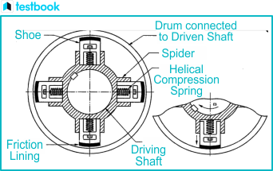

The centrifugal clutch is made up of several components which all contribute to the function of the clutch. The main components that make up the clutch are the shoes, spring, spider, friction lining, driving shaft and driven drum. Each component has its own purpose to allow the clutch to function for example to facilitate contact with the drum during engagement, the clutch shoes are sliding parts that travel within guideways and have friction linings at their ends. The springs’ main purpose is to disengage the clutch while the engine operates at slower speeds. Evenly spaced spiders, or guides, which are usually separated by 90 degrees if there are four of them, are mounted on the driver (engine) shaft or motor shaft. They support the sliding shoes and their corresponding springs. In addition to this the friction lining is in place to ensure a solid grip on contact the inner drum during operation. Finally, the drum of the clutch serves as a housing for all the clutch parts, such as the guides, springs, and sliding shoes. It is attached to belts, chains, or the driven shaft of the gearbox system (Sabhadiya, 2021). The image below demonstrates the working principle of a centrifugal clutch.

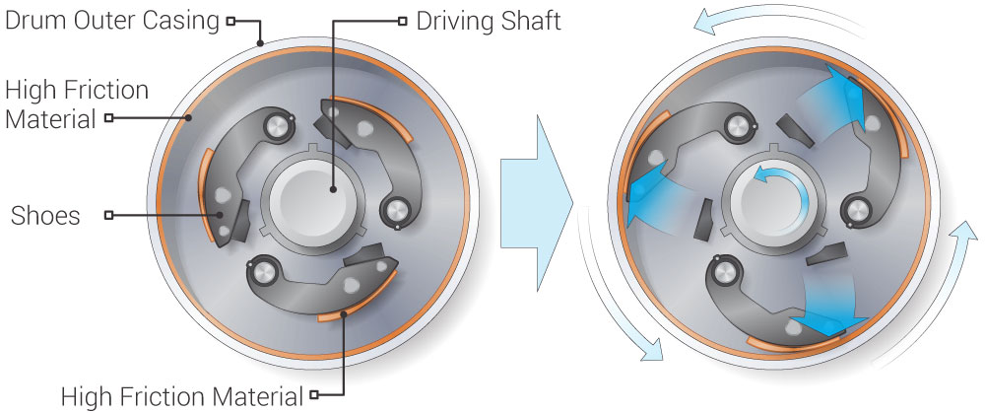

(on, 2018b)

Material Selection

When designing centrifugal clutches material selection is a massive factor for operation of the clutch. It is important to look at each component of the clutch and select the correct materials for the purpose of that component.

Firstly, the importance of material selection for friction lining will be discussed. Usually, ceramic compounds or other rough, high-friction materials are used to make brake linings. These components are bonded to the clutch shoes or brake shoes, respectively, when a clutch is used. The roughness of the linings provides a good grip, preventing slippage between the shoes and the housing when centrifugal force presses the clutch shoes against the inside wall of the clutch housing (O’Keefe, 2013). The image below shows a magnified view of the bonded friction material to the end of the shoe, this emphasises the need to ensure that the material selection is key for operation.

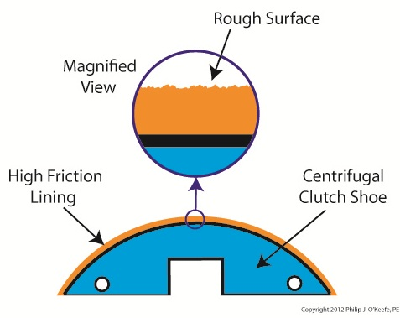
(O’Keefe, 2013)

Several components in the centrifugal clutch are made up of metals, it is important that metal properties are considered during selection. Because of centrifugal force, friction between the shoes and the housing occurs during centrifugal clutch operation, producing heat. Steel, which is strong and resistant to bending, is used to make clutch springs. However, they could reach temperatures of hundreds of degrees while operating, then gradually cool down again. This will result in the components losing their stiffness and becoming weaker, which further results in a breakdown of the clutch. This applies to the clutch drum, shoes, and springs (O’Keefe, 2013).

Typical Applications

Centrifugal clutches are frequently employed in a variety of settings where gradual torque transmission and automated engagement are required. Typical uses for centrifugal clutches include the following. Go-karts are one of the most popular applications for centrifugal clutches. When the throttle is applied, the kart may move smoothly and gradually because these clutches engage as the engine speed increases. In addition to this certain power tools, such as concrete saws and angle grinders, have centrifugal clutches that enable smooth start and stop operation without the need for a separate clutch lever. Finally, centrifugal clutches are often seen in off-road vehicles, like dirt bikes and trail bikes, and offer smooth acceleration and automatic engagement when riding over difficult terrain (Mechanical Education, 2017).

Advantages and Disadvantages of Centrifugal Clutches

There are several advantages and disadvantages to using centrifugal clutches within applications.

Advantages

There are several clutches available in the market however there are several reasons why centrifugal clutches are used over types in certain applications.

Firstly, a main selling point for centrifugal clutches being used within applications is their ability to automatically engage and disengage; this solely relies on the principle of centrifugal force to operate the clutch meaning there is no need for any control mechanism. In addition, due to the lower number of parts required to operate the clutch; this results in centrifugal clutches to beat other clutch types in price as they are relatively in expensive (Team, 2019).

Centrifugal clutches are also great for the ability of smooth engagement, they lessen shock and wear on the drivetrain components by providing a smooth and progressive engagement as engine speed increases. This is especially crucial for applications where sudden clutch engagement may cause issues (Mechanical Education, 2017).

Finally, they are also very beneficial for slippage control as when the engine reaches a particular speed, centrifugal clutches can slip, enabling a controlled and gradual acceleration. This may be useful in situations when you wish to restrict the torque applied to the driving load (Mechanical Education, 2017).

Disadvantages

As with any mechanical device, the centrifugal clutch also has its disadvantages.

The centrifugal clutch is known for having limited adjustability, centrifugal clutches typically have difficult-to-adjust engagement characteristics that are dictated by the clutch's design. This could be a drawback if exact control over interaction is needed (certain applications require this). Following this means that the centrifugal clutch is limited to its applications as they are best suited to applications where the engine speeds are relatively constant and predictable (Yousef, 2023)

Finally, Because of the constant friction that occurs between the clutch shoes and the clutch drum, centrifugal clutches may experience some power loss. This may have an impact on the system's overall effectiveness (on, 2018c).

Electromagnetic Clutches

Often referred to as "electromechanical" or "E.M." clutches, electromagnetic clutches operate electrically yet transfer torque physically. An electromagnetic coil housed in a metal housing, a rotor attached to the input shaft, and an armature attached to the output shaft, sprocket, or pulley make up the fundamental construction of an electromagnetic clutch. The image below shows the construction of an electromagnetic clutch (Mikipulley, n.d.)

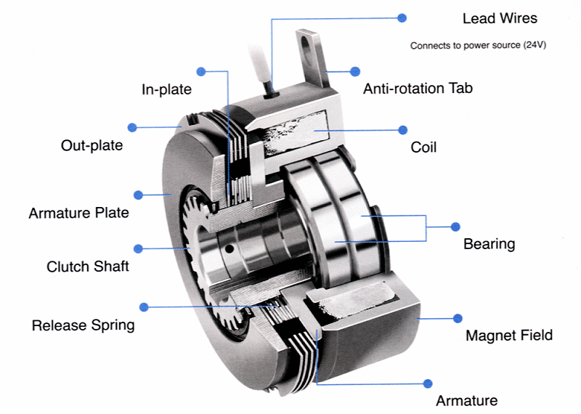

(Chain Tail, n.d.)

Electromechanical clutches are essential to the automation of production processes in the modern world. They are essential parts of several automated devices and systems, which improve manufacturing efficiency, accuracy, and adaptability (GlobalSpec, 2022)

There are several different uses for EM clutches in modern automation. One of the main uses is in safety mechanisms, systems frequently include electromechanical clutches. The clutch can quickly disengage to stop a machine's operation in the case of an emergency or a malfunction, averting mishaps and product or equipment damage. In addition, electromechanical clutches regulate the engagement and disengagement of tools in assembly line activities, facilitating accurate fastening and assembly processes. Among other industries, they are frequently used in the assembly of electronics and the manufacture of automobiles (GlobalSpec, 2022).

Task B

Question 1

What is the diameter of the outer drum?

From the following statement, we can calculate the diameter of the outer drum with the information that we have been given. We can calculate the radius of the outer diameter first and then multiply this by 2 to calculate the diameter.

The centre of mass of each shoe from the shaft centre = 95mm
Clearance Gap = 9mm
Outer drum thickness = 4mm

Total Radius = 95mm + 9mm +4mm = 108mm

Diameter = 108mm x 2 = 216mm

Diameter = 216mm or 0.216m

Question 2

To calculate the engagement force we must use the following equation.

$$kx=mω^{2}r$$

$$Stiffness of Sprinng \left(k\right)=7.5KN/m$$

$$Clearance distance \left(x\right)=9mm$$

$$ω= ?$$

$Radius \left(r\right)=104mm$

The radius has been calculated as 104mm as it is the radius of the shoe (95mm) and the clearance to the inner drum (9mm).

$$7.5×{10}^{3}×9×{10}^{-3 }= 275×{10}^{-3}×ω^{2} ×104×{10}^{-3 }$$

$$67.5= 28.6×{10}^{-3}×ω^{2}$$

This is then rearranged to find $ω^{2}$

$$ω^{2}= \frac{67.5}{ 28.6×{10}^{-3}}$$

$$ω^{2}= 2360.14$$

$$ω= \sqrt{2360.14}$$

$$ω= 48.58$$

$ω$ Then needs to get converted to RPM.

$$48.58 × \frac{60}{ 2×π} =464 RPM$$

Question 3

To calculate the radial force on the clutch face we need to calculate the centripetal force and take away the springs reaction force, this will then result in the total reaction force acting on the clutch per shoe. To calculate the total radial force, we simply multiply the total reaction force by the number of shoes (4).

The following equation below is required to calculate the centripetal force.

$$c_{F}=mrω^{2}$$
$$mass \left(m\right)=275g$$

$Radius \left(r\right)=104mm$

$$ω= 550 RPM$$

To use the equation $ω$must be in Radians/ Per second.

$$ω= × \frac{2×π ×550}{ 60} =57.6 Rad/s$$

$$ω= 57.6 Rad/s$$

To calculate the centripetal force for one shoe we must use the equation stated.

$$C_{F}=0.275 ×0.104 ×{57.6}^{2}$$

$$C_{F}=94.89$$

We must also calculate the spring force using $kx$

$$Stiffness of Sprinng \left(k\right)=7.5KN/m$$

$$Clearance distance \left(x\right)=9mm$$

$$F_{s}= kx$$

$$F_{s}= 7500 ×0.009$$

$$F_{s}= 67.5N$$

To calculate the Radial Force per shoe, we need to subtract the spring force from the centripetal force.

$$F_{r}=C_{F}-F_{s}$$

$$F_{r}=94.89-67.5$$

$$F_{r}=27.39N$$

Now to calculate the total radial force we must multiply by the number of shoes present.

$$Total F_{r}=27.39 ×4$$

$$Total F_{r}=109.56$$

Question 4

To calculate the torque transmitted with the information we are given we must use the following equation.

$$Torque T=Fr$$

To calculate the force, we must use the following equation.

$$F= μ x F_{r}$$

$$F= 0.35 ×109.56$$

$$F= 38.35N$$

Now we have all the required information to calculate the torque.

$$T=38.35 ×104 ×{10}^{-3}$$

$$T=3.99Nm$$

Question 5

To plot the graph, I had to calculate the radial force in increments of 25RPM from 450RPM to 700RPM. Once I calculated the radial force, we could then calculate the Force required to work out the transmitted torque.

To allow for ease of calculations I collated all the required data in Excel to calculate the torques at different RPMs, this also removes the chance of human error.

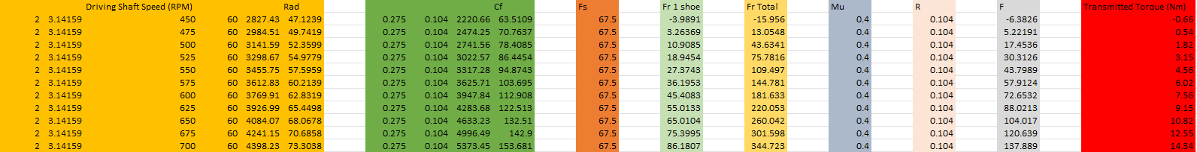

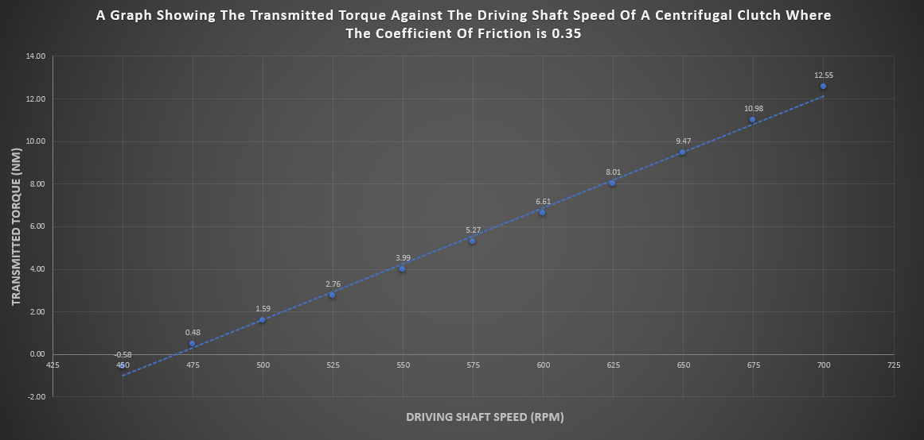

Image – Coefficient of Friction at 0.35

From the graph above we can see that as the RPM increases the torque increases.

From the graph above we can see the torque at 450 is -0.58N/m this shows that the shoes have not engaged with the inner drum, we can also back up this statement as in Question 2 we calculated the engagement speed to be 464 RPM.

Question 6

I have created 2 graphs representing the torque transmitted against the driving shaft speed with the coefficient of friction being the dependent variable.

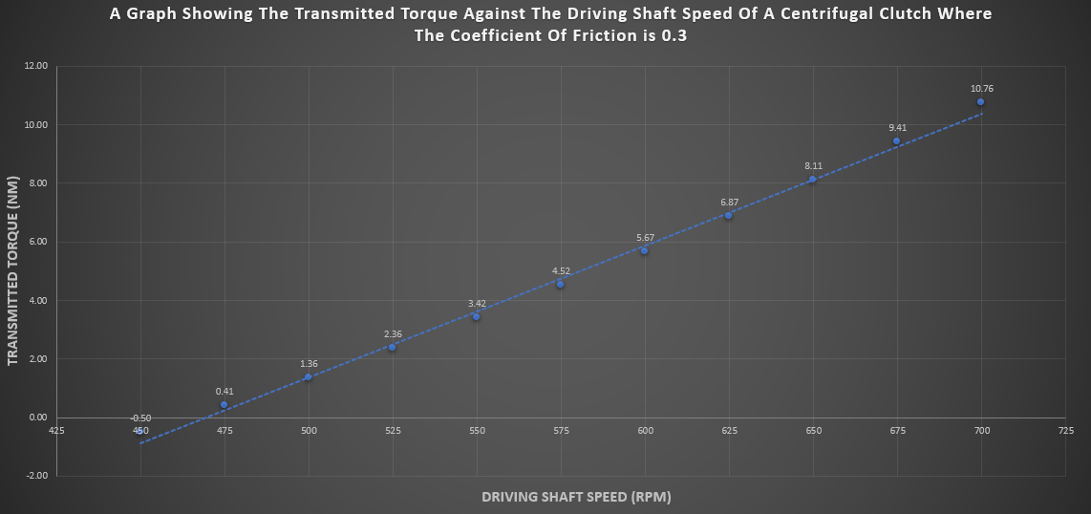

Image – Coefficient of Friction at 0.3

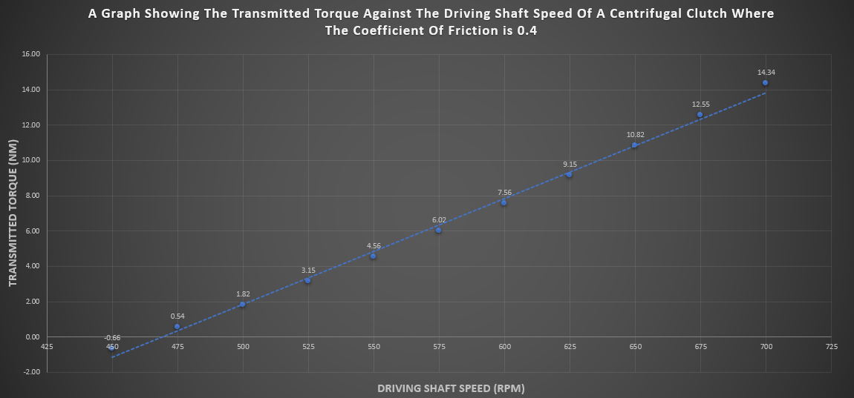

Image – Coefficient of Friction at 0.4

From the three graphs created, we can see that as the friction is increased the transmitted torque at each RPM has also increased. This is due to the likelihood of slippage being reduced as the friction lining is more capable of maintaining a stronger grip at the higher RPMs.

Question 7

To calculate the angular acceleration for point 6 with the coefficient friction being 0.4 the following equation is required:

$$T=Ia$$

$$T= 14.34$$
$$I= ?$$
$$a= ?$$

To find the angular acceleration we need to determine the mass moment of inertia ( $I$ )

$$I=m × k^{2}$$

For a rotating solid disk:

$$k= \frac{R}{\sqrt{2}}$$

$$k= \frac{0.108}{\sqrt{2}}$$

$$k= 0.0764$$

$$I=750 × {10}^{-3} × {(0.0764)}^{2}$$

$$I=4.37772 × {10}^{-3}$$

Now we can determine the angular velocity by using:

$$T=Ia$$

The equation needs to be rearranged to make $a$the subject.

$$a= \frac{14.34}{4.37772 × {10}^{-3}}$$

$$a= 3275.68 rad/s^{2}$$

References

Academic Accelerator (2022). Centrifugal Clutch. [online] Academic Accelerator. Available at: https://academic-accelerator.com/encyclopedia/centrifugal-clutch [Accessed 20 Oct. 2023].
Chain Tail (n.d.). Chain Tail-MWJ Oil Actuated Multi-Disc Electromagnetic Clutch. [online] www.chaintail.com. Available at: https://www.chaintail.com/mwj-oil-actuated-multi-disc-electromagnetic-clutch.html [Accessed 3 Nov. 2023].
Crane, N. (2003). Compliant Centrifugal Clutches: Design, Analysis, and Testing Compliant Centrifugal Clutches: Design, Analysis, and Testing. [online] Available at: https://scholarsarchive.byu.edu/cgi/viewcontent.cgi?article=1078&context=etd [Accessed 20 Oct. 2023].
GlobalSpec (2022). Electric Clutches. [online] Global Spec. Available at: https://www.globalspec.com/learnmore/motion_controls/clutches_brakes/electric_clutches#:~:text=Electromagnetic%20clutches%20are%20often%20chosen%20for%20remote%20operation,operation%20is%20a%20natural%20fit%20for%20electromechanical%20clutches [Accessed 4 Nov. 2023].
IndustrialFriction (2022). Centrifugal Clutches | Manufacturer of Centrifugal Clutches | Industrial Friction Materials. [online] Industrial Friction. Available at: https://www.industrialfriction.com/friction/brake-relining-services/clutches/centrifugal-clutches/ [Accessed 23 Oct. 2023].
Lancereal (2019). Centrifugal Clutch Explained – An Engineer’s Guide to a Centrifugal Clutch. [online] Lancereal. Available at: https://www.lancereal.com/centrifugal-clutch-explained/ [Accessed 20 Oct. 2023].
Mechanical Education (2017). Centrifugal Clutch: Construction, Working, Applications, Advantages, And Disadvantages - Mechanical Education. [online] Mechanical Education. Available at: https://www.mechanicaleducation.com/what-is-centrifugal-clutche/ [Accessed 30 Oct. 2024].
Mikipulley (n.d.). Electromagnetic Clutches | EM Clutches | Electric Clutches. [online] www.mikipulley-us.com. Available at: https://www.mikipulley-us.com/em-clutches [Accessed 1 Nov. 2023].
O’Keefe, P.J. (2013). Centrifugal Clutch | Engineering Expert Witness Blog. [online] Engineering Expert. Available at: http://www.engineeringexpert.net/Engineering-Expert-Witness-Blog/tag/centrifugal-clutch#:~:text=Like%20the%20brakes%20in%20cars.
on, B.T. (2018a). How does a Centrifugal Clutch work? What are the pros and cons? [online] EngineeringClicks. Available at: https://www.engineeringclicks.com/centrifugal-clutch/ [Accessed 20 Oct. 2023].
on, B.T. (2018b). How does a Centrifugal Clutch work? What are the pros and cons? [online] EngineeringClicks. Available at: https://www.engineeringclicks.com/centrifugal-clutch/ [Accessed 23 Oct. 2023].
on, B.T. (2018c). How does a Centrifugal Clutch work? What are the pros and cons? [online] EngineeringClicks. Available at: https://www.engineeringclicks.com/centrifugal-clutch/ [Accessed 1 Nov. 2023].
Sabhadiya, J. (2021). What Is Centrifugal Clutch? - Definition, Parts, Working. [online] Engineering Choice. Available at: https://www.engineeringchoice.com/what-are-centrifugal-clutches/ [Accessed 23 Oct. 2023].
Team, T.B. (2019). Advantages and Disadvantages of Centrifugal Clutches. [online] BLM Automatic Clutch. Available at: https://www.blm-cm.com/blog/advantages-disadvantages-centrifugal-clutches/#:~:text=Centrifugal%20clutches%20can%20be%20found [Accessed 30 Oct. 2023].
Yousef (2023). Centrifugal Clutch: Diagram, Parts, Working & Uses [PDF]. [online] The Engineers Post. Available at: https://www.theengineerspost.com/centrifugal-clutch/?utm_content=cmp-true [Accessed 1 Nov. 2023].

