MARKETING PLAN | MODULE NAME: Marketing Essentials (BMIH4009) STUDENT NAME: LARA MEDINA BARCENILLA 2334177 LECTURER NAME: NATALIE BRAILSFORD

Contents
INTRODUCION 1
MARKETING OBJECTIVES 1
MARKET RESEARCH 2
TARGET MARKET AND CUSTOMER PROFILE 2
SWOT ANALYSIS 3
UNIQUE VALUE PROPOSITION 3
MARKETING MIX 4
MARKETING ACTIVITIES 5
PROMOTION METHODS 5
GANNT CHART 6
MONITORING 6
CONCLUSION 6
APPENDIX 7
REFERENCES 7

INTRODUCION
This marketing plan presents a new experiential product for Oxwich Bay Hotel: Sunset Dining Domes, a private coastal dining experience designed to enhance the hotel’s evening offering. The objective is to attract both local customers and domestic tourists by creating a memorable, personalised experience that adds value to the hotel’s current services. The plan outlines the main marketing objectives, supported by market research, segmentation, and theoretical frameworks studied in the module, including the marketing mix and concepts of customer value creation (Hudson & Hudson, 2017). Stakeholders will gain a clear overview of how this product supports growth, strengthens the hotel’s brand positioning, and responds to customer trends in the hospitality sector.

MARKETING OBJECTIVES
The objectives follow the SMART framework recommended by Kotler and Armstrong (2020), ensuring clarity and measurability.
- SPECIFIC: Increase evening dining revenue by 18% within six months of launch.
- MEASURABLE: Achieve a 75% average occupancy rate per dome during the first three months.
- ACHIEVABLE: Generate at least 1,000 monthly social media engagements, using digital platforms discussed in class.
- RELEVANT: Reach 40% of bookings from new customers, supporting customer acquisition.
- TIME-BOUND: Achieve an overall guest satisfaction score of 4.5/5, measured through CRM feedback tools (Fill & Turnbull, 2019).
These objectives help evaluate the success of the product and guide strategic decisions.

MARKET RESEARCH
Market research is essential for understanding customer behaviour and the competitive environment, as highlighted by Benzo et al. (2017). The UK hospitality market shows a strong interest in experiential dining, particularly experiences that combine atmosphere, scenery, and personalised service. Trends in consumer behaviour suggest rising demand for unique experiences rather than standard meals, especially among younger demographics and couples (Hudson, 2020). Customers increasingly look for photogenic settings suitable for sharing online, reinforcing the importance of social media in hospitality decision-making (Kingsnorth, 2019).
In coastal regions like Gower, visitors seek nature-based experiences, high-quality local food, and authentic surroundings. The hotel already attracts many guests for weddings and short breaks, but there is a clear opportunity to expand dining services into premium experiential formats. Competitors in Swansea and Mumbles offer seafood and coastal dining, but none provide private domes with customised menus and sunset views.
The concept also aligns with post-pandemic preferences for semi-private, comfortable spaces (Hudson, 2020). Weather conditions can be unpredictable, so the domes allow for outdoor dining in a protected environment. Overall, market research confirms strong potential demand and limited direct competition, making this a suitable product for Oxwich Bay Hotel.

TARGET MARKET AND CUSTOMER PROFILE
Segmentation follows demographic, geographic, and psychographic factors, consistent with the frameworks introduced by Blythe (2019).
Primary segment:
Couples aged 25–55 seeking romantic or special-occasion experiences such as anniversaries, birthdays, or proposals. These customers typically have medium-to-high disposable income and appreciate premium dining and personalised service.
Secondary segment:
Small groups of friends or families celebrating milestones or visiting the Gower Peninsula for leisure.
Geography:
Local residents (Swansea, Gower, Mumbles) and domestic tourists from Cardiff, Bristol, and the Midlands.
Psychographics:
Experience-seeking individuals who value authenticity, scenic views, local food, and visually appealing environments. They are digitally active and heavily influenced by online content, making them ideal for social-media-led campaigns (Kingsnorth, 2019).

SWOT ANALYSIS
The SWOT analysis (see Appendix A) highlights key internal and external factors relevant to launching the Sunset Dining Domes. Strengths include the hotel’s beachfront location, strong brand reputation, and the ability to offer a personalised service, which fits well with the concept of customer value creation described by Hudson and Hudson (2017). The unique setting of Oxwich Bay provides a natural advantage over local competitors.
Weaknesses include the initial financial investment, limited dome capacity, and potential weather-related restrictions, although the dome structure reduces this risk. Opportunities are significant, especially the growing popularity of sensory and experiential marketing in hospitality (Hultén, 2020). Seasonal events such as Valentine’s Day can also drive demand.
Threats include economic uncertainty and increased competition if other venues adopt similar ideas. However, strong branding, social media engagement and consistent service quality can help protect the hotel’s competitive position (Fill & Turnbull, 2019).

UNIQUE VALUE PROPOSITION
The Sunset Dining Domes provide a combination of privacy, atmosphere, and immersive sensory experience, aligning with principles of experiential and sensory marketing (Hultén, 2020). The domes offer panoramic coastal views, comfortable seating, personalised menu options, and a warm ambient environment, creating a multisensory dining event that goes beyond traditional restaurant settings.
Real examples such as the dining domes at Coppa Club in London demonstrate how customers are drawn to visually striking, Instagram-friendly experiences. Oxwich Bay’s natural scenery enhances this value proposition by integrating nature with premium dining. The domes allow guests to enjoy sunsets regardless of the weather, giving the product a functional advantage and strong emotional appeal. This unique blend of comfort and natural beauty helps differentiate the hotel in the regional hospitality market.

MARKETING MIX
Product:
The Sunset Dining Domes are an experiential service combining private dining, local ingredients, and atmospheric design. As discussed in marketing theory, services rely on experience, environment, and people (Jobber & Ellis-Chadwick, 2019). Comfortable seating, controlled lighting and temperature, panoramic views of the coast, and personalised menu options all make for a memorable event. Trained staff play a big role in making sure that service is always high quality and consistent.
Price:
The premium pricing plan, which ranges from £75 to £95 per person, represents the exclusivity of the event and the extra value that comes from seclusion, location, and better service. Kotler and Armstrong (2020) say that prices in the hotel industry should not just cover costs of doing business, but also what customers think the value is, especially for unique and experiential services. In this case, the price of the Sunset Dining Domes makes them seem like a special-occasion gift that visitors will want for celebrations, romantic dinners, or fun activities that they will remember.
Place:
The domes are located in the hotel’s garden area overlooking Oxwich Bay, taking advantage of natural scenery. Bookings will be managed online through the hotel’s integrated reservation system to ensure smooth coordination. This digital strategy also helps build better relationships with customers by allowing for tailored contact and chances to book again.
Promotion:
Promotion focuses on digital channels, particularly social media, due to their importance in customer engagement (Kingsnorth, 2019). Collaborations with influencers and content made by users will boost. Also, offline marketing resources like brochures, partnerships with local tourism companies, and advertising on-site will help hotel guests and people in the area become more aware of the hotel, making sure that there is a good mix of marketing tools.
People:
People play a crucial role in the successful delivery of the Sunset Dining Domes experience. Staff training emphasises service quality, emotional engagement, and timing. Employees act as “experience creators,” a concept highlighted by Hudson (2020). Good staff performance not only makes the dining experience better right away, but it also leads to good evaluations, return visits, and word-of-mouth advertising.

MARKETING ACTIVITIES
Digital marketing will be very important, starting with professional photos and short videos that show off the environment, the cuisine, and the views of the sunset. These will be utilised on Instagram, TikTok, and Facebook to get people who like to look at things to come. Paid ads on social media will be aimed at couples between the ages of 25 and 55 who live within a certain area.
SEO work will make the hotel website better for terms like "romantic dining Wales" and "private dining Gower," and Google Ads will help during busy search times. The hotel's CRM information will be utilised for email marketing to encourage early bookings, seasonal events, and awards for loyal customers.
Visits from influencers and partnerships with local tourism businesses will help build trust and reach more people. Putting up fliers in popular tourist spots, making connections with wedding vendors, and promoting each other with local attractions are all things that happen offline. The goal of these initiatives is to raise awareness, get people to book, and help keep customers for a long time.

PROMOTION METHODS
There are many kinds of online promotion, including targeted advertisements, consistent visual content, relationships with influential people, and seasonal campaigns. Kingsnorth (2019) asserts that digital channels are essential to accomplish the goal of reaching customers who are interested in new experiences and engaging them in the process. Material that is provided by users will help to make things appear more real and will naturally reach a greater number of people.
On-site advertisements, printed brochures, and collaborations with local tourist businesses will all be part of the offline advertising strategy to encourage hotel guests to make further purchases. According to Fill and Turnbull (2019), maintaining consistency across all online and offline platforms plays a significant role in effectively communicating the experience and in developing a powerful brand.

GANNT CHART
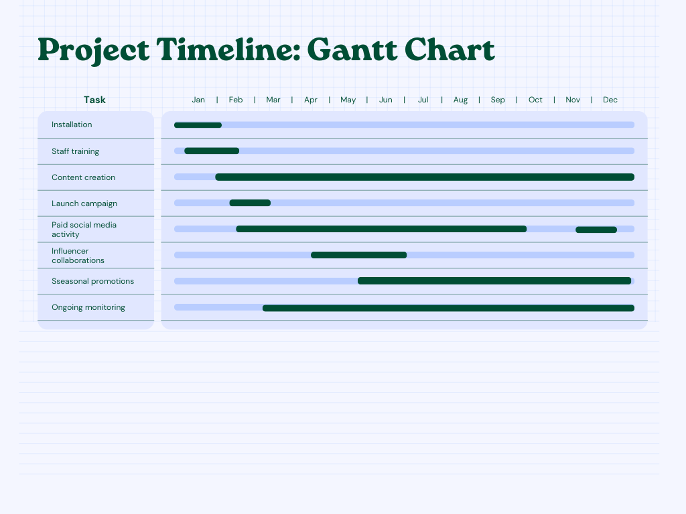

MONITORING
The performance will be evaluated based on key performance indicators (KPIs) such as the customer satisfaction scores, the amount of income earned, the amount of website traffic, and the amount of social media engagement. There will be a record of consumer feedback, preferences, and repeat reservations thanks to CRM technologies. Data from reservations will be used to demonstrate demand trends, while Google Analytics will be used to analyse the efficacy of digital campaigns. Reviews done every three months will help make changes to prices, discounts, and service delivery to make sure that things keep getting better and meet customer needs.

CONCLUSION
The Sunset Dining Domes give the Oxwich Bay Hotel a great chance to grow its dining services and bring in new clients by offering a unique, visually appealing experience. This marketing plan uses ideas from the module, such as segmentation, the marketing mix, CRM, and experiential marketing, to help create a viable launch strategy. The domes may become a unique feature of the hotel with good marketing, reliable service, and regular monitoring. This will help the hotel grow over time and strengthen its brand.

APPENDIX
A.
STRENGTHS | WEAKNESSES
Unique beachfront location with sunset views, creating a strong competitive edge.  High brand reputation of Oxwich Bay Hotel and strong wedding and event demand.  Private and weather-protected dining experience aligned with experiential trends. | Limited capacity, as only a small number of domes are available, which restricts revenue volume.  High initial investment costs, including installation, furniture, heating, and lighting.  Increased staffing requirements during peak seasons.

OPPORTUNITIES | THREATS
Rising demand for experiential and sensory dining within the UK hospitality market.  Seasonal events such as Valentine’s Day, Christmas, and anniversaries that increase sales opportunities.  Growing influence of social media and demand for “Instagrammable” dining settings. | Potential replication of similar dome dining concepts by competitors.  Economic fluctuations that may reduce customers’ willingness to pay for premium dining experiences.  Weather disruptions, including storms and strong winds, which may affect bookings despite dome protection.

REFERENCES
- Baines, P., Fill, C. & Rosengren, S. (2022) Marketing. Oxford University Press.
- Benzo, R., Moshenk, M. & Fourali, C. (2017) Market Research: Planning, Process, Practice. SAGE.
- Bitner, M. J. (1992) Servicescapes: The impact of physical surroundings on customers and employees. Journal of Marketing, 56(2), pp. 57–71.
- Blythe, J. (2019) Essentials of Marketing. Pearson.
- Fill, C. & Turnbull, S. (2019) Marketing Communications: Touchpoints, Sharing and Disruption. Pearson.
- Hudson, S. (2020) Customer Experience in Hospitality. Goodfellow.
- Hudson, S. & Balakrishanan, P. (2023) Customer Value Creation in Tourism and Hospitality: Concepts, Cases, and Strategies. Goodfellow.
- Hudson, S. & Hudson, L. (2017) Marketing for Tourism, Hospitality and Events. SAGE.
- Hultén, B. (2020) Sensory Marketing: An Introduction. SAGE.
- Jobber, D. & Ellis-Chadwick, F. (2019) Principles and Practice of Marketing. McGraw-Hill.
- Kingsnorth, S. (2019) Digital Marketing Strategy. Kogan Page.
- Kotler, P. & Armstrong, G. (2020) Principles of Marketing. Pearson.
- Mangold, W. G. & Faulds, D. J. (2009) Social media: The new hybrid element of the promotion mix. Business Horizons, 52(4), pp. 357–365.
- Middleton, V., Fyall, A. & Morgan, M. (2009) Marketing in Travel and Tourism. Butterworth-Heinemann.
- Poon, A. & Tsiotsou, R. (2021) Sustainable tourism marketing and the role of unique experiences: A framework for coastal regions. Journal of Destination Marketing & Management, 20, 100578.

