Module Code and Name: LCBB6015 Strategic Management and Sustainability
Written Report

Executive Summary
This strategic report is an assessment of Jaguar Land Rover, a key United Kingdom car builder, in the face of a United Kingdom call for zero-emission vehicles and the UK decline in internal combustion car production. The main goal is to understand the impact that environments and capabilities have on strategic decisions for long-term sustainability. The external environment reveals certain government legislation, inflationary pressure and tough competition from foreign manufacturers coming to the British market. Internally, brand value and engineering skills and specialised production facilities represent valuable assets, but the legacy combustion equipment and high capital requirements pose operational challenges. When all these factors come together, it becomes clear that fleet decarbonisation is essential in order to reach strategic goals in a reasonable time frame. There are calls on areas such as setting up joint technology ventures, investing in improved UK assembly plants and integrating a circular production model throughout the supply chain.

Table of Contents
Executive Summary 1
1.0 Introduction 1
2.0 Strategy Analysis 1
2.1 External Environment Audit 1
2.1.1 Macro-Environmental Analysis (PESTLE Framework) 1
2.1.2 Industry Structure Analysis (Porter's Five Forces) 2
2.2 Internal Environment Audit 3
2.2.1 Resource-Based View (RBV) and VRIO Framework 4
2.2.2 Value Chain Analysis 5
2.3 SWOT Analysis Synthesis 6
2.3.1 Synthesis Matrix (Internal vs. External Drivers) 6
3.0 Strategy Formulation 6
3.1 Evaluation of Strategic Alternatives 6
3.2 Strategic Alignment with Sustainability Goals 8
4.0 Conclusion and Recommendations 8
References 10

1.0 Introduction
Strategic management is an approach that is used to plan resources for use across the long term, predict the changes in the environment and understand the situation that a business is in. Indeed, as David and David (2020) explain, through strategic management commercial organisations can carefully consider their internal and external situation, prompting leadership teams to shift from reactive to directed action in positioning in the marketplace. The automotive sector currently faces heavy commercial pressure in a modern way of doing business due to the constraints imposed by the environment, by targets for decarbonization and by driver preferences. Traditionally, the company had concentrated on high-end sporty cars and utility vehicles, and now the market demands a shift towards electric vehicles and carbon emission reductions. The vision is becoming a modern luxury car company that is sustainable and has a neglected operation that produces more desirable cars through a sustainable process. As outlined by Whittington et al. (2023), organisational vision and mission statements need to “fit” with broader societal expectations and demands, especially if industry standards are evolving and bringing in new goals of becoming net zero.

2.0 Strategy Analysis

2.1 External Environment Audit

2.1.1 Macro-Environmental Analysis (PESTLE Framework)
British carmaking companies are under significant influence from the macro-environment shaped by government directives, economic trends and environmental policies. In the field of policy and legislation, the replacement of petrol and diesel vehicles is tied to a process of gradually increasing targets for zero-emission vehicle sales set by the statutory Zero Emission Vehicle mandate in the UK. National policy mandates mean that manufacturers must rapidly adjust their operational planning, or face spiralling costs for non-compliance, affecting their long-term profitability, according to the Society of Motor Manufacturers and Traders (SMMT, 2024). Additionally, trade protocols put in place as a result of the UK's departure from the European Union result in complicated rules of origin and local content requirements for electric powertrains and vehicle batteries.
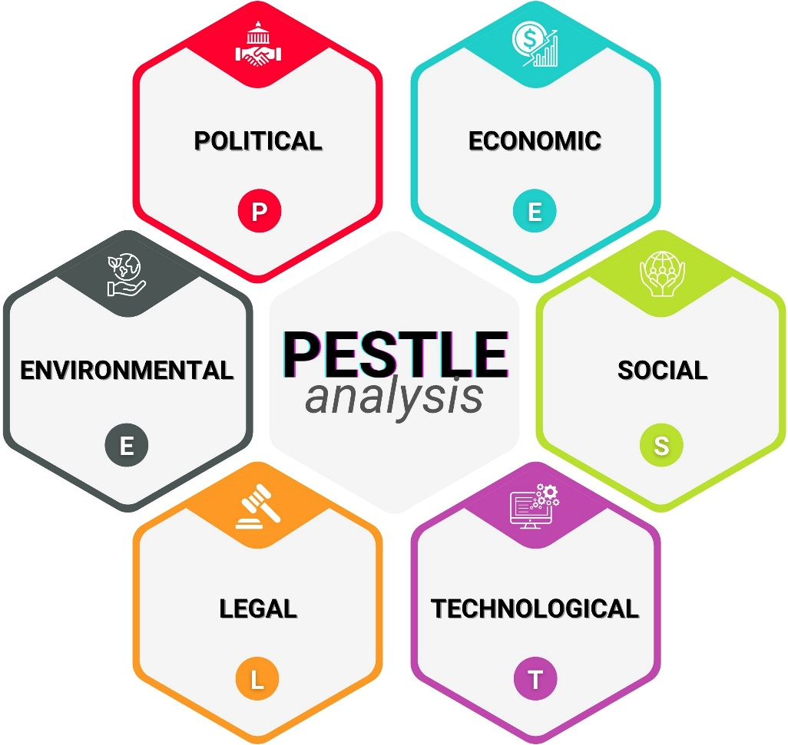
Figure: PESTLE Analysis (Iqbal, 2025)
Other operational challenges remain across European assembly networks, such as economic conditions. According to the European Automobile Manufacturers Association (ACEA, 2025), high borrowing costs, energy costs and ongoing inflation have reduced consumers' discretionary income, which has dampened general car sales dynamics in Europe. International motor vehicle production illustrates this global change of production centres, with the map below showing the impressive production growth in Asia that is rerouting existing trade routes, as reported by the motor vehicle manufacturing statistics of the International Organisation of Motor Vehicle Manufacturers (OICA, 2024). Socially, British consumers more than ever consider environmental performance, fuel costs and low-emission zone fees when purchasing vehicles and are showing growing interest in hybrids and 100% electric cars.

2.1.2 Industry Structure Analysis (Porter's Five Forces)
The profitability and competition in an industry are largely influenced by its structure. Porter (2020) clarifies that industry dynamics serve as a determinant of the (normal level) profit opportunity of a firm; it is a mechanism which determines the power balance between the actors in the industry. When applying this model to the United Kingdom manufacturing industry, it is apparent that the car industry is facing very strong structural pressures.
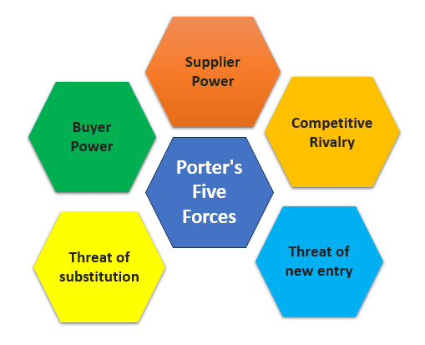
Figure: Porter’s Five Forces (Hessing, 2021)
There is a moderate to high threat of new entrants. Although historically there had been high barriers to capital, new foreign firms are now going to Britain – specifically Chinese electric vehicle manufacturers – with more affordable battery electric vehicles. The bargaining power of suppliers is still strong, as there are few global suppliers of lithium, cobalt and specialised semiconductor microchips that are used for manufacturing batteries for use in electric vehicles. Corporate fleet managers and private buyers are also given greater negotiating leverage, and their choice of equipment is broad, which means they are price-sensitive when choosing their new electric equipment. Threats from substitute products are moderate as a result of investments in urban public transport and shared transport schemes in major cities in Britain. Finally, there is an intense competitive rivalry between the firms in the market. Hypercompetition is defined by competing well-funded firms that also continuously introduce new, improved technologies, lower prices and more aggressive tactics to grab market share, as described by Hitt, Ireland and Hoskisson (2020).

2.2 Internal Environment Audit

2.2.1 Resource-Based View (RBV) and VRIO Framework
Internal capability analysis offers an understanding of how some firms are able to outperform others in the same business environment. Next, Barney and Hesterly (2019) describe the Resource-Based View whereby the concept of the firm is as a collection of tangible and intangible resources, and the authors argue that sustainable competitive advantage is a function of assets that are valuable, rare, inimitable, and backed up by organisational routines.
Resource / Capability | Valuable? | Rare? | Inimitable? | Organized? | Competitive Implication
Brand Heritage & Identity | Yes | Yes | Yes | Yes | Sustainable Advantage
Specialized Aluminium Engineering | Yes | Yes | Moderate | Yes | Temporary Advantage
Automated Production Sites | Yes | No | No | Yes | Competitive Parity
Software & EV Powertrain Tech | Yes | No | No | Developing | Competitive Parity
Table: VRIO Analysis
The company has unique assets, which include cherished luxury brand images, cutting-edge lightweight aluminium chassis technology, proven British manufacturing capabilities, and dedicated design centres. When analysing these resources using the VRIO framework, it reveals obvious gaps in operation. The luxury brand's values and image of Range Rover / Defender are rare and valuable, and hard for new market participants to replicate quickly, and organisational design allows premium pricing. This gives a longterm competitive edge. However, the advanced engineering skills in the construction of the aluminium body also provide a temporary edge, since the other players will also be building lightweight vehicles. A standard production location or an easy software system will provide competitive parity since rival companies can build similar production sites or get similar technology suppliers from the outside. Understanding that, as Grant (2021) points out, static resources will not generate lasting benefits unless they are continually developed in line with changing market demands, including transferring the skills of combustion engineering to software- (and battery-) integration.

2.2.2 Value Chain Analysis
To know where value is created, you need to look at the activities of the company from inside. The value chain is a method that involves analysing the activities in the production process that convert the raw materials into a final product and the activities that generate value for the buyer or cost advantages, according to Rothhaermel (2021).
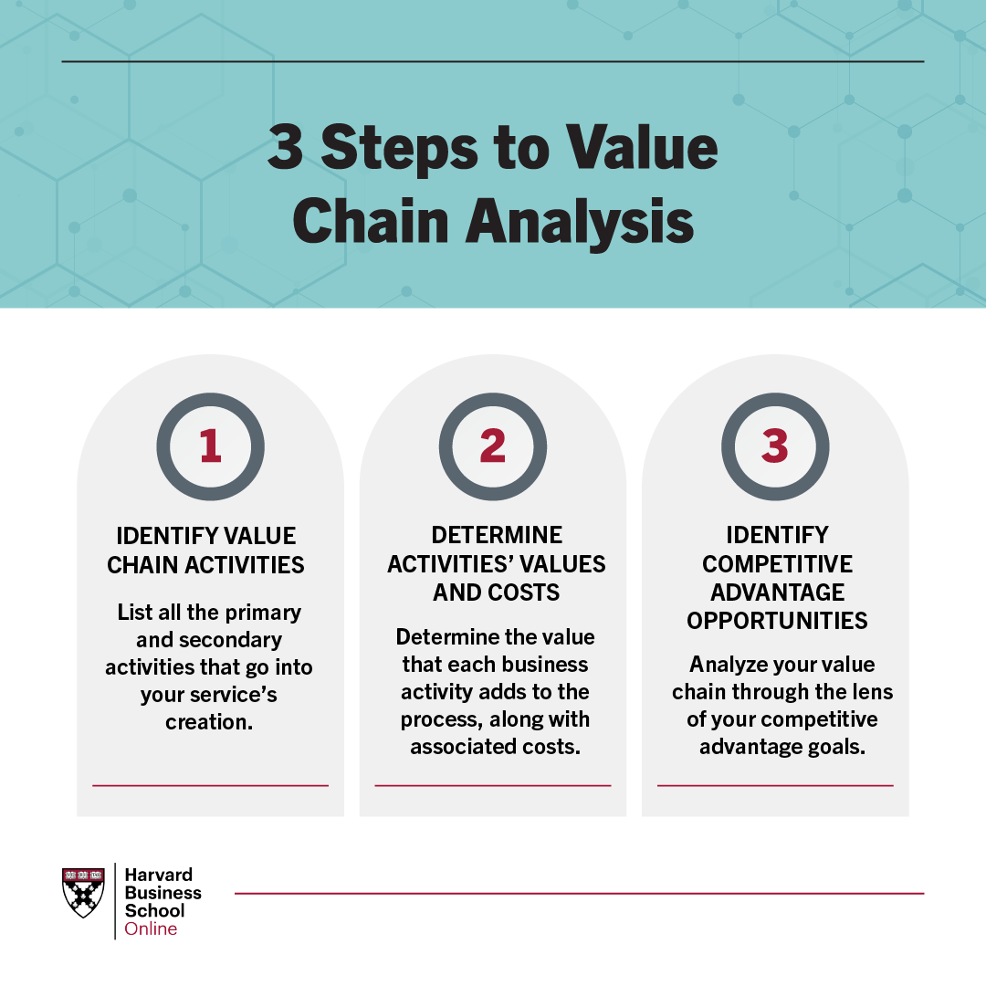
Figure: What Is a Value Chain Analysis? 3 Steps (Stobierski, 2020)
For Jaguar Land Rover, the primary activities start with inbound logistics, the sourcing and procurement of raw materials and battery cells, which is an important part of the manufacturing process. Operations include the conversion of a traditional assembly line in the West Midlands B&M to produce electric and hybrid vehicles that can be built on flexible architectures. The outbound logistics manages vehicle flow between dealerships, national and export ports and marketing and sales is dedicated to customer lifestyle positioning and luxury branding. Warranty repairs and software updates are provided via service. Technology development represents one key value driver among the support activities, receiving high investments, for example, in the electric drive units and vehicle software. HRM assists in retraining the workforce with the education of assembly line personnel for high-voltage systems. Having partnerships for local battery production also helps to mitigate risks in the inbound supply, thus enabling a smoother internal operation and safeguarding operating margins in the electric transition.

2.3 SWOT Analysis Synthesis

2.3.1 Synthesis Matrix (Internal vs. External Drivers)
A deterministic strategic alignment scenario can be as clear as combining internal findings with external conditions in the industry. Dess et al. (2021) stress the importance of a SWOT analysis not being a standalone set of facts, but rather a linking bridge between the internal strengths and weaknesses and the external opportunities and threats.
Element | Internal Aspects | External Aspects
Strengths / Opportunities (SO) | Strong global brand equity; proven premium pricing capability; specialized UK manufacturing plants. | Rising demand for premium electric SUVs; government support for clean technology investment; expanding charging infrastructure.
Weaknesses / Threats (WT) | High capital expenditure requirements; legacy combustion overheads; slower software development cycle. | Strict UK ZEV mandates and penalties; influx of low-cost foreign electric cars; volatile raw material costs.
Table: SWOT Analysis
Jaguar Land Rover (JLR) can leverage its brand power on both sides through its premium image; by introducing high-margin electric versions of their premium range, JLR can connect with high-value buyers and tech-savvy individuals. But internal vulnerability can also occur due to high capital re-tooling expenses when external vulnerabilities such as stringent government zero-emission targets and availability of low-cost foreign competition are put into play. Focusing on these will mean stimulating investment in battery software and manufacturing flexibility, maintaining legal compliance, and fending off new international brands from squandering market share.

3.0 Strategy Formulation

3.1 Evaluation of Strategic Alternatives
As international regulations change and competition is increasingly seen, vehicle manufacturers will have to make the right strategic decisions to enable sustainable growth. Jaguar Land Rover can think about market penetration, market development, or product development to grow its commercial output based on the product-market growth models. With industry changes prevailing, product development offers the best alternative. It is a strategy to launch fully electric luxury cars to current customers/ buyers in the United Kingdom and around the world.
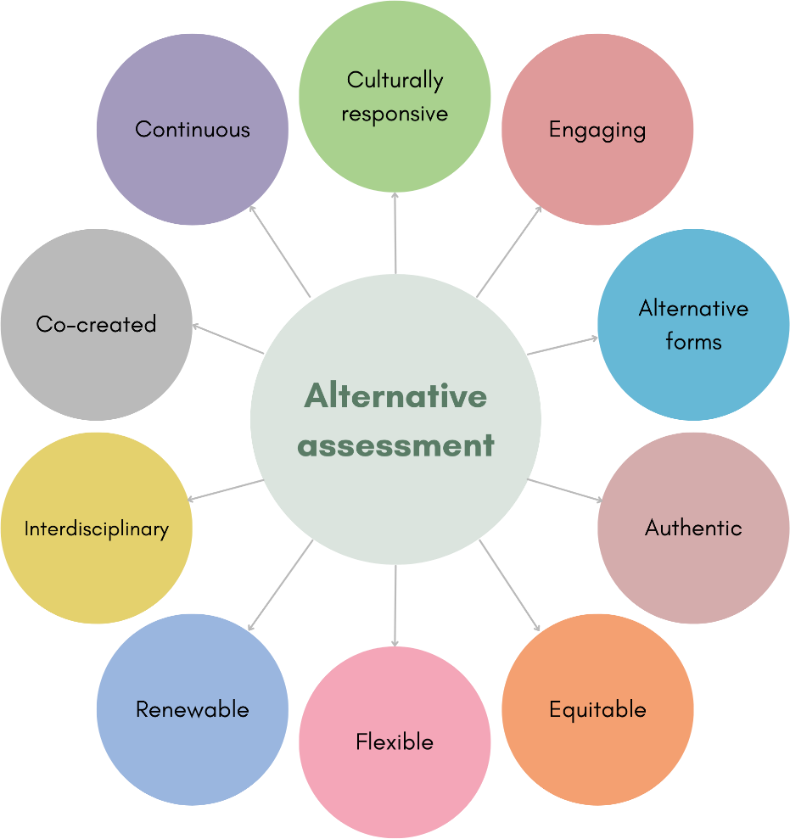
Figure: Alternative Assessment (Elkhoury, 2023)
Strategic alliances are a viable option for any product development firm aiming to develop their product without taking unsustainable debt. According to Hill and Schilling (2020), strategic alliances can help companies share the cost of developing technology, reduce the risk of investments and pool complementary resources to meet technological changes. The collaboration with established battery manufacturers and the technology provider provides the carmaker with secure battery cell supply and sophisticated software platforms. This helps to reduce capital exposure while shortening vehicle delivery cycles, enabling the company to withstand the international competitors of low-cost vehicles without compromising the luxury styling and engineering quality.

3.2 Strategic Alignment with Sustainability Goals
It is crucial that corporate strategies score high or are compatible with environmental, social and governance principles in the long run, in order to be viable. One of them is the need to rethink production processes, the sourcing of materials, and the energy consumption in the processes, so as to minimise the overall impact on the environment. Epstein and Buhovac (2018) make a point that PR companies' sustainability efforts are best when they are built into their everyday business and corporate agenda – and not run as a standalone public relations program.
Jaguar Land Rover can maximise sustainability in its own activities by introducing circular economy processes throughout its own manufacturing network. This includes acquiring recycled aluminium that can be used for the vehicle body components, importing power from renewable sources for the assembly plants, as well as creating battery packs that are easily disassembled for secondary use as energy storage or recyclable. In addition, stating the use of responsibly sourced materials for the electric motors will give customers reassurance about ethical standards.

4.0 Conclusion and Recommendations
In the automotive industry, strategic management offers analytical tools necessary to be able to appraise external pressures and internal capabilities. Government policy, changing customer expectations, and fierce competition from new overseas players working in the market are all influencing the Jaguar Land Rover environment. The business has also established brand equity and expertise in engineering, but the equipment costs are also quite high, and software integration remains a challenge.
To become competitive and find sustainable growth in the market in the United Kingdom, Jaguar Land Rover must take three specific actions:
Create strategic partnerships in technologies with battery suppliers and software developers to decrease research expenses & guarantee regional battery supply chains.
Quit stalling and speed up the process of repurposing existing British assembly plants to become flexible production centres that can build luxury cars as well as hybrid versions.
Embed circular supply patterns in the production process, with a focus on recycling aluminium and end-of-life recycling of batteries.
To become viable in the modern automotive industry, however, this viability must be more than just another incremental step and should rely on a systemic shift in how the car is designed, produced, and reutilised as a whole, as Wells (2020) states.

References
Barney, J. B. and Hesterly, W. S. (2019) Strategic Management and Competitive Advantage: Concepts and Cases. 6th edn. New York: Pearson.
David, F. R. and David, F. R. (2020) Strategic Management: Concepts and Cases—A Competitive Advantage Approach. 17th edn. New York: Pearson.
Dess, G. G., McNamara, G., Eisner, A. B. and Lee, S. H. (2021) Strategic Management: Text and Cases. 10th edn. New York: McGraw-Hill Education.
Elkhoury, E. (2023). Ten principles of alternative assessment. Learning design voices, [online] pp.435–451. doi:10.59668/279.12260.
Epstein, M. J. and Buhovac, A. R. (2018) Making Sustainability Work: Best Practices in Managing and Measuring Corporate Social, Environmental and Economic Impacts. 2nd edn. Abingdon: Routledge.
European Automobile Manufacturers Association (ACEA) (2025) Economic and Market Report: Global and EU Auto Industry Full Year 2024. Brussels: ACEA. Available at: https://www.acea.auto/publication/economic-and-market-report-global-and-eu-auto-industry-full-year-2024/ [Accessed 23 July 2026].
Grant, R. M. (2021) Contemporary Strategy Analysis. 11th edn. Chichester: John Wiley & Sons.
Hessing, T. (2021). Porter’s five forces. [online] Six Sigma Study Guide. Available at: https://sixsigmastudyguide.com/porters-five-forces/ [Accessed 23 July 2026].
Hill, C. W. L. and Schilling, M. A. (2020) Strategic Management: Theory & Cases: An Integrated Approach. 13th edn. Boston: Cengage Learning.
Hitt, M. A., Ireland, R. D. and Hoskisson, R. E. (2020) Strategic Management: Competitiveness and Globalization (Concepts and Cases). 13th edn. Boston: Cengage Learning.
International Organization of Motor Vehicle Manufacturers (OICA) (2024) Global Vehicle Production and Sales Statistics. Paris: OICA. Available at: https://oica.net/ [Accessed 23 July 2026].
Iqbal, A. (2025). Pestle analysis: The CEO’s guide to Future-Proofing a business. [online] Medium. Techno-Preneurship. Available at: https://medium.com/techno-preneurship/pestle-analysis-the-ceos-guide-to-future-proofing-a-business-877e6c4e20ea [Accessed 23 July 2026].
Porter, M. E. (2020) On Competition, Updated and Expanded Edition. Boston: Harvard Business Review Press.
Rothaermel, F. T. (2021) Strategic Management. 5th edn. New York: McGraw-Hill Education.
Society of Motor Manufacturers and Traders (SMMT) (2024) Automotive Insights and UK Sector Performance Reports. London: SMMT. Available at: https://www.smmt.co.uk/automotive-insights/ [Accessed 23 July 2026].
Stobierski, T. (2020). What is a value chain analysis? [online] Harvard Business School. Available at: https://online.hbs.edu/blog/post/what-is-value-chain-analysis [Accessed 23 July 2026].
Wells, P. (2020) The Automotive Industry and the Environment: A Technical, Business and Social Perspective. 2nd edn. London: Routledge.
Whittington, R., Regnér, P., Angwin, D., Johnson, G. and Scholes, K. (2023) Exploring Strategy: Text and Cases. 13th edn. Harlow: Pearson Education.

