Ways of Perceiving, Curation essay
Orla white

Orla white
2305399
BA Surface Pattern and Textiles
Word count- 1584
Julia Lockheart
This exhibition named “The Afterlife Of Art” features 3 different art pieces, each made in collaboration by 3 different artists. Focusing on Han Ulrich Obrist’s (2014) ‘Ways of Curating’, the exhibition is situated in Highgate Cemetery in London, see figures 5,6 and 7. Whilst looking at Sigmund Freud’s (1900) on the Death Drive and how art can have a clear inspiration and link to death. Along with, exploring themes of colour and how it impacts art, space and time, a cemetery will be a relevant space to hold my exhibition. I have curated a selection of various artworks that support my idea, taking into consideration the colour, the arrangement throughout pieces, and the way art is presented alongside others.
I will be using three 3 meter by 3-meter canvas walls to create an enclosed space within the surrounding cemetery. The entrance is formed by not having a fourth piece leaving the space open. By doing so it allows the cemetery to still be seen by spectators to feel the presence of where they are. As this exhibition is still open to the area around it, it allows the cemetery to almost frame the exhibition. Obrist reflects on the Monet paintings having their frames removed by curator William C. Seitz “the gallery itself became the framing mechanism” (Obrist, 2014, p. 29). This idea of the space as a frame will be used in The Afterlife of Art.
The gazebo tent is surrounded by three white walls, which enhance the idea of the exhibition being in heaven or another life after death, to correspond to my theme of space and time. Using the plain white walls as a curative decision, Obrist states “other visual cues in the space were reduced to a minimum, resulting in a clean, spare gallery space that we know today as the white cube” (Obrist, 2014, p. 29). Using this theory of the “white cube” enhances the art pieces themselves showing a clear difference between the cemetery symbolic of death and the white gazebo symbolising heaven or a later life.
The act of dying is an unknown period of time as no one can guarantee what happens after death, although there are many different views. The spectators of the exhibition then become in limbo themselves as they are taken through the possible stage after death to view the art being held by people also in the life after death. The use of a white background for all of the art pieces has a clear link to death through the symbol of emptiness and absence. White space is symbolic of emptiness and a void, which are both themes that are associated with death which often represent the void and absence left behind. The use of white space can evoke feelings of loss, sadness and emptiness for the viewer.
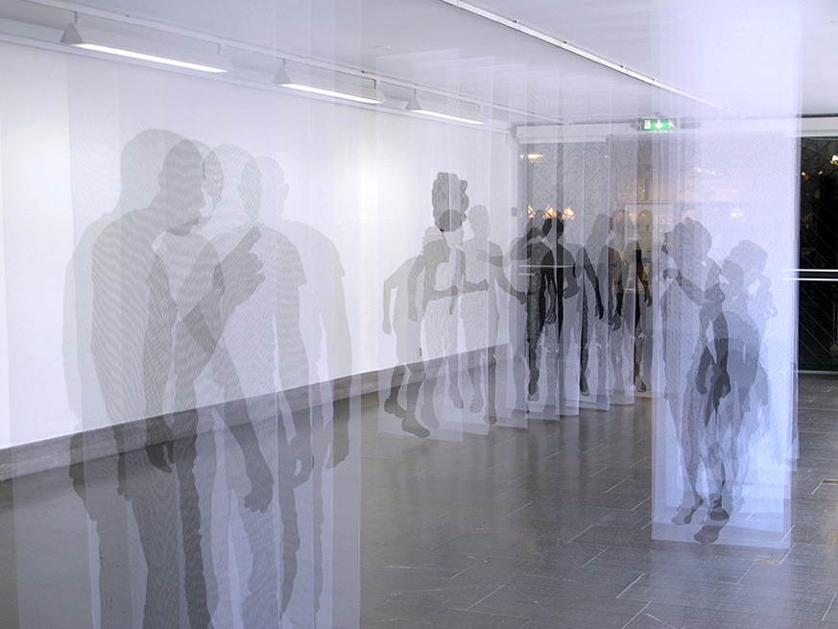
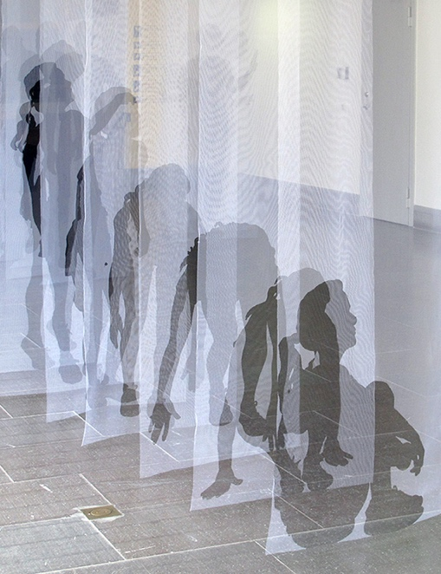
Fig one

‘Déjà Vu, 2013” by Pia Männikkö is in the centre of the gazebo. This piece depicts life size silhouettes that show a clear path of growth while also having gaps between each silhouette to portray gaps of uncertainty through life. Also, the piece is based around the idea of Déjà Vu, “a feeling of having already experienced the present situation” (Oxford languages 2000), which a lot of people have linked to the idea of death. The intention of having this piece is to show a visual representation of the stages of growing up that the spectators can visualise themselves at every stage of life up to now and possibly think beyond into the future. This piece is the largest piece in the room, with dimensions 70cm by 270cm. As it is on such a large scale and will be in the centre of the exhibition the spectators will be able to move around each silhouette and view them from all different angles. Also, the air draft of people walking past makes light fabrics move which emphasises the sense of movement in the images creating a more realistic atmosphere.
Fig two
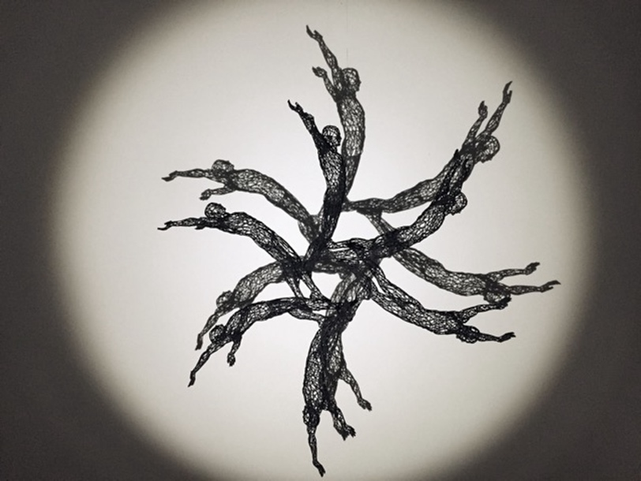

Displayed in the furthest back wall, opposite of the entrance will be ‘Spiral of life’ by Moto Waganari. Waganari creates 3D printed sculptures, by illuminating his sculptures it multiplies three dimensional objects by a two-dimensional shadow, revealing the immaterial alter ego of every figure. This links to my theme of colour through the contrast of a lighter coloured background to the darker forefront, allowing the main focus to stand out whilst also staying monochromatic. Along with the light creating a shadow that gives the effect of multiple, as well as connotations of death through the name of the ‘spiral of life’ because the concept of having them in a physical circle represents the idea of the life cycle having a starting point and continuing it round. Sigmund Freud’s(1920) idea of ‘The Death Drive’ is a concept that he used to explain the compulsion towards self destruction and the drive to return to a regular state of being. He believes that “The aim of all life is death”( Freud, 18, part V 1920), this shows that there is an inherent effort towards destruction and returning to an organic state. In art, this can be reflected through the impermanence of life which this piece shows as is it created from shadows so there are no structural figures replicating no set structure or permanence.This will be presented as in the photo, against the wall with a big white torch to create the shadow. Having no shelf or clear way of it being hung up apart from the small wire that is used so it cannot be seen, giving the illusion of it being floating.


Fig Three

On the left-hand side wall as you walk through the entrance will be the ‘Day of the Dead’ art piece by Maria Dimova (2015). This links to the themes of colour and how it impacts art while also linking to the idea of death as an ongoing theme through my exhibition. As this is the first piece that is full of a lot more colours and it starts to highlight the white cube theory. Due to the gazebo being plain white and all the other pieces of art in the exhibition so far are also monochrome this allows this piece to really stand out with the colours possibly catching the eye of the spectators. This piece also links to my theme as it is inspired by the day of the dead which combines the ancient Aztec custom of celebrating ancestors with All Souls’ Day, a holiday that Spanish invaders brought to Mexico starting in the early 1500s. This holiday, which is most celebrated in November on the first and second, is like a family reunion- except dead ancestors are the guests of honour (Natural Geographic Website,1888).Nicholas Serota reflects on the link to history and uses of different artists in the “Experience or interpretation: the dilemma of museums of modern art”( Serota, 1997).With the idea that ‘combining works by different artists to give selected readings, both of art and the history of art, is also fundamentals that have unwritten cultural practices. This is a good link to the setting of the exhibition as it is in a cemetery which is where many dead people are buried.
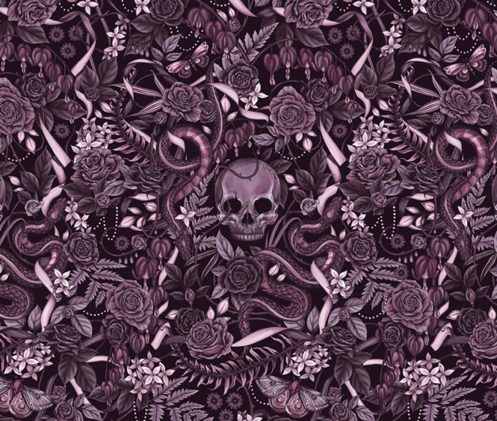
Fig four

As a surface pattern designer, I wanted to use a piece of work from my field of study, which is this piece called “Till death” by Maggie Enterrios. This piece is a more standard colour palette as it’s just one colour and different shades of that one colour to not overpower the other coloured piece. This repeat print is created with using photoshop which means it can be repeated and made on a larger scale, for that reason I would want it to cover the upper half of the wall. This piece also links to the theme of space as it is versatile and able to cover larger and smaller spaces and by splitting the top and bottom it creates a large contrast and allowing the print to stand out. Obrist reflects on this idea “The encounter between the spectator and one work dominated” (Obrist, 2014, p. 29). I chose this design as it is visibly inspired by death as a theme featuring skulls and butterflies which some see are a symbol of passed loved ones.
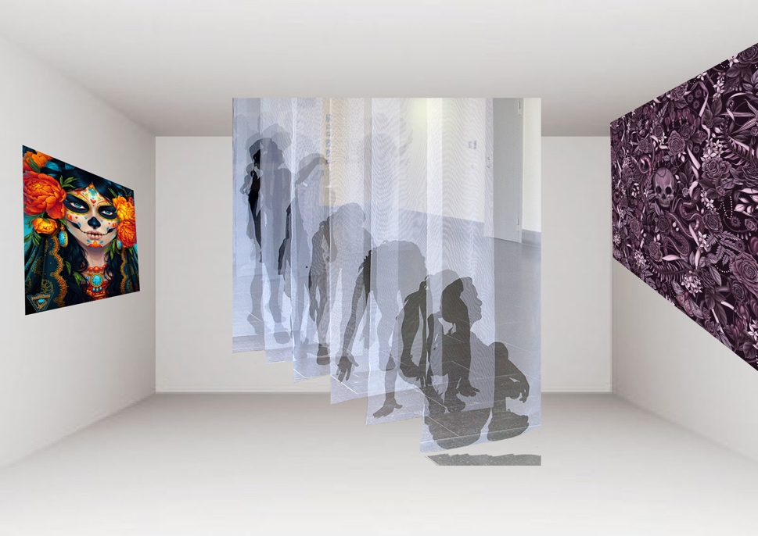
Fig Five
Entrance

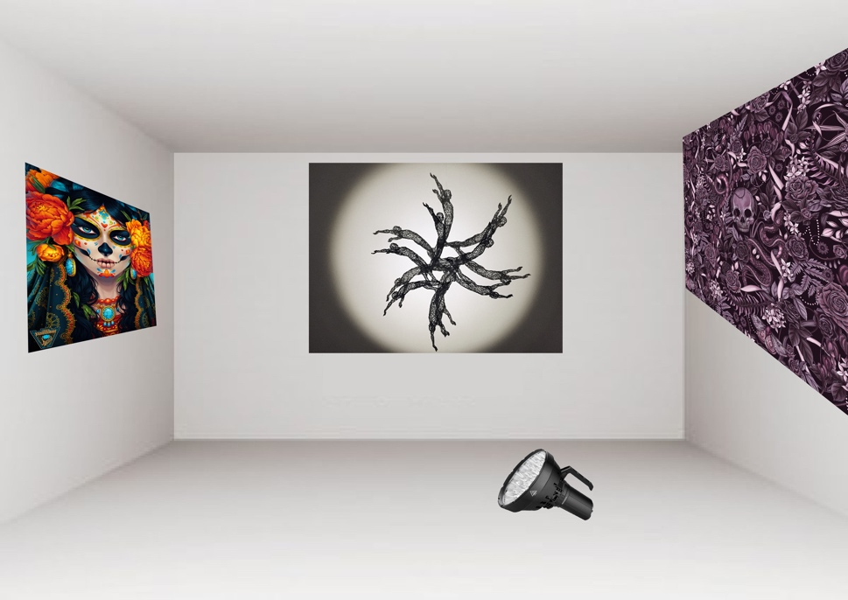
Fig six
Entrance

Entrance
Behind fig one

As mapped out above in fig five, my exhibition space is curated to be easy to access as it’s a open space so people can travel round. Using the white box theory, people should be more drawn to the left side first as the imagery is more of a contrast and stand out more, there for will take people in a natural direction.

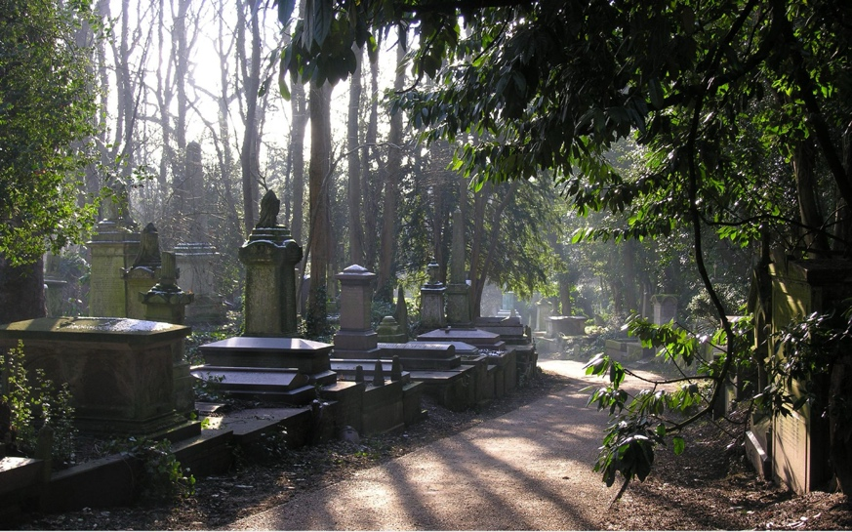
Fig seven

As shown in fig six, my exhibition will be positioned in a very central area of Highgate cemetery in London. It is very important when picking the location for my exhibition, that it was not placed directly on a grave area to keep it ethical and not being disrespectful. The only spectators who will be able to view the exhibition are people that are visiting graves so will have some view on death and the after life or possible will help create one for some people. Although this exhibition will also be shared through social media. My intention for my exhibition is to encourage people to take a view on death and the after life but to also show people that stories can be told through art and the colour and space, they are presented in can affect how it is seen.

Figures
Fig one-Mannikko, P. (2022) PiaMannikk, Available at: https//piamannikko.com/ (Accessed 3rd May 2024)
Fig two- Waganari, M. ‘Spiral of life’ Available at:https://motowaganari.wordpress.com/ (Accessed 3rd May 2024)
Fig three- Dimova, M. ‘ Day of the dead’ Available at: https://dimary.artstation.com/projects/ay442 (Accessed 5th May 2024)
Fig four- “Till Death” Available at- https://dribbble.com/shots/19294139--Til-Death-illustrated-pattern-by-Maggie-Enterrios (Accessed 5th May 2024)
Fig five- White room background Available at- https://cjx.2023cj.top/ProductDetail.aspx?iid=156403293&pr=29.88 ( with added photoshop images of figs one three and four) (Accessed 6th May 2024)
Fig six-White room background Available at- https://cjx.2023cj.top/ProductDetail.aspx?iid=156403293&pr=29.88 ( with added photoshop images of figs two, three and four) (Accessed 6th May 2024)
Fig seven- Cemetery image available at-https://harrisonfraser.com/highgate-cemetery (Accessed 6th May 2024)

Bibliography
Obrist, H. U. (2014) Ways of Curating. Great Britain
Nicholas Serota (1997) Experience or interpretation: the dilemma of museums of modern art
Sigmund Freud (1920) The Death Drive
Oxford Languages (2000) Definition of déjà- vu https://languages.oup.com/google-dictionary-en/
National geographic (1888) Day of the dead- https://www.nationalgeographic.com/amp-stories/travel/day-of-the-dead/

