Ana-Maria Hasu
1922794 | Lecturer-Efua Adams
Marketing Fundamentals Analysis and Evaluation
Marketing Fundamentals-LCBB4004

Table of Contents

Introduction 2

Blog 1: Principle of Marketing Mix management 3

Blog 3: Evaluation of Marketing Principle 4

Blog 5: Evaluation of Marketing Principle 8

Blog 6: Functions of marketing principles as well as its evaluation 9

Conclusion 12

Reference 13

Topic: Evaluation and analysis of the core principles of Marketing

Introduction

Marketing management may not emerge the equivalent as this was before and the valuations of the new digital business world, but basic main principles of marketing are the same. These marketing principles are also exercised as an essential method to appraise and manage re-evaluation in the market and make sure the business is accomplishing its occupied growth and potential. The business-related marketing analysis is a procedure of communicating, creating and delivering the products from assembling to consumer (Khojaeva,2020,p.23). The respective study discusses the marketing principles of Sainsbury. It is a famous international retail glossary company and a head office established in U.K. This study also includes a discussion part based on marketing principles and other associated aspects of this topic.

Blog 1: Principle of Marketing Mix management
As stated by Asih (2020,p.1515), the principle of marketing mix essentially is suitable training in the procedure of promotion and strategy to complete Sainsbury’s objective and goal. The commerce associated organization also supervises various procedures for marketing mix function connecting to Sainsbury. Principally, these maintain exceeding the market products, demographics and overhaul of the organisations, promotion and company size. The necessary advertising incorporation is the marketing functioning which helps marketers to appreciate the services and product-based manufacture or goods management.
The basic universal statuses of marketing mix also attach with the 4P’s strategies of marketing principle that eventually connect with price, product, promotion and place. These different business strategies were later on completed as 7P's marketing mix such as price, product, people, procedure, place, promotion and physical confirmation (B.D.J, 2020, p.987).
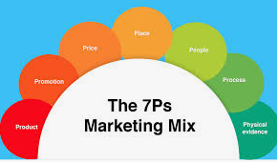

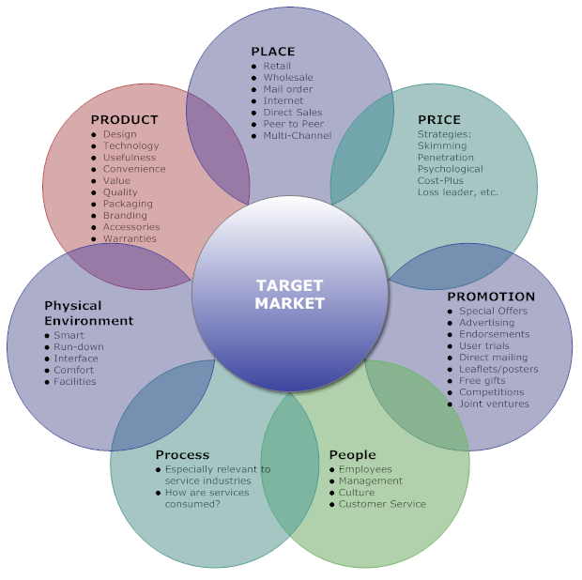
Figure 1: The 7ps of the marketing mix
Source: (Babazadeh et al.,2018,p.385)

Blog 2: The marketing 7 P’s of Sainsbury

Blog 3: Evaluation of Marketing Principle
As stated by Rezvani and Fathollahzadeh (2018, p.145), evaluation of marketing principles is a process by which groups and individuals satisfy their basic needs and requirements through exchanging and creating valued commodities with others. The marketing managers or marketers must synchronize all different activities and processes, to convince their target to gain accurate share and customers in the market. Here, it discusses current and future marketing trends in marketing management of Sainsbury.

Marketing Mix | Sainsbury’s aspects
Product | This company mainly sells and advertises a massive collection of various products with varied customers. This implementation helps customers to represent and accomplish the objective-based interview. These conglomerates supply various types of glossary items and other items like fries, wraps, sandwiches and fries. Currently, these organisations also contribute to bank-related services.
Price | Sainsbury also follows the necessary expenses management trend strategies and assists in identifying the drinks and foods on a basic enormous scale. The varied food merchandise is also abounding in malformed magnitudes that have conflicting cost status as well (B.D.J, 2020,p, 957).
Place | Sainsbury desires to detain the different improvement in production planning. The company also attempted to build the incidence in the marketplace with its incidence in every place in the United Kingdom.
Promotion | Promotion of Sainsbury manages to the television, newspaper and magazines management for advertising of many services. It is fundamentally considerate to function the accurate social media associated approval for the clientele to be a focus for them mainly in all age’s customers living status in many countries towards Sainsbury. This corporation uses an assortment of procedures for deal associated management related promotional status that is also like to accomplish one and accomplish the free strategy advocate for the customers (Cvjetkovic et al., p. 45).
Physical Evidence | It is associated with the basic position rules that function for the corporation for knowledge of the consumer’s environment and knowledge. The company needs to donate management functions associated that can build a basic feeling on consumers and the workforce.
People | The major explanation of organization must make available enhancement and education to the workforce in charge to provide outstanding services managerial and correspond to more consumers to the services and products.
Packaging | The development provides the position of appearance that operates to accomplish. These mostly also assist in commerce out the services and products to the consumers (Ferm and Raco, 2020,p.225).
Share your experience with us!

Blog 3: The current trends of Marketing
As per the viewpoint of Sanader et al., (2017,p.5),the trends of current marketing on which Sainsbury is necessary to spotlight upon cover media marketing, internet marketing and the content marketing.
Internet Marketing Management: This also includes services of marketing and management of products throughout the exploitation of new digital marketing technologies on new internet management through demonstrating advertising status, phone management and Apps include an assortment of many digital mediums. Also reflecting on the present trends, Sainsbury is already occupied in the internet marketing status. The organization is energetic on Instagram and Facebook. Nonetheless, to enlarge the presence, an organization is mandatory to provide a spotlight on remunerated protection campaigns on Instagram and Facebook. The organization is further compelled to be energetic on Twitter and LinkedIn in charge to amplify its shopper reach (Timchenko and Andryushchenko, 2019, p.35).
New Media based marketing strategy: As stated by Vaid et al., (2020, p.225), this part refers to many of fresh media marketing-based planning which the organization commences for the endorsement of many products. The new media marketing strategy making and energetically managing business benefits on media-based channels, bloggers and appointing as the energetic marketing associate, making efficient new content planning using new SEO to accomplish to numerous numbers of consumers. Sainsbury can provide its hard work in new SEO based marketing. It can facilitate the organization to improve its attendance through many searches’ engine-based optimization, management and engaging huge numbers of consumers through basic internet.
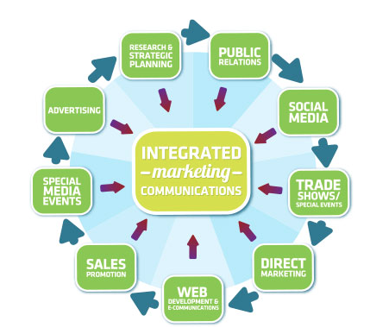

Blog 4: The future marketing trends of Sainsbury
Following trends are related to future marketing which is associated with the organization is also likely to comprise its basic marketing planning for making future trends of marketing requirements.
Relationship associated marketing management: The relationship associated marketing has amplified spotlight on the attractive contentment of the consumers and is embattled on consumer preservation rather than the basic number of products sales which this organization has made. Sainsbury is obligatory to occupation on the communication management with consumers so that consumers of the organization can feel respected and can attach themselves with the company (Vanany et al., 2019, p.105).
Societal Marketing management: The Societal marketing management covenants to investigate and function towards rewarding the commercial social role and responsibilities of clientele for the new welfare management of public status. In this particular context, the organization's accomplishment includes manipulating the superiority of goods and services which also can make available long and short-term profits to the regulars. Managing and considering the future marketing trend of Sainsbury is obligatory to afford good superiority and healthy products to the clientele as per the basis of international glossary standard. Additionally, commence a movement to supply the underprivileged might assist the organization to behave community marketing in an accurate effective method (Wrrink, 2018, p.5).
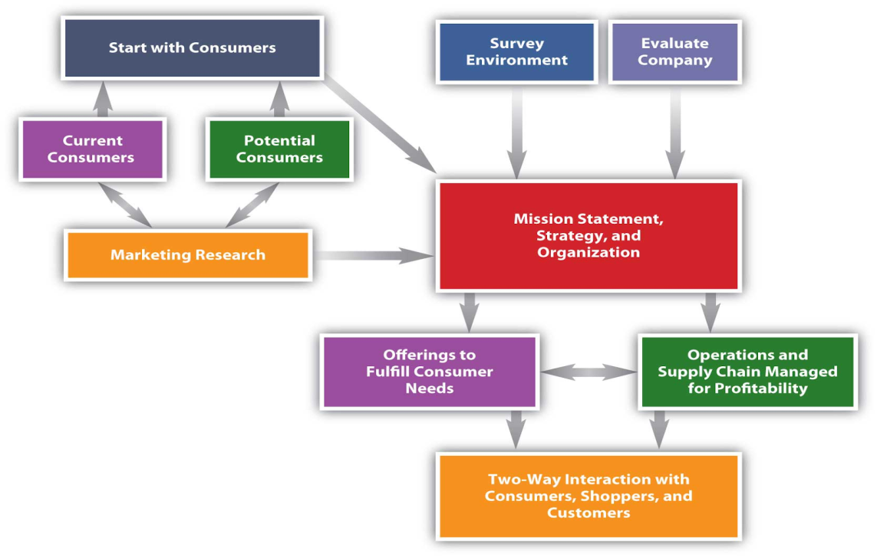
Figure 2: The status of marketing trends
Souce: (Ferm and Raco, 2020, p.225)

Blog 5: Evaluation of Marketing Principle

Blog 6: Functions of marketing principles as well as its evaluation
As stated by Langan et al., (2019, p.35), marketing functional management is principally apprehensive with selling and buying of products for fulfilling the requirements of the consumers. The function of marketing management and key roles includes moving the commodities where business management is essential, goods storing, gathering market knowledge for satisfying the consumer's needs. Here discuss the marketing functions of Sainsbury.
Identifying the needs of the consumer
Basic marketing function associated management is answerable for recognizing the altering requirements of the consumers. This is principally paying attention towards classifying the wants, needs, habits and attitudes of the consumer and managing with awareness analyzing the information to recognize what the consumers are essentially severe in the place of market.
Anticipating consumer requirements
The marketing function is also dependable for the necessities of the consumers. Anticipating consumer's needs makes available the company with first delivery service improvement and can assist the company to assemble the needs and demands of the consumers (Lord and O’brien,2017,225).
Satisfying consumer’s needs
It is referred to as prime responsibilities of basic marketing functional status to convince the requirements of its consumers. The function of marketing must recognize the goods that can convince the requirements of the consumers and can supply them the accurate value for the economy.
Making Profit management
The function of marketing is dependable to develop new and inventive ways to advertise its services and goods to the clients. This can embrace providing the consumers with basic value related packages management which actually cannot also supply the customers the assessment for finance but can also manage to enlarge the general profit and sales of the Sainsbury organization (Meghisan et al., 2017, p.7).
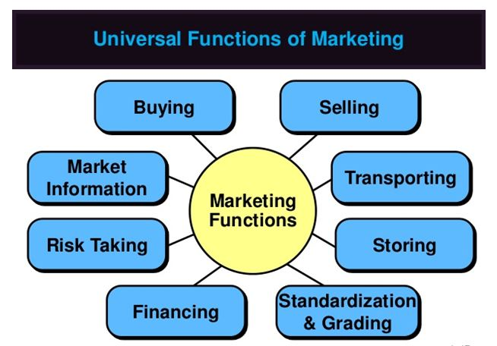
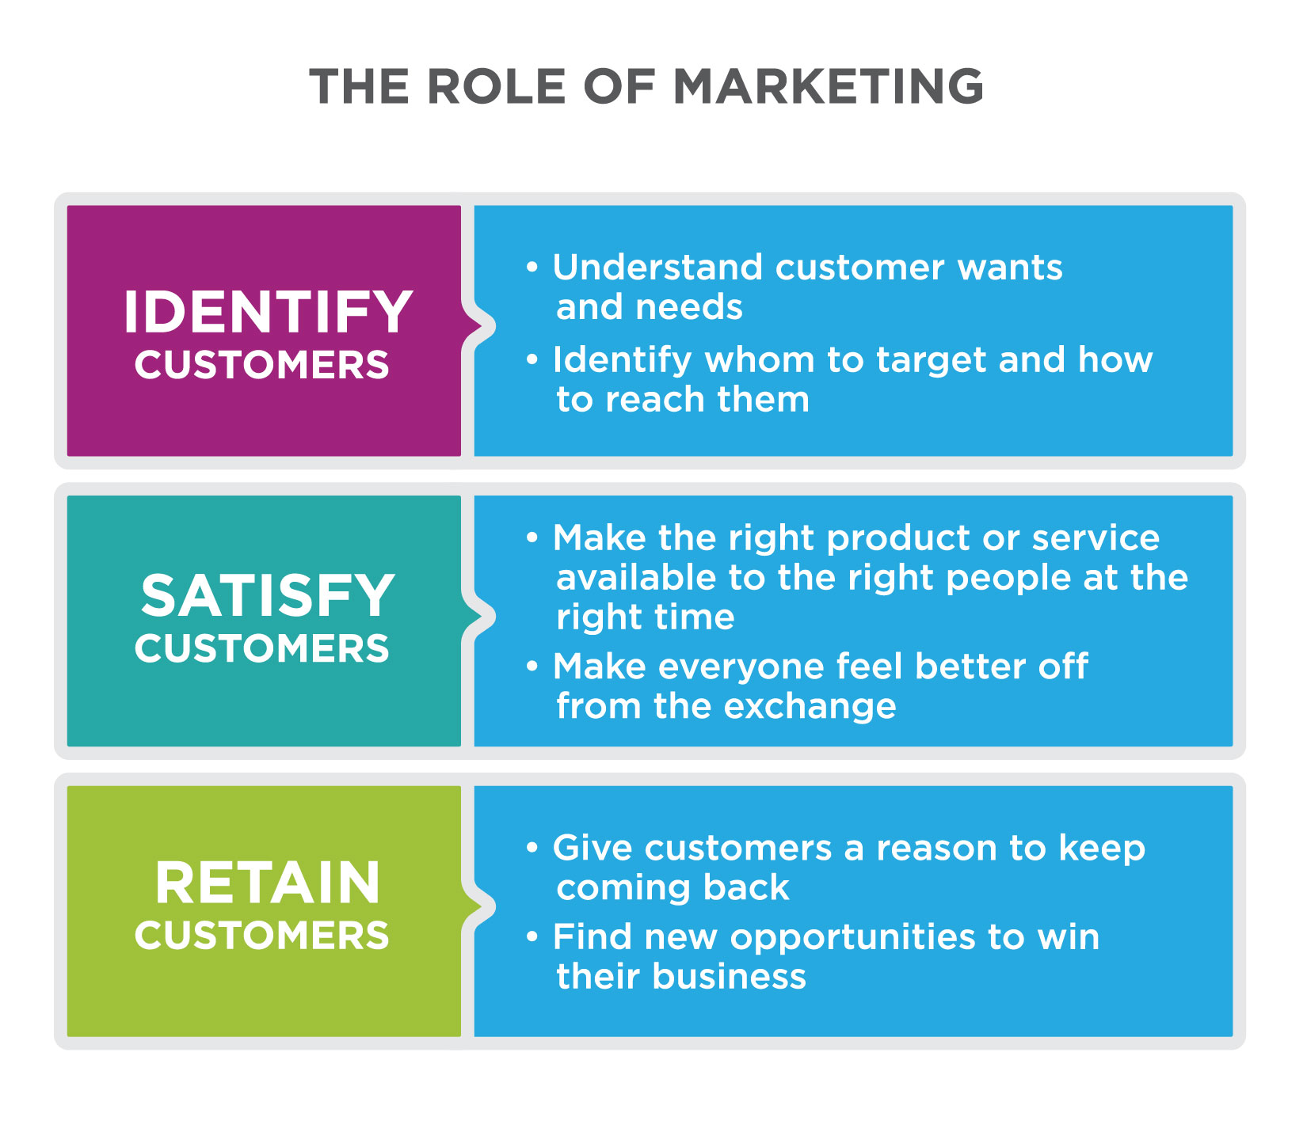
The marketing managers or marketers must synchronize all different activities and processes, to convince their target to gain accurate share and customers in the market.
We would like to hear from you!
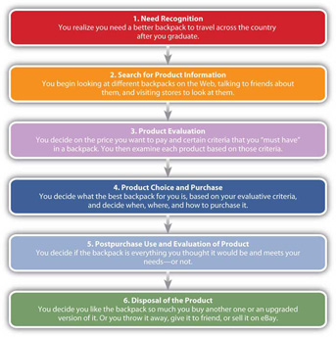
Figure 3: The marketing function of Sainsbury
Source: (Cvjetkovic et al.,2020, p.45)

The Dialogue with the audience:
The Senior Manager Sainsbury's mainly use this as a slogan which is 'Try amazing New things Today' and 'Live healthy For Less'. They use this dialogue to supply and seal many products to customers for gain and increase the profit.

Conclusion

This present study has been focused on core marketing principle management. This study has also involved the marketing mix of Sainsbury. This study has also emphasized on the evaluation of marketing trades and marketing functions.

Reference
Asih, D., 2020. A Complementary Relationship between Marketing Theory and Marketing History. Journal of Advanced Research in Dynamical and Control Systems, 12(SP5), pp.1515–1522. Available at: http://dx.doi.org/10.5373/jardcs/v12sp5/20202073.
B, D.J., 2020. Facebook as a Tool of Marketing in the Era of Digital Marketing. International Journal of Psychosocial Rehabilitation, 24(5), pp.957–964. Available at: http://dx.doi.org/10.37200/ijpr/v24i5/pr201768.
Babazadeh, S. et al., 2018. FPwatch: Facility-based Survey Data for Family Planning Market Analysis in Five FP2020-focus Countries. Studies in Family Planning, 49(4), pp.385–395. Available at: http://dx.doi.org/10.1111/sifp.12077.
Cvjetković, Milena et al., 2020. Digital marketing communications in the function of creating competitive advantages in the market. Marketing, 51(1), pp.43–50. Available at: http://dx.doi.org/10.5937/markt2001043c.
Ferm, J. and Raco, M., 2020. Viability Planning, Value Capture and the Geographies of Market-Led Planning Reform in England. Planning Theory & Practice, 21(2), pp.218–235. Available at: http://dx.doi.org/10.1080/14649357.2020.1754446.
Khojaeva, S.A., 2020. Marketing service in the management of enterprises as a basic function. TRANS Asian Journal of Marketing & Management Research (TAJMMR), 9(3and4), p.23. Available at: http://dx.doi.org/10.5958/2279-0667.2020.00013.9.
Langan, R., Cowley, S. & Nguyen, C., 2019. The State of Digital Marketing in Academia: An Examination of Marketing Curriculum’s Response to Digital Disruption. Journal of Marketing Education, 41(1), pp.32–46. Available at: http://dx.doi.org/10.1177/0273475318823849.
Lord, A. and O’Brien, P., 2017. What price planning? Reimagining planning as “market maker.” Planning Theory & Practice, 18(2), pp.217–232. Available at: http://dx.doi.org/10.1080/14649357.2017.1286369.
Meghisan, G.-M. & Burger-Helmchen, T., 2017. Meta-analysis in marketing research. Innovative Marketing, 13(1), pp.6–10. Available at: http://dx.doi.org/10.21511/im.13(1).2017.01.
Rezvani, M. and Fathollahzadeh, Z., 2018. The impact of entrepreneurial marketing on innovative marketing performance in small- and medium-sized companies. Journal of Strategic Marketing, 28(2), pp.136–148. Available at: http://dx.doi.org/10.1080/0965254x.2018.1488762.
Sanader, D., Laketa, M. & Laketa, L., 2017. Marketing analytics in the function of decision making in banks/marketing analitika u funkciji donošenja odluka u bankama. EMC Review - Časopis za ekonomiju - APEIRON, 13(1). Available at: http://dx.doi.org/10.7251/emc1701093s.
Timchenko, A. and Andryushchenko, I., 2019. THE PLACE OF FINANCIAL PLANNING IN MARKET ECONOMY. Market Infrastructure, (35). Available at: http://dx.doi.org/10.32843/infrastruct35-46.
Vaid, S. (Sash), Ahearne, M. & Krause, R., 2020. Joint marketing and sales appointment: Uncertainty from the intertwining of marketing and sales in one position. Industrial Marketing Management, 85, pp.221–239. Available at: http://dx.doi.org/10.1016/j.indmarman.2019.11.013.
Vanany, I., Maarif, G.A. & Soon, J.M., 2019. Application of multi-based quality function deployment (QFD) model to improve the halal meat industry. Journal of Islamic Marketing, 10(1), pp.97–124. Available at: http://dx.doi.org/10.1108/jima-10-2017-0119.
Warrink, D., 2018. The Marketing Mix in a Marketing 3.0 Context. International journal of innovation and economic development, 4(4), pp.7–30. Available at: http://dx.doi.org/10.18775/ijied.1849-7551-7020.2015.44.2001.

