STUDENT NAME AQSA SHAHZADI
STUDENT ID 2318967
MODULE NAME Digital Skills and Research Methods
MODULE CODE LCHS4007
ASSIGNMENT TITLE Component 2 – Research Report
SUBMISSION DATE 25th March 2025

Table of Contents
TASK 1 3
1. Introduction 3
2. The Rationale of the Study 4
2.1 The Impact of Digital Skills of Workers on Communication Skills 5
2.2 The Impact of Workers’ Digital Skills on Administrative Skills 5
2.3 The Impact of Digital Skills on Workers’ Development 5
2.4 The Impact of Digital Skills on Workers’ Professional Collaboration 6
3. Information Sources 6
4. Types of Data 7
4.1 Primary Data 7
4.2 Secondary Data 7
5. Data Considerations for the Current Research 7
6. Conclusion 8
7. References 9

TASK 1
Workforce Development and Retention through enhancing workers’ Digital Skills to overcome Workforce Crisis

Introduction
The healthcare industry is undergoing a significant transformation. The traditional setting of doctors, nurses, and administrative personnel is being transformed into a data-driven ecosystem by digital health tools and sophisticated computer science methods. According to a recent assessment of the difficulties facing digital transformation in the healthcare industry, the largest barrier to taking advantage of the opportunities presented by new technology is a lack of specialized knowledge and abilities (Mauro et al., 2024). According to the report by the European Health Parliament, the majority of healthcare professionals reported using digital skills more than once a week, whereas basic IT abilities and electronic patient records were utilized every day by almost half of the survey participants shown in Figure 1.
Figure 1: Use of Digital Skills in Current Practice
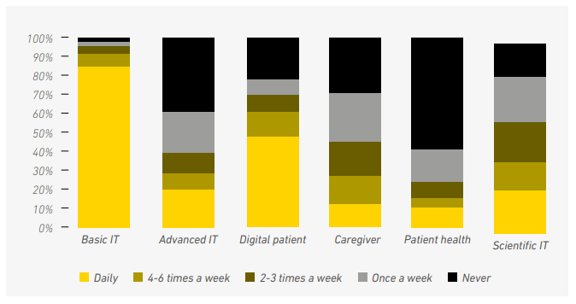
Source: European Health Parliament 2016
Moreover, the survey further emphasizes the significance of digital skills by evaluating their current and future consumption which highlights its importance for routine healthcare professionals to provide efficient services illustrated in figure 2.

Figure 2: Relevance of Digital Skills for Current and Future Practice
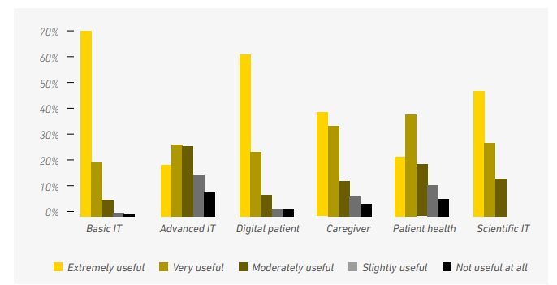
Source: European Health Parliament 2016
Despite the digital revolution's potential, many health professionals believe they lack enough training. Health workers prioritize continuous education throughout their careers. This training should be practical and interactive, with direct patient benefits (European Health Parliament 2016).

The Rationale of the Study
Staffordshire's Health and Social Care industry is failing to locate prospective workers with digital skills. According to a survey conducted for the Local Skills Improvement Plan (LSIP), 25% of businesses in the industry are looking for applicants who are computer and web proficient. In health sector businesses, approximately 71% have also claimed that they require individuals with sector-specific technical talents to experience challenges (Quenby, 2024). According to the NHS Long Term Workforce Plan, the number of persons aged 85 and more is estimated to increase by 55% by 2037, resulting in a workforce deficit of between 260,000 and 360,000 by 2036/37.
This scarcity is already having an impact on the patient experience, service capacity, and productivity, as well as the ability to improve patient care. An increasing deficiency would provide difficulties and missed chances. To ensure that the NHS remains the public's trusted health service, a solid plan must be in place to ensure that the necessary number of people, skills, and support are available to provide high-quality care at the point of need (NHS, 2023).
Digital skills are essential in today's technologically advanced society, yet the digital gap impedes growth. Although 92% of firms believe that basic digital skills are necessary for employees, 23% indicate a large skills gap. Almost a quarter of businesses say their employees are insufficiently digitally competent to complete their tasks. The NHS, the UK's largest employer, reflects the country's skills shortage in its staff. As technology becomes more prevalent and important in delivering effective health care, staff members must become entirely proficient, self-assured, and capable in its use (Diaz n.d.). A lack of digital skills can cause irritation and burnout among healthcare staff, adding to turnover and aggravating workforce shortages (Randa and Phale. 2023).
Developing digital skills can help healthcare staff advance in their careers while also increasing workplace satisfaction and retention. Digital literacy is required for healthcare personnel to feel knowledgeable and confident in their positions (Diaz n.d.). Many healthcare organizations still use out-of-date IT systems, which can impede the adoption of new technology and worsen the digital skills gap (Iyanna et al., 2022). Therefore, it is beneficial to enhance workforce digital skills for workers’ development and retention in several aspects to deal with healthcare workforce shortages are discussed below.

2.1 The Impact of Digital Skills of Workers on Communication Skills
The essential abilities in a human-oriented connection include a person-centered approach, relationships, and taking into account patients' preferences. This is consistent with the digital skills framework, which focuses on communication and collaboration in digital skills (Handley et al., 2022). It entails actively listening, connecting with the patients' stories, and investigating emotional indicators (Bashir and Miyamoto 2020). Furthermore, patients perceived that they possessed the ability to build positive relationships and speak in a courteous and supportive manner with healthcare workers (Jørgensen et al., 2021).

2.2 The Impact of Workers’ Digital Skills on Administrative Skills
As patient information gets moved online and healthcare relies more on technology, staff need to have digital skills. It's not just a choice anymore. Today, health care providers need these skills to give good and effective care. Using technology effectively helps increase productivity and efficiency, and it also improves patient results and the quality of care (Feirrera et al., 2024).

2.3 The Impact of Digital Skills on Workers’ Development
Providing opportunities for care professionals to learn new skills and use new technology can boost job satisfaction, help them achieve their career goals, and inspire new career paths. Digital skills can help with overall skill development as well as the integration of health and social care services. A defined pay and progression framework is required for digital skills development, as without acknowledgment, employees may move on to more appealing roles, increasing worker turnover (Oung et al., 2021).

2.4 The Impact of Digital Skills on Workers’ Professional Collaboration
Digital tools simplify procedures, lowering administrative responsibilities and providing additional opportunities for collaborative healthcare planning. Electronic health record systems improve teamwork and reduce errors by allowing for effective data sharing across departments. They let healthcare practitioners to properly analyze health data, facilitating data-driven decision-making and collaborative medical planning (Feirrera et al., 2024).

Information Sources
Skills for Care - Adult Social Care Workforce Data offers detailed information on the adult social care workforce in England, including workforce size, job vacancies, and turnover rates. Their reports provide information about the sector's structure and difficulties, such as excessive job vacancies and turnover. The website is useful because it provides a full examination of the social care workers, including demographic information and employment patterns (SFC 2024).
The National Health Service (NHS) recorded and forecasted data in NHS Workforce Statistics which publishes monthly workforce statistics, which include numbers of workers by profession and position. Such data are useful for tracking changes in workforce composition and size over time. It provides vital data on the NHS workforce, such as the amount of workers and vacancies, which is critical for understanding workforce difficulties. (NHS, 2024).
The Office for National Statistics (ONS) publishes data on the healthcare workforce in the UK, including the number of medical practitioners, nurses, and other healthcare workers. This information is useful in comparing workforce trends across regions. It provides an expanded viewpoint on healthcare workforce trends, highlighting variations in workforce policies and statistical approaches across the United Kingdom (ONS, 2024).

TASK 2

Types of Data

4.1 Primary Data
To specifically address a research question or issue, primary data was gathered straight from the source (Ajayi, 2023). Data that is directly gathered from healthcare professionals via surveys or interviews with the express purpose of determining how digital skills affect retention would be regarded as primary data. Surveys, interviews, and observations created especially to acquire fresh data regarding the digital capabilities and retention of healthcare staff are a few examples.

4.2 Secondary Data
Data that has previously been gathered by another party and is being utilized for a different purpose is referred to as secondary data (Ajayi, 2023). Publishable reports on the results of digital skills training, administrative data from healthcare businesses, and current research on healthcare workforce trends are a few examples. Secondary data would be defined as information that has been taken from previously published studies, publications, or databases (e.g., training program outcomes, and workforce demographic data).

Data Considerations for the Current Research
Healthcare businesses can solve workforce shortages, boost digital skills, and improve overall care delivery by utilizing these secondary data sources to guide their plans. Secondary data sources, which provide insights from a range of parties and projects, provide a comprehensive perspective on the workforce problem and the challenges associated with digital skills. Data and analysis from these sources back up evidence-based workforce development and retention plans. Primary data collection is less necessary when pre-existing research and reports are used, which saves time and money. These resources frequently represent ongoing governmental priorities and projects, guaranteeing that plans are in line with national frameworks and objectives.

Conclusion
The UK's health and social care industry is experiencing a personnel crisis that is only going to become worse over time, underscoring the necessity of a thorough plan to guarantee sufficient manpower and expertise. This study focuses on how a lack of digital skills among healthcare workers might result in higher turnover, burnout, and frustration. Since digital skills improve the quality and results of patient care, they are essential for professional, administrative, and communication development. The development of digital talents requires a clear structure for compensation and advancement.
Digital tools facilitate collaborative healthcare planning, simplify processes, and lessen administrative burdens. Additionally, secondary data sources like Skills for Care, ONS, and NHS Workforce Statistics, which can assist healthcare organizations in addressing workforce shortages, enhancing digital skills, and improving care delivery going forward, would be appropriate for the study of workforce development and retention through improving workers' digital skills to overcome workforce crises.

References
Ajayi, V.O. (2017). ‘Primary sources of data and secondary sources of data’. Benue State University, 1(1), pp.1-6.
Bashir, S. and Miyamoto, K., 2020. Digital Skills. Washington DC: The World Bank Group.
Diaz, D. (n.d.). Digital literacy in healthcare. Available at: https://online.sunderland.ac.uk/digital-literacy-in-healthcare/ (Accessed 15 March 2025).
European Health Parliament (2016). Digital Skills for Health Professionals Committee on Digital Skills for Health Professionals. Available at: https://www.healthparliament.eu/wp-content/uploads/2017/09/Digital-skills-for-health-professionals.pdf (Accessed 14 March 2025).
Ferreira, J. C., Elvas, L. B., Correia, R., and Mascarenhas, M. (2025). ‘Empowering Health Professionals with Digital Skills to Improve Patient Care and Daily Workflows’. Healthcare, 13(3), 329. https://doi.org/10.3390/healthcare13030329.
Handley, N. R., Heyer, A., Granberg, R. E., Binder, A. F., Gentsch, A. T., Csik, V. P., Garber, G., Worster, B., Lopez, A. M., and Rising, K. L. (2022). ‘COVID-19 Pandemic Influence on Medical Oncology Provider Perceptions of Telehealth Video Visits’. JCO oncology practice, 18(4), e610–e619. https://doi.org/10.1200/OP.21.00473.
Iyanna, S., Kaur, P., Ractham, P., Talwar, S. and Islam, A.N., 2022. ‘Digital transformation of healthcare sector. What is impeding adoption and continued usage of technology-driven innovations by end-users?’ Journal of Business Research, 153, pp.150-161.
Jørgensen, L., Jacobsen, H. R., Pedersen, B., and Uhrenfeldt, L. (2021). ‘Calling an Oncological Emergency Telephone to Seek Advice: An Interview Study’. Cancer nursing, 44(2), 98–105. https://doi.org/10.1097/NCC.0000000000000778.
Mauro, M., Noto, G., Prenestini, A. and Sarto, F. (2024). Digital transformation in healthcare: Assessing the role of digital technologies for managerial support processes. Technological Forecasting and Social Change, 209, p.123781.
NHS (2023). NHS Long Term Workforce Plan. Available at: https://www.england.nhs.uk/long-read/nhs-long-term-workforce-plan-2/ (Accessed 16 March 2025).
Office for National Statistics (2024). The healthcare workforce across the UK: 2024. Available at: https://www.ons.gov.uk/peoplepopulationandcommunity/healthandsocialcare/healthcaresystem/articles/thehealthcareworkforceacrosstheuk/2024 (Accessed 16 March 2025).
Oung, C., Rolewicz, L., Crellin, N. and Kumpunen, S. (2021). Developing the digital skills of the social care workforce. Research summary. Available at: https://www.nuffieldtrust.org.uk/sites/default/files/2021-09/workforce-research-summary-final.pdf (Accessed 17 March 2025).
Quenby, R. (2024). Skills Gap crisis: Health sector badly hit by lack of staff with digital aptitude. Available at: https://daily-focus.co.uk/2024/02/skills-gap-crisis-health-sector-is-badly-hit-by-lack-of-staff-with-digital-aptitude/ (Accessed 14 March 2025).
Randa, M.B. and Phale, J.M. (2023). ‘The effects of high nurses’ turnover on patient care: Perspectives of unit managers in critical care units’. International Journal of Africa Nursing Sciences, 19. 100580. 10.1016/j.ijans.2023.100580.
Skills For Care (2024). The state of the adult social care sector and workforce in England. Available at: https://www.skillsforcare.org.uk/Adult-Social-Care-Workforce-Data/Workforce-intelligence/documents/State-of-the-adult-social-care-sector/The-state-of-the-adult-social-care-sector-and-workforce-in-England-2024-Executive-Summary.pdf (Accessed 16 March 2025).

