
Global marketing strategy
Country and Market Entry

Jessica Rees - 1703037

February 2020


Table of contents

Executive Summary………………………………………………………………..Page 1

1. Introduction……………………………………………………………………………Page 2

1.2 Background to organisation,…………………………………………………Page 2

2. Introduction to Global Markets…………………………………………Page 3

2.1 Current Global Market Opportunities for Uber………………………Page 4

3. Marketing Mix for Uber……………………………………………………..Page 6

4. Market Entry Opportunities……………………………………………….Page 8

5. Conclusion………………………………………………………………………….Page 9

6. Recommendations………………………………………………………………….Page 9

7. References……………………………………………………………………………..Page 10

List of Figures

Figure One: Countries that Uber currently operates in. ………………………………..Page 4
Figure 2. Most recent figures of demand for transportation in Italy………………Page 6
Figure 3. The 7Ps …………………………………………………………………………………………..Page 8

Executive Summary

The purpose of this report is to establish an international market opportunity for Uber. Uber started as a simple idea on a cold winter evening in Paris in December 2008. Founders Travis Kalanick and Garrett Camp couldn’t get a taxi, resulting in the birth of Uber. By March 2009, the entrepreneurs had developed a smartphone app with a simple use - tap a button and take a trip. By July 2010, the first Uber ride was requested across San Francisco. (Uber.com, 2020)
Throughout the research conducted in this report, it is found that Uber already have a strong presence in many countries around the globe, although there are still many opportunities to venture further to new markets in different untouched countries. According to Muchneeded.com (2020), Uber currently operates in 83 countries and over 858 cities across the globe. Although, only a number of cities are known as Ubercabs cities such as New York, San Francisco and Los Angeles, due to being the most active in the west. To focus Uber away from its home country, the research in this report will help identify another market Uber can develop an entity in.
A market opportunity, founded through research, is Italy. Although it is worth considering that Uber already has a presence in Italy but was forced to take a hit due to fierce competition. It is argued throughout the findings in this report that perhaps Uber did not evaluate the market well enough to have identified these risks prior to entering, although this report will help scale how the framework of the marketing mix can help identify many risks by assessing each supporting factor in the business’ running.
The findings of this report will also find that Uber will need to consider their market entry to Italy, with the hopes of being successful by looking further into how a partnership with originating taxi drivers and companies can help keep Uber abiding by compliance and non-discriminating regulations. Although this brings inevitable disadvantages, the advantages could prove Uber to be successful in another country.

1

Introduction

Over the past few decades, globalisation has changed the way businesses work on an international level. It refers to the growing interdependence of self-contained countries, whilst continually moving towards a more integrated world, resulting in a company who once associated with a single country, to now operating in multiple. (Hollensen, 2013) Global marketing is the utilisation of international marketing, referring to the application of marketing principles to cater to the needs and wants of people residing in these different areas. (Lee, 2005) Globalisation often occurs surrounding 4 main factors: suppliers, customers, producers and governments – key parts to operating internationally. Undertaking marketing activities in more than one country or nation means designing the marketing mix according to the preferences of the local people.

1.2 Background to organisation

Uber started as a simple idea on a cold winter evening in Paris in December 2008. Founders Travis Kalanick and Garrett Camp couldn’t get a taxi, resulting in the birth of Uber. By March 2009, the entrepreneurs had developed a smartphone app with a simple use - tap a button and take a trip. By July 2010, the first Uber ride was requested across San Francisco. (Uber.com, 2020)
One year on and Uber was launched internationally, taken back to its birthplace in Paris which happened 3 years prior. By 2012, Uber’s potential to be more than just a ridesharing business was recognised resulting in on-demand ice cream deliveries launched in 7 cities across the US! From here Uber recognised its potential to create new projects, some of which that help important movements and local communities. Examples of these are the support of the LGBTQ+ community, UberKITTENS, UberMILITARY, Uber Eats, ‘Meals on Wheels’, Uber Health and so forth.

2

Introduction to Global Markets

Although in recent years more businesses are being introduced to global markets, global trading is not a new phenomenon, in fact there were many wars due to trading rights over a country or region. In fact, global trade has accelerated immensely, which has had a huge impact on economies.
The British Chambers of Commerce carried out a survey with 4,700 companies and found that over half (55%) of business noticed the positive impact that international expansion had on their bottom line within 12 months. (Britishchambers.org.uk, 2020) Doole, et al (1995) supports this point by noting that a company that has a presence in more than one country ensures that the firm isn’t reliant on the health of one economy. International expansion also mean an increase of sales, especially if domestic growth has taken a hit or stalled. By entering a new global market, there will be less competition and the demand may even be higher.
Whilst global expansion has its advantages, they are also many difficulties to doing so. For example, every country has differences in the way they operate. Building an infrastructure to work legally and compliantly can be very costly and time consuming since accountants, international HR staff and perhaps lawyers would be necessary to keep a successful running business. Even if a business is shutting down, closing the operation can be expensive and won’t always be instant. The inevitability of entering new markets can also be complex, especially when a new country is different to the company’s home country. For Uber to expand to an international market, they must adapt and operate according to the regulations of the government and to do so, it is important to hire and partner with the correct people who will help keep the company compliant, following all business regulations day to day, but this can also be costly and time consuming to find the right people. (Capital GES, 2020)

3

2.1 Current Global Market Opportunities for Uber

According to Muchneeded.com (2020), Uber currently operates in 83 countries and over 858 cities across the globe. Although, only a number of cities are known as Ubercabs cities such as New York, San Francisco and Los Angeles, due to being the most active in the west.
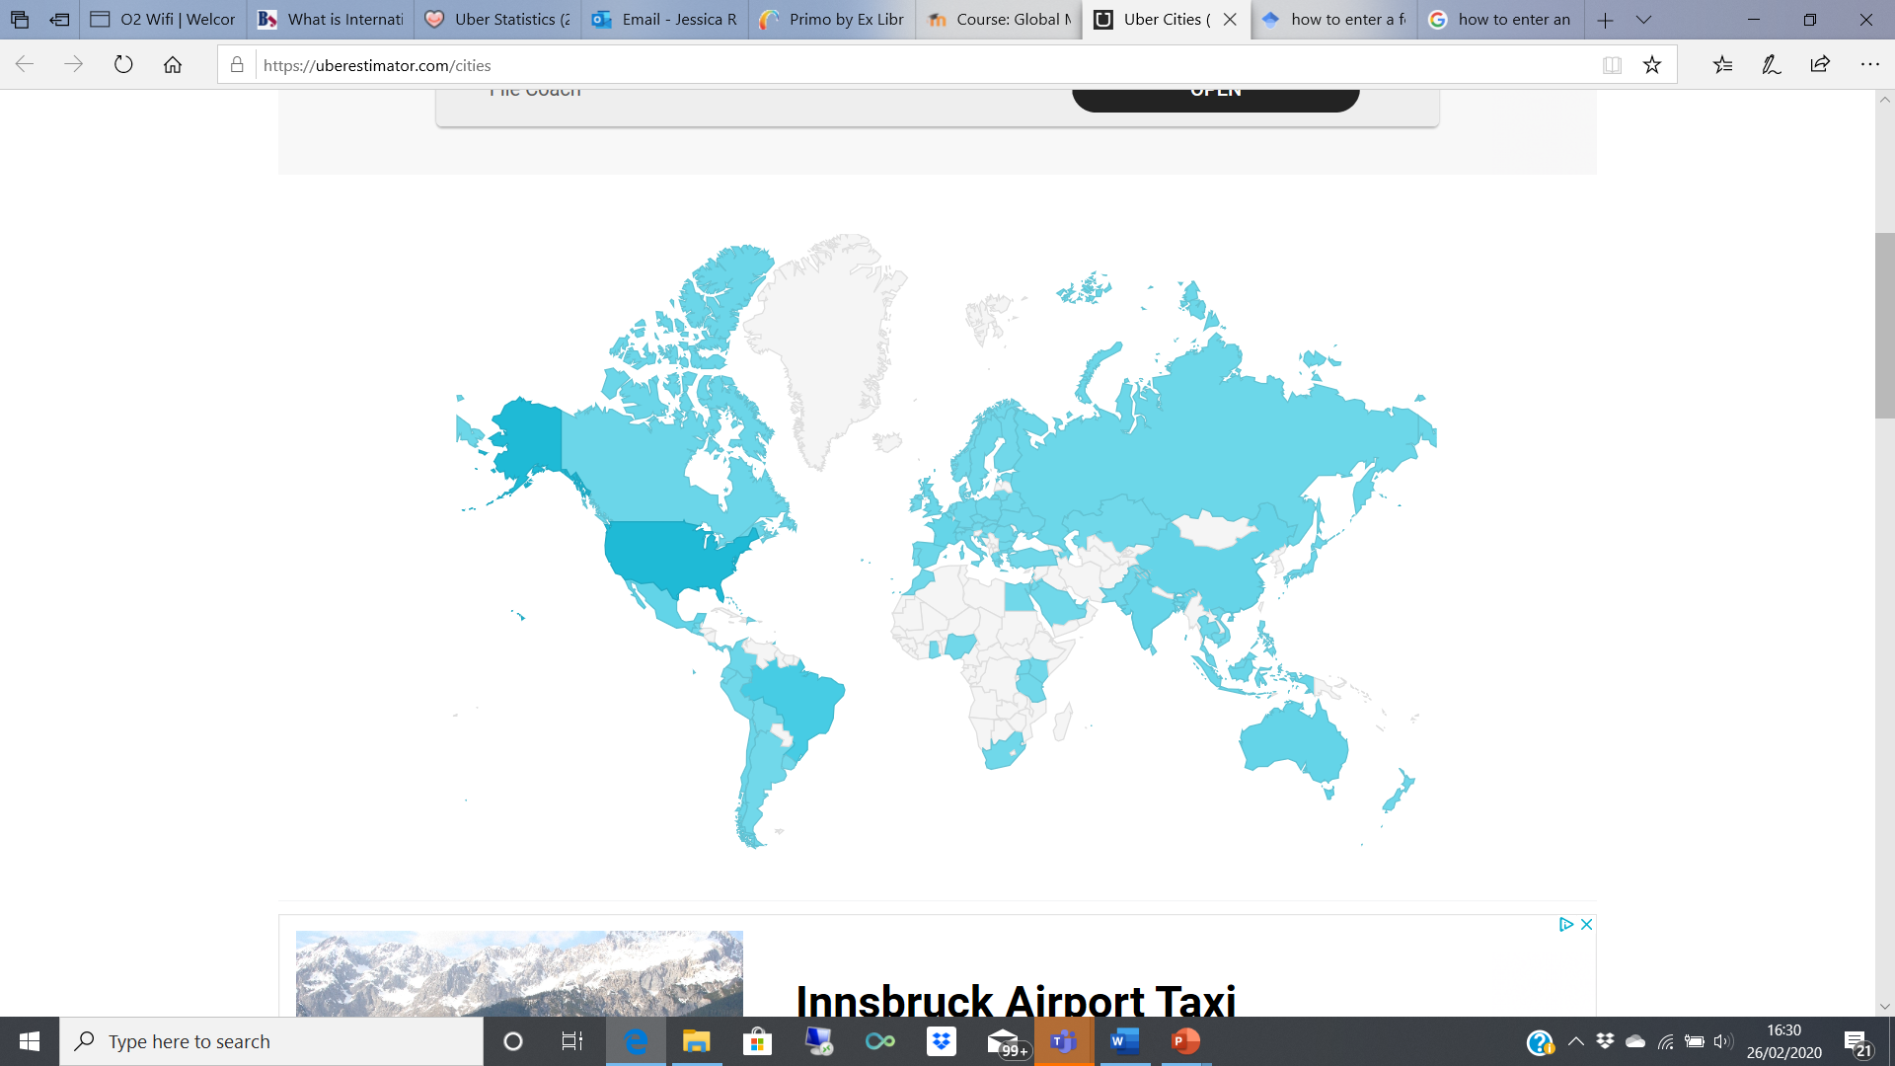
Image 1. Countries that Uber currently operates in. Source: https://uberestimator.com/cities

In the above image, it is clear to see that Uber has established many different markets across the globe. Although, there are still many more countries and cities that Uber is yet to reach, such as Italy. Italy is a picturesque country, renowned as one of the most popular tourist countries. With tourists coming in and out of the country, as well as exploring what the country has to offer, the demand for transportation is inevitable.

4

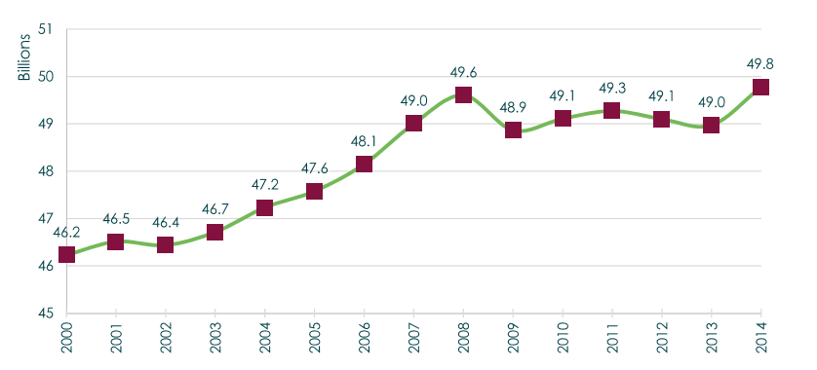
Figure 2. Most recent figures of demand for transportation in Italy. Source: https://www.uitp.org/news/statistics-brief-PT-in-the-EU

The above figure shows the most recent record of demand for transportation in Italy. Between 2008 to 2014, demand has seen to have slipped up and down, mainly due to the country’s economy, as well as issues regarding citizens disposable income to use transportation companies, and the amount of tourism during these periods. As of 2014, 6 years on and Italy is still thriving, with more and more people being eager to explore what the country has to offer. This rise in demand or perhaps ideal level is perfect for Uber to see where the niche is for the company can thrive.
Uber has an interesting competition in Italy, so much so that it was originally banned in some areas of Italy due to apparent unfair competition the company had with Italy’s cab drivers. Thelocal.it (2015) wrote about how Italian taxi drivers filed a compliant during April 2015 against Uber. Despite this hit, Uber released a statement looking into any appeal possibilities to continue Uber in Italy whilst keeping Italian citizens and workers safe and unproportionally discriminated, backed up by the company’s business model whilst citing the European Commissions rules of fairness with these technology-based services.
For Uber to operate more vastly around Italy, especially in thriving cities to even slightly smaller ones, this can help drive tourism to the country, as well as creating more jobs in the local community.

5

Marketing Mix for Uber

In basic marketing, businesses know that selling alone is only the basic factor of a marketing spectrum. Cateora, et al (2009) argues that profitability and shareholder value are the most important factors in all marketing pursuits. Major components of marketing are often seen under the marketing mix framework. As defined by Kotler et al (2020), it is simply about putting the right product or combination of such in the right place, at the right time and at the right price. To understand the marketing mix from a global perspective, the company needs to understand that their elements of the framework is either standardisation or adaption. For Uber, this will depend on the market they are trying to enter, as the company may need to rethink the product offering due to the country’s circumstances. Vrontis (2003) explains that with global expansion, adaptation is usually necessary as it involves modifying the product or service to meet the requirements and customs of the market. Uber would have to modify the ways of the company to fit the legal requirements of the market they are entering. Not only should Uber be aware of the adaptation needed to enter new markets, but to be aware of maintaining an ethnocentric approach, where HR hires the right person for the job in this international business, based on the skills required to mix with the culture of the country. (The Marketing Mix, 2020)
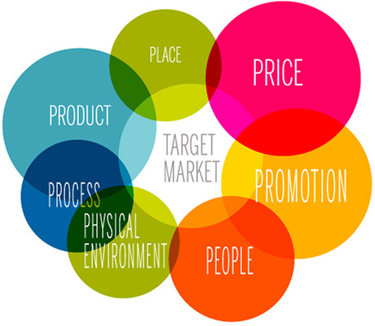
Figure 3. The 7Ps. Source: https://marketingmix.co.uk/

6

Bennett & Blythe (2002) define these individual factors as; product refers to the design and quality of the output, as well as assessing customers needs and how products are sold, including aftersale service.
In order for Uber to start utilising their marketing mix, the company needs to establish their target market as well as any other people directly affected, as it is important to hire and train the right people who will bring the superior service Uber expects. Since a service like Uber depends on people to perform them, the customer’s satisfaction is based on the quality and nature of the interaction between the service provider and the result hopefully being a positive experience. If Uber employee a person who enjoys driving and knows the surrounding areas well, it is likely the driver will help build the trust with the customer which, for a competitor, will be hard to break. (Brassington & Pettitt, 2006)
Physical evidence is a key driver in Uber’s marketing mix. This element can relate to the car being used, to the workings of the app. Although cars differentiate in each country, a customer would expect a relatively tidy car that can perform the job well with no interfering issues. If a customer was to be picked up in a car that needed a lot of work or was untidy on the inside, this will out strain on the perception of the company from consumers.
Pricing is another important factor for Uber, as there is not necessarily one set price. Uber calculates their prices due to contributing factors such as the time and distance of a trip, if a particular city has a flat fee or if a ride is requested during a busy time or area. Not only this, but Uber will decide what car is suitable for your requested journey.
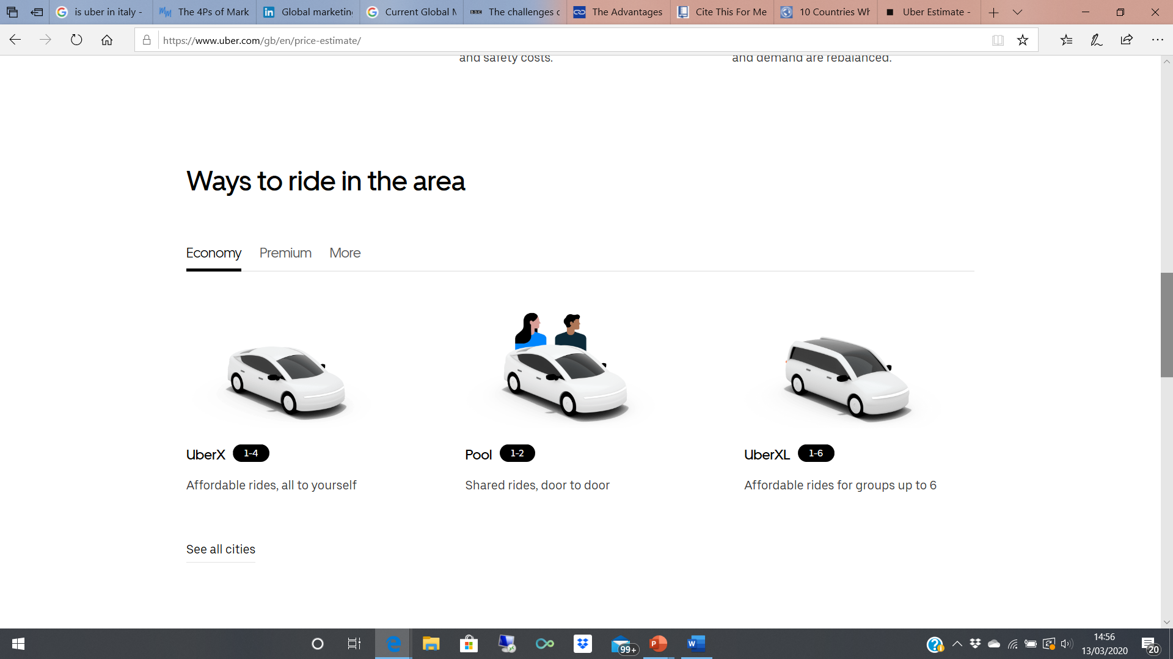
Figure 3. Ways to ride with Uber. Source: https://www.uber.com/gb/en/price-estimate/

7

The above figure shows how the vehicle you ride in is determined by your request, for example, the amount of people you are with, if you don’t mind sharing rides, travelling alone or even a short distance journey.

Market Entry Opportunities

Before Uber expand globally, they should look at key considerations such as how much will need investing? Does the company have the cost and time frames needed to set up a foreign entity? Has the right people been hired to keep the business running? Can the company manage and work with compliance, taxation and immigration regulations? (Strategydriven.com, 2020) Once Uber is confident that these factors are manageable, the next stage forward can be planned.
As discovered in the research, Uber’s main competition in Italy is other taxi companies, of whom can bring fierce competition to this type of industry. In Uber’s previous statement to the backlash of their Italian competition, the company backed up the European Commission rules of fairness, compliance and non-discrimination. Although it seems Uber would struggle to reinforce the company further into Italy, there is a different type of market entry Uber could take – Partnerships with current and original taxi drivers/companies. Sapp (2004) describes a partnership as a legal form of business operations between two or more individuals who share management and profits. It is typical for a partnership to be either general or limited. For Uber, a limited partnership would perhaps be the best route as there is both limited and general partners. Whilst the general partners are the side of the partnership that operate the business and own all liability, while the limited partners serve only as investors and do not necessarily have any control over the company or subject to liabilities. This could prove to the best route Uber can take to re-establish the brand in Italy, as this will mean the company is compliant with any originating taxi drivers/companies as both will continue to make money whilst being partnered together, which in actuality could benefit originating taxi companies more by bringing more awareness and pushing the company out further.
8
Whilst the decision to take on a partnership widely depends on the feelings of the Italian taxi companies, there is no way of predicting whether this route will work. Although, deploying a partnership market entry will mean that more high-calibre employees are made partners, specifically those who know the cities of Italy well. This will also mean that Uber can alter their legal structure easily if circumstances were to change. Whilst there are many more benefits, Uber should be aware that there is a risk of disagreements, perhaps if business decisions are put forward that are not supported by everyone. If it came to Uber needing to dissolve their partnership and close down the entity in Italy, this could mean seeking legal advice which could be costly and time consuming. (Business.tas.gov.au, 2020)

9

Conclusion

To conclude, Uber is a strong brand that can dominate almost any new markets they have not already got an entity in. By dominating these markets, Uber can be certain that the face of the business is not reliant on one country’s economy, and whilst doing so the increase of sales this brings is inevitable. Despite this, research into this suggest that Uber needs to be aware of the time consumption and costs involved with entering a new market, and to ensure that they are healthy enough for this, the company must assess the market as well as their financial position before going further. Uber can make use of the marketing mix to assess these global markets, as it focuses on each element regarding people, price, physical evidence and so forth, ensuring that a full analysis is done so any threats or opportunities are spotted.

Recommendations

A recommendation for Uber would be for them to understand any threats that are posed to them before entering a market. For example, when Uber initially entered Italy, they took a hit with the fierce competition from taxi companies and drivers, all of whom filed complaints over Uber until the company was forced to take a step back by only having Uber available in selected parts of the country.
Since Uber is a company based around technology, it would be deemed important for the company to stay up to date with the latest technology. Although Uber should consider ways for customers to reach them that is not through an app as not everyone may have access this. Vehicle advancements as the company ages is another important factor in modern society. It is predictable that only a couple of decades from now, Uber may be operating driver-less cars.

10

References

Bennett, R. & Blythe, J., 2002. International marketing: strategy planning, market entry & implementation. 3rd ed / Roger Bennett & Jim Blythe., London: Kogan Page.
Brassington, F. & Pettitt, S., 2006. Principles of marketing 4th ed., New York: Prentice Hall.
Britishchambers.org.uk. 2020. International Market Access. [online] Available at: <https://www.britishchambers.org.uk/page/trade-support-international-market-access> [Accessed 13 March 2020].
Business.tas.gov.au. 2020. Partnership – Advantages And Disadvantages - Business Tasmania. [online] Available at: <https://www.business.tas.gov.au/starting-a-business/choosing-a-business-structure-intro/partnership-advantages-and-disadvantages> [Accessed 13 March 2020].
Capital GES. 2020. The Advantages And Disadvantages Of International Expansion - Capital GES. [online] Available at: <https://www.capital-ges.com/the-advantages-and-disadvantages-of-international-expansion/> [Accessed 13 March 2020].
11
Cateora, P.R., Gilly, M.C. & Graham, J.L., 2009. International marketing 14th ed., Boston: McGraw-Hill Irwin.
Ellis, P., 2000. Social ties and foreign market entry. Journal of international business studies, 31(3), pp.443-469.
Hollensen, S., 2013. Global marketing 6th ed., Pearson Education Ltd
Keegan, W.J. & Green, M.C., 2013. Global marketing 7th ed., global., Boston, Mass. ; London: Pearson.
Kotler et al., 2020. Principles of marketing Eighth.,
Lee, Carter & Carter, S., 2005. Global marketing management : changes, challenges and new strategies, Oxford ; New York: Oxford University Press.
Muchneeded.com. 2020. Uber By The Numbers: Users & Drivers Statistics, Demographics, And Fun Facts. [online] Available at: <https://muchneeded.com/uber-statistics/> [Accessed 13 March 2020].
Phillips, C., Doole, I. & Lowe, R., 1995. International marketing strategy, London: Routledge.
Rahman, M., Uddin, M. and Lodorfos, G., 2017. Barriers to enter into foreign markets: Evidence from SMEs in emerging market. International Marketing Review, 34(1), pp.68-86.
Sapp, David Alan, 2004. GLOBAL PARTNERSHIPS IN BUSINESS COMMUNICATION. Business Communication Quarterly, 67(3), pp.267–281.
StrategyDriven. 2020. 7 Things To Consider When Expanding Your Business - Strategydriven. [online] Available at: <https://www.strategydriven.com/2018/11/14/7-things-to-consider-when-expanding-your-business/> [Accessed 13 March 2020].
Thelocal.it. 2015. Milan Court Bans Uberpop App Across Italy. [online] Available at: <https://www.thelocal.it/20150526/milan-court-bans-uberpop-banned> [Accessed 13 March 2020].
The Marketing Mix. 2020. Marketing Mix Definition - 4Ps & 7Ps Of The Marketing Mix. [online] Available at: <https://marketingmix.co.uk/> [Accessed 13 March 2020].
Uber Newsroom. 2020. The History Of Uber - Uber's Timeline | Uber Newsroom United Kingdom. [online] Available at: <https://www.uber.com/en-GB/newsroom/history/> [Accessed 13 March 2020].
Vrontis, D., 2003. Integrating adaptation and standardisation in international marketing: the AdaptStand modelling process. Journal of Marketing Management, 19(3-4), pp.283-305.
12

