

Student Name: | Zeenia Yusuf
Student ID: | 2407399
Module: | Academic Skills
Module Code: | LCBB4012
Lecturer: | Olubukola Adegbite
Assignment title: | Importance of critical thinking for academic success

Table of content:

Cover page : ------------------------------------------------------- 2
Introduction: -----‐‐------------------------‐-----------------------3
Definition of Critical Thinking:-------------------------------------- 3
Importance of critical thinking: -------------------------------- 4 - 5
Strategy of Critical Thinking: --------------------------------------6
Conclusion: -----------------------------------------------------6 - 7
References: ------------------------------------------------------7

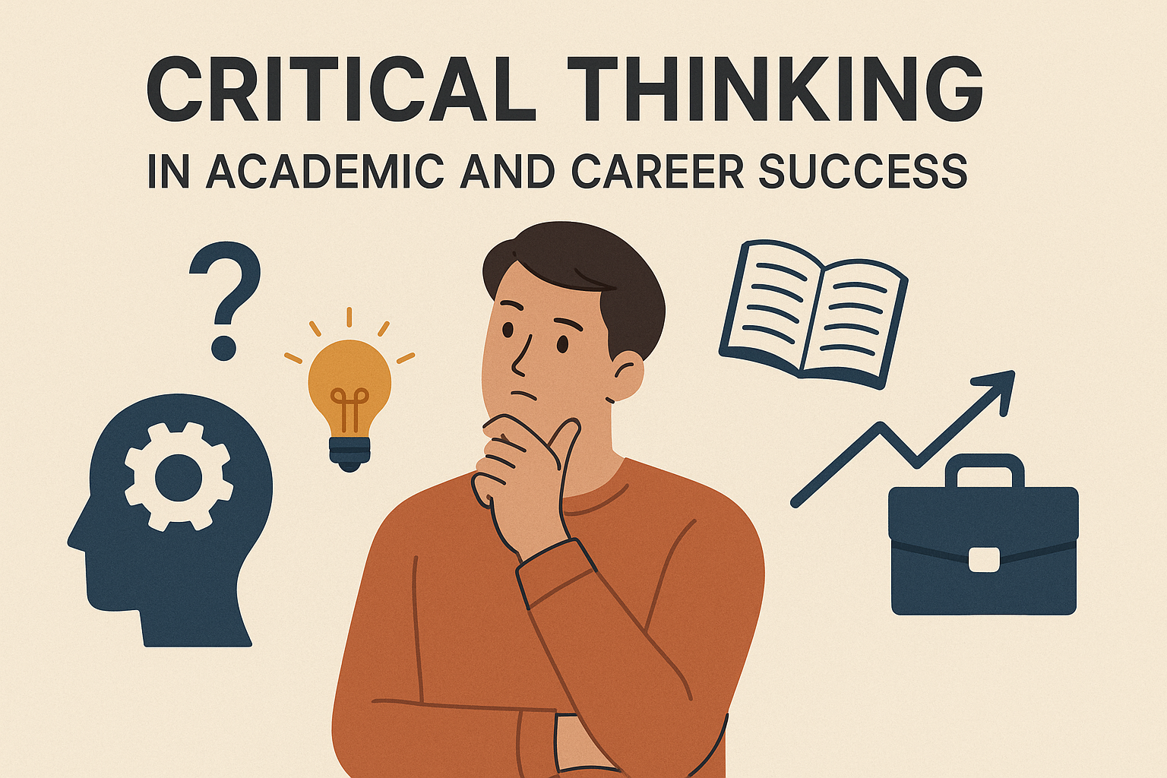
The Importance of Critical Thinking for Academic Success
Introduction
Critical thinking is a key skills that helps students to approach learning with curiosity and reflection. It encourages them to question information, explore different viewpoints, and make thoughtful judgements. In modern education, real success goes beyond simply recalling facts - it involves understanding concepts, connecting ideas, and using knowledge in practical ways. Developing critical thinking enables students to learn more deeply and become independent thinkers. This report discusses what critical thinking means, why it matters in education, and how it supports students in reaching their academic goals.
Understanding Critical Thinking:
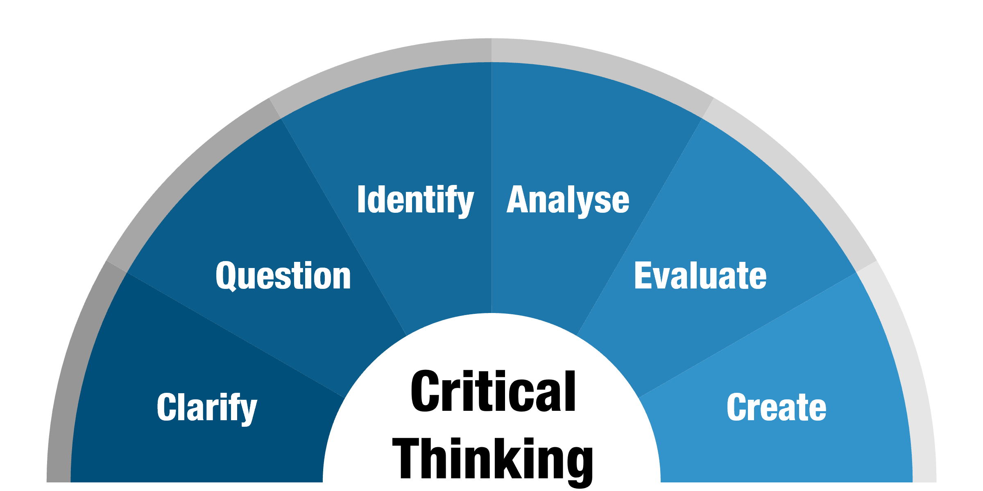
Critical thinking means using reasoning and evidence to evaluate ideas before forming conclusion. It is not just about learning information, but about understanding why things happen and how they are connected. A student who thinks critically looks at different sides of an argument, asks question, and seeks proof before accepting an answer. For example, instead of memorizing a scientific formula, a critical thinker would try to understand how it works and where it can be applied. This way of thinking helps students build stronger understanding and develop curiosity for deeper learning. A critical thinker does not simply accept what others say; instead, they evaluate arguments and come to their own conclusions.
For example, when reading an article, a critical thinker will ask:
Who wrote this and why?
Is the information based on evidence or opinion?
Are there other points of view?
By doing this, students learn to understand both sides of an issue and make fair judgments. This type of thinking is important not only in studies but also in real life, where people face complex decisions every day.
Why Critical Thinking Matters in Education:
In academic work, critical thinking helps students write better essays, solve problems effectively, and participate in discussions with confidence. When students use reasoning instead of guessing, they can create stronger arguments and support them with their work more original and convincing. Critical thinking also encourages creativity because it allows student to explore different view points and come up with new ideas rather than relying on what is already known.
Education is not just about passing exams — it is about learning how to learn. Critical thinking helps students to:
- Understand concepts better: Instead of memorizing facts, students learn to connect ideas and see the bigger picture.
- Improve problem-solving skills: Critical thinking teaches students to identify problems, find possible solutions, and choose the best one.
- Make logical arguments: It helps in writing essays, research papers, and debates where evidence and reasoning are required.
- Work independently: Students become more confident in making decisions and expressing their opinions.
- Adapt to new information: In a fast-changing world, being able to think critically helps students keep learning even after school or college.
For teachers, encouraging critical thinking also improves classroom discussions. Students learn to support their ideas with evidence and respect different opinions, which builds communication and teamwork skills.
- How Critical Thinking Supports Academic Success
Students who use critical thinking perform better in academic tasks because they can analyze information deeply. In subjects like science, mathematics, and history, critical thinking helps in understanding causes and effects, comparing theories, and drawing conclusions.
In writing tasks, it allows students to plan essays more clearly. They can identify main ideas, evaluate sources, and structure arguments effectively. For example, when writing a report or research paper, critical thinking helps students separate reliable information from unreliable ones.
Moreover, exams often test understanding rather than memorization. When students think critically, they can answer higher-level questions that require explanation, analysis, and evaluation. This skill is especially valuable in higher education, where independent study and original thinking are required.
- Developing Critical Thinking Skills
Critical thinking is not something people are born with — it can be learned and practiced. Students can improve it by:
Asking questions: Always question the reason behind facts and statements.
Reading widely: Exposure to different viewpoints helps in forming balanced opinions.
Reflecting on experiences: Thinking about what went well or wrong in a task encourages self-improvement.
Engaging in discussions: Talking and debating with others builds reasoning and communication skills.
Analyzing sources: Checking whether information is accurate, up-to-date, and from reliable sources.
Teachers can support this process by using open-ended questions and encouraging students to explain their thinking rather than just giving correct answers.

Critical Thinking Strategies:
Strategy: Questioning as a tool for critical thinking

One effective strategy for developing and applying critical thinking in academic contexts is to practice questioning every stage of the learning process. This means going beyond simply accepting what is written or said and instead asking purposeful questions such as “ what evidence supports this idea?”, and “ why might someone disagree with this point?.” by doing this, a student becomes more active in learning and less dependent on the information given. For example, when reading an academic article, a critical thinker might examine the author’s assumptions, consider whether the data is reliable, and think about how the findings relate to other research. This habit of questioning helps uncover deeper meanings, identify weaknesses in arguments, and build stronger, evidence- based conclusions. Overtime consistent questioning sharpens the mind, improves academic writing, and strengthens independents thinking - core qualities of true critical thinkers.
How the Questioning Strategy in Group Work and Research:
In group work or research projects, the questioning strategy can be especially useful for improving teamwork and deepening understand. When students share ideas, asking thoughtful questions helps the group explore different viewpoints and avoid relying on one person’s opinion. For example. During a project discussion, members can ask questions like. “ how do we know this information is accurate?.” or “ is there another way to interpret these results?” this kind of dialogues encourages everyone to think more carefully and supports decisions based on evidence rather than assumptions. In research, questioning helps students review sources critically, design better method, and draw conclusions that are logical and well - supported. By using questioning both individually and in collaboration, learners develop stronger reasoning skills and produce higher - quality academic work.
Conclusion:
The report argues that critical thinking is central to achieving academic success because it allows students to move beyond memorising facts and instead engage deeply with ideas. It emphasis that effective learners question assumptions, evaluate evidence, and make logical connections between concepts. By developing these analytical skills, students become more independent thinkers who can construct strong arguments, solve complex problems, and adapt to new challenges. The report concludes that critical thinking isn’t just an academic skill but a life long habit that underpins intellectual growth and success in any field.
These skills not only help them achieve good academic results but also prepare them for future challenges in their personal and professional lives. Therefore, both students and teachers should make the development of critical thinking a priority in education.

References:
Facione, P. A. (2015). Critical Thinking: What It Is and Why It Counts. Insight Assessment.
Ennis, R. H. (2018). Critical Thinking Across the Curriculum: A Brief Edition of Thought & Knowledge. Routledge.
Paul, R., & Elder, L. (2019). The Miniature Guide to Critical Thinking Concepts and Tools. Foundation for Critical Thinking.
Brookfield, S. (2017). Becoming a Critically Reflective Teacher. Jossey-Bass.
Halpern, D. F. (2014). Thought and Knowledge: An Introduction to Critical Thinking. Psychology Press.
www.libarary.leeds.ac.uk/info/14011/academic_skills/107/criticalthinking
(Accessed: 12 October 2025)

