Ryan Williams 1908507
MECHANICAL AND MANUFACTING PART TIME
Factory control 1

Contents
1 – Introduction 2
2 – PLCs used in Industry 3
3 – Factory lay out. 4
4 – Ladder logic to control factory 6
5 – HMI and alarm statagy 15
Works Cited 18

Figure 1 PLC architecture 4
Figure 2 Factory layout 5
Figure 3 Factory I/O list 5
Figure 4 System logic flow diagram 6
Figure 5 Network 2 7
Figure 6 Network 3 7
Figure 7 Network 4 8
Figure 8 Pulse timer function 8
Figure 9 Timer On function 8
Figure 10 Network 5 9
Figure 11 Network 6 9
Figure 12 Network 7 10
Figure 13 Picture of alarm master used in network 1 10
Figure 14 Network 8 10
Figure 15 Network 9 11
Figure 16 Network 10 11
Figure 17 Move function 11
Figure 18 Network 11 12
Figure 19 Network 12 12
Figure 20 Network 13 13
Figure 21 Count up function 13
Figure 22 Network 14 14
Figure 23 Up/down counter function 14
Figure 24 Network 15 15
Figure 25 Root screen 16
Figure 26 Warning screen 17
Figure 27 Engineer screen 18

1 – Introduction

This report outlines the control used with Factory I/O and Siemens PLC software to sort 4 different types of packages based on size and weight. The System features several factory components, ladder logic program and a human machine interface to allow complete control and feedback of the system.

2 – PLCs used in Industry

A Programmable Logic Controller, or PLC is a purpose-built rugged microprocessor designed to handle a large amount of input and output, I/O and execute logic or sequence control over many co-operating devices.
For programming a PLC in its machine language, programs are prepared on machine programming software using graphical aids and ladder logic diagrams, the programs are then directly downloaded into the PLC.
Ladder logic is a method constructing relay-based logic. The rungs of the ladder connect the power supplied along the right hand rail to the ground on the left hand rail, by completing this rung the outputs/relay coils are energised. A coil is a method of storing a value in the program.
Signal state at the input is usually binary code, 1 or 0 (‘high or low’) the PLC scans the signals at the inputs and executes logic operations in accordance with statement lists.
A PLC consists of five components; these are Processor unit, memory, power supply, input/output interface and programming device. (Bolton, 2006)
Figure 1 PLC architecture
Programming device
Memory
Processor
Power supply
Input
interface
Output
interface

Two general types of plc used in industry are called fixed or integrated and modular or rack.
Integrated PLCs have a set number of inputs and outputs determined by the manufacturer. These make these smaller, and cheaper but limited in their use, whereas modular or racked PLC’s allows expansion through additional I/O modules and are easier to use because each component is independent but are generally more expensive.

3 – Factory lay out.

The factory layout contains the following factory IO components:
3 x 2m conveyor belts | 2 x 4m conveyor belts | 1 x 6m conveyor belt
1 x curved conveyor belt | 8 x diffuse sensors | 1 x siren
2 x pushers | 1 x scale conveyor | 1 x pivot arm sorter
2 x stack lights | 1 x emergency stop button | 1 x package emitter
4 x package remover

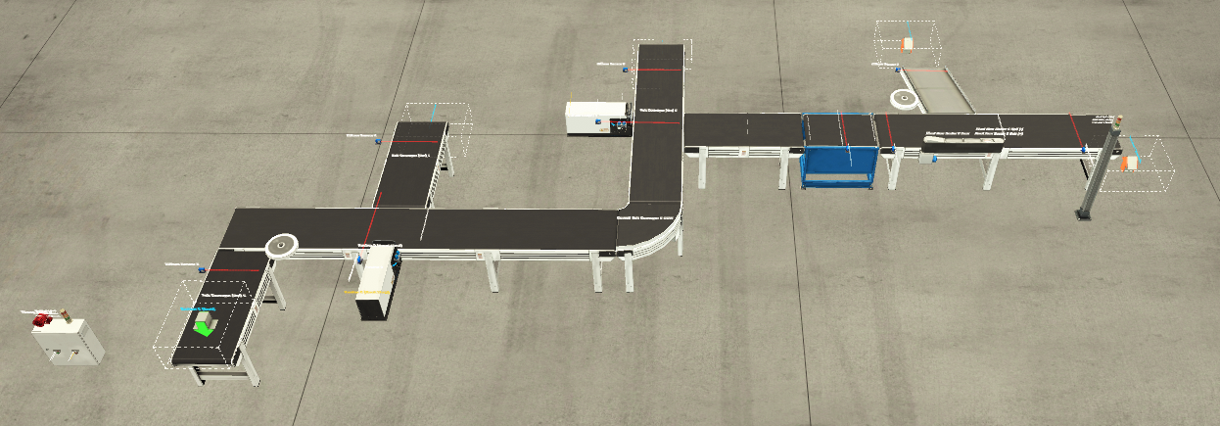
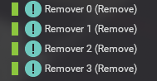
Figure 2 Factory layout
Figure 3 Factory I/O list
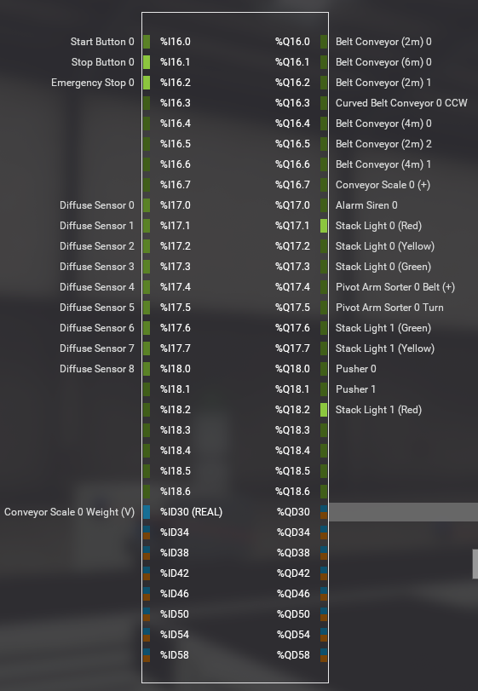
The package emitter and the package remover are set to ‘forced’ within factory IO therfore are not being controlled by the PLC, everything else within the factory gets assigned an unique address to the input/output module, it is these unique addresses that provide signal conditioning to the PLC to allow it to perform the logic functions within the ladder logic of the program.
The input module detects the status of input signals from things such as switches, push buttons and sensors etc. The output module controls devices such as relays, motors starters and lights etc.
A common type of PLC I/O is usually referred to as discrete I/O, discrete I/O is simply either on or off, true, or false, high, or low,1 or 0. For the remainder of this report high or low will be used.
Another common form of PLC I/O is analog I/O. Analog I/O are signals that contain a range or ‘real’ values usually in the ranges of -10 – 10v, 0-10v or 1-5 v DC and are produced by things such as scales, pressure, and temperature sensors. (Bolton, 2006)

A flow diagram can be used to help design a control system and the following flow diagram is representative of the logic behind this package sorting factory system.

Figure 4 System logic flow diagram
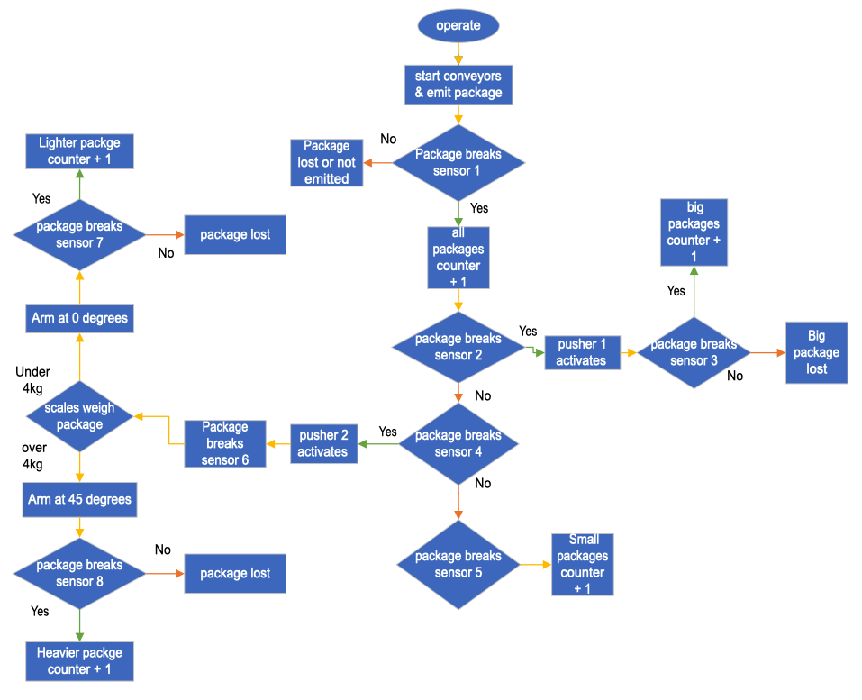

4 – Ladder logic to control factory

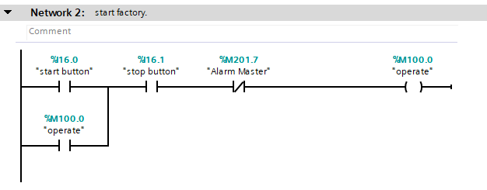
Figure 5 Network 2
Network 2 is where the factory starts. When the following input contacts: “start button (i16.0)” “stop button (i16.1)” and “alarm master (m201.7)” are high, the “operate (m100.0)” output is active. For this network a latch circuit is used, to hold on the output when the start button is released another set of contacts with the same output address are used. This set of contacts closes when the output is high creating an OR logic gate system.

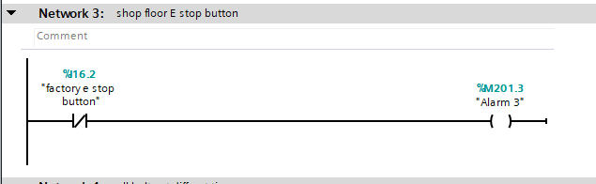
Figure 6 Network 3

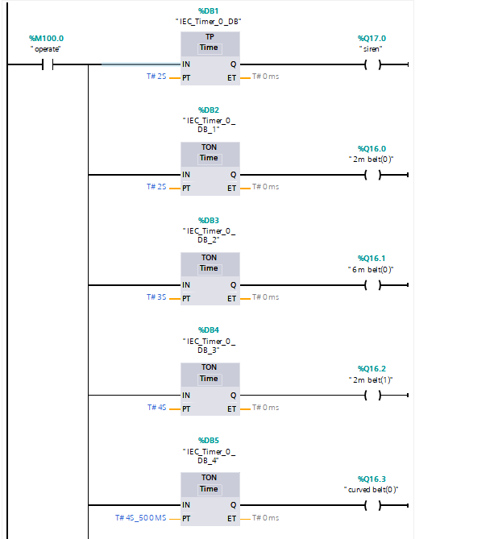
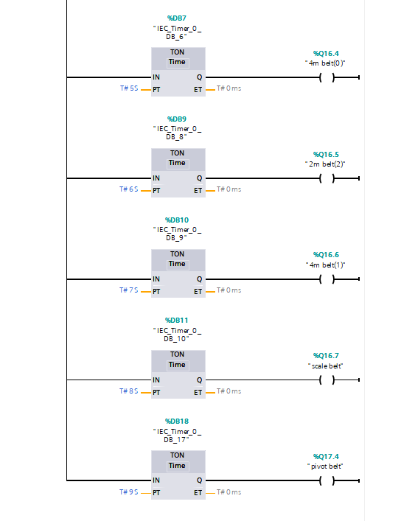
Network 3 is the factory floor E stop button. When the normally closed ‘factory e stop(i16.2)” input is high the output “alarm 3(m201.3)” is active.
Figure 7 Network 4
Network 4 is the siren and all the conveyor belts in the factory. All the outputs are dependant on two things, The input “operate (m100.1)” the timer functions are complete.
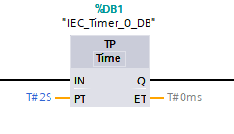
The Siren output is determined by a pulse timer function(TP), the pulse timer function generates an output for a pre determined time.

The programmmed time (PT), in this case is 2 seconds, starts when the input (IN) changes from low to high. In this timer function even if the IN signal is lost or another positive edge is detected the output (Q) is not effected. Therfore the siren will sound for two seconds.
Figure 8 Pulse timer function

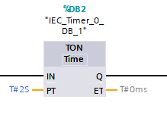
All conveyors are controlled by a timer on function, a timer on or timer on delay function delays the output for a pre programmed time.
Figure 9 Timer On function
When the function recieves a input (IN) the programmed timer (PT) starts, its only when this timer reaches 0 does the output(Q) become active.
All the programmed timers on the timer on functions are set at diffrent times to limit the current draw at start up. However the first conveyor doesn’t start until the siren has finished.
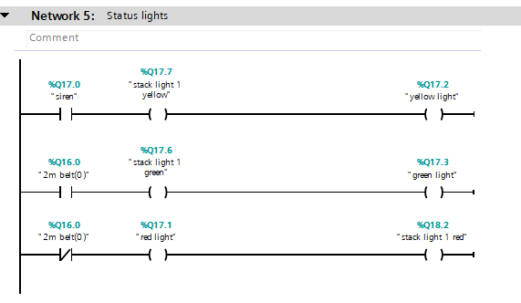
Figure 10 Network 5
Network 5 controls the stack lights. When output contact ‘siren(q17.0)” is high, output “stack light 1 yellow(Q17.7)” and “yellow light(Q17.2) are active. This rung of the network deteremines that both yellow lights are only active while the siren output is active.
When output contact “2m belt(0)(Q16.0)’ is high, outputs “stack light 1 green(Q17.6)” and “green light(q17.3)” are active. This rung ensures that both green light are active when the 2 metre belt is running. When the same output contact is used but in an opposite state(normally closed) the outputs “red light(Q17.1)’ and “stack light 1 red(Q18.2)” are active. This means that both red light will be on when the same 2 meter belt has stopped.
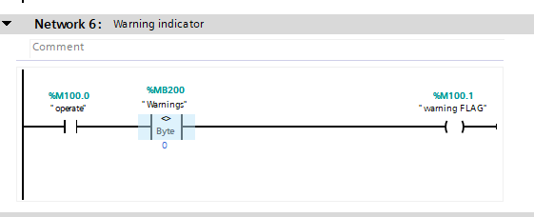
Figure 11 Network 6
Network 6 is the warning indicator, when “operate(M100.0)” is high and ‘warnings(MB200)” isnt equal to 0 the output “warning FLAG(M100.1) is active. This rung uses not equal (<>) comparator logic. Comparators are used for comparing two variables, as the all the bits of memory byte 200 are are assigned to warnings as long as those bits stay low the output “warning flag” stays low.
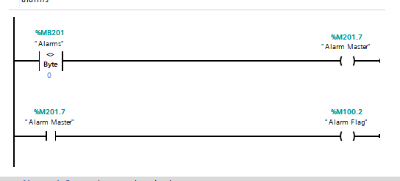
Figure 12 Network 7
Network 7 is the Alarms, a not equal comparator is used in the first rung, as all the bits with memory byte 201 are assigned to alarm, if any of those bits become high the output “alarm master”(m201.7 becomes active. While the output contact “alarm master(m201.7)” is high, output “alarm flag(m100.2)” is also active.
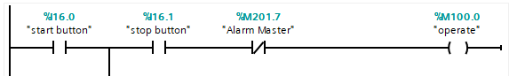
Figure 13 Picture of alarm master used in network 1
As the “alarm master” output contact was also used as a normally closed contact within network 1, when if it becomes high it also breaks the “operate” circuit and the factory stops.
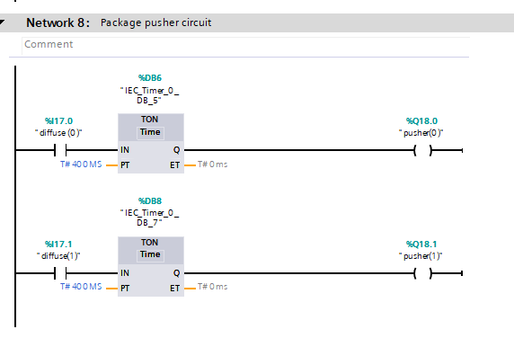
Figure 14 Network 8
Network 8 controls the package pushers whenever the diffuse sensors are high, and the pulse timers have counting down the pushers are active. “Diffuse (0) (i17.0) controls “pusher (0) (Q18.0)” and “diffuse (1) (I17.1)” controls “pusher (1) (Q18.1).
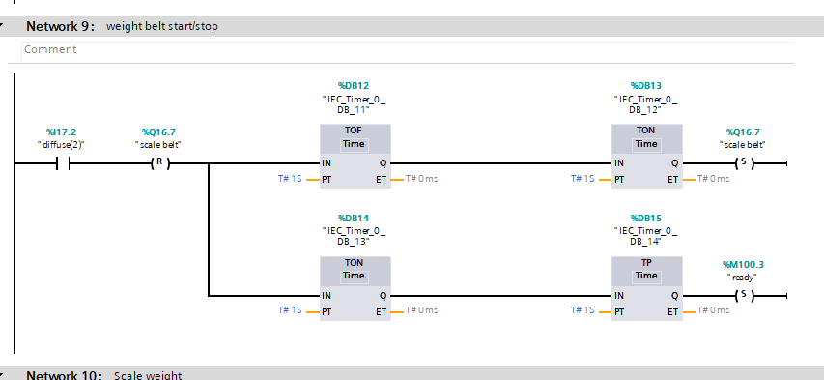
Figure 15 Network 9
Network 9 controls the scale conveyor, when input “diffuse (2) (i17.2)” is high “scale belt (Q16.7)” is reset. The timer off outputs for 1 second, the timer on outputs after 1 second and output “ready (m100.3)” is reset.
This stops the conveyor scales briefly enough to take an accurate weight of the package
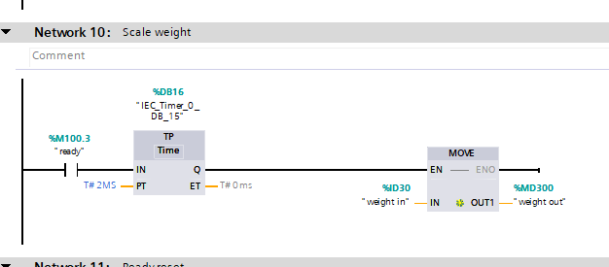
Figure 16 Network 10

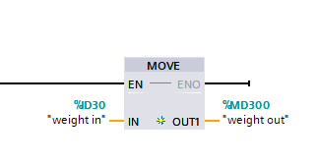
When the input “ready (m100.3)” is high and the pulse timer has finished, the move function moves the value from “weight in (ID30)” to “weight out (MD300)”
The move function copies a data element stored at a specified address to a new address or multiple addresses.
Figure 17 Move function

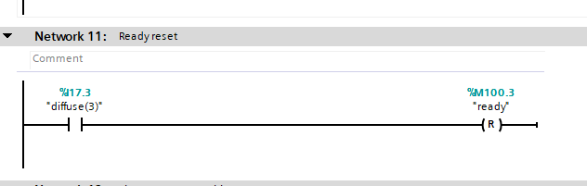
Figure 18 Network 11

Network 11 is the ready reset circuit. When input “diffuse (3) (I17.3) is high, output “ready (M100.3)” is reset ready for the next package.
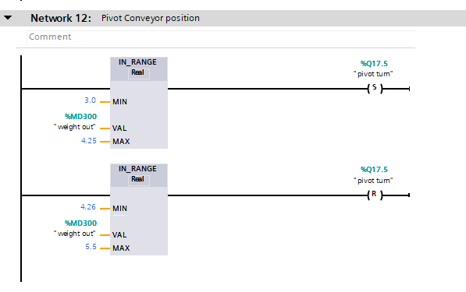
Figure 19 Network 12
Network 12 controls the pivot arm sorter. The position of the pivot arm sorter is determined by both in range instructions. If the value at “weight out (MFD300)” is between 3.0 and 4.25 the output “pivot turn (Q17.5)” is set and the arm moves to 45 degrees or stays at 45 degrees.
If the value is between 4.26 and 5.5 the output is reset, the arm moves to 0 degrees or stays at 0 degrees.

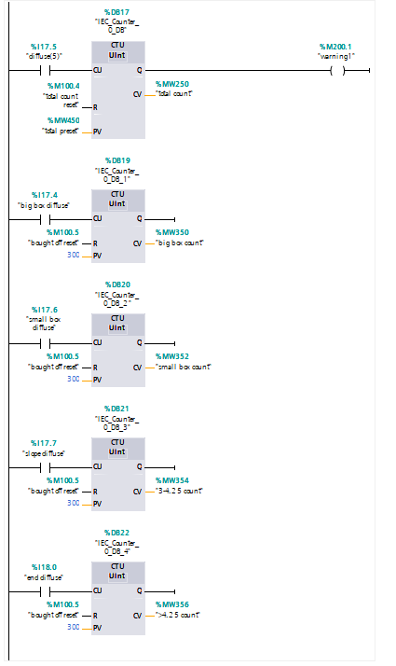
Figure 20 Network 13
Network 13 is the counters for all the boxes, the count up instruction is used for all the separate boxes to be counted.
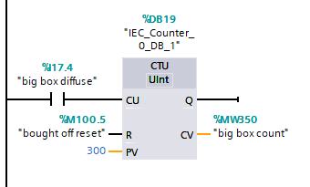
Figure 21 Count up function
For each pulse of the diffuse sensors at the input (CU) the current value (CV) will be increased by one. When there is a pulse at reset input(R) current value will be reset.

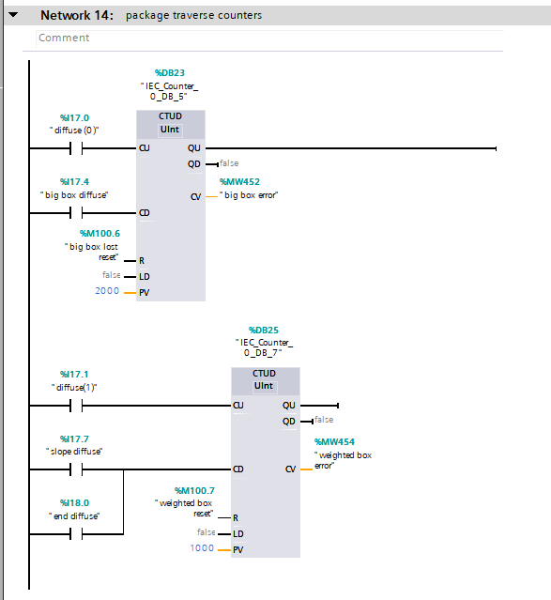
Figure 22 Network 14
Network 14 are the counters used to track the traversed big packages and weighed packages. Up down counter instructions are used for these
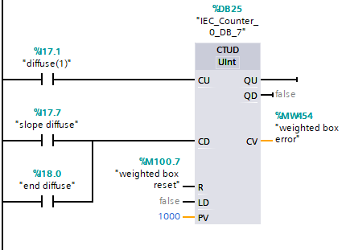
At each pulse at count up (CU) by inputs “diffuse(0)” and “diffuse(1)” at their respective counter the current value (CV) increases is by one, with every pulse from “big box diffuse”, “slope diffuse” and “end diffuse” at the respective count down (CD) the current value (CV) is decresed by one. The counters are reset(R) with a pulse by “big box lost reset” and “weighted box reset”
Figure 23 Up/down counter function

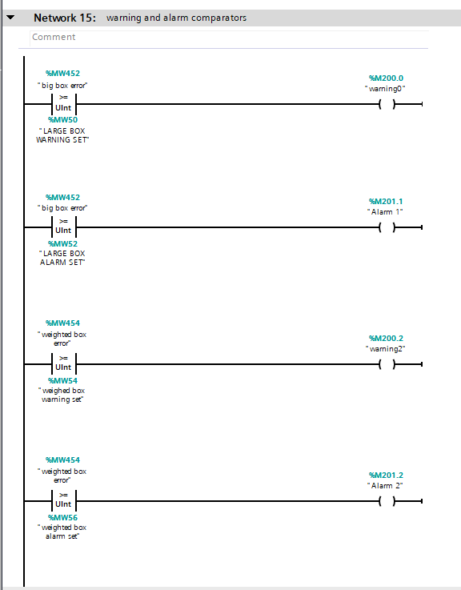
Figure 24 Network 15
Network 15 monitors the errors and sets the warnings and alarm outputs. In this network greater or equal comparotors are used(>=)
Therfore: if the value at “big box error(MW452)” is greater or equal to “large box warning set(mw50)” the output “warning0(m200.0)” is active.
if the value at “big box error(MW452)” is greater or equal to “large box alarm set(mw52)” the output “alarm 1 (m201.1)” is active.
if the value at “weighted box error(MW454)” is greater or equal to “weighted box warning set(mw54)” the output “warning2(m200.2)” is active.
if the value at “weighted box error(MW454)” is greater or equal to “weighted box alarm set(mw546” the output “alarm 2 (m201.2)” is active.

5 – HMI and alarm statagy

The following three screens make up the human machine interface panel that control the factory components and allow the operattor view the condition of the PLC program and set/reset package counters.
4
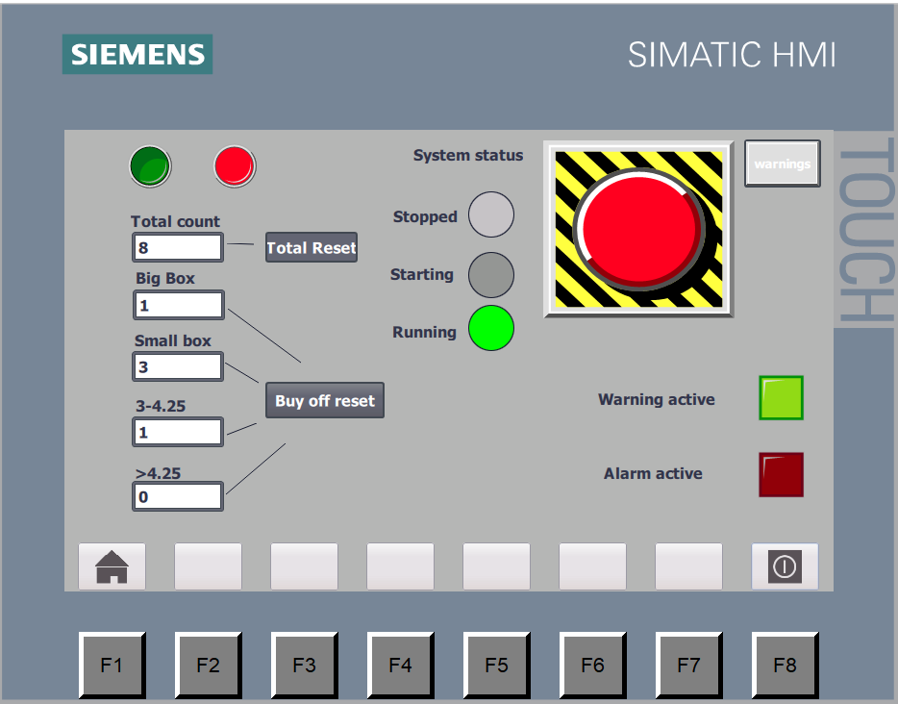
5
6
3
2
1
1
Figure 25 Root screen

- Start/stop buttons to control the start and stop functions of the factory
- Total count: total number of packages entered system; total reset is the reset button for total count only. This counter is set as output only so the count can’t be change from the HMI screen.
- Bought of counters: four separate counters for 4 separate size packages. These counters are set as output only so the count can’t be change from the HMI screen and buy off reset button resets all 4 counters.
- System status: theses three pilot lights flash and replicate the stack lights at the factory.
- Warning screen button: this button takes you to the warning screen.
- Alarm/warning pilot lights these let the operator know if an alarm or warning is present.

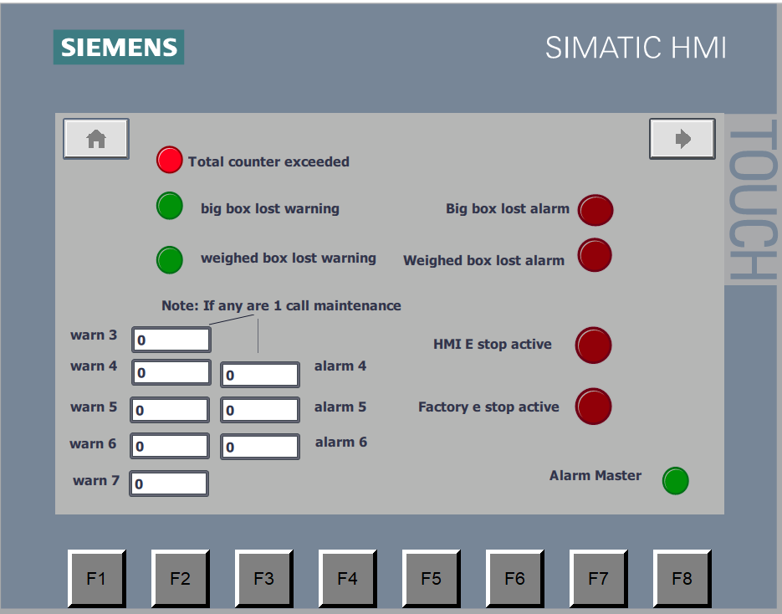
4
6
2
3
1
5
Figure 26 Warning screen

- Total counter exceeded warning pilot light.
- Big box and weighted box warning indicators.
- Un-used warning and alarm symbolic I/O’s, these are to notify the operator if any unused bits from the alarm/warning memory bytes are high because of a malfunction with the PLC these are outputs only.
- Navigation key this button navigates to the engineering screen.
- Big box and weighted box alarm indicators.
- E stop active indicators – these pilot lights are active if either E stop button has been pressed.
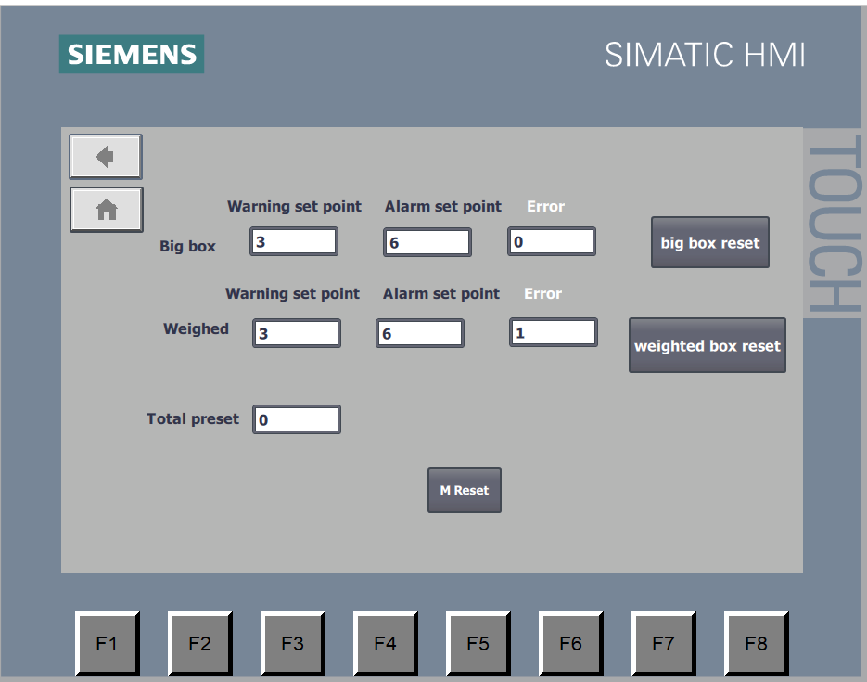
3
6
1
2
5
4
Figure 27 Engineer screen

- Error reset buttons resets the error count for big box and weighted packages.
- Total pre-set: this field is set as input and output to allow the operator to set the pre-set value of the total number of packages entered the system.
- M reset: resets alarm master.
The system will run with warnings active but will not run with an alarm active.

Works Cited
Bolton, W. (2006). instrumentation and control systems. oxford: newnes.
phillips, R. (2019, november 13). Basic PLC . Retrieved from www.basicplc.com: https://basicplc.com/different-types-of-plc/
Williams, D. J. (1994). manufacturing sytems an introduction to the technolgies. London: Chapman and hall.

