
APPENDIX GA36d

LEVEL 7 ASSESSMENT SPECIFICATION

Student name: | ARYA MARTIIN | Student ID number: | 2220294
Programme: | MSC
Module: | Ethical Hacking
Module code: | ACCA7033 | Contribution to Overall Module Assessment (%): | 100%
Lecturer: | Assoc. Professor Carlene Campbell | Internal Verifier: | Munyaradzi N Murira
Assignment Title: | Research into cyber security attacks and Penetration testing for a virtualise simulated company Website | Word count (or equivalent): | 5,000
Submission deadline: | Jan 8th 2024 | Return date of provisional marks & written feedback:
Submission method: | All written assessments, where practical and possible, must be submitted via Turnitin unless otherwise instructed by the Lecturer. (Please DO NOT put this assessment specification into Turnitin or it will match many similarities with other students’ submissions.)  Alternative submission method (if applicable):  Late submission of the assessment will result in a late penalty mark. Penalties for late submission: Up to one week late, maximum mark of 50%. Over one week late, 0%. Only the Extenuating Circumstances Panel may approve a change to submission dates.
Academic honesty / referencing: | Academic honesty is required. In the main body of your submission you must give credit to authors on whose research and ideas your work is based. Append to your submission a reference list that indicates the books, articles, etc. that you have used, cited or quoted in order to complete this assessment.
Contents
Introduction 1
LinkedIn 2021 Attack 2
SolarWinds Attack 3
Finnish Parliament Attack 4
Critically evaluate the attacks 4
Countermeasure 8
Contingency Plan for the Penetration Test 10
Penetration Testing Framework 10
Penetration Testing Tools 11
Penetration Testing 12
Vulnerability Analysis 12
Attack Tools and Protocol Involved in the Attack 13
Execution of the Attacks 14
Results of the Attacks 30
Solutions for Discovered Threats and Vulnerabilities 30
Cost Associated with Solutions 32
Time Table for the Execution of Solution 32
References 32

Task 1

Introduction
The threat of cyber-attacks has increased significantly over the past few years and these attacks pose a threat to businesses, organizations and institutions. Cybercrime costs global economies a great deal of money. Cybercrime was expected to cost the UK 320 billion dollars annually as of 2023. By 2028, this amount is expected to rise to more than 1.82 trillion US dollars [1]. The UK experienced the greatest losses from cybercrime in 2022 compared to other European markets and the US, with an average of 4.21 million US dollars lost due to a data breach [1]. Three notable cyber-attacks that have gained attention in recent years are the 2021 LinkedIn attack, the SolarWinds attack, and the 2023 Ring company’s ransomware attack. These mentioned cyber-events have prompted the need for in-depth investigation and analysis. The main aim of this report is to investigate the details of these attacks, critically assess their impact, and evaluate the measures that could have potentially prevented them.

LinkedIn 2021 Attack
The LinkedIn attack carried out by hacker “God User” in June 2021 was a significant breach with far-reaching implications. Unauthorized access gained by hackers resulted in the sensitive information of millions of LinkedIn users being compromised (approximately 700 million LinkedIn users' (90% of the total users) data has been compromised in this incident). The attack was not a traditional data breach but rather a large-scale data scraping operation [5]. The sensitive information included user profiles, contact details, and potentially sensitive professional data. This cyber incident raised significant concerns about data privacy and security within the professional networking platform. A third party misused LinkedIn's API in order to gain millions of users' personal information, potentially risking user and business security. According to LinkedIn, rather than a data breach, the data leak was the consequence of data scraping and aggregation from multiple sources. They claim that only publicly accessible member profile data along with information from various websites and businesses was exposed, not any private member data.

The financial repercussions of the attack were substantial, with LinkedIn facing heavy legal costs, fines, and compensation claims from affected users. The exact financial impact of the attack is estimated to have run into millions of dollars, considering the scale of the breach and the resulting legal and remediation expenses. In addition to this, the reputational damage suffered by LinkedIn as a consequence of the breach damaged user trust and confidence in the platform, which impacted the company's user base and market value. Following the incident, LinkedIn has removed more than 11.9 million fake accounts from the platform, and shortly after the company removed another 4 million fake users before being reported by other users [5].

Apart from the financial and reputational consequences, the attack highlighted the vulnerability of large online platforms to advanced cyber threats. It highlighted how important it is to have strong cybersecurity protections in place in order to protect user data, not just on LinkedIn, but on all other similar digital platforms. In today's connected digital world, this attack serves as a reminder of how important it is to prioritize cybersecurity and take practical security measures in order to protect user’s sensitive data. This cyber incident highlights the need for constant vigilance and investment in advanced threat detection technologies to mitigate the risks associated with such complex cyber threats.

SolarWinds Attack
The SolarWinds attack, discovered in 2020 and continuing into 2021, was a highly sophisticated cyber espionage campaign that targeted SolarWinds, which is a major provider of IT management software [2]. The attack was carried out by a group believed to be affiliated with the Russian government, known as APT29 or Cozy Bear [3]. This group gained unauthorized access to SolarWinds' software development environment and injected malicious code into updates for the Orion platform, a popular network monitoring product [4]. The attackers used a method known as a supply-chain attack, where they compromised the infrastructure of SolarWinds and then used that access to produce and distribute trojanized updates to the software’s users [4]. As customers downloaded the Trojan Horse installation packages from SolarWinds, attackers were able to access the systems running the SolarWinds product [4]. This cyber-attack was exceptionally complex and continues to evolve [3].
The financial impact of the attack was significant. The October quarterly report from SolarWinds stated that the Orion breach cost the company $40 million in the first nine months of 2021 [6]. The attack also highlighted the difficulties in detecting and mitigating supply chain attacks, highlighting the necessity of better security measures and inspection of third-party software suppliers. The SolarWinds attack affected many government and private sector businesses, indicating its wide reach. The attack had a wide range of victims, including government agencies, consulting firms, technology companies, telecom entities, and extractive entities in North America, Europe, Asia, and the Middle East [3]. SolarWinds stated that its customers included 425 of the US Fortune 500, the top ten US telecommunications companies, the top five US accounting firms, all branches of the US Military, the Pentagon, the State Department, as well as hundreds of universities and colleges worldwide [3].
As a result of the SolarWinds breach, governments, organizations and cybersecurity professionals around the world have strengthened their efforts to strengthen security protocols, increase network monitoring, and increase collaboration and information sharing in order to prevent similar attacks in the future. This incident served as a wake-up call for businesses and governments, highlighting the need for constant observance and robust cybersecurity measures in order to protect against complex threats.

Finnish Parliament Attack
In August 2022, the Finnish Parliament was under a major cyber attack [7]. The attack was a Distributed Denial of Service (DDoS) that temporarily brought down the Parliament's external websites [8]. This type of attack overwhelms a network with traffic making it impossible for its intended users to access it [7]. A Russian hacker group identified as NoName057 took responsibility for the attack [8]. It is pro-Russian and has been involved in several other cyber attacks [8]. The timing of the attack was notable, as it overlapped with the United States' move to admit Finland to NATO [9]. This led to speculation that this was politically motivated and meant to be a protest against Finland’s bid to join NATO [9]. There were serious consequences resulting from this attack on the Finnish Parliament. First, it disrupted the activities of the Parliament since the site was temporarily offline [7.] This may have made it hard for members of parliament to communicate effectively with their constituents or carry out their work properly. Second, this act might have exposed some loopholes in terms such as security measures taken by parliamentarians [7]. Although no evidence showed any unauthorized access or thefts occurred, disrupting these websites could reveal vulnerabilities exploited later by other hackers worldwide[7]. Other than this, the attack had potential reputational consequences for the Finnish Parliament. Trust in public institutions is essential, and a successful cyber attack can undermine this trust. If the public perceives that the Parliament cannot protect its own digital infrastructure, they may question its ability to protect the country's broader cyber infrastructure [7].

Critically evaluate the attacks
Distributed Denial of Service (DDoS)
Distributed Denial of Service (DDoS) attacks are a significant threat in the realm of cybersecurity [10]. According to [11], these attacks involve multiple compromised computers targeting a single system, causing a Denial of Service (DoS) attack .
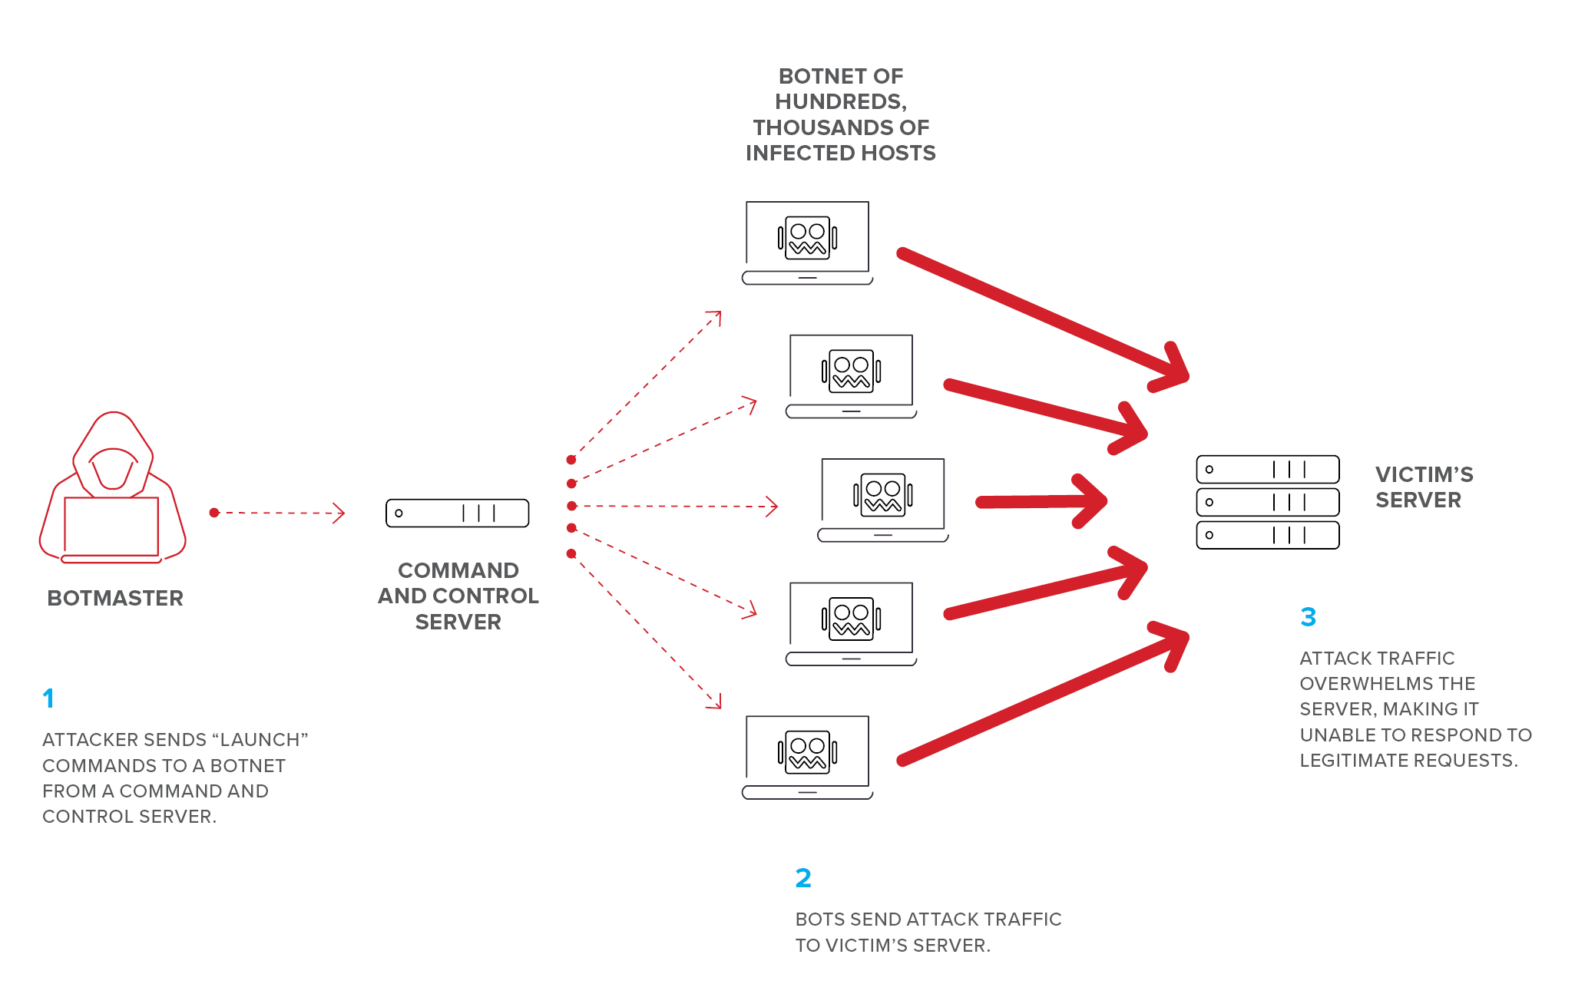
A DDoS attack has as its primary objective, making an online service unavailable by overwhelming it with traffic from multiple sources [10]. The size and complexity of DDoS attacks have increased significantly over the years. According to [10], attackers are continually updating their skill strategies which make it difficult for traditional detection mechanisms to detect novel DDoS attacks. Whereas the overall number of DDoS attacks experienced a slight decline compared to 2020, the size and complexity of these attacks increased significantly [10]. This implies that although the frequency of attacks may have reduced, the potential damage caused by each attack has risen. As per a study conducted by [12], there are three types of DDoS attacks: volumetric, protocol or application-based ones [12]. Volume based attacks aim at consuming the bandwidth of the attacked site or saturate the victim’s network [12]. Protocol-based attacks however seek to consume all processing capacity available in an intermediate critical resource like firewall through exploiting weaknesses within layer 3 and 4 protocols stack. Application layer attacks, the third type, aim to exhaust the processing capacity of the web server itself [12]. According to a report [13], in 2021, TCP DDoS attacks almost doubled compared with 2020 and accounted for 27% of all attacks. TCP DDoS attacks exploit the Transmission Control Protocol (TCP), which is one of the main protocols in the Internet protocol suite [14]. These attacks can be particularly damaging as they can disrupt the transmission of data between applications.
Data scraping attack
Data scraping involves importing data from websites into files or spreadsheets [15]. This method of extracting information from web pages is often used for malicious purposes such as content reselling or price undercutting [15].
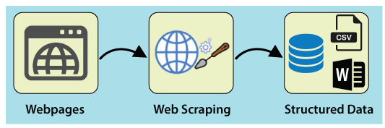
Scraping attacks contain three main phases: Target URL address and parameter values: Web scrapers identify their targets and make preparations to limit scraping attack detection by creating fake user accounts, masking their malicious scraper bots as good ones, obfuscating their source IP addresses, and more [16].
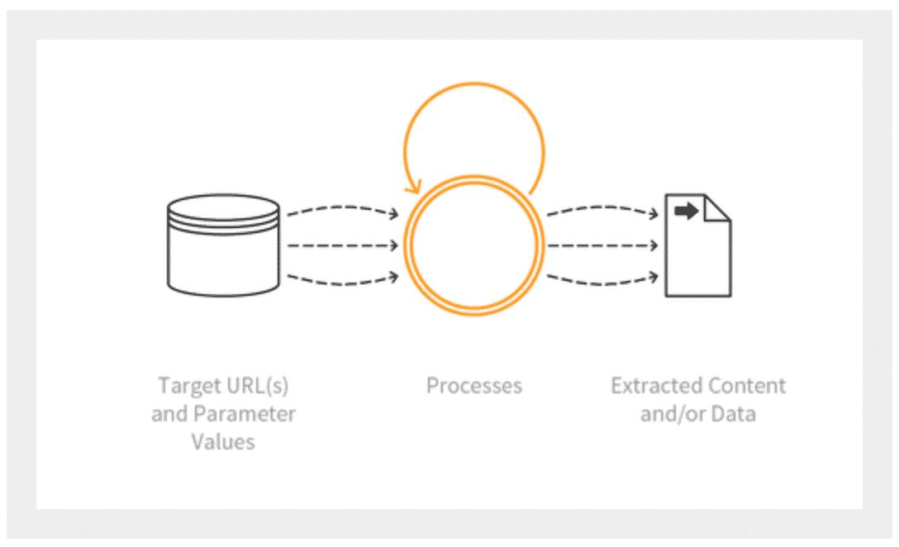
A study conducted by [17] stated that Data scraping attacks have become increasingly common in recent years, with attackers using advanced techniques to gather large amounts of data from different websites and online platforms. These can result in serious consequences, including personal information misuse, undermining competitive advantage as well as legal issues among others. The process of data scraping involves several steps. First and foremost, the attacker identifies the target which can be a particular website or an online platform [18]. Then they prepare themselves before launching an attack through creating fake user accounts, masking their malicious scraper bots as legitimate ones and hiding their source IP addresses so that they cannot be detected easily by anyone who might be watching out for any suspicious activities taking place on his/her computer screen. After all these preparations are done, then it means that an attacker is now capable enough to use a computer program which allows them to extract data from another web page without any permission. This data can include a wide range of information, such as user profiles, product listings, and pricing information. Finally, what happens next is that this extracted information often gets used for malicious purposes such as reselling the data or details and for undercutting prices.
Supply Chain Attacks:
A supply chain attack refers to when someone uses an outside provider or partner that has access to an individual's data and systems to infiltrate the digital infrastructure [19]. As the third party has been granted authorization to use certain sections of your network, applications, or sensitive information, the attacker just needs to either penetrate/hack into their defenses or program a loophole in a vendor’s solution to compromise the system [19].
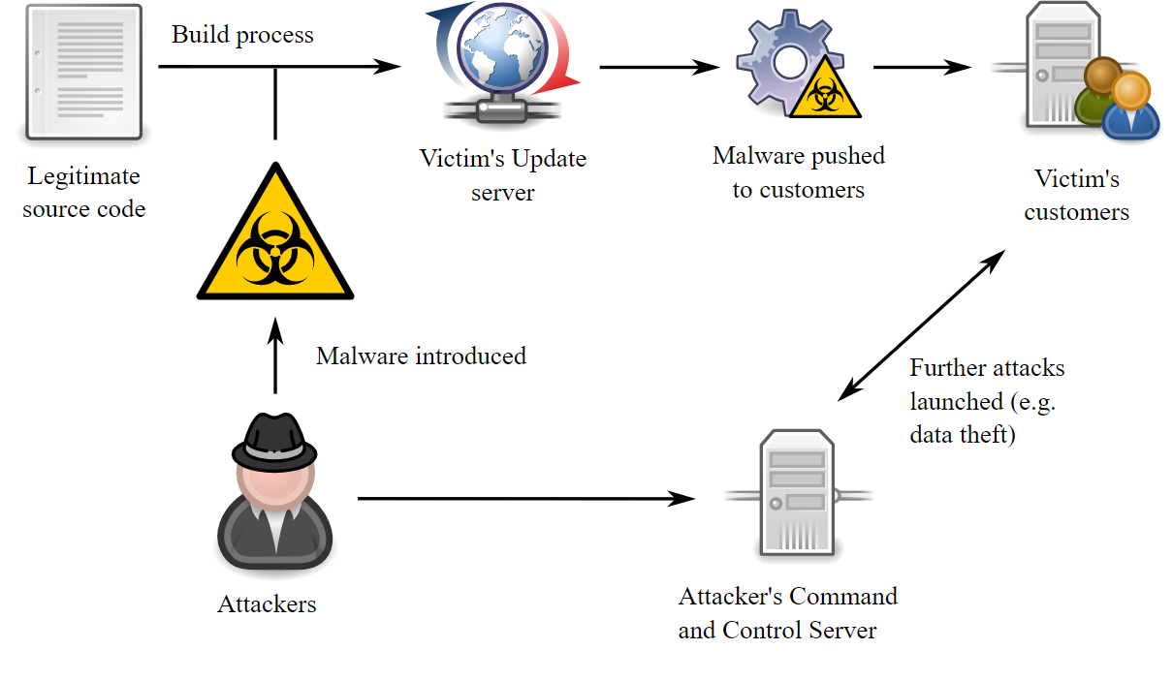
Supply chain attacks are diverse, impacting large companies, such as the case observed during Target security as well as typically dependable systems, like when automated teller machine (ATM) malware is used to steal cash [20]. According to [21], supply chain attacks have become a significant concern within cybersecurity. These attacks exploit the trust relationships established between organisations and their suppliers/partners, allowing hackers to penetrate networks/systems that would otherwise be difficult to breach into. In a supply chain attack, the victim’s data and systems are accessed by targeting a third-party provider/partner [22]. This could be either a software vendor, hardware manufacturer or service provider. The attacker then either penetrates the third party's defences or programs a loophole into a solution offered by the vendor to infiltrate the victim's system. Supply chain attacks can have far-reaching implications. According to [23], they can lead to the unauthorised access and theft of sensitive data, disrupt operations, and cause significant financial and reputational damage. Furthermore, because these attacks exploit trusted relationships, they can be difficult to detect and defend against.

Countermeasure
Countermeasures to Prevent Attacks
DDoS Attacks | A multi-faceted approach is required for preventing DDoS attacks [24]. One of the most effective methods is to increase network security, including firewalls and intrusion prevention systems [25]. Additionally, organisations with a DDoS response plan can respond quickly and effectively when an attack occurs. Other strategies involve scaling up bandwidth to handle increased traffic, using anti-DDoS hardware and software, and moving to the cloud [26]. Also, monitoring network traffic patterns as well as recognizing the pattern of an attack can help detect them early.
Data Scraping Attacks | Preventing data scraping attacks requires both technical and legal actions. Technically, the use of measures such as IP blocking, CAPTCHA, user behaviour analysis helps businesses identify and prevent scraping activities [27]. On the legal side, businesses can include clauses in their terms of service that prohibit data scraping [28]. In addition to this, businesses may utilise honeytokens - decoy data assets that alert companies to potential breaches within their networks [29].
Supply Chain Attacks | Preventing supply chain attacks involves securing privileged access management, implementing a Zero Trust Architecture (ZTA), and assuming that a data breach will occur [30]. Other strategies include identifying all potential insider threats, identifying and protecting vulnerable resources, minimising access to sensitive data, and implementing strict Shadow IT rules. Other than this, businesses can use honeytokens, which act like tripwires that alert organisations of suspicious activity in their network [31].

Recommendations to the Businesses
In order to prevent DDoS assaults, the Finnish Parliament can strengthen network security, develop a DDoS response strategy, increase bandwidth, use anti-DDoS hardware and software, and monitor network traffic patterns.
Coming to SolarWinds, the organisation can prevent data scraping attempts by using IP blocking, CAPTCHA, user behaviour monitoring, and honeytokens. They should also include provisions in their terms of service that discourage data scraping.
Finally, LinkedIn can secure privileged access management, implement a Zero Trust Architecture (ZTA), anticipate data breaches, detect insider threats, safeguard susceptible resources, limit access to sensitive data, enforce Shadow IT regulations, and use honeytokens for detection.

Task 2
This task is focused on Cureton Pharmaceutical Company (CPC) conducting a multi-layered, full-scope cyber attack simulation, and this paper offers the results and analysis. The goal of this simulation was to determine the effectiveness of CPC's system and infrastructure security controls. Potential risks, attack vectors, significant vulnerabilities, and techniques of exploitation were found by designing and implementing a virtualized duplicate of the production environment. This research paper provides a complete summary of the attack simulation results, with frameworks such as MITRE ATT&CK and OWASP Top 10 serving as reference points for different attack types. The analysis is based on thorough study, with proper citations to support the debates.

Contingency Plan for the Penetration Test
Purpose of Contingency plan
The purpose of this contingency plan is to develop and highlight guidelines that need to be followed by penetration testers while conducting penetration testing on the internal network of Cureton Pharmaceutical Company (CPC) [40]. The main aim of the policy is to safely conduct the penetration testing and while ensuring confidentiality and integrity of CPC’s assets.
Scope
This policy is applicable to all the individuals involved in the penetration testing, critical assets of the organisation and other relevant personnel.
Pre-Testing Preparation
- A written agreement must be signed by the CPC organisation and Penetration testing team which includes scope, objective and limitation of the penetration testing.
- Proper authorization to access all the critical systems in the scope of penetration testing must be obtained from the CPC management.
- Each and every member of the penetration tester must be aware of their roles and responsibility in order to conduct ethical penetration testing.
- A detailed plan must be developed for the penetration testing and it must be followed to mitigate any potential risks that could arise during the penetration test.
- Penetration testing must be conducted in a simulated or controlled network environment to avoid the execution of exploits to other systems. This can be done by replicating the CPC’s internal systems and services using appropriate tools.
Testing and Execution
- All the data of the organisation including system data, configuration data or confidential data must be backed up on a separate server or in the cloud to avoid data loss.
- Rules of engagement such as access to only required systems, use of only specified exploits and tools must be defined in the agreement to stay within the scope of penetration testing [41].
- Only legitimate penetration testing tools must be utilised to perform automated as well as manual vulnerability analysis.
Reporting
- A detailed report of the penetration testing including methodologies and key findings must be created.
- Detailed analysis of the vulnerabilities must be included in the report to highlight their severity levels and impact on the CPC organisation.
- Proper mitigation controls must be defined to remediate the identified vulnerabilities including vulnerability prioritisation.
Post-Testing Activities
- Penetration testing team must collaborate with CPC’s cybersecurity management to clearly communicate and present the plan of action to implement mitigation controls.
- Policy must be periodically reviewed to incorporate emerging practices and business changes.

Penetration Testing Framework
The Penetration Testing and Execution Standard (PTES) framework developed here outlines an organised approach to successfully executing penetration testing on digital systems such as servers and smart devices. This framework will be used in the context of CPC, to conduct penetration tests on its network infrastructure. CPC attempts to ensure a rigorous and systematic approach to discovering vulnerabilities inside their systems by adhering to the PTES-defined standards.–
- Pre-Engagement Interaction – During this phase, the CPC will engage with the penetration testing team and provide necessary permissions for conducting the tests. This step ensures proper coordination and authorization for the testing activities.
- Intelligence Gathering – During this phase,information about CPC's internal network and systems will be collected. This ensures that the testing team gains insights into the organization's infrastructure, which aids in identifying potential entry points for malicious actors.
- Threat Modelling – This phase defines an appropriate threat modelling approach to conduct penetration testing efficiently. Threat model represents the threats and their capabilities which are required to be identified for vulnerability analysis.
- Vulnerability Assessment – In this phase, vulnerabilities will be identified in the systems or devices which are defined in the scope of penetration testing.
- Exploitation – In this phase, identified vulnerabilities are exploited using multiple tools to penetrate into systems.
- Post Exploitation – In this phase, the control gained over the systems by exploiting vulnerabilities is maintained and lateral movement is performed to find other systems and valuable information.
- Reporting – This is the end phase of the penetration testing which defines the process of documenting the entire penetration process so that it is understandable by the client.
The above mentioned phases of PTES framework is used to conduct penetration testing and vulnerability assessment on the network of CPC organisations.

Penetration Testing Tools
There are multiple penetration testing tools available including open source and commercial. Such tools are used in the penetration testing process to automate some tasks such as executing a script to find service versions running in the operating system or executing a DDoS attack. Some of the penetration testing tools used for conducting PenTest are as follows–
NMAP – NMAP is a network mapper tool which is used to scan networks to find available hosts including service version and operating system [36]. NMAP is capable of executing automated scripts using the NMAP scripting engine. NMAP scripts use Lua programming language for creating multiple scripts to find vulnerabilities in the host.
Nikto – Nikto is an open source web server scanner which is used to perform multiple tests against web servers to find potentially dangerous files or programs [37]. Nikto scanner is designed to generate network traffic against the target to extract information, therefore, it can be detected by monitoring systems to block Nikto traffic.
Nessus – Nessus is an automated vulnerability scanner which automates the vulnerability analysis process in the penetration testing [38]. Multiple versions of Nessus are available but in this penetration testing, Nessus essential is used which provides all the basic features set to identify critical and informational vulnerabilities.
MSFCONSOLE – MSFCONSOLE is a widely used penetration testing tool developed by rapid7 organization to automate the process of exploitation phase in the penetration testing [39]. MSFCONSOLE is a command line tool which comes preinstalled with popular offensive security Linux distributions such as Kali Linux, ParrotOS and more.

Penetration Testing
The penetration testing conducted by the Red Team used the PTES framework to identify critical vulnerabilities in the internal network of the CPC organisation. Multiple vulnerabilities have been identified along with CVE ID, impact and severity level. Nessus, NMAP, Nikto and Metasploit tools were used to exploit the vulnerabilities and gain system access.

Vulnerability Analysis
In the intelligence gathering phase of the penetration testing, multiple vulnerabilities were found in the internal server of CPC. Identified vulnerabilities along with severity, impact, CVE ID and Vulnerable service are mentioned below–
Vulnerability | CVE ID | Vulnerable Service | Impact | CVSS Version (Severity)
Disabled DHE_EXPORT ciphersuite on client side application | CVE-2015-4000 | TLS Protocol 1.2 and earlier | Allows attackers to execute Man-in-the-Middle Attack | 3.7 (Low)
Vulnerable byterange filter in Apache HTTP | CVE-2011-3192 | Apache HTTP Server 1.3.x, 2.0.x through 2.0.64 | Allows attackers to execute denial of service attack | 7.8 (High)
Anonymous access configured in FTP | CVE-1999-0497 | FTP 1.3.1 | Allows attackers to login to FTP server anonymously | 0.0 (Low)
Remote Code Execution | CVE-2002-0082 | SSL and Apache-SSL | Allows attackers to remotely execute arbitrary codes on server | 7.5 (High)
Information Disclosure | CVE-2019-20372 | NGINX service < 1.17.7 | Allows attacker to perform HTTP request smuggling to read unauthorized web pages | 5.3 (Medium)
Heap based buffer overflow | CVE-2012-0870 | Samba 3.0 | Allows attacker to perform denial of service and remote code execution | 7.9 (High)
Weak hashing algorithm for SSL certificates | CVE-2004-2761 | SSL 1.33 | Allows attackers to execute spoofing attacks | 7.5 (High)
Cross Site Request Forgery | CVE-2020-13663 | Drupal Content Management System 7.31 | Allows attackers to perform unwanted actions on authenticated web pages | 8.8 (High)
The vulnerabilities which are targeted in the penetration testing are given below -
- Anonymous Access to FTP Server
- Vulnerable byterange filter in Apache HTTP

Attack Tools and Protocol Involved in the Attack
Tools which are used to perform cyber-attack against identified vulnerable services running in their systems are–
MSFConsole – MSF console is used to perform DDoS attacks using the auxiliary module (dos/http/apache_range_dos). This module sends DoS traffic to the vulnerable apache service until the service becomes unavailable or unreachable.
The same tool is also used to perform brute force attack against SSH service to extract username and password. The auxiliary module (scanner/ssh/ssh_login) is used to perform automated brute force attacks to get SSH credentials. The protocols which were involved in the attack are FTP, SSH and HTTP.

Execution of the Attacks
The current network infrastructure of the CPC organisation is replicated in a virtualized environment. As shown in the below network diagram, CPC virtual server, host machine and Kali Linux virtual machine are configured and connected to a virtual network interface for connectivity. The cyber-attack will be performed using Kali Linux virtual machine with all attack tools pre-installed.
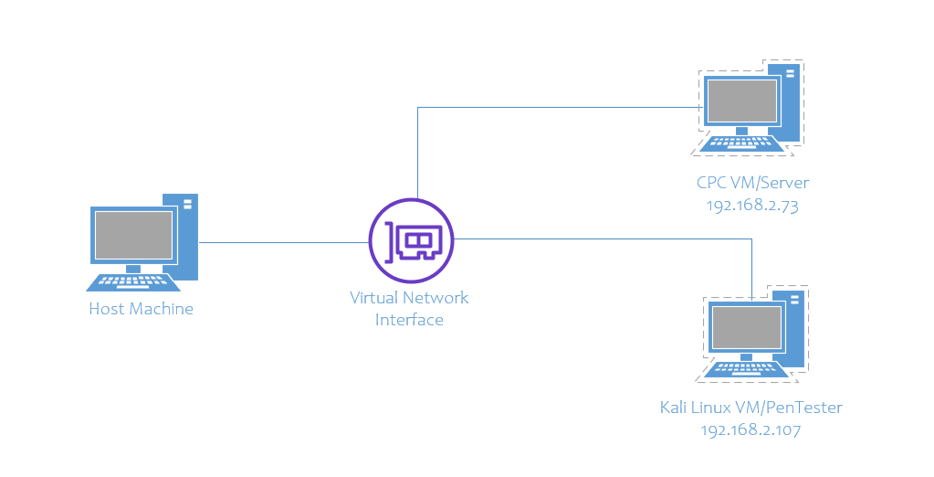
As shown in the below screenshot, bee-box and Kali Linux virtual machine were configured in Virtual Box. Appropriate hardware resources were assigned to both the virtual machines to efficiently perform cyber-attack.
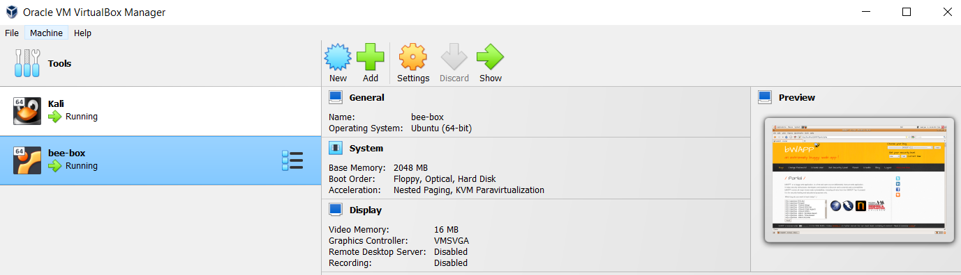
NMAP tool was executed to find open ports on the target server (CPC Server) as shown in the below screenshot. The command “nmap 192.168.2.73” when executed, showed all the ports which were opened in the server along with service name.
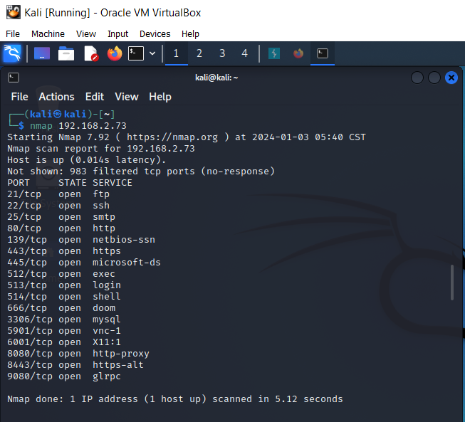
To extract more information about the open ports, “nmap 192.168.2.73 –sV” command has been used to list open services along with the service version. The service version allows us to find vulnerabilities and exploits.
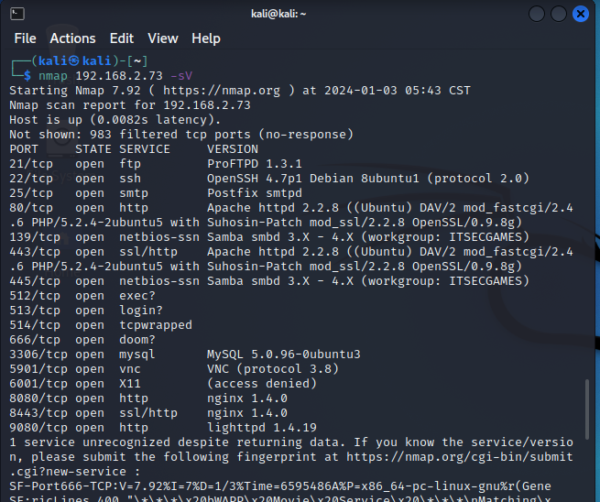
To identify open UDP ports on the server, “sudo nmap 192.168.2.73 –sU” command was executed. This command listed all the opened UDP ports along with corresponding running services as shown in the below screenshot.
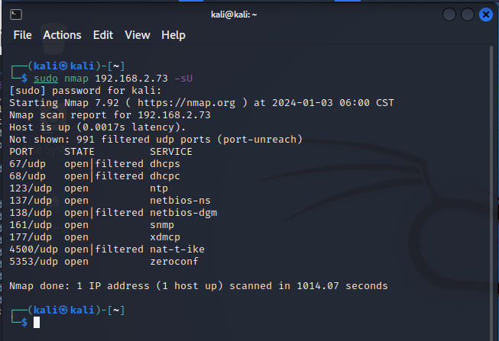

After identifying all the open ports, services along with their corresponding version, NMAP scripting engine was then used to run automated scripts to find vulnerabilities in each identified vulnerability. Below screenshot shows the execution of NMAP script “vuln” using the command “sudo nmap –script vuln 192.168.2.73 –v”.
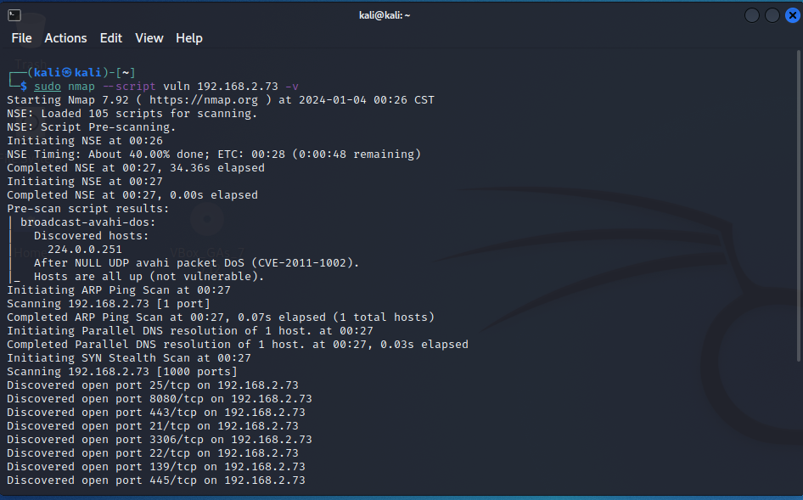
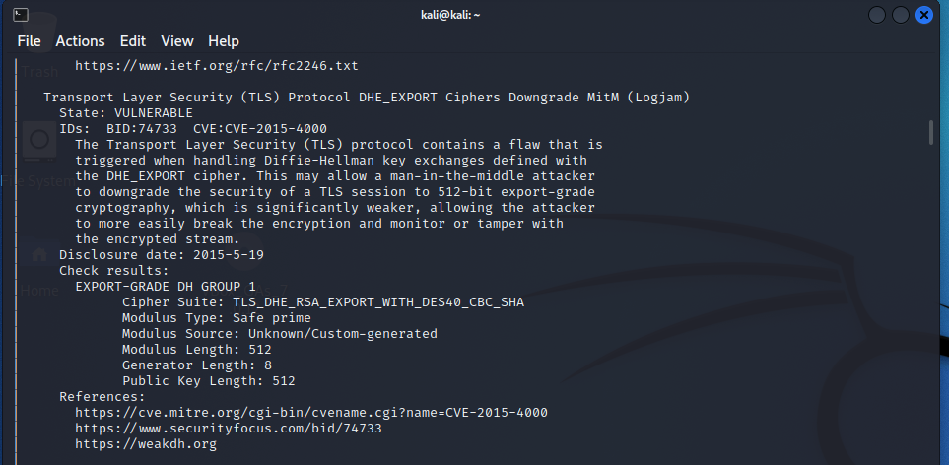
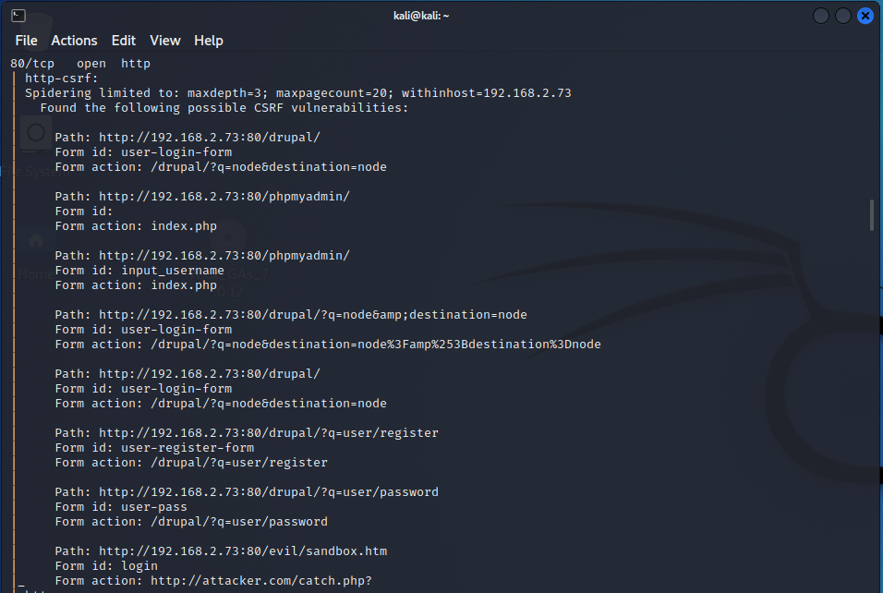

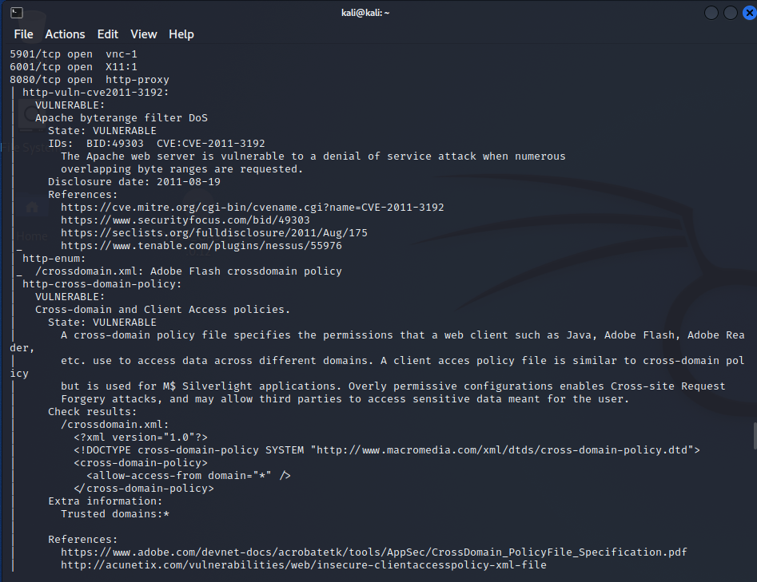

After executing the “vuln” script of NMAP, the default script was then executed to extract more information about the services and operating system. Below screenshot shows the execution of the command “sudo nmap 192.168.2.73 –sV –A –sC –o scan.txt” command.
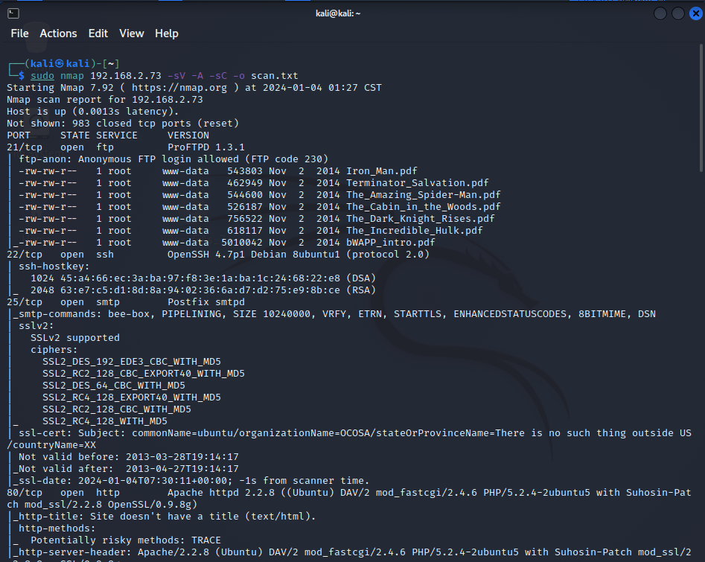

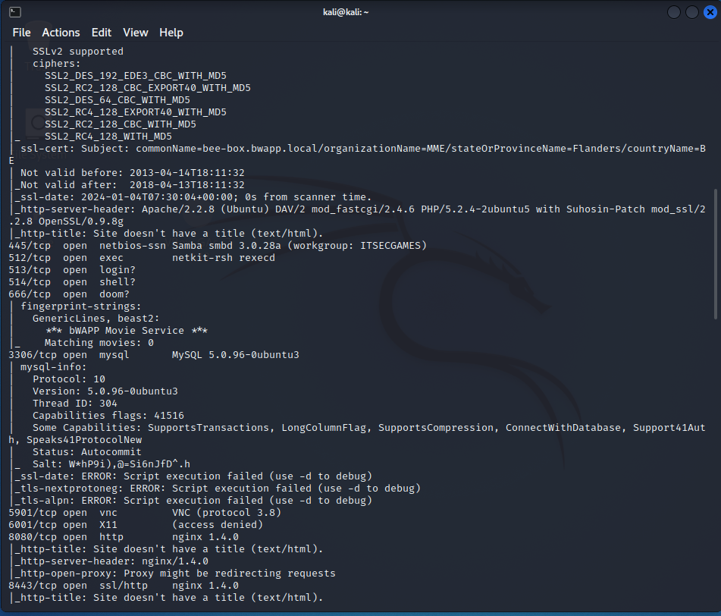
One of the tools listed above in this report was Nikto, which was then used against the web server running in the CPC server machine. Below screenshot shows the execution of the Nikto tool to find vulnerabilities in the web server using command “nikto –h 192.168.2.73”.
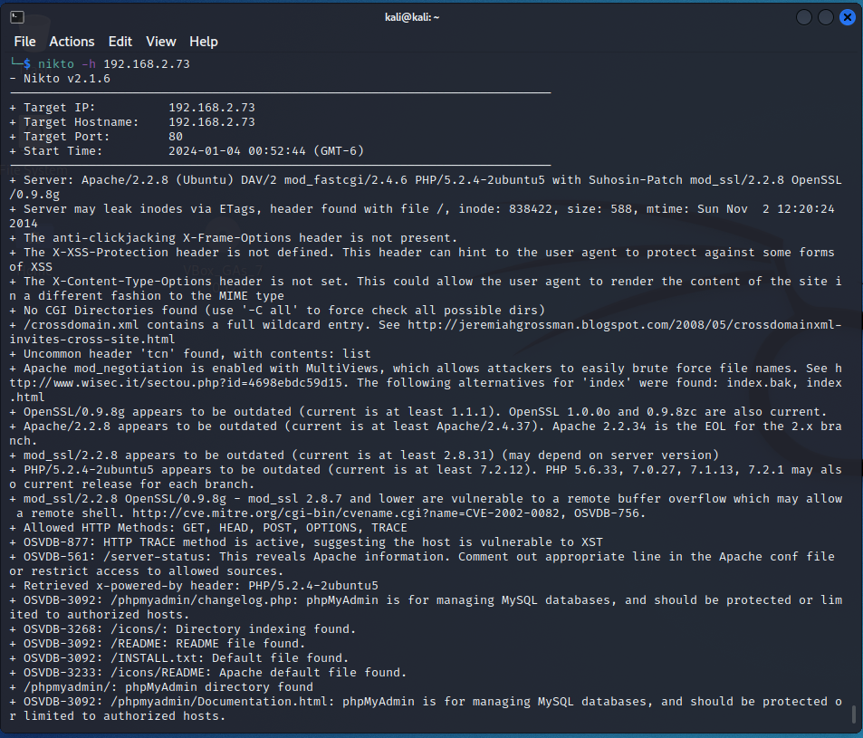
After executing the NMAP and Nikto tool, Nessus tool was configured to perform automated vulnerability analysis. Below screenshot shows the configuration panel where the IP address of the target was given.
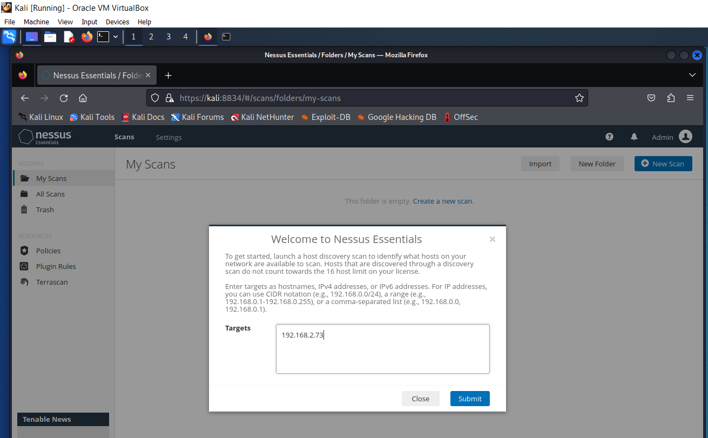
The host discovery process of the Nessus scanner showed the IP of the target server on which vulnerability analysis will be conducted.
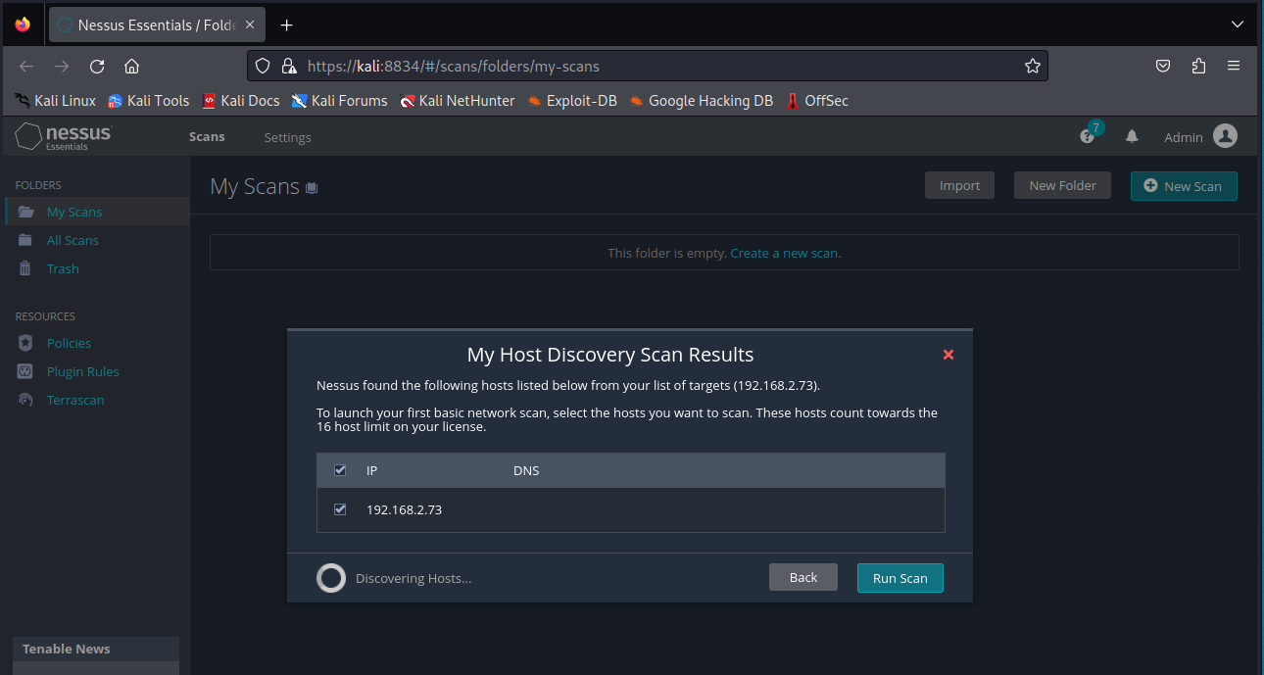

Below screenshot shows the scan result which was categorized into hosts, vulnerabilities, remediation and history. There were a total of 174 informational, 16 low, 48 medium, 15 high and some critical vulnerabilities were identified by Nessus.
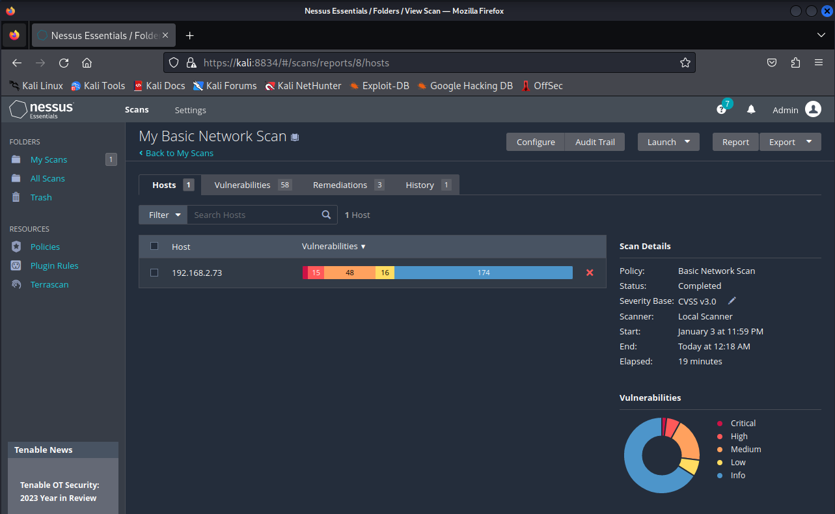
Below screenshot shows the details of identified vulnerabilities along with CVSS score, VPR, count and scan details.
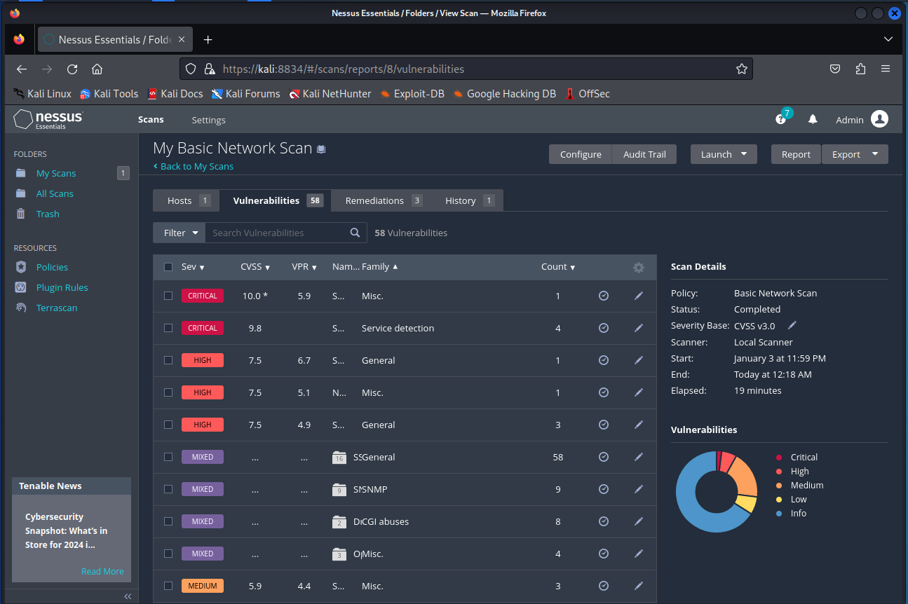

One of the identified critical vulnerabilities was heap based vulnerability as shown in the below screenshot. Additional information about the vulnerability was also given such as description, solution, severity, and more.
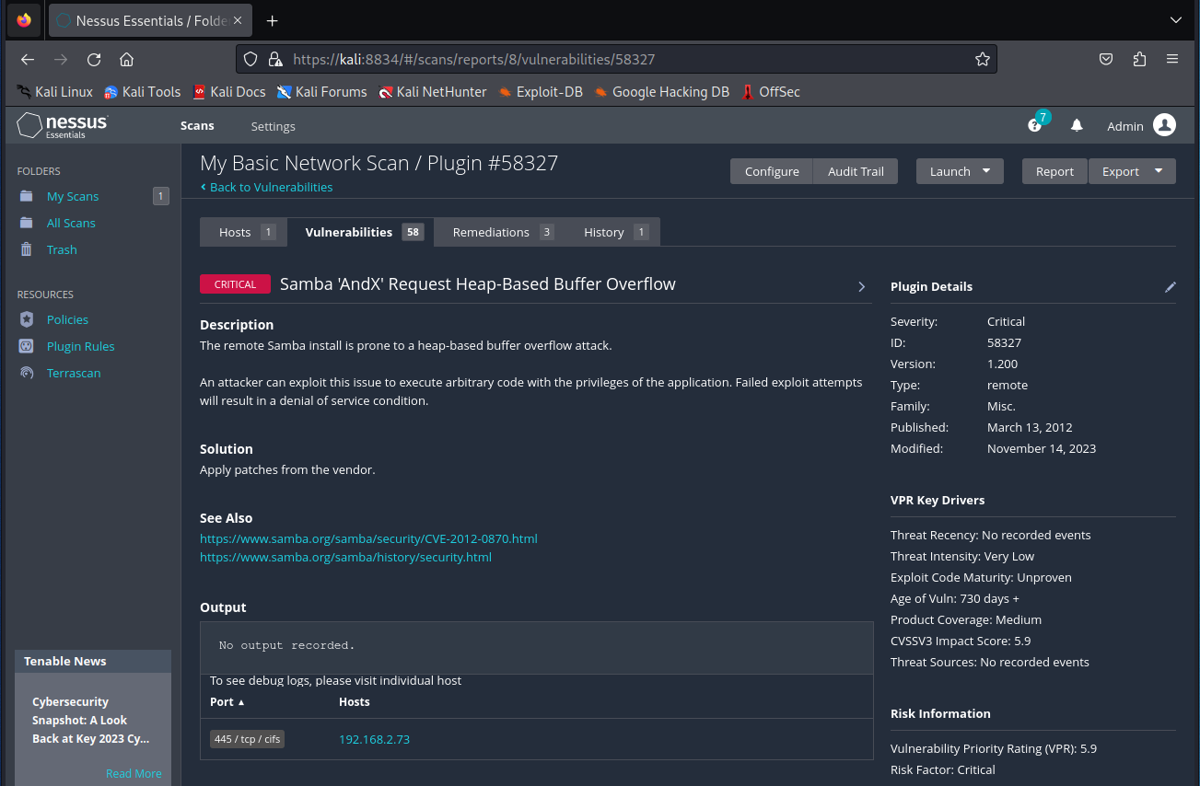
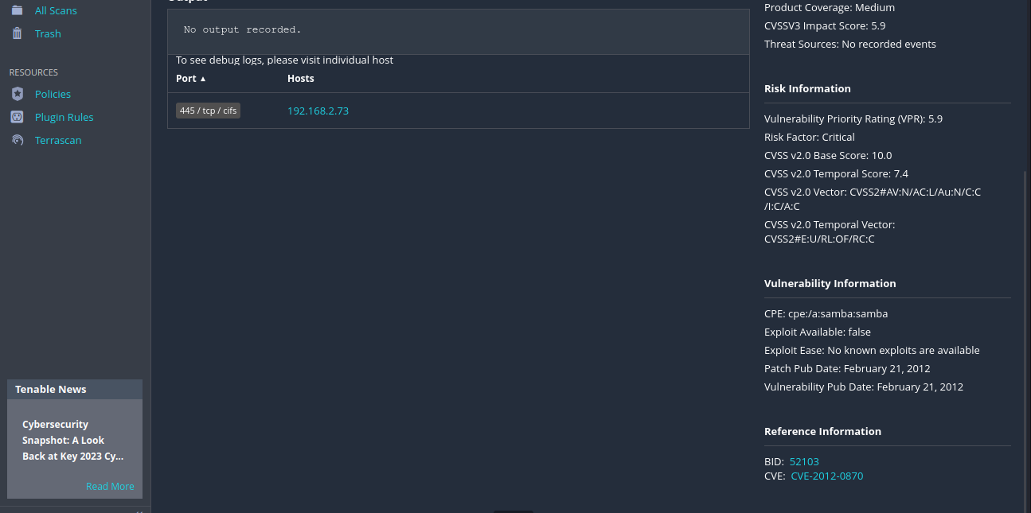
The below screenshot shows the remediation action for the identified vulnerability.
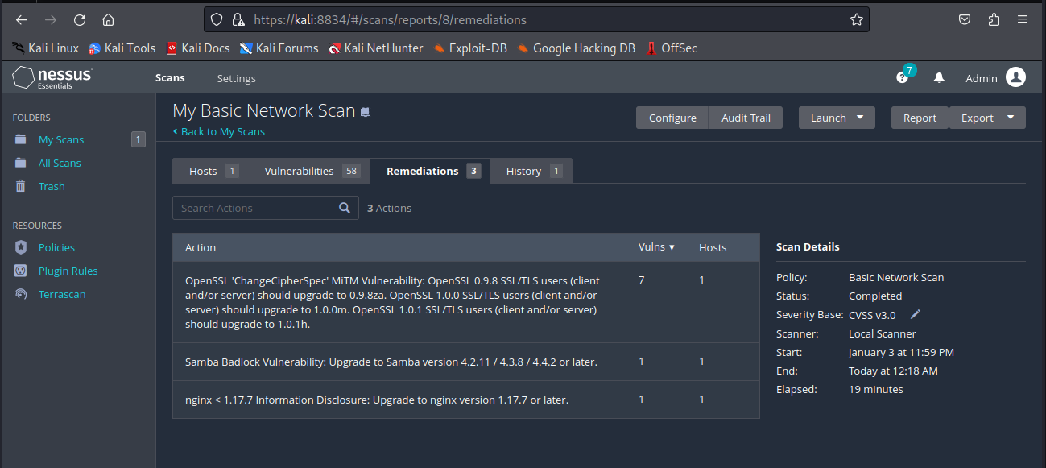
Another vulnerability identified by the Nessus was the use of a weak hashing algorithm for SSL certificates as shown in the below screenshot.
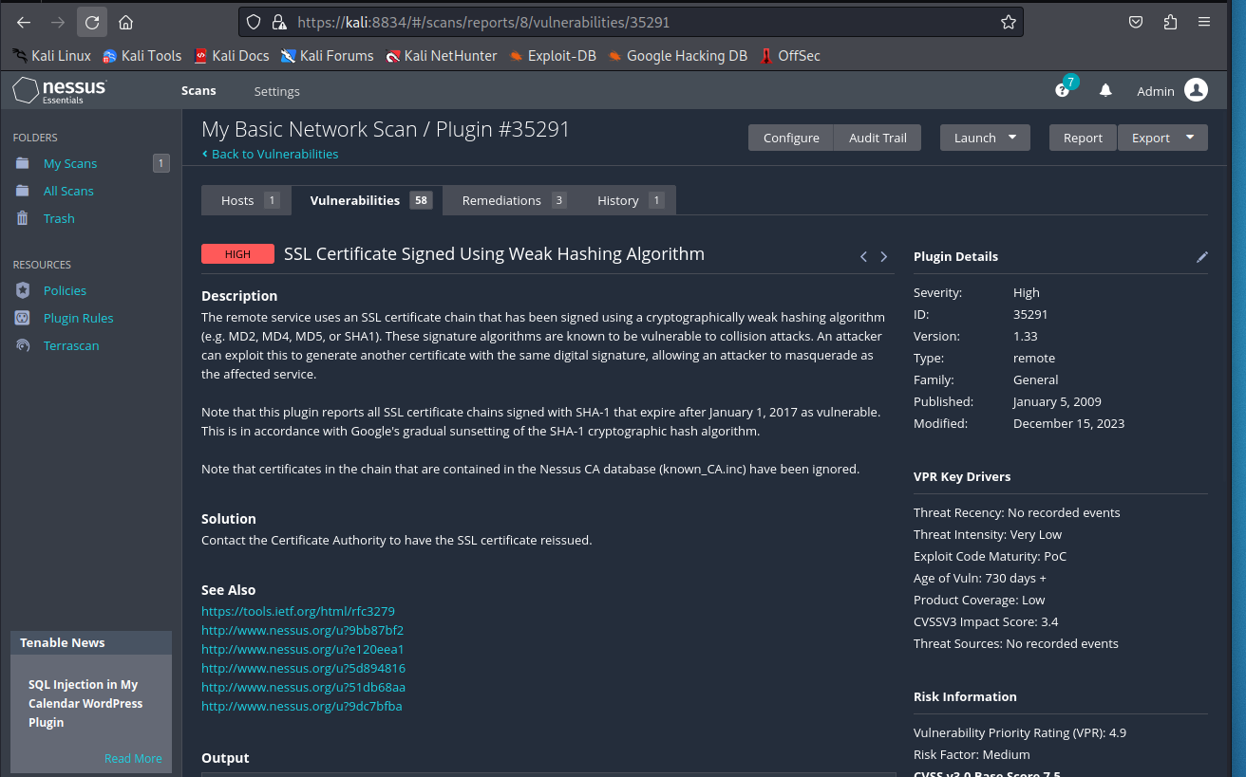
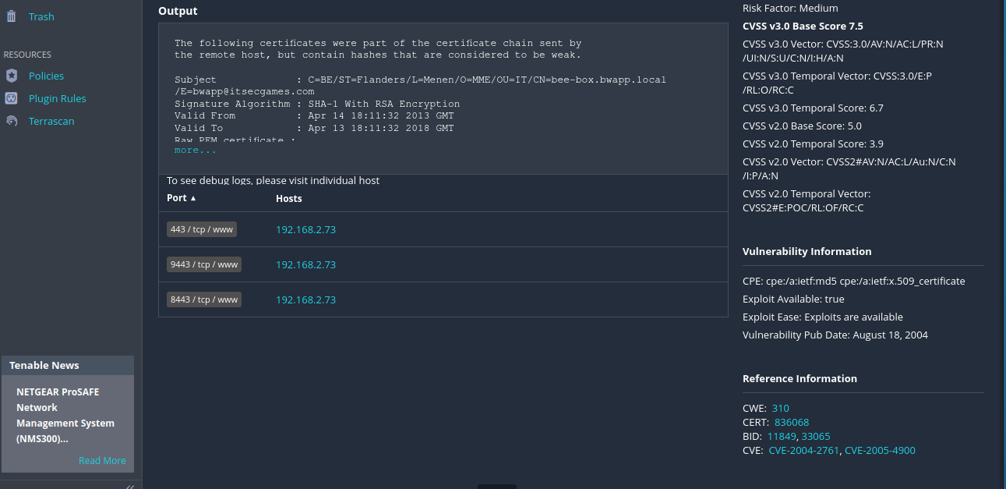
Another vulnerability called information disclosure was also identified by the Nessus scanner as shown below.
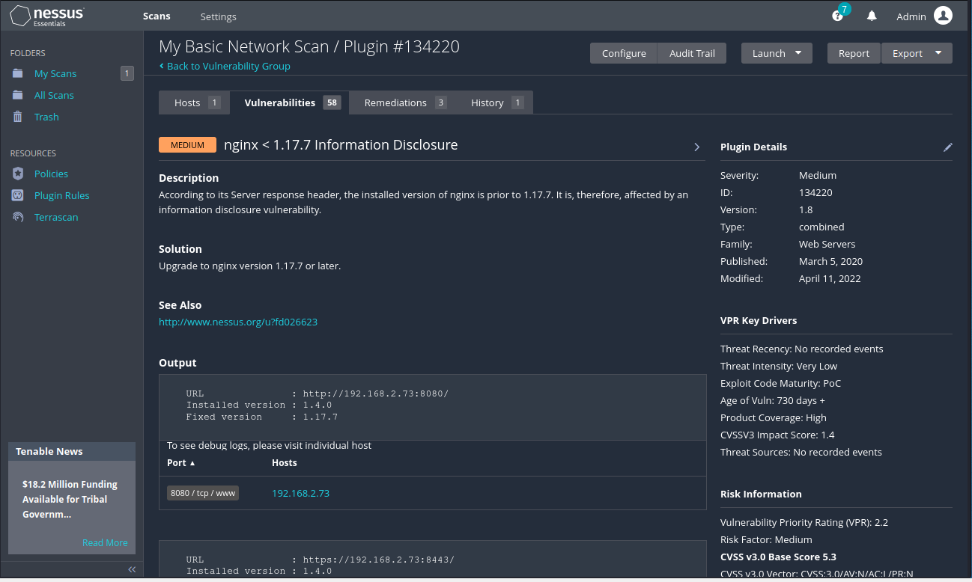
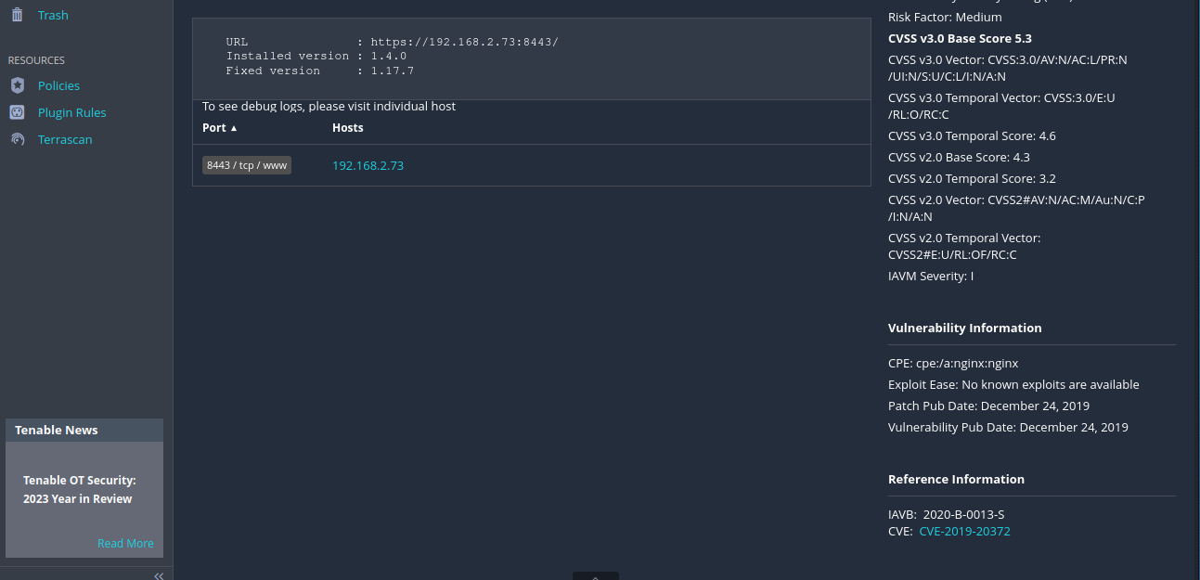
The identified vulnerabilities were then exploited using msfconsole and FTP utility. As shown in the below screenshot, the ftp command is used to access the FTP server using anonymous username and empty password. The FTP server successfully allowed the anonymous login by which contents of the FTP server were listed using ‘ls’ command. The GET command was then executed to download the files stored in the FTP server.
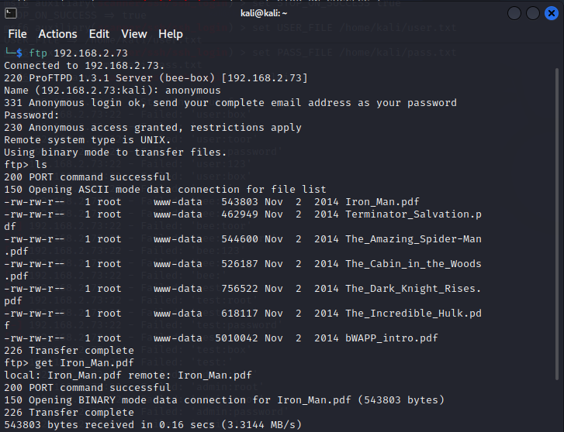
The below screenshot showed that the file was successfully downloaded to the attacker’s PC without using any FTP user account.
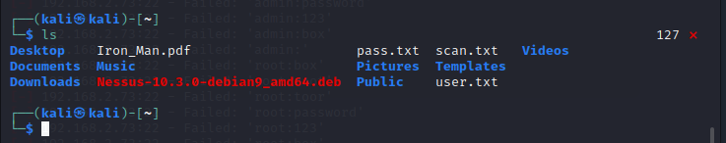
The Metasploit tool was then used to perform further attacks against the CPC server. Earlier in the vulnerability analysis, denial of service vulnerability was found with CVE ID – 2011-3192, which was exploited using a metasploit tool as shown below. The RHOST IP address and RHOST Port was configured and then the attack executed using run command.
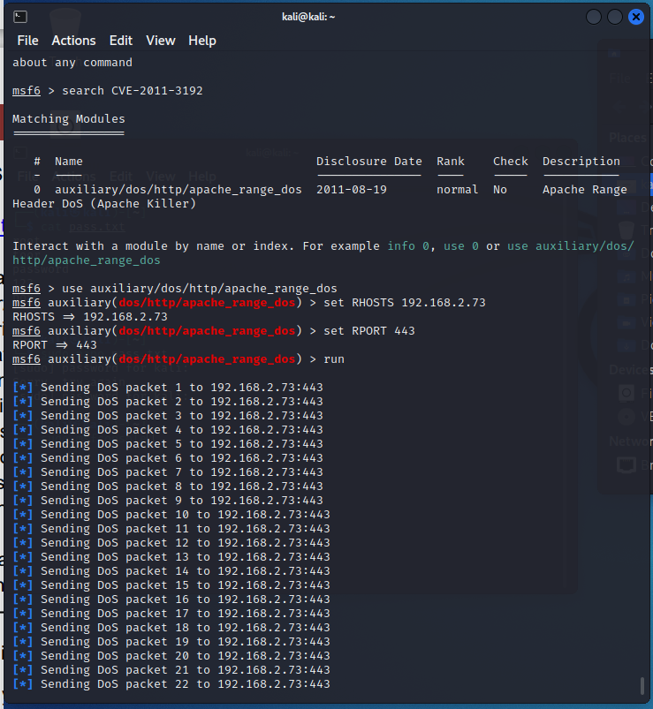
After executing the DDoS attack, brute force attack was then configured to be executed against SSH service by setting RHOST IP, Username and password file. As shown in the below screenshot, brute force attack successfully executed using and extracted the username and password of SSH service as root:bug and bee:bug.
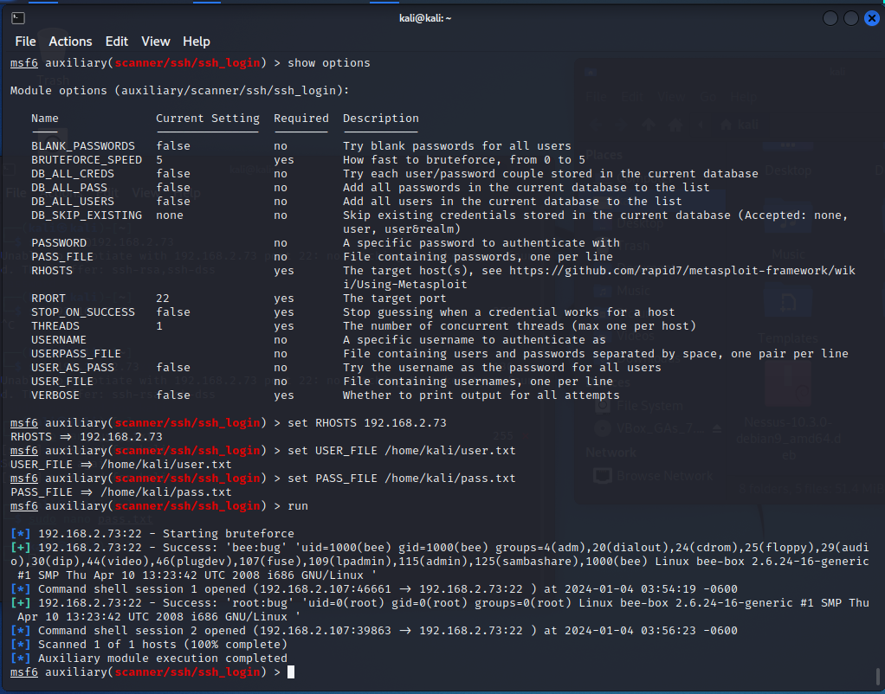
After exploiting SSH service using brute force attack, ‘ls’ command was executed after creating a session with SSH to list the directories. As shown in the below screenshot, the username and password found was correct and able to grant access to the server.
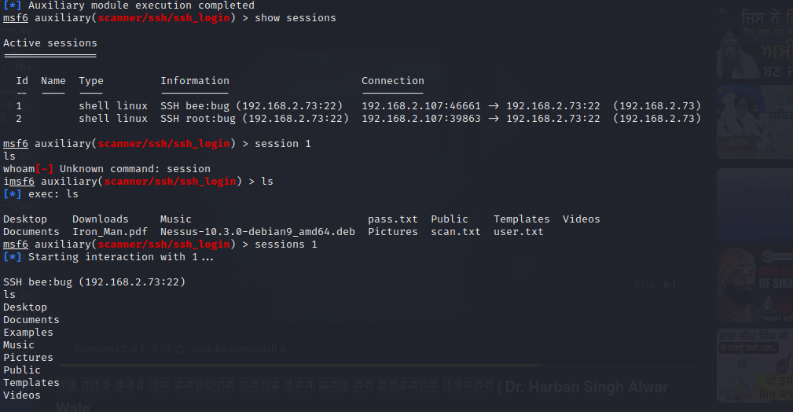

Results of the Attacks
In this penetration testing, multiple attacks were executed against the CPC server which includes FTP, SSH and HTTP service. By performing anonymous login to the FTP server, all the files stored in the server were visible and downloadable. As shown in the execution of the FTP attack, GET command was used to download the FTP files successfully without authorization.
Following this, the Denial-of-Service attack was executed where the apache HTTP server was flooded with malicious DDoS packets. The HTTP service becomes unavailable and unresponsive to accept new web requests from the client devices.
Finally, a brute force attack was then performed against SSH service. In this cyberattack, login credentials for the brute force were extracted which were then used to login to the server using SSH service. The full system access was then granted and any command can be executed on the server.

Solutions for Discovered Threats and Vulnerabilities
Based on the results of the attacks performed, following are a few recommendations in order to secure the network:
FTP: It is crucial to use secure FTP protocols (such as SFTP) to encrypt data transmission and adequate authentication techniques to prevent unauthorized access [42]. Regularly examine and adjust user access permissions to reduce the risk of data exposure.
DoS Attack: In order to identify and neutralise DDoS attacks, deploy a robust network firewall and an intrusion detection/prevention system (IDS/IPS) [42]. The company should consider using traffic filtering and rate restriction techniques to detect and prevent malicious traffic. In addition, use cloud-based DDoS protection services to absorb and mitigate volumetric attacks.
Brute Force Attack: It is of utmost importance to Implement strong password policies that include difficult and frequently updated passwords [42]. Implement account lockout techniques after a certain number of failed login attempts to protect against brute force attacks. Consider adding multi-factor authentication (MFA) to improve the security of SSH access.
Solution | Mitigation of Vulnerability
Disable weak keys on the client side by defining a minimum length for the Dffie helman keys. | Man-in-the-Middle Attack due to insecure TLS protocol
Update the Apache version to 2.2.21 or newer | Denial of Service
Disable FTP Anonymous logins | FTP Anonymous Access
Configure the Web server to use a named location instead of using the error_page handler | Information disclosure due to insecure configuration in NGINX server
Update Drupal CMS to latest version | CSRF due to insecure Drupal version
Implement Firewall in the Network | Detects and Block malicious network traffic to prevent DoS, Malware Attacks and more
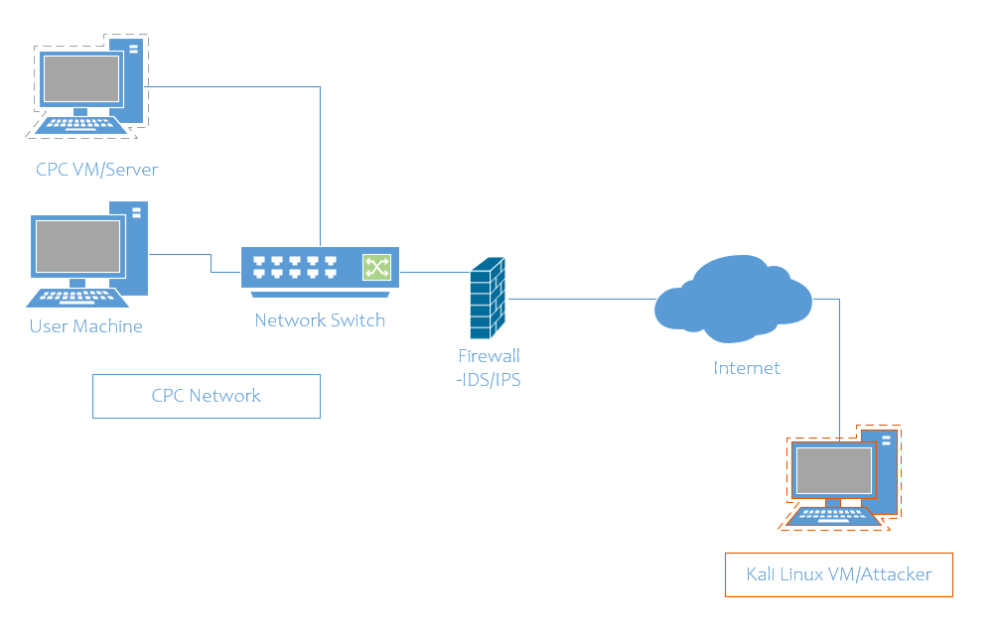
The above network diagram showed some security enhancements in the network. A Cisco firewall is implemented in the network to filter malicious traffic to protect internal servers and machines of CPC organisations. Inbound and outbound firewall rules are configured to block metasploit traffic and payload transfers towards the internal systems.

Cost Associated with Solutions
The cost of the solution is as follows:
- Software and Hardware:
  - Replacement of FTP server software with secure FTP protocols (SFTP): $500
  - Deployment of network firewall and IDS/IPS solution: $2,000
  - Cloud-based DDoS protection service subscription: $1,200/year
  - Implementation of multi-factor authentication for SSH access: $1,000
- Implementation:
  - Configuration changes and software/hardware setup: 20 hours at an hourly rate of $100: $2,000
Cisco Firepower ASA 5525-X firewall is the perfect solution to filter network traffic to prevent multiple cyber threats. Approximate cost of this firewall is $3000.

Time Table for the Execution of Solution
Time table for the execution of the solutions to mitigate the vulnerabilities is given below –
Execution | Time Period Required
Replacement of FTP software: | 1 Week
Deployment of network firewall and IDS/IPS solution | 2 Weeks
Subscription to cloud-based DDoS protection service | Immediate
Implementation of multi-factor authentication for SSH access | 1 Week

Invoice for the Service
Invoice for Professional Service:
Cureton Pharmaceutical Company
123 Main Street
ABC, London, 1010110
Invoice Date: [Insert Date]
Description of Services:
Penetration Testing and Execution Standard (PTES) - Full Scope Cyber Attack Simulation
Hourly Rate: $100
Total Hours: 20
Subtotal: $2,000
Total Amount Due: $2,000
Please make the payment within 30 days of receiving this invoice. If you have any questions or require further clarification, please don't hesitate to contact us. Thank you for choosing our professional services.

References
[1] “Topic: Impact of cybercrime on companies in the United Kingdom (UK),” Statista, Dec. 05, 2023. https://www.statista.com/topics/8131/cyber-crime-and-companies-in-the-uk/#topicOverview
[2] D. Temple-Raston, “A ‘Worst nightmare’ cyberattack: The untold story of the SolarWinds hack,” NPR, Apr. 16, 2021. [Online]. Available: https://www.npr.org/2021/04/16/985439655/a-worst-nightmare-cyberattack-the-untold-story-of-the-solarwinds-hack
[3] L. Constantin, “SolarWinds attack explained: And why it was so hard to detect,” CSO Online, Dec. 15, 2020. https://www.csoonline.com/article/570191/solarwinds-supply-chain-attack-explained-why-organizations-were-not-prepared.html
[4] CIS, “The SolarWinds Cyber-Attack: What you need to know,” CIS, Nov. 09, 2021. https://www.cisecurity.org/solarwinds
[5] trendmicro, “A growing goldmine: your LinkedIn data abused for cybercrime,” Trendmicro, 2023. https://www.trendmicro.com/vinfo/us/security/news/cybercrime-and-digital-threats/a-growing-goldmine-your-linkedin-data-abused-for-cybercrime
[6] D. Jones, “One year later: Has SolarWinds changed how industry builds software?,” Cybersecurity Dive, Dec. 14, 2021. https://www.cybersecuritydive.com/news/solarwinds-1-year-later-cyber-attack-orion/610990/
[7] I. Kagubare, “The Hill,” The Hill, Aug. 10, 2022. [Online]. Available: https://thehill.com/policy/technology/3595917-finlands-parliament-hit-with-cyberattack-following-us-move-to-admit-the-country-to-nato/
[8] Helsinki Times.fi, “Finnish Parliament’s website brought down by Russian hacker group,” Helsinki Times, Aug. 10, 2022. https://www.helsinkitimes.fi/finland/finland-news/domestic/22011-finnish-parliament-s-website-brought-down-by-russian-hacker-group.html
[9] T. Markovic, “Finland parliament’s website hit by DDoS launched by Russian hackers | Digital Watch Observatory,” Digital Watch Observatory, Aug. 16, 2022. [Online]. Available: https://dig.watch/updates/finland-parliaments-website-hit-by-ddos-launched-by-russian-hackers
[10] M. Mittal, K. Kumar, and S. Behal, “Deep learning approaches for detecting DDoS attacks: a systematic review,” Soft Computing, vol. 27, no. 18, pp. 13039–13075, Jan. 2022, doi: 10.1007/s00500-021-06608-1.
[11] A. Ahmad, Y. AbuHour, and F. Alghanim, “A novel model for distributed denial of service attack analysis and interactivity,” Symmetry, vol. 13, no. 12, p. 2443, Dec. 2021, doi: 10.3390/sym13122443.
[12] K. B. Adedeji, A. M. Abu‐Mahfouz, and A. M. Kurien, “DDOS attack and Detection Methods in Internet-Enabled Networks: Concept, research Perspectives, and challenges,” Journal of Sensor and Actuator Networks, vol. 12, no. 4, p. 51, Jul. 2023, doi: 10.3390/jsan12040051.
[13] Warbuon, “2022 Application Protection Report: DDoS attack trends | F5 Labs,” F5 Labs, Mar. 16, 2022. https://www.f5.com/labs/articles/threat-intelligence/2022-application-protection-report-ddos-attack-trends
[14] A. Pandey and J. R. Saini, “Attacks & defense mechanisms for TCP/ IP based protocols,” ResearchGate, Jan. 2014, [Online]. Available: https://www.researchgate.net/publication/260877113_Attacks_Defense_Mechanisms_for_TCP_IP_Based_Protocols
[15] B. M. Gibson, S. Townes, D. C. Lewis, and S. Bhunia, “Vulnerability in massive API scraping: 2021 LinkedIn data breach,” 2021 International Conference on Computational Science and Computational Intelligence (CSCI), Dec. 2021, doi: 10.1109/csci54926.2021.00191.
[16] Datadome, “Web Scraping Protection: How to Prevent Scraping & Crawler Bots,” datadome.co, 2022. https://datadome.co/learning-center/scraper-crawler-bots-how-to-protect-your-website-against-intensive-scraping/
[17] B. Zhao, “Web scraping,” in Springer eBooks, 2017, pp. 1–3. doi: 10.1007/978-3-319-32001-4_483-1.
[18] R. U. Rahman and D. S. Tomar, “Threats of price scraping on e-commerce websites: attack model and its detection using neural network,” Journal of Computer Virology and Hacking Techniques, vol. 17, no. 1, pp. 75–89, Oct. 2020, doi: 10.1007/s11416-020-00368-6.
[19] A. Yeboah-Ofori and S. Islam, “Cyber Security Threat modeling for supply chain organizational environments,” Future Internet, vol. 11, no. 3, p. 63, Mar. 2019, doi: 10.3390/fi11030063.
[20] Fortinet, “What are Supply Chain Attacks? Examples and Countermeasures | Fortinet,” Fortinet, 2023. https://www.fortinet.com/resources/cyberglossary/supply-chain-attacks#:~:text=Supply%20chain%20attacks%20are%20diverse,is%20used%20to%20steal%20cash
[21] M. N. A. Latif, N. A. A. Aziz, N. S. N. Hussin, and Z. A. Aziz, “Cyber security in supply chain management: A systematic review,” LogForum, vol. 17, no. 1, pp. 49–57, Mar. 2021, doi: 10.17270/j.log.2021555.
[22] M. Rodrigo, “Supply Chain Attacks case study,” ResearchGate, Mar. 2023, [Online]. Available: https://www.researchgate.net/publication/369480427_Supply_Chain_Attacks_Case_Study
[23] M. Alawida, A. E. Omolara, O. I. Abiodun, and M. Al-Rajab, “A deeper look into cybersecurity issues in the wake of Covid-19: A survey,” Journal of King Saud University - Computer and Information Sciences, vol. 34, no. 10, pp. 8176–8206, Nov. 2022, doi: 10.1016/j.jksuci.2022.08.003.
[24] cloudflare.com, “How to prevent DDoS attacks | Methods and tools,” cloudflare.com, 2023. https://www.cloudflare.com/learning/ddos/how-to-prevent-ddos-attacks/
[25] Amazon, “What is a DDOS Attack & How to Protect Your Site Against One,” Amazon Web Services, Inc., 2023. https://aws.amazon.com/shield/ddos-attack-protection/
[26] Amazon Web Services, “What is a DDOS Attack & How to Protect Your Site Against One,” Amazon Web Services, Inc. https://aws.amazon.com/shield/ddos-attack-protection/
[27] A. Haque and S. Singh, “Anti-scraping application development,” Journal, Aug. 2015, doi: 10.1109/icacci.2015.7275720.
[28] A. Ng, “Is web crawling legal? - Towards Data Science,” Medium, Dec. 10, 2021. [Online]. Available: https://towardsdatascience.com/is-web-crawling-legal-a758c8fcacde
[29] CrowdStrike and Vaideeswaran, “What are Honeytokens? | CrowdStrike,” crowdstrike.com, Jun. 26, 2023. https://www.crowdstrike.com/cybersecurity-101/identity-security/honeytokens/
[30] CrowdStrike, “What is Zero Trust Security? Principles of the Zero Trust Model,” crowdstrike.com, Nov. 14, 2023. https://www.crowdstrike.com/cybersecurity-101/zero-trust-security/
[31] broadcom.com, “Endpoint Protection - Symantec Enterprise,” Higher Logic, LLC, 2023. https://community.broadcom.com/symantecenterprise/communities/community-home/librarydocuments/viewdocument?DocumentKey=74450cf5-2f11-48c5-8d92-4687f5978988&CommunityKey=1ecf5f55-9545-44d6-b0f4-4e4a7f5f5e68
[32] M. Aljabri et al., “Intelligent Techniques for Detecting Network Attacks: Review and Research Directions,” Sensors, vol. 21, no. 21, p. 7070, Oct. 2021, doi: 10.3390/s21217070.
[33] Abbas, “Keeping Data Safe: How to Counter Web Scraping Attacks,” 2023. https://www.techopedia.com/keeping-data-safe-how-to-counter-web-scraping-attacks
[34] K. Wu, R. Cheng, H. Xu, and J. Tong, “Design and implementation of the zero trust model in the power Internet of Things,” International Transactions on Electrical Energy Systems, vol. 2023, pp. 1–13, Apr. 2023, doi: 10.1155/2023/6545323.
[35] Muhammad Fakhrul Safitra, M. Lubis, and Adityas Widjajarto, “Security Vulnerability Analysis using Penetration Testing Execution Standard (PTES): Case Study of Government’s Website,” Mar. 2023, doi: https://doi.org/10.1145/3592307.3592329.
[36] S. Liao et al., “A Comprehensive Detection Approach of Nmap: Principles, Rules and Experiments,” IEEE Xplore, Oct. 01, 2020. https://ieeexplore.ieee.org/document/9329410
[37] R. Lukanta, Y. Asnar, and A. I. Kistijantoro, “A vulnerability scanning tool for session management vulnerabilities,” 2014 International Conference on Data and Software Engineering (ICODSE), Nov. 2014, doi: https://doi.org/10.1109/icodse.2014.7062682.
[38] V. Balatska and M. Shabatura, “EXPLORATION OF COMPUTER NETWORK BY VULNERABILITY SCANNER NESSUS,” Bulletin of Lviv State University of Life Safety, vol. 20, pp. 6–11, Jan. 2020, doi: https://doi.org/10.32447/20784643.20.2019.01.
[39] S. Raj and N. K. Walia, “A Study on Metasploit Framework: A Pen-Testing Tool,” IEEE Xplore, Jul. 01, 2020. https://ieeexplore.ieee.org/document/9200028/
[40] S. Shah and B. M. Mehtre, “An overview of vulnerability assessment and penetration testing techniques,” Journal of Computer Virology and Hacking Techniques, vol. 11, no. 1, pp. 27–49, Nov. 2016, doi: https://doi.org/10.1007/s11416-014-0231-x.
[41] R. Messier, Penetration Testing Basics. Berkeley, CA: Apress, 2016. doi: https://doi.org/10.1007/978-1-4842-1857-0.
[42] Afraa Attiah, M. Chatterjee, and C. C. Zou, “A Game Theoretic Approach to Model Cyber Attack and Defense Strategies,” May 2018, doi: https://doi.org/10.1109/icc.2018.8422719.

