School of International Hotel
BA International Hotel Management

Name: Maria Mihaela Hirs
Student ID Number: 2226556
Module Title: Financial Management for the Hotel Industry (BMIH5007)

Name of Lecturer: Neil Dyer

Module Level: LEVEL 5

Table of Contents
Assessment 1 3
Introduction 3
1.0 Total Revenue 3
2.0 Market Position 5
3.0 Growth Potential 6
3.1 Expansion strategies 6
3.2 Market opportunities 7
3.3 Potential barriers to growth 7
4.0 Financial Commitment to CSR (Corporate Social Responsibility) 8
4.1 Shangri-La’s commitment to sustainability 8
4.2 Travelodge’s commitment to sustainability 9
Recommendation 10
Conclusion 10
References 11

Assessment 1

Introduction
The hospitality industry is much faster than that of any other industry, and Shangri-La and Travelodge are the two major players, of whom each have their specific differentiating factors. By catering for the high-end customers, the hotel does consider luxury in a very big way and also is conscious of the sustainability of its operations. While, Travelodge gives priority to the rooms which are easy to access and budget friendly for those who are hard on pocket. This begins by exploring some of the relevant strategic factors, including brand positioning, community engagement and growth prospects for the businesses. This would be an instrumental step towards helping audiences understand what the two businesses are doing well and the specific targets they are trying to achieve.

1.0 Total Revenue
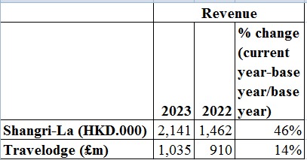
% change of revenue
(Source: Self-Deliberated from
An analysis of the income reports of Shangri-la and Travelodge shows that the two newly started companies registered an improvement in earnings during the first year of their operations, i.e., from 2022 to 2023. On the other hand, in the case of the western expansion for both the European Americans and Native Americans in the United States, the scope of use of land varies a lot.
Shangri-La Corporation experienced a remarkable rise in revenues in 2023, going up by 46% as it reached HKD 2.141 billion from HKD 1.462 billion in the previous year, thus displaying tremendous growth. Such result can be a mixture of few or many ingredients (Shangri-La. 2023). At first Shangri La develops the luxury segment of hotels that more often than not is more profitable than inexpensive or average hotel services. The consumers during the periods of the strong economy or the calm phases of the financial cycles tend to go for more upscale experiences like the ones the Shangri-La offers, with a sense of buying what happened to bring them during that good phase of the life. These non-strategic approaches yet are preferred by their businesses to gain further growth.
On top of that, it assumes two principal strategic positions, viz. completion of the business and thriving tourist activity in the Asia-Pacific region. The trips for work and tourism are helping a lot to fill up the brand Bookings and get more their revenues (From study material cost structure). Also, the great attention that is paid at Shangri-La to the needs of its customers and to the promotion of lofty customer loyalty programs could have kept customers coming back and spending more.
Travelodge, in the budget hotel sector saw growth of £146 million from £910 in 2022 to £1.035 billion in 2023, with a 14% rate of improvement (Travelodge, 2023). Firmly inclined the price sensitive market where shifts in the country may bring confusions, Travelodge authority could be attribute either firm’s strategic plan to grow the market or improved service operation. The fact that the brand is widely available and prices are quite competitive was probably a key aspect that made more customers choose then. As technology and digital marketing is their expertise, their progress in how they can improve their online booking system and the widening of their customer base are possible.
Surplus revenue in GBP of Shangri-La in 2023 over Travelodge is primarily attributed to target market differentiation, unique factoring tactics as well as brand recognition (Shangri-La. 2023). Shangri-la puts more emphasis on fifth-star hotels and specialized services that give the place an up-market feel. On the other hand, Travelodge is a budget friendly accommodation provider that attracts tourists who have a set budget that they cannot exceed. The divergence of the two organizations can't certainly depend on purely accidental factors.
Shangri-La and the partner firm need to overcome their hitches and also for them to keep going on with wealth growth, they require to tap on the right opportunities. Shangri-La has to keep being one of a kind but also to continue experimenting and testing new approaches in the high-end hotel sector consistently with the top quality service. It is crucial to channel all resources correctly by way of technology, sustainability, and exclusive experiences as this will give the Shangri- La brand an insight into what the modern customers want.
In the market of budget hotels for us the winner will be the Travelodge that will clearly stress the facilities that will make the most profit and not forget about the good customer service. The airline implements a number of initiatives including a streamlined operation, guest satisfaction is valued most, and increasing the locations that the airline operates and establishing a symbiotic partnership with the online travel agents. Through the application of this plan, Travelodge will be able to claim its spot as an important industry player and be recognized by a greater number of budget- seeking customers.

2.0 Market Position
In terms of designing guest-attractiveness for the hotels with different styles, Shangri-La and Travelodge are opposite. On the contrary, Shangri-La is all set to attract high-end visitors with personalized and luxury service such as upscale lodging, whilst Travelodge aims a wider range market by offering budget-friendly options with simple utility features (Ushakov et al., 2020). Housekeeping, repair service and basic amenities are the things that the hotel guests must pay only a small fee to enjoy them. On the other hand, hotels of Shangri-La often come with beautiful landscapes and strategic locations at the heart of the prime districts that act as a shuttle for retail and for sightseeing purposes.
Even though Shangri-la's market share compared to the mid-range and budget hotels might not be impressive, it is one of the important players for luxury market (Alhemeiri et al., 2024). Among other budget hotels, Shangri-La only holds a sway in specific fields, which usually translates into the thriving luxury markets, mainly in Asia-Pacific.
Shangi-La targets customers characterized by a high level of wealth. They include the top managers, wise wanderers, who crave enveloping comfort and deluxe service, offered at their whim (Ahmad, 2024). They are ready to spend large amounts of money in search of bespoke care, superior technologies, and unique cultural experiences, saturated in luxury and refinement. These VIPs are welded by frenetic pursuit of the highest extravagance and unimaginable enchantments of this bewitching site.
The Shangri-La standing among the competition depends largely on how the brand is viewed by customers. It carries opulence, superiority, and inters exemplary service. The Shangri-la, a name that evokes its excellence, the guest has to experience, in its entirety, and in every intricate detail, irrespective of whether it is the corporate or the personal traveler. This is the choice of discerning high- end customers!
The Travelodge hotel targets economy tourist repellent by offering great at a fair price. Traveldoge defines itself as a product that provides a comfort-yet-affordable match for its guests in the form of a fare that's also rate-sensitive. Whatever the traveler's purpose, (whether for business, vacation, or with very tight budget) it is all-in-one (George, 2021).
Travelodge is embraced by hoteliers worldwide as evolving as the not-pricey but comfortable resting places, while Shangri-La evolves to luxury hotels. Traders think of Travelodge as being the first company in affordable room service wherein no compromise is involved (Aroul et al., 2023). Holiday Inn branches all over the world is promoting keeping up of their customers because it is affordable but without sacrificing experience.
Travelodge is an affordable hotel that prioritizes easiness, convenience, and consideration when it comes to the pockets of consumers regardless their needs from staying as a frequent business traveler to an outbound family vacation (Jakhongir, 2023). Customers can make the difference between them which might be makeshift, one-night vacations, or short tours, deliberate choice of bookings from the hotels which can give them the more value and money.
Most of the Travelodge customers base their perception on the hotel's three features: the affordable rate, the consistent availability of the services, and the convenience of the location. While it could not compete in the category of luxury brands for example, Shangri-La, the Travelodge stays true to providing the clean, basic accommodation to the budget conscious customers as a relative option.

3.0 Growth Potential

3.1 Expansion strategies
To increase their reach, Shangri-La is expected to use both organic growth and deliberate partnerships. Firstly, this means creating new properties in areas that previously have not been highly active but are now coming to the forefront of the investment cycle. Emphasis may lay on those markets with a developing and upper-class and/or a tourism sector to match. But instead, associating with investors and developers covers financial and operational issues and reduces risks consecutively (Krupenna and Ostapenko, 2023). Also, the organization will have to explore other paths royalty areas or way of life sectors if the brand is to have secondary income sources while giving trust and credibility at large.
The Travelodge seeks corridors of growth in existing markets as well as the opening of new international territories that have a high demand for low-cost accommodation. It is feasible to bring about the required growth without massive financial investments by means of franchising or management contracts for instance (Issau et al., 2023). To take advantage of the potential of future growth, company concentrate on the cities that are weakly represented in the sector of low-cost hotel offerings. With client interaction and profitability being the primary focus, investment in technological developments and digital marketing is imperative.

3.2 Market opportunities
Shangri La has a path to capture niche markets like China, India and Southeast Asia that are fast growing. Moreover, branching out to various fields such as health resorts that prioritize wellness or venues specifically designed to host events that one would only experience once in a lifetime can also offer a better fulfilment of customers' newfound needs (Rather, 2023). The fact that the Shangri-La has a high standing coupled with the excellence of its loyalty system has attracted high-end clientele and also helped the hotel to acquire large market share in the high-end hospitality market.
Travelodge can take up the trend of a growing trend by budget travellers, notably millennial and travellers that are financially-aware. In the central business markets of major metropolis, there exists favourable opportunities as there is a significant desire for economical lodgings for both business trip and city tourism (Arvindaraj et al., 2023). It may be helpful to concentrate on sites with easy connections to transit as well as highways in a bid to lure in strolling visitors pursuing convenient stopping places in their marathon ordeals. Besides, adopting mechanisms towards a functional view of the environment and economic operations may not only make Travelodge unique but also ensure the attraction of environment-conscious tourists and the attainment of success.

3.3 Potential barriers to growth
The fact of a competition with world known well-established global brands operating in the niche of high-class hospitality can entail key issues for Shangri-La hotel. Moreover, negative external factors such as global economic challenges or political instability in the first destinations could follow their way and have impairing effect on the demand for luxury travel and thus cut down on revenue generation (Susilo and Santos, 2023). Along with the cruces, the regulators’ approval and especially the complex difficulties that come with the opening of the new outlets in emerging markets present increased risks in investment.
With many Travelodge chains such an overcrowding in the market, increased price competition, and deficiency in growth chances are among the difficulties that Travelodge could face. Notably, shifts in economic conditions coupled with volatility in currency exchange rates tend to greatly influence the shopping behavior of customers. In turn, this is the driving force of hotel profit and occupancy (Mnyakin, 2023). Regulatory processes can become a slowdown of property development or even a stopping behavior entering particular markets. The implementation of franchising in a large number of properties and maintaining the constant quality may present some operational issues that can be manifested in poor performance, which in turn can lead to jeopardizing the brand’s reputation.

4.0 Financial Commitment to CSR (Corporate Social Responsibility)

4.1 Shangri-La’s commitment to sustainability
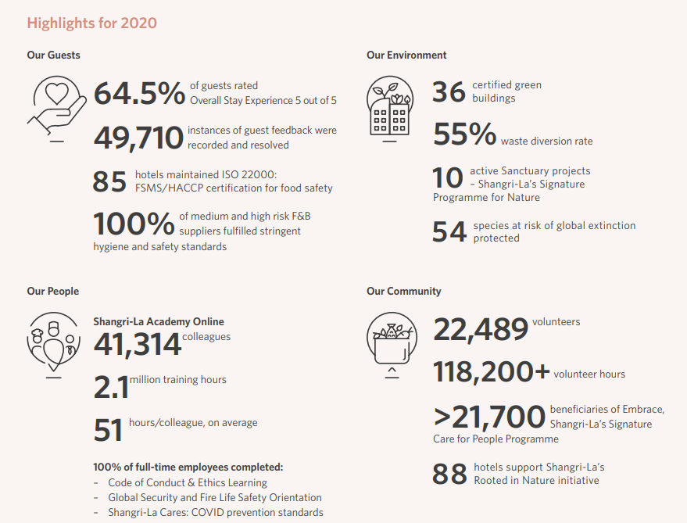
4 P’s of Shangri-La hotel
(Source: Shangri-La Group 2020)
Product: The standards of excellent hospitality are the main concern of the Shangri-la hotel backed by the guests' pleasure and the training programs arranged for employees. In other words, the commitment to food safety is manifested in that they are ISO 22000 certified, which guarantees high level of cleanliness and safety of their restaurants (Mishra, 2023). Especially, Shangri-la's desire for a sustainable environment is embodied by their priority for green constructions and Sanctuary efforts as it forms an important part of the destination concept for travellers with an eco-friendly mindset.
Price: Quality and ethics take prominent position in Shangri-La's services - this shows that this enterprise attracts high-end customers who choose luxurious, high-quality and ethically-tailored services even disregarding the final price (Yusuf and Keke, 2023). No exact price has been released yet, but beside reliability, reputation of exemplary guest services, safety, and environmental stewardship supports eagerness of paying in a premium category.
Place: Shangri-La Hotel Group insists on systemic establishment of food safety certification (ISO 22000) and has 85 hotels with this certification broad representing the geographical area (Mishra, 2023). The Shangri-La Academy mentions online training as the way to both keep consistent service quality at all of their outlets and also ensure that each of the properties is tightly connected. Shangri-La sites were characterized with a tight focus on quality control and trained their workforce to ensure the same world-class Tier a service across thousands of different markets.
Promotion: Shangri-la use different actions to reverse the image of the brand as best, in good or economically to offer the community. Proper corporate social accountability (CSA) cannot be realized solely based on provision of customer satisfaction, environmental preservation, and community improvement (Yusuf and Keke, 2023). This CSR strategy can be seamlessly applied during promotional campaign which will captivate socially-inclined tourists. Furthermore, Shangri-La's training sessions inculcate its commitment since most likely they could be considered as the good practice in the services of guests and health security.

4.2 Travelodge’s commitment to sustainability
Travelodge's "Better Future" sustainability strategy consists of three main pillars: Embracing, compassionate and alert. The emphasis is given to building a diverse and socially mobile team in the company as per the Inclusive pillar (From study material sustainability). For the second pillar, Travelodge has adopted support initiatives like collegial well-being and charity partnerships (Travelodge. 2022). The first Conscious pillar pays attention to mitigating harm to the environment, which means decreasing net emission effluxes and improving water usage.
In 2022, Travelodge delivered more than what was expected by far by meeting beyond the objectives for gender inclusivity done by Co-operative Performance Review, apprenticeship opportunities at remote places, disaster response meant for over 1,000 people and maintaining expert coaching to bring up safety standards. Being keen in ensuring that the company is able to achieve the Separate sections for choice and environmentally friendly packed products production records the efforts by the CEO, Jo Boydell (Travelodge. 2022). Boydell firmly emphasizes the fruits of their efforts which help steer the transition, contributing to sustainability as well as ethical initiatives.

Recommendation
Sustainability will help Shangri-La to remain the leaders in hospitality industry and provide the services of better quality around the world. To be like that is their advantage in the sea of commerce. To Travelodge, however, paying attention to good customer service, adopting technology to enable better room combination, and the green initiatives are the most important elements for their successful slog in the low-budget hotel industry. Through the provision of reliable and good quality cheap lodging facilities, the accommodation provider will attract not only the low budget travellers, but also help create the best experience for its value conscious customers.

Conclusion
Shangri-La Limited has its core of dominance in the luxury hospitality market but Travelodge is known to generate affordable accommodations. It is considered to be the fact of the matter if these companies will still take environmental effects and ethical responsibilities into account, or not. The fact is that the reputation of brands may depend on it. The two hotels have managed to achieve their remarkable position by explicitly highlighting their special traits and the problems faced by them. Hence, they have continued to flourish despite being in competitive industries.

References
Ahmad, S.R. and Khan, I.A., 2024. Effectiveness and impact of management accounting in hospitals: Evaluation of the effectiveness of cost accounting and revenue budgeting. Journal of Infrastructure, Policy and Development, 8(5), p.4159.
Alhemeiri, N., Ali, N., Alawlaqi, M., Almarzooqi, Y., Alshowab, A. and Nobanee, H., 2024. Financial analysis of Shangri-La Hotel.
Aroul, R.R., Hodari, D., Bianchi, G. and Martignoni, G., 2023. The impact of brand affiliation on asset values: the case of UK hotels. Journal of property research, 40(2), pp.157-187.
Arvindaraj, G., Manikandan, B., Rokesh, R. and Abinaya, M., 2023, March. Opportunities of Machine Learning Techniques in the Catering Industry-A Survey. In 2023 Second International Conference on Electronics and Renewable Systems (ICEARS) (pp. 1405-1409). IEEE.
George, R., 2021. Tourism and Hospitality Marketing Principles. In Marketing Tourism and Hospitality: Concepts and Cases (pp. 3-31). Cham: Springer International Publishing.
Issau, K., Gnankob, R.I., Ansong, A., Acquah, I.S.K. and Erskine-Sackey, N.M., 2023. Organisational learning and customer focus: implications on firm performance in the hotel industry. International Journal of Work Innovation, 4(2), pp.116-132.
Jakhongir, A., 2023. The Role and Importance of Accommodation Services in the Development of Tourism. Best Journal of Innovation in Science, Research and Development, 2(12), pp.164-168.
Krupenna, I. and Ostapenko, M., 2023. Marketing strategies of network forms of business in the hospitality industry. Збірник наукових праць Черкаського державного технологічного університету. Серія: Економічні науки, (69), pp.75-84.
Mishra, P., 2023. Brand sustainability of three star hotels: tourists' experience of service quality. Acta Universitatis Bohemiae Meridionales, 26(1).
Mnyakin, M., 2023. Big Data in the Hospitality Industry: Prospects, Obstacles, and Strategies. International Journal of Business Intelligence and Big Data Analytics, 6(1), pp.12-22.
Rather, R.A., 2023. Metaverse marketing and consumer research: theoretical framework and future research agenda in tourism and hospitality industry. Tourism Recreation Research, pp.1-9.
Shangri-La Group 2020. Sustainability Report 2020. Shangri-La Group. Available at: https://sitecore-cd.shangri-la.com/-/media/Project/Shangri-La-Group/OurStory/Files/Community-And-Social-Impact/Sustainability-Reports/2020_SustainabilityReport.pdf (Accessed: April 29, 2024).
Shangri-La. 2023. S07.SI - Singtel (Z74.SI) Stock Price, News, Quote & History - Yahoo Finance. Yahoo Finance. Retrieved from https://finance.yahoo.com/quote/S07.SI/financials
Susilo, D. and Santos, M.C.K., 2023. Digital marketing communication sustainable hotel practice of accor group in social media. International Journal of Economic, Business, Accounting, Agriculture Management and Sharia Administration (IJEBAS), 3(3), pp.730-743.
Travelodge, 2023. Thame and London Limited Annual Report [PDF]. Available at: https://www.travelodge.co.uk/nw/sites/default/files/Thame_and_London_Limited_signed_FY23.pdf (Accessed: April 29, 2024).
Travelodge. (2022, September 21). Travelodge launches new sustainability plan better future. Travelodge. https://www.travelodge.co.uk/our-business/blog/2022/09/21/travelodge-launches-new-sustainability-plan-better-future/#:~:text=Travelodge%20has%20recently%20officially%20launched%20its%20first%20sustainability,to%20be%20aligned%20to%20Science%20Based%20Targets%20%28SBTI%29.
Ushakov, R.N., Kryukova, E.M., Khetagurova, V.S., Mukhomorova, I.V. and Zelenov, V.V., 2020. Efficiency of hotel management. Training of specialists in hotel industry field. Journal of Environmental Management and Tourism, 11(2), pp.388-395.
Yusuf, T. and Keke, Y., 2023. Embracing the Future of Hotel Hospitality Digital Marketing. Jurnal Komunikasi Profesional, 7(1), pp.1-15.

