

RESULT

ASSIGNMENT DETAILS AND FEEDBACK
SOUTH WEST WALES CENTRE FOR TEACHER EDUCATION
Sections marked with * should be completed by module lead
Student number | 1700654
Programme: * | PGCE Primary
Module: * | The Enquiring Teacher | Module Level (6 or 7):* | 7
Module code: * | ECPP7001 | Contribution to Overall  Module Assessment (%): * | 100%
Module Lead:* | Catherine Morgan
Assignment Title:* | Write a critical and analytical essay that discusses your practitioner research ‘lesson study’ in relation to a chosen field. | Assignment No (x of x):* | 1/1
Start date:* | 09/01/18 | Submission deadline:* | 16/04/18
Word Count | 6558

Referencing: | In the main body of your submission you must give credit to authors on whose research your work is based. Append to your submission a reference list that indicates the books, articles, etc. that you have read or quoted in order to complete this assignment (e.g. for books: surname of author and initials, year of publication, title of book, edition, publisher: place of publication).
Submission: | All assignments must be submitted to Turnitin unless otherwise instructed by the Lecturer.  Note: the Turnitin version is the primary submission and acts as a receipt for the student. Late submission of the electronic version of the assignment will result in a late penalty. Penalties for late submission: Up to one week late, maximum grade D. Over one week late, Refer. Only the Extenuating Circumstances Panel may grant an extension. | Date: | 16/04/18

Module lead to tick to indicate if a hard copy version of the assignment must be submitted.* | YES
 | NO

This section repeats in brief the common assessment criteria detailed on previous pages. The extent to which these are demonstrated by you determines your mark. Using these criteria, tick the box that best indicates the level of achievement you feel you have achieved with regard to each of them.

Common Assessment Criteria Applied
Common Assessment Criteria Applied | REFER |  | D |  | C | B | A
 | OUTRIGHT FAIL | UNSATISFACTORY | SATISFACTORY |  | GOOD | VERY GOOD | EXCELLENT
1. Subject Knowledge and Understanding (which includes using research-informed literature and knowledge and understanding of the subject) |  |  |  |  |  | x
2. Intellectual Skills (Analysis) |  |  |  |  | x
3. Pedagogic and Professional Applications  (Practical Application and Deployment) |  |  |  |  |  | x
4. Key Transferable Skills |  |  |  |  |  | x
PLEASE COMMENT ON AREAS IN WHICH YOU FEEL THAT YOU HAVE PERFORMED WELL |  |  |  | PLEASE COMMENT ON AREAS YOU FEEL THAT YOU NEED TO DEVELOP
I collaborated well with my research partner. I was able to link the study back to the literature well. |  |  |  | I found it difficult to analyse qualitative data as on my undergraduate degree I only dealt with quantitative data.

Contents
Aims, focus and purpose of research……………………………………………………......5
Research context…………………………………………………………………………….…5-6
Literature review………………………………………………………………………….….....6-8
Lesson study methodology……………………………………………………………….......9-13
Design…………………………………………………………………………………...9
Participants………………………………………………………………………..…....9-10
Materials………………………………………………………………………………...10-12
Procedure………………………………………………………………………..……..13-14
Ethical considerations……………………………………………………………………..…14-17
Lesson study 1 analysis……………………………………………………………………..18-20
Lesson study 2 analysis……………………………………………………………………..21-23
Discussion…………………………………………………………………………………….23-24
Conclusion…………………………………………………………………………………....24-25
Recommendations……………………………………………………………………….….25
References…………………………………………………………………………………..25-28
Appendices………………………………………………………………………………….29-51
Appendix A………………………………………………………………………….29
Appendix B………………………………………………………………………….30
Appendix C………………………………………………………………………....31
Appendix D…………………………………………………………………………32
Appendix E…………………………………………………………………………33
Appendix F…………………………………………………………………………34-36
Appendix G…………………………………………………………………………37
Appendix H…………………………………………………………………………38
Appendix I…………………………………………………………………………39
Appendix J…………………………………………………………………………40-45
Observation schedule…………………………………………………….40
Focus group interview…………………………………………………….41-43
Reflection…………………………………………………………………..44-45
Appendix K…………………………………………………………………………46
Appendix L…………………………………………………………………………47-51
Observation schedule…………………………………………………..47
Focus group interview…………………………………………………..48-49
Reflection…………………………………………………………………50-51
How can we improve pupil involvement in collaborative learning groups through structuring group work in a Key Stage 2 classroom?
This research explores how pupil involvement in collaborative learning groups can be improved through the implementation of structuring the groups. This was of personal interest to me as I have very little experience of working with collaborative learning groups and I wished to improve my pedagogy and ability to use collaborative learning groups effectively. Upon discussion with my research partner, it became apparent that it was an area we both felt we could improve. Similarly, when we had used this method previously, some pupils did not collaborate with the group and we believe that this may have been due to our pedagogy. This is an important area for us to develop as Donaldson (2015) has highlighted collaborative learning as an important tool to produce enterprising and creative individuals. Therefore, improving our ability to foster effective collaborative learning groups within in the classroom will enable us to provide richer collaborative learning experiences for the pupils which allow them to excel with their collaborative skills.

Research context
The study took place in two large schools situated in a town in South West Wales. Both schools are partnership schools to Yr Athrofa. The class in School A was a mixed year 3 and 4 class which has 34 children aged 7 to 9 on role. The class in School B was a year 4 class which has 31 children aged 8 and 9 on role. This study explores how pupil involvement can be improved in collaborative learning groups as this was an area which the researchers sought to further develop their pedagogy in. Moreover, given the new curriculum reform in Wales (Donaldson, 2015), collaborative learning is an important aspect of classroom teaching and learning which has been highlighted by Donaldson (2015) as a useful tool to develop the four purposes of the curriculum.
In order to improve pedagogy related to collaborative learning, this research focuses on structuring groups through the use of roles in order to improve pupil involvement. For the children involved in the research, this meant participating in a problem solving task by carrying out the role assigned to them within a collaborative learning group. The aim of this was to increase involvement in a collaborative learning task. It was predicted that, providing them with a role would make them more involved in collaborative work and thus, improve their collaborative learning experience.

Literature review
Collaborative learning involves groups of pupils working together to achieve a shared goal (Johnson, Johnson & Holubec, 1994). Extending on this definition, Higgins et al. (2014) note that the groups must be small enough for everyone to participate on the task assigned. Donaldson (2015) highlights collaborative work as a useful tool to produce enterprising and creative individuals as it develops skills which employers desire (Donaldson, 2015; Wismath & Orr, 2015). Supporting this claim, the Organisation for Economic Cooperation and Development (OECD) (2014) state that in Singapore they ensure that students work collaboratively in group work as part of the curriculum which aims to develop creativity and problem-solving skills. This is worth noting as pupils in Singapore perform better in the PISA tests than students in the United Kingdom and their performance is considered world leading (Gurria, 2015). However, it must be acknowledged that although collaborative work may be a factor which strengthens their performance it is not the only factor in the strength of their performance. Supporting collaborative work, Donaldson (2015) argues that collaborative learning creates an environment which allows pupils to share ideas and receive feedback from peers which helps them develop their communication and thinking skills. Moreover, Blaschke (2012) highlighted collaborative work and problem based learning as educational strategies which provide students with skills to enable them to become autonomous and self-driven life-long learners, which is part of the vision which Donaldson (2015) outlines. In addition to this argument, Wismath and Orr (2015) suggested that metacognition, problem solving and collaboration are intertwined skills. Therefore, it is reasonable that Donaldson (2015) appreciates the need for teachers to encourage collaboration within the classroom, given its perceived importance in the development of imperative skills for children’s future careers. Supporting this view, Hattie (2009) highlights collaborative learning as an effective teaching tool. Moreover, collaborative learning is cheap and has a moderate impact on learners (Higgins et al., 2014). Furthermore, Donaldson (2015) emphasises that high quality collaboration skills are looked upon highly by employers and are necessary for children to become highly employable adults.
However, the implementation of collaborative learning in the classroom does not ensure student engagement or achievement of the learning objectives (Summers & Volet, 2010). Considering this, it must be remembered that the effectiveness of collaborative learning depends on the quality of the interaction of the pupils (Kaendler et al., 2014; Higgins et al., 2014). To manage this, the teacher can foster the collaborative learning and ensure that the groups are working together in a way which maximises their potential (Kaendler et al., 2014). This can be achieved through structuring approaches and a well-designed task (Higgins et al., 2014). This draws on social learning theory and the concept of scaffolding (Bruner, 1978). Social learning theory (Bruner, 1978), implies that collaborative learning is the foundation for all learning as it suggests that humans learn from social interaction. Kaendler et al. (2014) note that groups can be structured in several ways in order to foster effective collaboration.
Interestingly, groups may be structured through the allocation of roles (Kaendler et al., 2014). They note that this allows for pupils to feel individually accountable and creates positive interdependence within the group as each individual has a role to play. Teachers may assign roles to pupils or let them select a role, although allowing them to decide may result in pupils only experiencing roles which they feel comfortable in rather than gaining experience of new roles (Stewart, 2014). Supporting this view, Slavin (1990) argues that assigning specific roles to group members promotes individual accountability. Moreover, Slavin (1990) suggests that providing different members of a group with different resources encourages positive interdependence and subsequently motivates them to work as a group. However, this alone does not allow for effective collaboration and Stewart (2014) notes the importance of pupils’ knowledge and understanding of the roles and what their role entails, in order to ensure that they carry out their roles effectively.
Unfortunately, to date the researchers have little experience of teaching children in collaborative learning scenarios beyond employing assessment for learning strategies such as think, pair, share (Lyman, 1981) in the classroom. Although the Government recognise that strategies like this encourage thinking (Welsh Government, 2010), pupils need to experience working independently, in pairs and groups in order to gain experience in a range of situations (Donaldson, 2015). Conducting this study will enable the researchers to develop their confidence and ability to foster effective collaborative learning in the classroom. This is important as the curriculum review in Wales has highlighted collaborative learning as an important aspect of teaching and learning (Donaldson, 2015). Therefore, it is an aspect of pedagogy which needs to be developed in order to enhance the learning experience of future pupils.
Building on the research, this study will explore how structuring groups can improve pupil involvement in a close to practice manner. Upon reflection, the researchers will be able to enhance their own future teaching in collaborative learning situations which will improve their pedagogy and practice and consequently, enhance the learning experience of future pupils.

Lesson study methodology
Design
The methodology used to undertake this research was the lesson study method which is a form of action research conducted in the classroom in which teachers develop their own practice (Dudley, 2011). The method originates from Japan and involves two or more teachers collaboratively planning, delivering, observing and reflecting on lessons that focus on an aspect of pedagogical interest for their own professional development (Department for Education, 2009). It was conducted in a close to practice manner, allowing for high ecological validity as the study involved observations of normal classroom practice in its usual environment.

Participants
Participants were students from two large schools in South-West Wales. 29 pupils (17 males; 12 females) in a mixed year 3 and 4 class took part from School A, out of the class total of 34 pupils. The other 5 pupils were absent. 20 pupils (14 males; 6 females) from a year 4 class took part in School B, out of the class total of 31 pupils. One member of the class was absent and the other ten did not have parental consent and left the lesson in order to work on intervention activities. All the children that participated had informed parental consent (See appendix A) and had provided informed assent by signalling they wished to take part and this was witnessed by the class teacher for each class (See appendix B). Three focus children were then selected using the purposeful sampling method which Koerber & McMichael (2008) explain involves the researcher selecting participants based on the qualities they possess. From each class three children were selected from different attainment groups to try and ensure maximum variation (Higginbottom, 2004 cited in Koerber & McMichael, 2008: 464). The criteria also included the necessity of informed parental consent and that the children signed an informed assent form to notify the researchers that they were happy to participate in the study (See appendix C). All participants were aware of their right to withdraw.

Materials
Problem solving resources were used from the NRICH website (See appendix D) as it had been highlighted in the literature that collaborative work and problem solving were complementary (Wismath & Orr, 2015). NRICH also suggested roles for the tasks (See appendix E). These resources were selected as they are recognised by teachers to provide enriched mathematical problem solving experiences to children (NRICH, 2018) and can therefore be considered to be a well-designed task, minimising the risk of a poorly designed task affecting the outcome of the study (Higgins et al., 2014). Prior to the lesson the researchers created a lesson plan together (See appendix F) in order to try and minimise the risk of differences in delivery of the content of the lesson which may have interfered with the outcome of the study.
Qualitative data was collected during the lessons by the observer, using an observation schedule which employed structured and unstructured observation methods (See appendix G). This data type was chosen as it suited the nature of the study better than quantitative data. Acknowledging that the data was qualitative and based on the subjective experience of the observer and the children’s views and to avoid observer bias, we tried to ensure that observers were objective and refrained from letting personal views interfere with the study.
The schedule employed an adaptation of the Leuven Scale (Laevers, 1994), in order to measure involvement. This is a 5 point Likert scale on which the observer can rate the frequency of the observed child’s involvement, from 1 (extremely low) to 5 (extremely high). However, Likert Scales have been criticised as a method of data collection for failing to measure accurate attitudes and behaviours because there are intervals between points which are not accounted for and may be uneven (Bell, 2010; Coolican, 2014). Moreover, Dolnicar, Grun, Leisch and Rossiter (2011) argue that social desirability and the Hawthorne effect (Gillespie, 1991) could compromise the validity of the measure as the pupil being observed may behave differently because they are being observed. Moreover, the descriptors used for each point must be clear (Coolican, 2014). However, it must be acknowledge that the scale has been found to have satisfactory reliability (Laevers & Heylen, 2003). Although, this must be treated with caution as the researcher that developed the scale was involved in this finding. Acknowledging these limitations, we adapted the descriptors to suit the environment it was being used in and made the descriptors more specific to the behaviours being monitored. We altered them into a bullet point form which could be read with ease whilst observing and was more suited to this study and the specific ques we would typically find in this study of involvement levels. This also aimed to improve the inter observer reliability.
The observer also observed the communication of the focus children and rated their communication red, amber or green based on the level of communication they were engaging in. With red meaning no communication, amber meaning communicating with a partner and green meaning communicating with the group. The observer also wrote unstructured field notes on occurrences of interest during the lesson, about the behaviours exhibited by the focus children.
A pupil voice interview was conducted with the focus children as it is important for children to voice their views and have them considered, given article 12 of the Rights of the Child (United Nations, 1990) and the current recommendations of good practice by Estyn (Estyn, 2016). The interview was structured by prewritten questions (See appendix H), in order to minimise the risk of asking leading questions as this would not be ethical and could jeopardise the findings (Bell, 2010). An issue we may have faced with these interviews was that social desirability bias may have occurred with the focus children interviews and they may have said what they believed was the desired answer rather than have answered honestly. To avoid this, we tried to ensure that questions were not leading and allowed for honest answers. Moreover, we ensured that children felt comfortable in the environment which they were interviewed in by interviewing them in a group to make them feel more at ease. However, the weakness of this arrangement is that they may have felt obliged to agree with their class mates. To minimise this risk, the researchers tried to make the pupils feel comfortable and free to given their honest opinion. Another point which was considered is that given that the pupil voice interviews were voice recorded and then transcribed, some of the content may have been transcribed incorrectly. Thus, altering the points made by the pupils. To avoid this, the researchers listened to the recording multiple times and checked the transcription to ensure that it corresponded to what the children had said.
Upon completion of the experience, the researcher that had taken the teaching role reflected on the lesson and outcomes as part of the lesson study process (Dudley, 2011). This was captured using an Assisted Reflective Conclusion (ARC) (See appendix I). The ARC method of reflection combines several theories of reflection and is University of Wales Trinity St David’s (UWTSD) model. This model was chosen as the researchers were familiar with it. The ARC questions were altered in order to relate the reflection back to the focus of the study.

Procedure
Once parental consent had been confirmed and informed assent was obtained the children were grouped into groups of four and occasionally five. As the observer was not familiar with the class they observed, the researcher that took the role of the teacher ensured that the observer was aware of which children to observe. Then, the lesson was conducted. The observations were carried out for two minutes at fixed intervals by the observer. The observer ensured that they observed each child for two minutes at each observation point using their watch.
After the lesson, a pupil voice interview was carried out with the focus group children in a suitable room. This was recorded on a school iPad and deleted from the device once the researchers had transcribed the content. The focus group comprised of three children from each class. Finally the researchers discussed their findings and thought about how they could improve the pedagogy to enhance the collaborative learning groups and further improve the involvement of the children. The researcher that had taught the lesson reflected on it later that day. Finally, they planned how they could improve the lesson. The process was carried out again with School B.
The qualitative data will be analysed by exploring the focus children’s involvement during the lessons and their feedback about the experience.

Ethical considerations
Prior to conducting the research, it was important to consider the ethical issues surrounding conducting research with children. The school were aware of the study and signed an ethics form in order for the study to take place. Grigg (2010) notes that obtaining consent from parents is important. As children are not able to legally consent, informed assent must be obtained from them (Dockett, Perry & Kearney, 2012). Moreover, the British Education Research Association (BERA) state in their guidelines (BERA, 2011), that the informed consent and assent must be voluntary with no duress. This is part of the Nuremberg Code (United States Government, 1947). BERA (2011) states that the researcher has the responsibility to ensure that participants are treated fairly, sensitively and are not exposed to prejudice. Moreover, they must feel at ease and not be put in a situation which risks emotional or physical harm (BERA, 2011; United States, 1949). Also, participants must be able to withdraw from the study at any point (BERA, 2011; United States Government, 1949).
BERA (2011) specifies that researchers must comply with Articles 3 and 12 from the Rights of the Child (United Nations, 1990). Article 3 involves the best interests of the child being at the centre of all actions which affect children. Therefore, research undertaken must be done for the greater good of the child. This study is being conducted with the best interests of the children at the centre of it as its main aim is to improve future teaching in collaborative learning groups. Moreover, article 12 states that all children must be allowed to express their opinions and feelings about issues which affect them. Therefore, this study will allow for the focus children to express their views and feelings about collaborative learning groups and their structures during a focus interview. Under the data protection act (1998), all data collected about the participants will need to be kept secure and participants and the schools must not be identified in order to ensure confidentiality and anonymity. The lesson study was approved by the UWTSD’s Ethics Committee, prior to the study taking place (See appendix H).

Lesson study 1 analysis
Exploring the data collected during the observation at School A (See appendix J), it is of interest to explore the involvement of the focus group children and their success related to the learning objective (LO) and success criteria (SC). The involvement ratings of the three focus children at School A can be visualised in the graph below.

Child 1___ Child 2___ Child 3___
Figure 1: Graph showing the involvement ratings of three focus group children in School A.
Looking at Figure 1 above, it can be seen that the levels of involvement which the focus children were observed to display fluctuated across the course of the lesson. Looking at the data it can be argued that the children were generally involved in the collaborative learning task. However, it is noticeable that Child 1 was more easily distracted from the activity and consequently, had lower ratings for involvement than the middle attainment (Child 2) and higher attainment (Child 3) focus group children.
Exploring this finding further, Child 1’s communication with their group was also rated lower than the other two children. This may have been due to the child’s personality and attributes. However, it must be noted that at different observation points, all of the focus group children were observed to engage in all three of the communication levels. It is worth noting that at observation point 4 all pupils were not communicating and this may have been because they were all listening to the class teacher whom was delivering the plenary. Therefore, suggesting they were engaged with the lesson itself although the involvement ratings for Child 2 do not reflect this and instead note a dip in involvement for this child. Of interest, was Child 3, from the higher attainment group of the cohort, whom was experiencing difficulty with their group with regard to working as a team as other group members were disengaged. Consequently, this child failed to communicate with the group and completed the majority of the task working as a pair rather than a group.
The focus group children all managed to solve the problem which they had been given in their groups. However, as mentioned earlier, it was observed that Child 3 had difficulty working with other members of the group that seemed to be distracted and disengaged from the task. Although, the teacher tried to bring the group back on task around the third observation point, Child 3 generally worked in a pair rather than in a group and went on to carry out other group members’ roles when they failed to carry them out themselves. This meant that Child 3 was unable to meet the LO or aspects of the SC due to issues within their group. Feeding back to the researchers, Child 3 acknowledged that “not all of our group stuck to their role” and they thought that this was because “they did not want to do it, so it caused some arguments.” Child 3 reflected on the experience and said that it was difficult when the group were not listening. Contrastingly, the other two children thought that their groups worked well because they “were not squabbling” and “helped each other.” This suggests that the attitudes of pupils and the classroom ethos must be worked on for the allocation of roles to be successful.
Another notable aspect of the pupil voice interview was that the children felt positively about being given a role, remarking experiencing feelings such as “happy” and “special” because their “role was unique” and they had a “special piece to do.” Interestingly, they also resounded that “nobody has the same job” and that “if you had to share a role, it would not be fair.” They liked being given roles as “there is less arguing” and it is “equal for everyone.” All the focus children said they prefer working in a group and Child 3 recognised the benefit of collaboration, explaining that they preferred working in a group because “you can ask your friends for advice if you are stuck and give advice to your friends as well.”
When the children were asked if they thought there was something we could do to make working in groups better they suggested providing more work as “it was quite a short lesson.” Child 2 extended on this suggesting we “include more ideas to think about.” Child 3 then went on the say that having “2 things to focus on at the same time would test your knowledge and it would be a challenge to get both done.” The other children said this would be “interesting” and “more fun.”
Reading the reflection written by the researcher that took the role of teaching the class (See Appendix J), it is clear that they felt the roles helped the groups to engage and solve the problem based task as it gave them a responsibility. They noticed that some pupils did not like their role but felt that they had managed to change their attitude towards to task after she had made it clear that their role was important. However, although this worked briefly, the children were observed to continue to be disengaged with their roles. They thought that it would be important to rotate the allocation of roles over time in a class in order for pupils to experience different roles.
Upon discussion about our own views on the lesson and considering the pupil voice, to improve the lesson we decided to add a supplementary task (See appendix K), which complimented the current task and would encourage more discussion and thinking. We decided to continue to allocate roles rather than let children select their own as the pupil voice feedback highlighted the benefits of this approach for the children. However, it was noticed that some pupils did not like their roles both in the observation and in the pupil voice interviews, given that this was a fairly new experience for the pupils it was acknowledge by the researchers that this issue could arise in the next class and to address it the teacher must make an effort to encourage pupils to perform the role which they are responsible for. This could be done by interrupting the group to discuss why the children do not like roles, should a similar scenario arise in the future.

Lesson study 2 analysis
Exploring the data from School B (See appendix L), it will be interesting to note how the alterations to the lesson were perceived by these children and if the LO and SC were met by the focus group. All of the focus children managed to meet the LO and hit the SC points. The figure below shows the involvement of the three focus children through the lesson.
Child 4___ Child 5___ Child 6___
Figure 2: Graph showing the involvement ratings of three focus group children in School B.

Looking at Figure 2 above, contrasting with the previous cohort, focus Child 6 from the higher attainment group of this cohort, was observed to exhibit lower involvement than the other two focus children. Whereas, in the previous school, it was the child from the lower attainment group that was observed to exhibit lower levels of involvement. Exploring some of the unstructured notes taken by the observer, it can be said that Child 6 became distracted by resources and that their group as a whole appeared to lose focus and were distracted by other groups.
None of the focus group children in this class were observed to not be participating in communication which contrasts with the findings in School A where there were occasions where children were observed to not be communicating. Moreover, the children in School B were observed to be participating mainly in communication with the whole group rather than to a partner, with the observer noting that Child 5 was ensuring that the group were in agreement and actively listened to other group members. This was reflected in the pupil voice interviews when Child 5 emphasised the importance of not leaving group members out.
Echoing the findings in School A, the focus group in this class also felt positive about being given a role, stating that they felt “happy” and “grateful.” They voiced that this was due to being trusted and having a sense of responsibility for their role and that being given a responsibility was not a common occurrence for them. They acknowledge the importance of being given a role and how it was “more organised” and provided them with experience of the role allocated. However, they recognised that some roles may be “nerve wracking” but Child 6 believed that they would “just do a role I was given, even if it was something I did not like.” This view contrasted with the behaviour observed in School A in the group which Child 3 was in. Thus supporting the notion that children’s attitudes and the classroom ethos may be a factor in how involved children are in this task.
They all preferred the proposal of swapping roles and Child 6 also pointed out that swapping roles would allow you to gain experience of the different roles. This suggested that Child 6 is open minded and it must be acknowledged that their personality may contribute to their success at collaborative group work. Another similarity to School A was that this focus group preferred working as a group and highlighted the benefits of being able to “solve things together” and being able to help each other.
They suggested that for collaborative work to be successful the teacher needs to ensure that “everyone in listening and cooperating” and “give everyone a chance to share” their ideas. Child 5 thought that the “bullet points were useful to show everyone their role.” This is interesting and it will be worth considering this format of presentation in the future.
Upon reflection (See Appendix K), I felt that the roles helped to structure the groups and contributed to the fluidity of the problem solving and aided the children with the task. I noticed that on the whole pupils were engaged in the learning although an argument did occur over a conflict in roles. This was disappointing because it had not been an issue in the previous class and could have been overcome by having clearer details about what each role entailed. The added element of the task, as suggested by the previous school’s pupil voice, was a good idea and allowed for the children to have open discussion and engage in deeper thinking about why a review may have been left about the full glass of orange juice. It also left children feeling secure as there was no correct answer so they were free to voice their opinion without any risks.
Therefore, it must be acknowledged that the provision of a quality problem solving task along with a complementary open ended task is a good idea as it allows for discussion and interaction to take place. It was interesting to find, that a lot of the attributes the pupils said teachers needed to facilitate had actually been listed by the pupils in the lesson introduction as aspects that make good teamwork. Therefore, it is important to consider making children aware of these attributes prior to the task in order to activate prior knowledge of successful teamwork and ensure they are aware of what is required to be successful at collaborative learning. The use of bullet points to present the roles to the children was recognised as good practice by Child 5 and it will be worth considering this in future practice. To further improve the facilitation of collaborative learning groups in the classroom, it will be important to establish clearly defined roles which cannot be interpreted to overlap as this will minimise the risk of arguments arising.

Discussion
The aim of the present study was to explore how assigning roles to pupils can improve pupil involvement in collaborative learning groups and take collaborative practice beyond the think, pair, share (Lyman, 1981) approach which the researchers were comfortable with as strategies to encourage thinking (Welsh Government, 2010). It was found that pupils preferred working in groups to working independently and that they liked being assigned roles. Moreover, pupils were generally involved in the collaborative task suggesting that assigning roles may be beneficial to pupil involvement in collaborative learning groups. Interestingly, communication was observed to be better in the second class which had an additional task complimenting the original task. Although it could be argued that this was due to the provision of an additional task which opened discussion it must be remembered that cause and effect cannot be presumed and are not proven by this study.
Supporting social learning theory (Bruner, 1978), the children from both schools reported preferring working in groups and also acknowledged the benefits of collaborative learning. The study also supported the findings of Kaendler et al. (2014) and Slavin (1990) the focus group pupils reported feeling a sense of responsibility which supports their suggestion that providing pupils with roles allows pupils to feel individually accountable. However, as the task had been selected from the NRICH website as a task which promotes problem solving and collaborative learning (NRICH, 2018), it can be argued that the roles alone may not foster effective collaboration and that the task must also be well planned in order for the collaborative learning to effective (Higgins et al., 2014). Nevertheless, the roles appeared to stimulate involvement in the task and the study supported the view of Stewart (2014) that pupils need to understand the roles and what their role entails in order to carry out the task effectively because in School B, a collaborative learning group interpreted the roles as overlapping and this caused an argument among the group members. Consequently, the group members did not carry out their roles effectively until this issue had been addressed. Therefore, highlighting the emphasis which Stewart (2014) placed on the pupils’ knowledge and understanding of the roles in order for effective execution to occur. Moreover, it also supported Summers and Volet (2010) as they noted that implementation alone does not ensure pupil involvement or achievement of the LO as there are other factors involved.
It is interesting to note that this study also offers some support to a further argument of Stewart (2014) as in School A it was observed that some pupils were not comfortable with the role they were given and would have preferred to carry out a different role. This resulted in the pupils needing encouragement from the class teacher to carry out their assigned roles. However, it could be argued that Steward (2014) fails to acknowledge the ability of children to reason and explore the benefits of situations as the focus group pupils in School B voiced that they would rather swap roles than be assigned the same role every time. This suggests that they may have chosen roles which stretched their ability and were new to them in order to gain experience of the different roles. However, it must be acknowledged that this study has not proven this and that this is merely an interpretation of the data produced.
Although some of the findings concur with some of the literature, the study failed to support the findings of Laevers and Haylen (2003) as they noted that children tend to remain at the same point on the Leuven Scale (Laevers, 1994) whilst in the same environment. This was not the case as children were observed to be at different levels of involvement at different times during the lesson. This may have been due to the observers using the scale differently and may have been effected by the alterations made to the scale for this study. It must also be acknowledged that the scale has been criticised in the literature for the uneven intervals which allow for subjectivity between the points on the scale (Bell, 2010; Coolican, 2014). There were differences in the ratings given to the focus children by the two different observers. This may have been due to weak inter observer reliability. To rectify this a pilot test should have been conducted prior to the study taking place.
Although the findings of the study are interesting and will inform the future practice of the researchers, it must be acknowledge that there are some limitations to this study. Although every attempt was made to try and avoid observer bias and to ensure objectivity, given the subjective nature of the observation schedule the researchers may have subconsciously interpreted their observations in line with the literature they had been exposed to. It is also important to remember that the sample was quite small and therefore cannot be considered to be representative of the whole class or be generalised across the population of key stage two pupils. In order to overcome this future research would need to explore this research question with a larger sample size. Another limitation which must be acknowledged is that the participants may have behaved differently to how they normally would due to social desirability and the Hawthorne effect (Gillespie, 1991) despite the researchers’ attempts to minimise these risks (Dolnicar et al., 2011). Moreover, some behaviour exhibited would have been neglected from the study as the observer could not observer all of the focus children for the whole lesson. This could be overcome in future practice by using a one-way mirror in order to observe all focus children from behind a panel which can be considered to be unobtrusive and authentic in comparison to in class observation (Redillas, Dobson & Taddeo, 2016). However, they are not commonly found in mainstream classrooms.
Moreover, although using the purposeful sampling method has been highlighted as a way to ensure a sample is informative (Koerber & McMichael, 2008), it could be argued that the sample was not diverse enough to cover the diverse individual needs which occur in the classroom as the criteria participants were selected upon did not take individual needs into account. This potential limitation was noted by Koerber and McMichael (2008) and should have been more rigorously planned for by the researchers. Nevertheless, this study was only intended to be a small scale study which aimed to inform the future practice of the researchers, therefore, the strengths of the study outweigh the potential limitations.

Conclusion
To conclude, this study has enabled the researchers to explore how the assignment of roles can improve pupil involvement in collaborative learning groups. Which is important given the benefits highlighted by the literature (Blaschke, 2012; Donaldson, 2015; Hattie, 2099; Gurria, 2015; OECD, 2014; Wismath & Orr, 2015). Specifically, this study has shown that in order for this approach to be successful, the teacher must ensure that the roles are clearly explained to the children in order for them to have a strong understanding of what the roles entail (Stewart, 2014). Furthermore, it was highlighted that the use of bullet point lists can help children to quickly recap their responsibilities within the group. Moreover, it can be argued that the task needs to be carefully planned to allow for collaborative learning to occur (Higgins et al., 2014). In future practice, I will ensure that I apply these findings to my planning and implement them in future lessons in order to improve the collaborative learning experience of future pupils. This lesson study has enabled me to develop my confidence in work with collaborative learning groups and also to improve my practice. Moreover, I will consider using the lesson study methodology again as it allowed for the focus topic to be explored and for practice to be improved as Dudley (2011) and the Department for Education (2009) suggested.

Recommendations
In light of this study, if I conduct lesson study research in the future I will ensure that pupil voice is taken into account as this was interesting and allowed for the perceptions of the pupils to be taken into consideration. This is an important element to consider, given the current emphasis on pupil involvement in Wales (Estyn, 2016), and globally in relation to Article 12 of the Rights of the Child (United Nations, 1990). Moreover, I would ensure that the observation methods used had been researched and adapted where appropriate in order to ensure inter observer reliability.
Future research could further explore how collaborative learning groups could be facilitated in the classroom and extend the research across Key Stage 2 in order to gain a sample which is more representative of the population. This would obtain results which are more generalizable. Another possible route to explore is the use of roles in relation to mixed attainment groups as this study only explored the use of roles in attainment groups. Due to the time constraints and nature of the study, the suggestion of Slavin (1990) to provide different group members with different resources was not explored so cannot be commented upon. In the future, if the opportunity arose, I would explore this notion as it could further foster the involvement of the pupils in collaborative work which is important given the current emphasis on collaborative learning by Donaldson (2015).

References
Bell, J. (2010). Doing Your Research Project: A guide for first time researchers in Education and Social Science (2nd ed.). Buckingham: OUP.
BERA (2011). Revised Ethical Guidelines for Educational Research. British Educational Research Association. UK. Retrieved from: https://moodle.uwtsd.ac.uk/pluginfile.php/133352/mod_resource/content/1/2018%20BERA %20ethical%20guidelines.pdf [Accessed: 14th April 2018].
Blaschke, L. M. (2012). Heutagogy and lifelong learning: A review of heutagogical practice and self-determined learning. International Review of Research in Open and Distance Learning, 13(1), 56-71.
Bruner, J. S. (1978). The Role of Dialogue in Language Acquisition. In A. Sinclair, R., J. Jarvelle, and W. J.M. Levelt (eds.) The Child's Concept of Language. New York: Springer-Verlag
Coolican, H. (2014). Research methods and statistics in psychology. Sixth Edition., London: Psychology Press.
Dockett, S., Perry, B., & Kearney, E. (2012). Promoting children’s informed assent in research participation. International Journal of Qualitative Studies in Education. Vol 26, Issue 7.
Donaldson, G. (2015) Successful Futures: Independent Review of Curriculum and Assessment Arrangements in Wales. Cardiff: Welsh Government
Dudley, P. (2014). Lesson Study: a Handbook, Lesson Study UK. (First published in 2003 by NCSL). Available at: https://moodle.uwtsd.ac.uk/pluginfile.php/133342/mod_resource/content/1/Lesson%20Stud y%20Handbook.pdf [Accessed: 14th April 2018].
Estyn (2016). Pupil Participation: a Best Practice Guide. Available at: https://www.estyn.gov.wales/sites/default/files/documents/Pupil%20participation.pdf [Accessed: 4th April 2018].
Gillespie R. (1991). Manufacturing knowledge: a history of the Hawthorne experiments. Cambridge University Press; Cambridge, MA.
Grigg, R. (2010). Becoming an outstanding primary school teacher Harlow: Pearson Education
Gurría, A. (2016). PISA 2015 Results in Focus: OECD.
Hattie, J. (2011). Visible Learning: Maximizing Impact on Learning. London: Routledge.
Higgins, S., Katsipataki, M., Kokotsaki, D., Coleman, R., Major, L.E., & Coe, R. (2014). The Sutton Trust-Education Endowment Foundation Teaching and Learning Toolkit. London: Education Endowment Foundation.
Johnson, D. W., Johnson, R., and Holubec, E. (1994). Cooperative learning in the classroom. Association for Supervision and Curriculum Development.
Kaendler, C., Wiedmann, M., Rummel, N., & Spada, H. (2014). Teacher Competencies for the Implementation of Collaborative Learning in the Classroom: A Framework and Research Review. Educational Psychology Review, 27(3), pp.505–536.
Koerber, A. & McMichael, L., (2008). Qualitative Sampling Methods. Journal of Business and Technical Communication, 22(4), pp.454–473.
Laevers, F. (1994). The Leuven Involvement Scale for Young Children. Manual and video. Leuven, Belgium: Centre for Experiential Education; 1994. Experiential Education Series, No 1.
Laevers, F. & Heylen, L. (2003). Involvement of Children and Teacher Style: Insights from an International Study on Experiential Education, Leuven [Belgium]: Leuven University Press.
Lyman, F. (1981). The Responsive Classroom Discussion: The Inclusion of All Students. Mainstreaming Digest. University of Maryland, College Park, MD.
NRICH (2018). About NRICH: Project Aims. Available at: https://nrich.maths.org/about [Accessed: 12th April 2018].
OECD (2014). Improving Schools in Wales: An OECD Perspective.
Redillas, S., Dobson, S., & Taddeo, C. (2016). Observation and Research in Smart Classrooms. Technology and Ethics. University of South Australia.
Stewart, G. (2014). Promoting and managing Effective Collaborative Group Work. I-Teach, Quality learning and teaching induction and early professional development. Belfast Education and Library Board.
Summers, M., & Volet, S. (2010). Group work does not necessarily equal collaborative learning: Evidence from observations and self-reports. European Journal of Psychology of Education, 25(4), 473-492.
United Nations (1990). Convention of the Rights of the Child. Available at: https://downloads.unicef.org.uk/wp- content/uploads/2010/05/UNCRC_united_nations_convention_on_the_rights_ of_the_child.pdf?_ga=2.148856759.145814980.1519727583- 1802678951.1507379063 [Accessed: 27th February 2018].
United States Government (1949). Trials of War Criminals before the Nuremberg Military Tribunals under Control Council Law. No. 10. Vol. 2, PP. 181-182. Washington, D.C.
Welsh Government (2010). How to develop thinking and assessment for learning in the classroom. Guidance document No:044/2010. Cardiff: Wales.
Wismath, S., & Orr, D. (2015). Collaborative Learning in Problem Solving: A Case Study in Metacognitive Learning. Canadian Journal for the Scholarship of Teaching and Learning, 6(3), pp.1–19.

Appendices
Appendix A
Letter handed out by the school on my behalf in order to obtain informed parental consent. 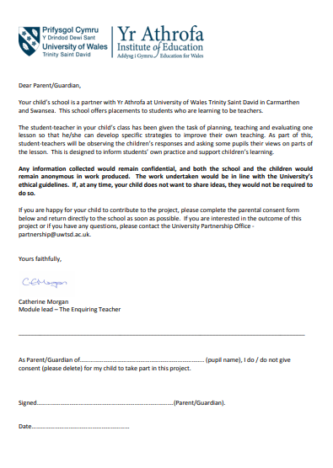

Appendix B
Preamble to obtain informed assent from the children (witnessed by the class teacher).
“We are learning to teach and are here to see how we can improve how we teach children when they work in groups. If you want to, you can help us find out how to be better teachers by letting us see you learn today when you are taught in groups. You do not have to do this and you can say no if you want to. If you do decide to take part you have the right to decide you do not want to carry on and can tell us that you do not want to take part anymore. If you decide not to take part anymore we will not ask you any more questions and you will not receive any consequences as it is your right to decide if you take part or not.
If you would like to take part, please put your thumb up so that we can see you would like to take part. If you do not wish to take part do not put your thumb up.”

I ________________________ witnessed the informed assent of the class to the above statement.
Date: ___________________

Children that do not assent to the study will remain in the class but no observational notes will be made about those children and they will not be asked any questions related to the research.

Appendix C
Informed assent sheet for focus group children.

We are learning to teach and are here to see how we can improve how we teach children when they work in groups. If you want to, you can help us find out how to be better teachers by letting us see you learn today answering some questions about working in groups. We are asking the questions about working in groups to help us become better teachers. If you are asked a question you should answer it honestly because we are asking these questions to help us become better teachers.
You do not have to do this and you can say no if you want to. If you do decide to take part you have the right to decide you do not want to carry on and can tell us that you do not want to take part anymore. If you decide not to take part anymore we will not ask you any more questions and you will not receive any consequences as it is your right to decide if you take part or not.
Tick one of the boxes once you have decided if you would like to take part or not:
- I agree to take part
- I do not want to take part

Name: _______________________________

Appendix D
Task used for the problem solving collaborative learning.
NRICH. Thirsty? Retrieved from: https://nrich.maths.org/6971&part=note [Accessed: 5th April 2018].
The yellow, orange and red drinks cards were used in order to differentiate the task for the different attainment groups within the classes.

Appendix E
NRICH website roles for the task. NRICH. Thirsty? Retrieved from: https://nrich.maths.org/6971&part=note [Accessed: 5th April 2018]. 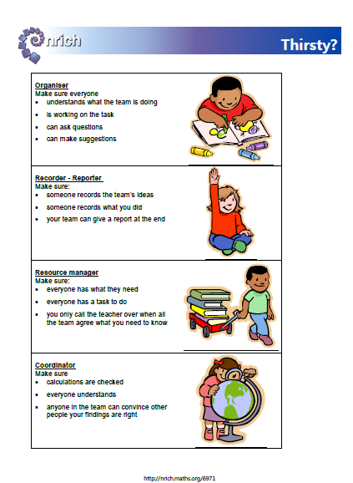

Appendix F
Lesson plan. Edits made for the second lesson are shown in highlighted yellow.
 |  |  |  |  |  |  |  |  |  |  | 1B

Session Plan – Key Stage 2
Name of trainee: |  | Shauna Morris & Charlotte Lawrence |  |  |  | Session ref: |  |  | Lesson Study: Group work
Personal target(s) in relation to QTS:
Year group: | 3&4  4 |  | No. of learners:  33  31 |  |  |  | ALN:
Additional Adults: |  |  | To support LA groups with reading the cards. Prompt them to look at the clues with a dot on first.
Learning objective(s): To be able to work in a group. |  |  |  |  |  |  | Success criteria:  - I can carry out my role in the group.  - I can listen to others.  - I can share my ideas with other people in the group.  - I can help my group to reach an agreement.
Links to previous learning:
Curriculum coverage (range, skills)
Strand: Oracy
Element: Developing and presenting information and ideas.
Aspect: Collaboration and Discussion.
Skills: contribute to group discussion and help everyone take part; help a group to reach an agreement.
Literacy(LNF)  Strand: Oracy  Element: Developing and presenting information and ideas.  Aspect: Collaboration and Discussion.  Skills: contribute to group discussion and help everyone take part; help a group to reach an agreement. |  |  |  |  |  | Numeracy (LNF)
DCF  N/A |  |  | Thinking  Process: Develop  Principle: Considering evidence, information and ideas. Thinking logically.  Context: Given cards and information that helps order the cards. They must think logically and consider the information provided to sequence the cards correctly. |  |  | ESDGC  N/A |  |  |  | YCC  Element: Linguistic.  Context: Use of incidental Welsh.
Key vocabulary(English/Welsh):

Team work
Roles
Organiser
Recorder
Reporter
Resource manager
Coordinator
Drink cards
Clue cards
Communication
Agreement

Tri, dau, un
Pawb yn barod
Helpwr heddiw

Resources:
Drink cards
Clue cards
Sheet of paper
Pen
Blue tac
Role definitions (on board)

Time | Session activities, organisation and management | Key questions & Assessment for Learning opportunities
7 mins | Introduction
7 mins | 4 mins  Inform the class that they will be working in groups to solve a problem.  Ask them what is important when working in groups?  Note important answers on the board: listening to others, sharing ideas, including everyone, working as a team. Etc.  3 mins  Put roles on board and explain them to the class. These will help you to make sure you solve the problem together.
7 mins |  |  | What is important when working in groups?  TTYP/Hands up
33 mins | Main activities
33 mins | 2 mins  Assign group members roles by walking round the groups.  4 mins  Ask resource managers to collect a pack of drink cards after un. Take them to their group and lay them out on the table so that everyone can see them. Everyone in the group needs to look at the cards and talk about what you notice about them. Tri, dau, un.  Mini Plenary 2 mins  Get reporters to feedback from the groups about what they noticed about the cards. (how many there are, how many drinks, how full the glasses are, are the glasses the same size etc).  2 mins  Tell them they are café owners. Tell them the café has had a busy day and just noticed that one of the customers from the has left a review on the café website and you want to work out what they had to drink. Tell class they will now have some clues to help them work out as a team which order the glasses need to be in. Hand clue cards to the resource managers.  10 mins  Groups work on task. Ensure group members understand roles whilst walking around.  Mini Plenary 3 mins  Check with reporters which card groups have first. Talk about strategy and which cards they looked at first if they know which glass comes first already (cards with dots first). Praise for using roles/remind them of the roles. Remind them to look for the reviewers drink and to discuss why the person might have left a review.  10 mins  Continue ordering the glasses.
33 mins |  |  | What do you notice about the cards?
10 mins | Plenary
10 mins | Get the reporters to feedback the order they put the glasses in and the order they went through the clues.  Also ask reporters to feedback which drink belonged to the person that left the review.  Why do they think that?  Why is the glass full?  Not thirsty, didn't like it, had gone off etc.
10 mins |  |  | Which card comes first/2nd/3rd etc?  Does every group agree?  What do you think?  Why do you think that?

Appendix G
Observation Schedule.
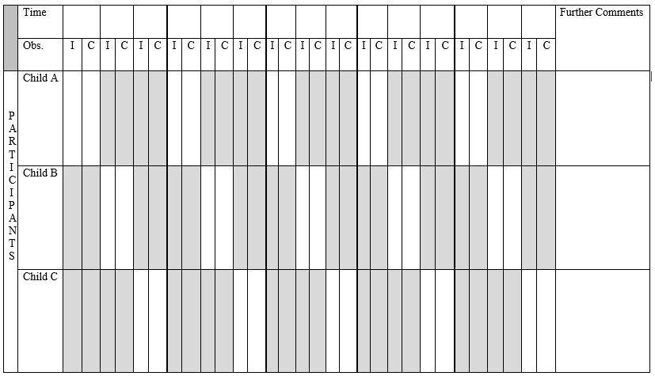

Appendix H
Pre structured interview Questions.
Pupil Voice Interview
As you know, we want to become better teachers and want you to help us by answering some questions as honestly as you can.

How did you feel about being given a role?
Why did you feel happy/excited/annoyed/sad/bored .etc?

What do you think about being given a role?
Why do you think that?

Did you like being given a role?
Why did you dislike/like being given a role?

Which do you like best, working in a group or on your own?
Why do you prefer working in a group/on your own?

We will have to teach other children working in groups, what do you think we could do to make working in groups better?
Why do you think that would help?

Do you prefer being given a role when working in groups, or not being given a role?
Why do you prefer not having/having a role?

Appendix I
ARC writing frame. Questions were edited to relate the reflection to the focus of the study.
Assisted Reflective Conclusions (ARC) Model
Date:
Critical incident (focus): Structuring the groups
Experience

Feelings

What are your feelings regarding the structuring of the groups in the lesson?

Remember and Understand

How did the structuring of groups impact pupil involvement?
Evaluate and analyse

“What will you keep the same to ensure effective teaching and learning in the future?”

“What was the cause of the most important disappointing element?”
Conclusions and actions

“What are your possible solutions to the disappointing issues identified?”

What will you do next?
Y profiad newydd / Transformed experience

Appendix J
School A data. In the study write up the children were labelled child 1-6. Child A on this sheet became Child 3, child B became Child 2 and child C became Child 1.
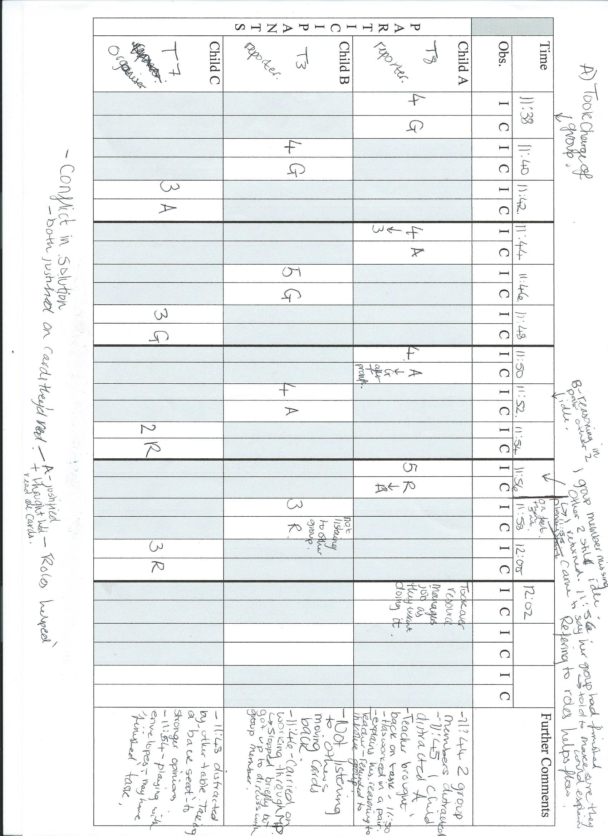
Pupil Voice Interview
LA (Female) = 1 MA (Female) = 2 HA (Male) = 3
How did you feel about being given a role?
2 – It felt good and special
3 – Happy
1 – It was good
* Why did you feel like that?
3 – Because our role was unique in what we had to do and how to help our group.
2 – Because we all had a special piece to do so there was no arguing in the group.

What do you think about being given a role? *Why do you think that?
1 – I like it because nobody else can do the same job as you so you get to be involved.
2 – It’s good because you’re the only one doing your job so it feels special.
3 – Yeah it’s good because f you had to share a role, it would not be fair. When you have your own role, everyone gets a turn.

Did you like being given a role?
1 - Yes
2 – Yes
3 – Yes
*Why did you dislike/like being given a role?
3 – It’s good because then you don’t have to decide on them and then there is less arguing.
2 – Well if you could choose, you’d normally give the best role to yourself so it’s better not to choose.

Do you prefer being given a role when working in groups, or not being given a role?
1 – Given a role
2 – Given a role
3 – Given a role
*Why do you prefer not having/having a role?
1 – It’s better because if you’re given a role you have to do that role so then it’s equal for everyone.
2 – Yeah I think it’s better too because you won’t be bossed around by anyone else who wants to do the same job. If we had to decide we would have to have the whole table talk through it and agree and that would take ages.
3 – I think it’s better because then your group won’t argue over roles and if you are given a role, you don’t have to do 2 things because everyone has a role.

Which do you like best, working in a group or working on your own? *Why do you prefer working in groups/working on your own?
2 – Group because it’s nice to work with your friends
1 – I think as a group too.
3 – Group because when you work in a group you can ask your friends for advice if you are stuck and give advice to your friends as well.

We will have to teach other children working in groups, what do you think we could do to make working in groups better?
3 – I think you could maybe given more work because it was quite a short lesson.
2 – Yeah you should include more ideas to think about when you do the drinks. So you could have drinks and sweets maybe.
*Why do you think that would help?
3 – If you had 2 things to focus on at the same time it would test your knowledge and it would be a challenge to get both done quickly as a group.
2 – It would be ‘funner’ with more things to think about because your group have 2 different things to work on.
1 – I think it would be interesting to do more items.

Did everyone in your group stick to their role?
2 – Yes
1 – Yes
3 – Not all of our group stuck to their role because ----- didn’t want to do it, so it caused some arguments.

Why do you think your group worked well/ didn’t work well?
2 – Because we weren’t squabbling in our group.
1 – Our group worked as a team and helped each other
3 – Sometimes they weren’t listening so it was hard.

Do you prefer being given a role when working in groups, or not being given a role?
1 – Given a role
2 – Given a role
3 – Given a role
*Why do you prefer not having/having a role?
1 – It’s better because if you’re given a role you have to do that role so then it’s equal for everyone.
2 – Yeah I think it’s better too because you won’t be bossed around by anyone else who wants to do the same job. If we had to decide we would have to have the whole table talk through it and agree and that would take ages.
3 – I think it’s better because then your group won’t argue over roles and if you are given a role, you don’t have to do 2 things because everyone has a role.

Which do you like best, working in a group or working on your own? *Why do you prefer working in groups/working on your own?
2 – Group because it’s nice to work with your friends
1 – I think as a group too.
3 – Group because when you work in a group you can ask your friends for advice if you are stuck and give advice to your friends as well.

We will have to teach other children working in groups, what do you think we could do to make working in groups better?
3 – I think you could maybe given more work because it was quite a short lesson.
2 – Yeah you should include more ideas to think about when you do the drinks. So you could have drinks and sweets maybe.
*Why do you think that would help?
3 – If you had 2 things to focus on at the same time it would test your knowledge and it would be a challenge to get both done quickly as a group.
2 – It would be ‘funner’ with more things to think about because your group have 2 different things to work on.
1 – I think it would be interesting to do more items.

Did everyone in your group stick to their role?
2 – Yes
1 – Yes
3 – Not all of our group stuck to their role because ----- didn’t want to do it, so it caused some arguments.

Why do you think your group worked well/ didn’t work well?
2 – Because we weren’t squabbling in our group.
1 – Our group worked as a team and helped each other
3 – Sometimes they weren’t listening so it was hard.

knowledge and it would be a challenge to get both done quickly as a group.
2 – It would be ‘funner’ with more things to think about because your group have 2 different things to work on.
1 – I think it would be interesting to do more items.

Did everyone in your group stick to their role?
2 – Yes
1 – Yes
3 – Not all of our group stuck to their role because ----- didn’t want to do it, so it caused some arguments.

Why do you think your group worked well/ didn’t work well?
2 – Because we weren’t squabbling in our group.
1 – Our group worked as a team and helped each other
3 – Sometimes they weren’t listening so it was hard.

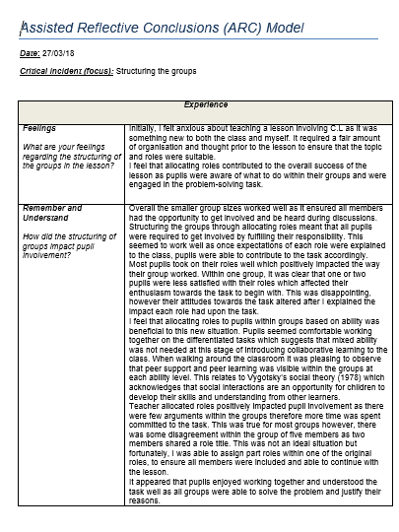
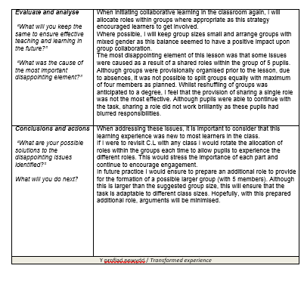

Appendix K
Complimentary problem solving task. Pupils worked out which glass had been reviewed and discussed if the review was positive/negative and why it may have been left.
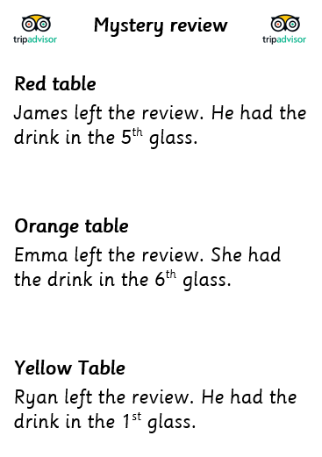

Appendix L
School B data.
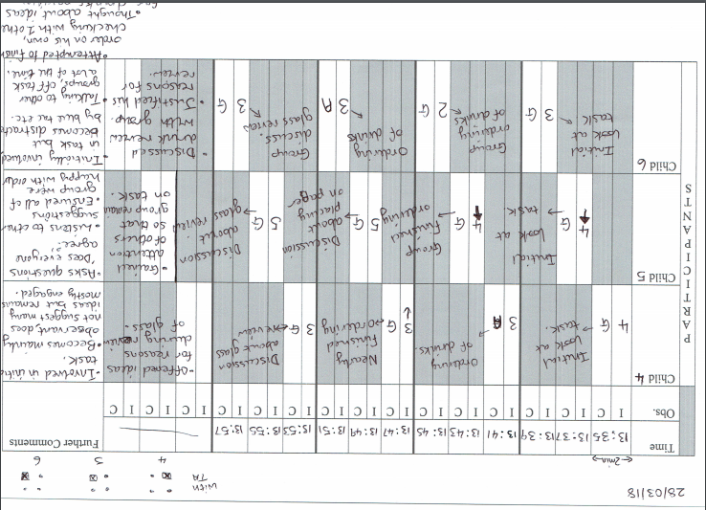
Pupil Voice (Lesson 2)
How did you feel about being given a role?
4- happy
6- Grateful
5 – you have to have responsibility for your roles and I’m grateful for it.

Why did you feel like that?
4- its not everyday you have a roles
6- Same as C.
5 Some people can’t have a role.

What do you think about being given a role?
4- Depends what it is. I’d be happy I had a role but not some.
6 – I’d just do a role I was given even if it was something I didn’t like.
5- It’s a responsibility and a big role could be nerve wracking.

Did you like being given a role?
4- It’s quite a nice feeling.
5 – it’s nice that you can be trusted with something.

Why did you like being given a role?
4- its good to have a role and its more organised and means that people aren’t just running about.
6 – its good to be given a role because if you’ve done it before you’d know you’re good at it an if you haven’t you can give it a go.
5- if you don’t have roles people might be left out.

Should you be given the sale role every time you work in groups?
4 – Better swapping around. If you only do one you won’t know what others are like. When you’re older you’ll know which one you like.
6- Swap – or I you do it over and over you could get fed up.
5- It gives an opportunity to do everything.

Which do you prefer, working in a group or on your own?
4- not confident in a big group but prefer groups.
6- groups can solve things together
5 – groups are better so people can help.
4- it’s a good way to make friends.

We will have to teach other children working in groups, what do you think we could do to make working in groups better?
5- Make sure everyone is listening and cooperating.
4- I thought it was quite good, so don’t know what to say.
6- Give everyone a chance to share so people hear people’s ideas.
5- if we listen to each other in the group we can hear ideas but if you didn’t then you won’t be proud at the end.

Did everyone understand their role?
5- the bullet points were useful to show everyone their role but some people had silly ideas.



