

Nojus Liubinas
Lecturer William Bateman
Research, Study and Presentation Skills
PCEE4002
PCPO4002
Element 2
Student Number - 2320127

Contents

Introduction 3
Element 2 4
Bibliography 12

List of Figures

Figure 1 – The North Side of the ULSG (Taken by a personal camera within Valero)
Figure 2 – The East side of the ULSG (Taken by a personal camera within Valero)
Figure 3 – LCN Feed into the Unit (Valero 2023)
Figure 4 – HCN Feed into the Unit (Valero 2023)
Figure 5 – HHCN Feed into the Unit (Valero 2023)
Figure 6 – Diagram of the process within the ULSG (Valero 2023)
Figure 7 – CDHYDRO Column diagram (Valero 2023)
Figure 8 - Diagram of the process within the ULSG (Valero 2023)
Figure 9 – Feed Diagram of Cracking and Olefins units (Valero 2017)
Figure 10 – Feed rate and Temperature Instruments in the ULSG (Valero 2019)
Figure 11 – CDHDS Column (Valero 2014)

Introduction

Within this element of the assignment this report goes over what the ULSG (Ultra Low Sulphur Gasoline) does and how it reduces the Sulphur content within gasoline and the reasoning behind it and which specific regulations must be met. Also, within this report it goes over the reasoning for my decision and due to it being in my workplace, the use of company specific documents and information is available allowing it to improve my report on this specific unit.

Element 2

ULSG

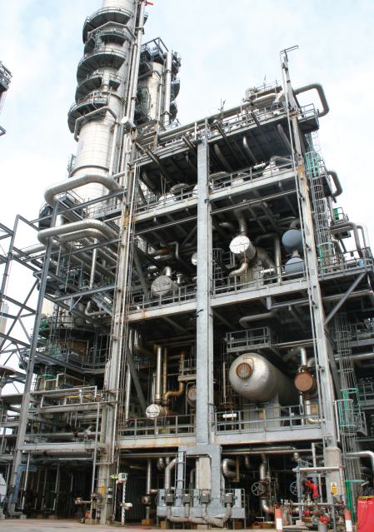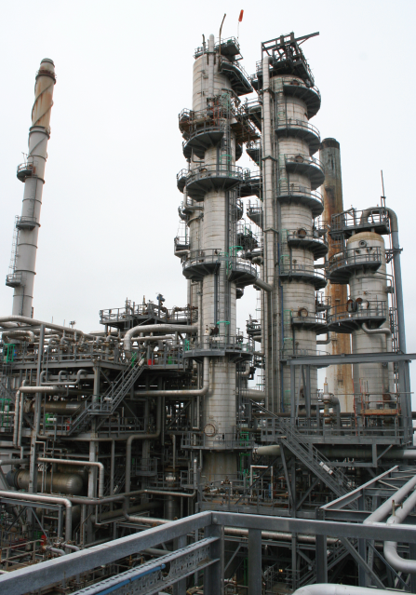
Figure 1, Figure 2 – Snapshots of the ULSG within Valero
The function of the ULSG unit is to reduce the Sulphur content of the following naphtha streams as produced by the FCCU (Fluid Catalytic Cracker Unit) while minimizing the amount of olefin saturation as high olefin saturation reduces the RON (Research Octane Number) of the naphtha product. The higher the RON rating, the more compression it can withstand in a spark-ignition engine before igniting. In the Uk, the standard RON is 95. In most cases as engine compression increases, so does the amount of power and efficiency.
The naphtha streams that are fed into the ULSG are Light Cat Naphtha (LCN). Heavy Cat Naphtha (HCN) and lastly Heavy/Heavy Cat Naphtha (HHCN). These will thereby produce Desulphurized Light Naphtha (DSLN) and Desulphurized Heavy Naphtha (DSHN) Which are suitable components for gasoline blending.
LCN Feed Line
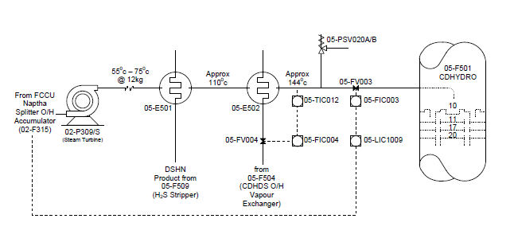Figure 3 – LCN Feed into the ULSG

HCN Feed Line
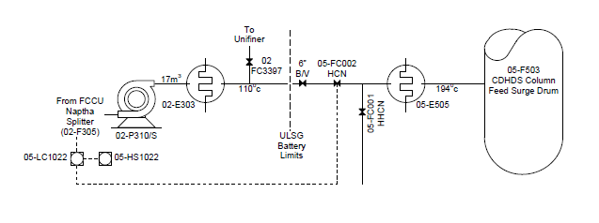Figure 4 –HCN Feed into the ULSG

HHCN Feed Line
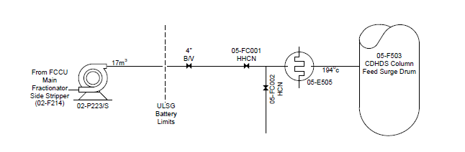Figure 5 - HHCN Feed Line into the ULSG
More information on the Feed in Appendix 1.0 - 1.3
The reason Sulphur is reduced from the content of gasoline is due to the European legislation, which is targeted to reduce the Sulphur content in gasoline. The FCCU Naphtha’s LCN, HCN & HHCN have a major impact on the site gasoline Sulphur which is around half of the entire site's gasoline pool. The Sulphur content of this stream can reach upwards of 2800 ppm of Sulphur, which will then be reduced to less than 50 ppm in the ULSG. The way this is done is through specific processes within Phase I such as Hydrogenation, Desulphurization, Stabilization, Amine scrubbing, and hydrogen compression/recycle
European legislation will eventually require the level of Sulphur in gasoline to be further reduced to below 10ppm, and so an addition is built onto the ULSG unit called Phase II. This process takes the ULSG I DSHN product and reduces the Sulphur content level below 10ppm. Within Phase II

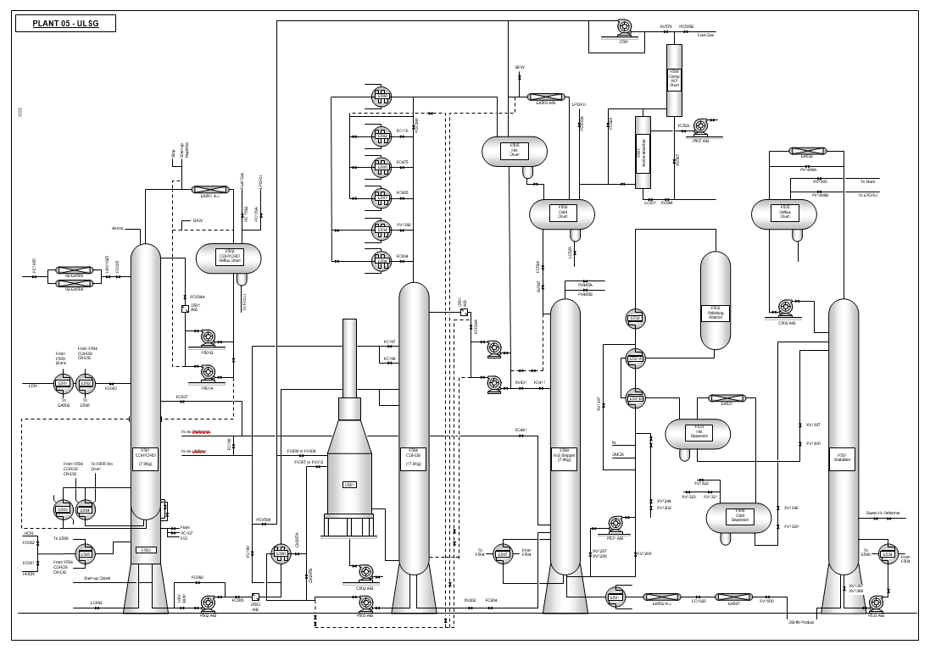Figure 6 – Diagram of the Process of the ULSG
Hydrogenation or CDHYDRO, is a process where olefin recovery is maximized in the Desulphurized Light Naphtha (DSLN) side draw product. The total Sulphur content in the DSLN is also limited while Fractionate Mercaptans and primary diolefins into the catalyst section for conversion to heavier stable olefinic sulphide.
This reaction occurs in 05-F-501 (CDHYDRO Column) which sits atop of 05-F-503 (CDHYDRO Surge Drum). 05-F-501 were Mercaptan Sulphur & Olefin distil up through the Catalyst Beds. Mercaptans and primary diolefins react with H₂ to form heavier stable sulphides, which then flow down, and out of the column into 05-F-503. 2 different catalysts are used. The lower bed contains nickel for mercaptan conversion, the upper bed contains palladium for olefin isomerization as stated by Valero (2023)
05-F-503 were bottoms liquid product from the CDHYDRO column drains via gravity into this surge drum, where it mixes with HCN/HHCN from the FCCU. These products are preheated by E505 taking its heating medium from the CDHDS overheads. Light ends will flash up via a vent line directly into the lower section of F501. Any free water in the mixed stream will collect in the inlet compartment and will be routed to the FCCU.
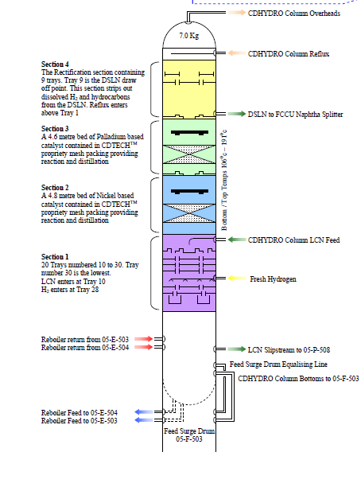
Figure 7 – CDHYDRO Column in the ULSG
Desulphurization or CDHDS occurs in 05-F-504 (CDHDS Column), done by using the catalyst beds to separate by distillation and convert Sulphur compounds into H2S by reaction with hydrogen, whilst minimizing olefin saturation. Approximately 85% of the tower feed is removed as overhead product and 15% is routed as lower feed to the Stabilizer (05-F-509). This bottom product contains dissolved H₂ and trace H₂S. The partly condensed overhead stream is separated in the reflux drum 05-F-505 (Hot drum). A portion of the hot drum liquid is refluxed back to the CDHDS column to ensure adequate wetting of the catalyst beds. The balance of F505 liquid is routed as middle feed to the Stabilizer. 05-F-506 (Cold drum) receives any free water that has collected in the boot of 05-F-505. Valero (2012) states that it also provides upper feed to the Stabilizer as cold liquid. This contains approximately 0.7% H₂S. Any condensed water in 05-F-506 is routed through LC529 which is a boot drum drain valve from the vessel to the FCCU.
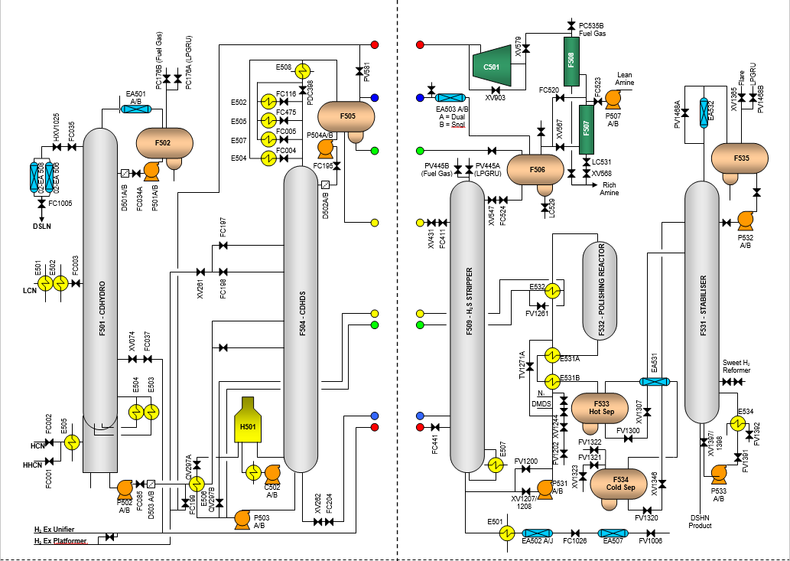Figure 8 – Diagram of the process in the ULSG
Phase 1
Phase 2

Stabilization is done to remove light hydrocarbons (cracked products), hydrogen and H₂S from the heavy product (DSHN). The light ends are removed as off gas to the LPGRU. This maintains the desired RVP of this light gasoline stream. The balance of the DSHN is routed to storage.
Amine Scrubbing is done when Off gas from the cold separator (05-F-506) is scrubbed in the packed bed amine absorber (05-F-507) to remove the bulk of the H₂S. A slipstream of off gas can be manually bypassed around 05-F-507, to maintain the desired level of H₂S in the recycle gas for the CDHDS column.
Hydrogen recycling systems provide the correct amount of hydrogen atmosphere in the CDHDS column, while optimizing the amount of available fresh import hydrogen. The scrubbed off gas passes through knockout drum 05-F-508, before recycling to the CDHDS column via 05-C-501 Recycle Gas Compressor. The unit can run without recycle gas however with reduced throughput depending on the availability of makeup gas from the CRU/Unifier
The H2S Stripper tower is where the desulphurized naphtha streams from the CDHDS system are stripped free of light hydrocarbons, H2S and dissolved hydrogen to less than 1ppm. So that the DSHN bottoms product is suitable for further treatment in the Merox Unit
More process information in Appendix 1.4 - 1.9
In conclusion, the ULSG (Ultra Low Sulphur Gasoline) is in Pembroke refinery to reduce the Sulphur content of naphtha that is fed into it by the FCCU while minimizing the amount of olefin saturation, this unit can make DSLN and DSHN which is suitable for gasoline blending. They reduce the PPM of Sulphur to under 50 but due to stricter legislations they can reduce it to below 10 ppm
1093 Words

References
Valero. (2019). C&O Process Units. Houston Texas: Valero Energy Corp.
Valero. (2023). Field Operator ULSG Training Manual. Houston Texas: Valero Energy Corp.
Valero. (2023). Panel Operator ULSG Training Manual. Houston Texas: Valero Energy Corp.
Valero. (2012). Process Units. Houston Texas: Valero Energy Corp.

Bibliography
(2011) The effect of three-way catalyst formulation on sulphur ... - JSTOR. Available at: https://www.jstor.org/stable/44612327 (Accessed: 13 December 2023).
(2019) Heat transfer, separation, fluid handling | alfa laval. Available at: https://www.alfalaval.com/globalassets/documents/industries/marine-and-transportation/marine/refuel/Bluebook__en.pdf (Accessed: 13 December 2023).
(2003) Modern Refining Concepts-an update on naphtha-isomerization to modern gasoline manufacture, Catalysis Today. Available at: https://www.sciencedirect.com/science/article/abs/pii/S0920586103001019 (Accessed: 13 December 2023).
Jenkins, G., Kuo, C.-Y. and Ozbafli, A. (1970) Cost-benefit analysis case study on regulations to lower the level of sulphur in gasoline, EconStor. Available at: https://www.econstor.eu/handle/10419/189410 (Accessed: 13 December 2023).
The transition to ultra-low-sulfur diesel fuel: Effects on prices and supply (2001). Washington, DC: Energy Information Administration, Office of Integrated Analysis and Forecasting, U.S. Dept. of Energy.

Appendix
1.0 - Where the Feed comes from
The feed into the ULSG (Ultra Low Sulphur Gasoline) comes from the FCCU (Fluid Catalytic Cracker Unit). The Feed is 3 main parts of naphtha, LCN which is Light Cat Naphtha. HCN which is Heavy Cat Naphtha and lastly HHCN which is Heavy/Heavy Cat Naphtha. This is what is stated by Valero (2017)
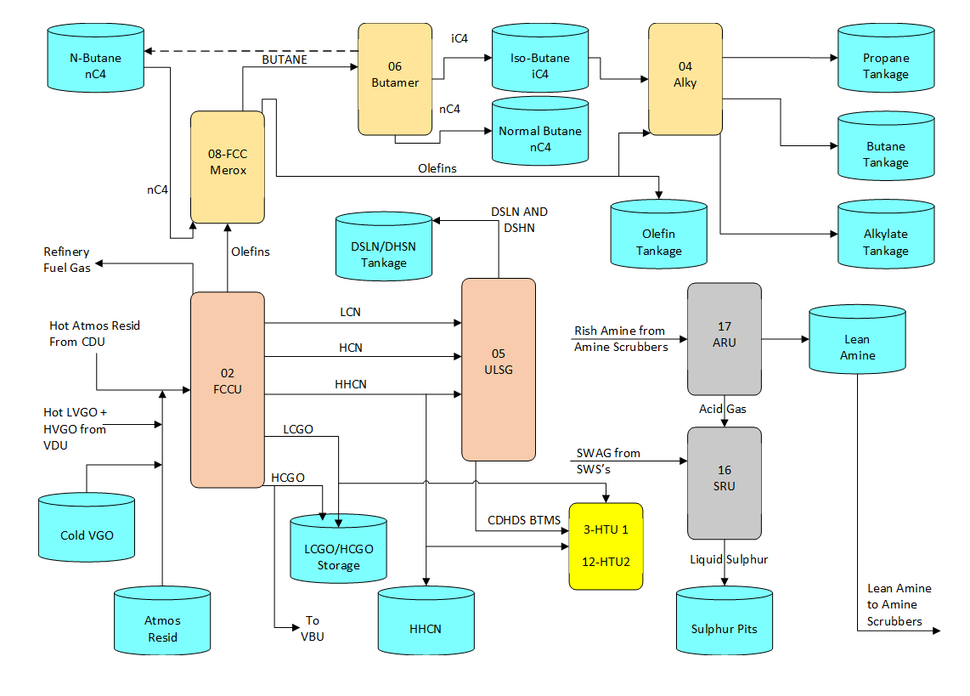Figure 9 – Feed Diagram of C&O
Figure 9 shows a feed diagram of Cracking and Olefins, It shows specific feed into units and where the products/byproducts of the units go. For example, using ULSG the 3 feeds come in from the FCCU. It shows how the DSLN (Desulphurized Light Naphtha) and DSHN (Desulphurized Heavy Naphtha) go into tankage while the CDHDS BTMS feed into the hydrotreaters stated by Valero (2019)
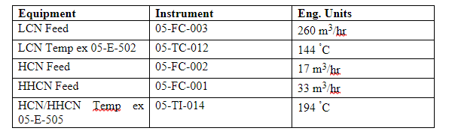Figure 10 – Feed rate and Temperature Instruments in the ULSG
Figure 10 shows the specific instrument and what it shows, so for example LCN Feed is shown by Instrument 05-FC-003 and it shows a feed rate of 260 m³/hr. Then instrument 05-TC-012 shows the temperature of LCN after leaving the exchanger of 144 degrees Celsius.
1.1 - LCN Feed
Approximately 260 m³/hr of cold Light Cat Naphtha from the FCCU Naphtha Splitter Overhead Accumulator 02-F-315 is pumped to the ULSG plant by the Naphtha Splitter Overhead steam turbine driven pumps 02-P-309 or 309S. The flow of LCN from the FCCU at between 55ºC and 75ºC is routed to the shell side inlet of tube and shell exchanger 05-E-501. Valero (2023) states the CDHYDRO Feed / DSHN Product Exchanger is heated by hot H2S Stripper bottoms on the tube side to approximately 110ºC . From the shell side outlet of 05-E-501 the LCN feed stream is routed directly to the shell side inlet of tube and shell exchanger 05-E-502, the CDHYDRO Feed / CDHDS Overhead Vapor Exchanger and it is there further heated to its bubble point and partially vaporized by hot CDHDS overhead vapors on the tube side to approximately 144ºC. The temperature of the LCN from 05-E-502 is controlled by a temperature controller which is located on the shell side outlet line which resets the flow of CDHDS overhead vapors. The shellsides of exchangers 05-E-501 and 502 are protected against overpressure by pressure relief valves 05-PSV-020 A or B. Downstream of the shell side outlet of 05-E-502 the two-phase flow of the now heated LCN feed is routed via a control valve to the CDHYDRO column at tray 10. In an emergency, LCN can bypass the unit using emergency multi hand switch, which closes 05-FC-003, 05-XV-1026 and opens 05-XV-1024. Allowing it to bypass the unit which is stated by Valero (2023)
See Figure 3 for the Diagram of LCN feed into the ULSG.
1.2 - HCN Feed -
Approximately 17m³/hr of Heavy Cat Naphtha from the FCCU Naphtha Splitter is routed by bottoms pumps 02-P-310/310S through the Debutaniser Feed Pre-heater 02-E-303 which is located on the FCCU plot. 50m³/hr of this hot stream at 110ºC is routed to the Unifiner , via 02-FC-3397 and the balance is routed to the ULSG Unit. The flow of HCN enters the ULSG battery limits where there is an isolation block valve. Downstream, the flow of HCN to the ULSG unit is controlled by 05-FC-002, located on the shell side inlet of feed preheater 05-E-505. This HCN stream is combined with a stream of Heavy/Heavy Cat Naphtha before passing to the shell side inlet of the HCN/HHCN Feed Pre-heater 05-E-505. The HCN/HHCN feed passing through the shell side of 05-E-505 is heated by overhead vapors from the CDHDS column passing through the tube side of the exchanger thereby heating the HCN/HHCN feed to approximately 194ºC as stated by Valero (2023). The hot mixed stream of HCN/HHCN from 05-E-505 is then routed to and enters the CDHDS column Feed Surge Drum 05-F-503. Valero (2023) States in an emergency HCN can bypass the unit using emergency multi hand switch which closes 05-FC-002, 05-XV-1025 and opens 05-XV-1023. Which allows the unit to be bypassed.
See Figure 4, for the HCN feed into the ULSG.
1.3 - HHCN Feed -
Approximately 33m³/hr of hot Heavy/Heavy Cat Naphtha from the FCCU Main Fractionator Side Stripper 02-F-214 is pumped by 02-P-223/223S, the HHCN Product Pumps, and is routed to the ULSG battery limits where there is an isolation block valve. Downstream of the battery limits the flow of HHCN is controlled by 05-FC-001 on the HHCN feed line inlet to 05-E-505. The flow of HHCN combines with the flow of HCN before entering the shell side inlet to the HCN/HHCN Feed Pre-heater 05-E-505. Valero (2023) states that the HCN/HHCN feed passing through the shell side of 05-E-505 is heated by overhead vapors from the CDHDS column passing through the tube side of the exchanger thereby heating the HCN/HHCN feed to approximately 194ºC. The hot mixed stream of HCN/HHCN from 05-E-505 is then routed to and enters the CDHDS column Feed Surge Drum 05-F-503. In an emergency, Valero states the HCN can bypass the unit using an emergency multi hand switch, which closes 05-FC-002, 05-XV-1025 and opens 05-XV-1023. Allowing the unit to be bypassed
See Figure 5 for the Feed of HHCN into the ULSG.
1.4 - Hydrogenation -
Hydrogenation or CDHYDRO. The purpose of the CDHYDRO fractionation column 05-F-501 is to firstly maximize olefin recovery in the DSLN side draw product and to limit the total sulphur content in the DSLN side draw product and to fractionate mercaptans and primary diolefins into the catalyst section for conversion to heavier stable olefinic sulphides which is stated by Valero (2017) The main body of the CDHYDRO Column consist of 4 sections.
Section 1 -
A lower section containing 20 trays numbered 10 to 30 The LCN feed, enters the column to chimney tray No. 10 via an internal ‘H’ shaped distributor. Hydrogen enters the column on tray No. 28 via an internal ‘H’ shaped distributor. There is a temperature indicator, located on tray No. 11. and a temperature indicator, located on tray No. 20. A Pressure differential indicator monitors the differential pressure across this lower section.
Section 2 -
The lower middle packed reaction section contains a 4.8-meter bed of Nickel based catalyst, contained in mesh packing. This provides simultaneous reaction and distillation. Immediately above the packing is a complex arrangement of troughs to ensure equal distribution of liquid across the column diameter; this ensures total wetting of the packed section. There are three temperature indicators on the top of the packed bed and three at the bottom of the packed bed, and three in the vapor space above the packed bed. These indicators are connected to the interlock shutdown system. The interlock system will shut off the hydrogen feed to the column and thereby stop all hydrogenation reactions. The interlock system will be activated on the detection of two out of three high temperature signals

Section 3 -
The upper middle packed reaction section contains a 4.6-meter bed of Nickel based catalyst contained in mesh packing. This provides simultaneous reaction and distillation. Immediately above the packing is a complex arrangement of troughs to ensure equal distribution of liquid across the column diameter; this ensures total wetting of the packed section. Adequate disengaging space is provided above and below the packed section. There are three temperature indicators on the top of the packed bed, and three at the bottom. There are three temperature indicators located in the vapour space above the packed bed. These indicators are connected to the interlock shutdown system. The interlock system will shut off the hydrogen feed to the column and thereby stop all hydrogenation reactions. The interlock system will be activated on the detection of two out of three high temperature signals

Section 4 -
The upper rectification section contains 9 tray levels. Tray 9 being the lowest is a chimney tray and is the De-sulphurised Light Naphtha product draw location. This rectification section serves to strip out dissolved hydrogen and light hydrocarbons from the DSLN product. Reflux flow to the column enters above the top tray 1 via an internal double elbow type downturn distributor.

In the CDHYDRO Column, mercaptans react with hydrogen to form thermally stable olefinic sulphide compounds, which are removed from the distillate DSLN product. Non mercaptan sulphur compounds such as dimethyl sulphide and thiophene are not reacted and will remain in the distillate. The reactions occurring in the column are exothermic and therefore to prevent damage to the catalyst beds, vessel internals and to the vessel itself, emergency shutdown instruments are provided, as well as a complex internal/external reflux control system. The flow of LCN passes under flow control to tray 10 of the CDHYDRO Column for fractionation into light and heavy naphtha streams. Fresh hydrogen is injected under flow control above tray 20. The column operates at a top pressure of 7.0 kg/cm²g and a top/bottom temperature of 106ºC/191ºC. Mercaptan sulphur and olefins are distilled above the feed tray through the lower catalyst bed. In this bed mercaptan sulphur and some of the primary diolefins are converted to heavier stable sulphides which fractionate with the heavy naphtha bottom stream. In the upper catalyst bed, hydro-isomerization reactions take place. A light naphtha fraction, along with a major portion of FCCU light naphtha olefins is withdrawn as a side stream product from chimney tray No. 9 located above the catalyst bed. The CDHYDRO Column also serves to isolate a major portion of the olefins in the feed from exposure to high reaction temperatures associated with the downstream CDHDS Column as stated by Valero (2017)

1.5 - Desulphurization -
Desulphurization happens in the CDHDS Coloumn. The purpose of the CDHDS Column is to convert sulphur compounds in the heavy naphtha feed into hydrogen sulphide while minimizing the amount of olefin saturation. The greater portion of the desulphurised naphtha leaves the column as overhead vapor. The column normally operates at a top pressure of 16.9 kgcm²/hr and a top/bottom temperature of 247ºC / 333ºC. The main body of the column contains five separate packed reaction sections, each containing a 4.5 meter bed of cobalt/molybdenum catalyst contained in mesh packing which is stated by Valero (2022). This arrangement facilitates simultaneous distillation and hydro-desulphurization reaction. Above the top catalyst bed there is a 1.5 metre deep bed of high-performance structured packing providing a heat transfer surface to raise the temperature of the incoming, cold reflux liquid to the desired reaction temperature. The reflux enters at the top of the column via a downturn distributor / trough arrangement located immediately above the structured packed section. Between the remaining four catalyst beds there is a complex arrangement of troughs/chimney trays to collect and redistribute the liquid from the bed above thereby providing good distribution of liquid/vapour and ensuring total wetting of the packed section below. A chimney liquid collector tray is placed below the fifth bed to guide the liquid flow into the bottom sump of the column. The feed normally enters the CDHDS column between beds 2 and 3 via an ‘H’ type distributor above the chimney tray. An alternative feed inlet location is between beds 3 and 4 lower in the column, again via an ‘H’ type distributor above the chimney. The lower head section of the column forms the reservoir for the CDHDS Reboiler Feed Pumps 05-P-503 A&B and for the bottoms flow to the H2S Stripper Column 05-F-509 as stated by Valero (2017)
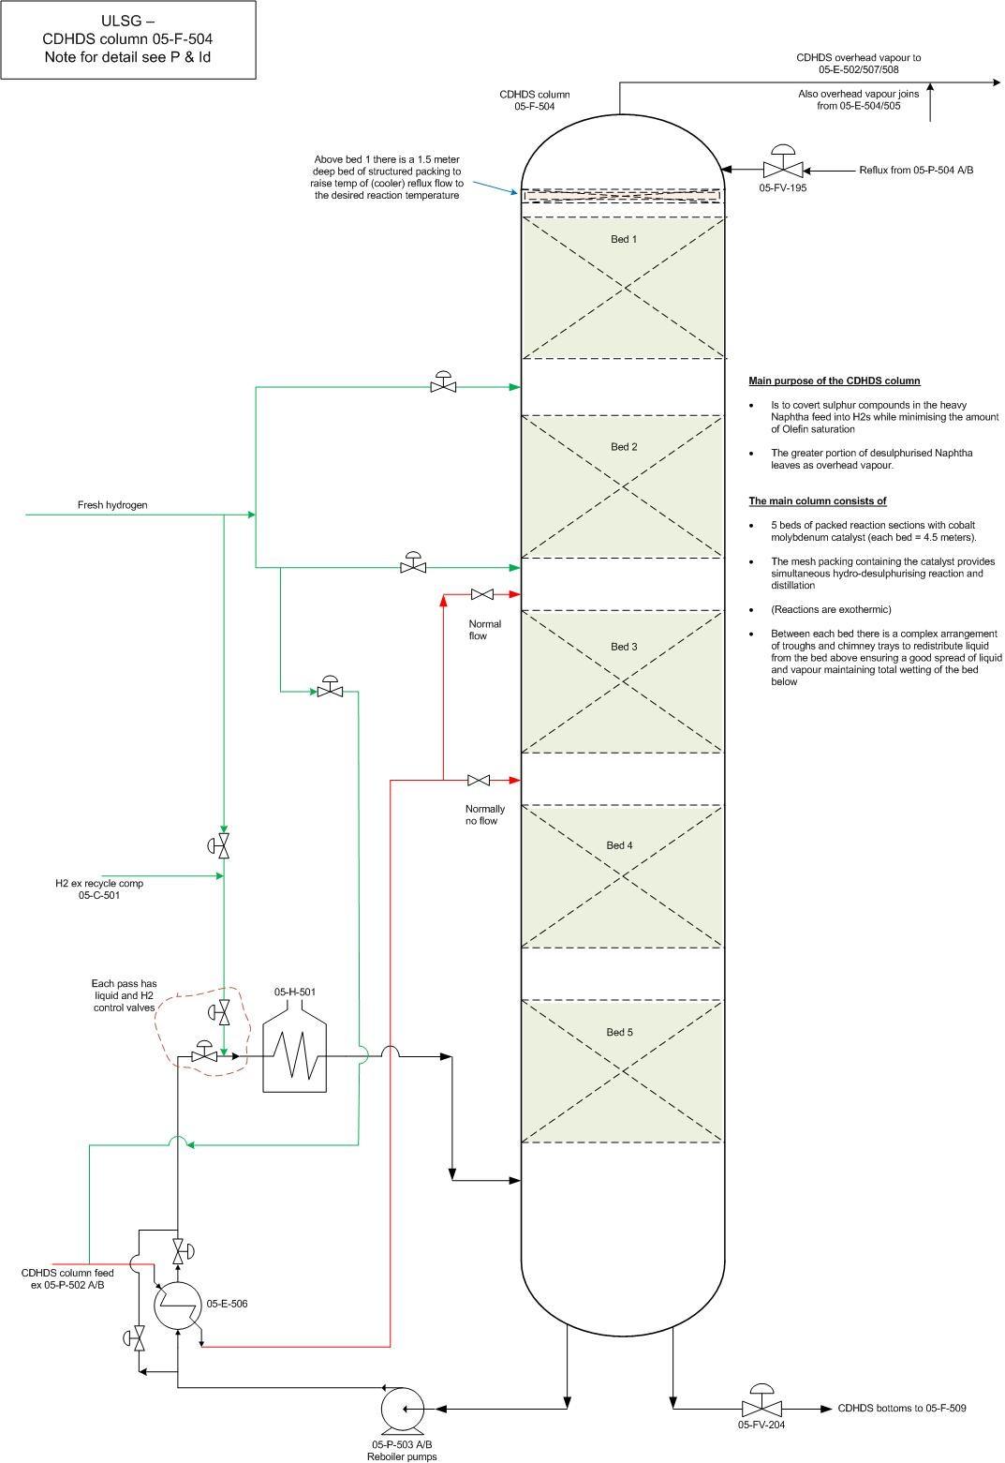
Figure 11 – CDHDS Column
Figure 11 shows the sections of the CDHDS Column. Stable and correct operation of the CDHDS Column is particularly important. In the CDHDS Column the majority of sulphur compounds react with hydrogen to form hydrogen sulphide and olefin saturation also occurs. The reactions occurring in the column are exothermic and the operating temperature, which is set by the column pressure and hydrogen partial pressure, can control the reaction rate. Controlling the total hydrogen feed to the column can regulate hydrogen partial pressure in the reaction zones. The heat released by the reactions is equivalent to approximately 40% of the heat input by the fired reboiler, which is significant. This heat is dissipated by vaporizing liquid in the reaction zones. Meaning tthe reaction is maintained at the boiling point of the liquid.

1.6 - Stabilization -
The CDHDS Bottoms stream is the heaviest on the ULSG process. CDHDS Bottoms are taken off under level control via 05-FV-204 and may either be manually routed to the Stabilizer column or routed for hydro treating. It is more profitable if the CDHDS Bottoms are fed for hydro treating in either HTU-1 or HTU-2 rather than kept in the gasoline blending pool. This means the installation of the stabilizer is there to provide piping and cooling to allow the CDHDS Bottoms stream to be fed to either of the hydrotreaters, along with LCGO and HHCN from the FFCU. It helps to remove light hydrocarbons (cracked products), hydrogen and H₂S from the heavy product (DSHN). The light ends are removed as off gas to the LPGRU. This maintains the desired RVP of this light gasoline stream. The balance of the DSHN is routed to storage.

1.7 - Amine Scrubbing -
Most of the sour off-gas from the Cold Separator 05-F-506 is routed to the Amine Absorber 05-F-507, where the H₂S content of the gas is reduced from approximately 8300 ppm to less than 300 ppm by counter current contact scrubbing with a lean aqueous amine solution. The sour gas enters at the bottom of the absorber vessel, above the sour amine bottom's level, and the lean amine enters at the top of the vessel. As it is essential to maintain the CDHDS catalyst in the sulphided state it is important that the concentration of hydrogen sulphide in the recycle gas should be kept at about 300 ppm as stated by Valero (2017). A slipstream of off gas can be manually bypassed around 05-F-507, to maintain the desired level of H₂S in the recycle gas for the CDHDS column. Rich amine is returned to the ARU for regeneration. Due to the expensive price of amine, it allows the amine to be reused and not wasted.

1.8 - Hydrogen Compression/recycling -
The purpose of the recycling gas compressor 05-C-501, is to provide the correct amount of hydrogen atmosphere in the CDHDS tower, while at the same time optimising the amount of available fresh import hydrogen. The unit is capable of running without recycled gas, on a once through basis, however it may be necessary to reduce throughput/severity depending on the availability of increased makeup from the CRU/Unifiner as stated by Valero (2019). The recycle compressor, KO drum 05-F-508, and the Amine Blow case 05-F-515, are at the northeast corner of the Merox Unit.

1.9 - H2S Stripper -
In the H₂S Stripper tower, the desulphurised Naphtha streams from the CDHDS system are stripped free of light hydrocarbons, H₂S, and dissolved hydrogen to less than 1ppm, so that the DSHN bottoms product is suitable for further treatment in the Merox Unit. The tower contains 24 trays, from top to bottom. Trays 19 to 24 in the lower stripping section are 2 pass valve trays, and the liquid from tray 24 is directed into the Reboiler reservoir by a cut-out in the downcomer trap pan. Stripping hydrogen enters below tray 19 – a sparger is not provided, as the anticipated normal flow will be zero. The centre section contains trays 8 to 18. Trays 9 to 17 are 2 pass valve trays, and trays 8 to 18 are both chimney trays as stated by Valero (2021). Hot CDHDS bottoms liquid enters via an ‘H’ type distributor above tray 18 – the distributor has top cut-outs at each end to correctly direct the flow across the tray. Liquid from the CDHDS hot overhead drum 05-F-505 enters via an ‘H’ type distributor above tray 8 – the distributor has top cut-outs at each end to correctly direct the flow across the tray, and the downcomer sump from tray 7 above has 2 extended downpipes to correctly direct the flow across the tray. The top rectifying sections contain trays 1 to 7, which are single pass valve trays. Liquid from cold drum 05-F-506 enters on top tray 1 via a plate. In extreme emergency situations e.g. unit fire, overpressure, this emergency depressuring valve 05-HXV-438 can be actuated from the panel. Hot CDHDS tower bottoms, containing <1ppm H₂S, enters on tray 18, and a temperature monitor records the temperature on tray 19. Hot liquid from 05-F-505, containing approximately 1000 ppm H₂S, enters on tray 8. Another temperature monitor records tray 10 and 13 temperature feed from 05-F-506, contains approximately 4200 ppm H₂S, enters on tray 1 which is stated by Valero (2019)

