University of wales Trinity saint david
Business Management
Caroline Jawad
M5X00803

Critical Discussion Of CSR Theory
Management Ethics – Reflective Report
Amy Williams – P151979
11/20/2017

I firstly looked at an unethical business called BP and evaluated its contradicting views on CSR against an ethical company called WWF. I secondly designed a promotional poster on how BP is unethical which will be displayed in an exhibition, the aim of this poster was to get consumers to try and avoid unethical businesses. I then completed a written discussion in which I answered key debating issues between both organisations, looking at both points of view. In this report I will apply CSR theory and look at logical solutions which would help avoid unethical business situations in the future; lastly I will provide a critical reflection on my academic practice.

Contents
Table of figures 3
Introduction 4
Main Findings 5
Conclusion 6
Refelction 7
Bibliography 8
Appendices 9

Table of figures

Figure 1 – Carroll’s CSR Pyramid Page 5
Figure 2 – Freeman stakeholders theory Page 6
Figure 3 – Freeman Management model Page 7

Introduction

This report will go into depth on the poster and written discussion regarding the unethical business BP and will support and derive the logical solutions and concepts of World Wildlife Fund (WWF). Both the poster and written discussion will be included in the appendices.
So firstly why is BP unethical? In 2010 an oil rig exploded in Mexico which killed eleven workers and caused one of the most disastrous events to happen to the environment in the US to date. Millions of gallons of oil caused havoc to the environment, sea life and surroundings.
‘’The withering public criticism of BP deepened as birds, fish and shrimp died and thick brown oil washed ashore on the white sand beaches and in the ecologically vital marshlands of the Gulf coast, forcing fishing and tourism businesses to shutter’’(Sherwell, 2017).
WWF concentrates on six main areas which are living sustainably; restoring wildlife; sustaining forests and wildlife; keeping rivers flowing; trading sustainable food and timber and finally reducing carbon emissions. So obviously BPs oil spill goes against everything WWF stands for.
‘’We’re making sure businesses, politicians, and local communities recognise the value of keeping our natural environments intact’’ (WWF, 2017).
The area that the poster, written discussion and reflective report look at is should businesses take more responsibility for sustainability? This report will look at both arguments for and against whether businesses should take more responsibility for sustainability and will also look into depth at corporate social responsibilities (CSR).
“There is one and only one social responsibility of business–to use it resources and engage in activities designed to increase its profits so long as it stays within the rules of the game, which is to say, engages in open and free competition without deception or fraud” - Milton Friedman 1970 (Goodreads.com, 2017).
This quote is one view from Milton Friedman. In my opinion it is saying businesses are just there to increase profit and should try and get away with whatever possible. As long as they don’t break any laws such as fraud then it doesn’t matter.
A contradicting quote which I mentioned in my written discussion (see appendix A) is ‘We are living on this planet as if we had another one to go’ – Swearingen.
This quote shows how people are taking advantage and neglecting the planet and once we run out of resources or a catastrophic event happens we have nowhere else to go and will have to live with the outcome.

Main Findings

  - What makes a business sustainable?
‘’Business sustainability, also known as corporate sustainability, is the management and coordination of environmental, social and financial demands and concerns to ensure responsible, ethical and ongoing success’’ (WhatIs.com, 2017).
‘’sustainable development is about making sure that people throughout the world can satisfy their basic needs now, while making sure that future generations can also look forward to the same quality of life’’ Gardner (2014)
Like I mentioned in my written discussion (see appendix A) I wanted to portray that businesses can be selfish and don’t care about what disastrous they cause as long as they make money. I think Gardner’ quote represents this perfectly. Instead of exceeding needs now and not caring about what happens to the world and what the future generations will be left with we need to satisfy our needs but also look after the planet so future generations and future businesses can have the same quality of life.

  - What is corporate social responsibility (CSR)?
‘’A company's sense of responsibility towards the community and environment (both ecological and social) in which it operates’’(BusinessDictionary.com, 2017).
‘’When the wind blows there are those that build walls and then there are those that build windmills’’ – Lawrence (HRZone, 2017).
I found the above quote which was written by Jamie Lawrence Extremely clever and interesting. I find it links with CSR because instead of just building a wall which is a quick and easy solution for your business now, why not build wind mills which both make money but help sustainability.
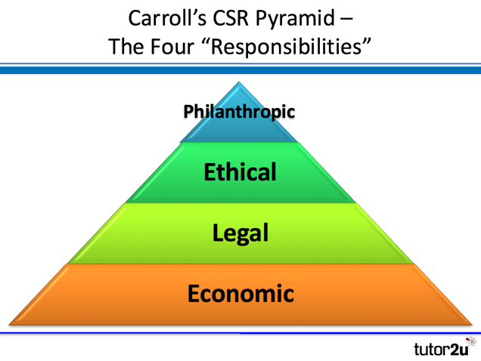 Fig 1 Source:(Carroll, 2016).
(tutor2u, 2017).
Economic is the base layer and this refers to the need of a business to be profitable so it can survive against other businesses. The layer above this is legal and this represents abiding to laws and regulations of the country. The layer above legal is Ethical and this representing how businesses need to act morally and ethically (which BP did not do). The top layer is Philanthropic and this is referring to the businesses responsibility to give back to society. This model shows that CSR doesn’t have just one aspect and is made up of important layers which all equally contribute to CSR. The model is easy to understand and makes it clear what is needed from a business in order to abide by CSR. A lot of businesses only think about profit and this model still refers to profit so businesses can understand they can still have profit even when applying CSR. ‘’The purpose of business is to make money for the owner or stockholders’’ Friedman. The only criticisms I have is perhaps the model could go into more depth rather than being so basic?

  - Arguments against sustainability and CSR
The first argument that is often seen is that CSR takes away from a business’s main aim which is to make profit. ‘’The social responsibility of a business is to increase its profits’’ (Friedman,1970)
‘’ A corporation is an artificial person and in this sense may have artificial responsibilities, but “business” as a whole cannot be said to have responsibilities, even in this vague sense’’ (Friedman, 1970).
‘’Business is not a charity’’.
‘’let the government or non profit organisations deal with social and environmental issues’’(ToughNickel, 2017).
  - Stakeholder theory versus shareholder theory
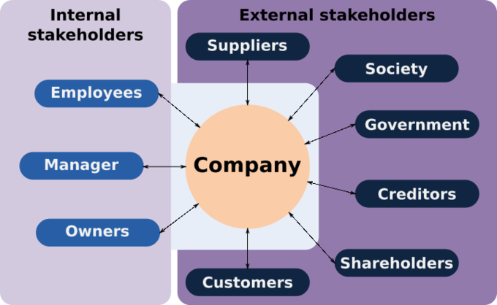
Fig 2 Original source: (Freeman, 2010). Source: (Google.co.uk, 2017).
In this graph freeman is showing is showing both internal and external factors that are the biggest influences on a company. All of these affect how successful a business is which refers to how much profit they make. "Stakeholder Theory is an idea about how business really works. It says that for any business to be successful it has to create value for customers, suppliers, employees, communities and financiers, shareholders, banks and others people with the money’’ –Freeman ((Stakeholdermap.com, 2017).
Fig 3:
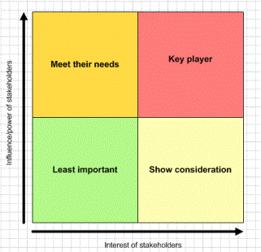Original source: Freeman, 2010. Source: (Stakeholdermap.com, 2017).
‘’Stakeholder Analysis is a systematic way to analyse stakeholders by their power and interest. High power, high interest stakeholders are Key Players. Low power and low interest stakeholders are least important’’(Stakeholdermap.com, 2017).
Basically this model can be used to see who has the biggest influence on the company and how to manage their interactions with your company. This was the second model created by freeman and this could help businesses manage effectively and successfully.

Conclusion

It is clear to see that sustainability and CSR theories and models are having a big impact on businesses; in return this is making more ethical businesses. Although businesses are still fighting that profits should remain their main aim they are realising that consumers are more aware on what impacts their purchases can make. Businesses who act unethically and cause disastrous events for example the BP oil spill will get stung with media talking about them negatively which will impact their consumers and profit, so businesses will want to avoid this. Consumers have power over businesses because obviously without them a business can’t make profit so it is important consumers recognise this and try and push businesses in the right direction in regards to sustainability. The main reason why consumers wouldn’t stand up to unethical businesses is obviously because they prove the cheapest prices. Consumers have to decide is sustainability more important than spending a little bit more?
I think this will be an ongoing discussion due to businesses not being ready to cut profits especially if not all businesses are doing it.

Refelction

My first stage of this assignment was to create a poster. My first step in doing this was researching famous posters and seeing what works best. I decided pictures were of importance so my poster was mainly picture based. My posters aim was to advertise how businesses can be unethical and greedy and only think about profit rather than sustainability and the damage their doing which would affect future generations. My poster contained a lot of black because I was trying to represent the dark side of businesses and the oil spill. I used my computer and word art to collaborate all the pictures together. I asked family and friends to give me advice on how I could improve the poster. A more detailed explanation on my poster can be seen in Appendix A and the poster itself can be seen in appendix B.
I then had to answer ten questions on the poster. The company I decided to represent was WWF the reason for this was because I found their views contradicted directly with the actions of BP. They strongly support sustainability and CSR.
The main skills I have improved on in this assignment are:
ICT Skills, I had to use ICT skills to both type my poster defence questions but also to make my poster.
Communication skills, I have developed my communication skills in a business manner because had to be open minded when asking people to critique my work.
I have thoroughly enjoyed doing this piece of work. I’m not usually someone who would think about the consequences of my actions but this assignment has led me to do that. While research WWF, CSR and sustainability it led me to set up a monthly donation subscription to WWF so I can do my part in helping the planet be a more sustainable place to be.
If I was to re do this assignment I would make my poster more professional and artistic. We hoped to speak with art students within our university this year but unfortunately our timetables clashed and were unable to collaborate with them. I think they could of helped make my poster more aesthetically pleasing. I also would of liked to have got more feedback from people I don’t know rather than friends and family who could possibly be biased.

Bibliography

BusinessDictionary.com. (2017). Read the full definition.. [online] Available at: http://www.businessdictionary.com/definition/corporate-social-responsibility.html [Accessed 20 Nov. 2017].
Friedman, F. (2017). A Friednzan doctrine‐. [online] Nytimes.com. Available at: http://www.nytimes.com/1970/09/13/archives/a-friedman-doctrine-the-social-responsibility-of-business-is-to.html [Accessed 20 Nov. 2017].
Google.co.uk. (2017). freeman 2010 stakeholder theory spider graph - Google Search. [online] Available at: https://www.google.co.uk/search?q=freeman+2010+stakeholder+theory+spider+graph&tbm=isch&tbs=rimg:CQPDbR7BBC_17IjhKn5z1LL0fjqKDHdx9Ne5ftnE9QHuLPOYBraYlD3j0umLpg97_1OmuDBOIJbeqb86LapzoovJeA3CoSCUqfnPUsvR-OEWGF9qwRTO2ZKhIJooMd3H017l8RTWcAPbDzi64qEgm2cT1Ae4s85hGIKnTPnhzqxSoSCQGtpiUPePS6EaaDrpEU0vbFKhIJYumD3v86a4MRDHciL5mjPCsqEgkE4glt6pvzohE_16HAC2YAr4yoSCdqnOii8l4DcET-fwGenIM5O&tbo=u&sa=X&ved=0ahUKEwjP7f2rgszXAhVHB8AKHb-3DewQ9C8IHw&biw=1366&bih=662&dpr=1#imgrc=m5j4IRIjlg7mlM: [Accessed 20 Nov. 2017].
Goodreads.com. (2017). A quote by Milton Friedman. [online] Available at: https://www.goodreads.com/quotes/240845-there-is-one-and-only-one-social-responsibility-of-business-to [Accessed 19 Nov. 2017].
HRZone. (2017). Ten powerful quotes on CSR from the Responsible Business Summit 2013. [online] Available at: https://www.hrzone.com/engage/managers/ten-powerful-quotes-on-csr-from-the-responsible-business-summit-2013 [Accessed 20 Nov. 2017].
Stakeholdermap.com. (2017). Stakeholder Management. [online] Available at: https://www.stakeholdermap.com/stakeholder-management.html [Accessed 20 Nov. 2017].
Stakeholdermap.com. (2017). Stakeholder Theory - Edward Freeman. [online] Available at: https://www.stakeholdermap.com/stakeholder-theory-freeman.html [Accessed 20 Nov. 2017].
Sherwell, P. (2017). BP oil spill: Five years after 'worst environmental disaster' in US history, how bad was it really?. [online] Telegraph.co.uk. Available at: http://www.telegraph.co.uk/news/worldnews/northamerica/usa/11546654/BP-oil-spill-Five-years-after-worst-environmental-disaster-in-US-history-how-bad-was-it-really.html [Accessed 19 Nov. 2017].
ToughNickel. (2017). Arguments for and Against Corporate Social Responsibility. [online] Available at: https://toughnickel.com/business/Arguments-for-and-Against-Corporate-Social-Responsibility [Accessed 20 Nov. 2017].
WhatIs.com. (2017). What is business sustainability? - Definition from WhatIs.com. [online] Available at: http://whatis.techtarget.com/definition/business-sustainability [Accessed 19 Nov. 2017].
WWF. (2017). Protecting our natural places. [online] Available at: https://www.wwf.org.uk/what-we-do/area-of-work/protecting-our-natural-places [Accessed 19 Nov. 2017].

Appendices

Appendix A:
BP poster
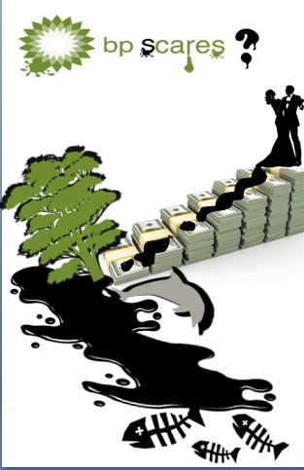

Appendix B:
Written discussion


