B.Eng. Electrical and Electronic Engineering
Gareth E John (2413461)
Module CODE: ACCA4028
Cybersecurity and Computer System Design
2025
Contents
1.1 - Introduction 2
2.1- Tasks 1 – Build a computer 2
2.2 - Shopping List 2
2.3 – Specification 3
2.3.1 - CPU and Motherboard 3
2.3.2 – RAM (Random access Memory) 4
2.3.3 – Storage 4
2.3.4 - Inputs/Outputs Ports 5
2.3.5 –GPU (Graphics Processing Unit) 6
2.3.6 – Computer Case and PSU (Power Supply Unit) 7
2.3.7 - Mouse, Keyboard and monitor 8
2.3.8 – Network 9
2.3.9 – Software 9
3.1- Task 2 Cyber security 11
3.1.1 – Introduction 11
3.2.1 Potential impacts of each cybersecurity risk 11
3.2.2 Prioritising Cyber risks. 13
3.2.3 Cybersecurity Strategy 14
3.2.4 Incident response plan 15
References 16
Appendix 21

1.1 - Introduction
In this report there will be 2 tasks, task 1 is to demonstrate how to build a home computer that will be capable to operate Software tasks with electrical design and simulations and writing reports, presenting presentation over online video calls.
Tasks 2 is to make sure that the system can defence with cybercrime and demonstrate what risks each cyber strategy that can impact on the company system.

2.1- Tasks 1 – Build a computer

2.2 - Shopping List
Below Table 1 shows a shopping list for all the hardware components that will be used to build a custom-built computer. It’s important to research before ordering any part for the computer to make sure that the components are compatible to each other.

Shopping list
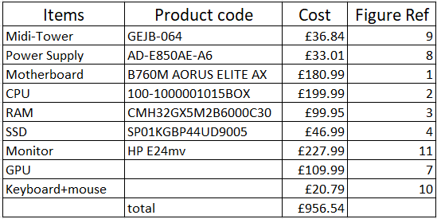
Table 1- List of componence.

2.3 – Specification

2.3.1 - CPU and Motherboard

Motherboard
The motherboard, a central component of a computer, facilitates faster connections between components like memory, processor, drives, and other devices [1]. A reliable product like the Aorus Elite AX [2] is recommended for home desktop computers.

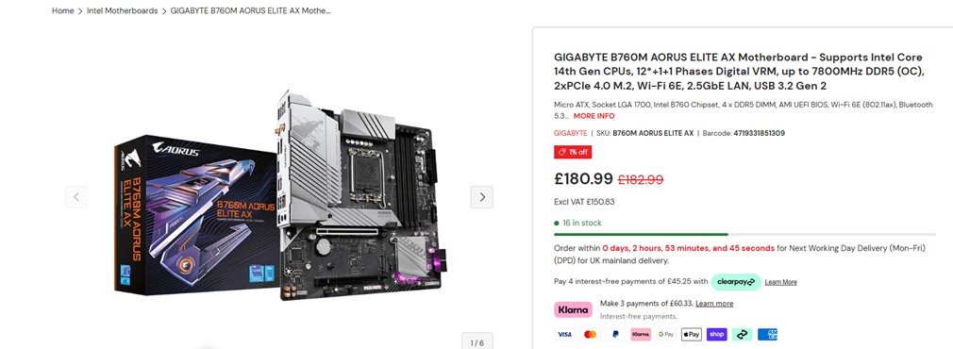
Figure 1 -Motherboard photo and price [3].

CPU – Central Processing Unit
The CPU is the brain of the computer processes data and is responsible for processing data [4]. The AMD Ryzen 5 CPU has 6 cores with 12 threads, each performing 2 threads simultaneously. More cores improve performance, but they also consume more power, leading to increased heat and decreased electrical resistance. Overheating can cause components to shut down, and the motherboard temperature sensor may signal processors and hard drives to slow down [5].

Figure 2- CPU and price [6].

2.3.2 – RAM (Random access Memory)
RAM (Random Access Memory) is a crucial component of computing equipment, essential for functionality and performance. It houses data and machine code used by the computer [7]. Without RAM, computers cannot perform multiple jobs or access necessary data and instructions for seamless operation. It is essential to have more than just enough random-access memories to handle multiple tasks, which is why 32GB RAM is used [7].

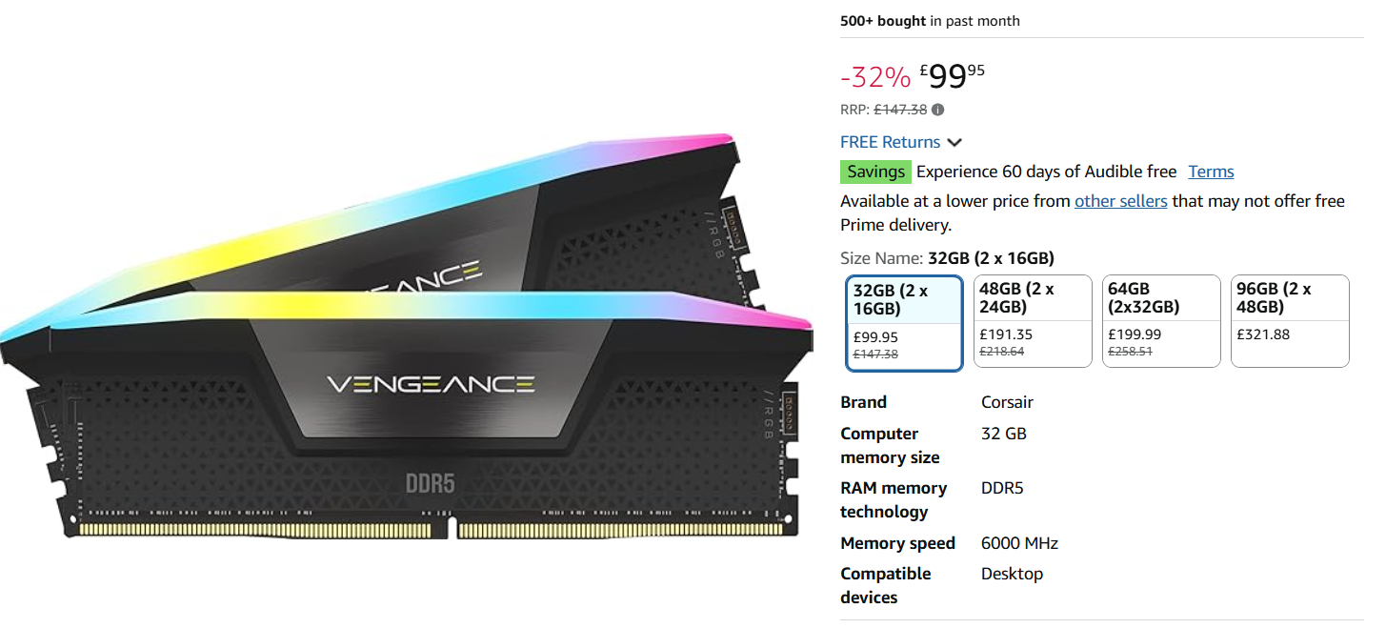
Figure 3-RAM and Price – (Random access memory) [8].

2.3.3 – Storage
The main points below why SSD is better than HDD:
- Reduced size,
- Lighter weight,
- Reduced power consumption due to no motor,
- Improved shock resistance,
- Faster reads and writes as compared to HDDs.
Consequently, SSDs are now the primary storage component in both local and cloud data centers [9].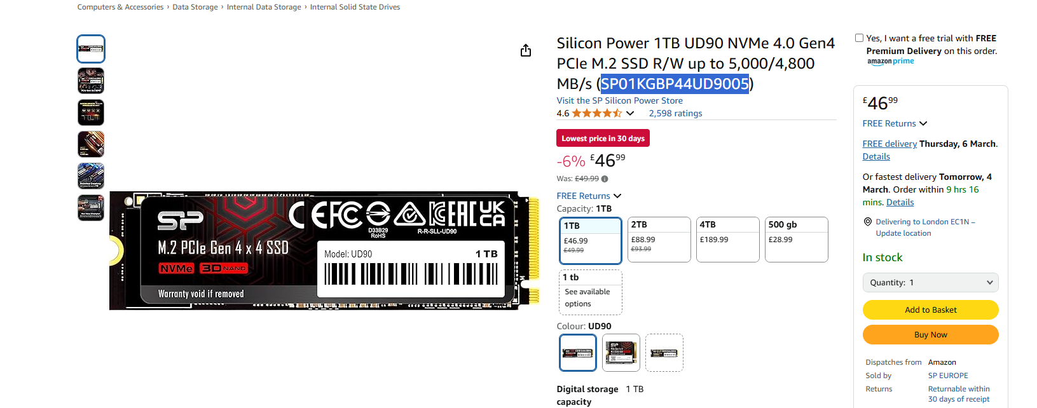
Figure 4-SSD (Solid State Drive) [10].

2.3.4 - Inputs/Outputs Ports

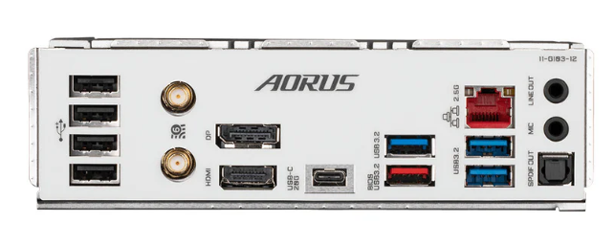
Figure 5 – Connection ports from the motherboard [2].
It’s important to keep the speed when connecting to the computer high as it is quite frustrating to wait for a response from the mouse, keyboard and monitor etc.
With Aorus Elite AX motherboard it comes with the following connection ports and brief description: -
- 4 x 2.0/1.1 USB
- 1 x 3.2 Gen 2 Type A port (red)
- 1 x 3.2 Gen 1 port
- 1 x USB type-C port with USB 3.2 Gen 2x2 support
- 1 x HDMI port
- 1 x Display port
- 1 x RJ-45 port
- 2 x Audio jacks
- 2 x SMA antenna connectors
There are a few different types of USB ports as figure 6 shown below that the speed is different from the standard Type A to Type C connection.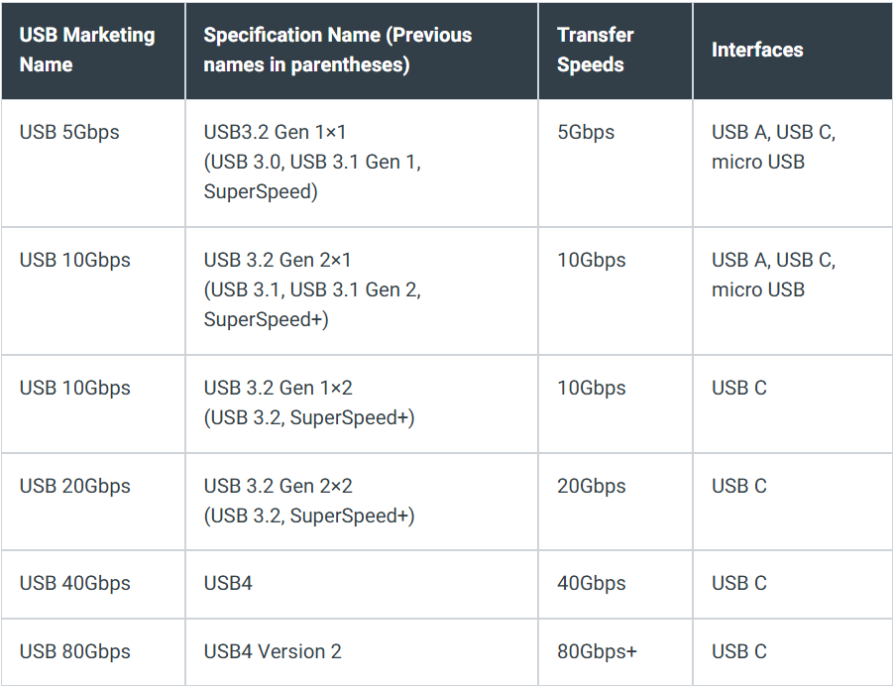
Figure 6 – different USB ports and speed [11].

2.3.5 –GPU (Graphics Processing Unit)
A dedicated graphics card is essential for graphically demanding applications like gaming, video editing, and 3D modelling. It improves performance and produces better images by removing graphical processing strain from the CPU, as integrated graphics are typically weaker than dedicated graphics cards [12].


Figure 7 – GPU (Graphics Processing Unit) [13].

2.3.6 – Computer Case and PSU (Power Supply Unit)

PSU (Power Supply Unit)
Folowing list below are the ouput from PSU:-
- 1 x 24 Pins connector
- 4 x SATA - is for powering the SSD storage
- 3 x Molex
- 1 x 8 Pin (4+4) connector – is to power the CPU
- 2 x PCI-E 6+2 Pin connector
24 pins and 8pins connectors connects to the motherboard, the voltage that is included in the pins are including in the motherboard manual as well as their locations, See appendix 2.3.1.
SATA cable is for powering the SSD storage card. Molex cables are to power old legarcy drives like CD/DVD drive. PCI-E connector are for the GPU(graphics processing unit) on this computer this is not needed as the supply will come from the motherboard.


Figure- 8 PSU (Power supply unit) [14].

Computer Case
A mid tower case was chosen for a desktop computer as there are room to expand in the future and their space for the air to circulate within the case to cool the components down.


Figure 9 – Mid-tower case [15].

2.3.7 - Mouse, Keyboard and monitor

To standardize the communication between devices such as game controllers, keyboards, and mouse, the Human Interface Device (HID) Protocol was developed. Through the abstraction of low-level data transmission details, it streamlines device-to-host communication [16].


Figure 10 – Mouse and Keyboard [17]

An image with a 1080p resolution has 1920 pixels on the horizontal plane and 1080 pixels on the vertical plane (1920x1080). Multiplying the height and width together gives the total amount of pixels in the image; so, a 1080p image has more than 2 million pixels. The terms 1080p, 1920x1080, and full HD are all simply ways of referring to the same resolution [18].

Figure 11 - Moniter [19]

2.3.8 – Network
This custom-built computer features an ethernet port for LAN and WAN connections to WIFI 6E, a 6 GHz radio frequency spectrum that offers faster internet speeds due to increased throughput. With more radio channels available, it supports more channels between 80 MHz and 160 MHz wide, improving high-bandwidth applications [20]. Ethernet connections are faster than Wi-Fi, with standard Cat6A connections rated at 10 Gbps, while Wi-Fi 6E can only achieve a few Gbps [21].

2.3.9 – Software
Operation system
Operation System software will be Windows 11 as this is the latest OS software out.
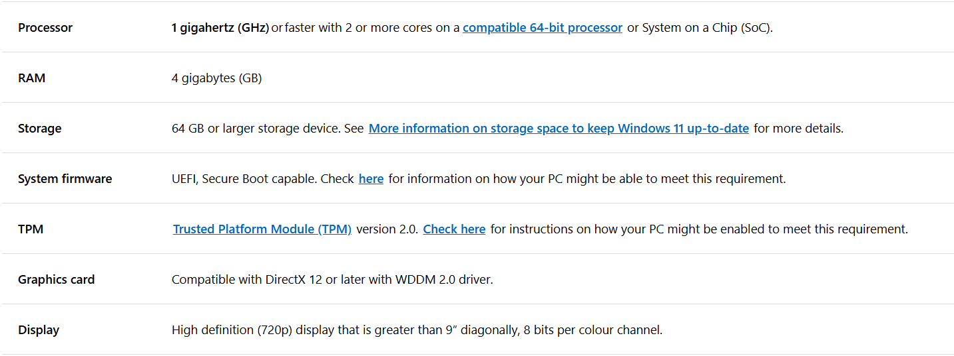
Figure 12- Minimum requirement for windows 11 [22].

SolidWorks Electrical
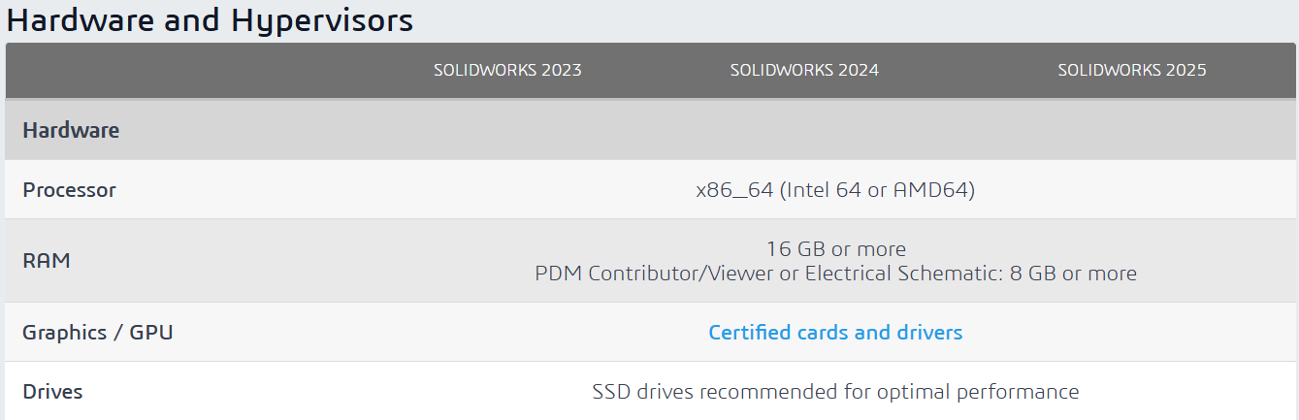
Figure 13 – minimum requirement for Solidworks software [23].
Pspice
Cadence owns PSpice and OrCAD X programs for electronic circuit design, layout, and schematic design, handling schematic and design aspects, circuit simulation, and PCB layout [24].

LabVIEW software
LabVIEW is a graphical programming environment that offers special productivity boosts for test system development, including completely integrated user interfaces, connectivity to any instrument, and an easy-to-use programming interface [25].

Microsoft 365
This is a subscription base software that includes all the essential programs for example: -
- Words
- PowerPoint
- Teams
- Excel and much more.

3.1- Task 2 Cyber security

3.1.1 – Introduction

The Company had brought in a cyber security consultant to evaluate the cyber risk at the manufacturer plants, the following points were raised from the report: -
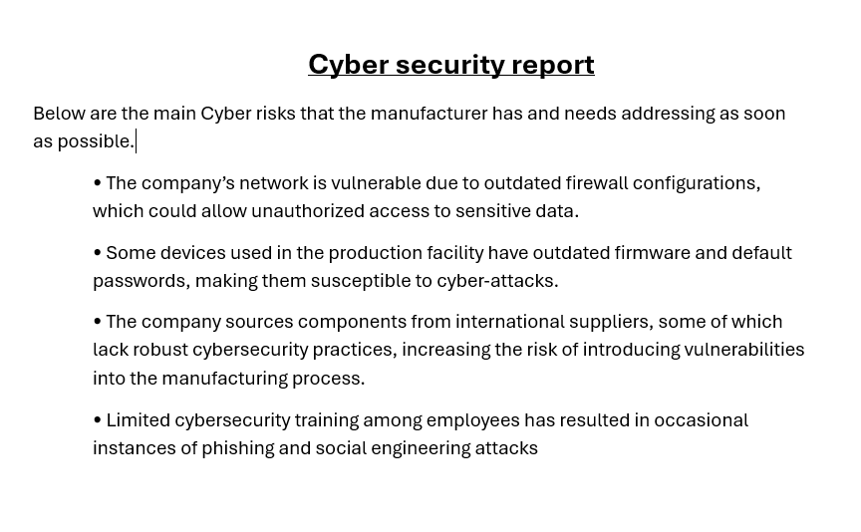
Figure 14- Cyber security report.

3.2.1 Potential impacts of each cybersecurity risk

Outdated firewall configurations
Firewalls are parts of a computer network or system that allow some outgoing communication while blocking unwanted incoming system access. It accomplishes this by carefully examining the data entering and leaving the computer system. After that, it makes sure all of the data complies with established security guidelines. The firewall will eventually become outdated. As threats change, an antiquated firewall becomes less effective in thwarting attacks. Your network and security are at risk due to this vulnerability [26].

Outdated firmware and default passwords on IOT devices
A lot of Internet of Things (IOTs) devices come with default passwords and usernames. Hackers can quickly locate these if they aren't altered, sometimes all it takes is a Google search. Attackers look for machines that have default login information, log in, and take over [27].
Device manufacturers distribute regular software updates, including bug fixes, performance enhancements, and new features, which should be installed after the product is no longer maintained.
Latest firmware is important because they address known product problems that hackers can use to infiltrate any devices. It is more difficult for hackers to successfully compromise devices thanks to new security measures [28].

Supplies vulnerabilities with cybersecurity.
Attackers must first obtain access to the third-party system, program, or tool they intend to exploit (sometimes referred to as an upstream attack) before they can launch a supply chain attack. Among other techniques, this can be accomplished by utilizing credentials that have been stolen, giving suppliers temporary access to a company's system, or taking advantage of an unidentified software flaw.
After gaining access to this third-party reliance, there are several ways to execute the downstream attack, which is the attack that ultimately targets the target, usually through their device or browser.

Lack of cybersecurity training with employee.
Businesses that prioritize cybersecurity awareness training may be less vulnerable than those that don't. Lack of expertise, education, and comprehension of the human error component may be partially to blame for this, as these factors can significantly raise security threats. Human mistake is frequently used by attackers as a starting point for additional assaults against companies of all kinds [29].
Some of the most security threats that employees may encounter are listed below.
- Phishing Email
- Exploitation Via Social Engineering
- Weak Passwords
- Unsecured Mobile Devices
- Lack of Incident Reporting

3.2.2 Prioritising Cyber risks.

This section will determine the severity and likelihood scoring of each Cyber risk on in section 3.2.1 Potential impacts of each cybersecurity risk. Below Graph 1 is the matrix used to score each threat.
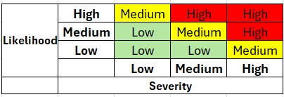
Graph 1

Outdated firewall configurations – High
- Severity – High
- Likelihood – Medium
Firewall is the 1st defence wall before hitting the company systems and data.

Outdated firmware and default passwords on IOT devices – High
- Severity – High
- Likelihood – High
Hackers frequently attack organizations by taking advantage of well-known flaws in out-of-date software. You may be vulnerable to ransomware, malware, data leaks, and other types of intrusions in the event use outdated software or firmware. Hackers can easily search the manufacture devices and find the default passwords to connect straight on the device [30].

Supplies vulnerabilities with cybersecurity - Medium
- Severity – Medium
- Likelihood – Medium
The Supplier are used to supply components parts to the company. If this supplier gets attack by cyber then the manufacturing line will stop and costing the company money at a short time until another supplier is found.

Lack of cybersecurity training with employee. – Medium
- Severity – Medium
- Likelihood – Medium
This risk happens occasionally, meaning it doesn’t happen all the time.

3.2.3 Cybersecurity Strategy

Outdated firewall configurations
List below that will lower the risk of being hack [31]: -
- Firewalls should be appropriately configured and hardened.
- Implement a tailored, staggered deployment plan.
- Improve and upgrade firewall protocols on a regular basis.
- Review and update access controls on a regular basis.
- Put in place a thorough logging and alerting system.
- Create procedures for backup and restoration.
- Policies should be in line with compliance requirements.
- Test and perform regular audits of your firewall.

Outdated firmware and default passwords on IOT devices
Most firmware upgrade coming with security fix, so it important to upgrade this firmware as soon as possible and change the default passwords. Password should change Max 3 months to keep the devices secure and enable Multi-Factor Authentication [32].

Supplies vulnerabilities with cybersecurity
Manufacturer must assess and keep an eye on their supply chain partners' cybersecurity posture. Supply chain threats can be avoided by putting strong controls in place and keeping an eye on vendor security procedures [33].

Lack of cybersecurity training with employee
Introduces a short basic cyber training on the following points below: -
- Phishing email
- Strong password
- Secure devices

Figure 15 – poster from National Cyber Security Centre [34].

3.2.4 Incident response plan

Preparation
Putting together a Cyber Security Incident Response Team (CSIRT), defining suitable channels of communication, outlining the services required to support response efforts, and acquiring the required equipment are all part of preparation [35].

Identification
Finding the original point of entry and verifying the fact of an incident are the goals of identification. It also attempts to preserve digital evidence, perform forensic analysis, and assess the incident's impact, degree, and scope of damage [35].
Containment
The purpose of the containment stage is to isolate impacted systems for forensic examination. Using several methods depending on severity, damage, and legal issues, this helps in gaining possession of the situation and limiting the amount of the harm [35].
Elimination
Elimination means removing and managing every aspect and symptom of the incident. Another step is done to make sure the problem doesn't happen again [35].
Recovery
Recovery refers to the actions needed to return systems and data to working order so that a company can resume [35].
Review
The systems that got impacted by the incident are reviewed. The attack's technique is explained and a strategy to stop it from happening again is created [35].

References

[1] | T. T. E. K. K. J. Tomljanović, “Motherboard and user experience,” Opatija, Croatia, 2013.
[2] | “Gigabyte,” GIGA-BYTE Technology Co., Ltd, [Online]. Available: https://www.gigabyte.com/Motherboard/B650M-AORUS-ELITE-rev-12#kf. [Accessed 12th March 2025].
[3] | “Amazon,” Amazon LTD, [Online]. Available: https://www.amazon.co.uk/GIGABYTE-B760M-AORUS-AX-Motherboard/dp/B0BSB4TYHV?th=1. [Accessed 13th March 2025].
[4] | O. K, “American Journal of Computer Science,” Understanding the Central Processing Unit (CPU): The Heart of the, vol. 11, no. 03, p. 1, 2023.
[5] | B. N. B. Best, “The Effect of Heat on Processors: A Challenge to Computer Usage in,” Journal of Global Research in Computer Science, vol. 6, no. 9, p. 3, 2015.
[6] | “Amazon,” Amazon LTD, [Online]. Available: https://www.amazon.co.uk/AMD-7600X-Processeur-Architecture-Fr%C3%A9quence/dp/B0BBJDS62N/ref=sr_1_3?crid=3NF1LVL7C698C&dib=eyJ2IjoiMSJ9.vcjh98wfbebADz505M-Zk850enWzqQ10mJw3ikmKuYm9pCZBs5AGApp58GSg0OrCzPbg7gl97jTr9j1O11-Ng-FsFAHsRL395_EIdxO-p0LcSV8ZBSNN9HFr. [Accessed 17th March 2025].
[7] | “Understanding Random Access Memory (RAM): A Crucial Component,” American Journal of Computer Science, vol. 11, no. 3, p. 1, 27th September 2023.
[8] | “Amazon,” Amazon.com, Inc, [Online]. Available: https://www.amazon.co.uk/CORSAIR-VENGEANCE-6000MHz-Compatible-Computer/dp/B0BPTKD797/ref=sr_1_4?crid=3SJHVH20WCZD1&dib=eyJ2IjoiMSJ9.fPDdVlp6jC94H1kyeUgvuna9FRz7RK01XpDFKGwKRKSgFX_-NPTHEgdHLrmkWXJ5yKEsAEdXLvOEyavh4f4XZIbp3nJEYhD2w-yCoxsCCslGNWyewGOVCk0s5KO. [Accessed 20 March 2025].
[9] | Journal of Information and Data Management, vol. 8, no. 1, p. 2, April 2017.
[10] | “Amazon,” Amazon LTD, [Online]. Available: https://www.amazon.co.uk/Silicon-Power-NVMe-Gen4-SP01KGBP44UD9005/dp/B0B217LZBG/ref=asc_df_B0B217LZBG?mcid=f93a954e1f4238ffa64cc73dac2fc69e&tag=googshopuk-21&linkCode=df0&hvadid=697193037966&hvpos=&hvnetw=g&hvrand=3845008953937361956&hvpone=&hvptwo=&hvqmt. [Accessed 25th March 2025].
[11] | D. Fanton, “onlogic,” OnLogic 2024, 25th July 2024. [Online]. Available: https://www.onlogic.com/blog/usb-type-c-and-usb-3-1-explained/. [Accessed 02nd April 2025].
[12] | “Lenovo,” Lenovo LTD, [Online]. Available: https://www.lenovo.com/gb/en/glossary/what-is-graphics-card/. [Accessed 07 April 2025].
[13] | “Amazon,” Amazon LTD, [Online]. Available: https://www.amazon.co.uk/RX-550-Computer-Graphics-DisplayPort/dp/B09SKZSDRT/ref=pd_ci_mcx_pspc_dp_d_2_t_1?pd_rd_w=zc2aH&content-id=amzn1.sym.707a350c-f6d8-4abf-9861-74c140760f91&pf_rd_p=707a350c-f6d8-4abf-9861-74c140760f91&pf_rd_r=YEC3CWGKVCSD4NDFD9DM&pd_. [Accessed 07 April 2025].
[14] | “watercoolinguk,” WCUK Online Ltd, [Online]. Available: https://www.watercoolinguk.co.uk/p/Artic-850W-Black-ATX-Gaming-PC-2x62Pin-PCIe-PSU-Power-Supply-120mm_29761.html. [Accessed 07 April 2025].
[15] | “Amazon,” Amazon LTD, [Online]. Available: https://www.amazon.co.uk/CiT-Mid-Tower-Rainbow-Tempered-Included/dp/B0CB1HPQDY/ref=sr_1_8?c=ts&dib=eyJ2IjoiMSJ9.IzmMWLl2XXesQ-UYQEX2TexJTu3MaTyVeVCjh6fWc-cibK9sqABd5Ssjbh3-AbKjhv4WI5QpC5hsybZrqGb35DO5i5RsScb0kMJWaIF4-FQvi_wdcOV_zvOw4tfoaIIzZcwRF6H7k6hTx5i. [Accessed 07 April 2025].
[16] | “The Gistre Blog,” [Online]. Available: https://blog.gistre.epita.fr/posts/ivan.imbert-2024-09-09-the_usb_keyboard_protocol/. [Accessed 01 May 2025].
[17] | “amazon,” amazon, [Online]. Available: https://www.amazon.co.uk/dp/B079FSMJ58/ref=sspa_dk_hqp_detail_aax_0?psc=1&sp_csd=d2lkZ2V0TmFtZT1zcF9ocXBfc2hhcmVk. [Accessed 01 May 2025].
[18] | “Best buy,” Best Buy, [Online]. Available: https://www.bestbuy.com/discover-learn/whats-the-difference-between-1080p-full-hd-4k/pcmcat1650917375500#:~:text=When%20it%20comes%20to%20choosing,in%201080p%20(Full%20HD).. [Accessed 01 May 2025].
[19] | “HP,” HP, [Online]. Available: https://www.hp.com/gb-en/shop/product.aspx?id=169L0AA&opt=ABU&sel=MTO&source=google&channel=cpc&adcampaign=OLS-UK-PS-Mon-Goo-Pmax&addisttype=xpla&kw=&adid=&infinity=ict2~net~gaw~cmp~OLS-UK-PS-Mon-Goo-Pmax~ag~~ar~~kw~~mt~&gad_source=1&gclid=EAIaIQobChMI_8P. [Accessed 01 May 2025].
[20] | “HP,” HP Development Company,, [Online]. Available: https://www.hp.com/us-en/shop/tech-takes/wifi-6-vs-6e. [Accessed 08 April 2025].
[21] | “The Wifi Specialist,” The Wifi Specialist Ltd., [Online]. Available: https://thewifispecialist.co.uk/blog/wifi-vs-ethernet/#:~:text=Ethernet%20is%20indeed%20faster%20than,a%20few%20gigabits%20per%20second.. [Accessed 08 April 2025].
[22] | “Microsoft,” Microsoft , [Online]. Available: https://www.microsoft.com/en-gb/windows/windows-11-specifications. [Accessed 08 April 2025].
[23] | “Solidworks,” SolidWorks Corporation, [Online]. Available: https://www.solidworks.com/support/system-requirements. [Accessed 08 April 2025].
[24] | “Cadence,” Cadence Design Systems, Inc., [Online]. Available: https://www.cadence.com/en_US/home/tools/pcb-design-and-analysis/orcad/faqs.html#product-services. [Accessed 13th April 2025].
[25] | “NI,” NATIONAL INSTRUMENTS CORP, [Online]. Available: https://www.ni.com/en/shop/labview.html. [Accessed 13th April 2025].
[26] | “OAC Technology.,” OAC Technology., 12th June 2024. [Online]. Available: https://www.oactechnology.com/blog/dangers-outdated-firewall/. [Accessed 18th April 2025].
[27] | O. Traynor, “CybelAngel,” CybelAngel, 8th April 2025. [Online]. Available: https://cybelangel.com/iot_cybersecurity/. [Accessed 21st April 2025].
[28] | “The National Cyber Security Centre,” The National Cyber Security Centre, [Online]. Available: https://www.ncsc.gov.uk/collection/device-security-guidance/managing-deployed-devices/keeping-devices-and-software-up-to-date. [Accessed 21st April 2025].
[29] | “sentinelone,” 23rd August 2024. [Online]. Available: https://www.sentinelone.com/platform/small-business/cybersecurity-awareness-training-for-employees/#potential-risks-to-smbs-that-lack-cybersecurity-awareness-training. [Accessed 21st April 2025].
[30] | E. Baran, “Blaze,” 26th March 2025. [Online]. Available: https://www.blazeinfosec.com/post/cyber-security-risks-in-iot-devices/. [Accessed 23rd April 2025].
[31] | “Paloalto Networks,” [Online]. Available: https://www.paloaltonetworks.co.uk/cyberpedia/firewall-best-practices. [Accessed 23rd April 2025].
[32] | “IOT for all,” 2nd December 2024. [Online]. Available: https://www.iotforall.com/how-to-secure-iot-devices-2. [Accessed 23rd April 2025].
[33] | A. Fitzgerald, “Secureframe,” 19th November 2024. [Online]. Available: https://secureframe.com/blog/cybersecurity-manufacturing. [Accessed 23rtd April 2025].
[34] | S. Lyons, “National Cyber Security Centre,” 14th April 2021. [Online]. Available: https://www.ncsc.gov.uk/blog-post/ncsc-cyber-security-training-for-staff-now-available. [Accessed 23rd April 2025].
[35] | “FR Secure,” [Online]. Available: https://frsecure.com/services/incident-response/. [Accessed 27th April 2025].
[36] | “Gigabyte,” GIGA-BYTE Technology Co., Ltd, [Online]. Available: https://www.gigabyte.com/Motherboard/B450M-S2H-V2-rev-1x#kf. [Accessed 12th March 2025].
[37] | “InMotion Hosting Blog,” InMotion Hosting Inc, 23rd January 2024. [Online]. Available: https://www.inmotionhosting.com/blog/what-are-motherboards/. [Accessed 13th March 2025].

Appendix

2.3.1 -Motherboard power supply manual

