

Data Handling and Business Intelligence
LCBB5000
Component 2: Practical: Essay
Student Name: Alin Florin Carare
Student number: 2246440
Lecturer name: Dr. Ejike Robert Udeogu

Introduction
The USA housing market analysis is a significant source of information regarding important parameters that define the price of real estate properties such as area, lot size, number of bedrooms and number of bathrooms. The correlation analysis makes it possible to find out which factors affect prices most of all, including living areas and views. Excel lacks the Data Mining Cycle because it provides a more orderly way of deeply analyzing data to gain insights now crucial in strategic determination in real estate (Ardito, 2019).
Section 1
1. Detailed Analysis of Descriptive Statistics
Overview of the USA housing dataset contains real estate type data related to the price range, sqft_living (size of living space), sqft_lot (total size of the lot), number of bedrooms and number of bathrooms. Mean, median and mode on these variables give important information on what influences the value of properties and assist the buyer and the analyst in decision-making on real estate investment (Chen, Preston and Swink, 2015).
Price
Mean: $553,063
Median: $460,000
Standard Deviation: $583,686
Range: $26,590,000 (from $0 to $26,590,000)
The mean price for the bulk of homes is $553,063, and the median price is $460,000, which explains why the aforementioned price distribution graph leans rightward. The standard deviation of data collected which is $583,686 makes it even more evident that varying prices are attributed to different home values in different regions, sizes, and amenities. This large price range, therefore marks the richness of the data set suggesting that the price of houses in the USA is realized through a system of checks and balances. For example, luxury areas such as beachfront homes or well-established estates will cost more than comparably sized homes in other parts of the city. The high-end is created by such homes and the existence of lower-cost homes (Choi, Wallace and Wang, 2018).
Square Footage of Living Space (Sqft_living)
Mean: 2,144 sq ft
Median: 1,980 sq ft
Standard Deviation: 957 sq ft
Range: 9,670 sq ft (from 370 sq ft to 10,040 sq ft)
Living space is 2,144 sqft for the average and 1,980 sqft for the median figure. There are many states with very large living areas. A higher value of standard deviation of 957 and range of 9,670 sq ft depicts that the size of living space varies significantly from home to home, with some homes having ten times more living area than other homes. Their relationship suggests that potential buyers in pursuit of cheaper solutions might consider the prospect of living in a small apartment since this is likely to be cheaper in the long run (Choi, Chan and Yue, 2017).
Total Lot Size (Sqft_lot)
Mean: 14,697 sq ft
Median: 7,676 sq ft
Standard Deviation: 35,877 sq ft
Range: 1,073,580 sq ft (from 638 sq ft to 1,074,218 sq ft)
The mean lot area is 14,697 sq ft, The median lot area is 7,676 sq ft this means that in actuality the majority of properties are not very big in lot size to the statistical mean. This might be due to the nature of the land which is urban and suburban. This house is located in the urban area which usually has a smaller area than the suburban or rural areas. Lot size as with any other factor affects the price of the house in some way but it may not be as significant as the living area (Ferraris, 2019).
Bedrooms
Mean: 3.4
Median: 3
Standard Deviation: 0.9
Range: 8 (from 0 to 8)
The mean number of beds in homes is 3.4 while the median shows that the majority of homes in this data set have 3 beds. This distribution raises the implication that it may be the three-bedroom unit that is the most standard perhaps because of the demand for such type of house by family-households. The extremely low standard deviation of 0.9 and a range of 0 to only 8 show the differences in the bedroom (Hazen, 2014).
More bedrooms help with the overall perceived quality of the house, and adding another bedroom to a home is almost guaranteed to increase its value to an extent the role of the difference in the number of bedrooms. For example, a three-bedroom house with open floor plans and lots of additional features will be considered equal to or more expensive than a four or more-bedroom residence (Khanna, Polkowski and Castillo, 2023).
Bathrooms
Mean: 2.16
Median: 2.25
Standard Deviation: 0.78
Range: 6.75 (from 0 to 6.75)
There are slightly more than two and a quarter bathrooms per home with the median right behind at 2.25. The general trend of having a house with at least two bathrooms or better still, a half bath. The relatively small standard deviation of 0.78 and the range of 6.75 bathrooms mean that the number of bathrooms does not differ as large as the size of the lots or price means that the number of bathrooms is relatively uniform in many homes. Buyers accentuate affordability and might consider a superior number of bathrooms unfathomable should it not be fundamental to them.
Interpretive Summary
Discrete statistics point to key issues that influence property values in a way that the P value of 0.00:000 shows the strength of the conclusions and the generalizability of the findings. This means that price and number of square meters are important changeable components of the property value while higher price corresponds to larger houses or those situated in the most popular districts. Housing size seems to be most relevant, as it has proved to be positively associated with price and meaningful and desirable home space (Kumar, Tewary and Shekhar, 2024).
For potential buyers:
Affordability: Housing hunters in search of cheaper options may find that incorporating features that lead to a smaller area or fewer bedrooms makes housing more affordable. Homes with normal-sized lots in suburban or transition zones also hold the potential to give better returns (Kwon, Lee and Shin, 2014).
Factors Driving Prices Upwards: Those homes with bigger living space, more numbers of bathrooms or are situated in well-established neighbourhoods containing superior features such as proximity to service facilities or waterfronts will generally attract higher prices.
2. Visualisation of the data
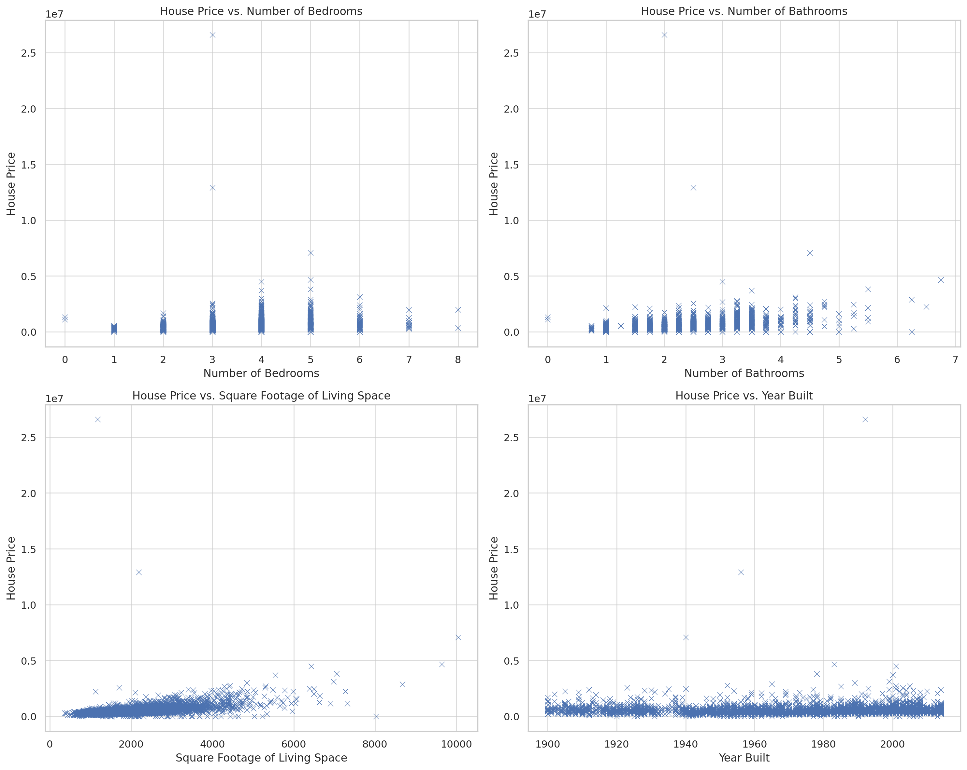
Figure 1: The figure shows the House Price vs. Number of Bedrooms (Self-Made).
Figure 2: The figure shows the House Price vs. Number of Bathrooms (Self-Made).
Figure 3: The figure shows the House Price vs. Square Footage of Living Space (Self-Made).
Figure 4: The figure shows the House Price vs. Year Built (Self-Made).
3. Using Correlation Analysis to Identify Key Drivers of House Prices
Correlation analysis enables findings to be made on the nature of relationships that exist between various aspects of houses and the price range of the houses. From the within and between distributions of these variables, one can deduce the variables that have the highest coefficients of association with the price changes. In this analysis determining the correlation of house prices with some property characteristics including living area, number of bathrooms, overlooking, basement area, and other characteristics using the Pearson coefficient of correlation. A coefficient closer to + 1 suggests a high positive correlation which means that as the value of one variable, the value of the other variable also increases. However, a coefficient close to 0 suggests a weak or no relationship at all, between the variable and the dependent variable (Raut, 2019).
Key Findings from Correlation Analysis
1. Living Area (sqft_living) – Correlation: 0.42
Among all the area-related factors, the living area size gives the highest positive coefficient with house prices. In general, the price of a house is directly proportional to the size of the living area. Intuitively, this makes a lot of sense as greater square footage implies more space. Moreover, a large area implies that the given properties are located in popular or offer high-quality finishing, which also increases the cost.
2. Above-Ground Area (sqft_above) – Correlation: 0.36
Another factor that has greatly influenced the price of houses is the above-ground area. Consumers prefer and pay a much higher price for existing space that occupies somewhat livable, above-ground areas with the preference for rooms with natural daylight and easy access. Those structures with greater above-ground square footage are likely to be larger, perhaps even luxury homes (Cohen, West and Aiken, 2014).
3. Bathrooms – Correlation: 0.32
The number of Bathrooms is also related to house price because the more the bathrooms the higher the price of the house. When it comes to the number of bathrooms they usually provide richer opportunities for comfortable accommodation for members of the house and guests. When the number of bathrooms goes up, the buyers are likely to realize a higher value, especially the segments occupied with the markets of living in families. Extra bathrooms are both functional and enhance the market value (Cohen, 2014).
4. Views – Correlation: 0.22
Many structures located in religious beliefs or attractive areas have higher costs. The presence of a view is an equally big selling point. Views are not a deciding factor in house price, however they are an asset for any buyer. Therefore, property with nice or unusual vistas may cost more, which remains another reason to draw the attention of the higher-tier audience.
5. Basement Area (sqft_basement) – Correlation: 0.20
Houses with basement spaces are usually more expensive because they add functional space for more rooms, storage or recreation areas. While basements are not as appealing as above-grade living areas, due to their impact on livable space, they remain a feature sought by buyers seeking more usable space in a home.
Implications for Homebuyers: From these statistics, potential homebuyers may enter the market with a more informed view of what influences house prices most. Here are some tailored recommendations:
For Buyers Seeking Affordable Housing:
Focus on Smaller Living Spaces: The size of the accommodated living space is proportional to the price tag, persons willing to purchase property in a smaller band should consider houses with fewer square footage (Bredenoord, Van Lindert and Smets, 2014).
Limit Above-Ground Area Preferences: Squares above the ground are closely related to price, therefore, due to this factor it is possible to make a significant step to the left towards the price by choosing a house with less above-ground area.
Consider Homes with Fewer Bathrooms: Houses having one or two bathrooms are cheaper than those with three or four bathrooms. With the modern trend of multiple-bath enclosures, it is common knowledge that single-bath homes or those with limited bath options in a home are cheaper.
Avoid Premium Views: Having scenery or any attractive view increases the cost of construction by a great deal. For example, those buyers who may fancy luxury properties with better views will have to price themselves (Luque, Ikromov and Noseworthy, 2019).
Reconsider Basements: If a basement is unessential, excluding homes with such a facility would render a property less expensive. However, should people prefer a small or incomplete basement, this can also make it easy to bring down the cost of construction.
Factors That Drive House Prices Upward:
Larger Living Area and Above-Ground Space: The correlation analysis validates the hypothesis of a positive relationship between living area and above-ground space and the prices of houses. As much as there are more spacious homes, the buyer should be ready to dig deeper into an individual pocket.
More Bathrooms: More bathrooms especially full bathrooms tend to be more appealing as it is regarded as a necessary factor that eases the buyer’s convenience. Since these features correlate with high costs, individuals are interested in gaining the most profits in the future.
Scenic Views: Viewers do not necessarily have the highest correlation as could be inferred from price, but clients who are viewed as noble or high class go for it. The beautiful view makes the houses unique and luxurious.
Basements with Functional Space: A basement adds extra square footage which combines with a finished or highly utilised space, which is considered valuable by most consumers.
Recommendations for Homebuyers and Market Strategy
When buying a home, those looking to save money need to consider that luxury is not essential and should not include advanced attributes such as more than two bathrooms, breathtaking views or large above-grade living space. Forcing for small and space-efficient homes and avoiding places with premium views helps make home ownership more manageable. Correlation analysis gives a clear road map of how some of these features affect the prices of houses (Abratt and Bendixen, 2018).
Section 2
(a) Advantages and Disadvantages of Using Excel
Microsoft Excel is used in managing data processing and creating databases, as well as in charting data. It is rather beneficial and usable for different tasks and processes Excel has its drawbacks too (Blackwood, 2014). Following are the strengths and weaknesses of using Excel in practice:
Advantages of Using Excel
User-Friendly and Accessible: Excel features such as gridlines and the toolbar enables many people even those with low data handling skills, to work on it easily. For example, the owner of a small business does not necessarily have to hire a professional to help an individual use Excel for expense and profit tracking.
Data Organisation and Filtering: Having rows and columns makes it easy to sort data well when using Excel. For example, the HR departments may take records of all employees either in Excel or may contain fields.
Formulas and Functions for Calculation: Calculation operations of Excel are pre-programmed or in other terms known as formulas or functions. For example, while using Excel an accountant may employ SUM and AVERAGE to arrive at monthly totals or average values respectively or even use VLOOKUP to search information from other sheets.
Data Visualisation: Excel allows users to convert data into charts so that it will be convenient for the users to figure out the patterns in data. For example, the audience of such visuals might be a marketing team as it will allow us to see the monthly sales (Schwabish, 2021).
Integration with Other Tools: There is a strong synergy with other Office applications, Excel is the import and export of data effectively. It can import CSV files and can be used with other applications including Word and PowerPoint, ideal for applications that need multiple tools in one,
Disadvantages of Using Excel
Limited Capacity for Large Datasets: With a row limit of approximately one million, Excel is not designed for large data processing exercises. For example, a researcher in possession of millions of customer records may discover that Excel is not workable for analysis, and other software like SQL is better (Medjedovic and Tahirovic, 2022).
Error-Prone with Complex Formulas: Excel is rather sensitive and it is capable of making mistakes as soon as a rather large dataset is involved. For example in finance, something as small as a figure discrepancy could lead to huge differences in balance sheets, meaning there needs to be absolute scrutiny of passage errors.
Limited Advanced Analytics Capabilities: Although Excel contains some statistical functions, it is not effective for data analysis or even a machine learning operation. Some jobs such as building a predictive model or clustering will need more advanced tools.
Security Concerns: Excel has built-in features of sharing that are dangerous as far as data security is concerned. Due to a lack of proper access controls, it is easy for some wrong persons to view or make changes to the information contained in Excel files.
Collaboration Challenges: Collaboration by using Excel can become challenging when multiple people edit the same Excel file. When multiple user amendments are made on different copies, integrating them would result in mistakes and confusion (Yale, Nisbet and Miner, 2017).
(b) The Data Mining Cycle:
Data mining refers to the process of extracting useful information from data and the Data Mining Cycle defines a systematic manner of making this extraction possible. The Data Mining Cycle typically involves six stages:
1. Problem Definition: This step means that the purpose of the analysis to be carried out must be spelt out to align with business needs. For example, if the goal of a particular business is to decrease the churn rate of its customers.
2. Data Collection: It is then possible to obtain relevant data from databases or CRM systems as sources of information. In retail For example the purchase history, demography and interaction information can be collected in an effort to analyze buying habits (Schoenherr and Speier‐Pero, 2015).
3. Data Preprocessing: Secondary and sometimes even primary data will need pre-processing before analytical processes can be performed on them. For example, variation in the database might require the values to be set to proper segmentations, such as correct customer demographic data.
4. Model Building: This step involves choosing a data mining model relevant to the problem at hand whether it is clustering or classification. For example, a bank may employ a classification to forecast loan defaults to separate borrowers based on a risk classification.
5. Evaluation: After a model has been developed it has to be validated to confirm the degree of precision or reliability. Testing is normally conducted on new data and common measures of accuracy and precision can be used. For example, an e-commerce firm developing a model that predicts customers' buying behaviour will check how the model measures against recent customer data for testing purposes.
6. Deployment: The final stage is to incorporate the model into the organisational business model. This could mean embedding a customer segment model into a CRM application to help have a feeling of what market strategy to engage in. For example, if a model predicts a specific group of customers that are likely to churn, the marketing department, could come up with the necessary retention efforts (Rae and Wong, 2021).
Importance of the Data Mining Cycle
The Data Mining Cycle allows an organisation to follow a structured process to make the best use of the data at its disposal and turn it into useful information. For example, by knowing the customer classification methods, a retail firm can create promotions to suit customer wants, which increases overall satisfaction (Spalek, 2019).
However, Excel is optimal for dealing with large amounts of data and performs excellent for basic analytics, but is not the best tool when working with large datasets or complex math models. Each serves particular but dynamic roles in current data practices, depending on the difficulty and scope of the particular task or process.
Conclusion
In conclusion, the analysis also shows the level of fragmentation in the US housing market, pointing at the fact that the size of living space, the size of the plot on which the house is built or even the number of bathrooms is important when it comes to defining the value of the property. Thus, Excel allows the presentation of descriptive statistics as well as the results of visual data analysis necessary to understand these relationships (Swaroop, 2024).

References
Abratt, R. and Bendixen, M. (2018) Strategic Marketing: Concepts and Cases. Routledge.
Ardito, L. (2019) 'A bibliometric analysis of research on Big Data analytics for business and management,' Management Decision, 57(8), pp. 1993–2009. https://doi.org/10.1108/md-07-2018-0754.
Blackwood, N. (2014) Advanced Excel Reporting for Management Accountants. John Wiley & Sons.
Bredenoord, J., Van Lindert, P. and Smets, P. (2014) Affordable housing in the urban global South: Seeking Sustainable Solutions. Routledge.
Chen, D.Q., Preston, D. and Swink, M. (2015) 'How the Use of Big Data Analytics Affects Value Creation in Supply Chain Management,' Journal of Management Information Systems, 32(4), pp. 4–39. https://doi.org/10.1080/07421222.2015.1138364.
Chen, Y. (2023) Financial Data Analytics with Machine Learning, Optimisation and Statistics. Wiley.
Choi, T., Chan, H.K. and Yue, X. (2017) 'Recent development in big data analytics for business operations and risk management,' IEEE Transactions on Cybernetics (Print), 47(1), pp. 81–92. https://doi.org/10.1109/tcyb.2015.2507599.
Choi, T., Wallace, S.W. and Wang, Y. (2018) 'Big Data Analytics in operations management,' Production and Operations Management, 27(10), pp. 1868–1883. https://doi.org/10.1111/poms.12838.
Cohen, P. (2014) Applied Multiple Regression/Correlation Analysis for the Behavioral Sciences, Psychology Press eBooks. https://doi.org/10.4324/9781410606266.
Cohen, P., West, S.G. and Aiken, L.S. (2014) Applied Multiple Regression/Correlation Analysis for the Behavioral Sciences. Psychology Press.
Ferraris, A. (2019) 'Big data analytics capabilities and knowledge management: impact on firm performance,' Management Decision, 57(8), pp. 1923–1936. https://doi.org/10.1108/md-07-2018-0825.
Hazen, B.T. (2014) 'Data quality for data science, predictive analytics, and big data in supply chain management: An introduction to the problem and suggestions for research and applications,' International Journal of Production Economics, 154, pp. 72–80. https://doi.org/10.1016/j.ijpe.2014.04.018.
Khanna, A., Polkowski, Z. and Castillo, O. (2023) Proceedings of Data Analytics and Management: ICDAM 2022. Springer Nature.
Kumar, D., Tewary, T. and Shekhar, S. (2024) Data Analytics and artificial intelligence for earth resource management. Elsevier.
Kwon, O., Lee, N.Y. and Shin, B. (2014) 'Data quality management, data usage experience and acquisition intention of big data analytics,' International Journal of Information Management, 34(3), pp. 387–394. https://doi.org/10.1016/j.ijinfomgt.2014.02.002.
Luque, J.P., Ikromov, N. and Noseworthy, W.B. (2019) Affordable housing development: Financial Feasibility, Tax Increment Financing and Tax Credits. Springer.
Medjedovic, D. and Tahirovic, E. (2022) Algorithms and data structures for massive datasets. Simon and Schuster.
Rae, A. and Wong, C. (2021) Applied Data analysis for urban Planning and management. SAGE.
Raut, R.D. (2019) 'Linking big data analytics and operational sustainability practices for sustainable business management,' Journal of Cleaner Production, 224, pp. 10–24. https://doi.org/10.1016/j.jclepro.2019.03.181.
Schoenherr, T. and Speier‐Pero, C. (2015) 'Data science, predictive analytics, and big data in supply chain management: current state and future potential,' Journal of Business Logistics, 36(1), pp. 120–132. https://doi.org/10.1111/jbl.12082.
Schwabish, J. (2021) Better data visualisations: A Guide for Scholars, Researchers, and Wonks. Columbia University Press.
Spalek, S. (2019) Data Analytics in project management. Taylor & Francis Group/CRC Press.
Swaroop, A. (2024) Proceedings of Data Analytics and Management: ICDAM 2023, Volume 2. Springer Nature.
Waller, M.A. and Fawcett, S.E. (2013) 'Data science, predictive analytics, and big data: a revolution that will transform supply chain design and management,' Journal of Business Logistics, 34(2), pp. 77–84. https://doi.org/10.1111/jbl.12010.
Wilke, C.O. (2019) Fundamentals of Data Visualisation: A Primer on Making Informative and Compelling Figures. O’Reilly Media.
Yale, K., Nisbet, R. and Miner, G.D. (2017) Handbook of Statistical Analysis and Data Mining Applications. Elsevier.

