HEAD, SHOULDERS, CHEESE ON TOAST, CHEESE ON TOAST

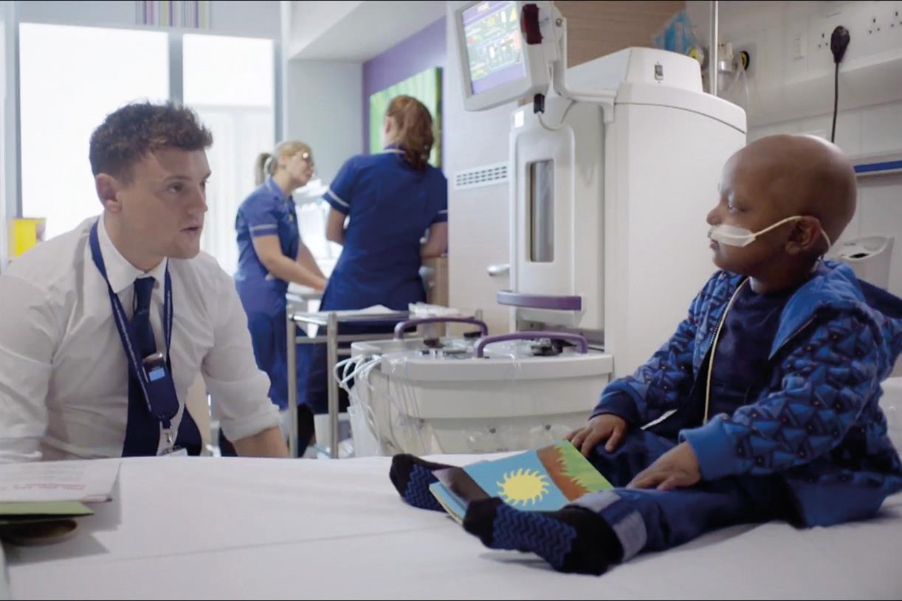
Figure 1 Campaignlive.co.uk 2015

Cancer Research UK is one of the most well-known cancer charities in the UK, the charity has progressed significantly in the last five years by redesigning its brand and marketing strategy. The organisation recognises the importance of incorporating all technological requirements to communicate with its audience, shifting away from brand campaigning and instead focusing on improving its marketing strategies. This demonstrates how the marketing concept has evolved over the past three decades. The importance of market orientation is identified by Cancer Research UK. The concept of market orientation is the core of the marketing process. Developing a market orientation refers to ‘the organization-wide generation of market intelligence pertaining to current and future customer need, dissemination of the intelligence across the departments, and organization-wide responsiveness to it’ (Kohli and Jaworski,1990).

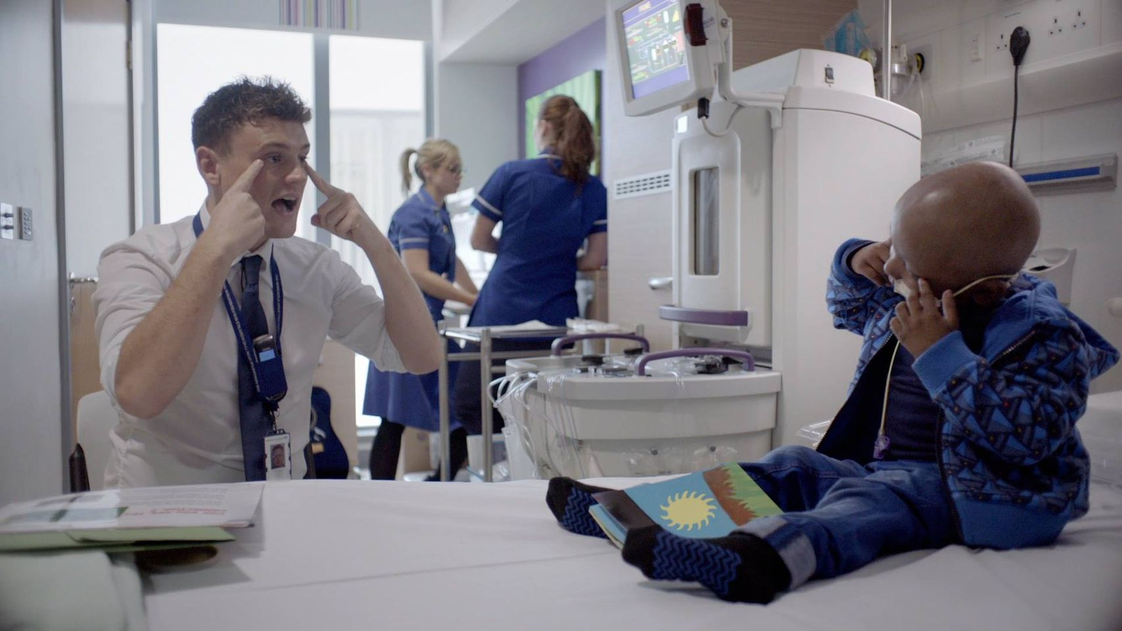
Figure 2 Markrtingweek.com 2015

Cancer Research UK released a new advertisement in 2015 to create a communication platform for the public to engage with. Rather than a one-time campaign, the charity revised their marketing strategy and took a risk with a new creative to communicate with the public. “Marketing is the activity, set of institutions, and processes for creating, communicating, delivering, and exchanging offerings that have value for customers, clients, partners, and society at large.” (AMA, 2007). Previously the organization's marketing strategy targeted 35-50-year-olds; the new communication platform aimed at adults 18+, utilizing a marketing technique known as Undifferentiated marketing, or mass marketing, a strategy that a company my chose to adopt if the market segmentation exercise has not been useful and has not produced meaningful and substantially different segments (Discussion, 2021).
The organisation took a different approach to their usual representation and instead focusing on bringing the patients' stories to life. The approach of combining brand and direct response campaigns raised awareness that cancer affects all adults and that anyone of any age can contribute to the charity.

Love vs Cancer Campaign

Our concept is to shine love on cancer rather than the sadness that surrounds it. Love vs Cancer is a cancer awareness campaign targeted directly at anyone who has lost a loved one to the disease. To raise awareness of Cancer Research UK's critical research, we created a platform where people can share their stories and experiences, thereby creating dialogue.
As of June 2019, Facebook had over 2.38 billion users, it’s the most influential social tool for any organisation seeking to raise awareness, gain support, and generate revenue.

We created a blog using content marketing and a Facebook page using social media marketing which are two types of digital marketing a modern marketing strategy marketing a form of direct marketing which links consumers with sellers electronically using interactive technologies like emails, websites, online forums and newsgroups, interactive television, mobile communications etcetera (Kotler and Armstrong, 2009).


Figure1 1000 logos 2019-2021

We designed an advertisement, logo, and the hashtag #todayimiss. We chose Facebook as a platform to launch our campaign to communicate with a larger audience, connect with new audiences, having a far better chance of reaching the intended audience.

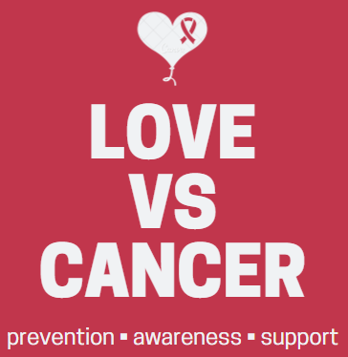
Figure 2 Love vs Cancer Campaign 2021
Visit our LOVE VS CANCER support group at - https://www.facebook.com/groups/1064828707648899

Cancer Research UK's latest campaign, "1 in 2 of us will get cancer," launched on June 1, 2021, with the creation of a new integrated platform that allows the organisation to take a singular creative approach across all its campaigns. It emphasises the heart-breaking fact that one in every two people will be diagnosed with cancer during their lifetime. The new brand response campaign is being promoted across multiple platforms, including television, video, video on demand, outdoor, and social media.

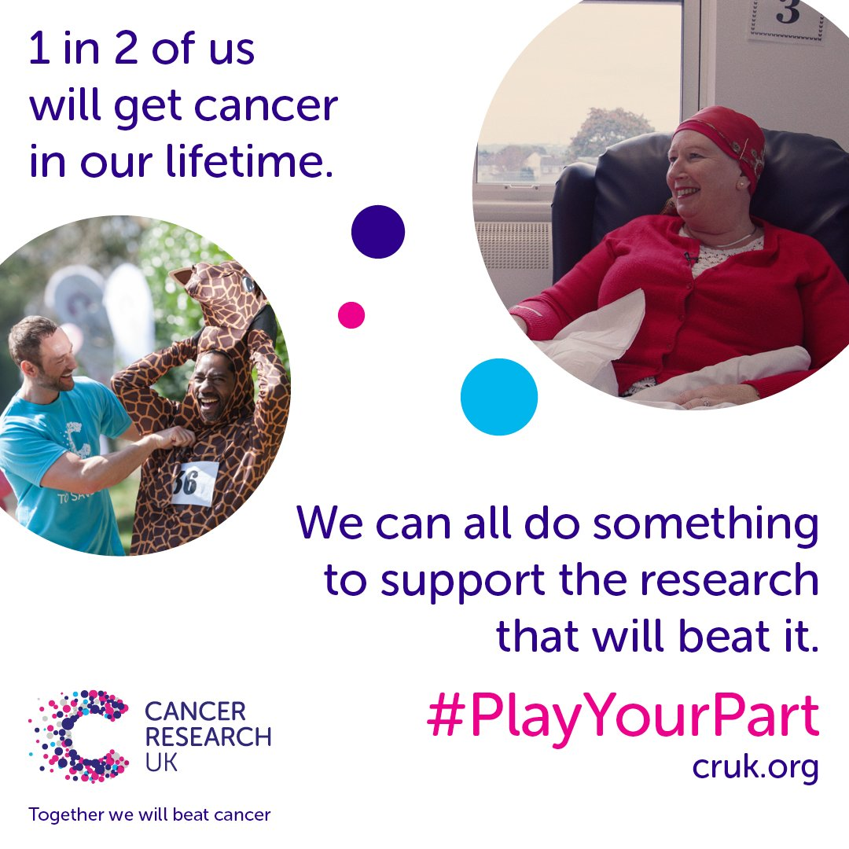
Figure 3 Cancer Research UK 2021

Group Members:
Tracey Louise Jones
Lisa Mary Pearce
Jade Gertruge Jones
Katie Margaret Hancox
Ntokozo Themba

Blog Link: https: //wordpress.com/view/lovevscancer.wordpress.com
(Please click on Menu Tap for group blogs)
Facebook Page Link: https://www.facebook.com/groups/1064828707648899

References
Amador, R., 2021. From Product Marketing to Digital Marketing. [online] Medium. Available at: <https://medium.com/stronger-content/from-product-marketing-to-digital-marketing-a94974b70a54> [Accessed 9 October 2021].
American Marketing Association. 2021. What is Marketing? — The Definition of Marketing — AMA. [online] Available at: <https://www.ama.org/the-definition-of-marketing-what-is-marketing/> [Accessed 9 October 2021].
Baines, P., 2014. Marketing. 3rd ed. Oxford: Oxford University Press, p.8.
Economics Discussion. 2021. Market Segmentation: Meaning, Definition, Bases, Importance, Levels, Benefits. [online] Available at: <https://www.economicsdiscussion.net/market-segmentation/market-segmentation/32464> [Accessed 11 November 2021].
Narteg, G., 2021. Digital Marketing Proposal 2. [online] Academia.edu. Available at: <https://www.academia.edu/37605036/Digital_Marketing_Proposal_2> [Accessed 11 October 2021].

