


LEVEL 4 ASSESSMENT SPECIFICATION

Student name: |  | Student ID number:
Programme: | Applied Computing
Module: | Software Development
Module code: | DUM4005 | Contribution to Overall Module Assessment (%): | 70%
Lecturer: | Daniel Davies | Internal Verifier: | Denise Hudson
Assignment Title: | Software constructs and the development of software | Word count (or equivalent): | 2800 Words
Submission deadline: | 21st December 2018 | Return date of provisional marks & written feedback: | 11th January 2019
Submission method: | All written assessments, where practical and possible, must be submitted via Turnitin unless otherwise instructed by the Lecturer. (Please DO NOT put this assessment specification into Turnitin or it will match many similarities with other students’ submissions.)  Alternative submission method (if applicable):  Late submission of the assessment will result in a late penalty mark. Penalties for late submission: Up to one week late, maximum mark of 40%. Over one week late, 0%. Only the Extenuating Circumstances Panel may approve a change to submission dates.
Academic honesty / referencing: | Academic honesty is required. In the main body of your submission you must give credit to authors on whose research and ideas your work is based. Append to your submission a reference list that indicates the books, articles, etc. that you have used, cited or quoted in order to complete this assessment.

Module Learning Outcomes
(from module syllabus)
1. Understand the syntax and semantics of a high-level programming language and develop programs using good programming practices.

2. Select and deploy basic software constructs using simple algorithms in the development of solutions to programming problems

TASK DESCRIPTION

A Lecturers Perspective
In completing this assignment, show Pride, Determination and Commitment.
You should be PROUD of the completed assignment; I don’t want to mark assignments you have rushed to complete with little thought or interest.
You need to be DETERMINED to learn everything you can. Success must be worked for through patience and practice.
You need to be COMMITTED by planning and finding the time to work hard to succeed, and practicing. The key to success in any field is, to a large extent, a matter of practice (see the “10,000 Hour Rule”).

This assignment is designed to test your understanding of the coding concepts covered in class, your ability to read & interpret code, your ability to test code and your ability to develop your own code.
The assignment comes in two sections, each section is worth 50% of the overall marks for the module and the results for each section will be recorded separately (out of 100%)

You are advised to complete part A of both sections 1 and 2 first.

Student FEEDBACK FORM

This section details the extent to which the assessment criteria are demonstrated by you, which in turn determines your mark. The marks available for each category of skill are shown. Lecturers will use the space provided to comment on the achievement of the task(s), including those areas in which you have performed well and areas that would benefit from development/improvement.

Generic Assessment Criteria | Marks available | Marks  awarded
1. Engagement with Literature Skills  . | 20
2. Knowledge and Understanding Skills | 25
3. Cognitive and Intellectual Skills | 15
4. Practical Application Skills | 35
5. Transferable Skills for Life and Professional Practice | 5

Assessment Mark (Assessment marks are subject to ratification at the Exam Board. These comments and marks are to give feedback on module work and are for guidance only until they are confirmed. ) | Late Submission Penalties (tick if appropriate) |  | %
 | Up to 1 week late (40% Max) |  | %
 | Over 1 week late (0%) |  | %

Gemma Jones GJ196454
HNC Applied Computing
Software Development DUM4005
Software Constructs and the Development of Software Assignment

Section 1 Part A
- What is a variable and why are they important in writing programs?
Variables are important as they store and represent data. They must be given unique names that correspond with the data they are storing. For example, if you want to store scores, a good naming convention to follow would be something with the word ‘score’ in the variable name (see screenshot below).
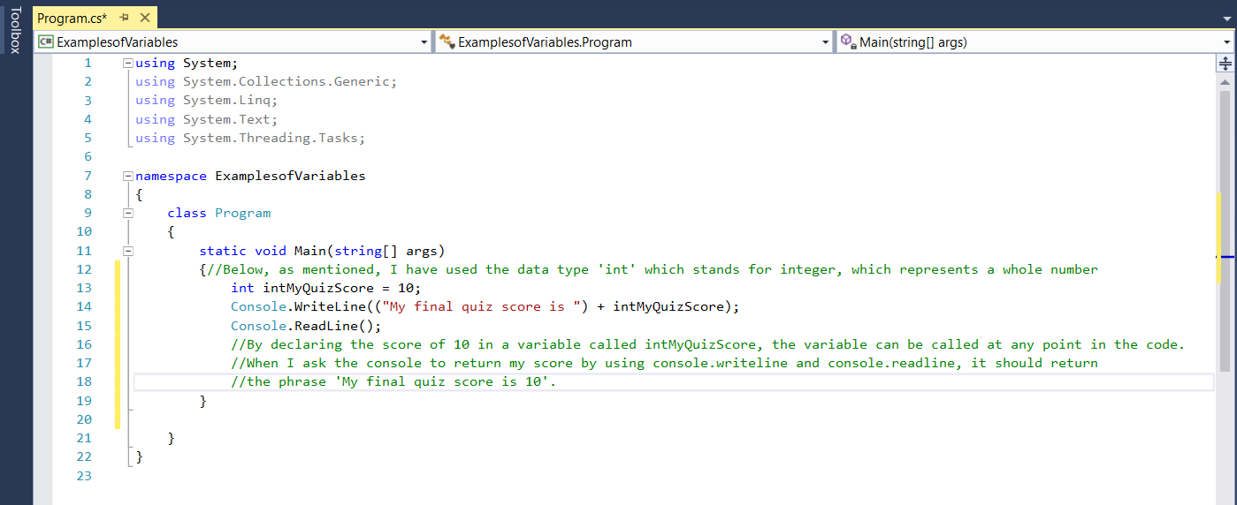
When this code is run, you get the following output:
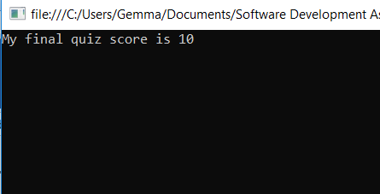
The variable name is relevant to the data that it has stored.

When you use the variable at any point in the code, the value stored will be called. In C# you declare the data type when you declare a variable. The data type determines the size of the variable’s memory. For example, if you’re going to be storing a whole number in your variable, you would probably use the data type int. Int stands for Integer which represents a whole number, it can store a value of up to 32 bits. If you needed a larger data type, you could use ‘long’ which stores 64 bits and a value with a decimal point would have a storage value of 64 bits, when stored with the data type ‘double’.
You could also use the data type var which figures out the data type for you.
John Sharp defines a variable as a storage location, which must have an unambiguous name that identifies uniquely in the context it’s used. (Sharp, 2013)

Other programming languages do not follow this naming convention. For example, in Python, you do not specify the data type, you simply define as follows:
Myquizscore = 10

- Explain the term code block.
John Sharp describes a code block as a sequence of statements between an opening and closing bracket. (Sharp, 2013). You can declare new variables inside a block, for use only within the code block. However, the Authors of Beginning Visual C# 2010 (Karli Watson, 2010) suggest it is best practice to declare all variables before initialising a code block. Personally, I don’t think it’s necessary to declare all beforehand. Any variable declared within a code block can only be used within that code block, which is fine if not needed anywhere else within the program, and would help keep the coding in the program neat and tidy.
When writing a program, the user does not need to see the code behind it, they just want to be able to put in whatever details are needed to return a result. For example, if a program is written to calculate someone’s BMI. The user simply wants to enter the information required. This is where functions come in. You can create a function code block and stipulate whether an item is to be public (for people to see) or private (viewed by the programmer only). This is referred to as encapsulation.

- In order to execute different branches of code (i.e code blocks), it must be possible to make decisions that change the flow of the program. Describe the Boolean operations that can be used.
Code blocks can change the flow of a program using Boolean values. There are a number of Boolean relational operators that can be used to do this:
< less than
> greater than
<= less than or equal to
>= greater than or equal to
<> not equal to
= equal to
These can all be used in an if statement to determine whether it is true or false (Boolean) and change the flow or a program and what you want it to execute.
Below is a simple example of this. I’ve written a program to output to a user whether they are old enough to drink alcohol. To do this, I request an age from the user. Within the IF statement, I simply specified if the age is > (greater than) 17, the program should output ‘you are legally allowed to drink alcohol. Please drink responsibly’. As there are only 2 outcomes, the user is either older than 17 or they are not, the code block finishes with an ‘else’ statement, which will output if the user inputs an age 17 or under.

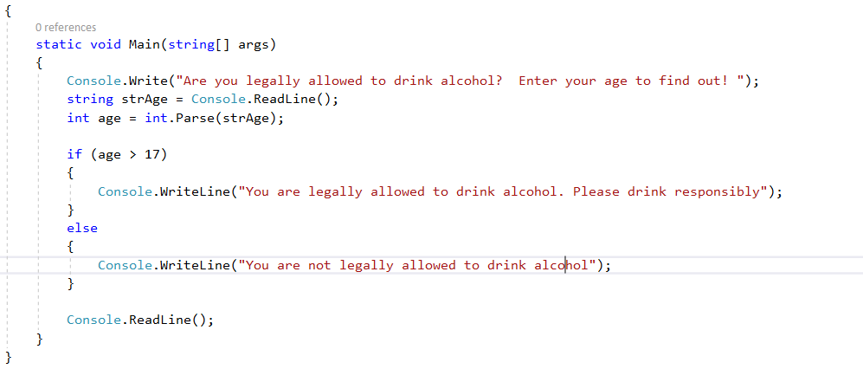
A more in-depth use of ‘if’ statements would be this example from the slot machine exercise. There were so many different possible outcomes to take into consideration when programming, I had to use several ‘else if’ statements to make sure the program outputted correctly depending on the outcome of the spin. Below is only a few of the statements.
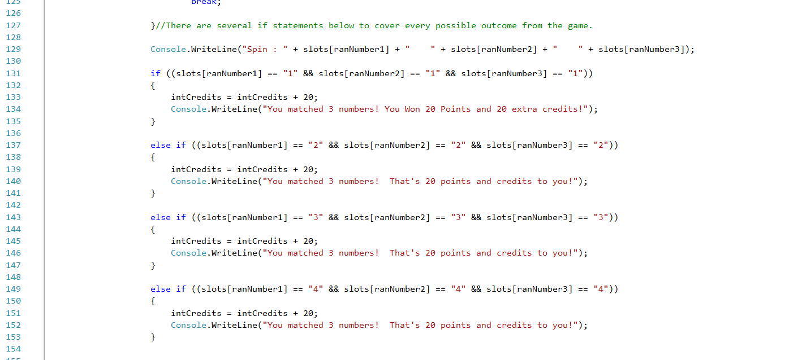

- Explain why the for-loop can also be referred to as a counting-loop and give an example of why you would use it.
When writing a program, if we know how many times a loop is to execute, we use a ‘for’ loop. While a for loop executes as true, it will continue looping/counting, until it becomes false. It can be referred to as a counting loop as it counts from the given input.
The simple flow chart below shows the process involved in a for loop.

INITIALISATION

CONDITION

If condition
is true
CODE BLOCK
If the condition is false

INCREMENT

John Sharp (Sharp, 2013) says if using a ‘for’ loop, it’s pretty difficult to accidentally create a program that has a never-ending loop. Again, this is because we are inputting the number of time’s we want the loop to execute. Author of ‘Begin to Program with C#’ Rob Miles writes if you want to make a program count a particular number of times, a for loop is easier to use. (Miles, 2016)
Below is an example of a for loop.
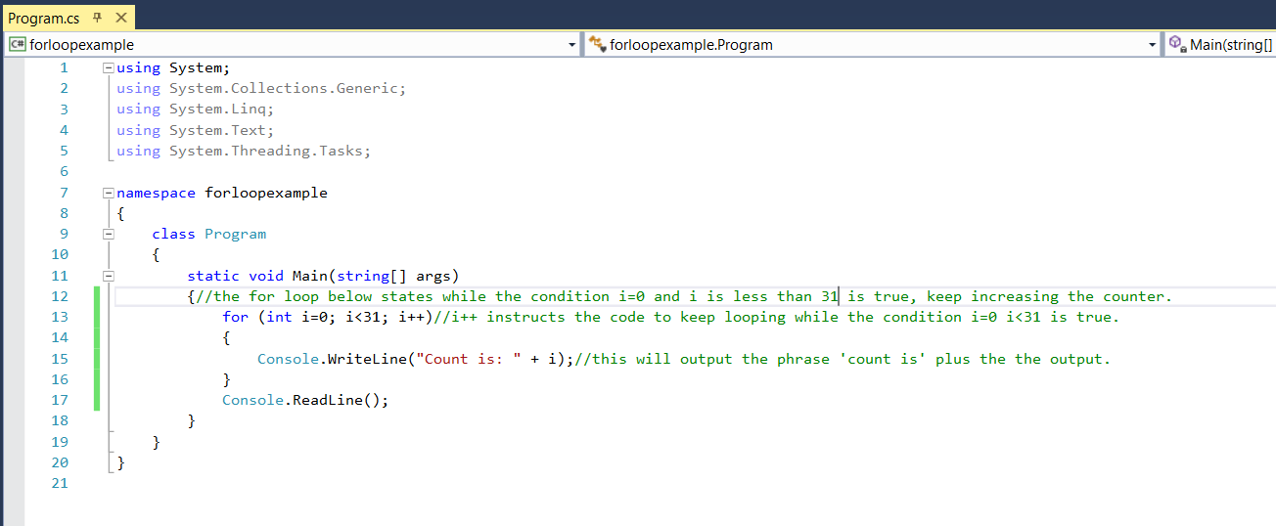
In the above example I produced, when the program is run, it counts while the condition i is less than 31 is true. i++ increases the count during each iteration and outputs the count until i is not less than 31, so it stops at 30.
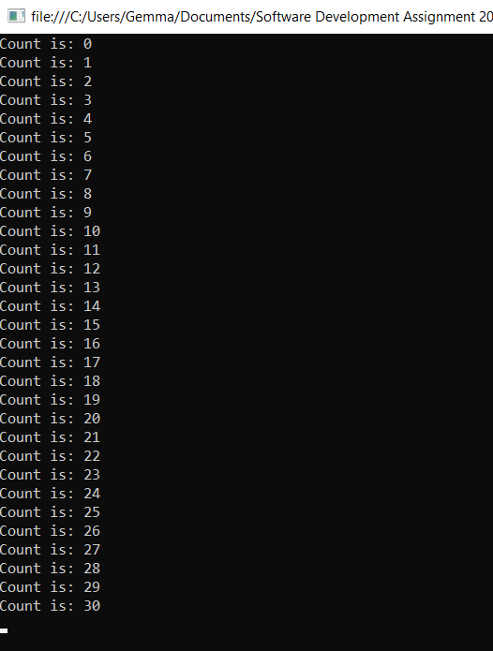

There are a few different loops that can be used in C#. For example, a ‘while’ loop, which will repeat a statement while a condition is true. This type of loop tests the condition before processing the code block. Due to the fact that it tests the condition first, a while loop may not actually run. The condition could be false straight away. In which case, the loop is passed over and the code jumps to the first statement after the loop. Unlike for loops, John Sharp (Sharp, 2013) writes that it is easy for a beginner to make the mistake of forgetting to get the code to evaluate false at some point, which will make the program run continuously.

There is also a ‘do while’ loop, which is similar to a while loop but it tests the condition at the end of the loop body. This means that unlike the while loop mentioned above, which may not execute at all, the code will definitely execute at least once as it has to go through the code block before the condition is tested.

Section 1 Part B
The code found in the appendix of the assignment allows a user to enter 3 numbers, the choose from the options to find the largest number, smallest number or the user can choose to display all the numbers they have inputted.
USER GUIDE:
On the Visual Studio Application, press start.
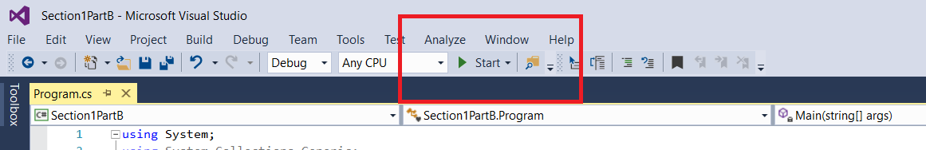
This will display the menu:
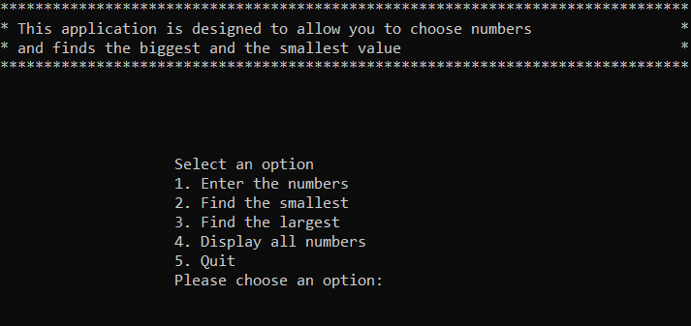
Press 1 and hit enter to input the numbers. You will have to hit enter after inputting each number.
After 3 entries, you will be asked again to choose an option. You can find the largest, smallest or display all numbers.
Choose an option and press enter again. This will output your answer.
Press 5 to quit.
How it Works
There are several different code blocks included in this program which executes the code depending on the input.
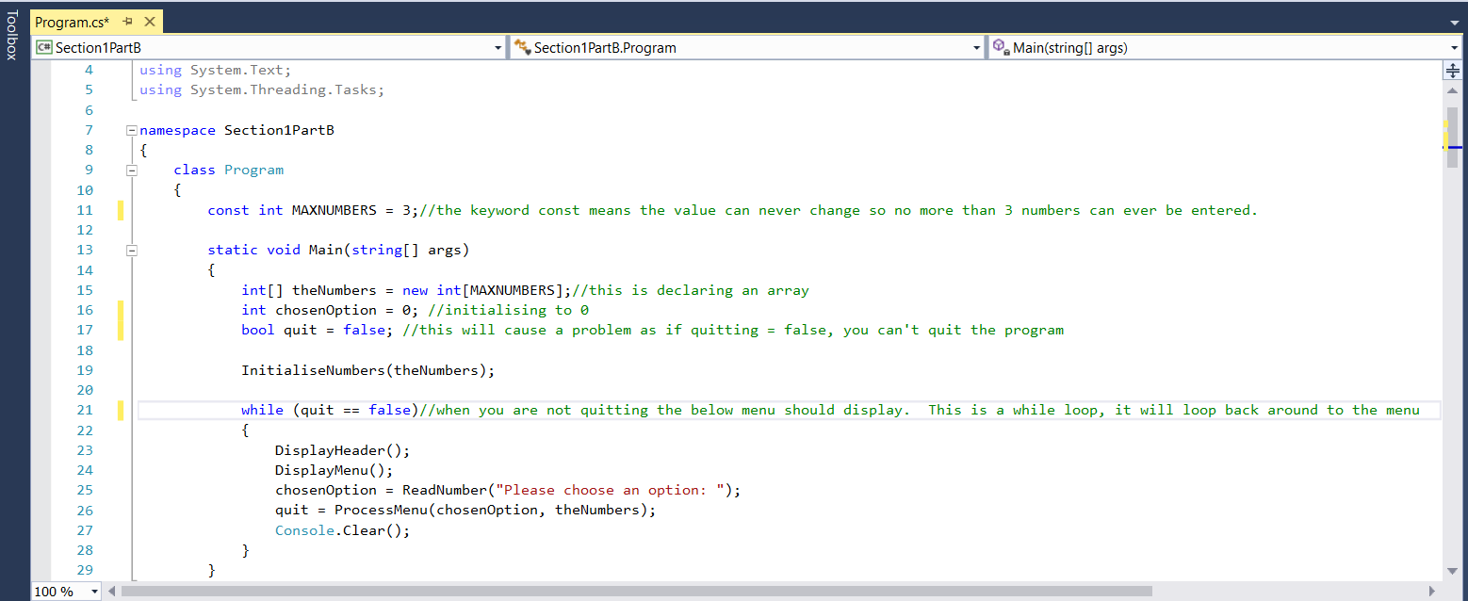
The above screenshot shows the start of the code. The variable MAXNUMBER has been declared as a const (constant). This means the user can only ever enter 3 numbers.
As 3 numbers of the same data type are going to be entered, this will be an array, this is why the square brackets have been used [ ] – these, are for declaring arrays.
There is also a while loop that states ‘while quit is equal to false’, the main menu should display again, so, if the user doesn’t wish to quit, they can choose another option.
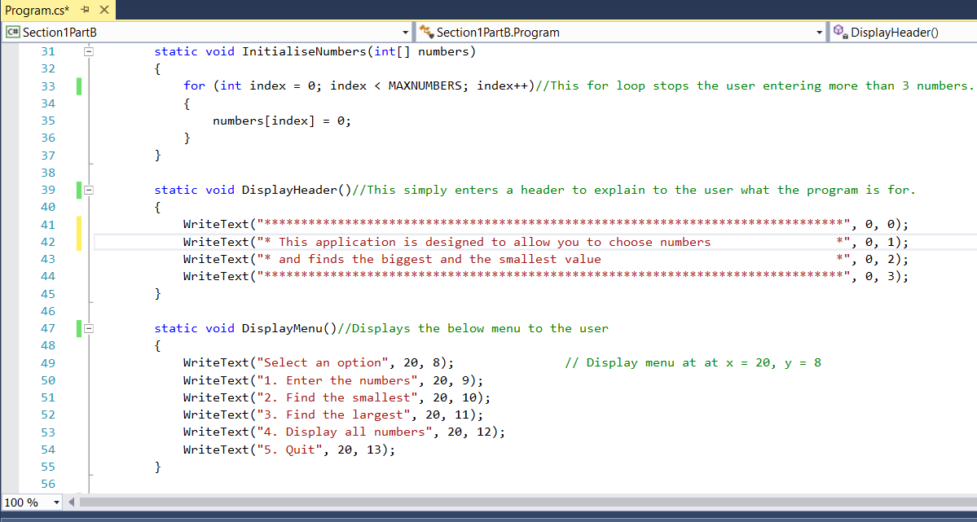
This section of the program concentrates on what is displayed to the user. The header explains what the program is for the and DisplayMenu() outputs the different options to the user. This isn’t coded to perform the function yet. That is later on in a switch statement.

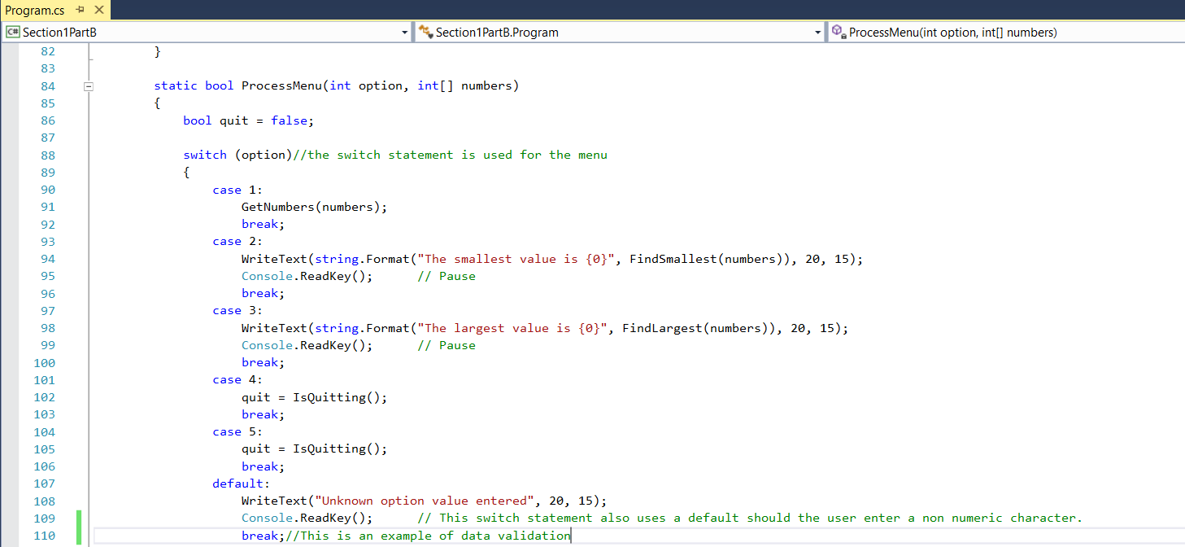
This switch statement programs each aspect of the menu. Within the switch statement there’s also a default. You don’t have to have a default but it’s good practice if you do. This allows the programme to output a statement if an unknown field has been entered. This is an example of data validation. The program only requests integers (whole numbers), so if you were to enter a letter, it will alert you to the fact you’ve entered an unknown input.
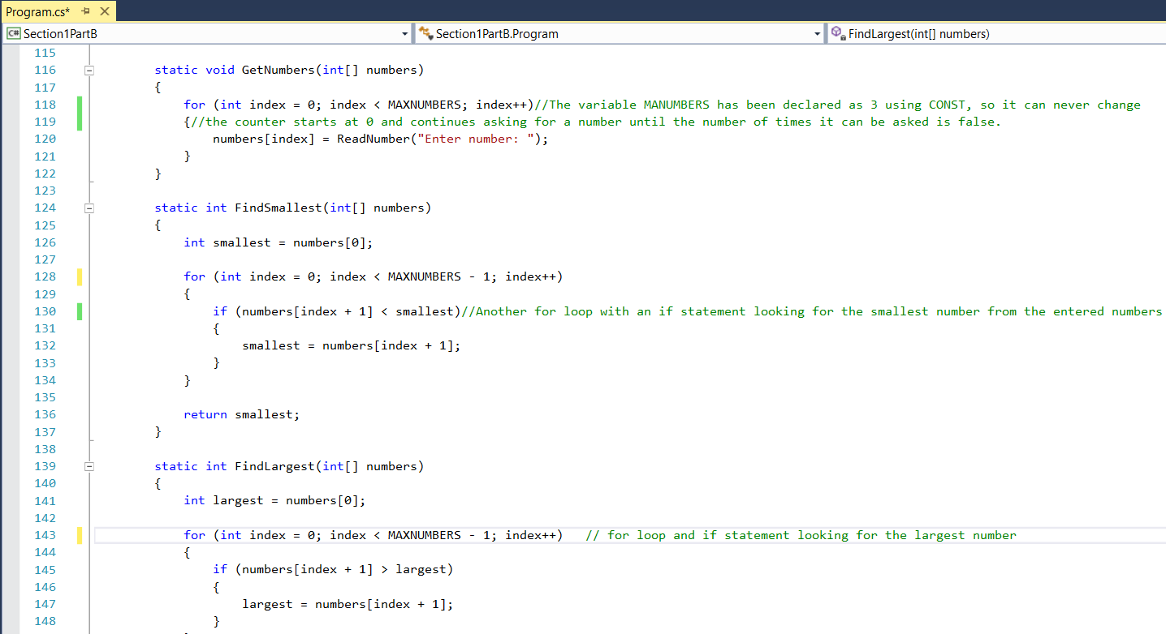
These for loops and if statements are what’s required to find the largest and smallest numbers within the arrays entered.
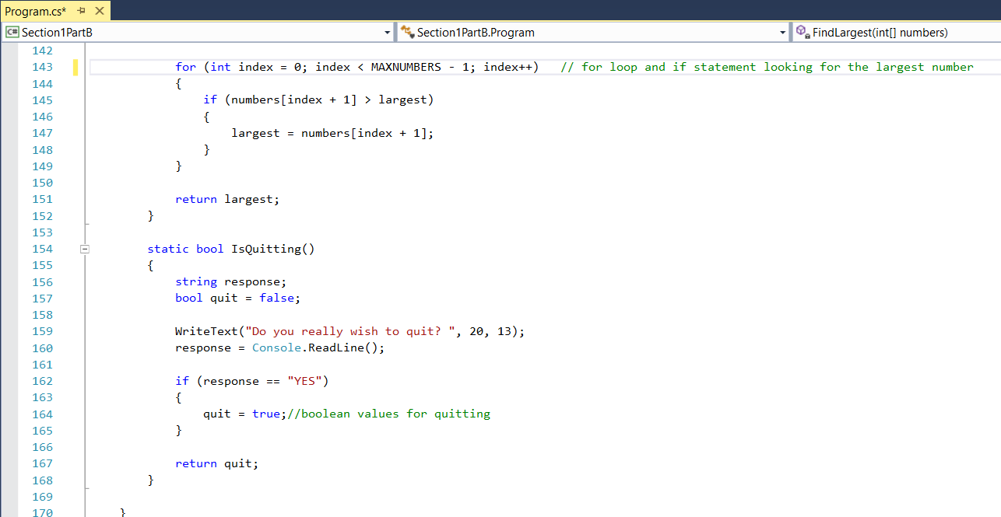
Finally, this is the program required when the user wants to quit. It specifies if the variable quit (which is assigned the data type bool for Boolean, as it can only be true or false) receives the response YES then quit = true so the program will quit.

Section 2 Part A
- When programming we may find that we are storing multiple values that serve the same purpose, but it would be inefficient to create 100s of variables to store these values. Describe a programming construct for storing such data. Assuming we wish to perform a calculation using all these stored values, how might we achieve this without duplicating the code 100s of times?
When programming, if we need to store multiple values being used for the same purpose, rather than duplicating code, we can use an array. An array, in simple terms is a list of items of the same data type.
You can use arrays to perform several actions.
To declare an array, you first specify the data type e.g int (integer) followed by square brackets then the variable name:
Int[ ] ageofplayers;
John Sharp (Sharp, 2013) explains that an array is an ‘unordered sequence of items’, that have the same type and rather that being accessed with a field, they are accessed by using an index.
In the below code example, I have declared an array of names and written the program to output the names in alphabetical order.
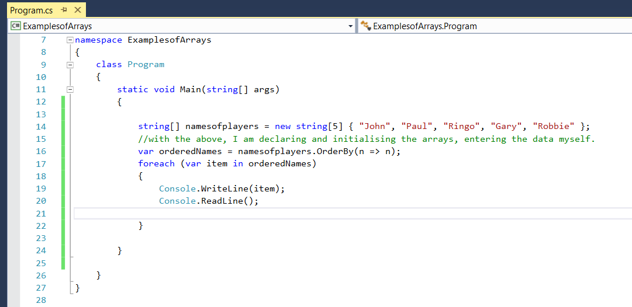
When the program is started it outputs each name in turn alphabetically when enter is pressed:

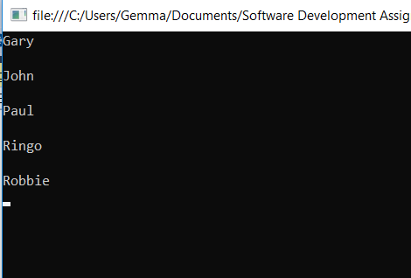
In the array below, I have used a program to add up all the values of the array and find out the average value of the data. In this example it’s test scores. I declared the values as integers, so when I hit start it returns the average of my test scores as 14. However, when I calculated it it’s actually 14.4.

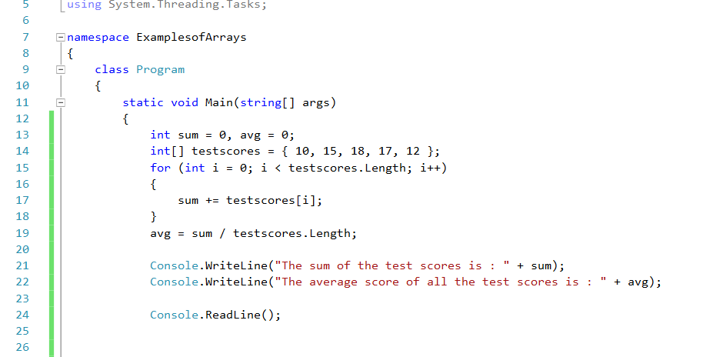
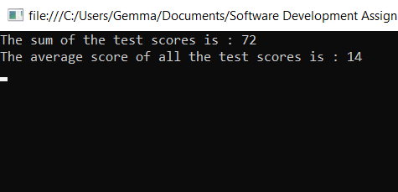

I have gone back and used the data type ‘double’ in my code which allows decimal places to see if it will provide a more accurate answer.
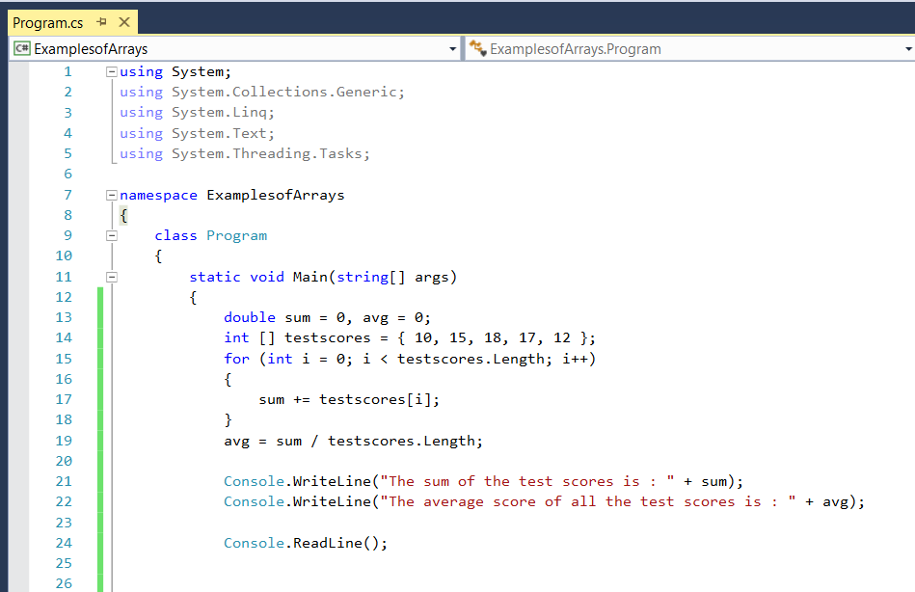

When outputted:
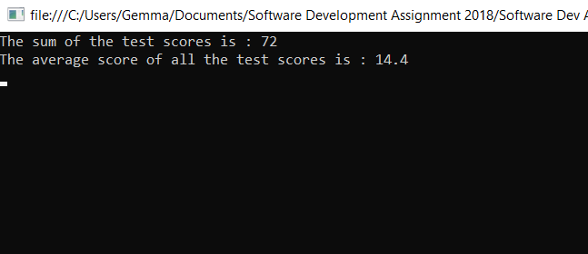

Although these are examples of small arrays. If a programmer didn’t use this method, they would have had to declare each score as a different variable, with unique variable names then performed long calculations. If a school or university wanted to find out average information on the scores of hundreds of pupils, this would be extremely time consuming and open to errors.

2) Explain how large problems should be subdivided and explain how functions enable us to do this.
Depending on the size of a program being written in C# it is sometimes prudent to subdivide it.
Depending on the purpose of the program, there may be certain elements you do not want a user to see, or you may need to re-use a piece of code several times within your program. By subdividing it into its own class, you can write the code once, then call it as many times as required in the main body of the code. This is referred to as encapsulation. This can also be made private so is only seen by the programmer.

Andrew Troelsen (Andrew Troelsen, 2015) writes, encapsulation is about the idea that an objects data should not be accessible from an object instance. The class should be defined as private. This not only hides (encapsulates) certain elements of code from the user, it stops them being able to amend it.
I believe Andrew Troelsen is right. Users should not have access to certain elements of code. An accidental touch of the keyboard could cause an error and throw out the whole code. Jesse Liberty and Brian Macdonald (Jesse Liberty, 2008) have the same opinion in ‘Learning C# 3.0’, stating the idea behind it is to keep your code discrete and self-contained.

In the below example from my slot machine program, you can see 3 tabs in the Visual Studio program. Program, Main Menu and Game. Both cls.MainMenu and cls.Game are classes that have been coded separately from the main program. This is encapsulation.

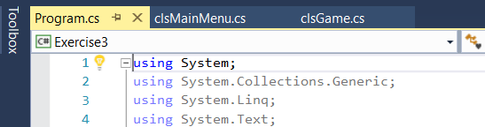

The main chunk of code can be found under the cls.Game tab. If this was not in a separate class, it would be open to interference from the user.
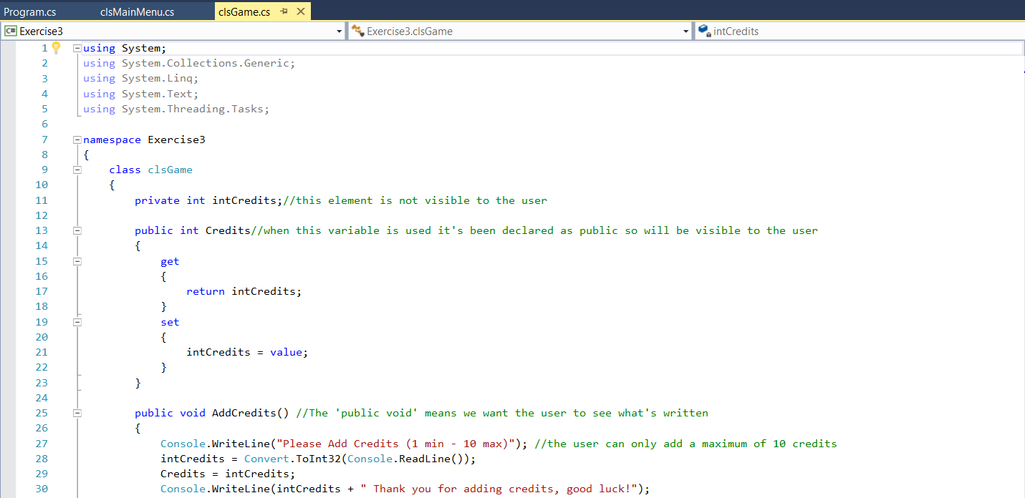
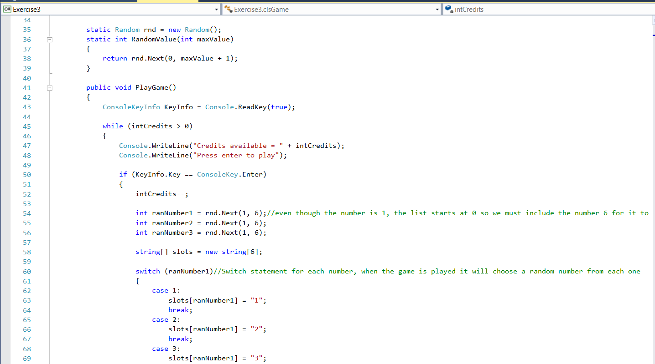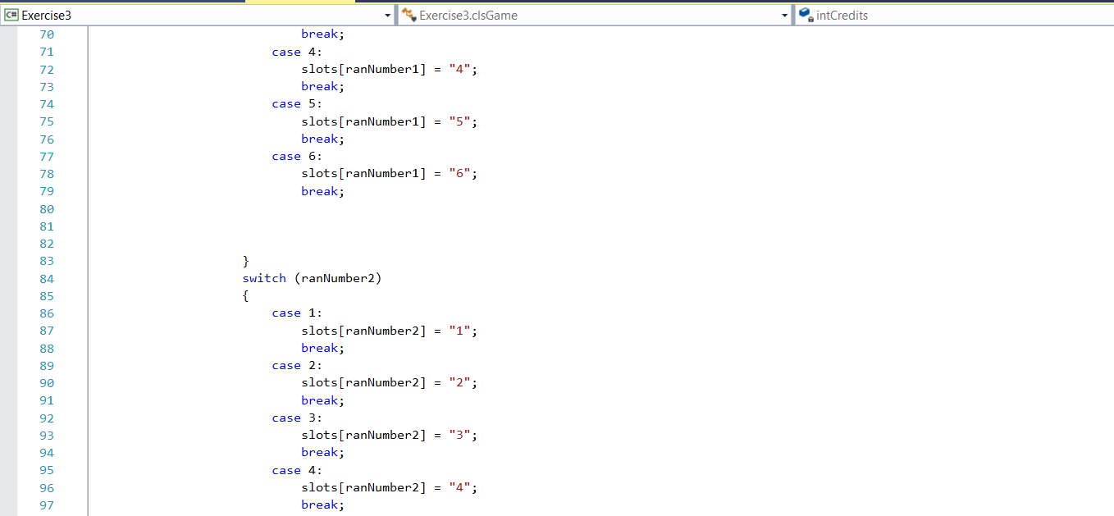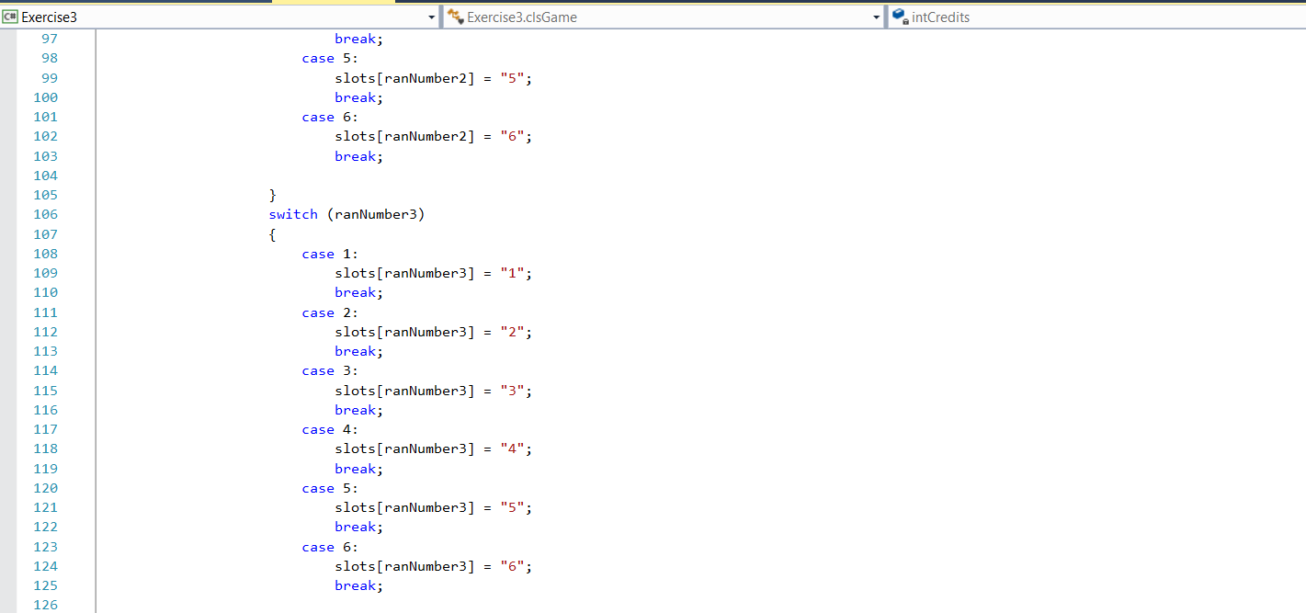

This is just an example. The code continues for over 200 lines. Not something the user needs or wants to see. The actual program can be seen on one page and the functions in the classes are called from this part of the program.
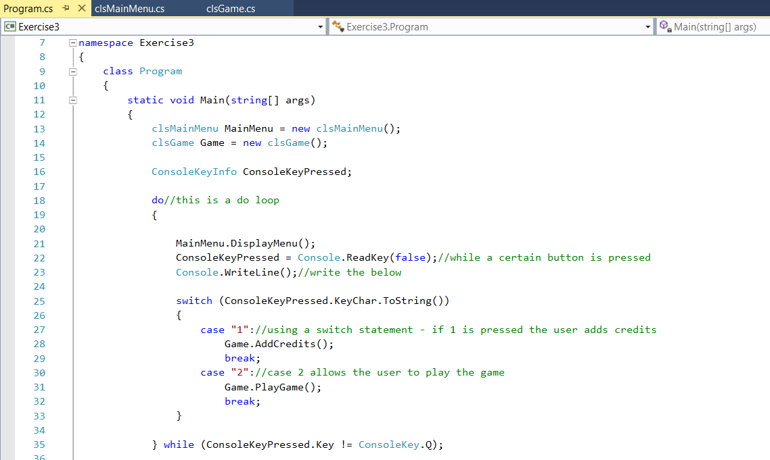

Section 2 Part B
When I ran the program, instead of entering a numeric option, I wrote ‘gemma’. This is what happened:
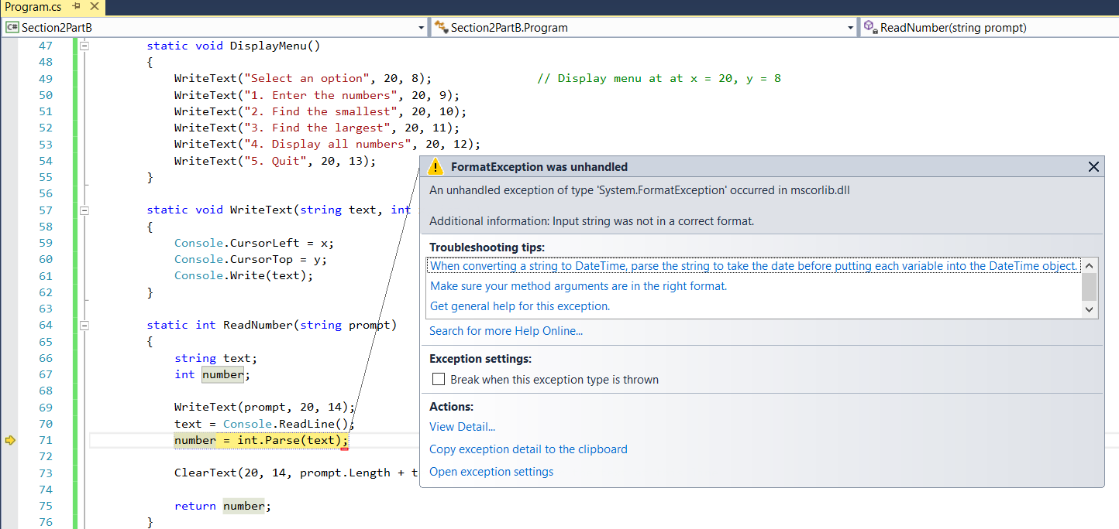
This is because the program is expecting the inputs to be integers, not a string. To improve this, we should use some form of data validation, so that if anything other than an integer is inputted, a message will display to let the user know.

As can be seen from the code below. The only option that allows a user to quit is to type ‘YES’. When I attempted to confirm with another option e.g Y or yes (lower case) it simply looped back to the main menu. A way around this is to either write in the code ‘Type YES to quit’. Or put more options in to the program to allow the user to type in a variation of inputs that has the same result.
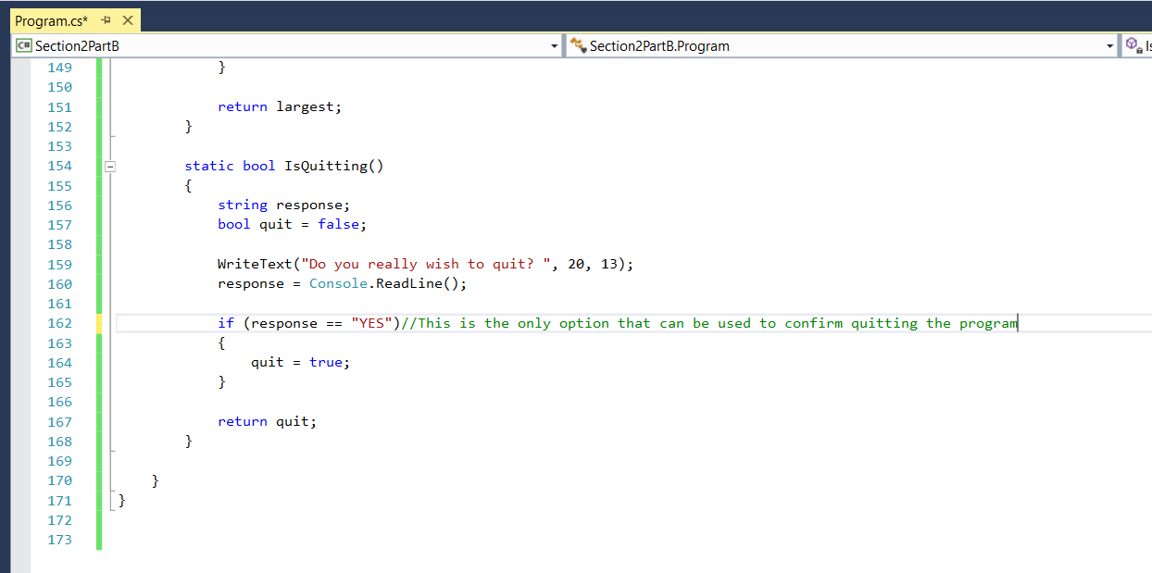

In the below, I amended the program to display the instructions for what to do to quit.
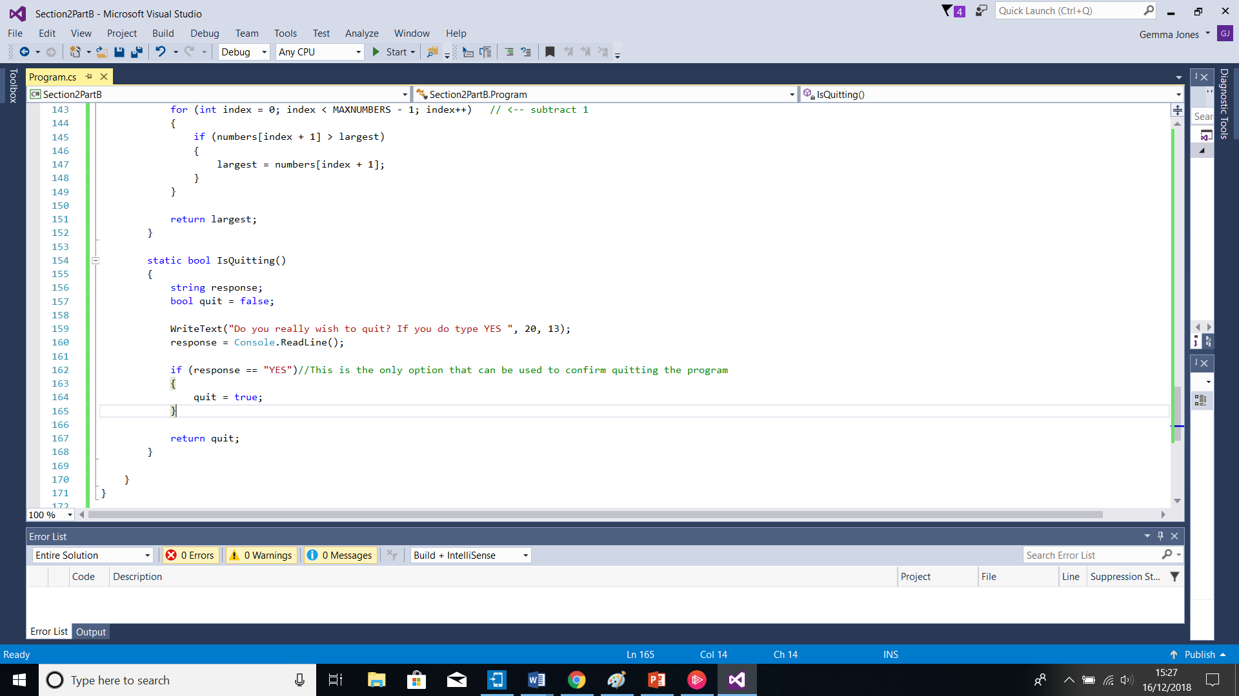
As you can see below, the menu is clearer and the user will know they must type YES.
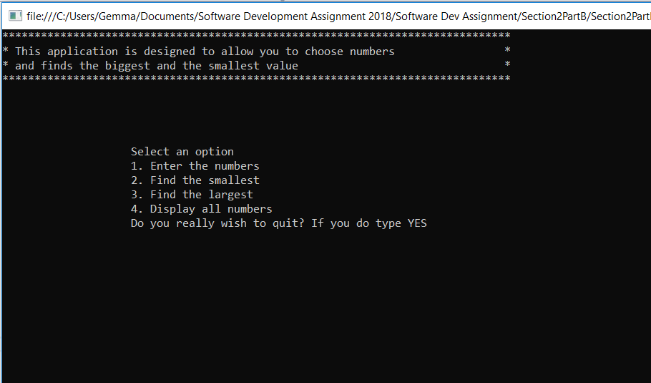

When I have run the program and chosen option 4 to display all numbers entered, it does not display the numbers, it loops back to the main menu. After reading through the code, I have found that in the switch statement, case 4, which relates to option 4, is actually coded to quit.
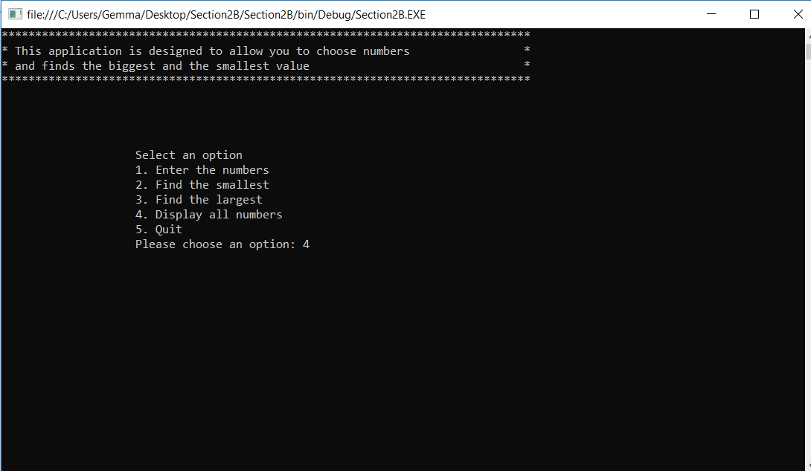
The result is:
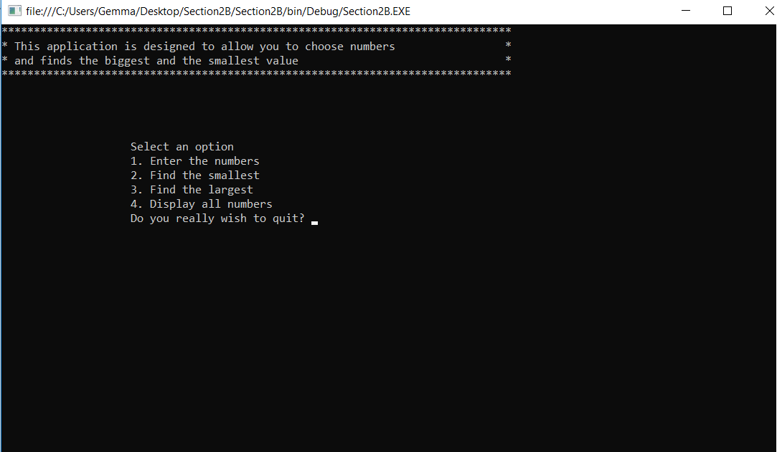

After finding the problem in the code. I have tried to amend it to display all the numbers. However, as you can see from my annotations, I didn’t have much luck. I amended the switch statement case 4 but couldn’t figure out the code behind it.
Below is the amended switch statement.
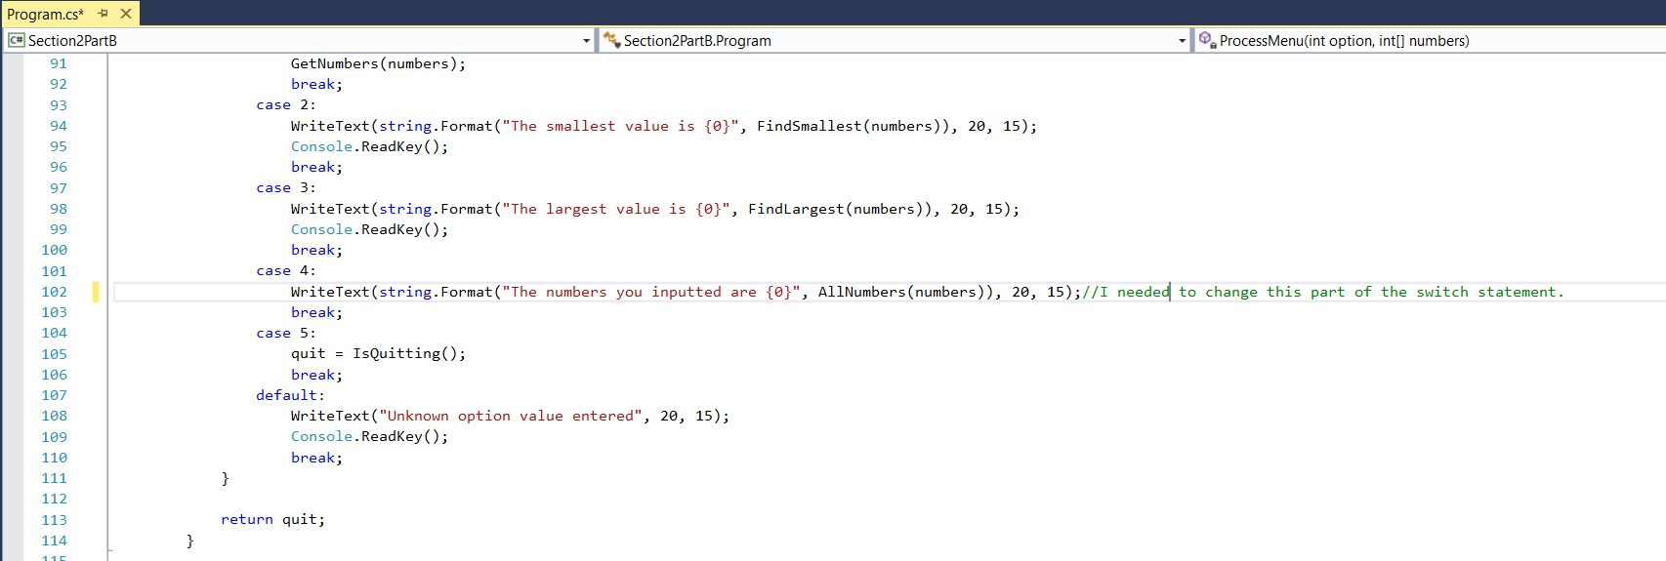

Below, the area within the rectangle is what I added to the program to try and get the code to work.
Although I investigated the error, I couldn’t figure out how to get the program to work correctly.
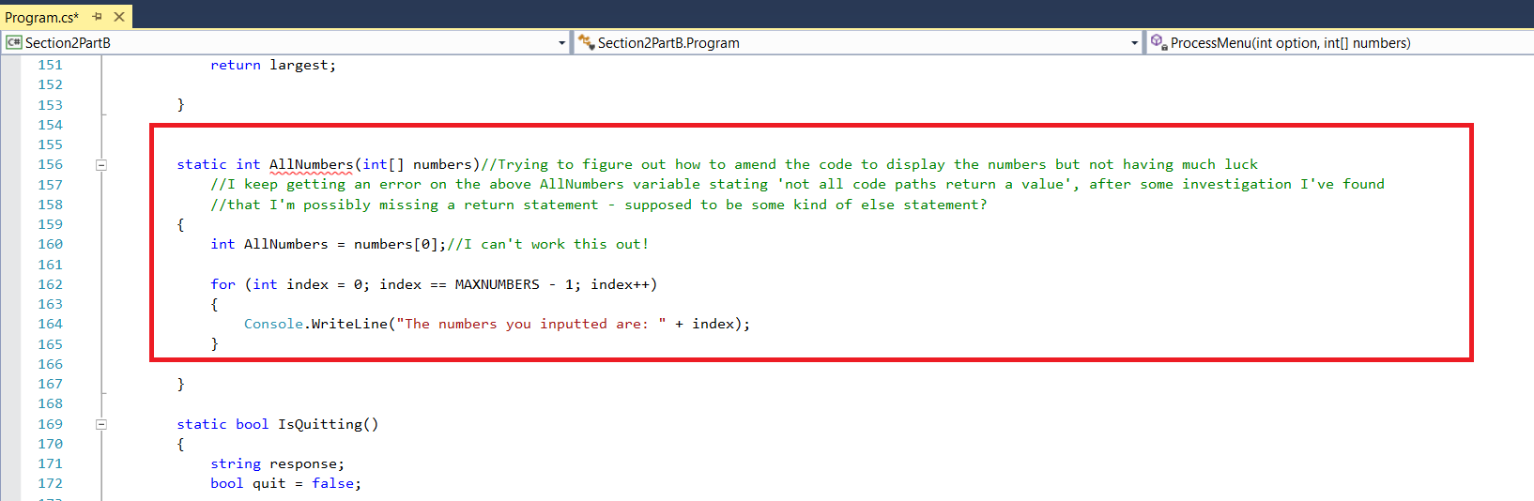

Bibliography
Andrew Troelsen, P. J. (2015). C# 6.0 and the .Net 4.6 Framework. New York: Apress.
Jesse Liberty, B. M. (2008). Learning C# 3.0. Master the Fundementals of C# 3.0. Sebastopol CA: O'Reilly.
Karli Watson, C. N. (2010). Beginning Visual C# 2010. Wrox.
Miles, R. (2016). Begin to Code with C#. Washington: Microsoft Press.
Sharp, J. (2013). step by step Microsoft Visual C# 2013. Microsoft Press.

Appendix
Section 1 Part C Exercises

Exercise 1 - Complete
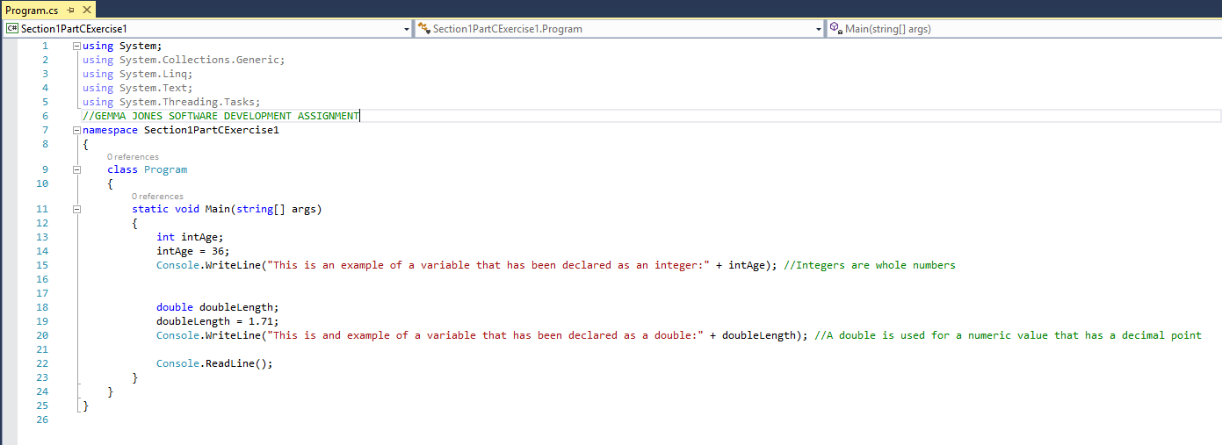
Exercise 2 – Complete
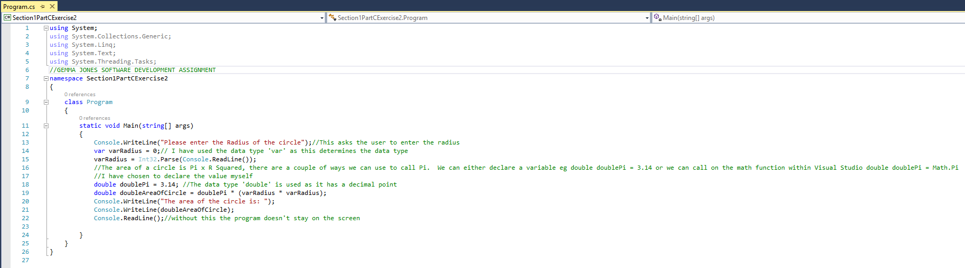

Exercise 3 – Mostly Complete, unable to figure out the additional challenge.
Program of Exercise 3
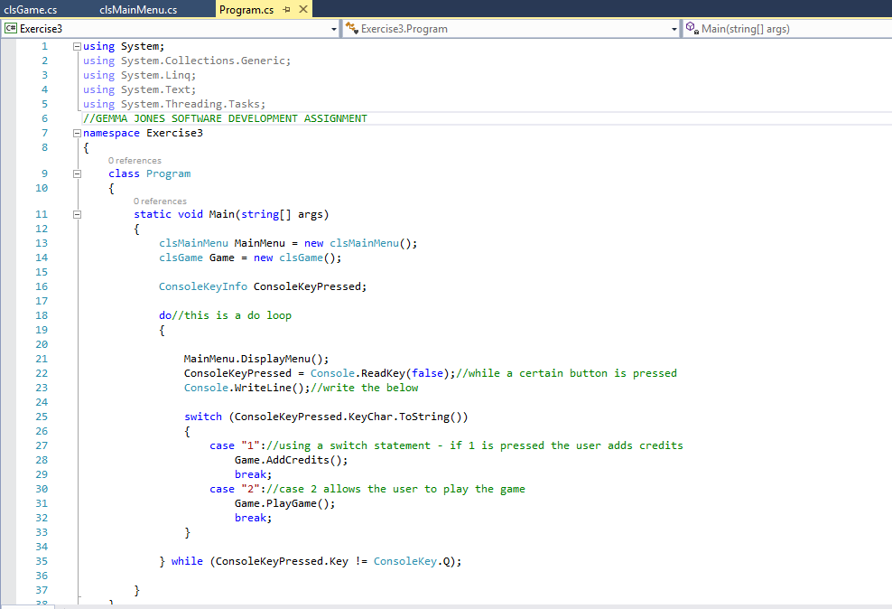
Class for the Main Menu
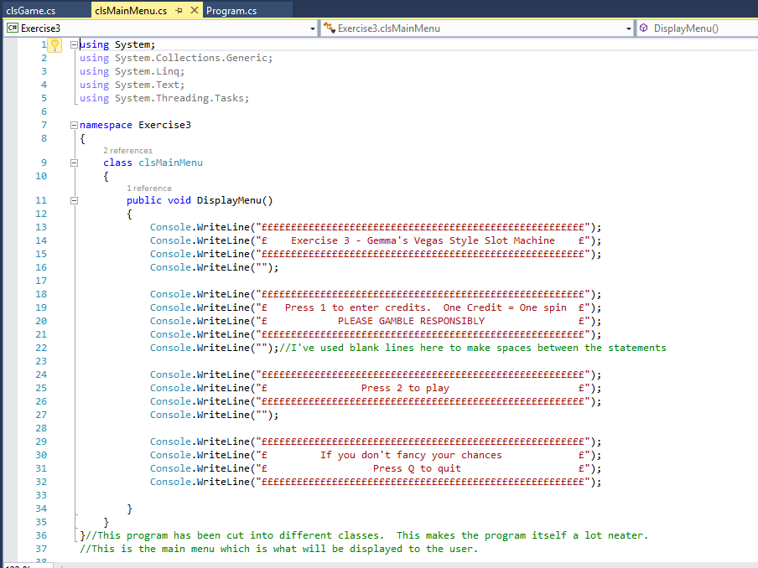
Class for the Game which contains the majority of the code.
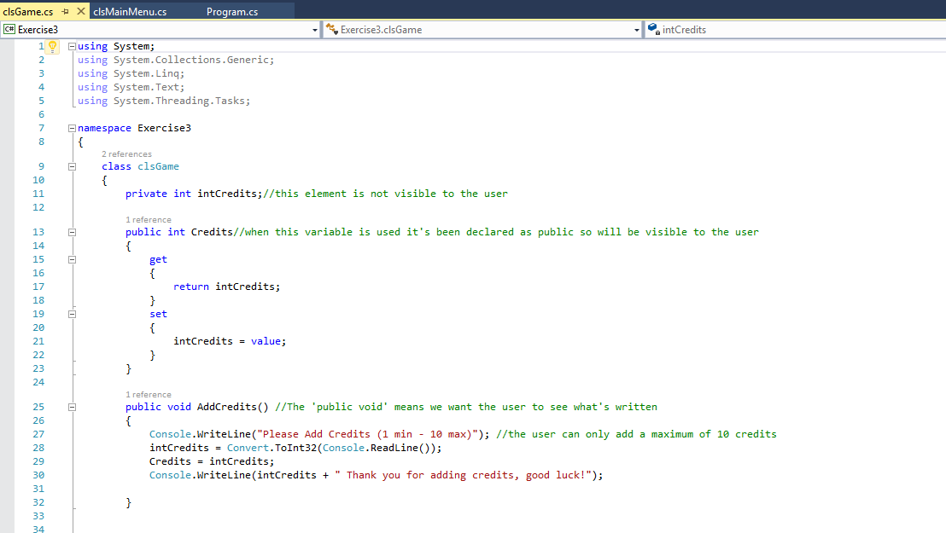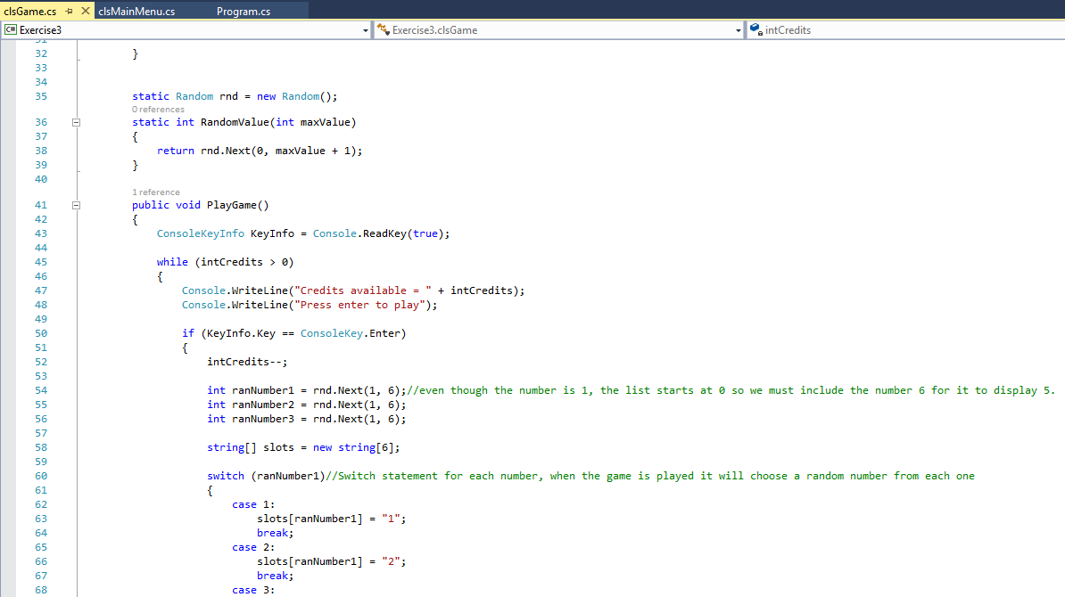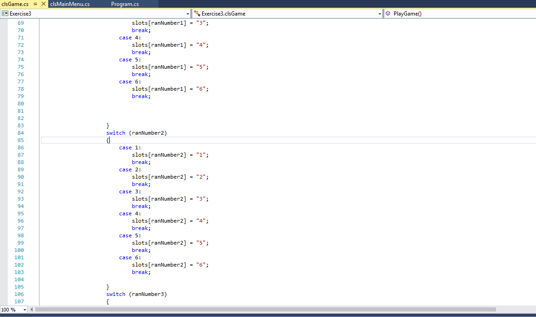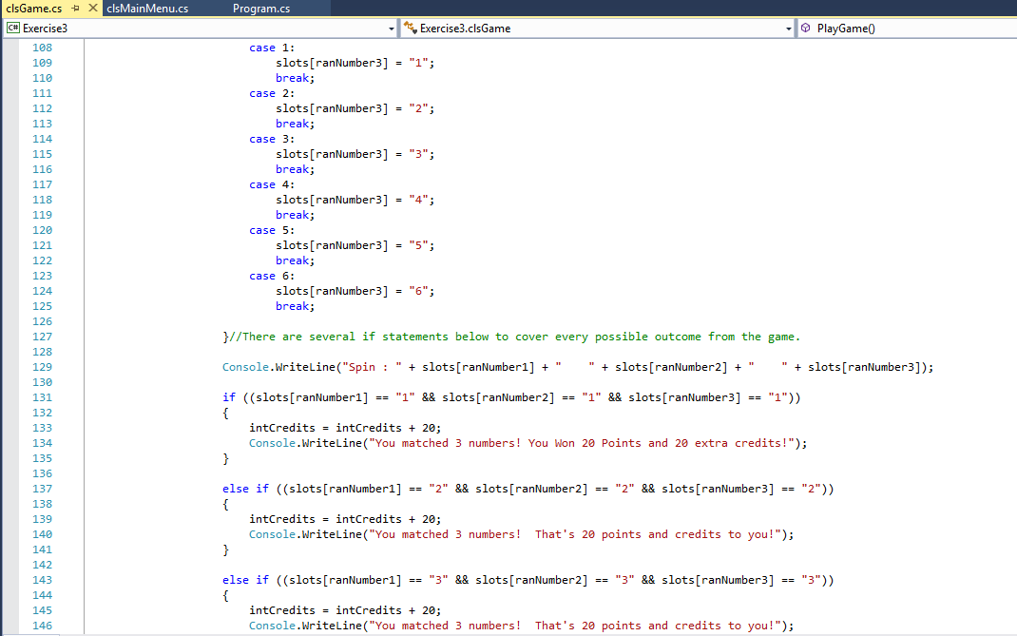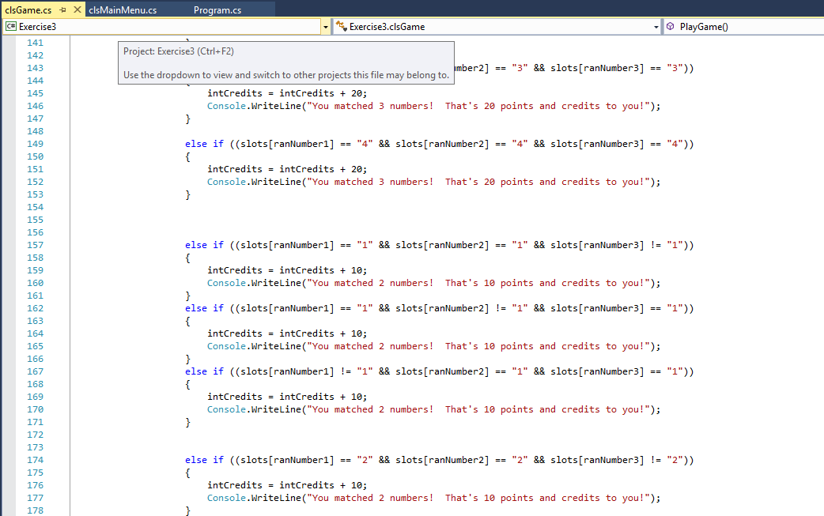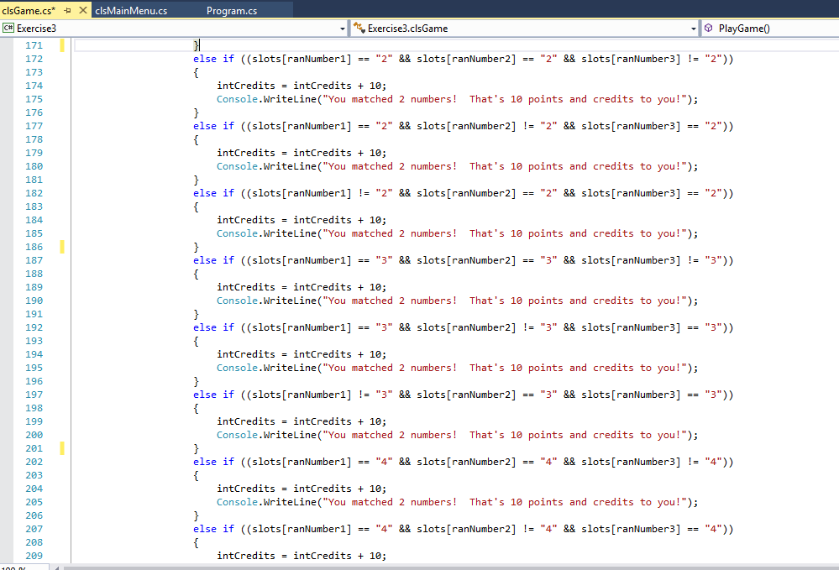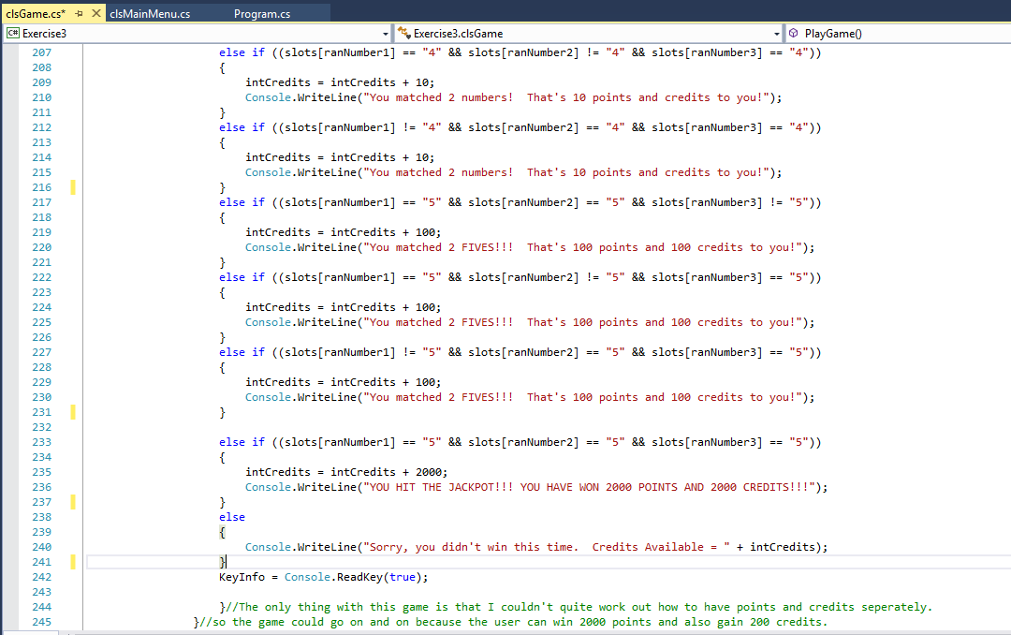

Exercise 4 Unable to complete
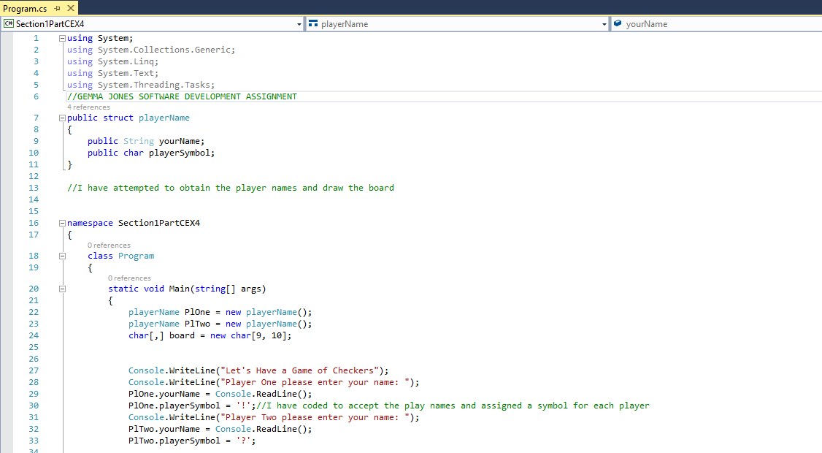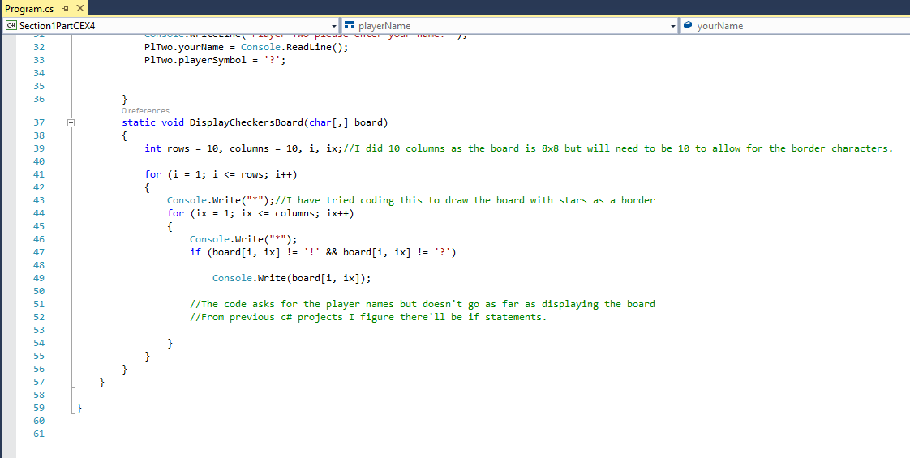

Section 2 Part C Exercises
Exercise 1 - Complete
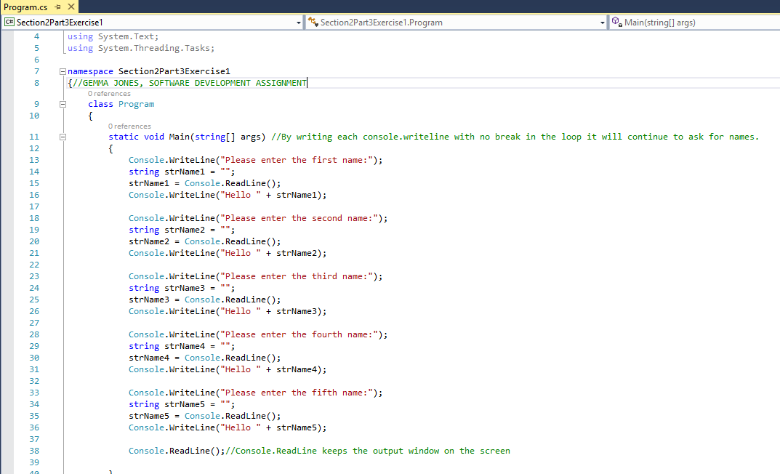

Exercise 2 – Unable to complete
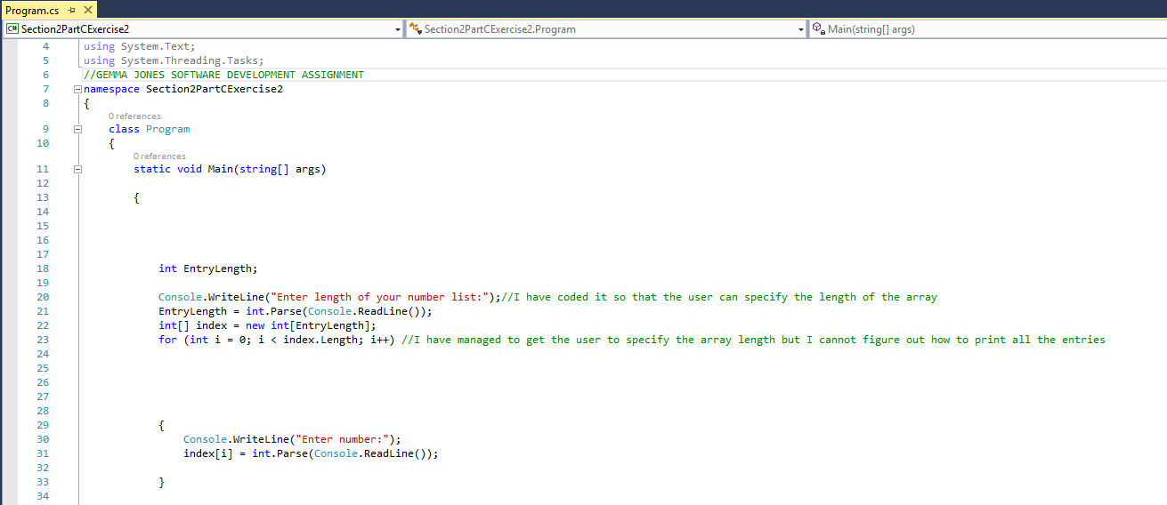
Exercise 3 – Completed to a point
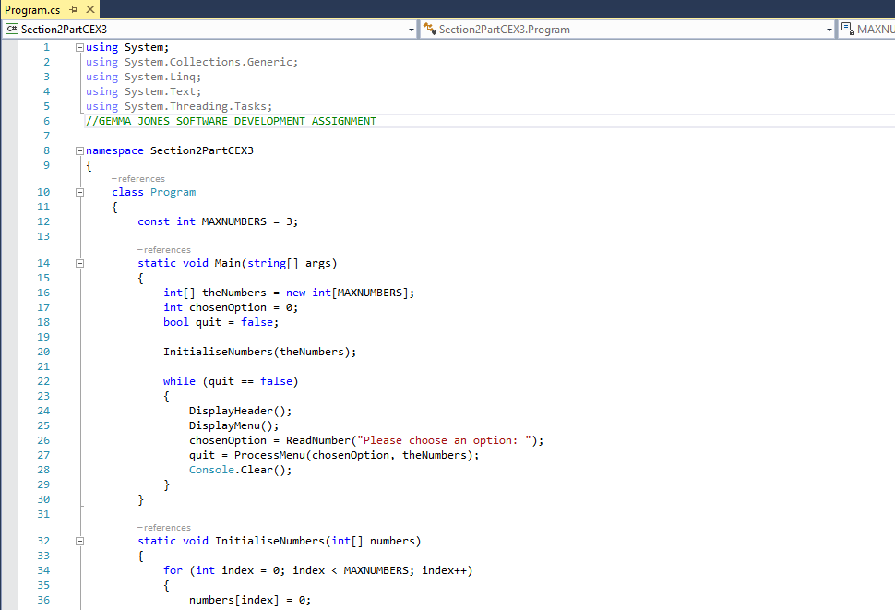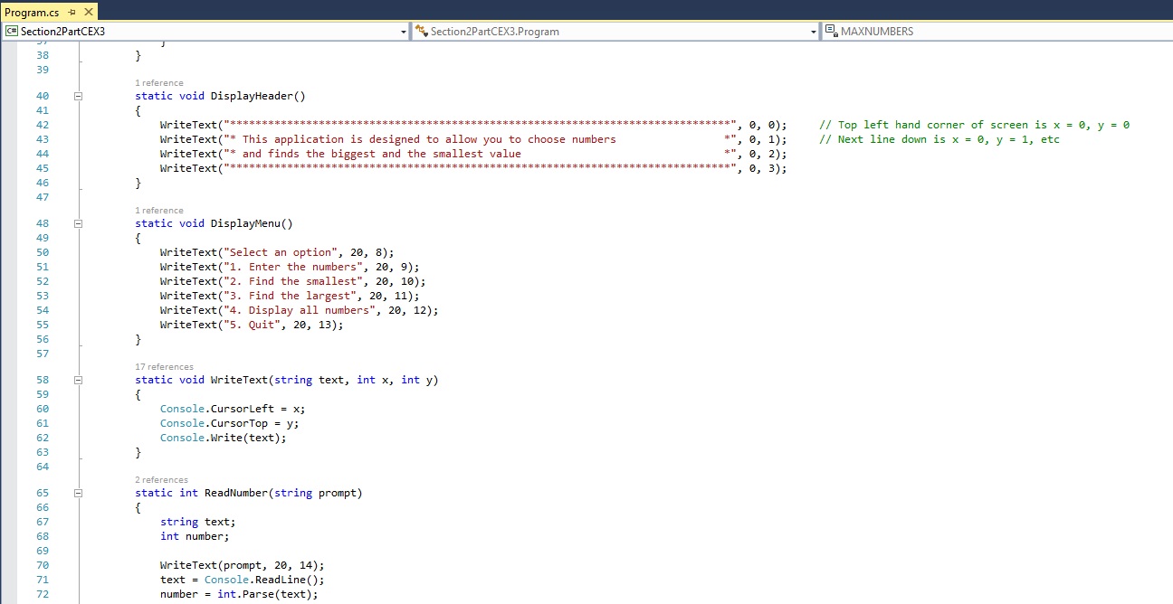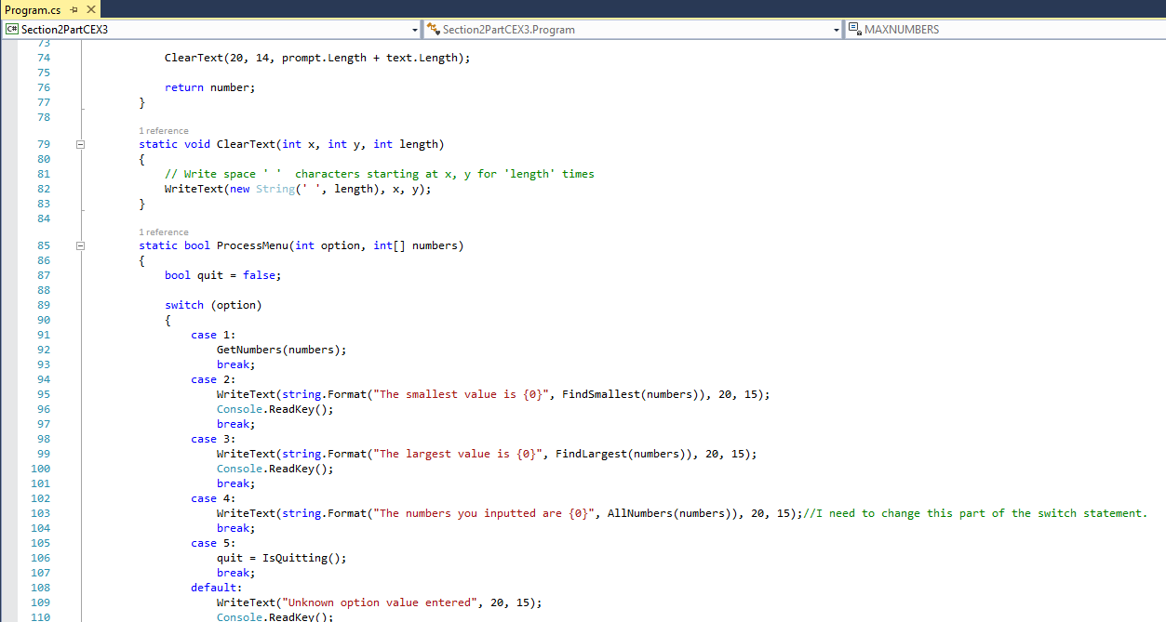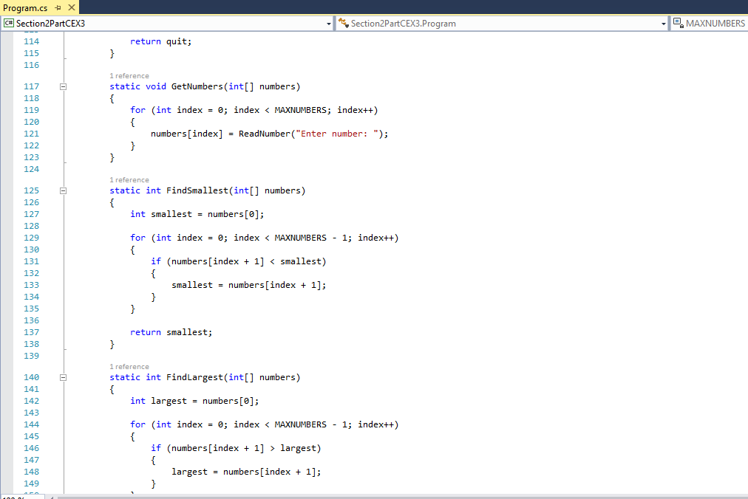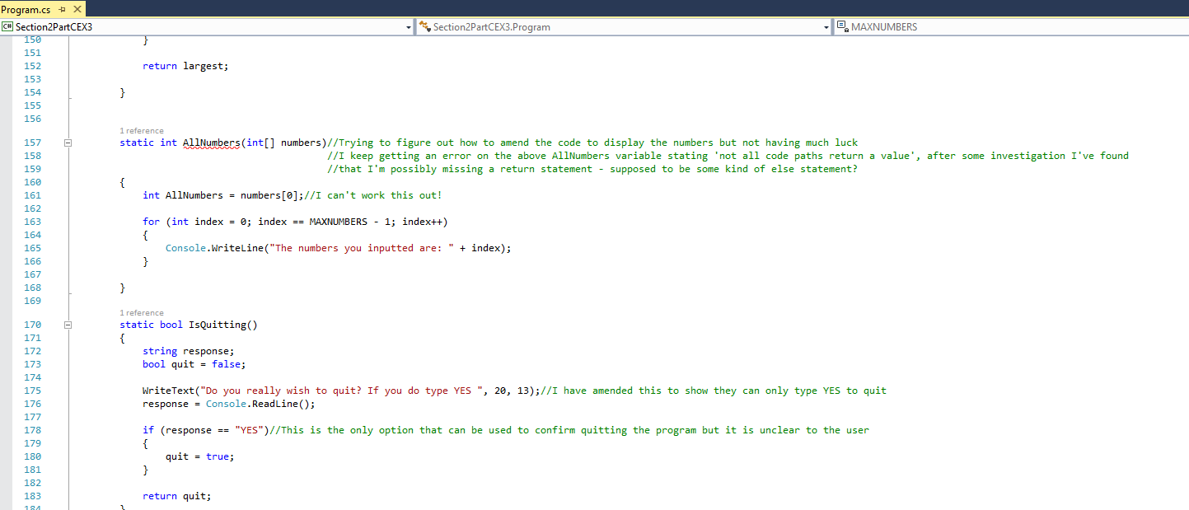

Exercise 4 – Barely Completed
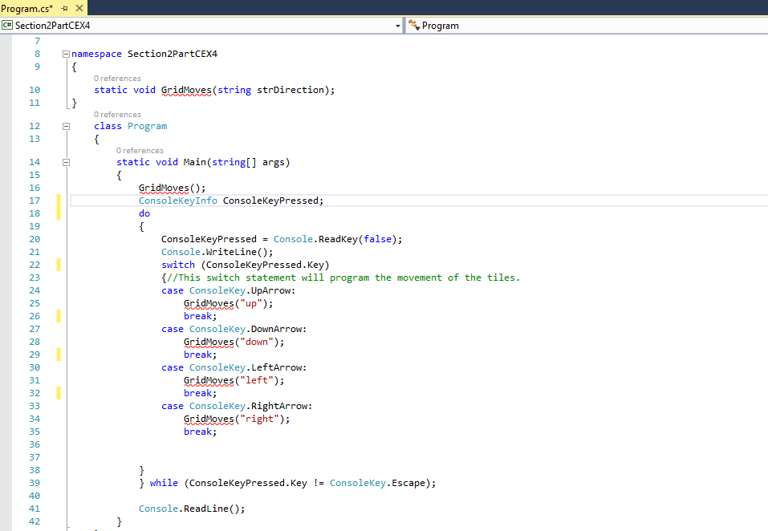

Exercise 5 – Mostly Completed


