Student Name : Adriana Mihaela Petcu
Student ID : 2126831
Programme : Master of Business Administration
Module : International Marketing: Principles and Practices
Module code : LCMB7026
Lecturer name : Taonga Kaonga Sobere-Snithers
Assignment Title : International Marketing Principles and Practices

Executive summary
The report demonstrated the marketing strategy of Coca-Cola in the United Kingdom and Australia. It has given the profile of the brand, discussions of the socio-cultural environments, compared STP strategies, and the 7Ps marketing mix of the company in the two countries. It was established that Coca-Cola, relative to regulatory requirements, adapted best in the UK and attempted to enforce long-term sugar reduction in Australia. One of the performance metrics counted was the market share, revenue, and interaction with the consumers, and the challenges of misleading health statements, selling Target to a child, and the environmental aspect were established. The company was advised to emphasise the innovation in products, transparency, sustainability, sensitivity in prices and localisation of cultures.
Table of Contents
1. Introduction 4
2. Brand overview 5
3. Comparison of the Socio-Cultural context of the UK and Australia 6
4. Comparison of Brand's STP strategies in the UK and Australia 10
5. Comparison of Marketing Mix Strategies in the UK and Australia 13
6. Evaluation of the performance of marketing strategies 16
7. Evaluation of marketing ethics practice 19
8. Recommendation and Conclusion 21
9. Reference 23

1. Introduction
The process of marketing where the products and services of the organisation go outside the national borders is defined as international marketing (Kotabe & Helsen, 2022). The main idea of this report is to understand the concept of international marketing and how it impacts the organisations. To understand this concept in a more practical way, a case study of Coca-Cola will be analysed. A PESTLE Analysis will be done for understanding the macro environment of Coca-Cola in the UK and Australia. A marketing mix will also be done for Coca-Cola in both the countries. The Segmentation, Targeting, and Positioning will also be mentioned in this report. The steps taken by Coca-Cola for determining its STP practices will be discussed.

2. Brand overview
Coca-Cola is a multinational soda and beverage number of employees working at the Coca-Cola company. In the year 1886, Dr John Pemberton first introduced Coca-Cola by bringing the syrup of Coca-Cola to Jacob’s pharmacy, and the very first glass of Coca-Cola was served there (Coca-Cola, 2025). The headquarters of Coca-Cola is located in Atlanta, United States. The brand owns more than 200 sub brands, and there are a total of 700,000 people working for Coca-Cola from different parts of the world (The Coca-Cola Company, 2025). In the year 2024, the net revenue for the company grew by 6% in the third quarter, and overall, it grew by 3% (The Coca-Cola Company, 2025).

3. Comparison of the Socio-Cultural context of the UK and Australia
The strategic framework which is used by organisations for evaluating and analysing their external and macro environment is defined as PESTLE Analysis. The six different factors which are considered in the PESTLE Analysis are Political, Economic, Social, Technological, Legal and Environmental (refer to appendix).
PESTLE Analysis for the UK
Political: As of the year 2023, the political stability index of the UK was reported to be 0.51 points, and the average political stability index of the UK from the year 1996 to 2023 has been 0.58 (The Global Economy.com, 2025). This highlights that the political stability is increasing in the UK, and due to this, Coca-Cola will also not need to change their policies and operations frequently according to the policies introduced by the new government. In the year 2021, the corruption index of the UK was 78 points, and it fell to 73 points in the year 2022 (Trading Economics, 2025). In the next two consecutive years, 2023 and 2024, the corruption index of the UK was 71 points (Trading Economics, 2025). This highlights that Coca-Cola will face challenges in operating its business smoothly and will also have to pay illegally to third parties and government bodies.
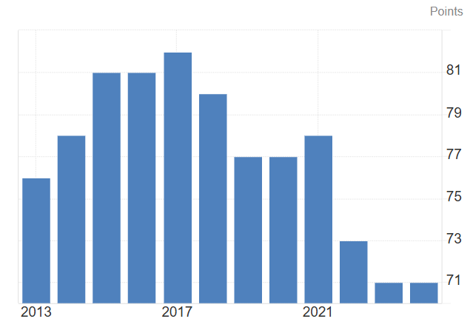
Figure 1: Corruption Index of the UK
(Source: Trading Economics, 2025)
Economic: In the UK, the economy is not increasing, as in the first quarter of 2025, the economic growth rate was 0.7% and in the second quarter of 2025, it went down to 0.3% (Trading Economics, 2025). It can be predicted from this data that the economy of the UK is not stable, and people residing in the UK are also facing financial challenges. Due to this, Coca-Cola will face challenges in managing its sales and improving its revenue and profits. The inflation rate of the UK is increasing as it went up to 3.8% July 2025 from 3.6% in June 2025 (Trading Economics, 2025). This will also be a problem for Coca-Cola in running their business in the UK, as they will not be able to control the finances of their operations.
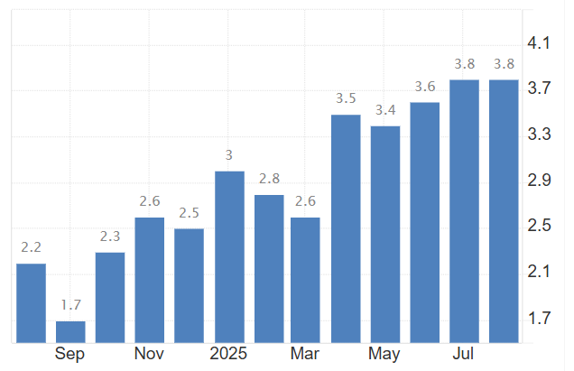
Figure 2: Inflation Rate of the UK
(Source: Trading Economics, 2025)
Social: The population rate of the UK is increasing, as in the year 2023, the total population was 68,682,962, and it went up to 69,138,192 in the year 2024 (World O Meter, 2025). This highlights that Coca-Cola will be able to increase its sales and number of target customers due to the increasing population in the UK.
Technological: The UK is known to have the third largest Artificial Intelligence (AI) market in the world after the United States and China. In the year 2024, the AI market of the UK was worth 92 billion US Dollars (Business.gov.uk, 2025). In all entire Europe, the UK is the first country for producing 168 different tech unicorns. The UK also have more than 3,700 AI organisations, and there are 60,000 employees working in the AI market (Business.gov.uk, 2025). This highlights that Coca-Cola will be able to use effective AI systems and tools for improving its operations.
Legal: The Employment Rights Act 1996 was introduced by the Parliament of the UK to define and consolidate the different rules and rights of employees of the UK. The key factors which are covered in this rule are the deduction and pay policies, providing a flexible working environment and providing sufficient and required leave to the people working (Legislation.gov.uk, 2025). It can be said after analysing this law that Coca-Cola will need to follow this law effectively to stay out of legal troubles in the UK.
Environmental: The Environment Act 2021 was introduced by the UK government to set targets for improving the quality of air and water by the end of 2030. This law also aims to reduce the declining nature of wildlife and nature (Legislation.gov.uk, 2025). Practising this law, Coca-Cola will be able to foster sustainability and also improve its brand value and image by highlighting its positive contributions.
PESTLE Analysis for Australia
Political: The political stability index of Australia as of the year 2023 is recorded to be 0.92, and in the year 2022 it was 0.98 (The Global Economy.com, 2025). Analysing and evaluating this data, this can be said that the political stability of Australia is decreasing, and this will impact the business of Coca-Cola negatively. The corruption index of Australia is increasing, as in the year 2023 it was 75 points and in the year 2024 it went up to 77 points (Trading Economics, 2025). It can be said from this data that Coca-Cola will not be required to pay the government and third parties illegally for operating their business smoothly in Australia.
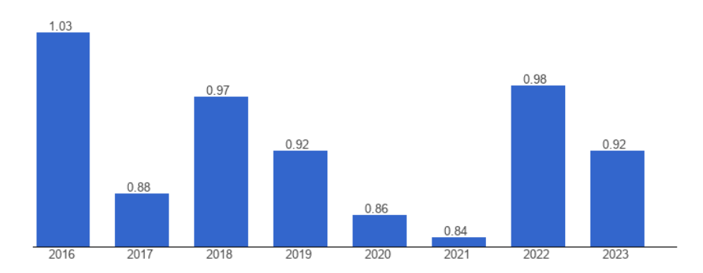
Figure 3: Political Stability Index of Australia
(Source: The Global Economy.com, 2025)
Economic: In the first quarter of 2025, the inflation rate of Australia was recorded to be 2.4% and in the third quarter, it decreased to 2.1% (Trading Economics, 2025). This highlights that in Australia, the economy is getting stabilised, and the purchasing power of the people living in Australia will not be negatively impacted. This will be a good sign for the business of Coca-Cola in Australia, as they will be able to sell more products. The economic growth rate of Australia is increasing as it went up to 1.8% in the second quarter of 2025 from 1.4% in the first quarter of 2025 (Trading Economics, 2025). This will also help Coca-Cola in improving its sales and capabilities of maximising its profits.
Social: The total population of Australia as of 31 March 2025 was 27,536,874, and the quarterly growth seen in the Australian population is 0.5% and the annual growth was marked to be 1.6% which stands to be 423,400 people (Australian Bureau of Statistics, 2025). It can be said from analysing this data that the sales of Coca-Cola will significantly increase in Australia due to the growing population and demand of the people residing in Australia.
Technological: In the year 2-024, the AI market in Australia generated a total revenue of 1,438.6 million US Dollars, and it is expected that by the end of the year 2030, the Artificial Intelligence market of Australia will reach 1,78.4 million US Dollars (Grand View Research, 2025). The growth rate which is expected to be seen in the Australian AI market between 2025 to 2030 is 49.7% (Grand View Research, 2025). Coca-Cola will also be able to leverage and enhance its operations and business practices using AI and other digital tools in Australia.
Legal: The Fair Work Act 2009, introduced by the Australian government in the year 2009, includes the guidelines fostered by National Employment Standards. This law makes sure that all the employees and people working are paid fairly for their services and no discrimination is practised by the organisations while paying the employees (Federal Register of Legislation, 2025). Coca-Cola will have to make sure to follow this rule and pay its employees fairly and not practice any discrimination.
Environmental: The Environmental Protection Act 1994 is the main legislation practised and followed for the environment of Australia. This law provides an overview and framework for managing and protecting the internationally and nationally important animals, plants and places (Queensland Government, 2025). Following this rule, Coca-Cola will be able to contribute to the environment of Australia positively.

4. Comparison of Brand's STP strategies in the UK and Australia
Segmentation, Targeting, and Positioning (STP) Strategy of Coca-Cola in the UK
Coca-Cola’s STP strategy in the UK is ingrained in responding to customer trends, particularly around health, sugar decrease, and sustainability, addressing diverse demographics and performance, and positioning the product as a contribution to both satisfied and responsible choice.
Segmentation
Coca-Cola segments the UK market along several axes:
- By health and nutritional needs: Low and no-sugar drinks customers seeking healthier replacements. In the UK, Coca-Cola has redeveloped 43 new products and launched around 100 new low and no-sugar sodas and drinks (Coca-Cola, 2025).
- By drinking occasion and usage: Everyday drinking in comparison to special moments; various package sizes for suiting individuals and family use; there are different brands for hydration and sparkling drinks.
- By demographic and behavioural factors: Individuals wanting variety are concerned with sugar and calories; those who are concerned about the environmental impact; and also segmented by age and existence, though less evidently publicly comprehensive in official documents.
Targeting
Coca-Cola uses a differentiated targeting strategy:
- It prioritises on low and no sugar drinks and sodas such as Coca-Cola Zero Sugar, and Fanta Zero, aiming customers who are health concisions (Coca-Cola, 2025).
- It preserves major classic products for the customers and buyers who prefer the traditional taste of Coca-Cola.
- It goals those people who are concerned about sustainability factors such as offering more choice, controlling portions, accountable marketing, and packaging inventiveness.
Positioning
Coca-Cola places its business along the key factors which are as follows:
- Taste and Choice: Great-savouring drinks for all cases, but with zero and less sugar is essential. They aim to reserve taste while contribution to healthier replacements.
- Health and Comfort: Focus on reducing the sugar level, transparency in classification, portion switch, and reformulation of the products.
- Accountability and Sustainability: Accountable and ethical marketing such as not targeting individuals under 16 in certain marketing programmes, ecofriendly initiatives like packaging, refill prosecutions, and corporate promises for reducing sugar and enhancing the healthier product collection.
STP Strategy of Coca-Cola in Australia
Coca-Cola’s strategy in Australia imitates consumer demand for healthier options, ecological responsibility, and varied cases of consumption. Their division, directing and positioning are tuned consequently.
Segmentation
Coca-Cola Australia segments the industry on different bases:
- Health and well-being orientation: Individuals looking to decrease their sugar intake are those who prefers the low- and no-calorie carbonated drinks. Coca-Cola Australia has also set an aim of reducing sugar across its non-alcoholic drinks section by 20% by the end of the year 2025 comparing from 2015 as the base year (AACS, 2021).
- Usage occasion and product type: Everyday drink such as sports and hydration like Powerade which are ready-to-drink coffee and tea and also the flavoured soft drinks for social and fun events (Coca-Cola, 2025).
- Environmental and Ethical customers: The people who prioritises the sustainable sourcing such as sugar which is sustainably certified, packing, carbon footprint and reutilising (Coca-Cola, 2025).
Targeting
The-Cola company in Australia uses distinguished targeting. The major target groups include:
- Health-conscious customers are the main target, and they are promoted with low and no-sugar alternatives, which include Coca-Cola Zero Sugar and also reduced sugar pledges (Coca-Cola, 2025).
- The traditional customers are promoted to those who still prefer the traditional Coca-Cola taste and also the full-sugar varieties. The full-range, which includes the classic Coke, flavoured soda and drinks mixers such as Sprite, Fanta, etc., water and energy drinks, makes sure that this broad base is served (Coca-Cola, 2025).
- Environmentally aware and morally engaged customers are targeted with the help of fostering sustainability initiatives such as packaging, obtaining sugar sustainably, using renewable energy and also taking transparency measures for their wide range of products (Food and Drink Business, 2025).
Positioning
Coca-Cola places itself in Australia, along with the factors which are as follows:
Great taste, less compromise, which keeps the taste and fragrance experience but also gives the customers more options across sugar, calories, and healthier product options (Coca-Cola, 2025).
An ethical, sustainable brand that keeps prioritising renewable electricity, sustainable sugar obtaining processes, recycling the packages, carbon emission targets, and health-oriented labelling, which is Health Star Rating (AACS, 2021).
Wide relevance and choice with a wide product portfolio including all products of Coca-Cola, such as classic colas, zero and low sugar choices, flavoured carbonated drinks, sports & energy drinks, waters, and ready-to-drink coffee and tea. Coca-Cola also provides different packaging flavours and sizes for matching various occasions and needs of the customers (Coca-Cola, 2025).

5. Comparison of Marketing Mix Strategies in the UK and Australia
Marketing mix strategy in the United Kingdom
Product: In the UK, Coca-Cola is a fully packaged timeless Coca-Cola soft beverage, including Diet Coke (UK: in olden days traditionally referred to as Coca-Cola Light), Coca-Cola Zero Sugar, seasonal or special edition drinks (The Coca-Cola Company, 2025). The labelling of the product has to adhere to the UK food and drink regulations on the contents of sugar, nutritional information and packaging labelling. Other than sodas, the product line consists of non-carbonated beverages, waters, juices, still and sparkling waters, energy drinks, sports beverages, and low or no-sugar beverages as a reaction to health-consciousness among the consumers of the products. The redefining of sugar content or the sale of low-sugar ranges is appropriate in the UK market. The perspective of Low, no sugar and other options is also covered in the General global product strategy of Coca-Cola (Marketing91, 2024).
Price: United Kingdom taxation affects pricing, with mattress taxation laws established or enforced in April 2018, like the Soft Drinks Industry Levy (SDIL) (Cobiac et al., 2024). Beverages that have a lot of sugar content are subjected to taxes; this raises the price of the high-sugar products. That compels Coca-Cola to redefine or reposition offerings/pricing. The consumer price mechanisms are mainly promotional, including a discounted price, multi-purchase offers, special pricing in the supermarkets, value packs, and price positioning to stay competitive against those of Pepsi, store brands and more, due to inflation and pressure of the cost of living.
Place: Coca-Cola in the UK enjoys an expansive distribution channel. The products are sold through the supermarkets of the convenience stores, vending machines, pubs and restaurants, and fast food chains. The latter, as well, is gaining influence through online sales and delivery. Its bottling and production are more or less local: Coca-Cola Europacific Partners (CCEP) in the UK has bottling facilities. One such plant is located in Wakefield; it manufactures large quantities to satisfy the demand of the UK (JustDrinks, 2024).
Promotion: Intensive advertisement is used, such as TV, print, and digital. Campaigns are frequently of strong local taste: the campaign ‘Share a Coke’ used personal names which are common in the UK (The Coca-Cola Company, 2025). Also, of the local events or regional events, sporting events, and music sponsorship. Focus on branding, emotional appeal, and heritage. Modified advertising according to health illusion and regulation. Popularising low sugar levels, emphasising ingredients, reformulation, and so on. The rate of engagement on Digital and social media is high for the case of Coca-Cola.
Marketing mix strategy for coca cola in Australia
Product: Coca-Cola is something similar in Australia, as it sells the standard cola drink and its variants (zero sugar drink, Diet and Light versions), and beverages that do not qualify as carbonated. The company has further claimed to have given service in Australia for over 80 years (Coca-Cola ep, 2025). The focus of reformulation of sugar content has been strong during recent years. Having conducted a thematic analysis of corporate publications (2003-2017), it proved that Coca-Cola Australia shifted its emphasis on the facilitation of choice to a more systematic sugar reformulation model (Lacy-Nichols, Scrinis and Carey, 2020). Additionally, product sizes and packaging can be varied (PET larger bottles, multipacks, cans) to solve Australian consumerism and distributional facts (long transport distances, focus on outdoor recreation).
Price: The factors that affected pricing in Australia are cost distances (logistics, bottling, raw materials), regulatory distance (tax on sugar or promise reduction of sugar), and price responsiveness by customers. It is indicated that the soft drinks business in Australia can be the target of sugar reduction promises and potential regulatory control. To illustrate, according to industry reports, the Australian soft drink manufacturing industry is highly concentrated with Coca-Cola Europacific Partners Australia controlling industry income (via soft drinks, but any type non-carbonated) of the industry at Landmark 51.7% of the industry revenue in the year pf 2024 – 25 and thus it can be said that revenue growth is modest (Obesity Evidence Hub, 2025).
Place: Australia is a geographically diverse country with the population centres relatively dispersed; distribution should take into consideration the remote regions, length of the transportation, cold chain or logistics of shelf-life, presence in supermarkets, convenience stores, petrol stations, fast food stores, vending and so on. The bottling is conducted by Coca-Cola Europacific Partners Australia, and distribution will take into consideration the remote areas, distance of transportation, along with the local processing and the bases that are supplied from the parent company (Obesity Evidence Hub, 2025).
Promotion: Specific campaigns, such as the one mentioned in Australia, which was first introduced there in 2011, namely, Share a Coke. Those efforts proved to be great engagements in Australia. Ogilvy had estimated that it had boosted the category share in Coke by 4% and consumption by the young adults by 7% (Medium, 2023). Advertising based on local preferences in reference to Australian culture, Australian celebrities, Australian events such as sporting events, open-air life, summer and more. There is also digital marketing, sponsorship, and point-of-sale promotion.
Comparative contrast
The two countries have an operation of health awareness and regulation on minimising the sugar content. However, Australia seems to be in a more systematic reformulation strategy in the long run, but in the UK, the reaction of sugar level is also high, and regulatory instruments such as the sugar levy compel previous action in price fixing and product variety. Further from the price perspective, the Soft Drinks Industry Levy in the UK (sugar tax) has a direct impact on pricing and product creation (Scarborough et al., 2020). Australia, although there are voluntary commitments and regulatory examination, appears to be less consistent on the sugar taxes; hence, Coca-Cola has fewer restrictions on actions to follow, yet, there is the force of the healthy population.
Australia has a more spacious geography than the UK, for example, remote communities and longer transport distances. Thus, the packaging volumes, format, and inspections are more vital. Future price may also be affected more in Australia by the cost of transport. Australia and the UK share similar strategies on campaigns, with Canada getting first to use Share a Coke, and the UK mostly having local versions. However, the UK has a more densely populated media industry, stricter rules on advertising (particularly focusing on children and health promotion) that can limit some of the promotional materials (Thompson et al., 2021).
The UK has a better regulatory motivation concerning packaging (recycling, producer responsibility) than post-Brexit and EU regulations or law provisions; Australia has reformulation and voluntary environmental sustainability planning, but potentially less restrictive regulation in a number of aspects. Consumer Behaviour The industry reports that cold/bottled water consumption is, in general, increasing, consumers are becoming more concerned about sugar, and the cost-of-living argument is moving the purchasing behaviour towards value packs or less expensive products. At the same time in Australia, there are such tendencies, as well as an outdoor lifestyle, a hot climate, perhaps more demand for big bottles, cold beverages, and more. The UK could be more price sceptical since it is currently facing a cost-of-living crisis, and it is more competitive retail; Australia, without avoiding it entirely, is still more tolerant of premium pricing in certain regions (brands, convenience and others), price subject to supermarket competition and margins as well.

6. Evaluation of the performance of marketing strategies
United Kingdom
Coca-Cola dominates the soft drinks market in the UK, which is estimated at around USD 25.32 billion in 2024 and is anticipated to only continue increasing throughout the next decade with a growth rate of around 4.88% (EMR Claight, 2025). Coca-Cola remains at the top of any brand list in the carbonated soft drinks sector, which is worth more than USD 12.07 billion, and is further projected to reach around 19.97 billion by 2033 (Spherical Insights, 2024). This is a successful show of its long-term branding, product diversification and local adaptation strategies.
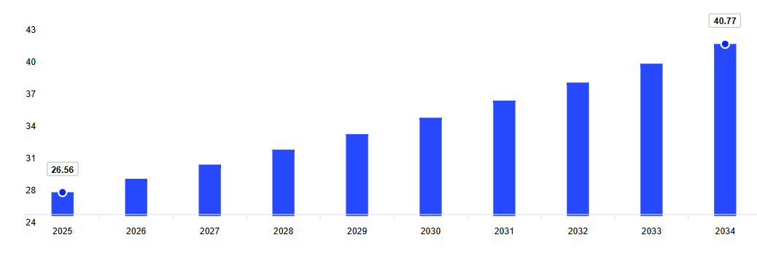
Figure 1: Annual Growth Rate
(Source: EMR Claight, 2025)
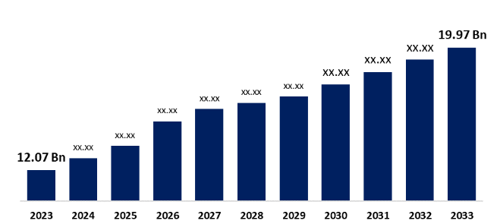
Figure 2: UK Carbonated soft drink market
(Source: Spherical Insights, 2024)
One of the central drivers of preserving performance has been the fact that the company reacted to the Soft Drinks Industry Levy (sugar tax) (Forde et al., 2022). Through repositioning products and marketing Coca-Cola Zero Sugar and Diet Coke aggressively, it enabled the company to absorb the adverse blow of the increased price on its traditional product. Although the drinking of beverages with full sugar has reduced, Coca-Cola has made sure that the sales volumes are maintained through healthier options. In addition, the pricing techniques that the brand has employed include multipacks, discounted pricing and value-based packaging methods to ensure the brand remains accessible throughout the UK cost-of-living crisis.
Promotional campaigns are also good contributors to performance. The UK adaptations of the Share a Coke campaign that included the names of well-known people in the UK on the bottle greatly generated consumer interest and commendation of emotional attitudes with the brand. Local music concerts and sports sponsorships further contribute towards the presence of Coca-Cola. Digital engagement in the company is also at a high level, as the company has been displaying appropriate social media activity and UK-specific content. But there have also been drawbacks, such as Coca-Cola Europacific Partners has also reported slight decreases in sales volume in Europe and in the UK, but those have been replaced with increased prices (Reuters, 2025). Comprehensively, this indicates that the marketing approaches taken by Coca-Cola in the UK are a continuing success, albeit more heavily depending on innovation and modification in the presence of regulatory demands and movement in consumer preferences towards health.
Australia
Coca-Cola is even more dominant in Australia, where Coca-Cola Europacific Partners Australia is projected to take in more than half of the revenue in the soft drink industry in 2024 - 25. The overall industry revenue is projected at AUD 3.9 billion, or in other words, the success of the marketing strategies adopted by Coca-Cola (Obesity Evidence Hub, 2025). Since it, as opposed to the UK, reformulation was largely motivated by taxation, Coca-Cola Australia maintained a long-term program of systematic sugar reduction, gradually offering low-sugar versions by 25% and modifying recipes, in accordance with the concerns of consumers in relation to health (Coca-Cola ep, 2022). This active policy has been successful in enhancing its reputation and preventing future intervention by stricter rules.
Coca-Cola can be very innovative in the responsiveness of its activities in the local market, though with international appeal in its campaigns. The company has also followed up by adjusting environmental advertising to fit the Australian lifestyle, to focus on summer, outdoor activities and sports events, which have been heavily identified with local culture. It is also noted that the Coca-Cola company in Australia has achieved a healthy rating score of greater than 80% of the portfolio, and thus these are helping customers to make a better choice from a health perspective (Coca-Cola ep, 2022).
Other strengths, under distribution, are found in Australia, where the challenges of the geography necessitate good logistics. The Coca-Cola bottling process and distribution network make the products available to customers in massive land areas, including city areas and isolated villages. This credibility supports the confidence of the consumer and brand loyalty. The financial performance of the company was positive as Coca-Cola Europacific Partners reported that the volume increased in the Australia and Pacific region and decreased in Europe (Coca Cola ep, 2025). This is an indication that not only are they effective, but they are also expanding the marketing strategies in Australia to a competitive and health-conscious market.
Comparative Evaluation
Coca-Cola has demonstrated its capability of localising its marketing plans to the local regulatory, cultural, and consumer controls in both the UK and Australia. The UK market needs to adapt to high taxes imposed on sugar and a developing level of consumer behavioural change, whereas Australia focuses on a voluntary and cultural adaptation toward promotional campaigns. These differences notwithstanding, Coca-Cola enjoys the status of a market leader in both nations, as evidenced by brand reputation, creative marketing forces and a large bank of distributors. The results of the performance are thus good in both scenarios, but further development would greatly rely on how sustainable and health-related innovations would be promoted in the marketing activity.

7. Evaluation of marketing ethics practice
Children Marketing and Use of Promotional Appeals.
Coca-Cola has formally (on the international level) pledged (Responsible Marketing Policy), which states that this company will not promote their products to children below 13. This will entail exclusion of the media where 30% or more of the audience is children under 13 years old, exclusion of the use of particular characters or celebrity influencers where their influence is on children under the age of 13, as well as exclusion of the tie-in to a child under 13-demographic oriented film (The Coca Cola Company, 2022). Nonetheless, research and reports have revealed that even though some of the marketing of Coca-Cola reaches kids who are below 12 or 13 years of age, it does so in an indirect manner. As an example, the UK programme Tricks of the Junk Food Business blamed Coca-Cola in innuendo to children with advertisement-packed games in their promoting packages and advertisements relating to children's movies and sponsorships, among other unscrupulous methods of directing youngsters as targets to be cool (Food Navigator, 2024). These questions bring up cognitively unsettling issues of vulnerability: children are not as capable of disproportionately judging marketing communication, and advertising appeals that seek to exploit cultural or celebratory events may find a way out.
Product Safety and Recalls
Coca-Cola experienced a product safety crisis in the UK in early 2025, due to a recall of several of its products (Coca-Cola Original Taste, Zero Sugar, Diet Coke, Sprite Zero and more) based on higher concentrations of a chemical compound, chlorate, which is the by-product of disinfectants added to water (BBC, 2025). The danger was still considered very low, but the recall, nevertheless, is an indicator of going through a product safety/quality control breach, which can damage the trust of consumers. These safety concerns are not necessarily marketing issues per se, although when the definition of purity, health or safety (implied or stated), product safety deficiencies become ethical concerns as they can be deceptive to the consumer or responsible for making implicit promises.
Voluntary vs Regulatory Actions
Coca-Cola experiences ethical concerns on greenwashing and plastic pollution, especially due to allegations of reportedly failing to achieve its goal of using reusable packaging and being ranked as the leading plastic polluter in the world by environmental organisations, calling for the name of Coca-Cola over the past few years. The activists attack the company, citing its acts of abandoning pledges and deceiving consumers based on recycled material (BBC, 2023). The ethical aspect in this case is the credibility because voluntary acts taken to bypass or pre-empt regulation or set forth as seeming to be socially responsible and consistent or less completely transparent. This tends to put the company on the road to be perceived as engaging in the acts of greenwashing or healthier-products washing.

8. Recommendation and Conclusion
Recommendation
Coca-Cola continues to reinforce its determination to reduce the sugar content, create more healthy drinks in the United Kingdom and Australia. Reformulation has seen success in both of these markets, but the increasing need for functional beverages and natural ingredients would represent an additional opportunity. The extension of product lines would allow the company to remain competitive (Attah et al., 2024). Further, the company can respond to the challenge of consumer health concerns that have triggered the regulatory response and consumer interest. Inaccessibility is also a problem in the two nations, especially in the UK, where there exists a cost-of-living crisis. Coca-Cola ought to embrace price segmentation techniques that will enable consumers to gain access to alternatives of healthier beverages at reasonable prices. Lower-sugar substitutes would be promoted by being packaged in smaller sizes or offering bulk discounts to help more consumers find useful packages without being locked out of the broad market.
The environment is one other main focus where improvements are necessary (Yang et al., 2024). Coca-Cola is encouraged to spend more on sustainable packaging by increasing recycled content and using other substitute materials that are less associated with the use of plastic. Introduction of strong car recycling measures with involvement of the local government might also enhance brand image. The company must also minimise the carbon footprint of its logistical scheduling and bottling division, especially in Australia, where distribution is resource-consuming due to the long distances in the country. Coca-Cola should keep on localising promotional advertisements in order to meet the cultural tastes of the two markets. The campaigns that stress being inclusive and including heritage, and the success of the Share a Coke campaign in Australia, speak of local innovation as the key to consumer loyalty. The digital engagement should become an element of the future strategy that will include the elements of balancing entertainment and educational content based on health and sustainability principles to make the brand remain relevant, ethical, and socially responsible.

Conclusion
The marketing strategies of Coca-Cola in the United Kingdom and Australia portray a high level of adaptation to the macro-environment, cautious product and promotion strategy and responsiveness to consumer trends. The regulatory pressure in the UK, soft drinks industry levies, growing health-consciousness, and varied price sensibilities demand that Coca-Cola be able to re-engineer with sugar through reformulation, expand the low/no sugar offerings and control the promotional campaigns under ethical and legal provisions. Coca-Cola has been effective in its endeavours to keep the dominant market share, especially through systematic reformulation strategies of sugar and through localised promotional campaigns, which have been yielding even favourable outcomes in Australia, though geography and logistics are other factors that have challenged it. Although the strategies are mostly effective in continuing to lead and develop, and sustain the brand, consumer awareness, and financial performance, there are some ethical issues, especially in terms of sugar content and advertising to children, environmental responsibility of the packaging and openness in communication. As a solution to maintaining success and keeping pace with the changing consumer demands and regulatory environment Coca-Cola has to focus more on the innovation of health-oriented products, environmental activism, and ethical marketing.

9. Reference
AACS (2021) Coca-Cola Amatil launches new sustainability ambitions and commits to net zero carbon emissions by 2040. Available at: https://aacs.org.au/coca-cola-amatil-launches-new-sustainability-ambitions-and-commits-to-net-zero-carbon-emissions-by-2040 (Accessed: 28 October 2025).
Attah, R.U., Garba, B.M.P., Gil-Ozoudeh, I. and Iwuanyanwu, O. (2024) ‘Corporate banking strategies and financial services innovation: Conceptual analysis for driving corporate growth and market expansion’, Int J Eng Res Dev, 20(11), pp. 1339-49.
Australian Bureau of Statistics (2025) Population. Available at: https://www.abs.gov.au/statistics/people/population (Accessed: 28 October 2025).
BBC (2022) Coca-Cola and Nestle accused of misleading eco claims. Available at: https://www.bbc.com/news/business-67343893 (Accessed: 28 October 2025).
BBC (2025) Coca-Cola recalls drinks in UK due to chemical levels. Available at: https://www.bbc.com/news/articles/czxkn393rwwo (Accessed: 28 October 2025).
Business.gov.uk (2025) Artificial Intelligence. Available at: https://www.business.gov.uk/campaign/grow-your-tech-business-in-the--uk/artificial-intelligence/ (Accessed: 28 October 2025).
CFI (2025) What is a PESTEL Analysis?. Available at: https://corporatefinanceinstitute.com/resources/management/pestel-analysis/ (Accessed: 28 October 2025).
Cobiac, L.J., Rogers, N.T., Adams, J., Cummins, S., Smith, R., Mytton, O., White, M. and Scarborough, P. (2024) ‘Impact of the UK soft drinks industry levy on health and health inequalities in children and adolescents in England: An interrupted time series analysis and population health modelling study’, PLoS medicine, 21(3), p. e1004371. Available at: https://doi.org/10.1371/journal.pmed.1004371
Coca cola ep (2022) Coca-Cola Australia commits to reducing sugar by 25% by 2025. Available at: https://www.cocacolaep.com/au/news-and-stories/coca-cola-australia-commits-to-reducing-sugar-by-25-by-2025/ (Accessed: 28 October 2025).
Coca cola ep (2025) Coca-Cola EP PLC - Results for the six months ended 27 June 2025. Available at: https://ir.cocacolaep.com/news-releases/news-release-details/coca-cola-ep-plc-results-six-months-ended-27-june-2025 (Accessed: 28 October 2025).
Coca cola ep (2025) Our Brands. Available at: https://www.cocacolaep.com/au/our-brands/ (Accessed: 28 October 2025).
Coca-Cola (2025) History. Available at: https://www.coca-colacompany.com/about-us/history (Accessed: 28 October 2025).
Coca-Cola (2025) Less Sugar, More Choices in Great Britain. Available at: https://www.coca-cola.com/gb/en/social/less-sugar-more-choice-great-britain (Accessed: 28 October 2025).
Coca-Cola (2025) OUR PLANET, PEOPLE AND COMMUNITIES MATTER. Available at: https://www.coca-cola.com/au/en/sustainability (Accessed: 28 October 2025).
Coca-Cola (2025) The world's most loved drinks. Available at: https://www.cocacolaep.com/au/our-brands/ (Accessed: 28 October 2025).
Coca-Cola (2025) We make the world’s most loved drinks - with and without sugar. Available at: https://www.cocacolaep.com/sustainability/this-is-forward/drinks/ (Accessed: 28 October 2025).
EMR Claight (2025) United Kingdom Soft Drinks Market Report and Forecast 2025-2034. Available at: https://www.expertmarketresearch.com/reports/united-kingdom-soft-drinks-market (Accessed: 28 October 2025).
Federal Register of Legislation (2025) Fair Work Act 2009. Available at: https://www.legislation.gov.au/C2009A00028/2017-09-20/text (Accessed: 28 October 2025).
Food and Drink Business (2025) Sweet new strategy for Coca-Cola Amatil. Available at: https://www.foodanddrinkbusiness.com.au/news/sweet-new-strategy-for-coca-cola-amatil (Accessed: 28 October 2025).
Food navigator (2024) What are you playing at? Kellogg, Coca-Cola and Cloetta accused of ‘sneaky’ advertising to kids. Available at: https://www.foodnavigator.com/Article/2014/06/04/Kellogg-Coca-Cola-and-Cloetta-accused-of-sneaky-advertising-to-kids/ (Accessed: 28 October 2025).
Forde, H., Penney, T.L., White, M., Levy, L., Greaves, F. and Adams, J. (2022) ‘Understanding marketing responses to a tax on sugary drinks: a qualitative interview study in the United Kingdom, 2019’, International Journal of Health Policy and Management, 11(11), p. 2618. Available at: https://doi.org/10.34172/ijhpm.2022.5465
Grand View Research (2025) Australia Cloud Ai Market Size & Outlook, 2024-2030. Available at: https://www.grandviewresearch.com/horizon/outlook/cloud-ai-market/australia#:~:text=The%20Australia%20cloud%20ai%20market,49.7%25%20from%202025%20to%202030 (Accessed: 28 October 2025).
JustDrink (2024) Coca-Cola Europacific Partners invests in UK plant. Available at: https://www.just-drinks.com/news/coca-cola-europacific-partners-invests-in-uk-plant/#:~:text=The%20move%20follows%20another%20multi,line%20at%20Wakefield%20last%20year.&text=Coca%2DCola%20Europacific%20Partners%20plans,warehouse%20at%20the%20Wakefield%20location. (Accessed: 28 October 2025).
Kotabe, M. M., & Helsen, K. (2022). Global marketing management. John Wiley & Sons. Available at: https://studentebookhub.com/wp-content/uploads/2024/preview/9781119563112.pdf (Accessed: 28 October 2025).
Lacy-Nichols, J., Scrinis, G. and Carey, R. (2020) ‘The evolution of Coca-Cola Australia’s soft drink reformulation strategy 2003–2017: A thematic analysis of corporate documents’, Food Policy, 90, p. 101793. Available at: https://doi.org/10.1016/j.foodpol.2019.101793
Legislation.gov.uk (2025) Employment Rights Act 1996. Available at: https://www.legislation.gov.uk/ukpga/1996/18/contents (Accessed: 28 October 2025).
Legislation.gov.uk (2025) Environment Act 2021. Available at: https://www.legislation.gov.uk/ukpga/2021/30/contents (Accessed: 28 October 2025).
Marketing91 (2024) About Coca-Cola. Available at: https://www.marketing91.com/marketing-mix-coca-cola/ (Accessed: 28 October 2025).
Medium (2023) ‘Share-a-Coke’ through the years. Available at: https://medium.com/@akshathas721/share-a-coke-through-the-years-431f51ea6fa8 (Accessed: 28 October 2025).
Obesity Evidence Hub (2025) Corporate political activity of the soft drink industry in Australia. Available at: https://www.obesityevidencehub.org.au/collections/environmental/corporate-political-activity-of-the-beverage-industry-in-australia (Accessed: 28 October 2025).
Queensland Government (2025) Environmental Protection Act 1994. Available at: https://www.legislation.qld.gov.au/view/html/inforce/current/act-1994-062 (Accessed: 28 October 2025).
Reuters (2025) Coca-Cola Europacific Partners post quarterly revenue rise on strong demand. Available at: https://www.reuters.com/business/retail-consumer/coca-cola-europacific-partners-post-quarterly-revenue-rise-strong-demand-2025-02-14/ (Accessed: 28 October 2025).
Scarborough, P., Adhikari, V., Harrington, R.A., Elhussein, A., Briggs, A., Rayner, M., Adams, J., Cummins, S., Penney, T. and White, M. (2020) ‘Impact of the announcement and implementation of the UK Soft Drinks Industry Levy on sugar content, price, product size and number of available soft drinks in the UK, 2015-19: A controlled interrupted time series analysis’, PLoS medicine, 17(2), p. e1003025. Available at: https://doi.org/10.1371/journal.pmed.1003025
Spherical Insights (2024) United Kingdom Carbonated Soft Drinks Market Size, Share, and COVID-19 Impact Analysis, By Soft Drink Type (Diet Cola, Fruit Flavored Carbonates, Standard Cola, and Others), By Distribution Channel (Hypermarkets, Supermarkets & Mass Merchandisers, and Online Stores & D2C), and United Kingdom Carbonated Soft Drinks Market Insights, Industry Trend, Forecasts to 2033. Available at: https://www.sphericalinsights.com/reports/united-kingdom-carbonated-soft-drinks-market (Accessed: 28 October 2025).
The Coca Cola Company (2022) The Coca-Cola Company’s Responsible Marketing Policy. Available at: https://www.coca-colacompany.com/policies-and-practices/responsible-marketing-policy (Accessed: 28 October 2025).
The Coca cola company (2025) Iconic ‘Share a Coke’ is Back for a New Generation. Available at: https://www.coca-colacompany.com/media-center/iconic-share-a-coke-is-back-for-a-new-generation (Accessed: 28 October 2025).
The Coca cola company (2025) Ingredients. Available at: https://www.coca-colacompany.com/about-us/faq/ingredients#:~:text=Coke%20Zero-,Yes.,(or%20Ace%2DK). (Accessed: 28 October 2025).
The Coca-Cola Company (2025) Coca‑Cola Reports Fourth Quarter and Full Year 2024 Results. Available at: https://www.coca-colacompany.com/media-center/coca-cola-reports-fourth-quarter-and-full-year-2024-results (Accessed: 28 October 2025).
The Coca-Cola Company (2025) OUR COMPANY. Available at: https://www.coca-colacompany.com/about-us (Accessed: 28 October 2025).
The Global Economy.com (2025) Australia: Political stability. Available at: https://www.theglobaleconomy.com/Australia/wb_political_stability/ (Accessed: 28 October 2025).
The Global Economy.com (2025) United Kingdom: Political stability. Available at: https://www.theglobaleconomy.com/United-Kingdom/wb_political_stability/ (Accessed: 28 October 2025).
Thompson, C., Clary, C., Er, V., Adams, J., Boyland, E., Burgoine, T., Cornelsen, L., De Vocht, F., Egan, M., Lake, A.A. and Lock, K. (2021) ‘Media representations of opposition to the ‘junk food advertising ban’on the Transport for London (TfL) network: a thematic content analysis of UK news and trade press’, SSM-Population Health, 15, p. 100828. Available at: https://doi.org/10.1016/j.ssmph.2021.100828
Trading Economics (2025) Australia Corruption Index. Available at: https://tradingeconomics.com/australia/corruption-index (Accessed: 28 October 2025).
Trading Economics (2025) Australia GDP Annual Growth Rate. Available at: https://tradingeconomics.com/australia/gdp-growth-annual (Accessed: 28 October 2025).
Trading Economics (2025) Australia Inflation Rate. Available at: https://tradingeconomics.com/australia/inflation-cpi (Accessed: 28 October 2025).
Trading Economics (2025) United Kingdom GDP Growth Rate. Available at: https://tradingeconomics.com/united-kingdom/gdp-growth (Accessed: 28 October 2025).
Trading Economics (2025) United Kingdom Inflation Rate. Available at: https://tradingeconomics.com/united-kingdom/inflation-cpi (Accessed: 28 October 2025).
World O Meter (2025) U.K. Population (LIVE). Available at: https://www.worldometers.info/world-population/uk-population/ (Accessed: 28 October 2025).
Yang, C., Zhu, C. and Albitar, K. (2024) ‘ESG ratings and green innovation: AU‐shaped journey towards sustainable development’, Business Strategy and the Environment, 33(5), pp. 4108-4129. Available at: https://doi.org/10.1002/bse.3692

