Student number: 1918687
Student name: Ionut Claudiu Paraschiv

Effective Team Work and Communication

Contents
1. Introduction 3
2. Communication skills and modules 3
2.1 Interactive model of communication 3
2.2 Transaction model of communication 4
2.3 Skills required for communication 5
3. Case study of Google for understanding communication and its modules 6
4. Cases of poor communication and how it can be improved 7
5. Conclusion 9
6. References 10

Introduction
The importance of communication in the business world is not unknown. Communication is a complex process and it is difficult to determine where or with whom a communication starts or ends (West and Turner 2018). Communication process refers to the series of actions or steps that are taken for communicating among the different members. It is with the help if right communication process that the organisations are able to exchange the relevant information. However, the concept of communication is not just confined to the exchange of business information but extends way beyond that (Lawson et al. 2019). In addition to this, it is also seen that it is with the help of effective communication that employees and management interact with each other for achieving the organisational goals and are aligned with the core organisational values.
The following discussion is presented in the form of a report wherein different aspects of communication in the workplace are discussed. In addition to this, within this report the real life business instances are discussed for discussing the aspects of communication models and theoretical aspects. At last, recommendations and conclusion are provided to the entire discussion.

Communication skills and modules
Different communication models are used for simplifying the process of communication. Some of the models explain communication in a detailed manner while others explain communication through simple means (Zerfass and Viertmann 2017). The most common model of communication is the interactive model of communication.

2.1 Interactive model of communication
It is also called transmission model of communication describes communication as a process in which participants alternate the positions as sender and receiver and messages are sent and received within physical and psychological context (Mihai and Mihai 2016). This method is better than linear model as it incorporates feedback and communication is made more interactive.
Interactive model of communication
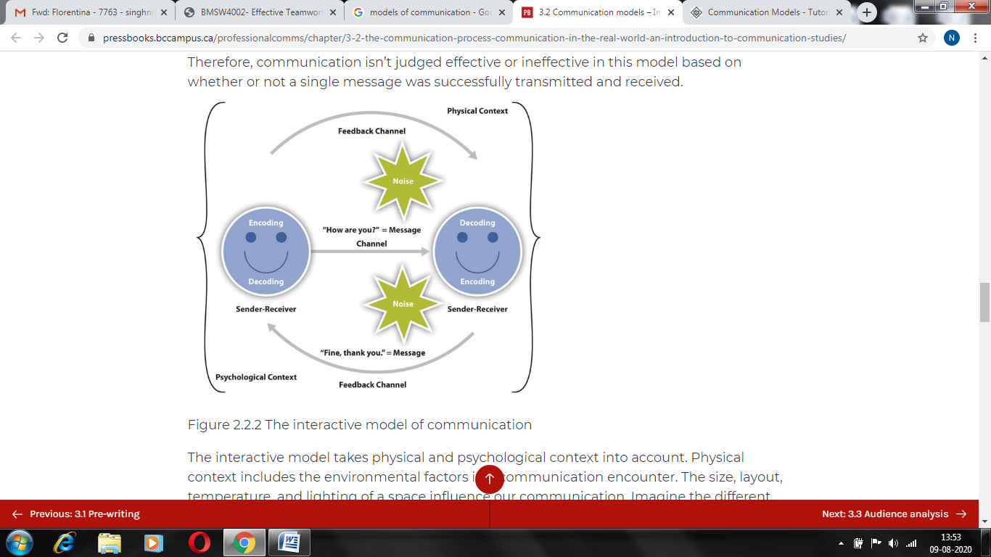
Source: Allen 2016
From the above diagram it is seen that physical context includes the environmental factors in a communication encounter. The size, layout, temperature and lighting of a space influence the communication. Psychological context mainly includes mental and emotional factors within a communication encounter (Chang et al. 2018). Stress, anxiety and emotions are the common examples of psychological influences that tend to affect communication.

2.2 Transaction model of communication
The transaction model of communication depicts communication as a process through which communicators are able to gather social realities within the social and cultural contexts. Thus, communication is not just done for exchanging messages but for the creation of relationships from the intercultural alliances and engaging with others (Pfeffermann 2017).
Transaction model of communication
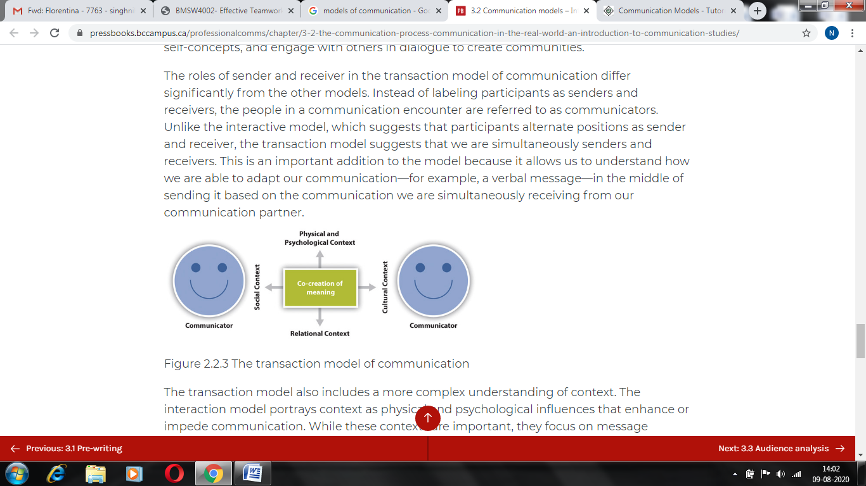
Source: Allen 2016
In this model the sender and the receiver differ significantly differ. The sender and receivers are considered as communicators. This means that every individual gets to play the role of sender and receiver (De Luis et al. 2019). The above diagram given clearly explains the situation.

2.3 Skills required for communication
A number of skills are required to be possessed for indulging in effective communication. Good communication skills both in-person and online are required to be possessed (Chang et al. 2018). Following are the list of skills required for good communication-
Emotional intelligence
It refers to the ability to understand and managing the emotions so as to communicate effectively. As a part of emotional intelligence, an individual is required to have good self awareness, self-management, social awareness and relationship management (Zerfas and Viertmann 2017).
Cohesion and clarity
Good communication is all about communicating in clear and concise manner. Thus the individual with good abilities to draft the scenario and what to say in the mind and then implementing it properly is effective in communicating effectively.
Confidence
Confidence is the main skill that is required to be possessed for communicating effectively. Demonstrating confidence gives the picture to the other person that one is sure about his or her ideas and the other is able to indulge more effectively with this (De Luis et al. 2019).
Empathy
Disagreements can act as barrier to communication and thus having empathy is the essential skill or quality which helps in communicating effectively (Kwilinski et al. 2019). With proper emphatic skills an individual consider the respect the views of other even if there is disagreement involved.
Listening skills
Listening skills are yet other important skills to be developed for essential communication. Listening is important part of the communication because being receptive to the other person helps him or her to communicate effectively (De Luis et al. 2019). Moreover, it also helps in developing a bond and a two way communication can be created.

Case study of Google for understanding communication and its modules
From the case study of Google it is seen that the company owes its success to the effective and clear team work among the employees and the managers. Moreover, from the case study, it is seen that the effective team work is being done within the organisation due to the advanced level of communication that is facilitated within the organisation and among the employees and managers (Lawson et al. 2019). From a closer analysis it is seen that the company has been following transaction model of communication wherein the sender and receiver keep switching their positions and thus communication is always two-way. Adding it further, it is also seen that as per this module of communication the company has developed its internal communication strategy which followed ‘Me to We’ continuum.
Google strongly believes that the employees are required to be considered in the decision making process and this in turn helps in effective team working as the productivity of the employees tends to improve with this. In addition to this, it is seen that the communication is kept strong among the employees. When the modules of communication and the communication skills which have been discussed in the above section is applied to the case scenario of Google it is seen that the communicators in the company interact with each other not to exchange the business messages but also on the cultural context, more general context and relationship context. Hence, in this regard, it is seen that the employees of Google are able to interact with each through ice-breaking sessions which is organised by the company (Stockdale et al. 2018). This helps in building relationship with other and employees get to know each other personally which also helps them in cooperating effectively on the professional grounds. Moreover, with the ice-breaking sessions organised by the company the different personal barriers to communication can be avoided. Thus, in this regard, it is seen that communication in the company is effective as per the transaction module of communication.
The company also gives training courses to its employees with regard to communication skills. With these courses the different skills are taught to the employees for communicating in an effective manner. Considering all these aspects, it is understood that the organisation in the current time are required to apply different theoretical concepts related to communications in order to succeed in the market. Moreover, it is understood from the case scenario of Google that the more the companies practice two-way communication the more they are able to succeed in the market. Thus, transaction model of communication is one of the most effective modules of communication process. In addition to this, it is understood that it is not possible that all employees possess all the necessary skills for having an effective communication (De Luis et al. 2019). Therefore, with the help of training courses the necessary skills and abilities can be developed just as it was done by Google. Overall it is understood that the team working can be improved with the right model of communication process applied in the right time. Effective communication is identified to be an effective strategy for good team working and thus communication should be clear and concise in order to guarantee success in the market.

Cases of poor communication and how it can be improved
Poor communication in the workplace can be very negative for the entire organisation leading to issues and problems. In my workplace, I have witnessed poor communication. We were 10 analysts in a team who were leaded by 1 manager. We all were supposed to have an open communication with the manager in order to be always informed and aware. However, our manager followed a passive-aggressive communication which had impacted the most of us. He refused to speak directly to us and was very passive-aggressive (Pffferman 2017). Whenever, we had any kind of doubt or issue in the workplace, we tried to reach him but he avoided discussing with us directly. He chose to speak to our supervisors instead, but he never followed direct communication. He communicated exclusively on emails and memos but did not let us have any face-to-face and one-on-one communications. The people who are on the receiving end of the communication feel neglected repeatedly and we also felt the same. He purposely tried to avoid communication with the analysts and chose to talk to supervisors instead.
This type of communication is not only toxic for individuals but also for the organisation as a whole. There is a dire need to improve such type of communication. This can be done by promoting one-on-one communication. The person supervising the manager should look into the matter and should encourage him to stop avoiding communication with the analysts (Lawson et al. 2019). Instead one-on-one communications need to be encouraged in the workplace to identify any disconnect that the people have and in turn promote better understanding of information and scenarios. The interactive model of communication needs to be applied which will look into the aesthetics of communication as well. There may be chances that the manager was not speaking to the analysts because of any off-putting environment in the workplace which aggravated his passive-aggressive behaviour. Considering this, it should be ensured in the workplace to provide a separate room for talking which can accommodate one-on-one conversations between the manager and the analysts. In the room, special consideration needs to be paid on the lighting, space and interiors. For instance, a calm looking room with light shaded walls and natural sunlight can enhance the communication of the manager. Likewise, transaction model of communication also needs to be considered which emphasizes on the skills required for effective communication (Dwyer and Hopwood 2019). As per this model, the manager needs to possess active listening skills as well as emotional intelligence skills which are prime considerations for effective communication. The manager needs to enhance his listening skills and emotional intelligence skills. He needs to make an eye contact with the people and wait for pauses in the conversations for effective communication. He just cannot avoid communication with the analysts and instead, needs to pay attention to the grievances and queries of the analysts for better attainment of organisational objectives (Mihai and MIhai 2016). There is no denying the fact effective communication enhances the performance of the organisation as a whole and accordingly, poor communication in workplace should be improved on priority basis.

Conclusion
On the basis of the above discussion it is concluded that the communication is key to the success of the business as it is the communication which helps in effective team working and planning. In addition to this, it is also concluded that there are different models of communication in theory which when applied in the right manner in the practical scenario help in guaranteeing success to the business. In addition to this, it is also concluded that Google is one of the successful companies of the world and it owes its success to the proper communication process being followed. Two way communications is identified to be the best approach for communication. In addition to this, various skills are required to be developed for effective communication. These skills are confidence, emphatic, listening skills and cohesive and clarity skills. Overall it is concluded that the organisations are required to work upon the identified pitfalls in the communications process.

References
Chang, H., Park, P. and Cho, S., 2018. An analysis of business communication courses in business schools and suggestions for curriculum development. Business Communication Research and Practice, 1(1), pp.33-40.
de Luis, B., Llopis‐Lorente, A., Rincón, P., Gadea, J., Sancenón, F., Aznar, E., Villalonga, R., Murguía, J.R. and Martínez‐Máñez, R., 2019. An interactive model of communication between abiotic nanodevices and microorganisms. Angewandte Chemie, 131(42), pp.15128-15132.
Dwyer, J. and Hopwood, N., 2019. The business communication handbook. Cengage AU.
Kwilinski, A., Dalevska, N., Kravchenko, S., Hroznyi, I. and Kovalenko, O., 2019. Formation of the entrepreneurship model of e-business in the context of the introduction of information and communication technologies. Journal of Entrepreneurship Education, 22, pp.1-7.
Lawson, C., Gill, R., Feekery, A., Witsel, M., Lewis, M. and Cenere, P., 2019. Communication skills for business professionals. Cambridge University Press.
Mihai, C.G. and Mihai, R.L., 2016. Communication management and team working sale. Valahian Journal of Economic Studies, 7(3), pp.91-96.
Pfeffermann, N., 2017. The role of communication as a dynamic capability in business model innovation. In Revolution of Innovation Management (pp. 191-212). Palgrave Macmillan, London.
Stockdale, S.E., Rose, D., Darling, J.E., Meredith, L.S., Helfrich, C.D., Dresselhaus, T.R., Roos, P. and Rubenstein, L.V., 2018. Communication Among Team Members Within the Patient-centered Medical Home and Patient Satisfaction With Providers. Medical care, 56(6), pp.491-496.
West, R. and Turner, L.H., 2018. Introducing Communication Theory: Analysis And Appliaction. McGraw-Hill Education,.
Zerfass, A. and Viertmann, C., 2017. Creating business value through corporate communication. Journal of Communication Management.

