

Blake James McGrath Auchterlonie

Analysis of Electromagnetic wave propagation

Ordnance, Munitions & Explosives

Stalin Jacob
Academic Year: 2023 - 2028

Supervisor: Enter the name of your supervisor
May 2025

Abstract
This report investigates electromagnetic wave propagation using simulations in Ansys. Two main tests were carried out, the first a simulation of a rectangular waveguide in two mediums, Vacuum and Teflon. The simulation cutoff frequency closely matched that of the theoretical calculations, confirming the expected behaviour across the two simulations. The Teflon waveguide had a cutoff frequency of 4.45GHz while the vacuum had a cutoff frequency of 6.52GHz, this was expected due to the Teflon’s higher relative permittivity. The port fields and electric magnitude simulations also matched what would be expected from the two materials. The second task was less successful as the simulated 231mm dipole transmitted a frequency of 2.64GHz, rather than the expected calculation of 1.297GHz, which suggests an issue with the simulation model. Overall the simulation demonstrated how it can assist in aiding electromagnetic wave behaviour, while also highlighting the importance of checking the results with regular calculations to ensure its accuracy.

Table of Contents
Abstract ii
List of Figures iv
List of Tables v
List of Equations vi
List of Abbreviations vii
1 Introduction 1
2 Task 1 Method 2
2.1 Task 1a 2
2.2 Task 1b 3
3 Task 1 results 5
3.1 Task 1a 5
3.1.2 port field display in waveguide port 1 and port 2 5
3.1.3 Port field display in waveguide port 1 and port 2 6
3.1.4 Calculateing the cutoff frequency of the first three modes using theoretical formulas for rectangular waveguide 7
3.1.5 Rectangular plot to visualise the cutoff frequencies for all modes 7
3.2 Task 1b 9
3.2.1 Port field display in waveguide port 1 and port 2 9
3.2.2 Calculateing the cutoff frequency of the first three modes using theoretical formula for the design using Teflon 9
3.2.3 Rectangular plot to visualise the cutoff frequencies for all modes in the design using Teflon 10
4 Task 1 Discussion 11
5 Task 2 Method 12
6 Task 2 results 14
6.1 Calculation for the length of the halfwave dipole antenna aswell as its operating 14
6.2 S-parameter plot 14
6.3 Radiation pattern of the antenna 15
7 Task 2 discussion 16
8 Conclusion 17
9 References 18

List of Figures
Figure 1 Magnitude and Vectors for the electric field for mode 1 6
Figure 2 Magnitude and Vectors for the magnetic field for mode 1 6
Figure 3 Magnitude and Vectors for the electric field for mode 2 6
Figure 4 Magnitude and Vectors for the magnetic field for mode 2 6
Figure 5 Magnitude and Vectors for the electric field for mode 3 7
Figure 6 Magnitude and Vectors for the magnetic field for mode 3 7
Figure 7 Regtangular plot of the cutoff frequencys for the vacum 8
Figure 8 Rectangular plot of the cutoff frequencies for Teflon 10
Figure 9 The models dipole with the central lumped port 12
Figure 10 The S-parameter plot of the simulated dipole antenna 14
Figure 11 The radiation pattern of the dipole antenna 15

List of Tables
Table 1 A table to show the halfwavelengths in relation to port feilds and modes for a vacum waveguide 5
Table 2 A table to show the half wavelengths in relation to port fields and modes for a Teflon waveguide 9

List of Equations
(1-1) 3
(4-1) 13
(4-2) 13

List of Abbreviations
HFSS | High-Frequency Structure Simulator
PEC | Perfect Electrical Conductor

Introduction
Electromagnetic wave propagation plays a critical role in modern communication systems [1], with waves traveling though different mediums between transmitting and receiving antennas. This lab aims to designed to explore how electromagnetic waves propagate through different mediums and how simulation tools can aid in modelling these wave behaviours. By using Ansys to simulate the different wave models it will allow analyses and visualize wave propagation in a controlled virtual environment. These results can then be compared agaist theoretical calculated models to see the simulations accuracy. If accurate, this would then allow for detailed examination of isolated field distributions, boundary interactions, and performance that would be difficult or costly to obtain through purely physical testing in anechoic chambers.

Task 1 Method

Task 1a method
The first simulation was for a rectangular waveguide model with perfect electric conductor walls (PEC) with the interior being a vacuum which has a relative permeability is 1 and relative permittivity of 1. The dimensions of the waveguide in the first simulation was 23mm in high, 7mm in length, and a width of 50mm. In order to create this a new High-Frequency Structure Simulator (HFSS) project was created within Ansys, an electronic analysis system. After setting the units in to millimetres a rectangle was drawn with its X, Y, and Z sizes set to 23mm, 7mm, and 50mm respectively.

Properties where then selected for the rectangle in order to make it a suitable model for a wave diagram. For the first simulation a vacuum was selected for the material of the rectangle, with the transparency set to 0.8. This does not affect the model or simulation, it will just allow the waveguide to be seen accurately later in the simulation.

So that the waveguide can work as intended, the four larger planes on the rectangle where selected and the Perfect E boundary was assigned to them. This boundary is PEC and it removes the tangential component of the electric field on the surface [2]. This allows the model to represent a small part of a larger electric field without the smaller nature of the simulation having any effect on the results. So that signals are able to enter and exit the geometric model [3], excitations where then made at the two smaller unused ends. These where assigned as wave ports and then the number of waveguide modes was set to three.

After verifying that all of the waveguides where working as intended in the Project manager, a solution was created to run the simulation. The frequency sweep was set to start at 2GHz and end at 30GHz. This was then ran and the results calculated on to a rectangular plot.

The following equation was then used to calculate the cutoff frequency of the three modes.

$$f_{c}= \frac{(\frac{c}{2})}{\sqrt{εμ}} \sqrt{{(\frac{m}{a})}^{2}+{(\frac{n}{b})}^{2}}$$ |  | (1-1)
Where:
c = the speed of light in a vacuum (3x108m/s2)
m = The number of half-wavelengths in the azimuthal direction
n = The number of half-wavelength in the transverse direction
a = The width of the waveguide
b = The hight of the waveguide
ε = The absolute permittivity of the medium
μ = The absolute permeability of the medium

Task 1b
The simulation for task 1b was similar to the simulation created for task 1a, the difference being that during the properties step during creation, the material Teflon was used for the rectangle material instead of vacuum. The Teflon used has a relative permeability is 1 and relative permittivity is 2.1. The wave port, frequency sweep and dimensions for the waveguide where identical to the simulation setup in task 1a.

Task 1 results

Task 1a

Identifying the dominant mode and the modes propagating through the waveguide
The dominant mode in a waveguide is the propagation mode with the lowest cut-off frequency, in the case of the simulation this is mode 1 with a cutoff frequency of 6.48GHz.

Port field display in waveguide port 1 and port 2
In table 1 the waveguides are shown for both port field 1 and port field 2 with the waves plotted on to them. The results are what was expected with the waveguides from port field 1 and port field 2 being identical. This was expected due to the shape of the waveguide being regular and symmetrical with the parameters of both wave ports having the same parameters set. The number of half waves are also shown in the port fields, with mode 1 having 1 half wavelength, mode 2 having two half wavelength and mode 3 having 3 half wavelength.
Table 1 A table to show the half wavelength in relation to port fields and modes for a vacuum waveguide
 | Mode 1 | Mode 2 | Mode 3
Port field 1 | 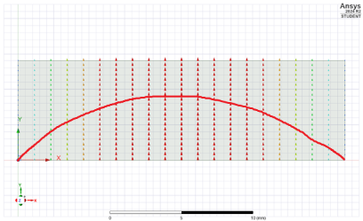 | 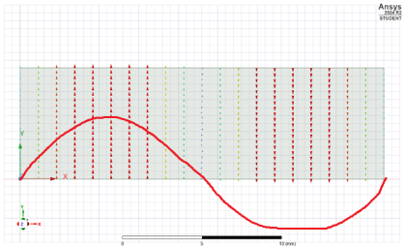 | 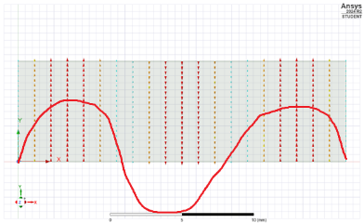
Port field 2 | 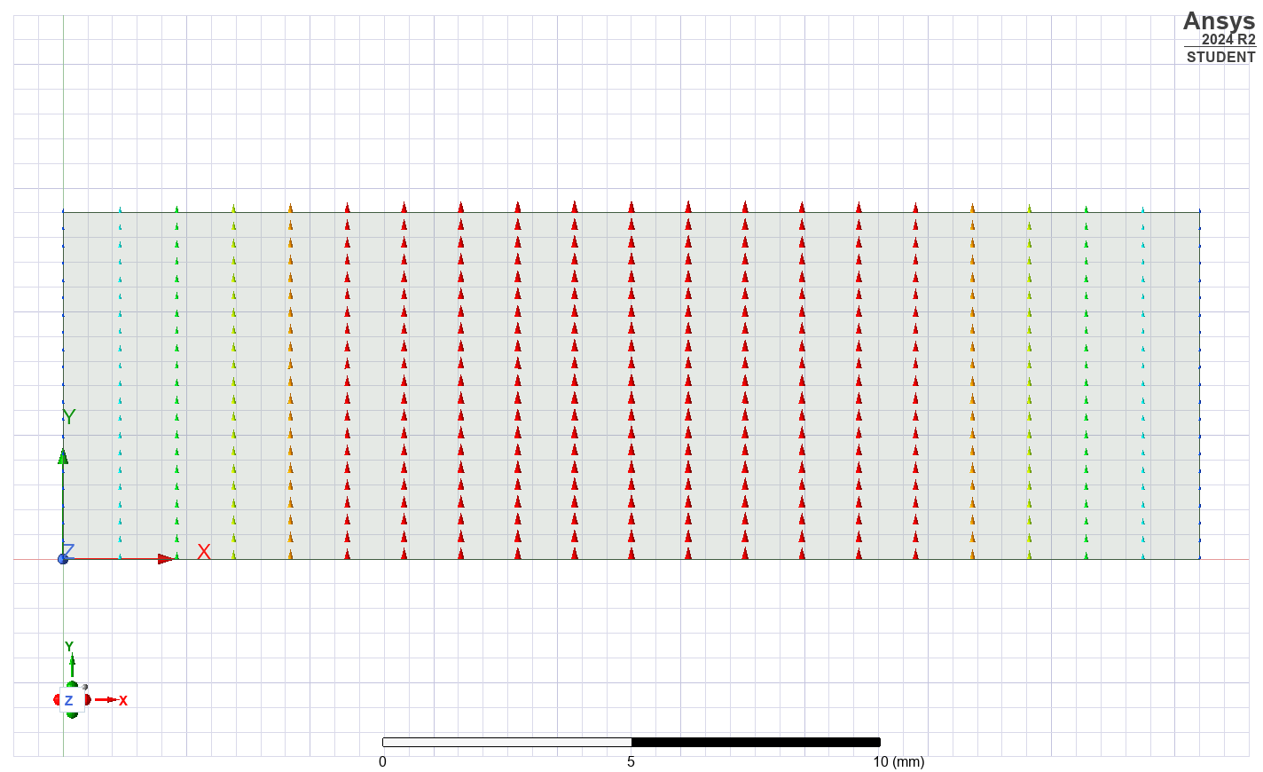 | 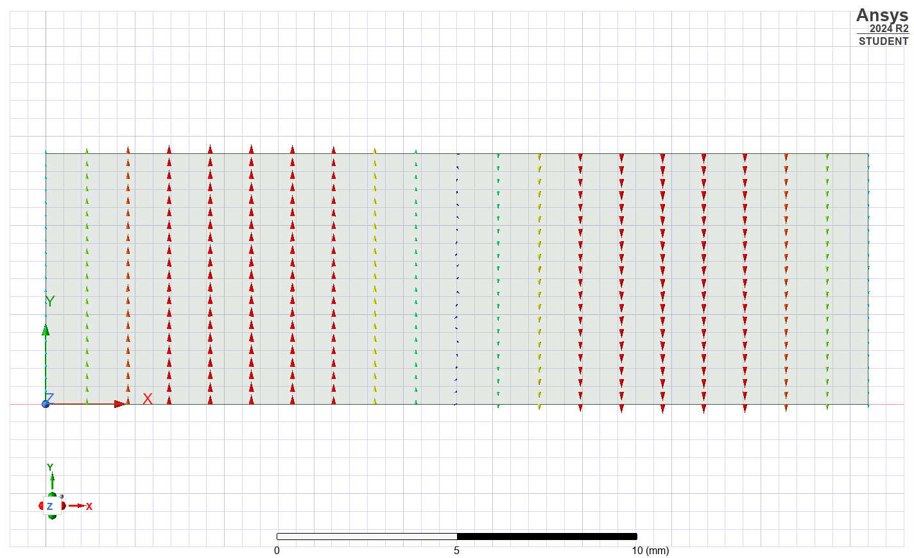 | 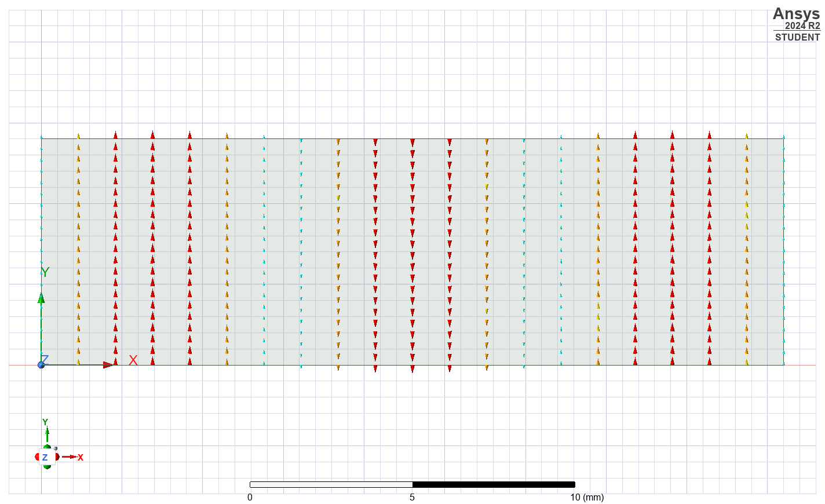

Port field display in waveguide port 1 and port 2
Figures below show the magnitude and vectors for the magnetic and electric fields within the waveguide model for each of the modes.

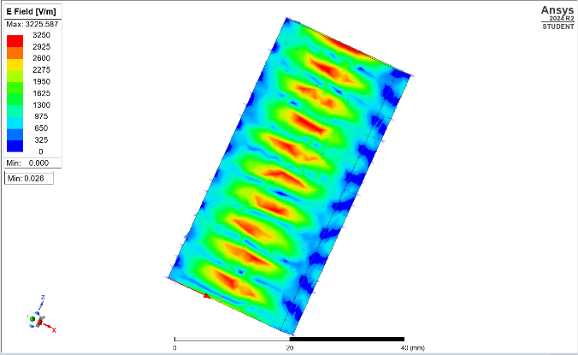  Figure 1 Magnitude and Vectors for the electric field for mode 1 | 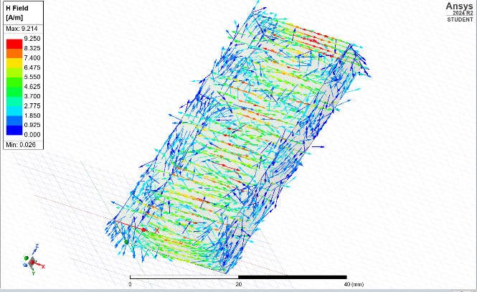  Figure 2 Magnitude and Vectors for the magnetic field for mode 1
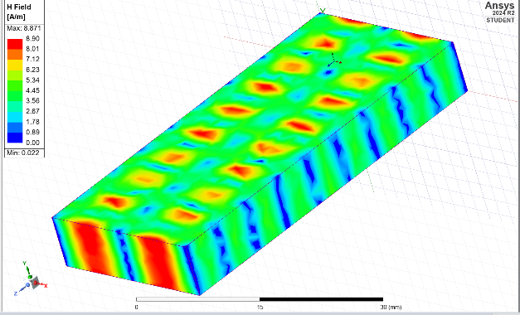  Figure 3 Magnitude and Vectors for the electric field for mode 2 | 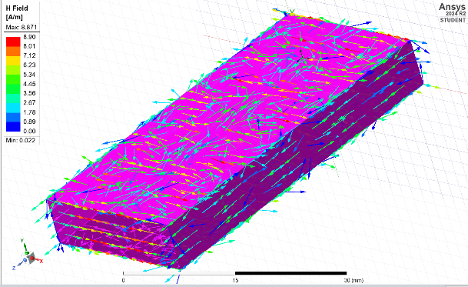  Figure 4 Magnitude and Vectors for the magnetic field for mode 2
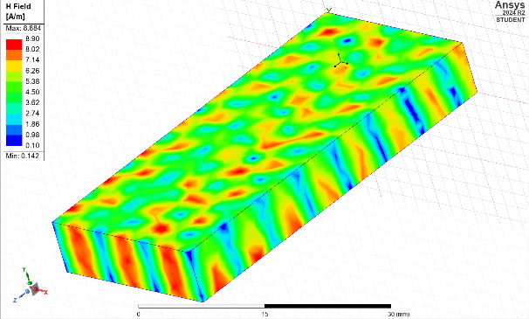  Figure 5 Magnitude and Vectors for the electric field for mode 3 | 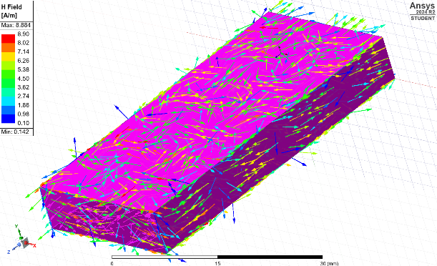  Figure 6 Magnitude and Vectors for the magnetic field for mode 3

Calculating the cutoff frequency of the first three modes using theoretical formulas for rectangular waveguide

Using Equation (1-1) from the method the theoretical cut frequency cutoffs can be calculated for the waveguide. The vacuum has a relative permittivity and relative permeability of 1 and c stays as a constant. The width and hight of the waveguide stay as a constant for all three modes, being 0.023m and 0.007m respectively. n will also stay for the three modes, remaining as 0 with m changing from 1 to 3 for the three difrent modes.
For mode 1 the calculated frequency is 6.52Ghz, for mode 2 the calculated frequency is 13.03GHz, and finaly the calculated frequency for mode 3 is 19.55GHz.

Rectangular plot to visualise the cutoff frequencies for all modes
Figure 7 shows the rectangular plot of the cutoff frequencies for all modes. The cutoff frequency for mode 1 is 6.48GHZ. The cutoff frequency for mode 2 is 13.06GHz and the cutoff frequency for mode 3 is 19.5GHz. 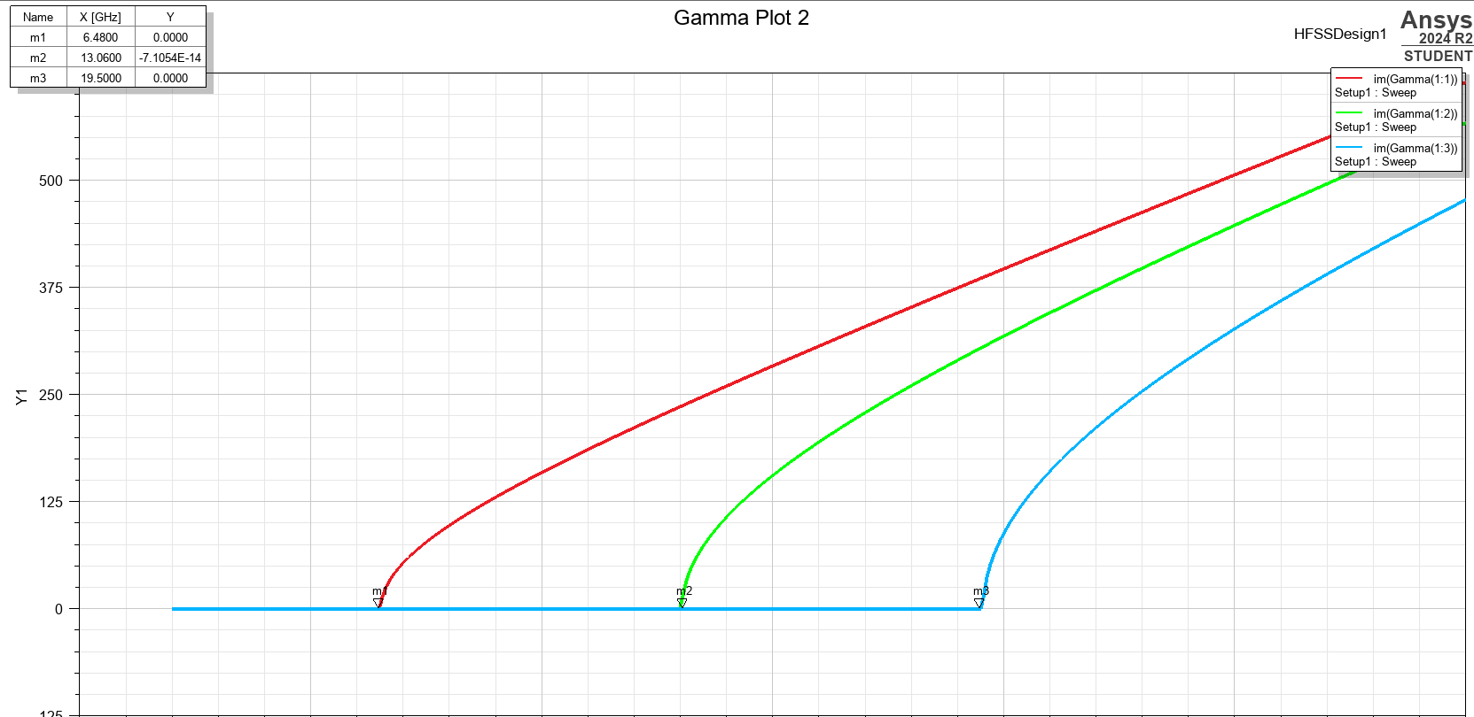
Figure 7 Rectangular plot of the cutoff frequency for the vacuum

Task 1b

Port field display in waveguide port 1 and port 2
The port field display was recorded for the Teflon waveguide. They were similar to the ones obtained for the vacuum waveguide with the modes matching for both the entrance and exist field port.
Table 2 A table to show the half wavelengths in relation to port fields and modes for a Teflon waveguide
 | Mode 1 | Mode 2 | Mode 3
Port field 1
Port field 2

Calculating the cutoff frequency of the first three modes using theoretical formula for the design using Teflon
I used Equation (1-1) from the method the theoretical cut frequency cutoffs can be calculated for the waveguide. The Teflon has a relative permittivity of 1 and relative permeability of 2.1. c still stays as a constant aswell as the width and hight of the waveguide, still being 0.023m and 0.007m respectively. n will also stay for the three modes, remaining as 0 with m changing from 1 to 3 for the three difrent modes.
For mode 1 the calculated frequency is 4.50GHz, for mode 2 the calculated frequency is 9.00GHz, and finaly the calculated frequency for mode 3 is 13.49GHz.

Rectangular plot to visualise the cutoff frequencies for all modes in the design using Teflon
The figure shows the cutoff frequency for the Teflon simulation for all modes. The cutoff frequency for mode 1 is 4.45GHz. The cutoff frequency for mode 2 is 8.86GHz and the cutoff frequency for mode 3 is 13.41GHz.
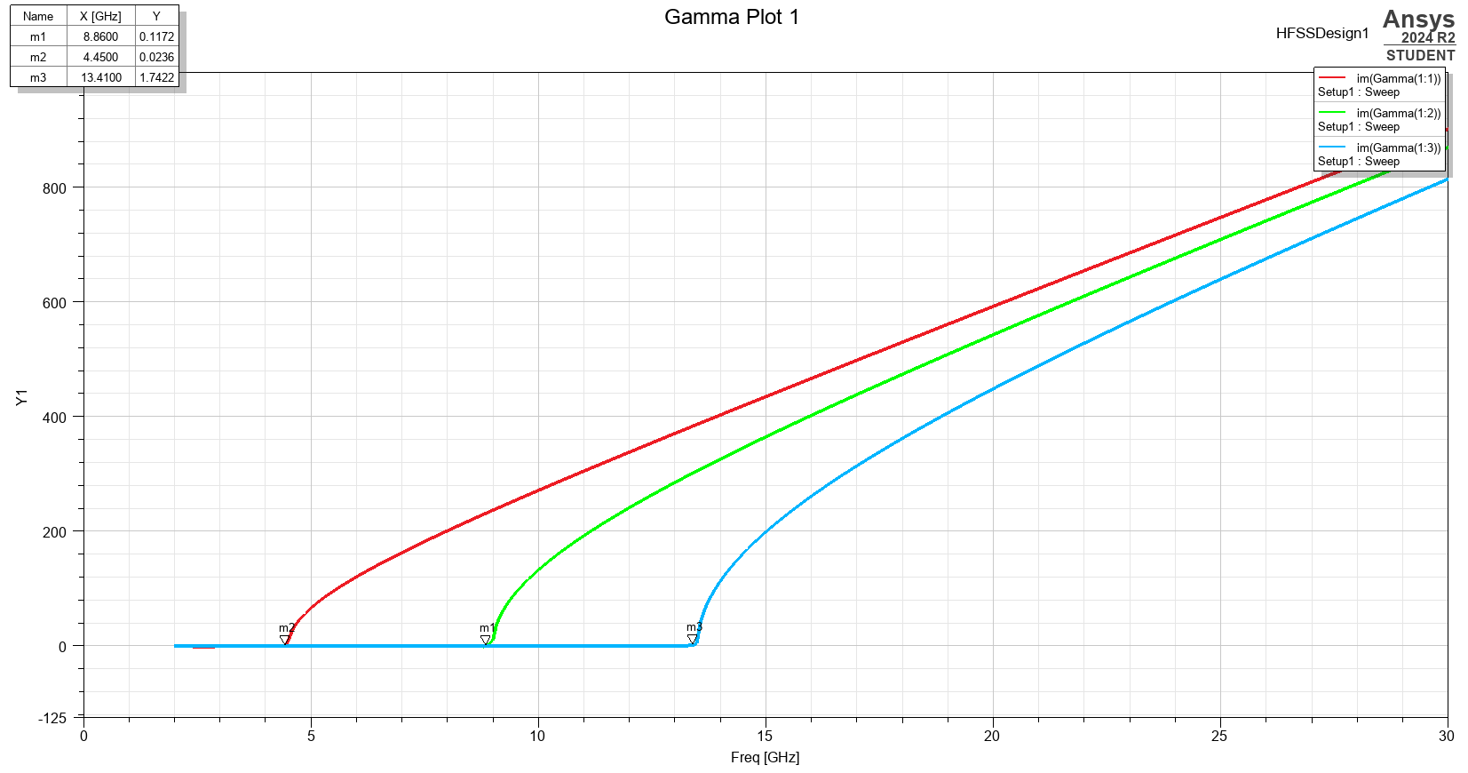
Figure 8 Rectangular plot of the cutoff frequencies for Teflon

Task 1 Discussion
The results from task 1a (vacuum filled waveguide) and 1b (Teflon filled waveguide) show the influence that the material properties have on wave propagation for the rectangular wavelength. The dominant mode for both simulations was TE₁₀ as this was the mode which showed the lowest cutoff frequency.

The simulation and theoretical calculations where consistent for task 1a, with the greatest difference between the two frequencies being for mode 3. The simulated frequency was 19.50GHz while the calculated frequency was 0.05GHz greater at 19.55GHz. This is still a small discrepancy however and it shows that the simulation is valid for determining the cut off frequencies using the method used. The port fields also show expected wave propagation at both the input and output ports with the expected number of half wavelengths at each port aswell as being symmetrical.

For task 1b, the simulated and calculated results were also similar aswell, showing the reliability of the software simulation. The effect of replacing the vacuum with Teflon is shown in the propagation characteristics as due to its higher permittivity it slows down the wavelength, leading to a lower cut of frequency. This is how the waves where expected to react in a material with higher permittivity.

Task 2 Method
The task 2 simulation was also created in Ansys, and was for a halfwave dipole antenna with a radius of 1mm. It was intended to radiate electromagnetic waves with a wavelength of 231mm. It is designed with perfect electric conductor walls and excitation is applied through the lumped port with a port impedance is 50 Ohms.

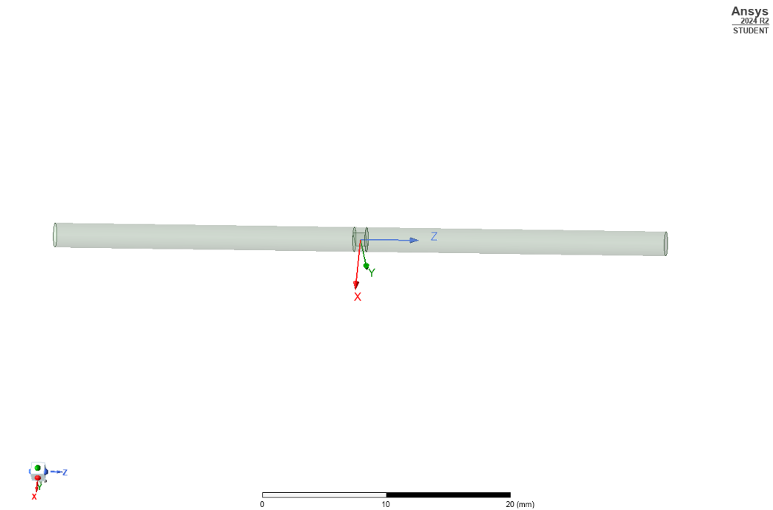
A cylinder of 231mm was created and centred within the HFSS project it was given the properties of a vacuum, the same vacuum as from task 1a with a transparency of 0.8 aswell. A gap of 1mm was then removed from the cylinder by creating a second object within the original vacuum cylinder, and then subtracting the Boolean from the original. This split the cylinder in to two half and allowed space for a lumped port to be created. Lumped ports are used to drive input signals between two conductors from a transmission line signal conductor to ground [4]. After the lumped port was created between the two vacuum cylinders, a rectangular open region was made around the dipole with an operating frequency of 1GHz. Figure 9 shows the two dipols with the Lumped port in the center.
Figure 9 The models dipole with the central lumped port
The two following equations where used to calculate the Antenna length (4-1) and the operating frequency (4-2).

$$L= \frac{λ}{2}$$ |  | (4-1)
Where:
L = The length of the antenna (m)
λ = The wavelength (m)

$$f= \frac{c}{λ }$$ |  | (4-2)  (4-1)

Where:
f = Frequency (GHz)
c = the speed of light in a vacuum (3x10⁸m/s²)
λ = The wavelength (m)

Task 2 results

Calculation for the length of the halfwave dipole antenna aswell as its operating
Using the equation (4-1) the length of the dipole antenna can be calculated. As the wavelength of the wave is 0.231m, the dipole antenna is 0.116m in length.

The operating frequency of the dipole antenna can be calculated using equation (4-2). C in the equation is the speed of light in a vacuum and is the constant 3x10⁸m/s². λ remains the same at 0.231m. as such the frequency of the dipole antenna is 1.297GHz.

S-parameter plot
Figure 10 shows the S-parameter plot of the dipole antenna. The minimum point on the dB sweep shows the operating frequency of the plot. For the simulated dipole antenna this is approximately 2.64GHz.
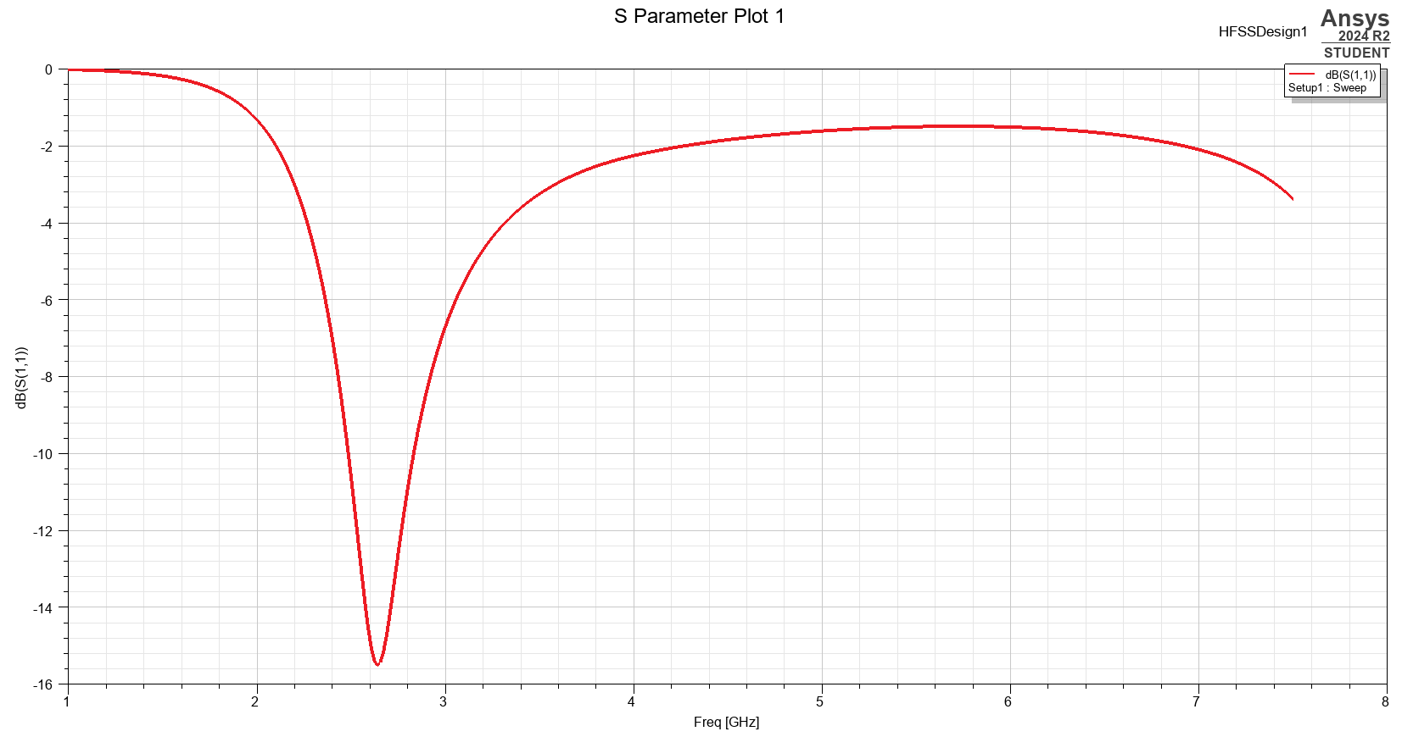
Figure 10 The S-parameter plot of the simulated dipole antenna

Radiation pattern of the antenna
Figure 11 shows the radiation pattern of an antenna. It shows what is expected of a dipole antenna with the maximum radiation perpendicular to the centre of the antennas axis, aswell as no radiation along its axis [5].
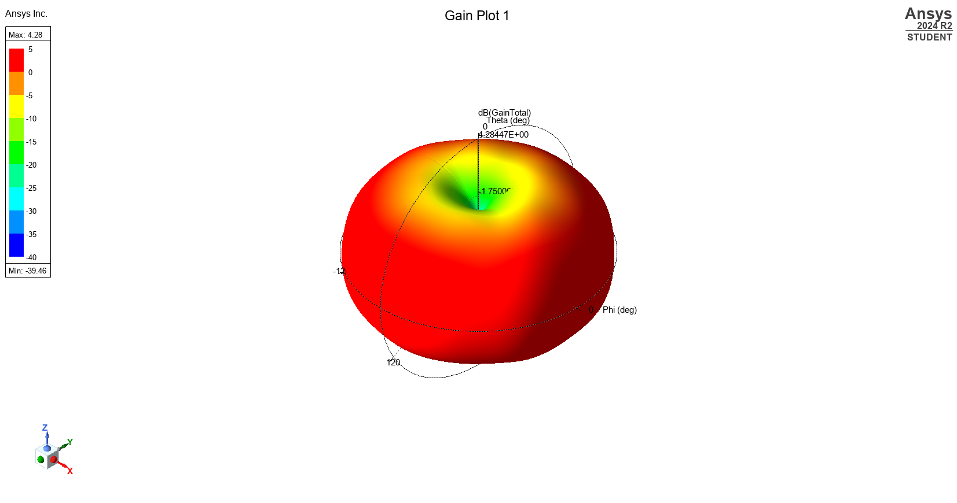
Figure 11 The radiation pattern of the dipole antenna

Task 2 discussion
The purpose of task 2 was to design and simulate a half wave dipole antenna with a wavelength od 231mm. Both the target frequency and dipole length where able to be determined from the wavelength, with the target frequency being 1.297GHz and the dipole length being calculated at being 0.116m.
The simulated S-parameter plot (Figure 10) showed a minimum reflection S11 point at approximately 2.64 GHz, rather than the anticipated 1.297 GHz. This is a significant frequency shift and suggests that the simulated antenna did not transmit at the target wavelength. This inaccuracy could have been caused by the model in the simulation not fully representing the ideal dipole antenna, or inaccuracies in the modelling of the lumped node, as if the gap or feed structure was not idea it could affect the antennas output greatly [6].

Conclusion
The lab report looked at two electromagnetic structures created and simulated in Ansys. The two rectangular wavelength simulations behaved as was expected from the theoretical calculations done before the simulations, with only small discrepancies between the ideal calculations and the simulated results. The Teflon rectangular waveguide also produced lower frequency cutoffs when compared to the vacuum filled waveguide. This was also expected to happen due to the higher relative permittivity of Teflon compared to a vacuum. The port fields also showed expected behaviour doing the two simulations, with the halfwave lengths increasing as additional modes where added to the simulations.
The half-wave dipole antenna model differed from the ideal calculations done before the simulations. The length of the dipole antenna matched the model, however the simulated S-parameter plot indicated that the simulation transmitted at 2.64GHz rather than the expected frequency of 1.297GHz. As the simulated result was almost exactly double the expected frequency, an error in the model is most likely to be the cause of the discrepancy rather than an error with the simulation. This is backed up by the simulation showing the expected radiation pattern of a dipole antenna.

References

[1] | S. A. L. M. Marefat Fazli, “THE ROLE OF ELECTROMAGNETIC WAVES IN MODERN COMMUNICATIONS,” Academic research in educational sciences, vol. 5, no. 7, 2024.
[2] | Ansys, “Module 2: Boundaries and Simulation Space,” 2020. [Online]. Available: https://innovationspace.ansys.com/courses/wp-content/uploads/2021/07/HFSS_GS_2020R2_EN_LE2_BoundsSimSpace.pdf. [Accessed 25 4 2025].
[3] | A. Learning, “Modelling Signal Inputs with Ansys HFSS Using Wave Ports and Lumped Ports,” 25 Febuary 2021. [Online]. Available: https://www.youtube.com/watch?v=KkiCTtLegjQ. [Accessed 23 April 2025].
[4] | Optics, “Ports and Lumped Ports for Wave Electromagnetics Problems,” 9 March 2015. [Online]. Available: https://optics1043.rssing.com/chan-55567357/article4.html. [Accessed 1 May 2025].
[5] | Antenna Theory, “The Dipole Antenna,” [Online]. Available: https://www.antenna-theory.com/antennas/dipole.php. [Accessed 26 April 2025].
[6] | A. Bhuddi, “How to Use Lumped Elements to Model a Mechanical System,” 19 May 2019. [Online]. Available: https://www.comsol.com/blogs/how-to-use-lumped-elements-to-model-a-mechanical-system. [Accessed April 24 2025].

