Name: Bethany Stock
Student Number: 1902668
Module: Advanced Character Animation (M6X02056)

Submission Links:
Link to blog: https://uni-animationblog.neocities.org/BlogEntries.html
Link to animations: https://youtu.be/9cX3FevUedQ
NOTE: At the recommendation of my lecturer, I have included the blog posts compiled below in the event that the website is not accessible.

Animation Progress November 1st – November 7th
This week, I decided on what I would do for my animation and started planning it.
As this assignment is meant to support our independent project, I had initially considered on animating a human with the idea of animating them using a variety of weapons to give better insight into how weapons are handled for when it was time to animate the attack animations for our character in our independent project and created some test models, one of which was a low-poly humanoid model (Fig. 1) whilst the other was more stickman-like (Fig. 2).
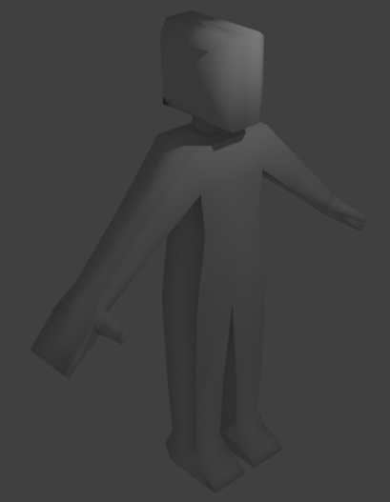
Fig. 1
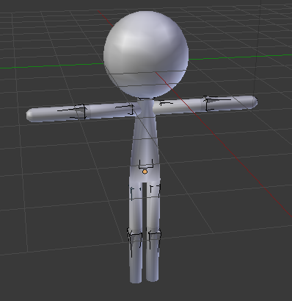
Fig. 2

However, I ultimately decided to go with animating a monster instead, as monsters would also appear in the game and I found it more enjoyable and expressive to animate with when testing the rigs.
For the model that I will use, I chose to use a model (Fig. 3) of the character Charizard [1] from the Pokemon franchise [2].
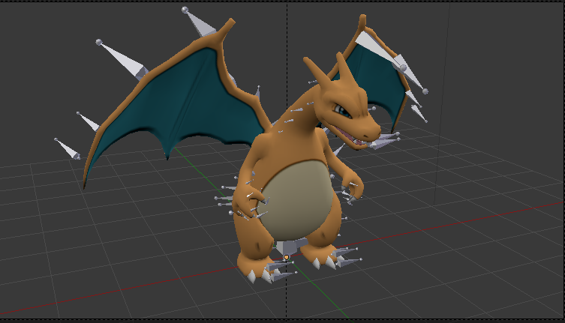
Fig. 3
Initially, I had some trouble importing this into Blender as I would get an error message when I tried to import it due to the model using an unsupported version of the FBX file format (Fig. 4).
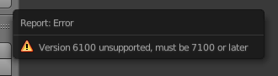
Fig. 4
To fix the model and make it compatible with Blender, I used Autodesk’s FBX converter tool [3] (Fig. 5) to convert it into a FBX file that would be compatible with Blender.
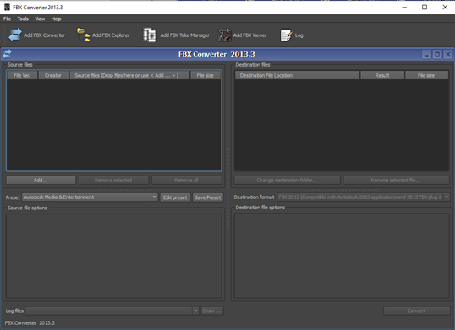
Fig. 5
Now that I had converted the model into a compatible format, I was then able to successfully import it into Blender (Fig. 6).

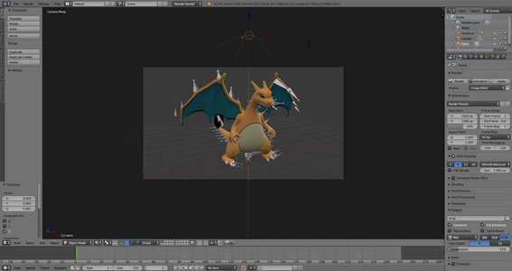
Fig. 6
Now that I had settled on what I was going to animate, I also needed to create a blog to record my progress.
To create the blog, I had considered a range of options such as Wordpress [4] and Wix [5]. However, I ultimately decided that I would create my own website from scratch for the blog so that I could additionally develop my web development skills when working on the animation.
As I had little to no experience with developing a website from scratch, I looked online for tutorials and came across an “Intro to Web Development with HTML and CSS” course on Zenva [6].
This course comprised of around 23 videos which were all under 10 minutes, with most being under 5 minutes which made them very easy to follow and put together a website using HTML and CSS.
Much like how I needed a 3D modelling program for the animation, I also required an IDE (Integrated Development Environment) to code the website and went with the Atom IDE [7] (Fig. 7), as this is my IDE of choice.
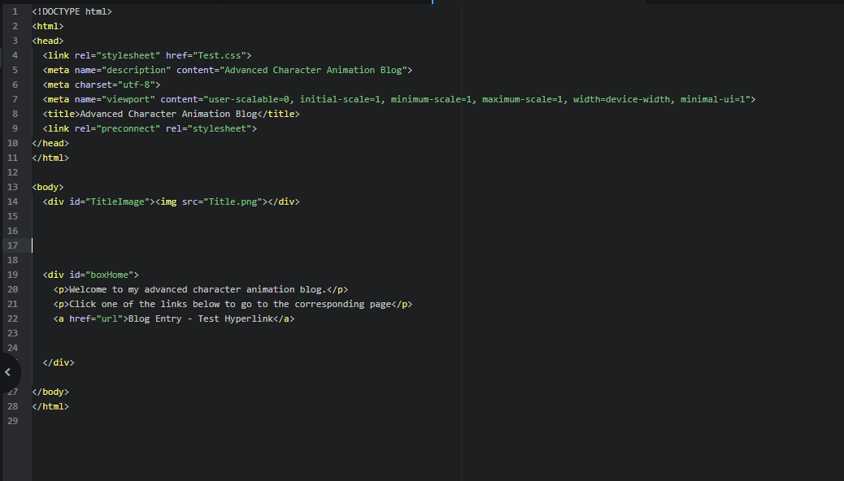
Fig. 7
After spending some time programming, I finally create a website that I could post updates on my animation to (Fig. 8).
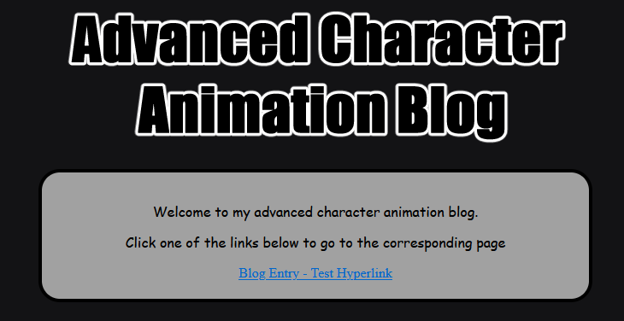
Fig. 8
After coding my website, I needed a web hosting service to host the website so that it could be accessed by others and decided to go with Neocities [8], a web hosting service for static webpages which is perfect for my website.
Setting up my website on Neocities was easy as, after creating my website, all I needed to do was click and drag my website’s HTML and CSS files into the browser and it was ready (Fig. 9).
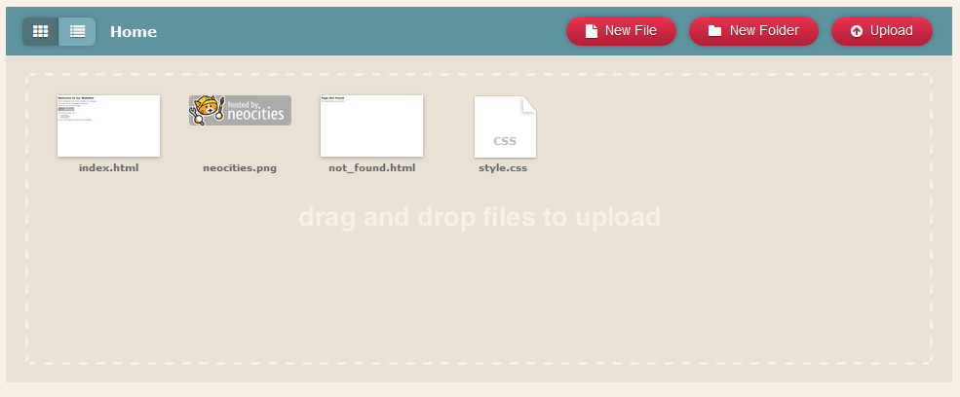
Fig. 9
One downside of the website being a static website is that I would need to create the HTML pages for blog entries and manually upload them to the site, however, I think this was a fine trade-off for having total customisation over my website.
Week summary: During this week, I decided on what I would be animating and acquired a model that I was going to use. I also created a website where I would be uploading my blog posts to with updates on my progress.

Animation Progress November 8th – November 12th
This week, I began creating some of the animations.
As mentioned in the previous blog post, the animation software I am using is Blender [9]. Blender is a 3D modelling and animation software that I have used previously and as such, I know my way around the program. However, despite my past experiences, it has been quite a while since I had last used the program so I needed to refresh myself on how to use the program before I could start animating in it.
To do this, I searched for videos on rigging and animation to refresh my knowledge and watched videos on rigging [10] and animating [11] in Blender.
After refreshing myself on how to use the software, I began to create an animation with the model I had chosen for the assignment. Fortunately, this model was already rigged so I would not have to create a skeleton and rig it myself (Fig. 10).
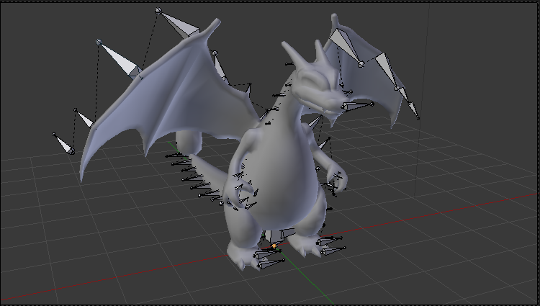
Fig. 10
For the first animation, I had the model roar and move its wings.
After creating this animation and previewing it in Blender, it had come to my attention that Blender did not have the option to output the animation as a video and that the “Render animation” option simply rendered it as a sequence of separate images so I would need an external video editing software to compile the image sequence into a video.
To render the animation in Blender itself, I just had to go to the “Render” tab on the menu and choose “Render Animation” (Fig.11).
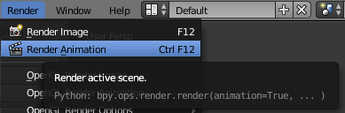
Fig. 11
After rendering the frames of the animation, it was time to compile them together in an external video editing software.
The software I used for this being Vegas Pro 16 [12] (Fig. 12) as, like with Atom, it was a program I already had installed.
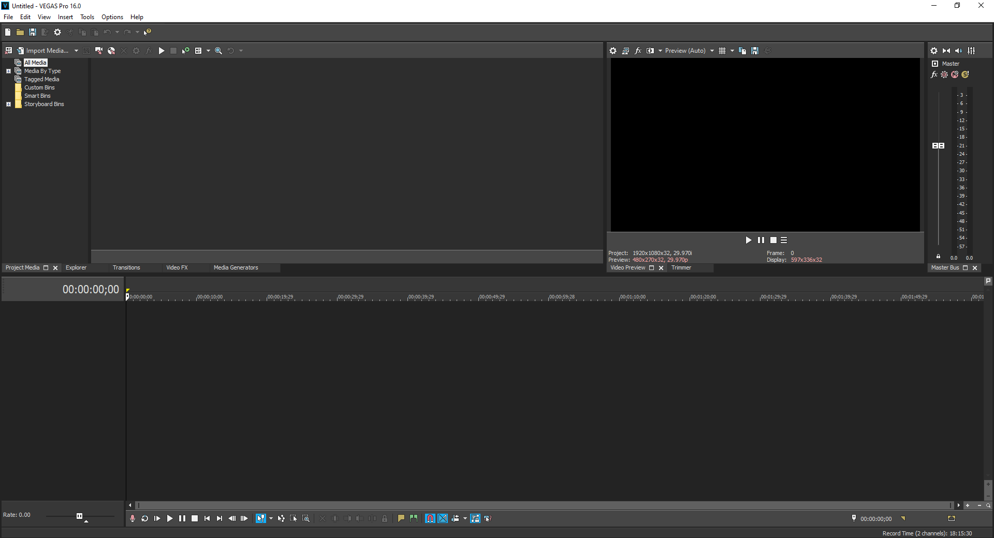
Fig. 12

There were some initial issues when inserting the images into the program, as they would play at the wrong framerate. To fix this, I watched a video tutorial on how to change the framerate [13].
After viewing the video, I changed the framerate in the software to 25 frames per second, which is the framerate that I had rendered the animation as in Blender, and the video was ready to be exported.
After successfully exporting that video and having my software configured properly, I began on another animation. This time the animation was of the dragon flapping its wings while flying in the sky.
For this animation, I carried out research on how bats manoeuvre their wings when flying. Initially, I had considered researching birds but I decided to go with bats instead as their wings are closer in build to the dragon’s wings than birds wings are (Fig. 13).
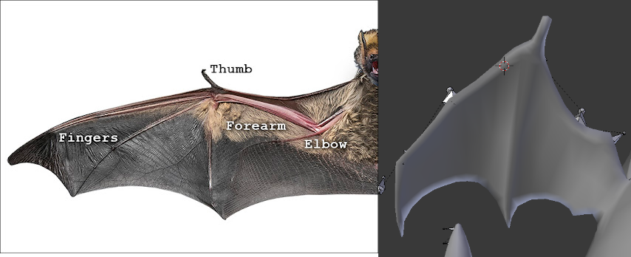
Comparison between a bat’s wing [14] and the wing of the model. Fig. 13.
After I settled on using bats as the reference for the animation, I carried out research online of bats flapping their wings and watched a video on the bats flying capabilities [15] which I looked at when creating reference sheets consisting of top-down and side view sketches based on the bats movements which I could use when creating the animation (Fig. 14) (Fig. 15).
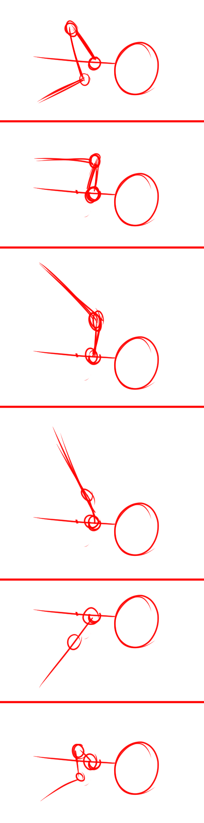
Fig. 14
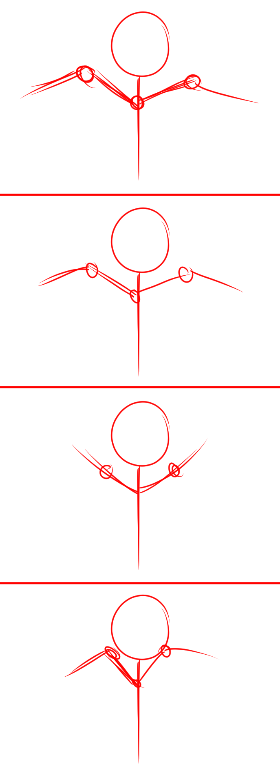
Fig. 15
After creating the reference sheet, I began working on the flying animation based on it (Fig. 16).
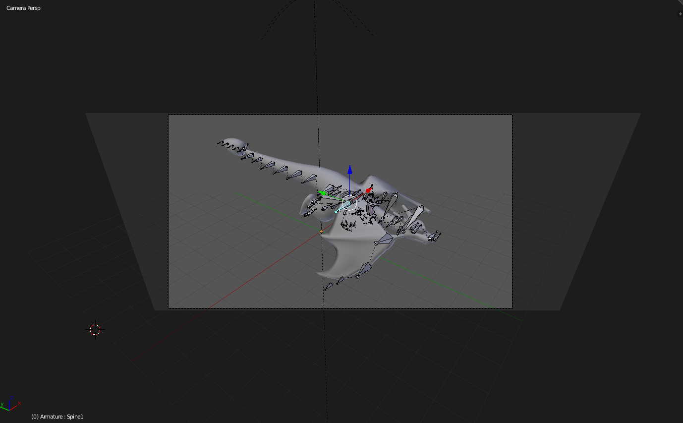
Fig. 16

Week summary: Rendered an animation in Blender as a test, made a start on a flying animation and a roaring animation, configured video editing software to render at 25 frames per second.

Animation Progress November 20th – November 26th
This week, I received feedback from my lecturer on my animations so far and began to apply the feedback to the animations.
One piece of feedback I had received was to add a stomping animation to the animation of the dragon roaring, which I added (Fig. 17).
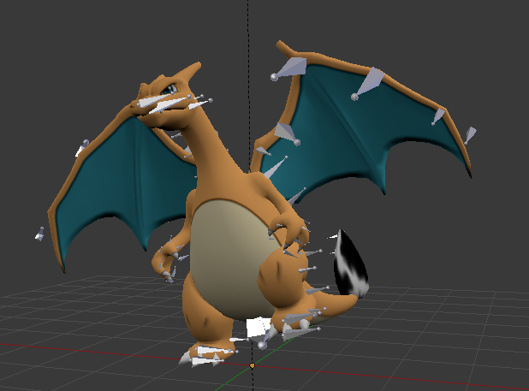
Model midway through stomping. Fig. 17.
While this next part was not part of the feedback, I had decided to add more head flailing and roaring to the end part of the animation as well and the dragon now braces itself after the initial roar before going in for a more intense roar (Fig. 18).
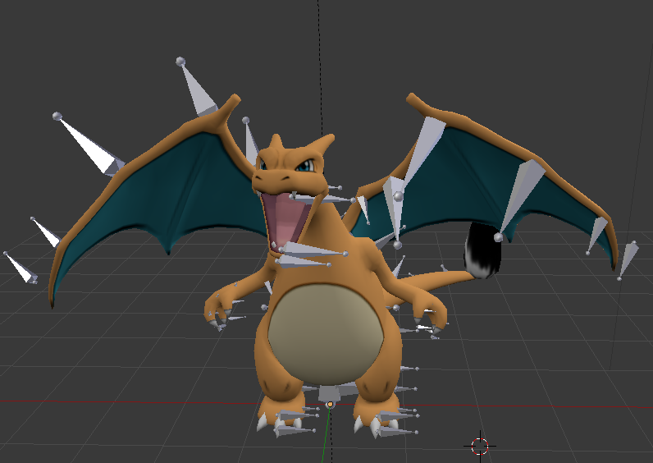
Fig. 18
The other feedback I had gotten was for the flying animation, which was to make the wings flap down quicker. This was an easy adjustment to make and I also adjusted the animation slightly so it appears smoother and more fluid when looping.

Animation Progress November 27th – December 2nd
This week I had received further feedback and began applying it to the animation like last week.
One piece of feedback I had received was to make the dragon look down as they flap their wings. This was easy to add (Fig. 19) and I also had the dragon’s head return to a neutral position after looking around before the dragon performs a barrel roll, which was also part of the feedback.
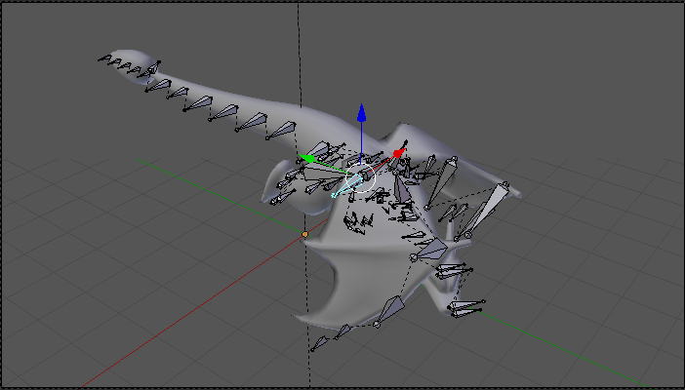
Fig. 19

When implementing the barrel roll, I had researched a video of an eagle hunting prey [16] and took note of how it would spin in the air and created a reference sheet based on this that I would use when animating the barrel roll (Fig. 20).
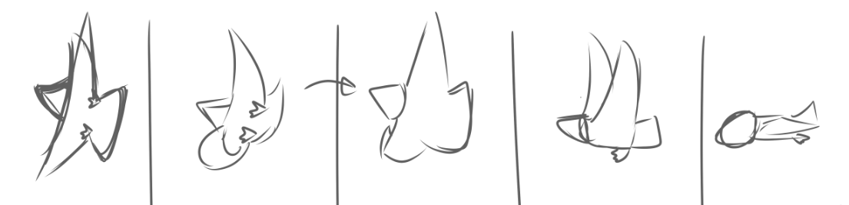
Fig. 20
The barrel roll portion had caused some issues initially, as the dragon would turn the correct way but then turn 360° the other way. I had no idea what was causing this issue, but I was able to fix this by deleting the final frame of the animation and redoing it.
Additionally, I also created a background for the flying animation.
Up to this point, the background had merely been a blue gradient to act as a placeholder which sufficed as a placeholder although it looked like the dragon was floating in a blue void when viewing the animation.
When creating the actual background, I once again started out with a blue gradient, however, this time around I would add clouds to make it look like the dragon was actually flying in the sky.
To create the clouds, I watched two video tutorials [17][18] to get an idea as to how to go about drawing them.
After watching the tutorials, I began to draw a cloud that I would alter until I was satisfied with it.
After drawing the cloud, I would then apply a Gaussian blur to give it a cloud-like quality and began duplicating it. I would then resize and reposition these duplicates around the canvas, overlaying them at times to create larger clouds along with adding some extra detail. Clouds further back were also given a darker overlay to convey depth (Fig. 21).
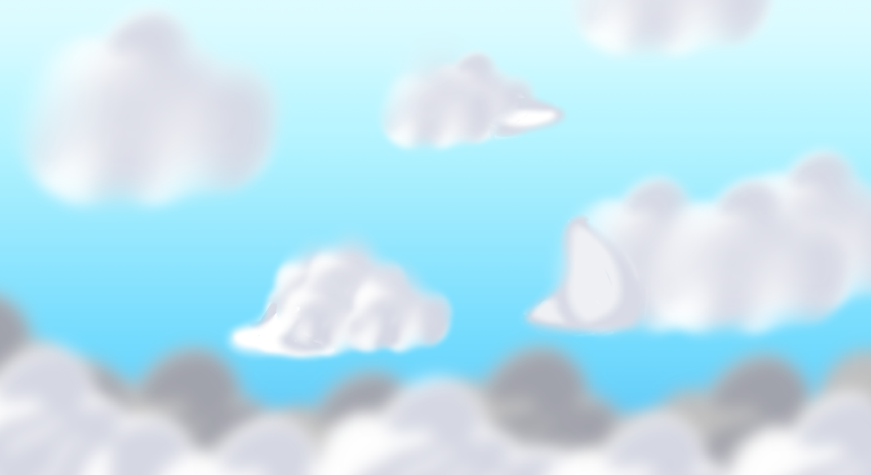
Fig. 21
Importing this texture into the scene was a simple task as I merely had to select the plane that was already acting as a background and replace the texture it was using with the new one I had just created (Fig. 22).
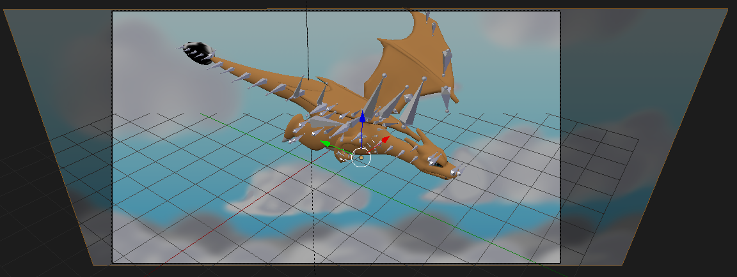
Fig. 22
In addition to adding more to the flying animation and creating a background for it, I also created an animation of the dragon moving its tail.
As a test to try out the tail bones of the rig, the first part of this animation was the dragon swaying its tail from side to side.
For the second half of the animation, I decided to have the tail move in a swishing movement like how small mammals may move their tails.
For research, I looked at videos of animals moving their tails to get an idea of how they move [19][20], along with making a reference sheet for the tail movement based off the research.
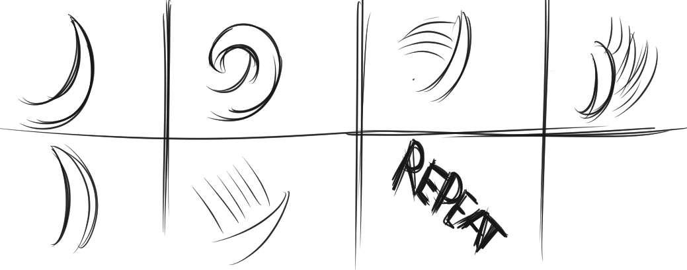
Fig. 23
Like the other animations, after I created the reference sheet I began work on the animation.
After finishing that part of the animation, I worked on an animation where the dragon lifted up their tail to hit the ground a few times.
Next, I began working on the environment for the roaring animation.
For the environment, I decided to have it set inside of a cave with some pits of lava and create an image that I would use as the lava texture (Fig. 24).
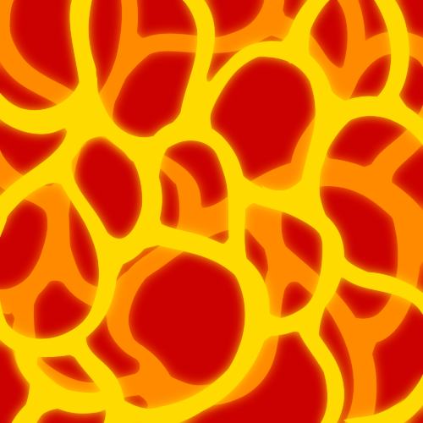
Fig. 24
After creating the lava texture, I began on creating the 3D environment within the animation itself. To begin, I created a flat plane which I positioned under the dragon (Fig. 25).
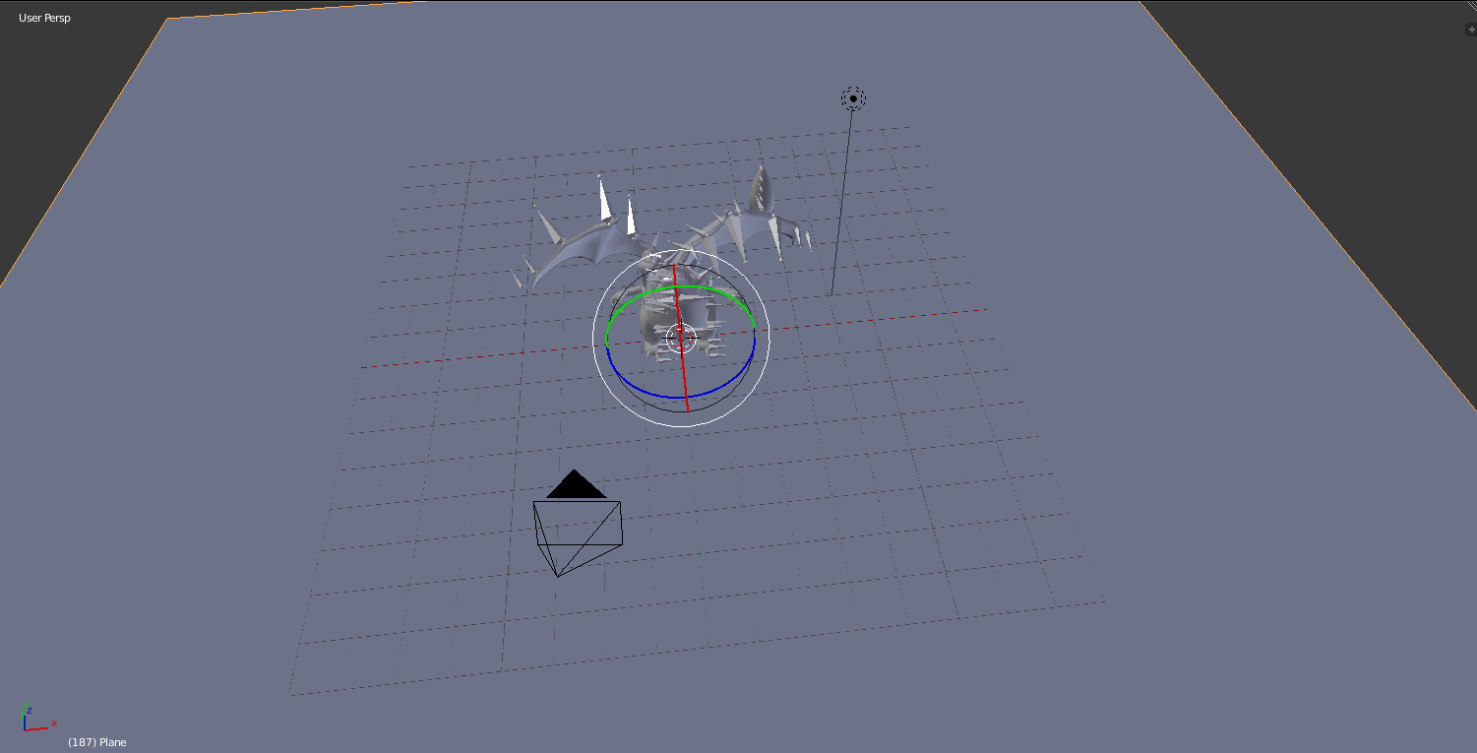
Fig. 25
After positioning this plane, I used the knife tool to create the edges from which I would extrude to create the lava pits (Fig. 26).
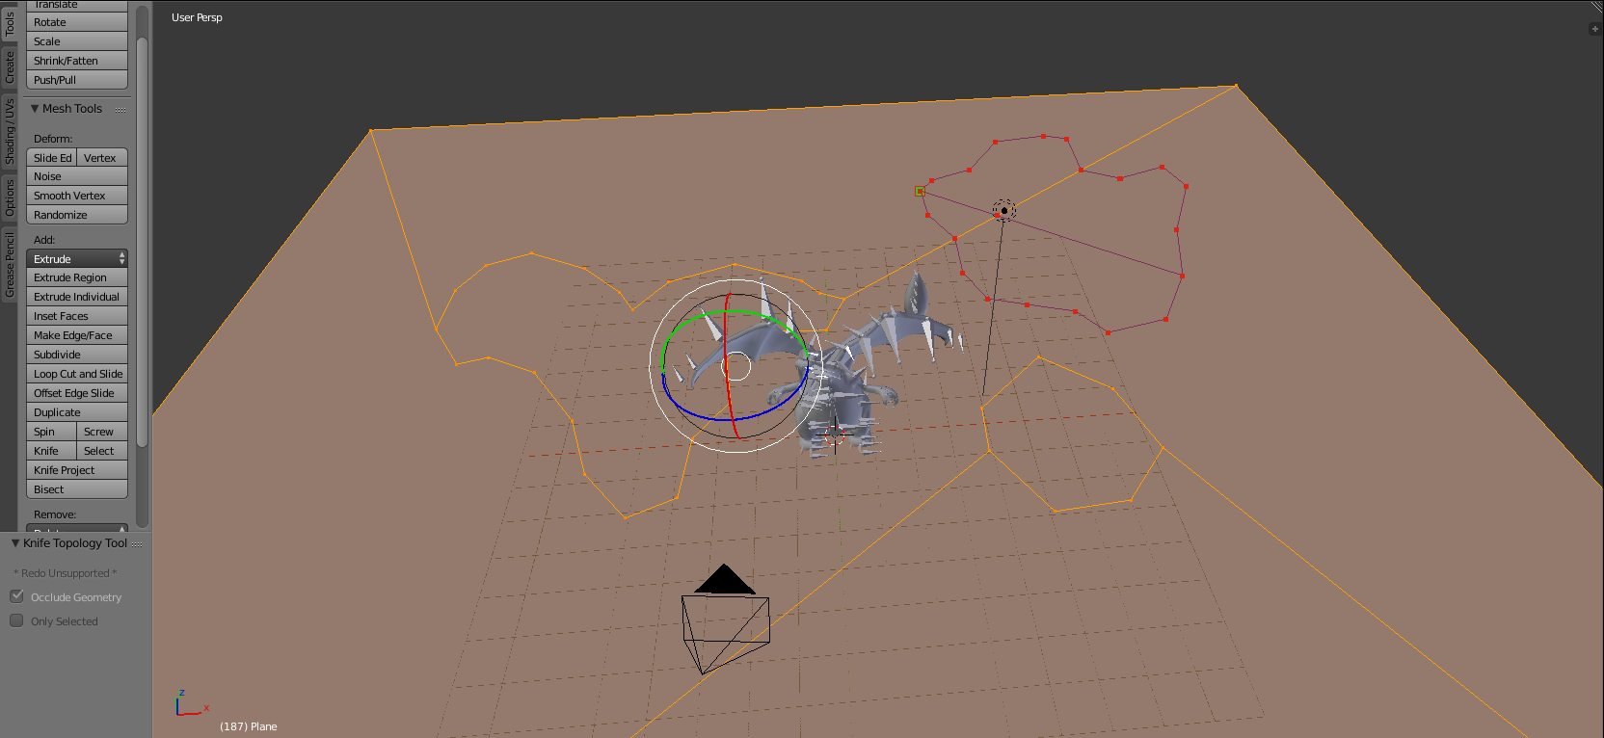
Fig. 26

After creating the edges, I extruded the newly created faces downwards (Fig. 27).
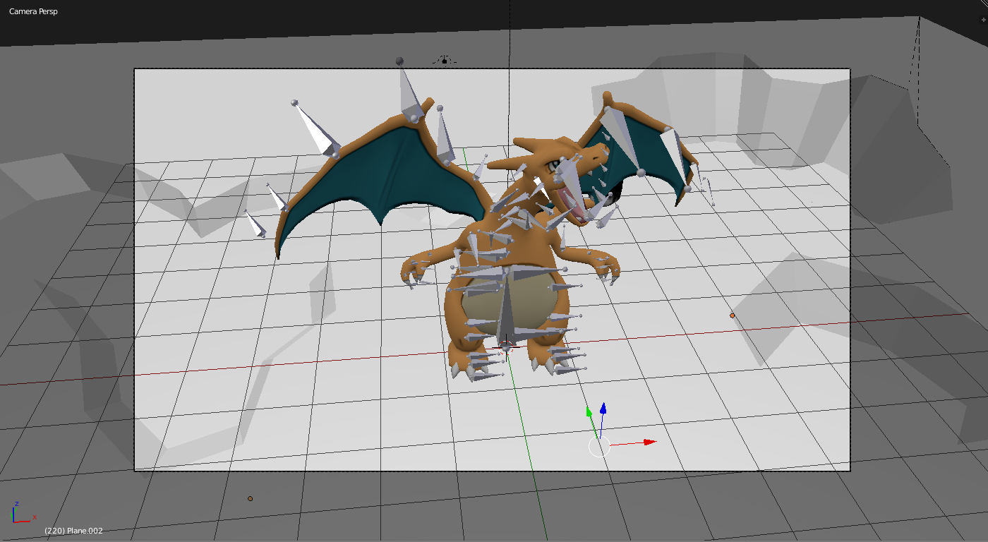
Fig. 27
After creating these craters, I then created another plane and applied the previously created lava texture to it and used it to fill in the craters. I also ticked the emit option in the texture tab (Fig. 28) to give it a glowing effect (Fig. 29).
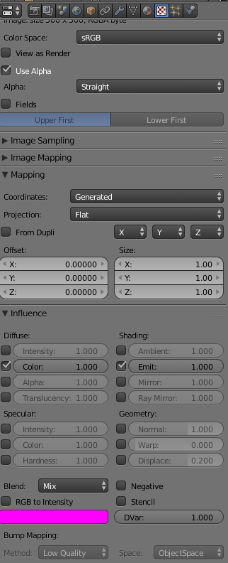
Fig. 28

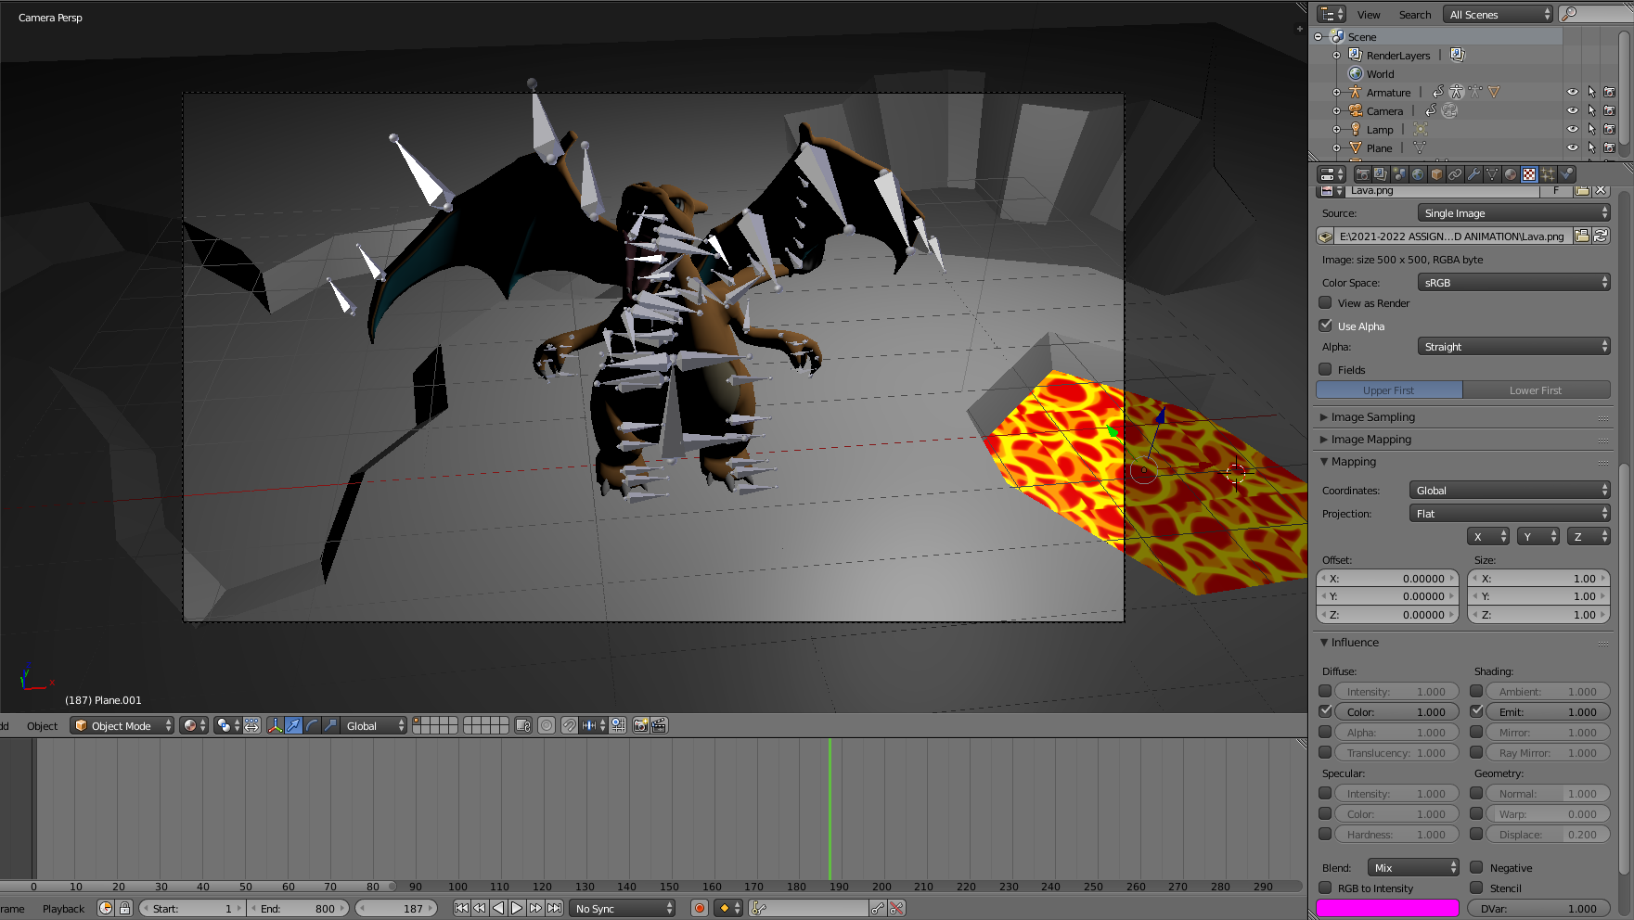
Fig. 29
Next, I created a light source and coloured it a light red-ish colour to make it look like the room was being illuminated by the light of the lava (Fig. 30).
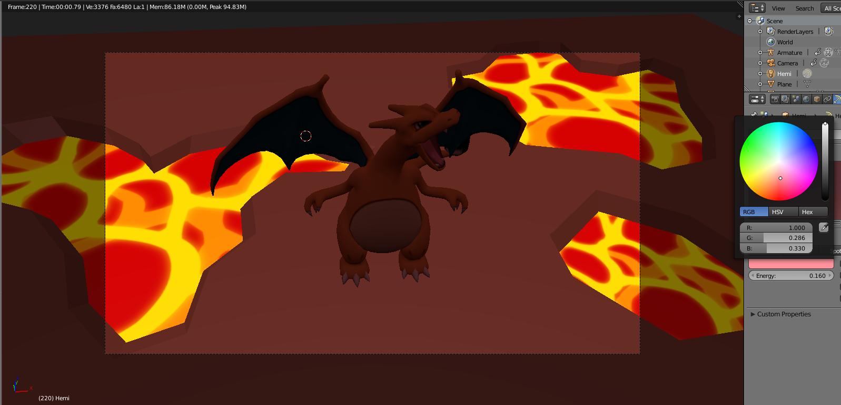
Fig. 30

I also repeated this process for the tail swinging animation (Fig. 31).
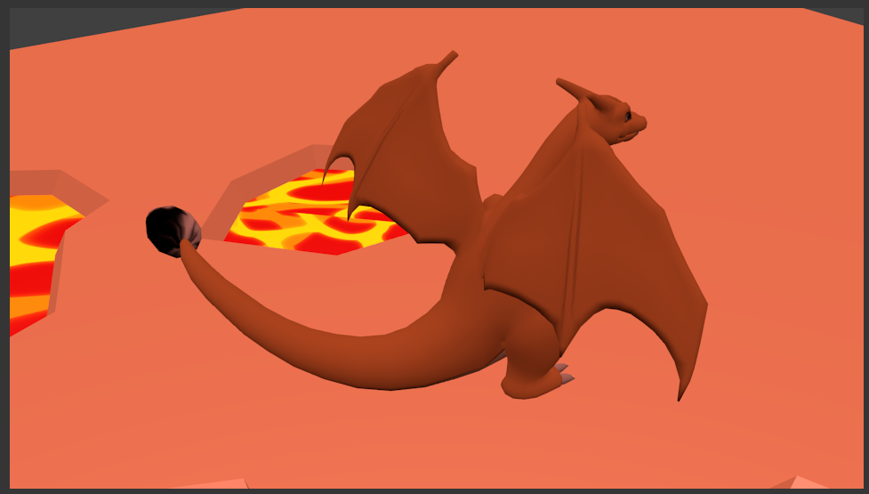
Fig. 31
After creating the environments, the animations were ready to be rendered.
After rendering the animation frames in Blender and rendering them into a video in Vegas Pro 16, I needed a place to host the videos and chose to use Youtube [21].

Submission Links:
Link to blog: https://uni-animationblog.neocities.org/BlogEntries.html
Link to animations: https://youtu.be/9cX3FevUedQ

References:
[1] “3DS – Pokémon X / Y – #006 Charizard – The Models Resource,” Models-resource.com. [Online]. Available: https://www.models-resource.com/3ds/pokemonxy/model/9158/. Visited on 04/11/2021.
[2] Pokemon Company, “Charizard | Pokedex,” Pokemon.com. [Online]. Available: https://www.pokemon.com/us/pokedex/charizard. Visited on 04/11/2021.
[3] Autodesk, “Fbx Converter Archives,” Autodesk.com. [Online]. Available: https://www.autodesk.com/developer-network/platform-technologies/fbx-converter-archives. Visited on 04/11/2021.
[4] “WordPress.Com: Fast, secure managed WordPress hosting,” Wordpress.com. [Online]. Available: https://wordpress.com/. Visited on 04/11/2021.
[5] “Free Website Builder,” Wix.com. [Online]. Available: https://www.wix.com/. Visited on 04/11/2021.
[6] “Intro to web development with HTML and CSS,” Zenva.com. [Online]. Available: https://academy.zenva.com/product/intro-to-web-development-with-html-and-css/. Visited on 04/11/2021.
[7] GitHub, Atom. 2014.
[8] “Neocities,” Neocities.org. [Online]. Available: https://neocities.org/. Visited on 04/11/2021.
[9] Blender Foundation, “blender.org - Home of the Blender project - Free and Open 3D Creation Software,” Blender.org. [Online]. Available: https://www.blender.org/. Visited on 12/11/2021.

[10] “How to start rigging in blender? - quick tutorial,” 10-Apr-2017. [Online]. Available: https://www.youtube.com/watch?v=n-BktRwy7UA. Visited on 12/11/2021.
[11] “Blender basic animation - inserting keyframes, getting the cube to move (new version),” 05-Oct-2012. [Online]. Available: https://www.youtube.com/watch?v=gMuJCiLS4yo. Visited on 12/11/2021.
[12] “VEGAS Pro: Video & audio for professionals,” Vegascreativesoftware.com. [Online]. Available: https://www.vegascreativesoftware.com/gb/vegas-pro/. Visited on 12/11/2021.
[13] “Sony Vegas - image sequence [tutorial 15],” 27-Aug-2011. [Online]. Available: https://www.youtube.com/watch?v=QiutgskKghw. Visited on 12/11/2021.
[14] “The Bat Wing,” Theamazingbat.com. [Online]. Available: http://theamazingbat.com/bat-natural-history/the-bat-wing/. Visited on 12/11/2021.
[15] “Bats - Mind blowing flying Capabilities in slow motion,” 19-Aug-2017. [Online]. Available: https://www.youtube.com/watch?v=ezF9yrplT2A. Visited on 12/11/2021.
[16] “Bird strike - do a barrel roll!,” 21-Oct-2008. [Online]. Available: https://www.youtube.com/watch?v=a88OoFOwE4o. Visited on 02/12/2021.
[17] “How to paint clouds – digital painting tutorial in Clip Studio Paint,” 03-Jan-2021. [Online]. Available: https://youtu.be/D10SaeX6LfQ. Visited on 02/12/2021.
[18] “HOW TO PAINT CLOUDS in photoshop | digital art tutorial,” 26-Dec-2018. [Online]. Available: https://youtu.be/YeURSgyZdGM. Visited on 02/12/2021.
[19] “Eastern Grey Squirrel can’t stop wagging its tail!,” 01-Nov-2012. [Online]. Available: https://www.youtube.com/watch?v=1u_RTQL_Stw. Visited on 02/12/2021.
[20] “Squirrel wagging tail,” 20-Feb-2015. [Online]. Available: https://www.youtube.com/watch?v=T1klQS79cao. Visited on 02/12/2021.
[21] “Youtube” Youtube.com. [Online]. Available: https://Youtube.com/. Visited on 02/12/2021.

