3/24/2025
University of Wales Trinity Saint David
London campus
E-Portfolio Link:
Module Name: Learning In the Digital Era
Module Code: ACCA 4025

Student Name: Ammar Doudou
Student ID: 2349672
Group: 1

Lecturer’s Name: Koushik Modak

LDE Assignment 1
E-Portfolio
Table of Contents
Introduction 2
Main Body 2
Task 1: Essential Academic and Employment Skills for the future career Path 2
Task 1 (a): Report on Essential Academic and Employment Skills 2
Task 1 (b): Evaluation of Task 1 (a) based on Similarity report 2
Task 2: Collaborative Mind Map and Individual Poster 2
Mind Map (Collaborative) 2
Poster (Individual) 2
Task 3: Virtual Collaboration and RefWorks 2
Report on Virtual Collaboration 2
Step-by-step process of using RefWorks with visuals 2
Task 4: E-Portfolio Creation and Evaluation 2
Task 4 (a): E-Portfolio Creation 2
Task 4 (b): Illustrative Review of E-Portfolio tool Selection 2
Conclusion 2
References 2
Task 1 References: 2
Task 3 References: 2

Introduction

Main Body

Task 1: Essential Academic and Employment Skills for the future career Path

Task 1 (a): Report on Essential Academic and Employment Skills
It's important to have good academic and work-related skills to do well in college and in future jobs. Communication, teamwork, problem-solving, time management, and knowing how to use technology are some of the most useful skills [ [1]

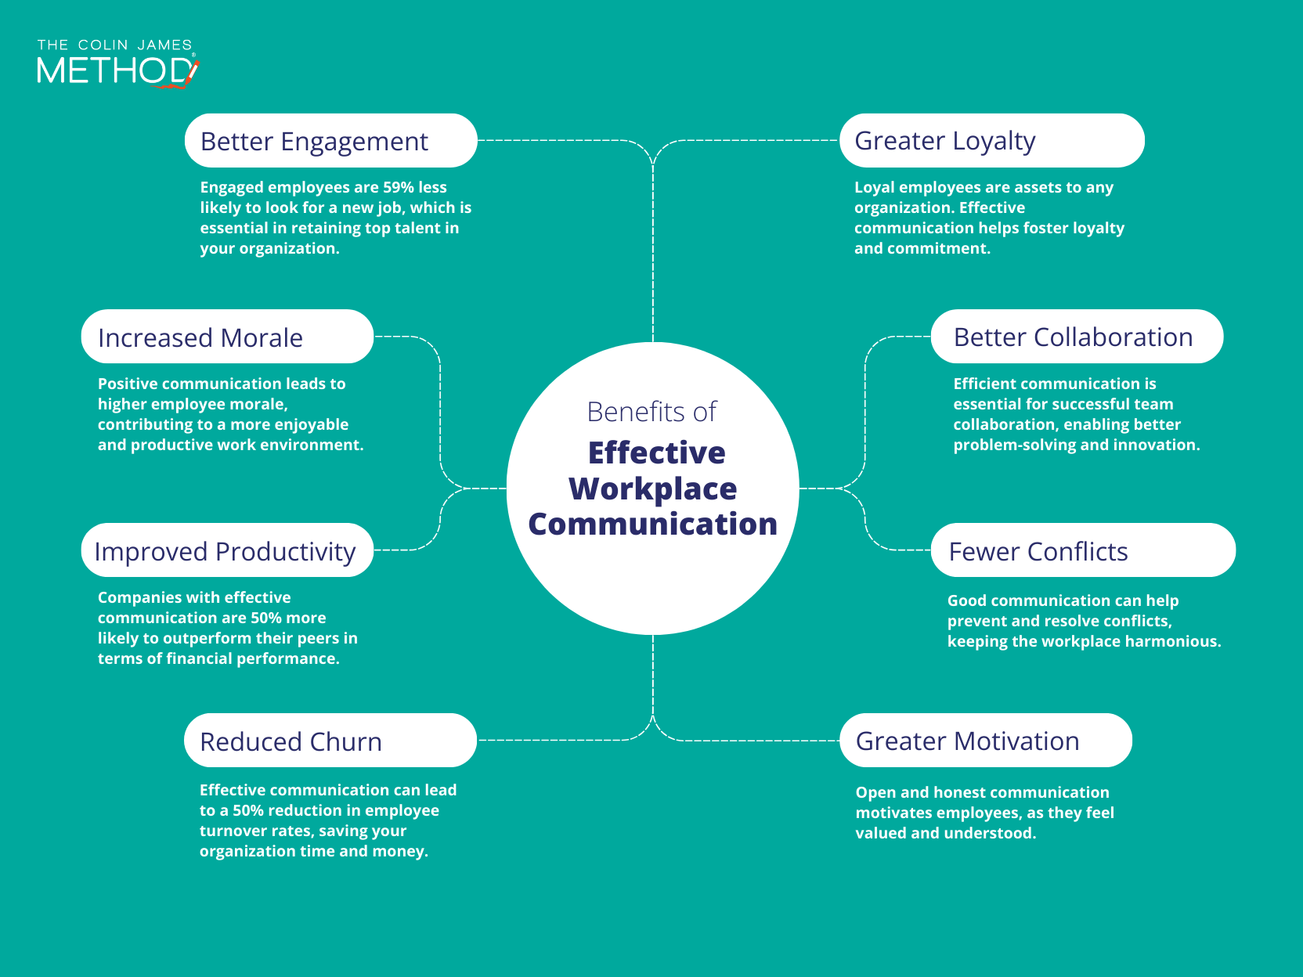

Communication is particularly crucial since it facilitates clear idea expression and mutual understanding. When working in a group, effective communication helps to avoid misunderstandings and gives everyone the confidence to voice their opinions. Additionally, teamwork is crucial because it allows individuals to leverage their own skills to accomplish a task more successfully [2]. Critical thinking and problem-solving abilities are also essential. When presented with obstacles, these skills enable people to make wise choices and come up with original solutions [3].Learners apply methods for problem-solving, for instance, when evaluating assignments or resolving technological problems. Additionally, time management is crucial since it keeps people organized and helps them achieve their objectives. Planning, establishing priorities, and avoiding procrastination are all components of effective time management, which lowers stress and boosts output [4]. these days, practically every industry uses technology, and proficiency with digital tools increases productivity and fosters teamwork.
I think these abilities will be very helpful in my future work as a software engineer. I will be able to interact and communicate well with clients and other developers. My ability to think critically and solve problems will help me create, test, and enhance software. I'll be able to keep organized, meet deadlines, and finish projects successfully with the aid of time management and digital skills. Developing these skills will enable me to succeed in college and pursue a lucrative career in software engineering. Technology is a big part of education and the profession in today's modern society. People who possess good digital abilities can efficiently use various software applications, conduct research, and communicate online [5].
these days, practically every industry uses technology, and proficiency with digital tools increases productivity and fosters teamwork.
I think these abilities will be very helpful in my future work as a software engineer. I will be able to interact and communicate well with clients and other developers. My ability to think critically and solve problems will help me create, test, and enhance software. I'll be able to keep organized, meet deadlines, and finish projects successfully with the aid of time management and digital skills. Developing these skills will enable me to succeed in college and pursue a lucrative career in software engineering.

Task 1 (b): Evaluation of Task 1 (a) based on Similarity report

