L4 - Introduction to Web and Database Concepts

DATABASE ANALYSIS & design

Rhys Davies | Id: 2008896 | 5 may 2021

Contents
1 Introduction 2
1.1 Abstract 2
1.2 The Brief (User Requirement) 2
2 Design 2
2.1 Context Diagram 2
2.2 Level 0 Data Flow Diagram (DFD) 3
Entity Relationship Diagram 4
3 Celtic Caterers’ Database 5
3.1 Tables and their relationships 5
3.2 Queries 6
3.3 Forms 7
3.4 Reports 8
3.5 Macros 9
4 Conclusion 10
4.1 Closing Statement 10
5 References 12

Figure 1: Context Diagram 3
Figure 2: Level 0 DFD 4
Figure 3: Entity Relationship Diagram 5
Figure 4: Tables and relationships 6
Figure 5: Kitchen Order Query 7
Figure 6: Customer Input Form 8
Figure 7: Report Calculation 8
Figure 8: Customer Invoice 9
Figure 9: Macros 10

Introduction

Abstract
The purpose of this short report is to demonstrate an understanding of the database concepts. The database in this case has been designed for Celtic Caterers as the name suggests they are a Catering company. Their current systems are largely paper based and needs updating to prevent clerical errors, double booking and to be able to keep track of orders and supplier invoices.
The first portion of the report will look at the design of the system with the second portion looking at the implementation of the database. The reports closing statement will reflect on the database and determine whether it satisfies the needs of the business.

The Brief (User Requirement)
The following key points were the focus when designing and building the database:
  - Provide a system that can generate printable invoices.
  - Able to look up past purchases
  - Able to query bookings, retrieving information about those bookings

Design
The new system has been designed using different diagrams; A Context Diagram, a Level 0 Data Flow Diagram, and an Entity Relationship Diagram.

Context Diagram
The purpose of this diagram is to illustrate the high-level inputs and outputs of the Data system. This diagram shows:
- The system itself (circle)
- The external entities (rectangles)
- Input Output (arrows)
One of the benefits of Context Diagrams are that they are very simple to understand and can communicate with any system efficiently and can be used to spot flaws in the system early on in the project. [1]
Celtic Caterers’ Context diagram can be seen in Figure 1: Context Diagram.
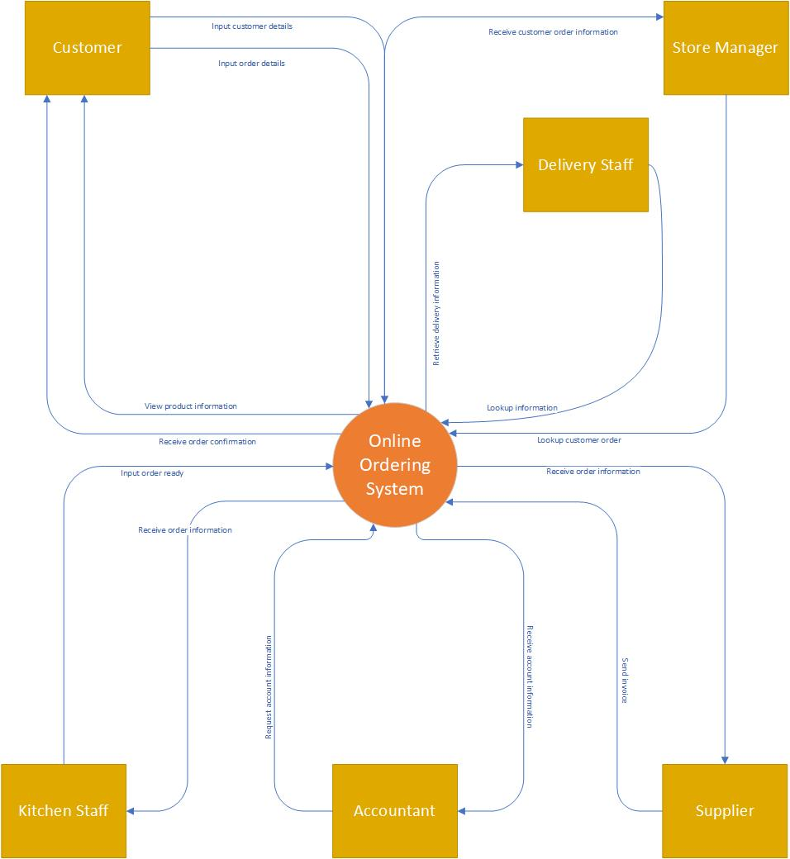
Figure 1: Context Diagram

Level 0 Data Flow Diagram (DFD)
These diagrams show a little more information about the proposed data system. These diagrams are made up of:
- Entities (squares)
- Processes (green rectangles)
- Data Stores (blue rectangles)
- Flow of Data (arrows)
The DFD is again, simple to understand and gives a little more detail regarding the different entities, the processes of the system, how data flows through the system and where it is stored. [2]
Celtic Caterers’ Level 0 DFD can be seen in Figure 2: Level 0 DFD
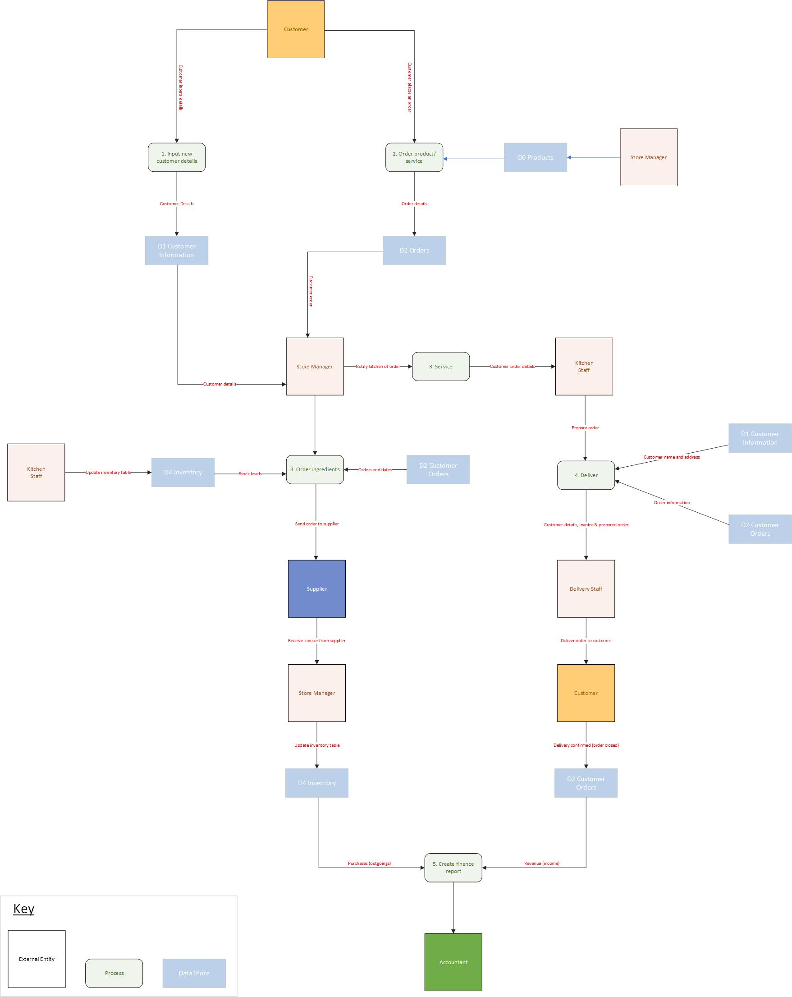
Figure 2: Level 0 DFD

Entity Relationship Diagram
The purpose of this diagram is to show the relationships between the different entities to give an indication of how a database could be structured. The diagram is made up of:
- Entities (rectangle table)
- Attributes (what’s in the table)
- Relationship Type
- Primary and Foreign Keys [3]
Celtic Caterers’ Entity Relationship Diagram can be seen in Figure 3: Entity Relationship Diagram.
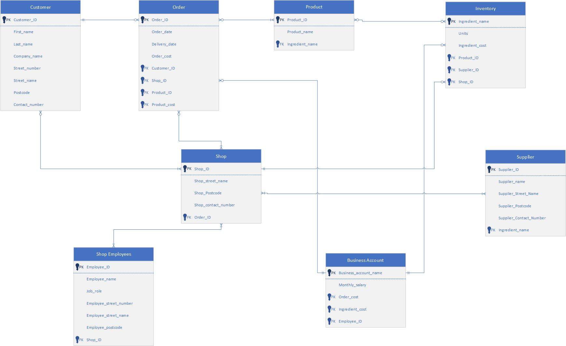
Figure 3: Entity Relationship Diagram

Celtic Caterers’ Database
Once the system was designed, the database was built using Microsoft Access software. The structure of the database and its function is highlighted in this section.

Tables and their relationships
Tables are where the data is stored. The entity relationship diagram was used to determine what data could be stored in the tables as well as how the different tables related to each other. This is illustrated in Figure 4: Tables and relationships.
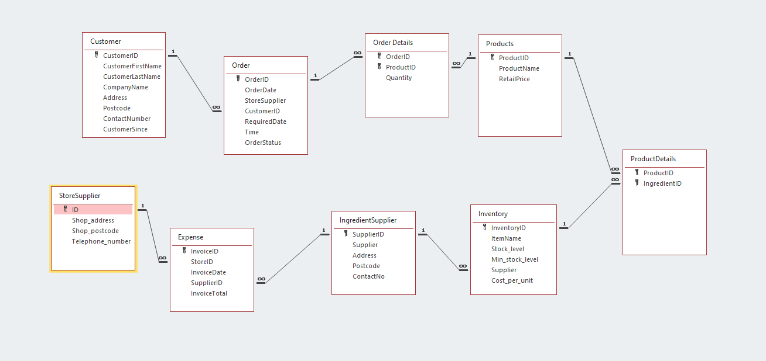
Figure 4: Tables and relationships
Please note that the tables, their attributes, and relationships may vary from the ERD. The ERD was an effective design tool. However, when the database was being built in Microsoft Access, it was realised that certain areas needed amending to ensure that the database functioned as intended.

Queries
In Microsoft Access, a Query is a request for data from the different tables. It is used to gather information on a particular subject, perform calculations and it can be used to edit data within the tables themselves.
“In a well-designed database, the data that you want to present through a form or report is usually located in multiple tables. A query can pull the information from various tables and assemble it for display in the form or report.” [4]
In this database, queries were used to find out information on the following:
- Delivery dates and Time
- Purchases (orders)
- Kitchen order Schedule and status of order
- Low Stock Levels
An example of a query can be seen in Figure 5: Kitchen Order Query
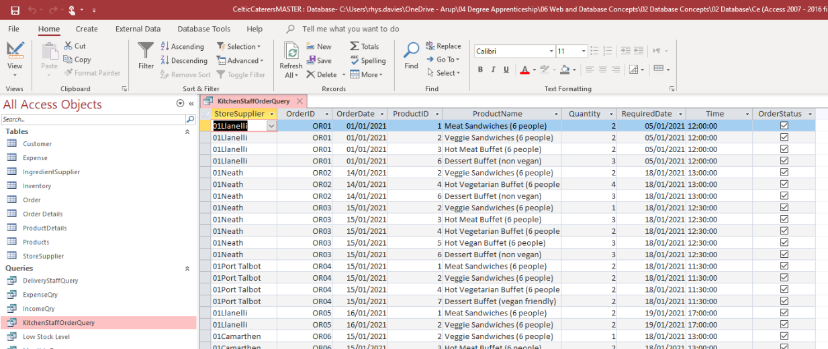
Figure 5: Kitchen Order Query
The kitchen staff at Celtic Caterers can find out:
- What orders they need to complete based on the ‘Store Supplier’ and ‘OrderID’
- What products are needed in each order and how many,
- When the order needs to be completed by,
- If the order is complete or not.

Forms
Forms are a way of displaying information for use. It can also be a more human-friendly way of inputting information to the database.
“If your Access desktop database is going to be used by multiple users, well-designed forms are essential for efficiency and data entry accuracy.” [5]
An example of a form can be seen in Figure 6: Customer Input Form. This form makes it easy to add a new customer to the database as well as being able to view their order history.

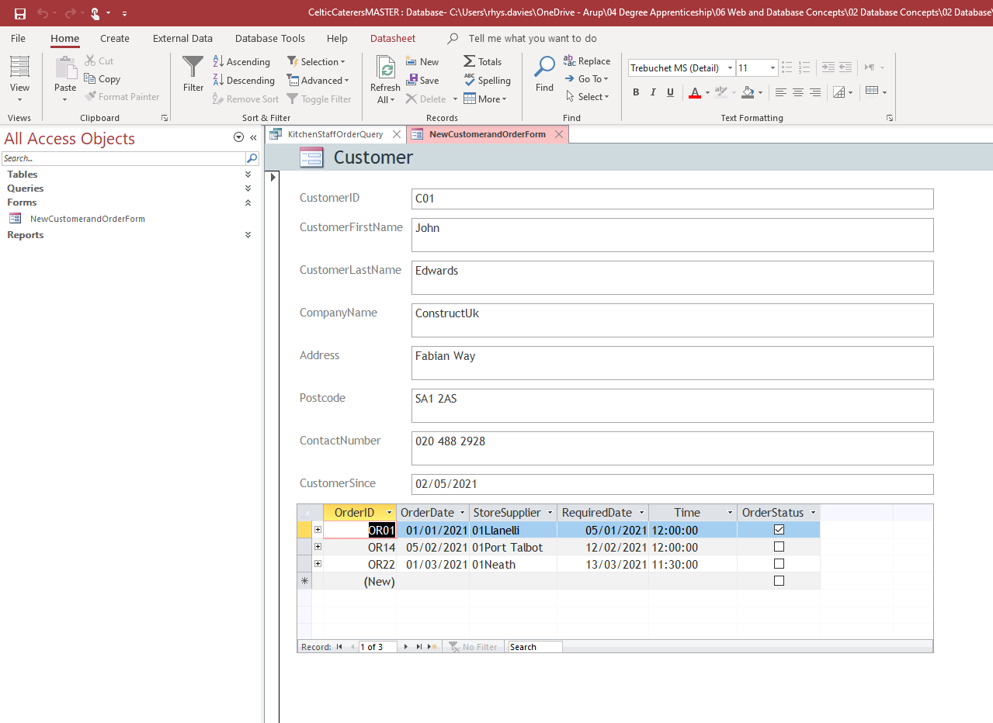
Figure 6: Customer Input Form

Reports
Reports are documents that display information on a subject. In Microsoft Access, a report is needed to be able to print information. Reports can also be used to calculate values. In Figure 7: Report Calculation, a formula is used to summarise to total income from customer orders.
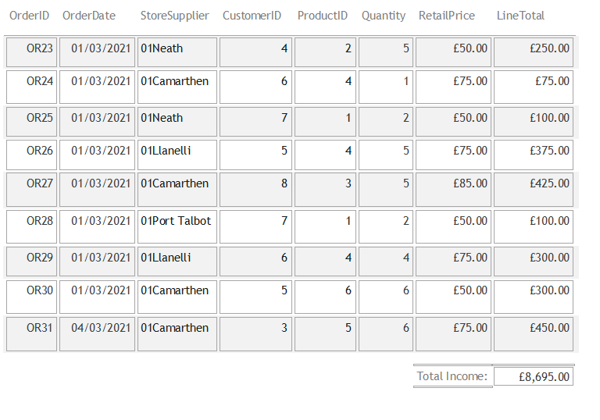
Figure 7: Report Calculation
A report can be used to generate customer invoices, this is show in Figure 8: Customer Invoice

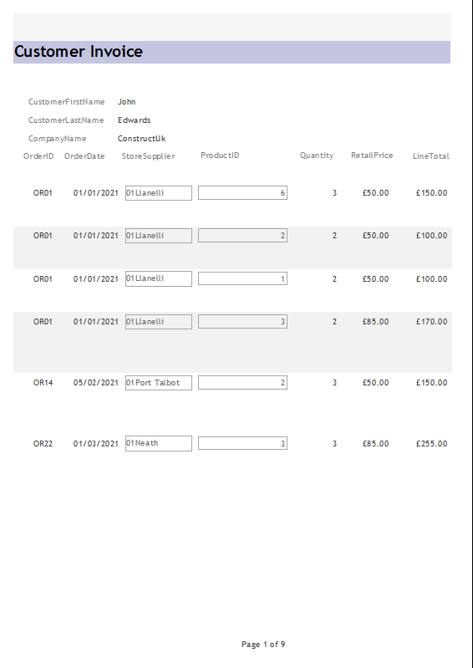
Figure 8: Customer Invoice

Macros
A macro is a tool that is used in the automation of tasks. They can be used to add additional functions to reports and forms in Microsoft Access. Two Macros have been added to the database:

- One allows the manager to add new customers and take orders by opening the form.
- The other opens the invoices
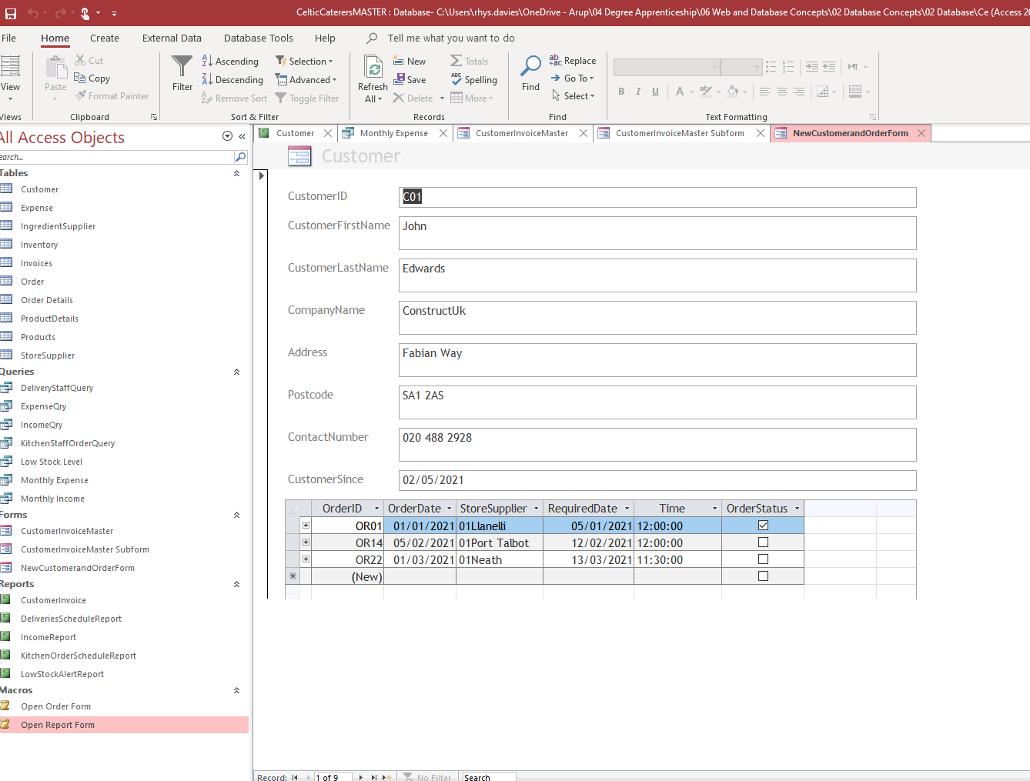
Figure 9: Macros

Conclusion

Closing Statement
A database has been created for Celtic Caterers with the aim of moving their records from paper based to a digital interrelated format. With the new system, the business can now store their orders within the database with the customer ID, Company name and order details etc. Celtic Caterers can query order information, sorting it by date, by shop and to understand which orders take priority.
The business can generate a customer invoice as shown in Figure 8: Customer Invoice. However, the invoice design needs further development as it displays all orders made by the customer instead of showing the products within the one order ID.
The business can update stock levels in the Inventory table and make orders to their approved suppliers, recording the invoices from them. A report has been created which lets the business know when the stock levels are below the minimum acceptable level. When they receive invoices from the supplier, they can record the cost in the Expense table and attach the invoice as a record.
To summarise, the database seems to function as intended and will make Celtic Caterers’ data recording more orderly and interconnected. This would reduce clerical errors and the risk of double booking. The business can now keep track of income and expense which will allow them to calculate their profit/loss more accurately. The invoice report system is too basic and requires further development.

Bibliography

[1] | Wondershare Edraw Max, “What is a Context Diagram – Explain with Examples,” [Online]. Available: https://www.edrawmax.com/context-diagram/. [Accessed 04 05 2021].
[2] | Lucidchart, “Data Flow Diagram Symbols, Types, and Tips,” [Online]. Available: https://www.lucidchart.com/blog/data-flow-diagram-tutorial#:~:text=Data%20flow%20diagram%20levels&text=Level%200%20DFDs%2C%20also%20known,its%20connections%20to%20external%20entities.. [Accessed 04 05 2021].
[3] | Guru99, “ER Diagram: Entity Relationship Diagram Model | DBMS Example,” [Online]. Available: https://www.guru99.com/er-diagram-tutorial-dbms.html. [Accessed 05 05 2021].
[4] | Microsoft, “Introduction to queries,” [Online]. Available: https://support.microsoft.com/en-us/office/introduction-to-queries-a9739a09-d3ff-4f36-8ac3-5760249fb65c#:~:text=A%20query%20can%20either%20be,delete%20data%20from%20a%20database.. [Accessed 05 05 2021].
[5] | Microsoft, “Create a form in Access,” [Online]. Available: https://support.microsoft.com/en-us/office/create-a-form-in-access-5d550a3d-92e1-4f38-9772-7e7e21e80c6b. [Accessed 2021 05 05].

References

[1] | Wondershare Edraw Max, “What is a Context Diagram – Explain with Examples,” [Online]. Available: https://www.edrawmax.com/context-diagram/. [Accessed 04 05 2021].
[2] | Lucidchart, “Data Flow Diagram Symbols, Types, and Tips,” [Online]. Available: https://www.lucidchart.com/blog/data-flow-diagram-tutorial#:~:text=Data%20flow%20diagram%20levels&text=Level%200%20DFDs%2C%20also%20known,its%20connections%20to%20external%20entities.. [Accessed 04 05 2021].
[3] | Guru99, “ER Diagram: Entity Relationship Diagram Model | DBMS Example,” [Online]. Available: https://www.guru99.com/er-diagram-tutorial-dbms.html. [Accessed 05 05 2021].
[4] | Microsoft, “Introduction to queries,” [Online]. Available: https://support.microsoft.com/en-us/office/introduction-to-queries-a9739a09-d3ff-4f36-8ac3-5760249fb65c#:~:text=A%20query%20can%20either%20be,delete%20data%20from%20a%20database.. [Accessed 05 05 2021].
[5] | Microsoft, “Create a form in Access,” [Online]. Available: https://support.microsoft.com/en-us/office/create-a-form-in-access-5d550a3d-92e1-4f38-9772-7e7e21e80c6b. [Accessed 2021 05 05].

