11/7/2025
Assessment 1
Student Name: Mehran Pouzesh Azar
Student ID: 2218967

Module NaMe: Usability Engineering
Module Code: ACCb6017
Lecturer: Koushik Modak
University of Wales Trinity saint david (London Campus)

Table of Contents
Introduction 2
Personas, Scenarios & UX Requirements 2
Information Collection Procedure 6
Designing for User-Friendliness 8
Wireframe Storyboards 11
Prototype Feedback and Evaluation 17
Conclusion & Future Work 18
References 20

Introduction
The objective of this report is to record the design and assessment process of a mobile prototype for the Cluedo game, with the goal of enhancing usability, accessibility, and engagement among a varied user demographic. The design prioritizes user-cantered design (UCD) and is informed by recognized principles from usability engineering (ISO 9241-210). The prototype was created using Figma and is showcased through wireframe storyboards (in PNG format) instead of refined visuals, thereby concentrating on interaction flow and usability rather than visual appeal.[1]
This report outlines the following components:
- Four comprehensive personas along with their corresponding usage scenarios and the resulting UX requirements.
- An explanation of the methods employed for user data collection, including surveys, interviews, and observation.
- The rationale behind design choices made for usability, supported by references to HCI literature.
- A summary of the wireframe storyboard screens and the navigation flow.
- The approach taken for gathering prototype feedback, including a summary of the results (both positive and negative) and reflections on the findings.
- Conclusions and recommendations for future actions.
This framework guarantees a clear connection from user needs to design decisions and evaluation outcomes, thereby anchoring the prototype in empirical user research and HCI theory.[2]

Personas, Scenarios & UX Requirements
Persona 1: Ethan Davies (University Student)

- Age: 21
- Background: Undergraduate student at Swansea, frequently experiences brief intervals between classes.
- Scenario: Ethan aims to swiftly initiate a multiplayer Cluedo session with friends while awaiting the commencement of a lecture.
- Goals: Reduce setup complexity, expedite matchmaking, facilitate seamless invitations to friends.
- Frustrations: Lengthy login procedures, sluggish loading times, perplexing menus.
- UX Requirements:
  - Guest or social login (minimal friction)
  - Quick-match "Start Game Now" feature
  - Distinct "Invite Friend" / share link capability
  - Rapid load/transition times

Persona 2: Margaret Lewis (Retired Teacher)
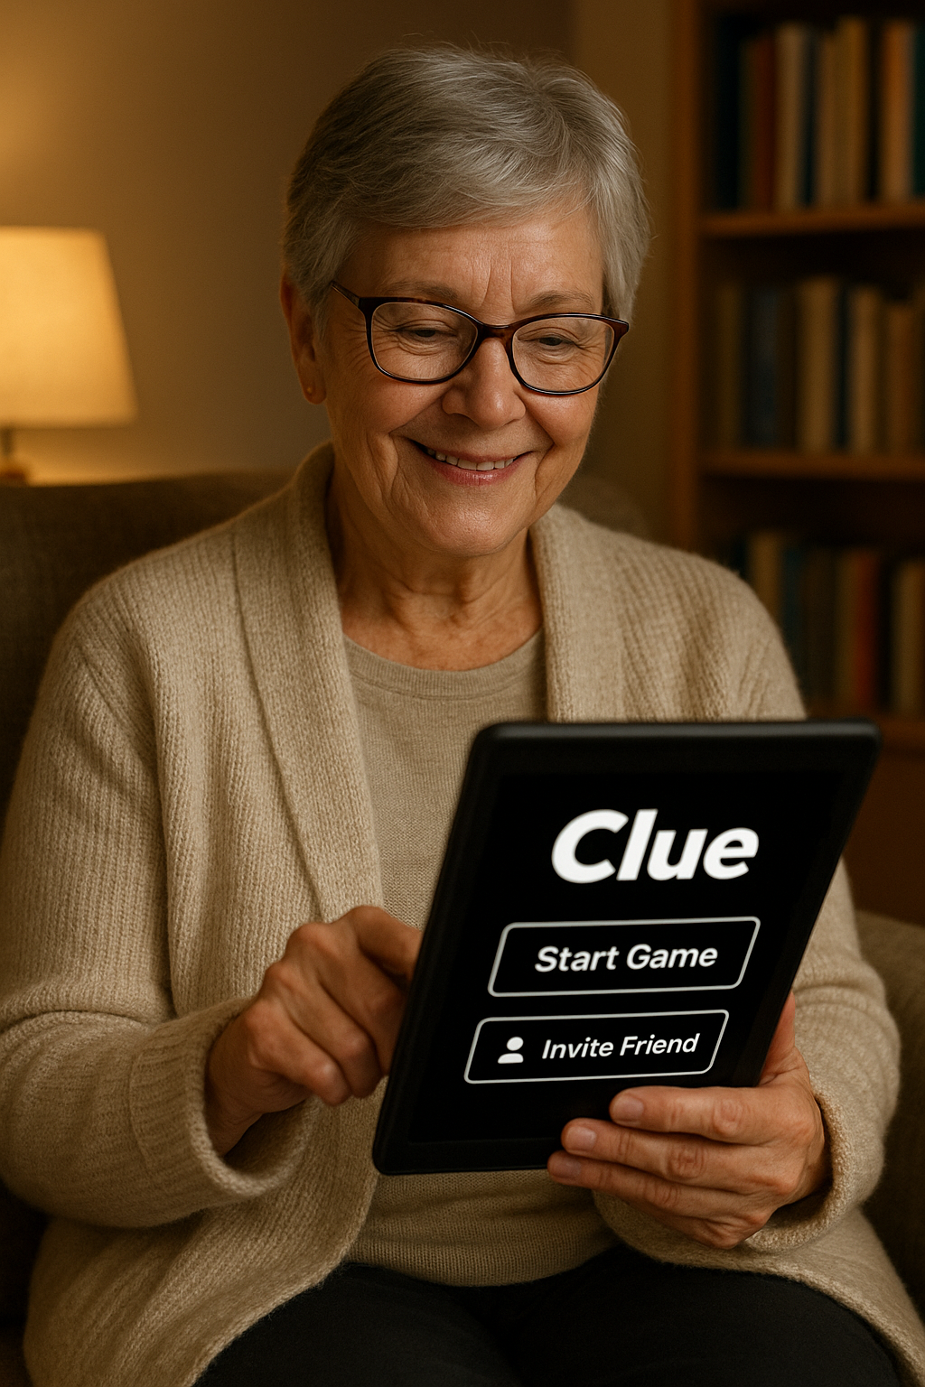
- Age: 65
- Background: Has a penchant for puzzle and mystery games, engages in leisurely gaming sessions.
- Scenario: In the evenings, Margaret utilizes her tablet, frequently in solitude.
- Goals: Seeks comfortable reading experiences, clarity in instructions, and a forgiving pace.
- Frustrations: Finds small text, low contrast, and ambiguous icons to be problematic.
- UX Requirements:
  - Requires large fonts and icons
  - Needs high contrast (for instance, black/white or a bold contrast mode)
  - Desires optional voice narration or text walkthroughs
  - Prefers slower transitions and ample time to confirm choices

Persona 3: Ravi Patel (IT Professional, Colour-blind)
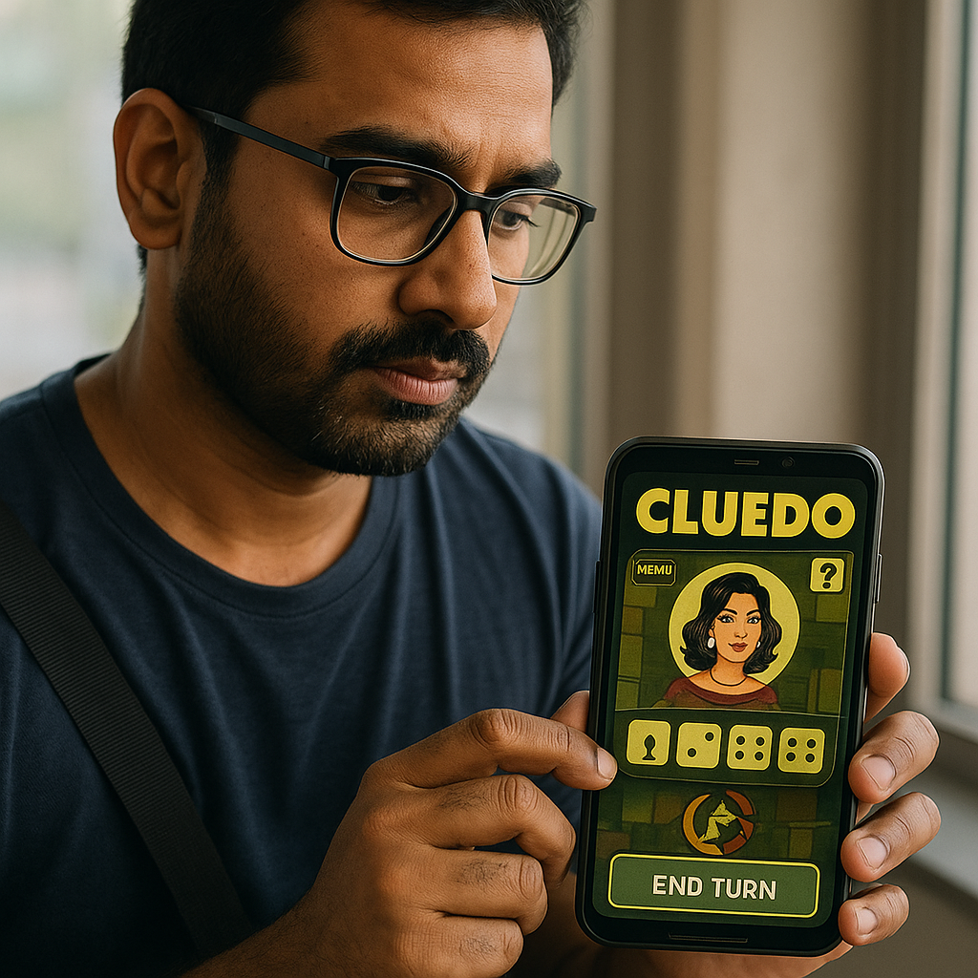
- Age: 34
- Background: Extensive working hours, commutes by train, utilizes an Android device.
- Scenario: Ravi engages in gaming during his commutes, frequently in ambient lighting conditions.
- Goals: Swiftly resume gameplay, guarantee visual clarity for individuals with colour-blindness.
- Frustrations: Red and green visual components are indistinguishable, frequent disruptions.
- UX Requirements:
  - Alternative colour schemes (e.g., for protanopia/deuteranopia)
  - Clear visual differentiation beyond colour (patterns, icons)
  - Auto-save or resume capability
  - Minimal data consumption / offline alternative

Persona 4: Chloe Nguyen (Casual Gamer)
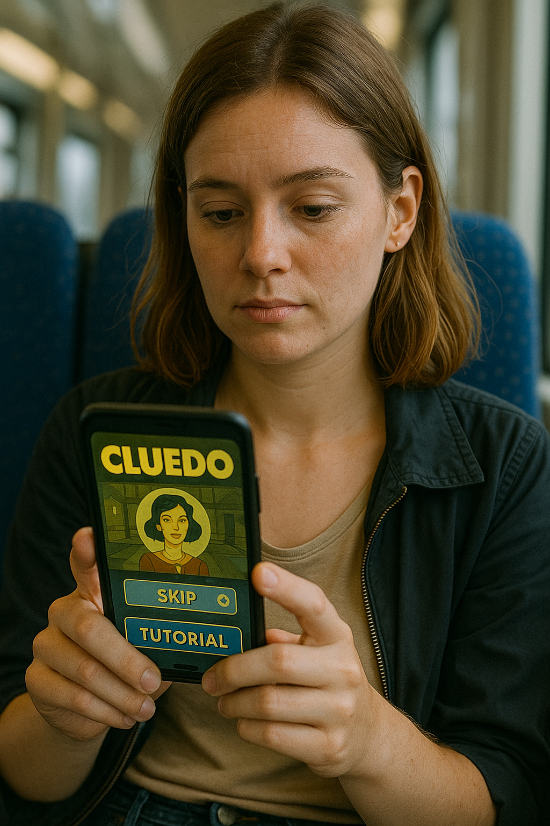
- Age: 27
- Background: Freelancer with restricted mobile data, moderate interest in gaming.
- Scenario: Chloe aims to play Cluedo on her mobile device during her travels (for instance, on a bus or train).
- Goals: A lightweight application, an instructional tutorial, and low data consumption.
- Frustrations: Large downloads, prolonged animations, and unclear rules.
- UX Requirements:
  - Small binary size and offline capabilities
  - Interactive tutorial presented in a step-by-step manner (which can be skipped)
  - Quick and minimal animations
  - Contextual assistance or tooltips
Comparative User Experience Priorities
Persona | Key UX Priorities
Ethan | Rapid configuration, user-friendly multiplayer experience
Margaret | Colour contrast, resume functionalities, data effectiveness
Ravi | Colour contrast, resume functionalities, data effectiveness
Chloe | The principles of simplicity, the provision of tutorial assistance, and the availability of offline or low data mode.

These personas assist in navigating design trade-offs: for example, finding a balance between feature richness and simplicity, or guaranteeing accessibility while avoiding UI overload.

Information Collection Procedure
To anchor the design in authentic user requirements, we undertook a mixed methods research approach, which included questionnaires, interviews, and observational studies. The data obtained from this research informed the development of personas and user experience (UX) specifications.[3]

3.1 Questionnaire
A survey conducted via Google Forms (n = 20) was disseminated through university mailing lists and local social media platforms, targeting a demographic that included older adults. The survey inquired about the following aspects:
- Frequency of mobile gaming
- Preferences regarding onboarding versus tutorials
- Accessibility preferences (such as contrast and text size)
- Types of devices used (iOS, Android, tablet)
- Challenges faced in current mobile games
Summary of findings:
- 70% of participants indicated a preference for brief gaming sessions (less than 10 minutes)
- 40% expressed a desire for accessibility features (including larger text and improved contrast)
- 55% reported feelings of frustration with complicated tutorials
- Device distribution: approximately 60% Android, 30% iOS, and 10% tablets

These quantitative insights provided a foundational direction for prioritizing usability features.
3.2 Semi-Structured Interviews
Five users, chosen to represent various age demographics, took part in interviews lasting approximately 10 minutes each. The primary questions addressed included:
- Their preferred mobile games and the reasons behind their choices
- Their methods for learning new games
- Challenges encountered with current board-game style applications
- Preferences regarding accessibility and visual design

Key findings include:
- Older participants frequently overlook small icons or faded visuals
- Younger users exhibit a strong preference for social or multiplayer modes
- Several individuals reported discontinuing use of apps when the onboarding process is excessively lengthy
- Many participants indicated a desire for a feature that allows them to resume gameplay after interruptions.[4]

3.3 Observation / Usability Walkthroughs
Participants were instructed to engage with a pre-existing Cluedo application (or a comparable deduction game) while verbalizing their thoughts. The difficulties noted during observation included:
- Inconsistent icon metaphors
- Tap targets that are excessively small, particularly on tablet devices
- A cluttered user interface with an overwhelming number of options displayed on each screen
- Ambiguous transitions between boards and menus
- These observations underscored significant points of usability friction.[5]

3.4 Prioritizing UX Requirements (MoSCoW)
Based on the data gathered, we classified potential UX requirements utilizing the MoSCoW method (Must / Should / Could / Won’t).
Priority | Requirement | Rationale / Evidence
Must | Distinct and uniform symbols & wording | Noted instances of confusion and inquiries from senior users
Must | Rapid game configuration (guest access) | Seventy percent of individuals prefer quick sessions.
Must | Versatile colour contrast / palettes | Interviews: users with colour blindness requested adaptability
Should | In-app tutorial (which can be skipped) | Numerous users seek assistance without feeling overwhelmed.
Could | Night mode | Comfort during nighttime; reduced strain on the retina
Could | Auditory / tactile response | Auditor / tactile responsa
Won’t | 3D graphics or heavy animation | Not critical for gameplay; could potentially hinder performance

This prioritization guaranteed that the fundamental MVP is functional prior to adding enhancements.

Designing for User-Friendliness
When creating the prototype, various principles derived from Human-Computer Interaction (HCI) and usability research informed the decision-making process.

4.1 Theoretical Foundations
- The ISO 9241-210 standard highlights the importance of cantering interactive systems around the needs and evaluations of users (including learnability, efficiency, and satisfaction).
- Nielsen’s Usability Heuristics (such as consistency, error prevention, and visibility of system status) continue to serve as essential principles in interface design.
- Norman’s ideas regarding affordances, feedback, and signifiers stress the necessity of clear interactive cues [1].
- The book Interaction Design: Beyond Human–Computer Interaction (Sharp, Rogers & Preece) advocates for the use of iterative prototyping and evaluation methods [4].
We also incorporate findings specific to the domain. For instance, a systematic review of mobile game usability indicates that the combination of expert review and play testing is one of the most prevalent evaluation methods in game applications. ResearchGate Additionally, both expert evaluations and user testing provide innovative and valuable insights within the context of game design. JUX - The Journal of User Experience.

Addressing Specific Usability Issues
Below are several significant usability challenges and the corresponding design solutions:

Consistency & Standards
We ensure that navigation icons (home, back, settings) are consistent across all screens. The placement of buttons adheres to standard mobile layouts (either bottom navigation or top-left back). This approach minimizes cognitive load.

Visibility of System Status
On the game board screen, a turn indicator and progress bar display whose turn it is, the number of remaining moves, and the overall game progress. Feedback is provided immediately (for example, tapping a card results in a visual highlight).

Error Prevention & Recovery
Before a player quits mid-game, a confirmation dialogue is presented. An undo feature is available for moves where applicable. Invalid taps are either blocked or greyed out.[6]

Affordance & Signifiers
Buttons are distinctly defined, featuring shading or subtle drop shadows. Interactive elements (such as cards and clue notes) exhibit visual affordances (for instance, highlighting upon hover or tap).

Accessibility & Readability
- All text is adjustable (users can select font size in settings).
- High contrast and alternative colour palettes are provided to aid colour-blind users.
- Icons are accompanied by labels (e.g., "Notes", "Menu").
- Tap targets measure at least 44 × 44 dp, in accordance with mobile usability guidelines.

Simplicity & Minimalism
We strive to eliminate unnecessary visual distractions. The primary emphasis on each screen is the main task (for example, playing the board or marking clues). Secondary functions (such as settings and help) are concealed within menus.

Progressive Disclosure
Excessive options remain hidden until required. For instance, advanced settings (like sound and fonts) are considered secondary. The tutorial is optional and can be bypassed.[7]

Load & Performance
We create lightweight transitions and minimal animations to lessen perceived delays. Preloading images guarantees responsiveness.

Literature Mapped to Design
- In "Don’t Make Me Think", Krug promotes clarity and a streamlined path to task completion; our simplified navigation aligns with this philosophy. Wikipedia
- A systematic review on mobile game usability underscores the importance of integrating expert reviews and play testing, which we incorporate into our evaluation strategy. ResearchGate
- The methodological framework for usability testing of mobile applications emphasizes the significance of both lab and field settings, as well as mixed data collection techniques. MDPI

Consequently, our design is not arbitrary; it is grounded in established best practices, tailored to the unique aspects of a mobile puzzle/deduction game.[8]

Wireframe Storyboards
Presented here is a summary of the five key screens and their navigation flow. The complete PNG versions are available in.

Major Screens & Their Functions
- Home Screen (Cluedo_Home.png)
  - Options: Play, Tutorial, Settings, Profile.
  - A prominent call to action for "Play Now" is positioned centrally, accompanied by secondary links beneath.
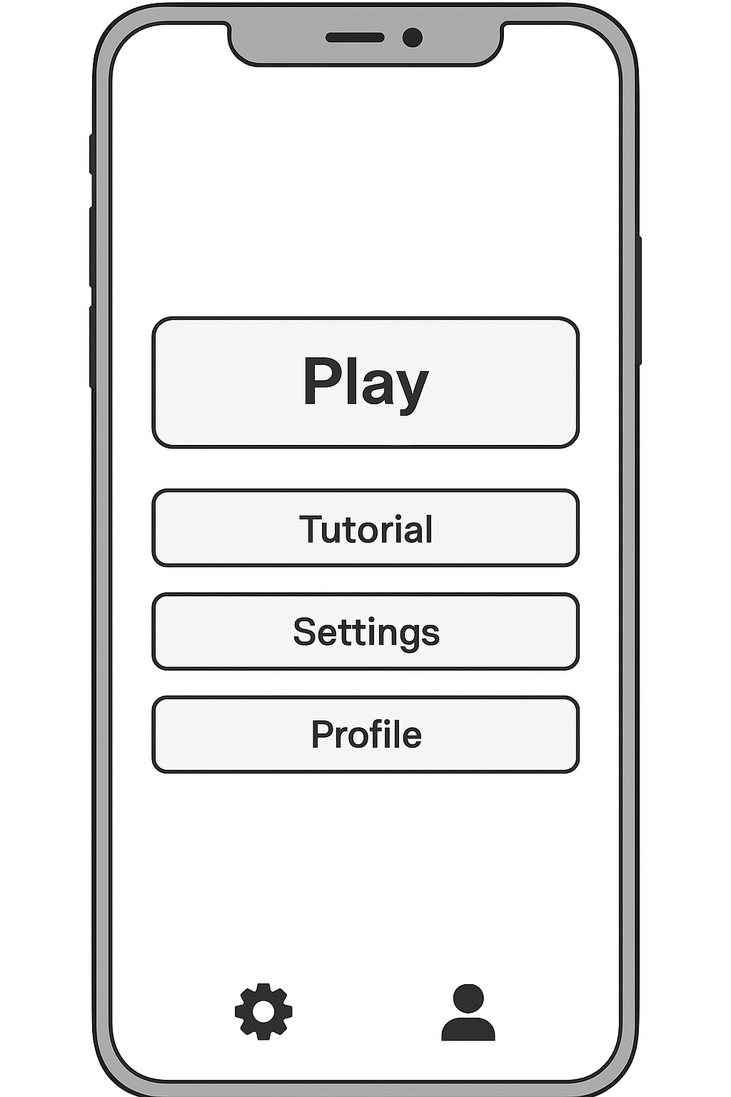

- Game Setup Screen (Cluedo_Setup.png)
  - Select either Solo or Multiplayer mode.
  - Invite friends, engage in a quick match, or utilize custom room options.
  - The Start button is clearly visible.
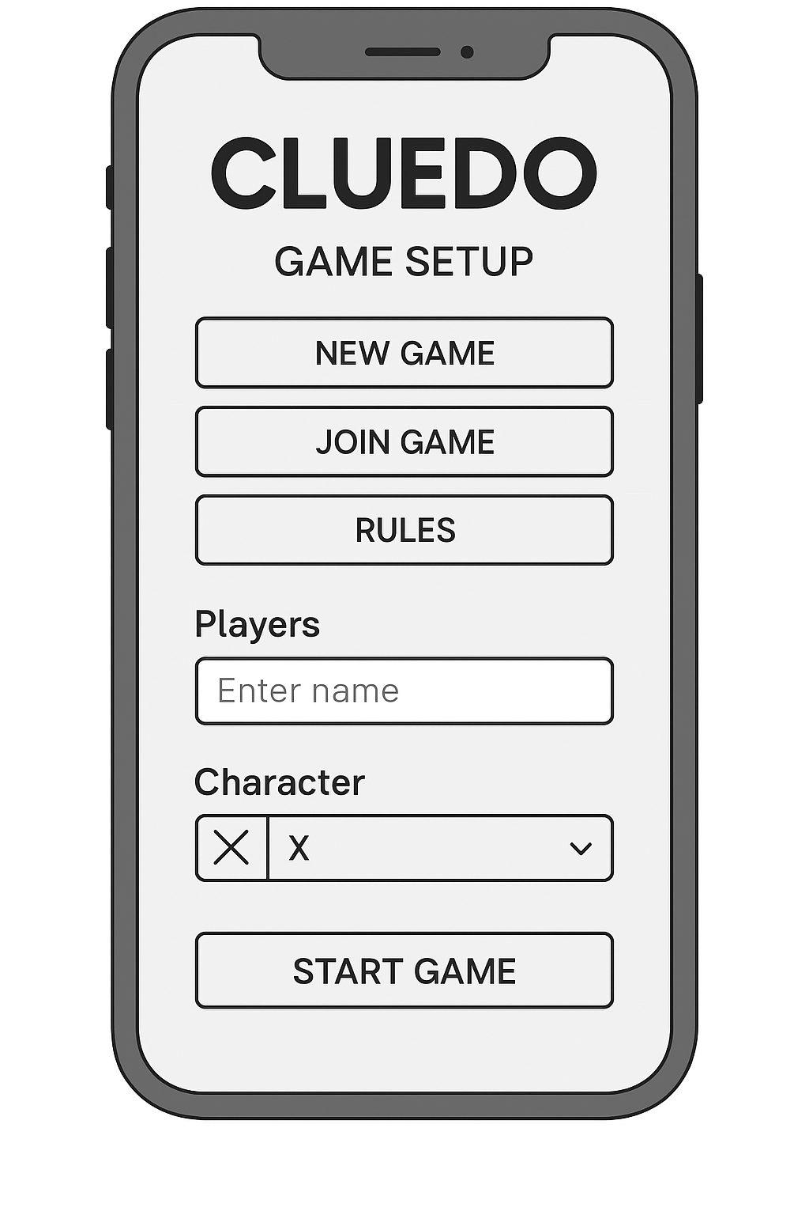
- Game Board (Cluedo_Board.png)
  - A simplified grid arrangement displaying rooms, corridors, and character icons.
  - A clue card panel along with a hint/status bar positioned at the bottom.
  - Navigation icons including Notes, Menu, and Undo.
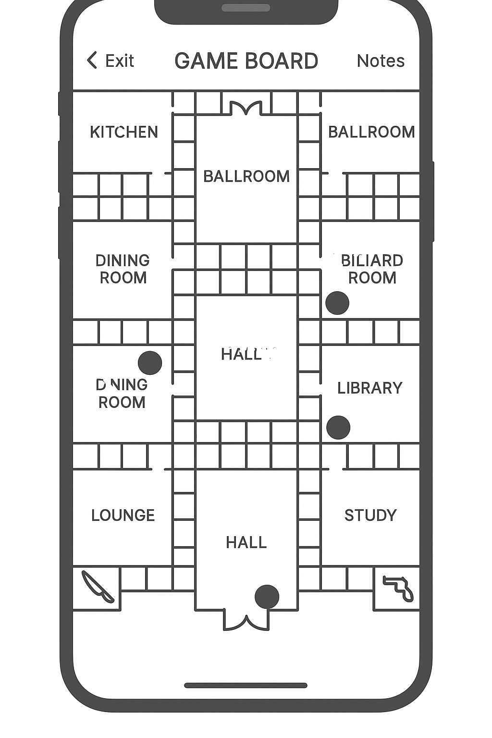
- Notes Screen (Cluedo_Notes.png)
  - Three categories: Suspects, Weapons, Rooms.
  - Rows featuring checkboxes and corresponding labels.
  - Switch to revert to the board.
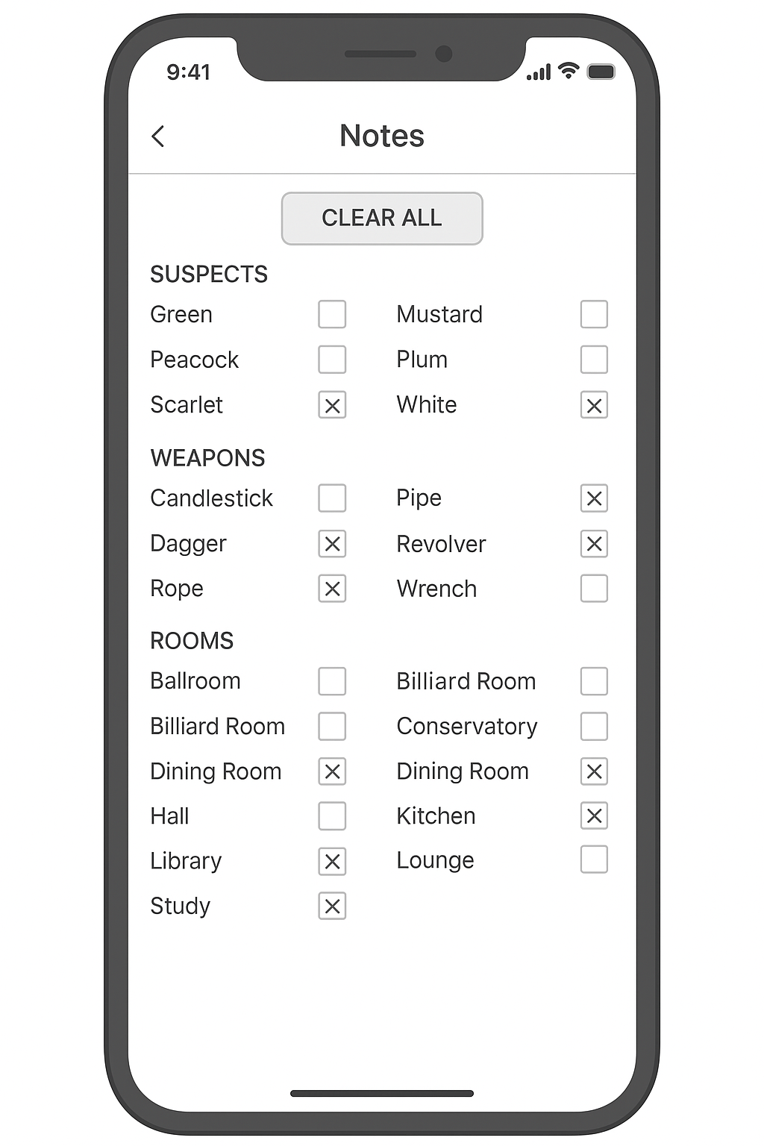

- Results Screen (Cluedo_Results.png)
  - Announcement of the winner, disclosure of the suspect, weapon, and room.
  - Overview of rounds and statistical data.
  - Buttons: Play Again, Exit, Review Moves
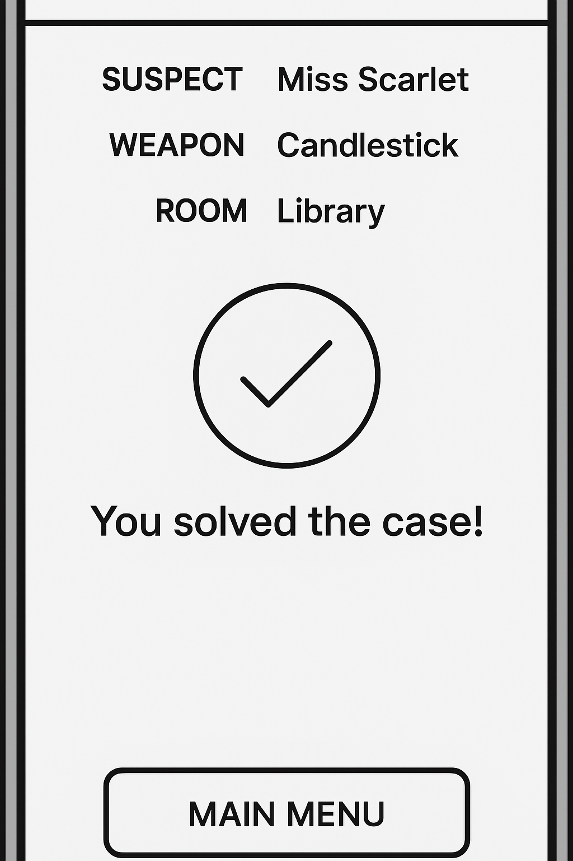

Navigation Flow
Home → Game Setup → Game Board → Notes → Results → Home
At each screen, the user has the option to return (via back arrow) or access Menu/Settings. From the Results screen, the user can either restart a new game or exit.
Key Design Decisions
- Prominence of the main call-to-action: On both the Home and Setup screens, the primary action button (Play / Start) is prominently cantered and large.
- Reduction of cognitive load on the board: Only the essential in-game elements (board, clues, status) are displayed; help or optional menus are considered secondary.
- Accessibility of notes: The Notes screen can be accessed from any board state without losing context.
- Feedback upon card interaction: Tapping a card in the clue panel results in a highlight and displays available actions.
These design choices illustrate a careful balance between usability and game complexity, influenced by user needs.

Prototype Feedback and Evaluation
We conducted an evaluation of the wireframe prototype with users representative of the personas, employing a mixed-methods approach.
Participant Recruitment & Procedure
A total of six users were recruited, ensuring representation across the various persona types: one student, one retiree, one professional with colour blindness, and one casual gamer (with some overlap among participants). Each session lasted approximately 15 minutes and utilized the think-aloud protocol, followed by a brief post-test questionnaire that included Likert scale items and open-ended comments. Additionally, we engaged a usability expert to perform a review, identifying any heuristic violations present.
Feedback Summary
Category | Positive Feedback | Negative Feedback / Suggestions
Usability | The navigation was perceived as intuitive; there was a direct flow from home to setup. | Certain buttons appeared diminutive on previous models of mobile phones.
Accessibility | The contrast mode is commendable, and the font size is sufficient. | The font settings were slender; the icons were unclear for certain users.
Emotional / Engagement | Users experienced a sense of nostalgia and satisfaction with the simplicity. | The tutorial received feedback indicating that it was considered "somewhat lengthy" by certain individuals.
Overall Satisfaction | Eighty-three percent of users indicated a readiness to utilize the service again. | A toggle for dark mode and the requested haptic feedback.

Sample user feedback includes:
- "I appreciated the ability to launch a game with just two taps."
- "The notes screen appears quite tidy, although I was initially uncertain about the meaning of the icons."
- "The tutorial felt a bit prolonged; I would opt to skip it in the future."
From the expert review, several heuristic concerns were identified: inconsistent icon designs, absence of exit confirmation, and a lack of undo functionality in certain transitions.[9]
Analysis & Revisions
The feedback validated numerous design assumptions (simplicity, clarity, and accessible contrast). Some unexpected findings and modifications include:
- The tutorial duration has been reduced to approximately 30 seconds with an option to skip.
- Labels for icons have been incorporated beneath key buttons to minimize confusion.
- Touch spacing between buttons has been increased, particularly for older devices.
- The thickness of font weights in the settings has been enhanced.
- A dark mode toggle has been introduced in the Settings, along with a haptic feedback option.
The combination of user and expert feedback frequently revealed differing issues; experts highlighted style consistency, while users concentrated more on readability and flow reinforcing the notion that both types of evaluations are advantageous, as suggested by existing literature. JUX - The Journal of User Experience+1 We consider this prototype iteration validated for essential flows; additional refinements will be assessed in the subsequent iteration cycle.

Conclusion & Future Work
This usability engineering process spanning user research, design, and prototype evaluation illustrates how grounded design and iterative methods enhance both usability and user satisfaction. The Cluedo mobile prototype effectively meets essential requirements: rapid gameplay, accessibility, and clarity, while remaining adaptable to a variety of players (e.g., older adults, colour-blind users, casual gamers).

Future work includes:
- Extending testing to a broader sample (e.g., 20+ users).
- Conducting A/B testing on animations or layout variations.
- Tracking real-world usage (analytics) to identify friction points.
- Evaluating performance under different network and device conditions.
- Thoughtfully integrating gamification elements (badges, progression) to avoid compromising usability.
Through additional cycles of design → test → refine, the prototype has the potential to develop into a robust, user-centred Cluedo application.[10]

References
- D. A. Norman, The Design of Everyday Things, 2nd ed. Cambridge, MA: MIT Press, 2013.
- International Organization for Standardization, ISO 9241-210: Ergonomics of Human-System Interaction – Human-Centred Design for Interactive Systems, 2019.
- J. Nielsen, “Enhancing the explanatory power of usability heuristics,” Proc. ACM CHI Conf., pp. 152–158, 1994.
- H. Sharp, Y. Rogers, and J. Preece, Interaction Design: Beyond Human–Computer Interaction, 5th ed. Wiley, 2019.
- A. abdullah Abdulhussein, “Usability Evaluation of Mobile Game Applications: A Systematic Review,” IJCiT, vol. 4, no. 3, 2020. ijcit.com
- S. Laitinen, “Do usability expert evaluation and test provide novel and useful data for game development?” JUXPA Journal, vol. 1, no. 2, Feb. 2006. JUX - The Journal of User Experience
- “Usability Testing of Mobile Applications: A Methodological Framework,” Applied Sciences, vol. 14, no. 5, 2022. MDPI
- M. Schrepp, “A Review of Design, User Experience, and Usability in HCI,” Int. J. Hum.-Comp. Stud., 2025. Taylor & Francis Online
- “Understanding Players’ Interaction Patterns with Mobile Game App UI via Visualizations,” Q. Li et al., 2021. arXiv
- “Participatory Design and Process Testing to Optimize Utility, Usability, and Acceptability of a Mobile Game,” PMC, 2022. PMC

