Design of control systems

Albie Willett (2030850)

ACDA5011 Instrumentation and Control

Wales Institute for Science and Art

University of Wales Trinity st David



Contents
- Abstract 3
- Introduction 3
  - What is a control system? 3
  - How does a PID controller work? 3
  - What is tuning? 4
  - Uses of PID controllers 5
  - What is a CIWS turret? 5
  - Transfer functions 5
- Equipment 5
- Method 6
- Results 7
- Discussion 11
- Conclusion 11
- References 12
Table of figure
Figure 1 4
Figure 2 6
Figure 3 6
Figure 4 7
Figure 5 7
Figure 6 8
Figure 7 8
Figure 8 9
Figure 9 10
Figure 10 10

- Abstract
The purpose of this assignment is to design a control system for controlling the angular positioning system of an automatic CIWS turret. Beginning with a step input of 1, the control system must be able to control the process within 2 seconds and have an overshoot of less than 5%. The closed loop transfer function of the whole system is to be calculated in order to validate the results and the outcomes of simulations of the forward transfer function of the controller and provided in the requirements and the closed-loop transfer function are to be compared.
The transfer function given in the brief is:
$$G\left(s\right)=\frac{1}{as^{2}+bs+c}$$
Where$a=8, b=5$ and$c=0$. This simulates the angular positioning system of the CIWS turret. [1]
Simulink and MATLAB software packages were used to simulate the process and design a closed loop control system. The result from the simulation The control system controlled the process well, achieving a control time of less than 2 seconds and an overshoot of less than 5%, although it took some time to tune the system to this specification using the Simulink tuning tool.
- Introduction
2.1 What is a control system?
A system in which deliberate guidance or manipulation is used to achieve a prescribed value for a variable. [2] An example of this is a household oven which uses a thermostat to control the oven to ensure that the food inside is cooked at the right temperature. If the oven is too hot the system will reduce the heat inside and vice versa for when the oven is too cold.
There are two main types of systems Open loop and Closed loop additionally closed loop is split further into positive feedback and negative feedback. Open loop control means that no feedback is provided from any information received so the input cannot change depending on the response. Closed loop control uses the responses gained to adjust the input using a transfer function. A positive feedback loop enhance/amplifies the changes making the system more unstable and is used in oscillators however a clearer example from biology is the process of ripening a fruit [3]. A negative feedback loop dampens/buffer changes making the system more stable and is used in audio amplifiers reducing the distortion another example in biology is Body temperature which is maintained at 37 °C [3].
The controller used in this assignment is a PID (proportional integral derivative) controller. This is an extremely stable controller and is used to regulate speed, pressure, temperature and other variables.
  - How does a PID controller work?
A PID controller tracks the process variable and set point, the integral of recent errors and the derivative of the error signal to create a corrective response from a weighted sum of the three terms. The results are then applied and the process begins again until the error is eliminated. An example of this process is a thermostat which continuously adjusts the actuator to ensure that the temperature is not too high or too low.
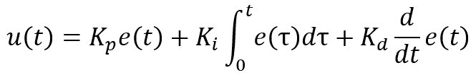
Figure 1

Proportional term

Integral term

Derivative term

Controller Output

Terminology of figure 1 explained [4]:
Proportional term: error multiplied by constant Kp
Integral term: cumulative total error multiplied by constant Ki
Derivative term: rate of change of the error multiplied by constant Kd
Kp, Ki, Kd = respective P, I,D constants
U = final output of cycle
u(t) = Drive coming from the Controller and inputted into the process at time (t)
e(t) = Difference between set point and measured process variable with respect to time

The combination of each individual term in the above equation allows for the system to capture the history of the output through integration; the current output of the system through the proportional term and finally able to predict the future output through differentiation. [4] This is why the controller is inherently stable if set up correctly as it does not have a static error and includes a dampening effect that limits overshoot. This allows to converge to achieve the set point as well as being quicker.
  - What is tuning?
Tuning is the process of finding the values of the proportional, Integral and derivative constants/gain to achieve the desired performance of the PID controller and to meet the Design requirements.
Tuning can completed in multiple ways including manual tuning, tuning heuristics and auto tune. For this investigation the tuning software on Simulink allows to easily tune the controller avoiding the issues that arise from the above methods. [5]

2.4 Uses of PID controllers
Examples of Where PID controllers are used:
- Ovens and furnaces
- Motion control systems
- Ph control
- Humidity control
PID controllers are used within most systems as they are so effective at providing stable control. If the controller is not used then Oscillations could potentially happen leading to the system failing as it cannot cope. [5]
2.5 What is a CIWS turret?
A Close in weapon system (CIWS) is a last resort defence system usually against anti-ship threats. An example of this system is the Phalanx CIWS which is fitted on navy ships and is designed to protect against missiles, aircraft, and small surface vessels, helicopters. This particular system is capable of autonomous search, detection, evaluation, tracking and many other functions. The brief for this assignment is to look into controlling the angular positioning of the turret. This is vital for the success of the system as it achieves the destruction of the potentially deadly threat by quickly positioning and firing up to 4500 shots per minute all while tracking the threat. [6]

2.6 Transfer Functions
Analysis can be completed of the control system by looking at the transfer function within the system. The transfer function can be analysed by comparing the ratio of the output to the input. This function is the mathematical model which allows the prediction of the operational behaviour. A Laplace transform is used to simplify the time domain response of the system. The transfer function will be evaluated at the end of the simulation to ensure that it has worked as intended.

- Equipment
The simulation software used is called Simulink this is part of the Matlab software and can analyse multi domain system. The components within the system include a step input, this is the input signal that the control system must be able to control. The step input is followed by an Add block which allows for the input signal to be combined with the feedback signal which is from the transfer function. This is then inputted into the PID controller which will be tuned by the tuning feature in Simulink this will then ensure the signal is tuned. From the PID controller the signal is sent to the transfer function which models the system. Each stage of this system is also connected to an oscilloscope so the output from each component can be viewed.
The transfer function which models the control system in Simulink can be seen below in figure 2
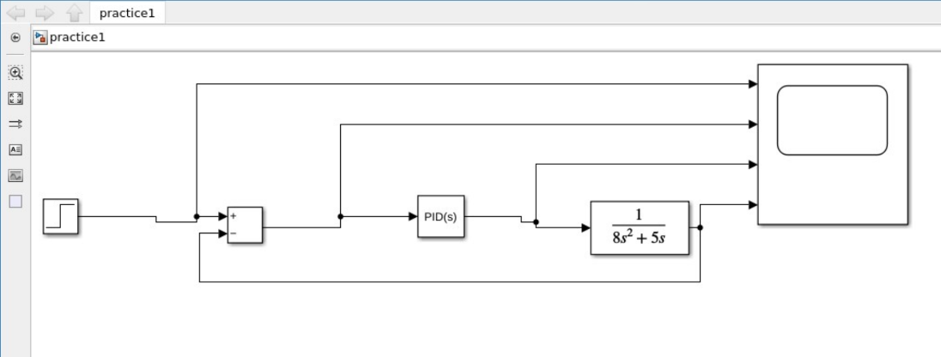

Figure 2
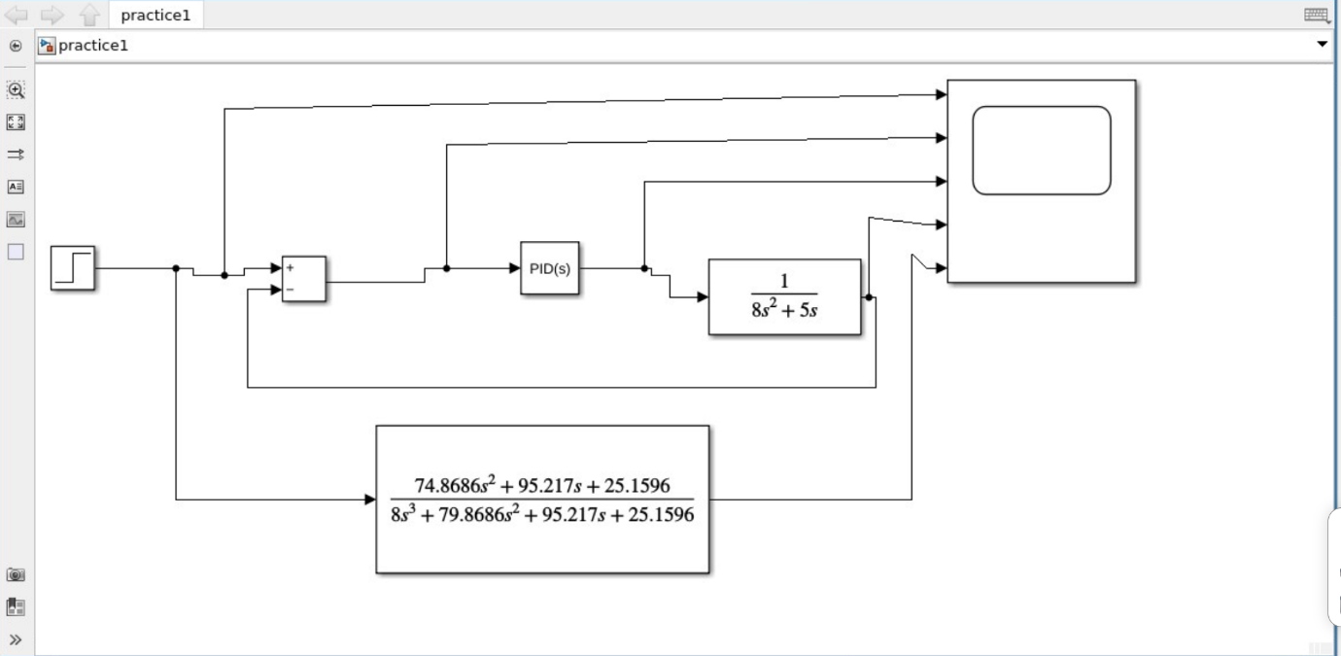
A closed loop transfer function which is found mathematically can be seen in figure 3 this allows for the two to be compared to verify the system is working.

Figure 3

- Method
Once the Simulink tool has the system set up as in figure 2 the parameters and tuning can be completed to meet the design requirements of that are: design a closed loop system capable of controlling a unit step input which should be able to control the process within two seconds with overshoot of less than 5%. [1]
The angular positioning transfer function of the CIWS turret has the transfer function:
$$G\left(s\right)=\frac{1}{{8s}^{2}+5s}$$

The PID controller requires to be tuned as seen in Figure 4 this ensures that the system can be controlled and meet the above requirements. This can completed in the PID tuning tool by adjusting the Response Time and Transient Behaviour to meet the overshoot and control requirements. This will produce values for the Proportional, Integral and Derivative terms.
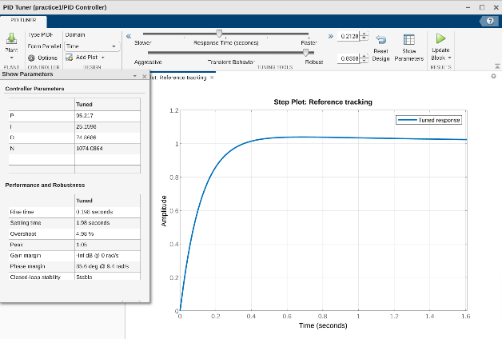

Figure 4

- Results
The figure below shows the scope output of each individual process in the system before tuning:

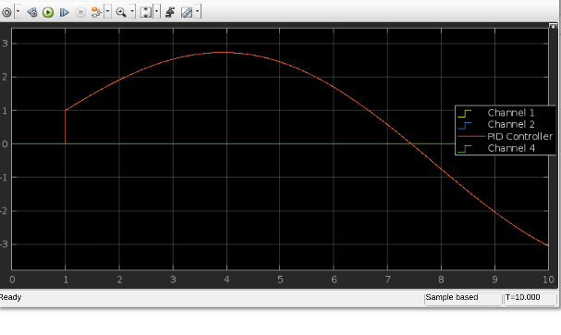
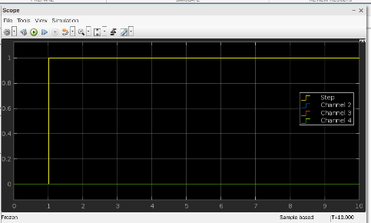
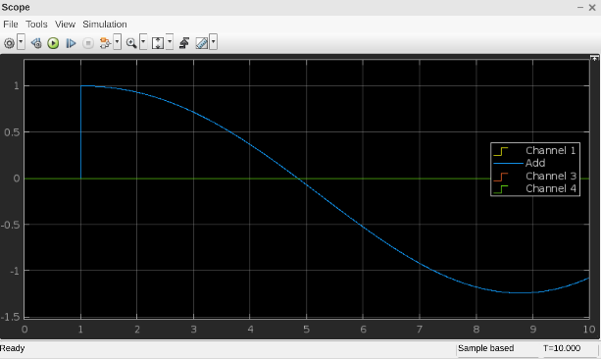
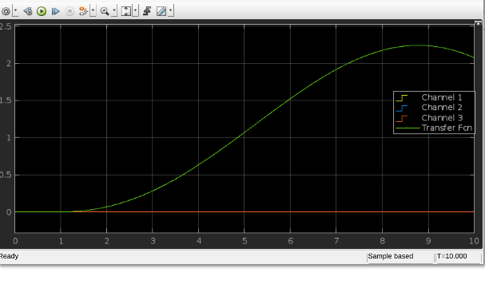

Figure 5
In the figure 5 the 4 channels include the Step input, Add channel, PID controller and the Transfer function/ output. The axis for each graph are signal output against time.
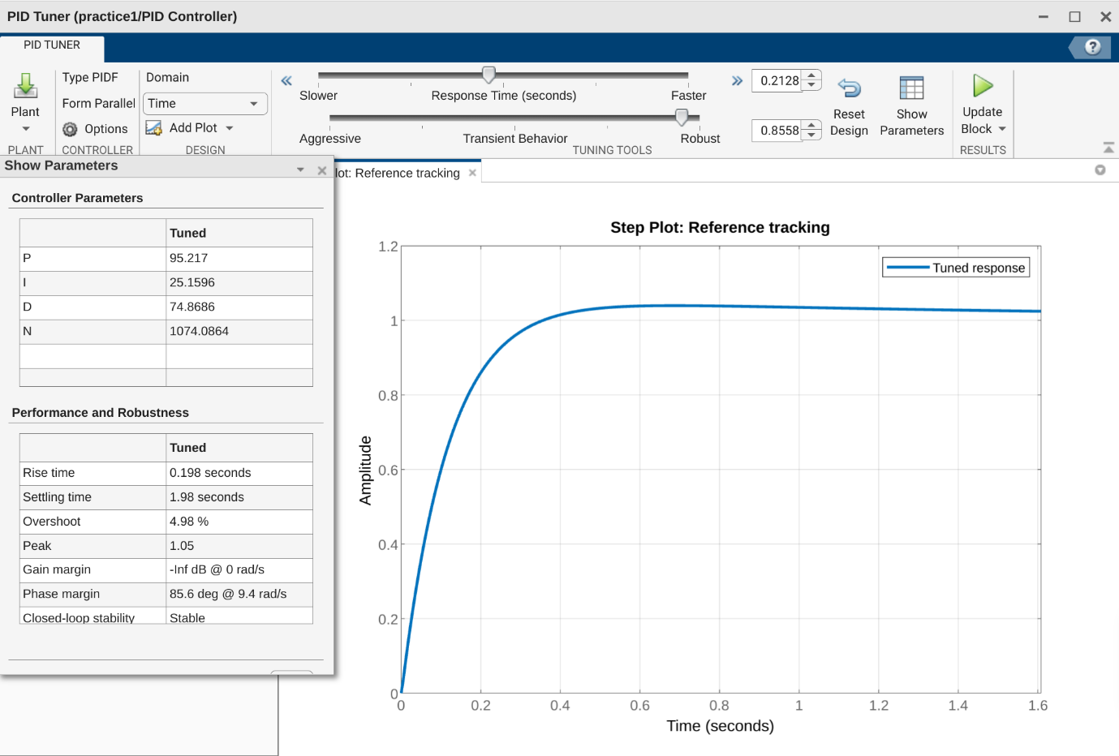
The PID values are then tuned using the Simulink tuning tool as seen in Figure 6 which allows to adjust the response time and transient behaviours to achieve the result found in the figure below. As seen the settling time and overshoot meet the requirements set out in the brief. The Settling time achieved is 1.98 seconds and the overshoot is 4.98%.

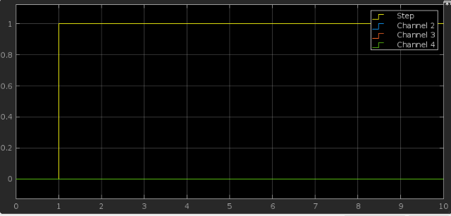
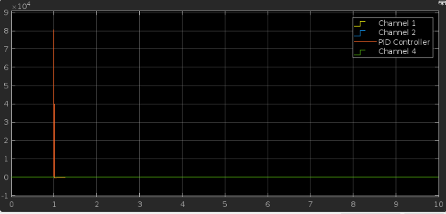
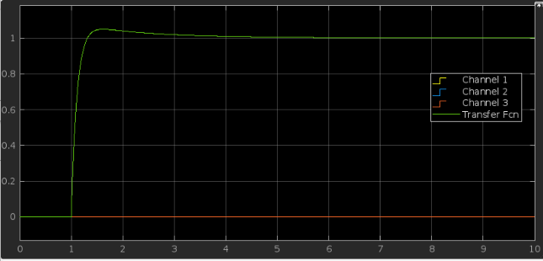
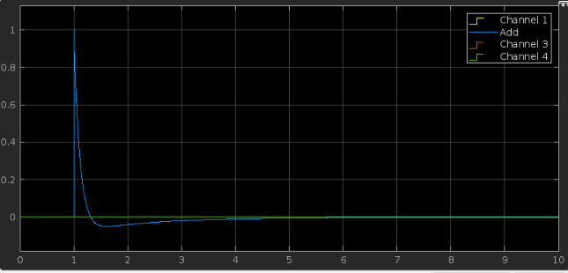
Figure 6
Figure 7
The figure 7 above shows the results after tuning. Step input remains the same, Add channel different due to changes from PID controller due, PID controller now shows tuned values where the terms now are adjusted to achieve the desired control, finally the Transfer function/ output channel shows the system controlling within the design requirements.

With the individual terms found from the tuning process the PID values can be used to then find a closed loop transfer function which firstly ensure that the tuning process was completed correctly and also the transfer function is used to replace the other processes involved in the system.
This transfer function is found using the following steps:
$$\frac{kds^{2}+kps+ki}{s} ×\frac{1}{8s^{2}+5s}$$
The Values for the PID constants found in the tuning can be inserted into the above.
$$\frac{74.8686s^{2}+95.217s+25.1596}{8s^{3}+5s^{2}}$$
This can then be substituted into the closed loop transfer function formula as seen below.
$$\frac{\frac{74.8686s^{2}+95.217s+25.1596}{8s^{3}+5s^{2}}}{1+\frac{74.8686s^{2}+95.217s+25.1596 }{8s^{3}+5s^{2}}}$$
When rearranged this can be seen below:
$$\frac{74.8686s^{2}+95.217s+25.1596}{8s^{3}+79.8686s^{2} 95.217s+25.1596}$$

This is closed loop transfer function and can be added to the Simulink simulation as shown in Figure 8 where the output from the entire control system can be compared to the closed loop transfer function.
Figure 8

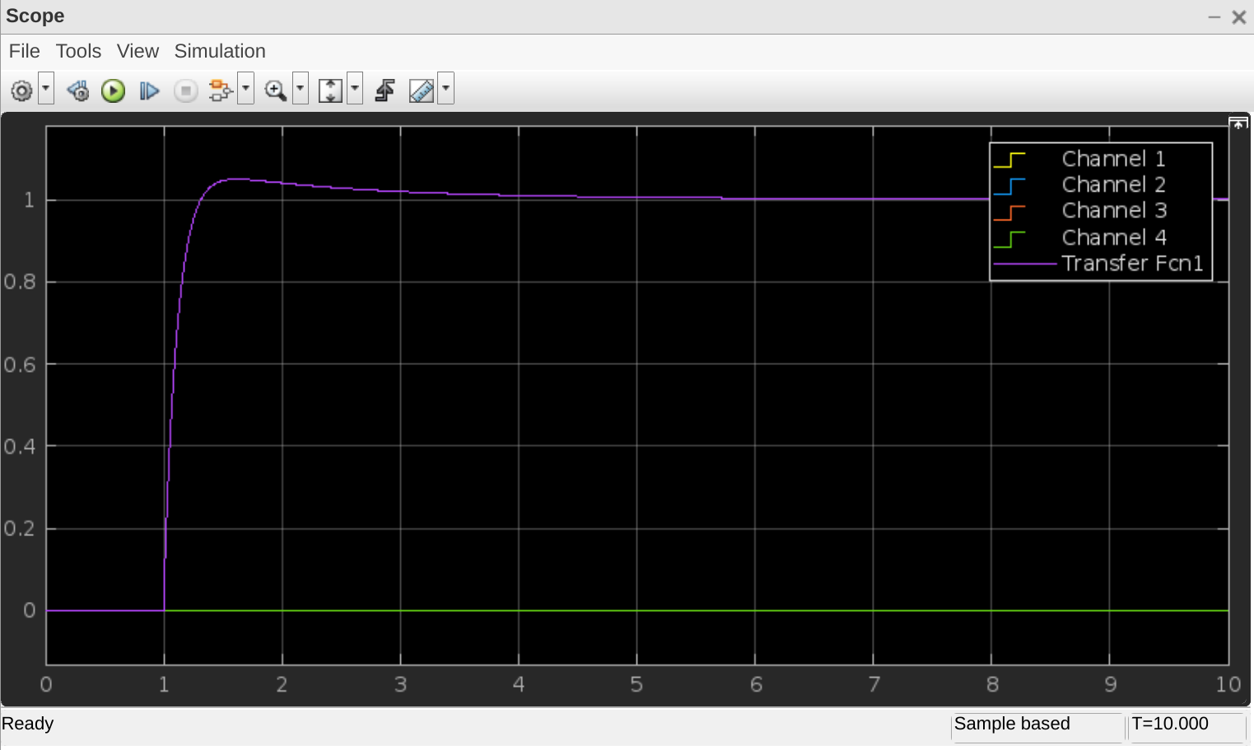
Figure 9
In the figure above the Scope shows the output of the closed loop transfer function which is able to match that of the control system.
This can be inputted into a Plot Zero map as seen in figure 10
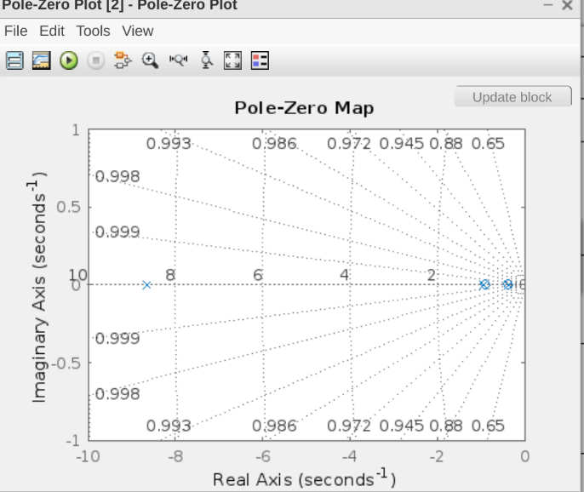

Figure 10

- Discussion
Figure 9 shows that the response from the closed loop transfer function matches that of the control system in the time domain. This means that the closed loop transfer function can effectively control the input given to the CIWS turret with the constraints stated in the brief. This is even the case when there is feedback within the system.
Figure 10 shows a Pole zero plot of the results from the input and output of the closed loop transfer function. A pole zero plot shows stability of a system this is achieved by plotting responses in the time domain. What can be deduced from the responses from this diagram can be seen below:
- a negative real pole means that the system response exponentially decays in amplitude
- a pole at the origin means the system response remains constant in amplitude, defined by the initial conditions
- a positive real pole means that the system response exponentially increases in amplitude
- a negative conjugate complex pole pair means that the system response exponentially decays in an oscillatory fashion
- an imaginary pole pair means the system response is oscillatory and constant in amplitude, as defined by the initial conditions
- a positive conjugate pole pair means that the system response exponentially increases in an oscillatory fashion
The pole zero plot found in this design found in figure10 has points in the negative region on the real axis of the plot showing stability.
The Phase margin found in Figure 6 shows a phase margin of 85.6 degree. This phase margin is defined as the amount of change needed in an open loop system needed to make a closed loop system unstable. A shift of -180 degrees is seen as unstable and the greater it is the more stable any figure above 45 is seen as stable as a result the 85.6 achieved in the control system can be seen as suitable for the CIWS turret control.
- Conclusion
To conclude the assignment brief specified to design a control system for controlling the angular positioning system of an automatic CIWS turret. Following a step input, the control system must be able to control the process within 2 seconds and have an overshoot of less than 5%. Then create a closed loop transfer function of this system.
This has been achieved by achieving an overshoot of 4.98% and controlled within 1.98 seconds. Additionally this has been validated and successfully turned into a closed loop transfer function that is stable.
The use of a PID controller did not affect the tuning of the system and its ability to control the system hence proving that it is a suitable choice.

References

[1] | S. Mosey, Instrumentation & Control Assignment Specification, Swansea: University of Wales Trinity Saint David, 2023.
[2] | National institute of standards and technology, "Computer security resource center," National institute of standards and technology, may 2015. [Online]. Available: https://csrc.nist.gov/glossary/term/control_system. [Accessed 09 07 2023].
[3] | T. A. Team, "Albert," Learn by doing, INC, 10 may 2023. [Online]. Available: https://www.albert.io/blog/positive-negative-feedback-loops-biology/#:~:text=Once%20ripe%2C%20they%20too%20produce,is%20a%20positive%20feedback%20loop.. [Accessed 17 july 2023].
[4] | S. Zhuge, "Crystal Instruments," Crystal instruments, 24 August 2020. [Online]. Available: https://www.crystalinstruments.com/blog/2020/8/23/pid-control-theory. [Accessed 17 July 2023].
[5] | Omega, "Omega," Omega Engineering Inc, [Online]. Available: https://www.omega.co.uk/prodinfo/how-does-a-pid-controller-work.html. [Accessed 17 July 2023].
[6] | General Dynamics, "General dynamics ordnance and tactical systems," General dynamics ordnance and tactical systems, july 2003. [Online]. Available: https://www.gd-ots.com/wp-content/uploads/2017/11/Phalanx.pdf. [Accessed 17 july 2023].

