Introduction.

What could go wrong on your first day? How about everything! This is logline for a 3D short animation called “First Day”; a slapstick comedy aimed at 5-8 years old. The secondary target is the parents of 25-40 years old. The 3D short is a pilot for 12 episode of 2 to 3 minute long each. The short involves two characters; “Businessman” and “Henry the Handyman”. “Businessman” is going in for his first day on his new job but things do not go his way. “Businessman” is very clumsy and nervous but also determined not to let these setbacks stop him. Rather he keeps his head held high and carried on. The second character, “Henry”, is the opposite of “Businessman” in both appearances and personality, such as; “Businessman” is skinny, tall, clumsy and nervous whereas “Henry” is short and wide but walks with confidence and is very calm. The art style will look similar to “Captain Underpants; The first Epic Movie.”
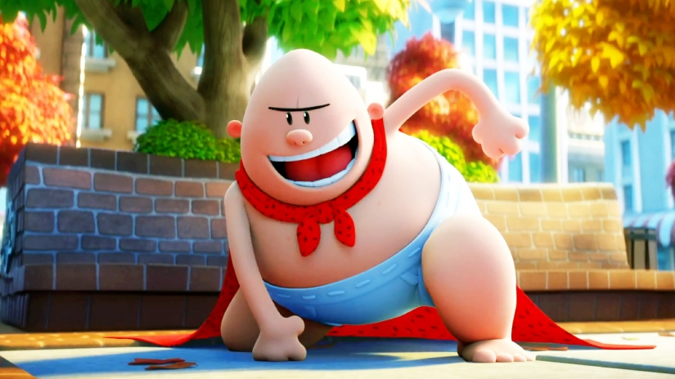

Concept art of “Businessman” & “Henry” Figure 1


As shown in “Figure 1”, the colours are very bright and bold with soft and round characters. Also, the background is stylized; a theme that happens very frequently in kids cartoons. therefore, I will be replacing this for the background with unrealistic building shapes, large windows and doors. Show below are some of the concept art for the background.

The animation style will be similar to “Popeye” 2016 and "Looney Tunes". However “Popeye” the movie was never finished productions but rather replaced by “The Emoji Movie” in 2017, Sony Pictures Animation released a teaser trailer which was titled “Popeye animation test” whose style of animation I would like to replicate. The natural human movements do not restrict the characters movement as it is incredibly exaggerated, at one point Olive's arm starts to move in a wave-like motion. This style has been popular in slapstick as it has a lot of dynamic movements and over the top reaction.

Target Audiences
The reason for the target audience to be around the age 5-8 is because most shows targets for that age group matches "First Day", which is a slapstick comedy. Furthermore, slapstick comedy is a universally understandable form of comedy meaning even children as young as three years old can understand what is happening and find humour in some level unlike stand-up or most other forms of comedy as they require a certain level of intellect and life experiences which kids have not developed and learned yet.

The secondary target audiences are the parents aged between 25 to 40 years old. As most parents would keep an eye on what their children do or watch online, having a family friendly content that parents would approve and believe to be suitable for kids will allow them to be more willing to let their children watch the shows and buy merchandise from the show for their kids.

Cinema

Some of the popular recent kids' movies are “Incredibles 2” 2018, making more than $182.6 million in the opening weekend in the USA and a worldwide gross of more than $1.121 billion, with an estimated budget of $200 million. Minions were secondary characters from the movie “Despicable Me", however, their popularity grew, so they created a spin-off movie called “Minions Go Back To the Beginning”, where it explains the evolution of Minions. The movie generated over $115.2 million on its opening weekend and earned more than 1.163 billion worldwide, the estimated budget of $74 million. The franchise both of Despicable Me and Minions is estimated at $8.36 billion. “Frozen” 2013, one the most popular Disney film with its award-winning original music “Let it go” made more than $243,000 on its opening weekend and made over $1.272 billion worldwide. The franchise is estimated at $11.5 billion, and now they are working on Frozen 2 which has been announced and the released date set on 22nd November of 2019.

Out of these three popular movies, the “Minions” is the closest to what my short is about as they are both slapstick comedy plus the minion do not talk per se as they speak gibberish except for the word “Banana” which has become their catchphrase. Both have the characters going through misfortune except “Business'” misfortune does not affect others but rather himself.

TV and Streaming service
My competition is TV shows like Mr.Bean and SpongeBob SquarePants, both shows are, but Mr.Bean aired their final episode on the 16th of March 2016. Spongebob SquarePants is a popular Nickelodeon show streaming on many platforms such as Nickelodeon tv channel and Netflix. SpongeBob SquarePants has been going on for almost 20 years as the first episode aired on 1999 May 1st. Now the series airs in 170 countries in more than 20 languages to millions of their fan. Furthermore, one-third of SpongeBob's audiences are aged between 18 to 49 yrs, from this we know a large number of people are willing to watch kids cartoon. Furthermore, people aged between 18-25 are most likely fans who have grown up with the show and still enjoy the show, and others might come back for that nostalgiac feeling.

After Mr Bean ended back in 2016, there has not been a show that is similar to Mr Bean which has a big focus on minimal uses of dialogue and more focused on the action and significant sound effect. Furthermore, looking at well-known movies and TV shows, I noticed that people who used to watch the cartoon in the early 2000s and late 1990s have grown up but still enjoy those type of content. Additionally, now they are at an age where they have money to spend on things such as; merchandise, paid membership for streaming services and novelty items. So, by seeing there is a market for slapstick comedy and nostalgic shows, I will be trying to market "First Day" as the next Mr.Bean with old school stretchy animations.

Whereas in Netflix shows like “Horrid Henry”, “Paw Patrol” and “Boss Baby: Back In Business” are popular in Netflix Kid under "Funny category". Paw Patrol stars a ten-year-old kid who is a leader of a group of dogs who have rescue jobs and every week they help adults with a mild problem or trouble they might face. Boss Baby back in business was created after the movie “Boss Baby” 2017, which got great reviews. Later on, on April 6th 2018 Netflix released the first episode and from then to now “Boss Baby” has already released season 2 on Netflix.
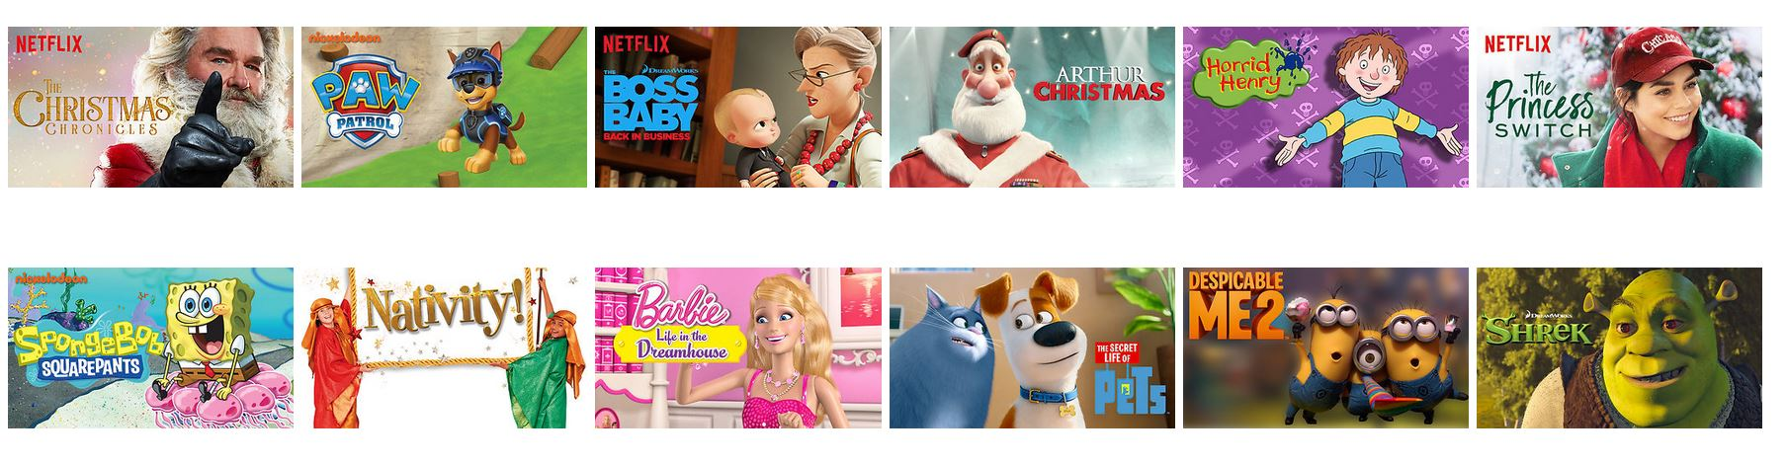
Source: Netflix

Both shows “Paw Patrol” and “Boss baby” have one thing in common that is both aimed at 3+, and both shows' the main character is calm and collective. The protagonist is presented as a leader and more mature than their portrayed age which allows them to be more understanding about situations. As a kid, we see the freedom that adults have and want the same, but at the same time, they can connect with a younger protagonist more easily. Plus, kids are very easily influenced, therefore, having a role model that is calm and understanding has a positive effect on the child. There are the trails for Henry, the janitor as he is calm and collective and seems like an adult that has things together as he does not panic or lets his nerves get to him.

Youtube
Children friendly Youtube content are in the rise, having channels such as
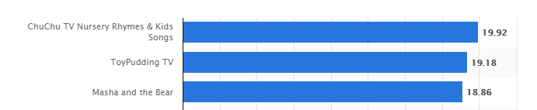
Chu-Chu Nursery Rhymes at 21 million subscribers, ToyPudding TV at 20 million subscribers. Masha and The Bear at 18.86 million subscribers.
Figure 2 Source: The Statistics Portal

The graph shows that there is a large market for kids shows and a large amount of following. Plus, we also see that parents are allowing their child to use Youtube even at a young age as some of the contents are targeted at young children. Youtube has a wide range of users from young kids to people over 70+, and as shown by the graph below, taken from January 20th to 22th, 2018 in the region of the United States. With a wide range of audiences, Youtube has become the second biggest search engine, behind Google. 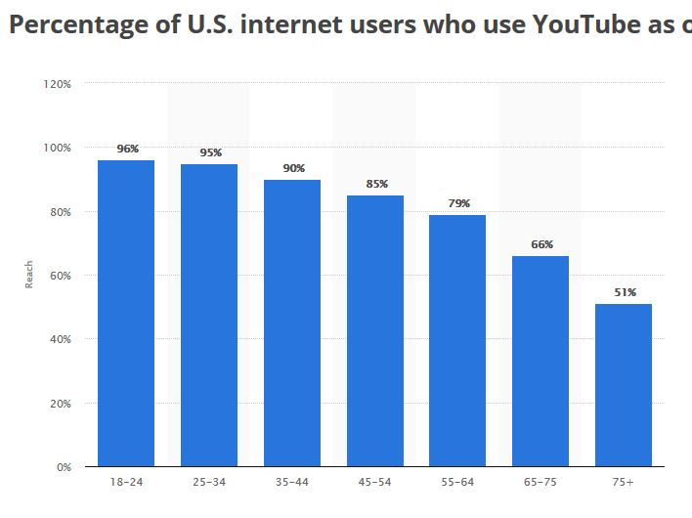
Figure 3 Source: The Statistics Portal

2. Distribution

I want to distribute the show on as many platforms as possible, but the main platforms would be Netflix and Youtube. As seen in the graph above, the younger generation are more likely to use Youtube rather than TV for their entertainment. Every month Youtube brings 1.9 billion members, close to Facebook's 2 billion unique users every month.

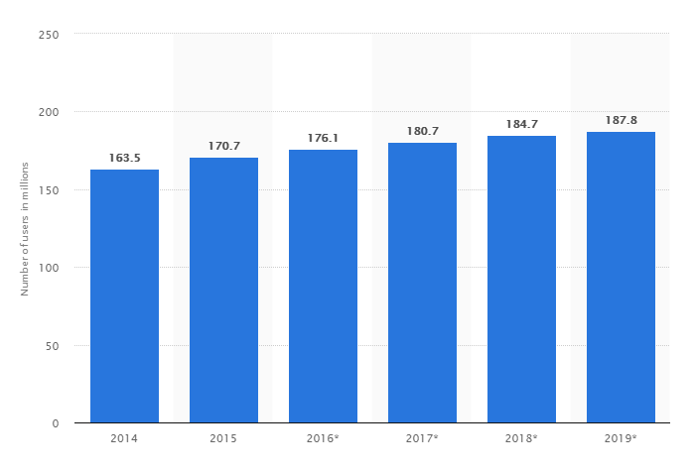
Region
United States
Survey time period
2014 to 2015

Figure 4 Source;The Statistics Portal

The bar graph shows the number of Youtube users from 2014 to 2019 in the United States, and this also includes the forecast of Youtube users till 2019. In my research, I found that United States Youtube users only make up for 20% of all of Youtube users worldwide, so if Youtube is bringing 1.9 billion per month, and we know there is an estimated 380 million United States unique Youtube users in 2018, which is an increase of more than 105% form the estimated growth of 184.7 million by 2018. With more than 300 videos beings uploaded every minute, Youtube has become the second most visited website in the world with more than 22.35 billion visits per day, again being second to Google at 42.46 million visits per month.

Netflix started as a DVD rental service with 600,000 members in the United States in 2002, but in 2007 Netflix introduced streaming; since then, Netflix has been in the rise. As of 2018, they have more than 130 million paid members in 190 different countries with a net worth of $1.4 billion and rapidly becoming the number one paid streaming service. The graph below shows the growth of Netflix from 2012 to 2018, for example, we see in 2012 Q1 26.48 million subscribers in total, then in 2018 Q1, they have 125 million subscribers in total; a growth of over 372% in 7 years.

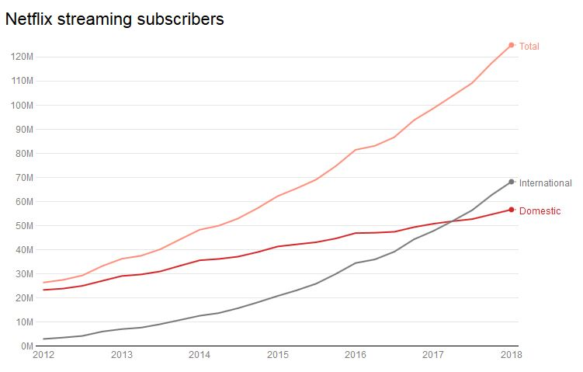
Figure 5 Source: Recode

AD placement

Choosing the right platform to place the advertisements is a crucial part of success as I do not have any audience or fan base right now, so to try to get much notice as possible I will be using different social website and app to promote "First Day" before the release. One of the Choosing the right platform to place the advertisement is a crucial part of success. Since, I do not have any audience or fan base right now, to get as much notice as possible, I will be using different social website and apps to promote "First Day" before its release. One of the main sources of promotion would be Youtube, as a large base of the target audience are already using Youtube it will be advertised directly at the target audiences. Thus, by promoting on Youtube, I would cast a “large net” as people who are not in my original target audiences might enjoy the short which might lead to finding new demography to focus. If not, then the advertisement will still be aimed at the target audiences.

As for other streaming sites and social media platforms such as Twitch, Twitter, Facebook or Vimeo I have taken into consideration of posting the pilot in varieties of platforms to get recognised, such as Facebook, Vimeo and Instagram; which are free services and more likely to be used by kids as they do not have money to use paid subscribers such as Netflix or Prime Video. However, through the research, I have found that places like Facebook and Instagram are not well regulated; consequently, parents are less likely to allow their kids to have accounts at these websites and social media app. Although Vimeo is not used by children, as such, placing the promotion video there might not be as effective as placing it on Youtube.

Twitch is also somewhat unregulated since some of the channels involves swearing or are more violent than parents might approve. Twitch is also primarily game based website where people come and watch other people play games and commentate over the gameplay. The primary audience is the people who are into games and want to interact with their favorite streamers. In this generation where Youtuber and streamers almost have the same amount of fame as celebrities, being able to see them and talk to them is a selling point as they feel more connected to the people they enjoy watching.

Cinema is a media that is declining with the new streaming services that are being provided with Netflix and Prime; it has changed the way people consume entertainment. With the ability to have new movies and the full box set of TV series all being in one place, it allows people to “binge watch”; this is when people spend a significant amount of time watching TV shows or movies, mainly done with different seasons of a single show. Binge-Watching has led to other streaming services provides complete box set in their streaming sites such as 4OD, BBC iplayer and Hulu. Furthermore, as box sets and complete collection rises, people are more likely to stay in and watch from streaming sites rather than go to the cinema and pay for expensive food and uncomfortable seats. This is shown in the statement I made earlier about popular kids movies. However, placing an Ad or showcasing the short before the movie could be a good idea as the child will be occupied before the movie starts giving the parents the opportunity to buy snacks.

As I talked about before about how much the franchises are worth for both “Minions” and “Frozen”, we can see the revenue of the box office sale only makeup estimated less than 15% for both franchises. The rest of the revenue is generated from selling merchandise and spin-off short animation. In the same way, I will be trying to make revenue by selling such merchandise as cups, stationery, stickers, clothing, and many more.

Conclusion

Netflix and Youtube would be the best option for distribution as they have users from all around the world. As slapstick being a universally form of comedy, it can have a broader range of audience, in term of language. Therefore, it would reduce the cost of dubbing over the audio track. Both Netflix and Youtube have users from all around the globe. Netflix is reaching over 190 countries, and Youtube has over 1.9 billion users per month would be one of the fastest ways to reach a wide range of audience. Netflix recently in the last two years have bought a lot of animated series such as; “Hilda”, “Final Space” and “Castlevania” which recently got a season 2 on the 7th of July 2017. As shown before, Netflix has a market for animated series. However, Netflix has a lot of original series and exclusivity. Meaning Netflix will most likely want exclusivity with the series, which would be accepted as Netflix would reach the target audiences.
Youtube, on the other hand, has more active users and user visits per day and is the place for people to watch short videos. However, after the new Youtube Ad restriction, videos under 10 minutes are not likely to get demonetised. Meaning, the video will not generate money from views but rather replay solely on merchandise to make revenue.

References
Figure 1; Den of Geek. (2018). Captain Underpants: The First Epic Movie review. [online] Available at: https://www.denofgeek.com/uk/movies/captain-underpants-the-first-epic-movie/50996/captain-underpants-the-first-epic-movie-review [Accessed 5 Dec. 2018].
Figure 2; Most popular children-themed YouTube channels as of September 2018, r. (2018). YouTube most subscribed kids content channels 2018 | Statistic. [online] Statista. Available at: https://www.statista.com/statistics/785626/most-popular-youtube-children-channels-ranked-by-subscribers/ [Accessed 7 Dec. 2018].
Figure 3; Percentage of U.S. internet users who use YouTube as of January 2018, a. (2018). U.S. YouTube reach by age group 2018 | Statistic. [online] Statista. Available at: https://www.statista.com/statistics/296227/us-youtube-reach-age-gender/ [Accessed 7 Dec. 2018].
Figure 4; (millions), N. (2018). U.S. YouTube audience 2014-2019 | Statistic. [online] Statista. Available at: https://www.statista.com/statistics/469152/number-youtube-viewers-united-states/ [Accessed 7 Dec. 2018].
Figure 5; Recode. (2018). Netflix now has nearly 118 million streaming subscribers globally. [online] Available at: https://www.recode.net/2018/1/22/16920150/netflix-q4-2017-earnings-subscribers [Accessed 7 Dec. 2018].
The-numbers.com. (2018). Frozen Franchise Box Office History - The Numbers. [online] Available at: https://www.the-numbers.com/movies/franchise/Frozen#tab=summary [Accessed 18 Nov. 2018].
Team, F. (2018). Kids under 8yo spend 65% of their online time on YouTube. [online] Familyzone.com. Available at: https://www.familyzone.com/blog/what-kids-did-online-2016 [Accessed 18 Nov. 2018].
YouTube. (2018). Popeye Teaser TRAILER (2016) Animation Movie HD. [online] Available at: https://www.youtube.com/watch?v=yrpWqhh_Bgk [Accessed 28 Nov. 2018].
License Global. (2018). SpongeBob SquarePants Turns 15. [online] Available at: https://www.licenseglobal.com/magazine-article/spongebob-squarepants-turns-15 [Accessed 31 Nov. 2018].

The Numbers. (2018). All Time Worldwide Box Office. [online] Available at: https://www.the-numbers.com/box-office-records/worldwide/all-movies/cumulative/all-time [Accessed 8 Dec. 2018].
IMDb. (2018). Incredibles 2 (2018). [online] Available at: https://www.imdb.com/title/tt3606756/ [Accessed 8 Dec. 2018].
Forbes.com. (2018). The 'Frozen' Effect: When Disney's Movie Merchandising Is Too Much. [online] Available at: https://www.forbes.com/sites/natalierobehmed/2015/07/28/the-frozen-effect-when-disneys-movie-merchandising-is-too-much/ [Accessed 8 Dec. 2018].
Revolvy, L. (2018). "List of highest-grossing media franchises" on Revolvy.com. [online] Revolvy.com. Available at: https://www.revolvy.com/page/List-of-highest%252Dgrossing-media-franchises [Accessed 8 Dec. 2018].
Hollywood-movies.yoexpert.com. (2018). What is the average budget for a Hollywood movie? | YoExpert Q&A. [online] Available at: http://hollywood-movies.yoexpert.com/movies/what-is-the-average-movie-budget-for-a-hollywood-m-1403.html [Accessed 8 Dec. 2018].
The Globe and Mail. (2018). What’s Paw Patrol’s secret? How it captivated children and conquered the world. [online] Available at: https://www.theglobeandmail.com/arts/television/whats-paw-patrols-secret-how-it-captivated-children-and-conquered-theworld/article37417532/ [Accessed 9 Dec. 2018].
Omnicoreagency.com. (2018). • YouTube by the Numbers (2018): Stats, Demographics & Fun Facts. [online] Available at: https://www.omnicoreagency.com/youtube-statistics/ [Accessed 9 Dec. 2018].
Netflix Media Center. (2018). About Netflix. [online] Available at: https://media.netflix.com/en/about-netflix [Accessed 9 Dec. 2018].
Medium. (2018). 30 Most Visited Websites on the Internet in 2018 – Hot In Social Media – Medium. [online] Available at: https://medium.com/@hotinsocialmedia/30-most-visited-websites-on-the-internet-in-2018-523be3aca0df [Accessed 9 Dec. 2018].
Pew Research Center: Internet, Science & Tech. (2018). Social Media Use 2018: Demographics and Statistics. [online] Available at: http://www.pewinternet.org/2018/03/01/social-media-use-in-201 [Accessed 9 Dec. 2018].
Pew Research Center: Internet, Science & Tech. (2018). YouTube, Instagram and Snapchat are the most popular online platforms among teens. [online] Available at: http://www.pewinternet.org/2018/05/31/teens-social-media-technology-2018/pi_2018-05-31_teenstech_0-01/ [Accessed 9 Dec. 2018].

