Pictures which can help “tell 1000 stories”! Steve Griffiths. 17 March 2023
In offering you my old article on SME ethics, I was embarrassed to see a selling error in the diagram of Carroll’s Pyramid of CSR!!!!
I obviously cannot spell citizen!
I hope this was changed for the final submission to the journal.
If you wish to cite it:
Griffiths, S.L. & Jawad, C. (2012) CSR in SMEs: Assessing Ethical Risk, Proceedings of the 11th International Conference on Corporate Social Responsibility, Social Responsibility Research Network (SRRNet), Lahti, Finland, May 2012, ISSN 2048-0806.

Here is a better (correctly spelt version)
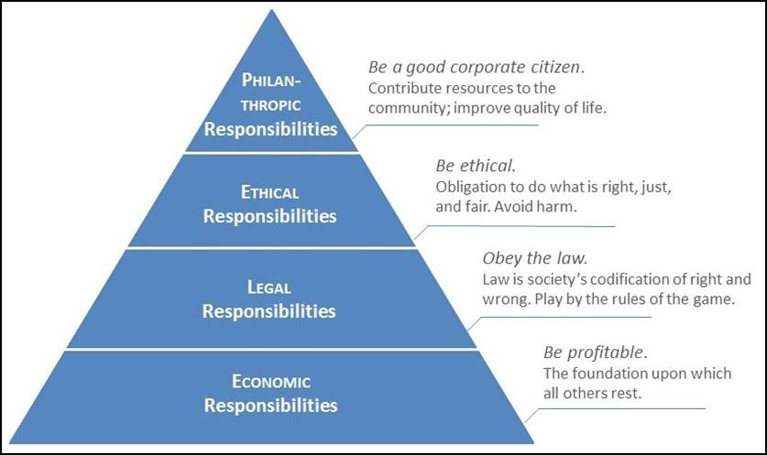

See Carroll’s articles in the Articles on CSR section. He is a very good read. He has now retired. Do search for “updates on Carroll’s Pyramid” type articles if you are getting into this.
I would not expect much detail n the assignment on CSR (unless you are looking at CSR software investment, which are quite innovative). However if you want to expand discussions on CSR there are:

- Need to link to STRATEGY- CHANGE- DIGITAL INNOVATION to make CSR reelvant to your assignment. Here is a nice table I cannot find the source but think it is in one of the standard textbooks:

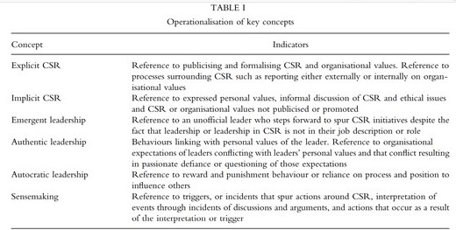
- In Caroline and my most recent article, we (mainly due to me) are a little pessimistic about the way world leaders are going to make changes in the face of other pressures. Maybe CSR, global warming, human rights etc will be put on the back burner in the face of low growth, falling living standards, international tensions etc.:
Jawad, C. and Griffiths, S.L. (2023) The Future of CSR? Back to the Past, Proceedings International Conference on Business, Accounting and Finance, Kuala Lumpur, February.
The Future of CSR? Back to the Past.
Dr Caroline Jawad (Senior Lecturer, UWTSD) & Stephen Griffiths (Visiting Post Graduate Tutor, UWTSD & Swansea University).
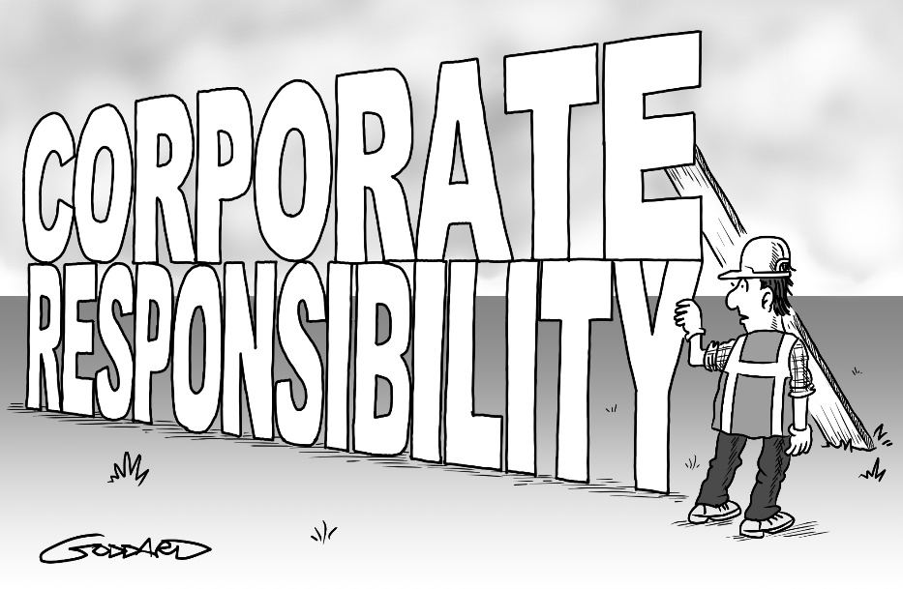
Signposting corporate responsibility: It's big, it's everywhere, we hear a lot about it but ... there's nothing behind it. A cartoon by renowned cartoonist Clive Goddard. (Permission obtained for the use of image).
Abstract.
The pandemic, global warming, economic recession, political and military strife have created uncertainty in all cultures, but especially in business spheres. Goddard’s cartoon suggests that CSR adoption is ubiquitous, however the reality of CSR performance is nebulous. The cartoon was created before the current crisis of confidence and security. Even then critics of business maintained the need to continually campaign for business CSR adoption, beyond simple PR cosmetic effect or compliance with regulation. In crisis businesses as a priority may seek to reduce risk, secure future resources and protect profits. In the face of current threats to business sustainability, environmental/ecological sustainability may appear a luxury that they cannot afford. Understandably most accept the need for government intervention. Yet governments themselves find it difficult to respond, already committed to high debt as a result of pandemic management. Governments also are tempted to soften or abandon current (often inadequate) CSR regulation frameworks, in the interest of supporting economic growth and protection of living standards at home. It is the belief of the authors that CSR policies will be “postponed” by most, with no definite readoption date. Superficial CSR policies will be the new paradigm (unless an obvious business payback is evident). However without development of sustainable policies (attempting to achieve UN Sustainable Development Goals), many of which do not promise immediate payback, the crisis is likely to continue and worsen. Goddard’s cartoon may be sadly redundant as organisations may not even feel driven to adopt a cosmetic level of CSR.

- Porter and Kramer, CSV.
Porter, M.E. and Kramer, M.R. (2011) Shared Value- How to reinvent capitalism and unleash a wave of innovation and growth, Harvard Business Review, January-February, pp. 62-77.
I tend to feel this is a modified version of Friedman’s view. It does talk about wider concerns than simply the stockholders, but to action things there needs to be shared values by stockholders and stakeholders. Obviously this is good, but might we need some consideration of stakeholder interests even if stockholders were disadvantaged? For example getting rid of pollution or slave labour?
Porter has updated since this time. He regularly writes in the HBR.

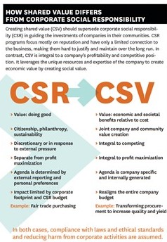

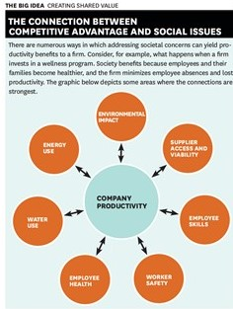

- A good text on Ethics and CSR is:
Crane, A., Matten, D., Glozer, S. and Spence, L. (2019) Business Ethics. 5th ed. Oxford: Oxford University Press.
If you were at the lecture and look at my article bibliography, you will know of my “secret” love for Laura Spence, who is absolutely delightful, intelligent , generous and great fun. I will continue to admire her from afar. Please do not tell anyone about my “crush”!
These links to Laura’s blogs are not evidence of stalking.
https://walton.uark.edu/business-integrity/blog/laura-spence.php
https://www.youtube.com/watch?v=h3lSAjRFdBA
These pictures are from their textbook.
They extend the discussion on CSR to include Corporate Citizenship (CC).

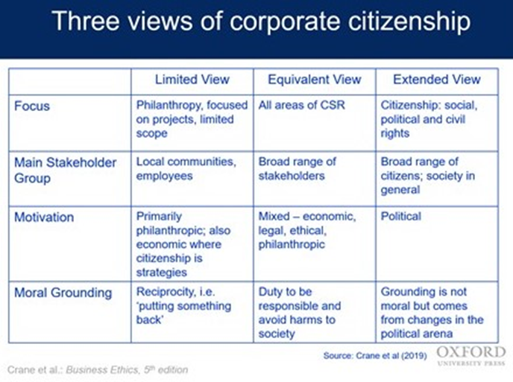

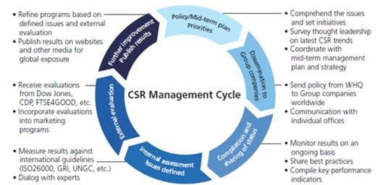

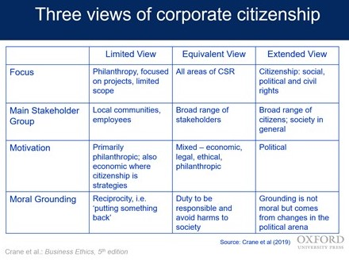

- I also mentioned the Body Shop, one of the few organisations who go through each stage of the Andersen Model, including the final external audit. You can see this on their website.
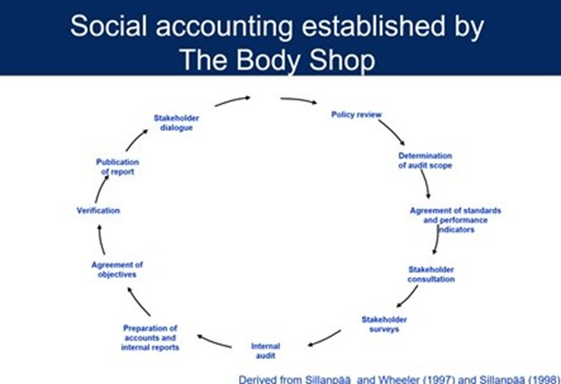

- Not sure where I got this from, but if you are looking at unethical practice there are plenty of sources to explain why it takes place (they do not condone it or recommend it. Identifying when managers are likely to break rules could be important in stopping them do it. See “Nudge Theory”.


