Marketing Fundamentals
Topic: Exploring the range of Marketing Functions within Next Plc and ways in which these functions influence customer needs
Student Name: Silviu Mircea Moisa
Student ID: 2014968
Module code: LCB4004_Birm
Lecturer: Dr. Yousuf Kamal

Executive Summary
Understanding the needs of customers is one of the prime objectives of businesses. Next Plc. operates in a highly competitive environment in the global market. This has made it essential for the respective organisation to understand different external factors that have the potential to influence consumer needs. The report has focused on various marketing theories such as PESTEL analysis, Porter’s 5 forces, and SWOT analysis for determining the marketing environment of Next Plc. Moreover, the marketing functions of the respective organisation have been determined by using the marketing mix. Based on the marketing mix, relevant recommendations have been provided for Next Plc.

Table of Contents
Introduction 4
Marketing Environment of Next Plc. 5
SWOT Analysis of Next Plc. 5
Porter’s five force analysis of Next Plc 7
PESTEL Analysis of Next Plc. 10
Marketing Functions of Next Plc. and their influence on customer needs 15
Recommendations on ways in which Next Plc can improve its marketing mix 19
Conclusion 21
References 22

Introduction
The report will indicate the operational activity of Next Plc. during the point of time which will offer the items like footwear, clothing and other aspects to fulfil the needs of the consumer over the period of time. It has about 700 outlets among which around 500 are situated in the location of United Kingdom this retail business is founded in the year 1864, with the help of Joseph Hepworth (nextplc, 2022). On the basis of the estimation, the level of the ultimate income is around £677.5 million in the period of 2022 and the value of the working employees in the daily operations is around 43040 (Nash, 2019). The core aim of the function of Next Plc is to offer the items in such a way that is capable to meet consumer demand by offering efficiently designed, exciting footwear, accessories and other aspects. With the support of this, it can generate more income over time and fulfil the expectation of the consumer over time. Apart from that, the report will reflect the analysis of the marketing environment like a SWOT description for the internal part, for the external part this will also describe porters 5 forces (Jin and Shin, 2020). The discussion of the PESTEL analysis regarding several factors like political, social, and environmental will be analyzed in the portion over time to meet the needs of the consumer. On the other hand, the description of the 7p's of the marketing mix will be depicted more efficiently for promoting the activity of the business among the consumer and offer recommendations to bring improvement in this (Namugenyi et al., 2019).

Marketing Environment of Next Plc.

SWOT Analysis of Next Plc.
Strengths
Strong Brand Image: Next Plc. has a strong brand image and is one of the most recognized and reputable fashion retailers in the UK. The company has been in the retail industry for more than three decades and has built a loyal customer base (nextplc, 2022).
Multichannel Retail: The respective organisation is a multichannel retailer, with a strong presence both in-store and online. The company has a well-developed e-commerce platform, which is a significant source of revenue for the company.
Strong Financial Position: Next Plc. has a strong financial position, with consistently high revenue and profits. The company has a stable dividend policy and has returned value to its shareholders over the years.
Efficient Supply Chain: Next Plc. has an efficient supply chain, which helps the company to maintain a high level of product availability and reduce lead times. The company has been able to establish a positive relationship with its suppliers (nextplc, 2022).
Weaknesses
Limited Geographical Presence: Although Next Plc. is a multinational company, and the majority of its revenue comes from the UK. The company has a limited geographical presence, which makes it vulnerable to economic fluctuations in the UK market.
Dependence on Third-Party Suppliers: Next Plc. relies heavily on third-party suppliers for its products (nextplc, 2022). The company's inability to manage its supply chain effectively could result in delayed delivery times or quality issues.
Limited Product Range: Next Plc. mainly focuses on clothing, footwear, and home products, which could limit its customer base. Moreover, the company is mainly known for its clothing and footwear. This restricts the image of Next Plc. only as a fashion retailer.
Opportunities
Expansion of E-commerce: Next Plc. can capitalise on the growing trend of online shopping by expanding its e-commerce platform. Moreover, it can invest in developing technology considering the demand for AR retailing among customers.
Diversification of Product Range: Next Plc. can diversify its product range by expanding into new product categories, such as electronics or beauty products (nextplc, 2022). A wider product range will help the company to tap into new sectors, further increasing the customer base.
International Expansion: Next Plc. can expand its geographical presence by opening new stores in different regions such as Asia or North America. Moreover, the company can also increase the number of stores in the existing market.
Threats
Economic Instability: Next Plc. is vulnerable to economic fluctuations in the UK market, which could impact the company's revenue and profits. This is because the main revenue of the company comes from the UK market.
Intense Competition: Next Plc. faces intense competition from other retailers, both online and in-store, which could impact the company's market share (nextplc, 2022). A few major competitors include M&S, Burberry, Zara, and many more.
Changing Consumer Behaviour: Consumer behaviour is constantly evolving, and Next Plc. must adapt to changing trends and preferences to remain competitive.

Porter’s five force analysis of Next Plc
The threat of New Entrants: Low
Next plc operates in the fashion retail industry, which requires a significant investment in establishing a retail chain, creating a brand, and building a customer base. The high costs associated make it difficult for new entrants to enter the market (Bruijl and Gerard, 2018). Additionally, the fashion industry is already saturated with established players, such as Zara, H&M, and Topshop. These companies have a strong brand presence and well-established supply chain making it difficult for new entrants to gain market share. Therefore, the threat of new entrants is low for Next plc, which means that the company can focus on maintaining its customer satisfaction by investing in new products and services, improving its supply chain and delivery, and providing exceptional customer service.
Bargaining Power of Suppliers: Low to Medium
Next plc has a large number of suppliers that provide various products such as clothing, footwear, and accessories. The company sources its products from multiple suppliers to reduce the risk of supply chain disruption and ensure that it can offer a broad range of products to its customers. Next plc has strong bargaining power over its suppliers due to its large customer base and well-established brand (Gazzola et al., 2020). The company can negotiate better prices, payment terms, and delivery schedules, which helps keep the cost of goods sold low. Additionally, Next plc has established long-term relationships with its suppliers, which ensures a stable supply of high-quality products.
Bargaining Power of Buyers: High
The fashion retail industry is highly competitive, and customers have a wide range of options to choose from. Customers are more informed and empowered than ever before, and they can easily switch to other retailers if they are not satisfied with Next plc's products or services (Arrigo, 2021). Therefore, the bargaining power of buyers is high, which means that Next plc needs to prioritize customer satisfaction to retain its customers. To maintain customer satisfaction, Next plc needs to provide high-quality products with competitive prices and exceptional customer service. The company should also be responsive to customer feedback and complaints, making changes to its products to meet their needs and preferences.
The threat of Substitutes: High
The fashion industry is constantly evolving, and new trends and styles are emerging all the time. Customers have a wide range of options when it comes to fashion retailers, high-street stores, online stores, as well as luxury boutiques (Tete, 2018). Therefore, the threat of substitutes is high, as customers can easily switch to other retailers offering similar products. To maintain customer satisfaction and competitive advantage, Next plc needs to stay up to date with the latest fashion trends and styles, and ensure that its products are of high quality, unique, and relevant to its target market. The company should also invest in marketing and advertising to raise brand awareness and attract new customers.
Competitive Rivalry: High
The fashion retail industry is highly competitive, with a large number of players in the market. Next plc faces competition from other high-street fashion retailers such as H&M, Zara, and Primark, among others. To maintain its market share and customer satisfaction, Next plc needs to differentiate itself from its competitors by offering unique products and exceptional customer service.

PESTEL Analysis of Next Plc.
Understanding the needs and preferences of consumers enable organisations like Next Plc. to increase their customer base and customer loyalty, further providing respective organisations with a competitive edge in the market. External factors that are influencing the consumer needs of Next Plc. can be analysed by implementing a PESTEL framework.
Political factors
Brexit: The political condition of the UK has been a mess since the Brexit referendum in 2016. The political relationship between the UK and other EU nations was affected due to the withdrawal of the UK from the EU (Global Times, 2022). This has affected the operations of businesses like Next Plc. that operate in other European nations. The supply chain of businesses was also disrupted due to trade barriers between the UK and other EU nations. This restricted Next Plc to acquire the required raw materials for manufacturing products that meet the requirements or needs of consumers.
Changing government: The recent change in the UK government has contributed to the political mess in the UK. Political elements such as government expenditure, policies, tax regimes, and other factors changed as the government changed (Global Times, 2022). This affected the organisations in the UK, creating instability in their operations as well. The changing government has affected the operations of Next Plc., restricting the respective organisation from meeting consumer needs effectively.
Russia-Ukraine war: The ongoing Russia-Ukraine war has compelled the UK to impose various sanctions on Russia. The countermeasure implemented by the Russian government has further disrupted the supply chain of businesses in the UK. This has affected the manufacturing operations of Next Plc. and the organisation is facing challenges in meeting customer needs.
Economic factors
Surging inflation: The UK economy was facing a constant surge in the inflation rate in the country. According to Trading Economics (2023), the annual inflation rate was 11.1% by the end of October 2022. This affected the operation of businesses as they were compelled to rise the price of products or services due to the surging operating cost. However, the inflation rate declined to 10.1%, enabling businesses like Next Plc. to reduce their product prices. This is helping to increase their sales again by attracting customers.
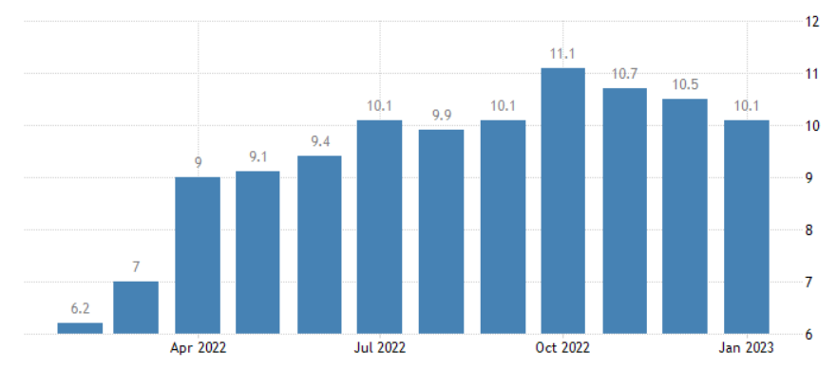
Figure: UK inflation rate
Source: (Trading Economics, 2023)
Increasing fuel prices: The rising fuel price in the UK due to the Russia-Ukraine war has affected the operations of organisations. The cost associated with the logistic operations of Next Plc has increased due to the rise in fuel prices. This has compelled the company to increase the prices of its products and online delivery services, affecting customer satisfaction in terms of the pricing strategy.
Social factors
High cost of living: The living cost in the UK increased majorly as the inflation rate increased. The affordability of services and commodities for households was affected due by the high living cost. This has compelled consumers in the respective country to reduce their average household spending (Francis-Devine, 2023). Since household spending reduced, consumers were only preferring to purchase essential services or products, affecting the sales of Next plc. negatively.
Online shopping: The trend of online shopping has surged in the UK since the outbreak of the coronavirus. It is estimated that the UK have approximately 60 million people using e-commerce platforms for shopping. This has influenced the operations of Next Plc. as the respective organisation has also focused on enhancing its e-commerce platform. Considering the dynamic nature of consumer preferences, Next Plc. has prioritised both offline and online sales.
Technological factors
AI-powered retailing: The UK retail industry is being driven by AI-powered technology. The use of such technologies has increased in warehousing, e-commerce, customer service, and product design. Moreover, more than 40% of the Gen Z population in the UK is estimated to use AR while shopping (Statista, 2023). These technological preferences of people are influencing the operational decisions of Next Plc. in order to meet consumer needs.
Data security risk: Risks associated with data security and privacy have increased in the UK retail industry with the increasing use of technological platforms. It is reported that cyberattacks have disrupted the operations of about 34% of retailers in the UK. Moreover, the retail industry of the respective country confronted at least one cyber-attack every eight days (UKtech.news, 2021). This has the potential to negatively affect the operations of Next Plc. as the trust of customers is gradually diminishing.
Environmental factors
Eco-friendly preferences: Environmental degradation has become of the major concerns of consumers in the UK. About 36% of consumers in the country mostly prefer purchasing from brands with good environmental sustainability credentials (Consultancy.uk, 2022). This has the potential to influence the manufacturing operation of Next Plc., compelling the respective organisation to focus on eco-friendly approaches.
Environmental sustainability: Retail businesses in the UK are prioritising their environmentally sustainable initiatives due to the eco-friendly preferences of consumers. Moreover, the retail industry contributes majorly to climate change, especially fast fashion companies like Next Plc. These aspects will influence the operations of the respective organisation as it has to focus on more sustainable approaches.
Legal factors
Consumer rights: The Consumer Rights Act 2015 is implemented by the UK government in order to protect customers from being treated unfairly. It provides consumers with several rights such as the right to reject, the right to replacement or repair, the right to price reduction, and many more (Gov, 2023). Adhering to these rights will influence Next Plc. positively, helping the company to conduct operations ethically.
GDPR: The GDPR protects the data or personal information of an individual or business from unethical parties. The respective regulation will influence Next Plc. as it will help the company to protect consumer data and enhance loyalty.

Marketing Functions of Next Plc. and their influence on customer needs
Marketing functions plays a significant role in boosting the sales of an organisation. It enables the respective organisation to increase awareness of customers regarding its services or products, boost engagement, and influence the purchasing decision of customers. The marketing mix helps in addressing major marketing functions (Marketing-insider, 2020). It is a set of marketing tactics or actions used by businesses for promoting their products or services in the market.
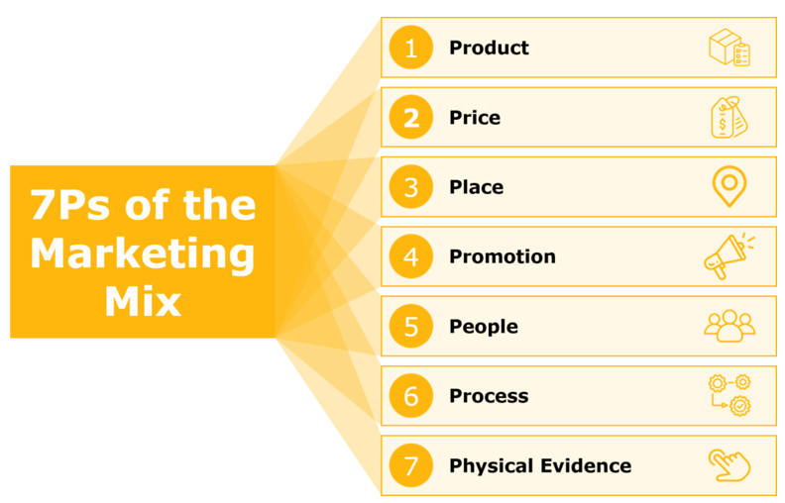
Figure: The Marketing Mix
Source: (Marketing-insider, 2020)
Seven major elements of the marketing mix are discussed below in the context of Next Plc. along with their influence on consumer needs.
Product
Next Plc. is known for its wide range of product portfolio. The respective organisation mainly sells clothing, accessories, footwear, homeware products, and beauty products. Fashion products for men, women, and kids are sold by Next Plc. of its own brand name as well as other brands (nextplc, 2022). Next Plc. is a major brand that creates fast fashion; however, this type of fashion is slowly being avoided by consumers due to increasing environmental concerns. Fast fashion is known for contributing majorly to environmental degradation. Therefore, Next Plc. is required to change its products according to changing consumer preferences.
Price
The price of a product is a vital factor in attracting customers and meeting their needs. Next Plc. has implemented a competitive pricing strategy. This has allowed the respective organisation to set prices of its products by analysing the prices set by its competitors such as M&S, Zara, and other significant fashion brands. The competitive pricing strategy allows the respective organisation to attract customers over other businesses. However, economic instability and reduced household income is changing consumers’ needs and their pricing preferences as well.
Promotion
Promotional activities are crucial marketing aspect that allows a business to increase customer awareness regarding its products or services through relevant messages. Establishing an effective communication channel is an essential part of a promotion. Next Plc. promotes its products through both online as well as offline channels. The company has increased its investment in digital marketing after a surge in full-price sales by 17% in 2021 (Rogers, 2021). However, the advertising campaigns of Next Plc. is failing to create a long-lasting impression on consumers as it is unable to address the preferences of consumers in its advertising campaigns.
Place
In terms of the place, Next Plc. has been able to boost its full-price sales through its effective distribution network. According to a report by Russell (2019), the respective organisation knows its customers well and understands their preferences. Next Plc. has been able to create a positive relationship with its customers by aligning both an online presence and bricks and mortar stores as well. There are over 500 stores of the company in the global market along with a well-developed e-commerce platform. This has enabled Next Plc. to address the transforming online shopping behaviour of consumers with the outbreak of the pandemic.
Physical Evidence
It mainly refers to the tangible elements that help in establishing the credibility of a business while including the feel and look of the brand. Next Plc. has focused on enhancing its e-commerce platform by highlighting offers and discounts on the homepage (nextplc, 2022). In terms of packaging, the respective organisation is working on eliminating the use of plastic packaging, considering the preferences of customers for eco-friendly initiatives. Moreover, Next Plc. has improved its in-store operations through automation which has helped to reduce the check-out time of customers, further increasing customer satisfaction.
People
This indicates people who are indirectly or directly involved in an organisation. In terms of Next Plc., the respective organisation has over 43,040 employees who are serving customers globally (nextplc, 2022). The company has prioritised diversity and inclusion in its workforce; moreover, proper training has been provided to staff. However, the increasing technological inclination of customers is increasing the demand for a more technically advanced workforce.
Process
The process involves ways in which the business delivers its services or conducts its operations. Being a fast fashion brand, it is essential for Next Plc. to focus on environmental sustainability. The respective organisation is working on achieving net zero in its processes (nextplc, 2022). Moreover, the respective organisation has determined the increasing eco-friendly needs of consumers and has taken initiatives to eliminate the use of plastic. In order to address the needs of customers, Next Plc. has enhanced its customer service processes as well.

Recommendations on ways in which Next Plc can improve its marketing mix
The marketing mix of Next Plc. reveals that there are certain marketing aspects that the respective organisation is required to improve for meeting customers’ needs effectively. A few recommendations have been highlighted for the respective organisation in terms of its marketing mix.
Recommendation for the product: Considering the increasing demand of consumers for eco-friendly products and services, Next Plc. is recommended to introduce green fashion. Being a fast fashion company, the environmental impact of Next Plc. is quite high. Introducing green fashion like using eco-friendly materials for the manufacturing process will help to minimise the negative impact on the environment while meeting consumers’ needs.
Recommendation for price: The average household spending has reduced in the UK which is compelling consumers to purchase only those goods and services that are perceived as essential or valuable. Next Plc. is recommended to change its pricing strategy from competitive to value-based. This will enable the respective organisation to set prices based on the perceived value of customers.
Recommendation for promotion: Sustainability and ethical approaches have become major concerns for businesses as these aspects are prioritised by consumers as well while purchasing goods or services. Next Plc. is recommended to develop advertising campaigns based on sustainability and ethical business approaches. For instance, the company can communicate its environmental sustainability journey through its advertising campaigns. Moreover, it can address body positivity in its promotional campaigns. This will enable the company to attract more customers.
Recommendation for people: Since the use of technology is increasing for enhancing customer experience, Next Plc. is recommended to recruit more employees with technical skills. Moreover, the respective organisation is also required to introduce training programs for enhancing the technical skills of employees. This will help to enhance business operations and boost customer satisfaction as well.

Conclusion
The report has been focused on the identification of the capability to meet the needs of the consumer to attract more traffic to consume the services over time for generating a reasonable income. This report has focused on the strengths of Next Plc that have been related to the financial position and supply chain that has been increasing the level of turnover over time. Also, the mentioned business has suffered from the threat of huge competition while trying to conduct the services over time. The result of the PESTEL analysis has helped to know about the economic factor like increasing inflation has a great effect on consumer needs and creates a problem for businesses to increase the cost of living. Moreover, the technological improvement in the daily activity of the business help Next Plc. to achieve the demand of the people and offer this at a justified price. The data that has been found on the basis of the estimation of the 7p’s analysis, the probability of being improved in the portions of products by the innovation, place by selecting the more gathering places and other things to meet the consumer expectations. On the other hand, the analysis of Porter's 5 forces has been discussed in the report and has the potential to meet consumer expectations.

References
Arrigo, E., (2021). Collaborative consumption in the fashion industry: A systematic literature review and conceptual framework. Journal of Cleaner Production, 325, p.129261.
Bruijl, D. and Gerard, H.T., (2018). The relevance of Porter's five forces in today's innovative and changing business environment. Available at SSRN 3192207.
Consultancy.uk, (2022). UK consumers embracing more sustainable behaviour. [Online] Available at: https://www.consultancy.uk/news/30077/uk-consumers-embracing-more-sustainable-behaviour. [Accessed 12 March 2023].
Francis-Devine, B., (2023). Rising cost of living in the UK. [Online] Available at: https://commonslibrary.parliament.uk/research-briefings/cbp-9428. [Accessed 12 March 2023].
Gazzola, P., Pavione, E., Pezzetti, R. and Grechi, D., (2020). Trends in the fashion industry. The perception of sustainability and circular economy: A gender/generation quantitative approach. Sustainability, 12(7), p.2809.
Global Times, (2022). UK's political chaos an embodiment of the country's confusion in the post-Brexit era. [Online] Available at: https://www.globaltimes.cn/page/202210/1277856.shtml [Accessed 12 March 2023].
Gov, (2023). Consumer rights. [Online] Available at: https://www.gov.uk/consumer-protection-rights#:~:text. [Accessed 12 March 2023].
Jin, B.E. and Shin, D.C., (2020). Changing the game to compete: Innovations in the fashion retail industry from the disruptive business model. Business Horizons, 63(3), pp.301-311.
Marketing-insider, (2020). 7PS OF THE MARKETING MIX – COMPREHENSIVE MARKETING STRATEGY FRAMEWORK. [Online] Available at: https://marketing-insider.eu/7ps-of-the-marketing-mix/ [Accessed 13 March 2023].
Namugenyi, C., Nimmagadda, S.L. and Reiners, T., (2019). Design of a SWOT analysis model and its evaluation in diverse digital business ecosystem contexts. Procedia Computer Science, 159, pp.1145-1154.
Nash, J., (2019). Exploring how social media platforms influence fashion consumer decisions in the UK retail sector. Journal of Fashion Marketing and Management: An International Journal, 23(1), pp.82-103.
nextplc, (2022). OUR HISTORY. [Online] Available at: https://www.nextplc.co.uk/about-next/our-history [Accessed 10 March 2023].
Rogers, C., (2021). Next continues to ramp up digital marketing spend as online sales surge. [Online] Available at: https://www.marketingweek.com/next-digital-marketing-online-sales/ [Accessed 13 March 2023].
Russell, C., (2019). Next Knows The Customer And Grows Full Price Sales. [Online] Available at: https://www.forbes.com/sites/callyrussell/2019/09/24/next-knowing-the-customer-and-growing-full-price-sales/?sh=33b54bdbd447 [Accessed 13 March 2023].
Statista, (2023). Retail technology in the United Kingdom (UK) - Statistics & Facts. [Online] Available at: https://www.statista.com/topics/5425/retail-technology-in-the-uk/#topicOverview [Accessed 12 March 2023].
Tete, A.S., (2018). Study on Product Development, Dropout Analysis and Recovery of Styles. NIFT.
Trading Economics, (2023). United Kingdom Inflation Rate. [Online] Available at: https://tradingeconomics.com/united-kingdom/inflation-cpi [Accessed 12 March 2023].
UKtech.news, (2021). Retail sector in the UK faces one cyber attack every eight days. [Online] Available at: https://www.uktech.news/news/retail-sector-uk-faces-one-cyberattack-every-eight-days-20211117 [Accessed 12 March 2023].

