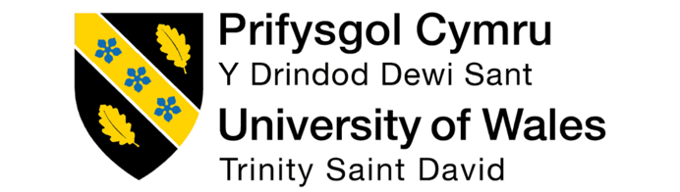
Master of Business Administration (MBA)
Module: Strategic Management (LCMB7003)
Assessment: Individual Report – Unilever PLC

Title: Strategic Analysis and Growth Opportunities for Unilever PLC: Evaluating Competitive Advantage in the Global FMCG Industry

Lecturer: Hoang Nguyen
Student Name: Rabin Hasan
Student ID: 2504378

Word Count: 5257

Date of Submission: 01 May 2026

AI Acknowledgement

I acknowledge the use of ChatGPT (https://chatgpt.com/) on 25 March 2026 to write my
notes into submission format using the prompt(s):
- Please give me recent statistical data about BP at the university level.

I acknowledge the use of Grammarly (https://www.grammarly.com/) on 29 April
2026 to check my work using the prompt(s):
1. Please check the following text for readability, grammar and syntax.

I confirm that I have not presented any AI-generated text as my own work. I confirm I
have copies of my drafts, notes, and other resources I used before and after the use of
AI tools which I may be asked to provide in evidence.

Table of Contents
AI Acknowledgement 2
Introduction 6
Organisational Context and Overview 6
Unilever’s Background 6
Unilever’s Mission, Vision, and Business Model 7
Industry Overview and Competitive Position 8
External and Internal Environment Analysis 8
Macro-Environment (PESTEL) Analysis 8
Political 8
Economic 9
Social 9
Technological 9
Environmental 10
Legal 10
Micro-Environment Analysis 10
Industry Life Cycle 10
Porter’s Five Forces Analysis 10
Critical Success Factors and Strategic Challenges 12
Internal Environment Analysis 12
Unilever’s Strategic Resources and Capabilities 12
Tangible Resources 12
Intangible Resources 13
Value Chain Analysis 13
Primary Activities 13
Support Activities 13
VRIO Framework 14
SWOT Analysis 15
CSR and Sustainability Strategy 15
Unilever’s CSR Strategy 15
Strategic Alignment 16
Comprehensive and Holistic View of the Organisation 16
Balanced Scorecard 16
Balanced Scorecard 16
Financial Perspective 17
Customer Perspective 18
Internal Business Processes 18
Learning and Growth Perspective 18
Strategic Choices and Implementation 19
Strategic Choices at Business Level 19
Corporate-Level Strategy 19
Evaluation of Strategic Choices 20
Change Management and Implementation 20
Strategic Evaluation and Recommendations 20
Evaluation of Unilever’s Strategy 20
Recommendations 22
Conclusion 22
Reflective Account (Gibbs Reflection Cycle) 23
Description 23
Feelings 24
Evaluation 24
Analysis 24
Conclusion 25
12.6 Action Plan 25
Reference 27
Appendix 30
Value Chain Framework 30
VRIO Analysis 30
Balanced Scorecard 31

Introduction
Unilever is a multinational FMCG firm producing a plethora of brands, which are oriented towards sustainability (Unilever, 2025). This report exemplifies Unilever's world market strategy, strengths, weaknesses and opportunities. Special attention will be paid to the assessment of the strategy through several business strategy frameworks, including PESTEL, VRIO, Porter's Five Forces, SWOT, Balanced Scorecard and CSR strategies. This will allow the report to provide an insight into Unilever's internal and external environment, resources and capabilities for competitive advantage and market alignment (Unilever, 2025). This evaluation will employ the PESTEL model for macro-environmental factors analysis, VRIO for resource and capability analysis and Porter's Five Forces for analysis of the business environment. SWOT will focus on value and weaknesses, and Balanced Scorecard on goals. Finally, the CSR strategy will be considered for environmental achievements.

Organisational Context and Overview

Unilever’s Background
Unilever PLC is a British multinational company established in 1930 from the merger of Lever Brothers and Margarine Unie to form the company as it is today. It is headquartered in London and in 2026 had 125,000 employees across over 190 countries (Unilever PLC, 2025a). In 2025, it had revenues of €50.5 billion and is active in personal care and cleaning, beauty and nutrition. Unilever has a broad and varied portfolio of brands, including Dove, Lifebuoy, Persil and Hellmann's, reaching one billion consumers around the world (Unilever PLC, 2025a). It has been progressively "refreshing" its portfolio, shedding brands in ice cream in order to focus on the growth segments. This reflects the transition towards higher-end markets and optimisation.
The company's recent performance indicates modest growth, with the first quarter of 2016 underlying sales growth of 3.8 %. This was due to increased volume, rather than price increases, and reflects an increase in consumer demand, despite inflation.
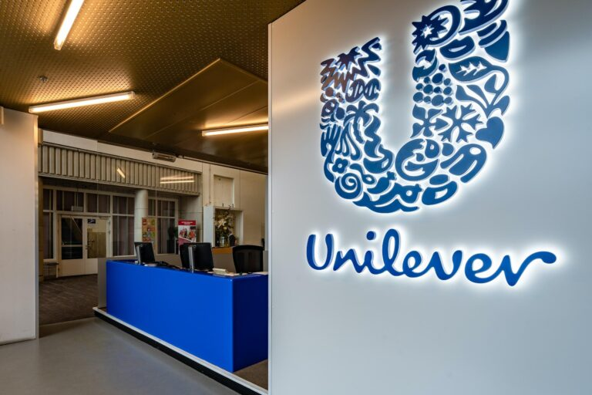
Figure 1: Unilever PLC
Source: (Unilever, 2025)

Unilever’s Mission, Vision, and Business Model
Unilever is driving for sustainable living. Unilever's mission is to make sustainable living commonplace by delivering beauty, personal care, home care and nutrition products that make people feel good, look good and do good. They vision to lead the world in sustainable business, with the best environmental and financial performance through brands that grow in a sustainable way. (Unilever PLC, 2025b) Unilever has a strategy built on a portfolio of brands through broad networks that are supported by R&D. It has revenues from various product segments (personal care, household care and nutrition) to reduce market risk. Unilever concentrates on "power brands" that generate the most income and profit to invest in more lucrative opportunities, innovation, and marketing.

Industry Overview and Competitive Position
Fast-Moving Consumer Goods (FMCG) is an industry characterised by high velocity (turnover) of products (consumer goods), and low competition and barriers to entry. It comprises commodity products which are consumables, replenished regularly and are highly price-inelastic (Nurlatifah et al., 2023). The global FMCG market is still growing, driven by the development of urban centres and rising personal income and is likely to experience moderate growth in the coming years.
Unilever's main competitors in the FMCG sector are Procter & Gamble and Nestlé. Procter & Gamble, for example, is a leader in personal and home care and often a more profitable and valuable company (Lakshman et al., 2017). Nestlé is the kingpin of food and nutrition. Unilever's advantages range from product portfolio to emerging market dominance, which defends against global demand setbacks. However, profitability and share of leadership are fiercely contested and private labels are becoming increasingly popular.

External and Internal Environment Analysis

Macro-Environment (PESTEL) Analysis
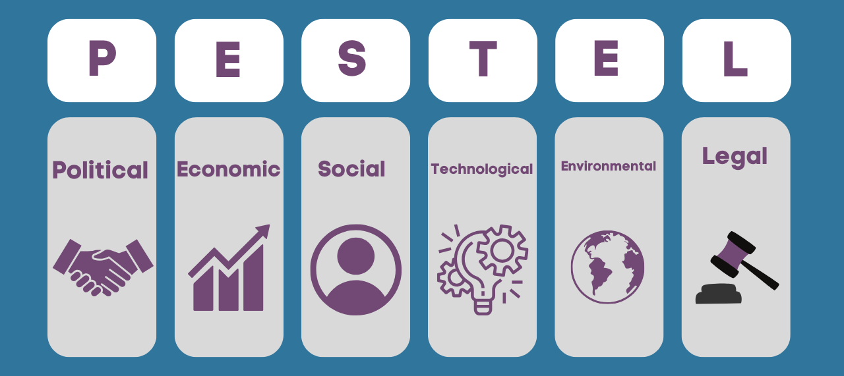
Figure 2 : PESTEL Analysis
Source: (Castro and Moreira, 2023)

Political
Unilever operates in almost 195 countries, with different political systems. Stability in trade policies in major markets (U.S., some Asian countries) enables cross-border trade and improves global supply chain (scheduling and planning), while instability and policy changes in other markets (e.g., EU) create regulatory risks and operational inefficiencies (Aithal, 2017). The UK/EU exit, or Brexit, adds to cross-border trade and tax complexities. Some emerging markets harbour regulatory risks given political uncertainty. The countermeasure is regulatory risk assessment and portfolio diversification for risk reduction and non-dependence on a certain political environment.

Economic
2016 is a tough economic year. Unilever had underlying growth of sales of ~3.8% in Q1 2016, but it is impacted by higher cost inflation, probably up by ~€750-900m as a result of geopolitical risk and rising prices for commodities and energy (Unilever PLC, 2025a). This compresses margins, and the company is expected to introduce step-up pricing in the range of ~2-3% in some categories to prop up margins. Meanwhile, growth in emerging markets accounts for 59% of turnover, driven by good performance in India and Asia, offsetting any slowing growth in Europe and America. The exchange rate and inflation force a responsiveness in price and cost (Bouguerra et al., 2023).

Social
There's a growing trend towards healthy and environmentally-friendly products. Unilever's planned growth reflects these trends with its personal care and wellness businesses. Its well-being category grew 3.7% in the first half of 2015, for example, reflecting a trend for wellness and good health (Unilever, 2025). Millennials and Gen-Z are also more concerned about ethical and environmentally responsible product options - in line with Unilever's wellness and sustainable living strategies. Social factors affect marketing, corporate social responsibility (CSR) and branding in crowded FMCG markets.

Technological
Unilever is technology-driven. It uses digital transformation for supply chain optimisation, to better plan consumer demand, and for e-commerce growth. E-commerce is expanding rapidly with double-digit growth as consumer goods find sales traction with the growth of online retail (Castro and Moreira, 2023). Data analytics and automation improve manufacturing productivity and innovation pipelines, supported by enabling research and development (R&D), which helps Unilever drive product innovation. But technology also raises the bar in the business as rivals start using the same technologies to improve their agility and engagement.

Environmental
Unilever embeds sustainability in its strategy through its "growth action plan 2030" by demonstrating a focus on decarbonisation, plastic and sustainable sourcing. Sustainability is viewed as a risk for packaging, emissions and waste, as more stringent environmental policies are sought (Unilever PLC, 2025a). But it is also a market opportunity as product sustainability projects enhance brand and loyalty. But initiatives also involve large capital outlay and transformational changes to sourcing and manufacturing, resulting in a higher cost of production.

Legal
Labour and packaging regulations and international trade are critical. To operate in large markets, companies need to comply with the strict environmental protection and product safety regulations of major markets (i.e., the EU single-use plastic regulation and product safety regulations) (Franco, 2021). These are expensive, but companies that comply with more than the regulations gain a competitive advantage. Intellectual property and consumer protection also help to build brand and product differentiation.

Micro-Environment Analysis

Industry Life Cycle
Unilever is in the FMCG industry, which is in a mature stage. This is a challenge and opportunity for Unilever. Price pressure, competition and innovation are major challenges. As the industry becomes more saturated, there is a need for companies to explore some alternatives and opportunities, such as sustainability and digitisation (Önören et al., 2017). In turn, Unilever has focused on innovation and has expanded its offerings with more sustainable, natural and healthy products. And a boom in e-commerce, as well as changing consumer preferences, means new ways to change its marketing and distribution strategy.

Porter’s Five Forces Analysis

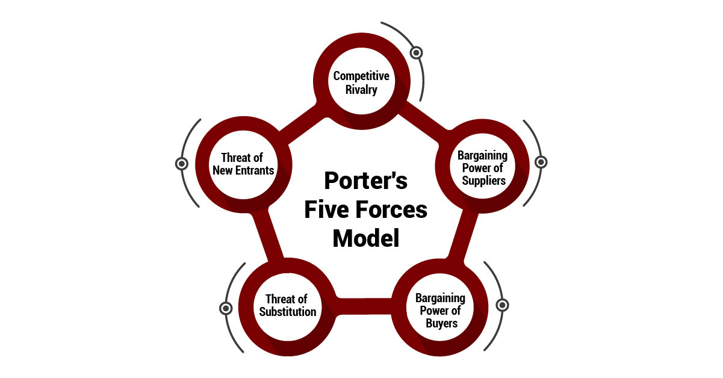
Figure 3: Porter’s Five Forces
Source: (Dobbs, 2014)

Competitive Rivalry: The FMCG sector is competitive. Unilever's main competitors include P&G, Nestlé and Reckitt Benckiser. Frequently, they have similar products, which can be hard to differentiate (Pangarkar and Prabhudesai, 2024). Business Insider says Unilever's key strengths, which give it a competitive edge, are its strong branding, innovative products and its concerns with sustainability.
Bargaining Power of Suppliers: As a multinational organisation, Unilever is able to exert bargaining power over its suppliers, but it's also subject to leveraging at times. For example, dependence on these suppliers (of raw materials such as palm oil and soybeans) affects costs and availability (Dobbs, 2014). Unilever has neutralised this threat through sustainable sourcing and supply.
Bargaining Power of Buyers: The power of buyers is high in the FMCG sector due to high competition and alternative products. However, Unilever's high brand awareness and promotional activities allow it to retain market share despite the competition (Dobbs, 2014). The power of buyers has also increased due to the emergence of the internet, as buyers can easily compare prices online and purchase accordingly.
Threat of New Entrants: New entrants also face barriers as they need to invest significantly in manufacturing and distribution (Pangarkar and Prabhudesai, 2024). But the new entrants' targeting of small segments, which use the internet for distribution, may still be a threat to Unilever. Unilever's response to this threat is through focus on product and service innovation and brand loyalty.
Threat of Substitutes: There is a high threat of substitutes in the FMCG market with a range of smaller, cheaper alternatives to brand names (Mussayeva, Savina and Panzabekova, 2025). Unilever overcomes the threat of substitutes by increasing brand loyalty and developing new products (including plant-based food), which are growing in popularity.

Critical Success Factors and Strategic Challenges
Key Success Factors: For Unilever, the key success factors are the brands, innovation and sustainability. Unilever's commitment to sustainable sourcing, a reduced environmental impact and a focus on healthy living has kept them afloat in a low-margin industry (Sen, 2024). And it is innovative in its product development and digital technology development, allowing it to remain competitive.
Challenges: Unilever has several challenges on the path to sustainable competitive advantage. Higher input prices, for sustainable products in particular, affect profitability. It must also innovate to align with these changes in consumer trends, particularly health and sustainability (Potter, 2015). In addition, it faces increasing competition from both traditional and new, nimble competitors. Lastly, although Unilever is making great efforts to become sustainable, it is struggling to reach its sustainability goals.

Internal Environment Analysis

Unilever’s Strategic Resources and Capabilities
Unilever's resources and capabilities are essential in gaining a competitive edge in the FMCG industry. It can be split into two types: tangible and intangible:

Tangible Resources
Manufacturing and Supply Chain: Unilever has more than 300 factories across the globe and can efficiently produce and deliver its products. Through its efficient supply chain, it can quickly adapt to market needs, minimising costs (Franco, 2021). According to Unilever's 2025 Annual Report, their sustainability efforts in their supply chain have improved efficiencies and reduced waste and emissions.
Financial Strength: Unilever's turnover of €60.1 billion in 2023 shows it has a healthy financial position, which enables it to research and develop products and brands, make acquisitions and pursue sustainability (Unilever PLC, 2025a). This helps Unilever to weather economic cycles and pursue growth opportunities.

Intangible Resources
Brand Equity: Unilever includes popular brands like Dove, Hellmann's and Lipton. These are internationally recognised and help Unilever capture market share (Dabic and Kiessling, 2019).
Customer Loyalty: The fact that Unilever is so popular, with 2.5 billion customers consuming its products daily, means it can build on brand loyalty to its own growth (Unilever PLC, 2025a).
Intellectual Property: Unilever has patents and trademarks in areas such as product formulas and design, creating intellectual property and advantages (Dabic and Kiessling, 2019).

Value Chain Analysis

Primary Activities
Inbound Logistics: Unilever has international suppliers for its raw material purchases. It employs sustainable sourcing, for example, through the Sustainable Agriculture Code, which covers 50% of its farm products (The Guardian, 2020). This guarantees the company quality material and that environmental risks are mitigated.
Operations: Unilever has efficient and innovative operations. Unilever has made significant investments in automation and digital technologies in its production processes to boost efficiency and reduce its impact (Gordon-Farleigh, 2026). By leveraging artificial intelligence (AI) technologies in forecasting demand and managing inventory, it improves manufacturing efficiency and reduces costs.
Marketing and Sales: Unilever's marketing is largely centred on consumer insights. This allows it to tailor its marketing and product offerings. It also engages in digital marketing, driving strong digital sales growth. For instance, more than 25% of its sales in 2015 were from digital media (Unilever PLC, 2025a).
Service: Unilever offers service to customers through after-sales activities and customer engagement programs (Unilever, 2025). It also has a positive impact on the community through social responsibility and sustainability.

Support Activities
Technology: Technology is dedicated to product innovation, digitalisation, and sustainability. It employs its Open Innovation and employs AI in the supply chain to innovate (Aithal, 2017).
Human Resources: Unilever emphasise knowledge and human resource management, particularly in the areas of innovation and leadership (Castro and Moreira, 2023). It also undertakes training for responding to market changes.
Procurement: Sage's procurement strategy focuses on sustainability, and more than 60% of its suppliers follow sustainable principles (Aithal, 2017). Suppliers assist Unilever in waste reduction and efficiency.

VRIO Framework
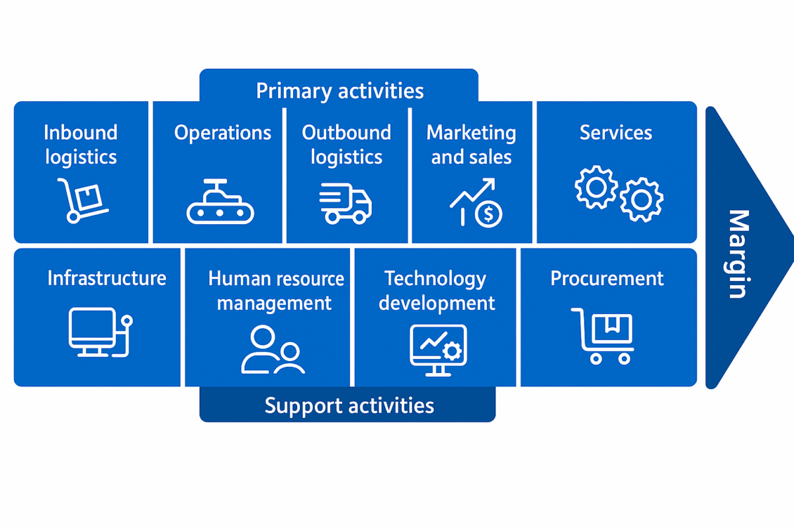
Figure 4: Value Chain
Source: (Bouguerra et al., 2023)

The VRIO analysis highlights the key resource and capability-based sources of advantage.
Value: The Unilever brand and global presence are valuable. It creates value by delivering consumer needs through an effective distribution and portfolio strategy. Unilever delivered underlying sales growth of 3.8% in 2015, demonstrating the value of its business model in providing solutions that meet consumer needs (Unilever PLC, 2025a).
Rarity: Unilever's brands, such as Dove and Ben & Jerry's, are rare because of their brand equity and global market share. They're rare because of the strong brand loyalty and consumer connections they enjoy, allowing them to engage consumers on issues of sustainability and social responsibility (Bouguerra et al., 2023). However, while brand equity is rare, it's not uncommon, as other firms like Procter & Gamble (P&G) hold brand equity too.
Imitability: Unilever's resources are somewhat imitable. Others can imitate its product and packaging designs and marketing, but its supplier relationships and sustainability are hard to copy. For instance, its emphasis on sustainability with no waste to landfill and its aim to become carbon neutral in 2015 is difficult (Unilever PLC, 2025a).
Organisation: Unilever's efficient resource utilisation through technology, supply chain, and human resource development enables it. Its organisation can build flexibility to quickly respond to market opportunities and ensure consistency in its global practices (Cheng, 2021). Sustainability is part of its DNA and allows it to grow in emerging and established markets.

SWOT Analysis
Strengths | Weaknesses
Strong global brand portfolio (Dove, Lipton, Ben & Jerry’s) (Unilever PLC, 2025b). | Complexity in operations due to size and scope (Unilever PLC, 2025a).
Market leader in sustainability initiatives (Sustainable Living Plan) (Unilever, 2025). | High operational costs in certain regions (Unilever PLC, 2025b).
Diverse geographic presence (60% of revenue from emerging markets) (Unilever PLC, 2025a). | Reliance on third-party suppliers for raw materials (Unilever PLC, 2025b).
Opportunities | Threats
Expansion in emerging markets with rising middle-class populations (Unilever PLC, 2025b). | Economic volatility and price sensitivity in developed markets (Unilever PLC, 2025a).
Growing demand for sustainable and health-conscious products (Unilever PLC, 2025b). | Intense competition from rivals like P&G and Nestlé (Unilever PLC, 2025a).
Innovation in plant-based and eco-friendly products (Unilever PLC, 2025b). | Regulatory pressures, especially in packaging and labor laws (Unilever PLC, 2025b).

CSR and Sustainability Strategy

Unilever’s CSR Strategy
The Unilever corporate social responsibility (CSR) policy is part of the 2010 Sustainable Living Plan (USLP). The plan seeks to achieve ambitious product-related goals to deliver products with a reduced environmental impact and improve the lives of 1 billion people in 2025 (Gordon-Farleigh, 2026). This includes significant progress in sustainable sourcing, energy and water conservation. For example, Unilever has already achieved over 60% sustainable sourcing of its agricultural raw materials, ensuring responsible sourcing (Unilever PLC, 2025b). Unilever is also on the road to net-zero emissions by 2039 for a safe climate.
Unilever integrates social and environmental sustainability into its strategy by a three-pronged approach of sustainability, social equity and economic growth (Hansen, 2020). Leveraging the voice of brands like Dove, promoting body acceptance, and Hellmann's, urging an end to food waste, it is evident that it is committed to sustainable products. And Unilever works with suppliers to reduce carbon footprints and improve labour practices, further contributing to its firm's reputation as an industry leader.

Strategic Alignment
Unilever's CSR strategy is in line with its business strategy. CSR now works as a communication tool for the customers. It's no longer just an ethical aspiration. Unilever promotes sustainability with products and programs, and this is attractive to the eco-savvy consumer; hence, this increases customer retention (Hansen, 2020). In fact, sustainable brands such as Dove and Ben & Jerry's outperform others. Unilever's Sustainable Living Plan provides cost-effective resource management and better product efficiency, for example, a waste and energy reduction in the production of products, increasing profitability.
Unilever's view of sustainability is integrated into its business strategy. This enhances its market positioning and minimises regulatory and reputational risks as environmental governmental regulations become more stringent and consumers increasingly hold companies to achieve good environmental practice (Shaw and Luiz, 2018). Thus, Unilever's CSR efforts, while achieving its strategies of growth, innovation and leadership, support its purpose of sustainable growth.

Comprehensive and Holistic View of the Organisation

Balanced Scorecard
The Balanced Scorecard (BSC) is a tool to manage and examine an organisation's performance in four areas: financial, customer, internal business processes and learning & growth (Castro and Moreira, 2023). Unilever is using it to link its strategies to objectives to achieve growth and gain competitive advantages.

Balanced Scorecard

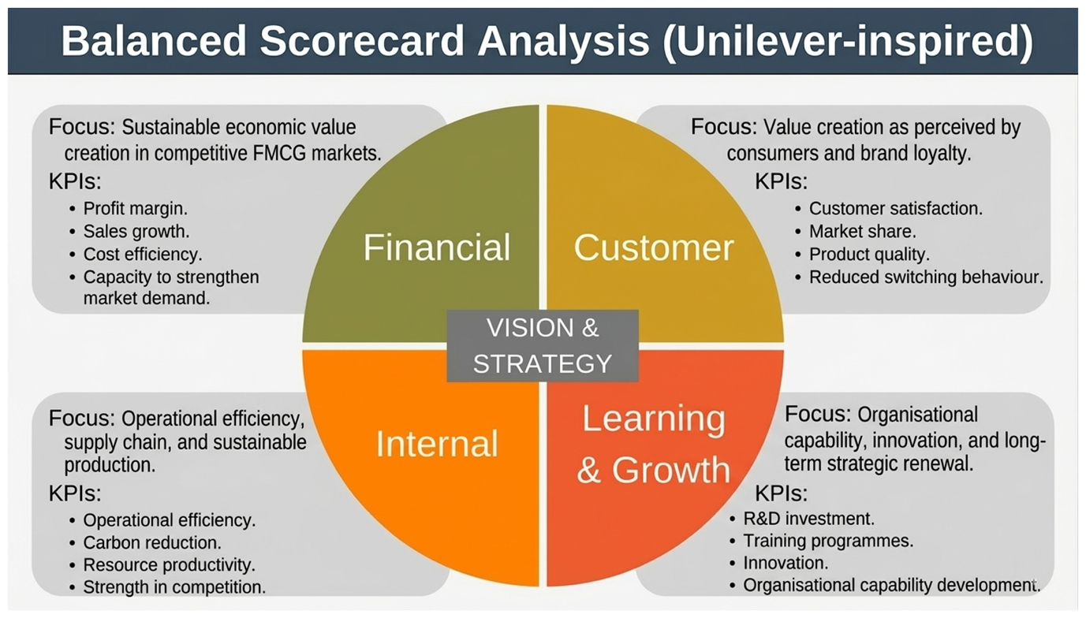
Figure 5: Balanced Scorecard
Source: (Self-constructed)

Financial Perspective
Objectives
Unilever's primary objective is to grow sales revenue, and hence profits, by controlling costs and investing in new ideas.
KPIs:
- Revenue Growth: 3-5% sales growth.
- Operating Margin: Target 20% margin (Unilever PLC, 2025a).
- ROI: Remain capital efficient with good ROI.
Targets: Unilever is targeting €60.1 billion in revenue in 2023, and is looking to grow by 3.8% in its key segments. It will try to preserve its operating margin of around 20%, and grow in emerging markets (Dabic and Kiessling, 2019).
Initiatives: Efficiency and transparency in business operations, cost and portfolio management, and sustainable business practices are KPN's "Connected 4 Growth" initiatives to enhance profits.

Customer Perspective
Objectives: Unilever is committed to improving customer satisfaction, loyalty and brand through innovation and sustainability (Aithal, 2017).
KPIs:
- Customer Satisfaction: Improve customer satisfaction and loyalty.
- Brand Strength: Increase the brand equity of major products such as Dove and Hellmann's (Unilever PLC, 2025a).
- Market Share: Grow in emerging markets.
Targets: Targeting 5% brand equity growth, Unilever’s core brands will focus on healthy and sustainable innovations with a 3.8% growth in global sales (Aithal, 2017).
Initiatives: Loyal customers via ethical marketing and "green" brands (e.g. Dove's real beauty campaign) build a strong rapport with customers.

Internal Business Processes
Objectives: Unilever’s goal is to enhance operational efficiency, product innovation, and sustainability.
KPIs:
- Operational Efficiency: 3-4% cost reduction per year through supply chain innovation.
- Sustainability Goals: Achieve net-zero emissions by 2039 (Unilever PLC, 2025a).
Targets: Unilever aims to reduce waste, enhance the accuracy of forecasts for its supply chain, and adopt digital solutions to further enhance efficiency and sustainability (Bouguerra et al., 2023).
Initiatives: Unilever optimises operations and reduces waste to improve profits with its Sustainable Living Plan and adoption of AI forecasting tools.

Learning and Growth Perspective
Objectives: Learning and growth, IT support and employee development are the focus points for Unilever (Önören et al., 2017).
KPIs:
- Employee Engagement: Improve through opportunities for career growth and leadership.
- Technology Investment: $1 billion in digital initiatives by 2027 v.
Targets: Unilever aims to have 25% of revenue coming from digital by 2025, to enhance its global programs for training and development of its employees to fit the requirements of its business.
Initiatives: Unilever's Future Leaders Program supports employees in having the insights to innovate, enabling sustainability and helping Unilever adapt in the future to new markets and technologies (Önören et al., 2017).

Unilever's balanced approach to implementing growth and performance is shown in its Balanced Scorecard. By focusing on its financial performance, customer, process and employee performance, Unilever sustains its growth. Through innovation and sustainability programs, the company supports its competitive ability and its ability to meet customer needs, resulting in success in all four areas.

Strategic Choices and Implementation

Strategic Choices at Business Level
Unilever adopts a differentiation strategy, at the business level, which focuses on innovation and brand, not cost. Unilever has a portfolio of brands, such as Dove, Hellman’s and Ben & Jerry's, that differentiate through appeals to emotion (Shaw and Luiz, 2018). Dove, with its "real beauty" emphasises a difference of confidence and acceptance. This allows it to increase the price of its products. This enables an increase of 5% market share in 2023 for Dove (Unilever PLC, 2025b).
Innovation is key to this strategy. Unilever's focus on R&D includes sustainable and health brands. For instance, it pioneers plant-based products (Hellmann's and Ben & Jerry's being examples). This is in line with consumer demand for ethical and healthy products, essential in branding and marketing in the competitive FMCG sector.

Corporate-Level Strategy
Unilever is adopting two strategies: diversification and globalisation. Diversification is a hedging against risk diversification strategy by moving into new product lines (Nurlatifah et al., 2023). Acquiring The Vegetarian Butcher steakhouse recently is one such diversification, allowing it to add to its repertoire and serve the burgeoning veggie burger industry.
Globalisation is another Unilever tactic. 59% of revenue came from emerging markets in 2023 (Unilever PLC, 2025b). This strategy, in markets like India, China and Africa, takes advantage of the rise in middle-class consumption and wealth. Unilever has capitalised on its large network and brand values to sustain growth in these fast-growing markets, with a 5% revenue growth in 2023 (Unilever PLC, 2025b).

Evaluation of Strategic Choices
Unilever has effectively used its strategy to maintain its market position. Its product differentiation allows it to price its products at a premium, build brand loyalty, and align its products to consumer tastes for healthier and sustainable products (Franco, 2021). Innovation ensures Unilever's products align with market trends.
Its focus on plant-based and beauty products has enriched its product portfolio and created diversified and new revenue streams, helping manage risks in declining markets. It has also benefited from globalisation (Nurlatifah et al., 2023). Unilever recorded 5% growth in emerging markets in 2023, taking advantage of opportunities in emerging markets like Asia and Africa. But it is competing fiercely both in emerging and growth markets.

Change Management and Implementation
Unilever is adept at change via digitalisation and sustainability. It is working towards net-zero emissions by 2039 and sourcing sustainable materials for its products. This includes initiatives like the Sustainable Living Plan, which helps Unilever reduce its environmental impact and respond to consumers' demand for sustainable products (Franco, 2021). The other major priority for Unilever is digital. Its focus on artificial intelligence and big data analytics has enhanced its supply chain, forecasting and e-commerce. Online revenues increase to over 25% of sales in 2023 (Unilever, 2025). Unilever is adapting to the market and improving its strategies in a digital era through its use of technology and concern for the environment.

Strategic Evaluation and Recommendations

Evaluation of Unilever’s Strategy
Unilever's strategy can be assessed via the BCG Matrix, which classifies the company's products into the following categories: Stars, Cash Cows, Question Marks and Dogs.
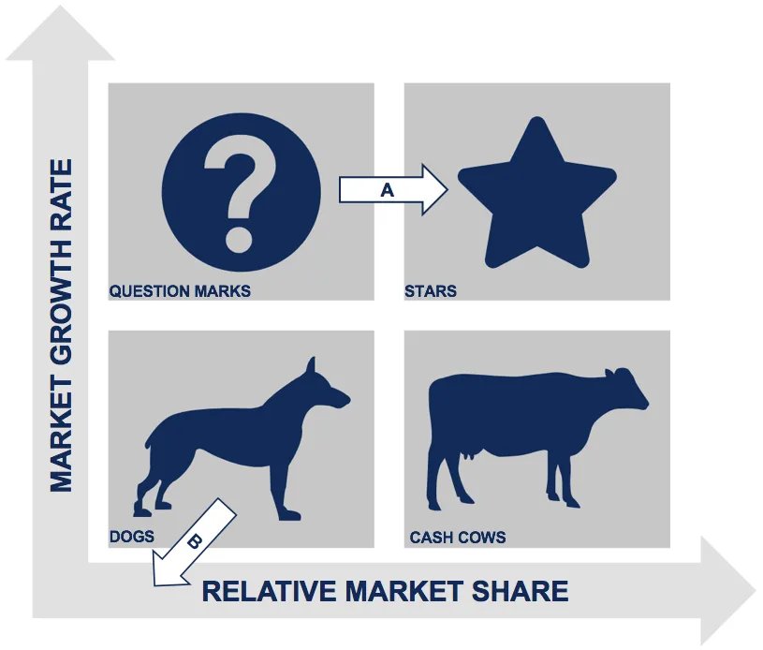
Figure 6: BCG Matrix
Source: (Sen, 2024)
Stars: Dove, Hellmann’s and Ben & Jerry's are examples of Stars. These are products with a high market share and high market growth. For example, in 2023, posthum to its emotional marketing, Dove grew its revenue by 5%. Stars can be grown with considerable capital investment, but are still profitable (Unilever, 2025).
Cash Cows: Lipton tea and Rexona deodorant are Cash Cow products that generate steady sales but don't have much room for growth. They provide Unilever with the cash to fund its growth strategy.
Question Marks: Sustainable beauty and plant-based food products are examples of such products that have been created by Unilever. The Vegetarian Butcher, for instance, is a product with high growth potential but with low market share (Sen, 2024). However, to grow and increase market share, more investments are needed for this category of products.
Dogs: Dogs are older products in saturated markets, such as some home care products. They have limited growth prospects and are in a highly competitive market, leaving Unilever with a choice: invest to develop them or sell them off (Sen, 2024).

Overall, Unilever’s portfolio strategy balances high-growth investments with stable revenue generation, though it needs to address low-performing products.

Recommendations
1. Strengthen Emerging Market Strategy: Emerging markets have been highly successful for Unilever, with 59% of 2023 revenue from these markets (Unilever, 2025). But there is increasing local competition. Unilever should continue to localise for these markets, especially in India, Africa and Asia (Sen, 2024). The Ansoff Matrix suggests that market penetration in these markets will grow the company. For example, Unilever's low-priced water purifier—Pureit in India - shows the value of product localisation (market penetration and loyalty).
2. Increase Digital Presence: For Unilever in 2023, 25% of turnover was from digital sales. It needs to invest more in e-commerce and digital marketing to expand its global e-commerce presence (Unilever, 2025). Its alliance with digital platforms like Amazon and Alibaba will assist. It can engage in big data and AI for supply chain management and customer interactions. Digitisation, as the Value Chain Model indicates, will boost efficiency and profitability and make Unilever adaptable to the digital age.
3. Enhance Sustainability Transparency: Unilever is targeting net-zero greenhouse emissions by 2039, but it should be more transparent in its sustainability practices (Unilever, 2025). Triple Bottom Line theory emphasises a balance between social, environmental and financial aspects. Unilever must transparently communicate its progress towards its sustainability goals to customers (Sen, 2024). Others have done this very well, like Patagonia, and should be looked to by Unilever. This will enable Unilever to target green consumers.

Conclusion
This report highlights Unilever's great strategic position in the FMCG market, due to using differentiation, sustainability and innovation. It has a diverse range of brands together with sustainability initiatives (Sustainable Living Plan) and an emphasis on emerging markets (Hansen, 2020). Its tactics, such as digitisation and its country-based marketing, are consistent with its aim of improving the well-being and sustainability of its consumers. Consolidating its digital engagement, focusing on the emerging markets and investing in the sustainability initiatives will continue to offer Unilever an edge and growth in the FMCG space.

Reflective Account (Gibbs Reflection Cycle)
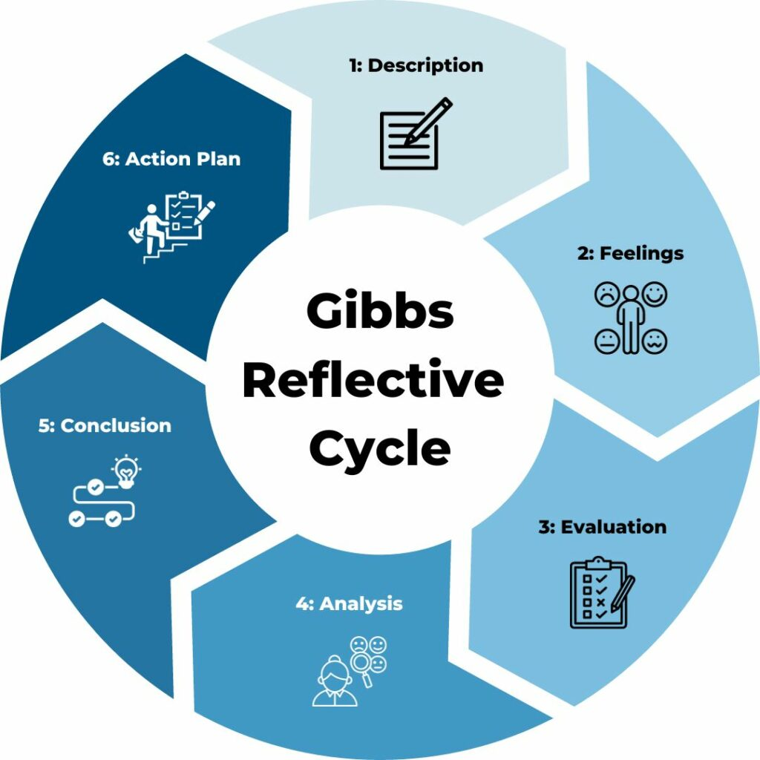
Figure 7: Gibbs Reflection Cycle
Source: (Trimasse, 2025)

Description
In preparing the report on Unilever’s strategic position, I conducted research on Unilever's performance, brands and sustainability initiatives. I began by gathering information from Unilever's annual reports, journals, existing websites and other sources. I used the PESTEL, Porter's Five Forces, VRIO, SWOT and Balanced Scorecard frameworks to analyse Unilever's external environment, Porter's Five Forces and VRIO frameworks to analyse Unilever's internal environment. This was to find Unilever's strengths, weaknesses, opportunities, and threats in the FMCG industry Nurlatifah et al., 2023). My research process involved understanding the trends of the FMCG industry and Unilever's responsiveness to social and economic events, such as the shift to sustainable products. I also explored how Unilever allocated resources and the need for innovation. Then I completed the analysis and provided recommendations to help Unilever to enhance its performance for emerging market growth and online commerce.

Feelings
The strategy research and analysis process was challenging and rewarding for me. The most difficult task was sourcing information, especially since Unilever is a multinational company. I struggled with combing through a sea of reports and articles for the information. For instance, with Porter's Five Forces model, it was difficult to pinpoint how various market factors affected competition in Unilever's core industries (Potter, 2015). But these challenges led to growth. I learned how to get better at research by gathering relevant data. The lesson on the integration of sustainability and business was also important. I learned the value of CSR strategies to create loyalty and reduce costs. One of the challenges improved my analytical and time management skills, which I was hoping to develop for my future projects.

Evaluation
Afterwards, I think the PESTEL and Porter's Five Forces were good choices to use to get insight into Unilever's strategy. PESTEL helped me understand the external factors (such as economic and social) affecting Unilever. For instance, I found out how inflation and political factors affect Unilever: for instance, its supply chains in emerging markets. Similarly, Porter's Five Forces highlighted competition with other consumer goods manufacturers like Procter & Gamble (P&G) and Nestlé, and how Unilever differentiates by being innovative and developing brands (Trimasse, 2025). The SWOT analysis helped to clarify strengths and weaknesses, such as brand and sustainability, and high costs. But I found the Balanced Scorecard and VRIO analysis more challenging. This required more knowledge on internal key performance indicators (KPIs), which I found difficult to relate to Unilever.
In retrospect, I would have given attention to financial performance indicators to really break down the numbers of the revenue and margins to do a deeper analysis.

Analysis
I have developed my understanding of Unilever's position in the FMCG market through the use of strategic models. I examined the external environment and competition using PESTEL and Porter's 5 Forces. I understood sustainability is both the right thing to do and good business. For instance, their 2039 net-zero emissions and sustainable sourcing make Unilever attractive to eco-conscious consumers (Trimasse, 2025). The VRIO analysis helped understand that Unilever's resources, such as its brand and innovation, are key to competitive advantage. While I found it difficult to work with a Balanced Scorecard, it was helpful to know Unilever measures performance on different fronts - financial, customers, process and learning. This will enable them to be competitive and improve their performance. In examining CSR at Unilever with its Sustainable Living Plan, I demonstrated how the integration of CSR within business strategies leads to brand enhancement, efficiencies and cost reductions.

Conclusion
This case study highlighted how Unilever addresses the issues in the external environment and the internal challenges by using the PESTEL, SWOT and Porter Five Forces models. I discovered the impact of environmental forces on its strategy and how sustainability has been factored into its strategy (Nurlatifah et al., 2023). Unilever's CSR increases value to their long-term performance, and VRIO and the Balanced Scorecard were used to assist them in assessing their resources and strategies. The key idea to take from this case is that Unilever's innovation, diversification and sustainability actions are very important. Unilever is doing well as it speaks to market trends and meets needs in emerging markets.

12.6 Action Plan
Action | SMART Goal | Timeline | Measure of Success
Improve time management in research | Complete future assignments on time by better managing research and writing phases (Nurlatifah et al., 2023). | 2 months | Timely completion of assignments without delay.
Enhance financial analysis skills | Study financial metrics and integrate them in future strategic analyses. | 3 months | Ability to provide financial insights in future reports.
Deepen understanding of VRIO framework | Gain confidence in applying VRIO by studying its application in real companies. | 4 months | Demonstrated proficiency in VRIO application in future case studies (Nurlatifah et al., 2023).
Improve application of Balanced Scorecard | Apply the Balanced Scorecard with clear examples in future strategic evaluations (Nurlatifah et al., 2023). | 3 months | Successful use of Balanced Scorecard to analyze company performance.

For future tasks, I plan to manage time more efficiently, enhance my knowledge of financial metrics, and refine my application of strategic models. This will allow me to produce more comprehensive and accurate analyses.

Reference
Aithal, P.S. (2017) A Critical Study on Various Frameworks Used to Analyse International Business and Its Environment, papers.ssrn.com. Rochester, NY. Available at: https://ssrn.com/abstract=3073051.
Bouguerra, A., Hughes, M., Cakir, M.S. and Tatoglu, E. (2023) ‘Linking Entrepreneurial Orientation to Environmental Collaboration: A Stakeholder Theory and Evidence from Multinational Companies in an Emerging Market’, British Journal of Management, 34(1). Available at: https://doi.org/10.1111/1467-8551.12590.
Castro, R. and Moreira, A.C. (2023) ‘Mapping Internal Knowledge Transfers in Multinational Corporations’, Administrative Sciences, 13(1), p. 16. Available at: https://doi.org/10.3390/admsci13010016.
Cheng, Y. (2021) Analysis on the Opportunities and Challenges of Unilever’s Differentiated Competition by Using SWOT and PEST, www.atlantis-press.com. Atlantis Press. Available at: https://doi.org/10.2991/aebmr.k.210210.044.
Dabic, M. and Kiessling, T. (2019) ‘The performance implications of knowledge management and strategic alignment of MNC subsidiaries’, Journal of Knowledge Management, 23(8). Available at: https://doi.org/10.1108/jkm-03-2019-0129.
Dobbs, M.E. (2014) ‘Guidelines for Applying Porter’s Five Forces Framework: a Set of Industry Analysis Templates’, Competitiveness Review, 24(1), pp. 32–45. Available at: https://doi.org/10.1108/CR-06-2013-0059.
Franco, S. (2021) ‘The influence of the external and internal environments of multinational enterprises on the sustainability commitment of their subsidiaries: A cluster analysis’, Journal of Cleaner Production, 297, p. 126654. Available at: https://doi.org/10.1016/j.jclepro.2021.126654.
Hansen, M.W. (2020) ‘Toward a strategic management perspective on local content in African extractives: MNC procurement strategies between local responsiveness and global integration’, Africa Journal of Management, 6(1), pp. 1–19. Available at: https://doi.org/10.1080/23322373.2020.1717283.
Lakshman, S., Lakshman, C. and Estay, C. (2017) ‘The relationship between MNCs’ strategies and executive staffing’, International Journal of Organizational Analysis, 25(2), pp. 233–250. Available at: https://doi.org/10.1108/ijoa-10-2015-0913.
Mussayeva, D., Savina, N. and Panzabekova, A. (2025) ‘The global digital economy market development through the prism of Porter’s Five Forces model’, Problems and Perspectives in Management, 23(4), pp. 384–397. Available at: https://doi.org/10.21511/ppm.23(4).2025.28.
Neve Gordon-Farleigh (2026) ‘Mustard-making legacy in Norwich protected with £5m expansion’, BBC News, 16 January. Available at: https://www.bbc.com/news/articles/c1dkn1kxkpeo (Accessed: 15 March 2026).
Nurlatifah, L., Purnawarman, P. and Sukyadi, D. (2023) ‘The implementation of reflective assessment using Gibbs’ reflective cycle in assessing students’ writing skill’, Nucleation and Atmospheric Aerosols, 2621(1). Available at: https://doi.org/10.1063/5.0143375.
Önören, M., Arar, T. and Yurdakul, G. (2017) ‘Developing Competitive Strategies Based on SWOT Analysis in Porter s Five Forces Model by DANP ’, Journal of Business Research - Turk, 9(2), pp. 511–528. Available at: https://doi.org/10.20491/isarder.2017.282.
Pangarkar, N. and Prabhudesai, R. (2024) ‘Using Porter’s Five Forces Analysis to Drive Strategy’, Global Business and Organizational Excellence, 43(5), pp. 1–11. Available at: https://doi.org/10.1002/joe.22250.
Potter, C. (2015) ‘Leadership Development: an Applied Comparison of Gibbs’ Reflective Cycle and Scharmer’s Theory U’, Industrial and Commercial Training, 47(6), pp. 336–342. Available at: https://doi.org/10.1108/ICT-03-2015-0024.
Sen, S. (2024) ‘Strategic Management Practices in Multinational Corporations: A Comparative Study’, Journal of Advanced Management Studies, 1(3), pp. 36–39. Available at: https://doi.org/10.36676/jams.v1.i3.18.
Shaw, B. and Luiz, J.M. (2018) ‘The Impact of Distance (External) and Organizational Factors (Internal) on the Knowledge Chain of Multinational Corporations: South Africa as a Host Country’, Thunderbird International Business Review, 60(3), pp. 295–311. Available at: https://doi.org/10.1002/tie.21892.
the Guardian (2020) Company profile for Unilever, The Guardian. www.theguardian.com. Available at: https://www.theguardian.com/sustainable-business/profile-unilever (Accessed: 19 March 2026).
Trimasse, N. (2025) ‘The use of reflective reports in higher education’, Reflective Practice, 26(1), pp. 1–18. Available at: https://doi.org/10.1080/14623943.2024.2424520.
Unilever (2025) Our Company, Unilever. www.unilever.com. Available at: https://www.unilever.com/our-company/ (Accessed: 18 March 2026).
Unilever PLC (2025a) Unilever Annual Report and Accounts 2025, https://www.unilever.com/investors/annual-report-and-accounts/. Unilever PLC. Available at: https://www.unilever.com/files/unilever-annual-report-and-accounts-2025.pdf (Accessed: 21 March 2026).
Unilever PLC (2025b) Unilever Sustainability Statement 2025, https://www.unilever.com/investors/annual-report-and-accounts/. Unilever PLC. Available at: https://www.unilever.com/files/unilever-sustainability-statement.pdf (Accessed: 21 March 2026).

Appendix

Value Chain Framework
Figure 8: Value Chain
Source: (Bouguerra et al., 2023)

VRIO Analysis
Resource/Capability | Valuable | Rare | Inimitable | Organised | Competitive Implication
Strong Brand Portfolio | Yes | Yes | Difficult | Yes | Sustained Competitive Advantage
Global Distribution Network | Yes | Moderate | Difficult | Yes | Competitive Advantage
Sustainability Leadership | Yes | Moderate | Moderate | Yes | Temporary Advantage
R&D and Innovation | Yes | No | Moderate | Yes | Competitive Parity
Digital Capabilities | Yes | Moderate | Moderate | Yes | Competitive Advantage

Balanced Scorecard

Figure 9: Balanced Scorecard
Source: (Self-constructed)

