

Effective Teamwork and Communication

AMIR PERVAIZ - 2028687 - BMSW 4002 – EFFECTIVE T EAMW ORK AND
COMMUNICATE ION - LLOYD BEHARRY

Importance of communication skills:

Introduction

Communication describing it in a simple way is the act of transferring information from one place to another. It can be in various ways like using your voice, using digital media, using logos, charts maps, etc. Communication skills are the most important skill in any job, it not only allows you to understand others but also others to understand you.
Communication skills include numerous ways of understanding others for instance actively listening in any provided conversation, speaking in groups, and of course receiving and giving critical feedback. Being able to cooperate with others by listening and acting wisely on the advice make to succeed.
Therefore, it is very important to understand the importance of communication skills. It may take you a lifetime to master this skill. There are, however, a lot of stuff and practices that you can do to polish your communication skills. The most important of all will be surely practice

What are good communication skills?
Different kinds of information can be provided by communication skills. For instance, you get to know what’s happening in your surrounding, communicating ideas and feelings. Developing communication skills will not only help you in your professional life but will play a very important role in your personal social gathering and anything else that requires you to speak up for yourself or present your idea.

Having a communication platform around you is very essential as it allows you to work with your team effectively and relay ideas that can not only help each one of you in the team but also help the whole team succussed. Communications play a very important role in a successful team.
Communication skills include speaking with each other, at the same time listening to each other, and of course understanding. Out of this the most important communication skills are speaking and listening. These two skills are important regardless of you working in big teams or individually. For instance, you need to actively listen to the need of your client so that you can fulfill the request. And similarly, when you speak or listen to the team you all get on the same page and work effectively towards your goal.

Illustrations of communication skills:
Below are some communication skills you use to be productive and successful in your teams.



LISTENING UNDERSTANDING CLARITY ATTENTIVENESS CONFIDENCE

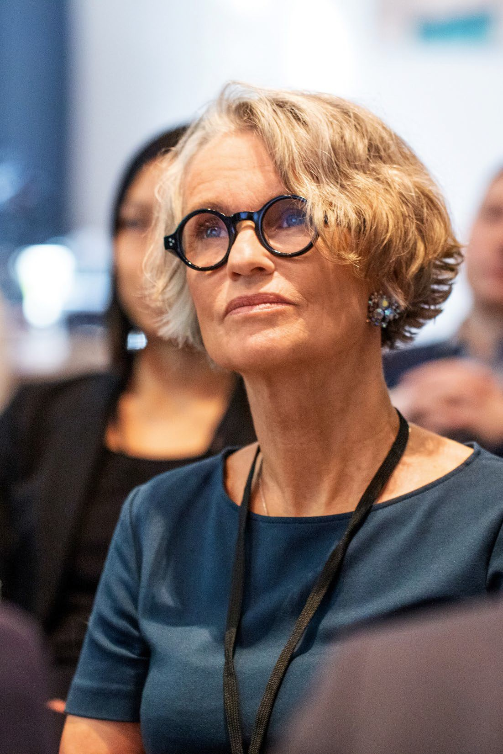

Listening:

- Listening is very important, active listening give the speaker a comfort zone and confidence in you. The person speaking with you will know that you are listening and understanding if you give continuous nods or gestures of acknowledgment.
- Similarly on the other hand when you are actively listening you are paying attention to the posture and gestures of the speaker. This helps you to have a better understanding of your client or team member and therefore a better connection is build.



Understanding:

- A successful deal closes when the communication happens through understanding. Most important are eye contact and facial expression.
- Always be very careful of your own body language when you are trying to talk with someone so that



Clarity:

- Clarity is very important; this doesn’t mean you should know how to speak and say proper phrases or even know the language proficiency. Clarity means your voice is clear and distinct. Your idea is heard in the same sense in which you are speaking it.

- Always speak at a volume where everyone hears you. Speak with the authority of clarity so no one is interrupting your conversation.

- The ability to communicate your perspective in a proper way, with clarity, and as intended plays a very important role. This skill should not be overlooked. It is very too late to do something in life, improving your communication skills will not only help you in your professional life but also it will improve your quality of life.

- Communication skills with clarity are used in almost every aspect of life, going to buy a suit for your sisters weeding you have to provide the salesman a clear picture or description of what you want in order to get the suit of your dreams.



Attentiveness:

- Attentiveness is very important in the communication skills world. It is always appreciated if you showcase attentiveness. For instance, if you send a prompt reply to an email or a message it is a sign or a gesture of respect and attentiveness your client or your team will always appreciate.
- In some cases, we don’t know the exact answer right away or we don’t know the response. In such situations the best approach is to just acknowledge that matter and let the person know that you will get back to them soon with a proper answer.

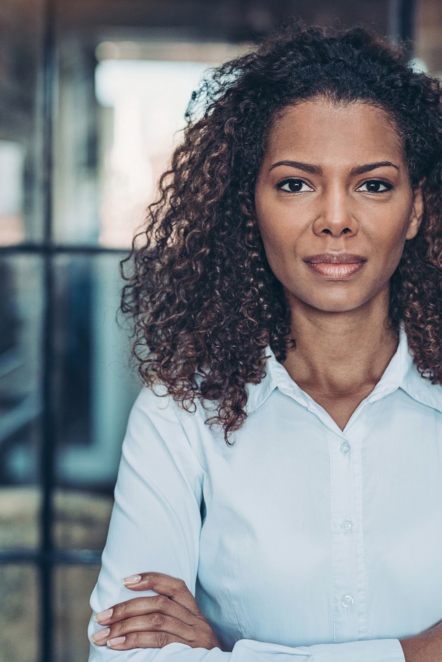

Confidence:

- Engaging with confidence will make people respond and be attentive. Speaking in a confident manner allows you to retain your audience’s attention. This makes it easy to deliver your perspective and get more acceptance.
- Confidence is the key to success. Confidence not only comes from always being right but from not fearing to be wrong.



Improve your communication skills:

- You can only improve your communication skills by practicing. You will mumble at times you will feel unheard but soon you with practice you will develop the skill of speaking loud and clear with confidence.
- It is well said that “The most beautiful thing you can wear is confidence.”
- Below are some processes you can try to develop your communication skills.



Find an opportunity to communicate.

Always hunt for an opportunity where you can polish your communication skills. For instance, when there is a group presentation just raise your hand to be a volunteer or to be a speaker or leader of the presentation.

Practice communication.

Try to communicate via different platforms. Face-to-face communication is the hardest, but the advantage is that your body gestures and expressions are supporting you, whereas when it comes to communicating via emails or messages all you are speaking are is words. You have to be very careful when writing an email because the person reading can misread your phrase and come to the opposite conclusion. In this digital world, we all communicate more nowadays via different digital platforms. Practice written skill as its most difficult.

Request constructive criticism.

Ask your trusted friend or team member to provide honest feedback, getting an understanding of where is the place that you can improve helps you be a better leader and speaker.

Poor communication skills can sour relationships between businesses or personal life. And this can take a lot to bring forward your opinion. Always make sure you ask your team to let you know about how you can improve. You don’t have to listen to each piece of advice and change your personality but a few pieces of advice that can help you develop can always be welcomed.



Communication skills is a Two-way process:

Communication skills are not just broadcasting, or in simple words, it is not just sending out information.

It is absolutely a two-way process. Again, to say that in simple words it involves receiving communication and at the same time sending communication.

It requires you to either speak or listen and most importantly both parties should have a shared understanding.

If you are going to send the information or be the speaker it is very important that you ask questions in between to check whether the listener is understanding or not. And when the listener asks a question make sure you listen to them to ensure that you and your listener both have the same understanding and booth are on the same page. If needed make sure you change the direction or try to convoy in a way that your intention is clear.

It is an active progression. In either direction there is nothing passive.

Case study ( Department: health care )
- Purpose: Nurses as originators in hospitals should be trained to communicate effectively and towards one goal. That is helping the people in need. This study aimed to figure out the status of how the nurses are communicating in the health care department.
- Methods: in this case study there were nine hundred and twenty-six ( 926) nurses working in the health organization. However, not all of them were part of the study but they were selected randomly. Talking about the collection of the data a two-part questionnaire skill test was used.
- Results: the results of this study was a standard deviation of the total communication skills measured
2.70 ± 0.43. there was a huge relationship between the score of communication skills and variables such as
marital status, employment background, division, work shift, and type of employment.
- Conclusion: The result of this case study revealed that the knowledge of communication skills in nurses is Moderate. Therefore, it was recommended to provide courses on communication skills with the aim to improve the quality of nursing care. What I learned from this case study is that various online courses or practices are required to polish communication skills. There is no age set to learn. Keep polishing your communication skills.



Example of poor communication skills :

As I have been a part of many teams throughout this journey of learning and studying I have experienced many kinds of communications.

Some team members did an effort to create whats app groups so everyone is on the same page, some didn’t even bother to participate in those groups. What I have learned is that effective communication in those group chats helped me a lot to understand different assignments. Many students tried to break down assignments in easy language that helped many of us to present better.

There were few fellow students who besides being a part of the group just decided not to participate and in fact, they decided to call people and ask questions.

Example of poor communication skills (cont. ) :

One of my fellow fried called me during my work hours and had numerous questions, I advised him and apologized that I can not answer all his questions at the moment as I am busy at work. I asked him to go through the chat history and many of these questions will be answered however he replied he is not very good in reading and responding to written communication. Regardless of that time I called him later and answered his concerns, but I did advise him to take some courses outside of this module where you can polish your communication skills. Reading or writing is an important communication skills. You can't just be good in one communication skills and not be good at others as all communication skills are equally important.



References

  - References
- Ahmadi A, Ahmadi M, Elyasi F, Ahmadi A, Ahmadi N (2013) The relationship of occupational burnout and communication skills in nurses. J Mazandaran Univ Med Sci 23(106):130–139
- Ak M, Cinar O, Sutcigil L, Congologlu ED, Haciomeroglu B, Canbaz H, Ozmenler KN (2011) Communication skills training for emergency nurses. Int J Med Sci 8(5):397– 401



Conclusion:

  - Communication skills are not just one skill, you have to be good at listening, reading, speaking and so much more and then you are able to consider yourself aware of communication etiquette. You still can not call your self-Master of Communication skills as no one can. There is always room for improvement. As we deal with different people, businesses, mindsets, and personalities we have to continuously change our way of communication, learn new ways to express ourselves in different circumstances.

AMIR PERVAIZ.

Thank you

