
Applied Leadership and Management Outreach
Module Assignment Submission
Student Name: | Joanna Drozd
Student Number: | 2308210
Module No: | BMSK4014
Module Title: | Problem Solving and Decision Making

Statement of Confirmation of Authenticity
By the act of making this submission, the student declares that this is the work of the student named above. The work has not, in whole or in part, been knowingly presented elsewhere for assessment, or where assessment has been built on a previous assessment, this has been identified. Where materials have been used from other sources it has been properly acknowledged. If this statement is untrue, the student acknowledges that an assessment offence has been committed.
Attention is drawn to the plagiarism and unfair practice policies of UWTSD.

Table of Contents
1. Introduction 3
2. Define a complex problem in the workplace, including its scope and impact 3
2.1. Definition of a Complex Problem 3
2.2 Scope of the Problem 6
2.3 Impact of the Problem 6
3. Analyse information on the identified problem, to help inform the decision-making process. 7
3.1 Brainstorming 7
3.2 Mind mapping 9
3.3 "5 Whys" analysis 9
3.4 The Fishbone diagram 10
4. Strategic Solutions for Enhancing Quality and Reducing Errors 12
5. Evaluation of Solutions Using Decision-Making Techniques 14
5.1 Grid Analysis 14
5.2 Cost – Benefit Analysis and Ratios 16
6. Develop a detailed plan for implementing the solution 20
7.Communicate the plan to relevant stakeholders 24
8. Evaluation of monitoring and review techniques to ensure successful implementation of the solution. 28
9. Conclusion 30
10. Recommendations 31
11. References 32
Appendix 1 34

1. Introduction

This report focuses on a complex problem encountered by a company that manufactures massage and support systems for car seats. Recently, there has been a noticeable increase in the number of defective products and rejections during the production process. This issue adversely affects the company's reputation, leading to additional costs and production delays. These quality problems are particularly significant in maintaining high standards, which is crucial for sustaining good customer relationships and the company's market position.
This report aims to analyse the causes of these quality issues and explore possible solutions. This analysis will incorporate theoretical aspects, allowing for a comprehensive and academic approach to understanding the problem. Based on the gathered data, various alternative solutions will be proposed and evaluated using decision-making techniques. The goal is to identify the most appropriate solution to improve production processes and ensure higher-quality products.
The report's final section will detail a plan for implementing the chosen solution and outline the communication strategy for informing relevant stakeholders. Additionally, it will discuss appropriate monitoring and review techniques to ensure the solution's successful implementation and the long-term resolution of the issue.

2. Define a complex problem in the workplace, including its scope and impact

2.1. Definition of a Complex Problem
In the context of workplace challenges, a complex problem is characterised by its multifaceted nature and the interrelated elements contributing to its difficulty. This section defines the complex problem faced by a company specialising in massage and support systems for car seats, where a noticeable increase in defective products and production rejections has been observed.
According to Frensch and Funke (1995), complex problem-solving involves navigating obstacles between an initial state and a desired goal, often with unclear start states, goals, and barriers. The process necessitates effective interaction between the individual and the task environment and employs cognitive, emotional, and social resources. Several vital aspects define the complexity of this problem:
- Multiple Relationships
The problem at hand involves numerous interconnected components within the manufacturing process. Halford et al. (1998) assert that complex problems involve managing multiple relationships between different system parts. In this case, the defective product issue may be linked to material quality, machinery performance, operator skill, and process standards. Each of these elements interacts in ways that influence the overall quality of the product, making it challenging to identify and isolate the root causes.
- Uncertainty and Change
Complex problems are often marked by uncertainty and dynamic changes over time. VanLehn (1989) highlights that these problems involve ambiguity about the necessary information and potential solutions. The increase in defective products might be attributed to evolving factors such as changes in supplier materials, alterations in production techniques, or unforeseen wear and tear on machinery. This uncertainty requires ongoing monitoring and adjustment to strategies, as the nature of the problem can shift, complicating the identification of practical solutions.
- Interactions and Emergent Effects
Funke (1991) describes how different parts of a complex system can interact to produce new, unexpected outcomes. In manufacturing, interactions between various elements (e.g., machinery, materials, and personnel) can lead to emergent effects, such as the exacerbation of quality issues due to previously unnoticed interactions or feedback loops. For example, a minor adjustment in machinery settings might lead to unexpected increases in product defects, which are not immediately apparent but emerge over time.
- Difficulty in Breakdown
Phillips (1997) points out that complex problems often cannot be easily decomposed into more straightforward, manageable parts. The issue of defective products involves multiple interdependent aspects, making it challenging to address each element in isolation. Solutions require an integrated approach that considers the interconnected nature of the problem. For instance, addressing quality control issues might require simultaneous improvements in supplier management, equipment maintenance, and staff training.
The complex problem of increasing defective products and production rejections in the company specialising in massage and support systems for car seats has been analysed and broken down into various contributing factors. Based on the analysis, the primary sources of the issue have been quantified as follows:

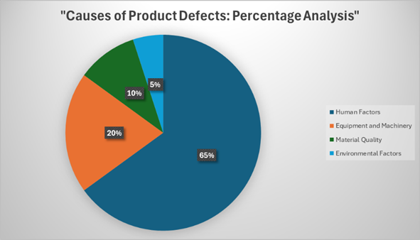

Among these contributing factors, human factors constitute the most significant portion of the problem, accounting for 65%. This significant impact highlights personnel's critical role in the manufacturing process and suggests that addressing human-related issues should be the primary focus for resolving the problem.

2.2 Scope of the Problem
Extent
The scope of the problem is extensive, affecting several aspects of the company’s operations. The rise in defective products impacts production efficiency, cost control, and overall product quality. These issues extend beyond the manufacturing floor to affect customer satisfaction, as defective products can increase returns and dissatisfaction. The problem also influences the company’s financial performance and market reputation, as continuous quality issues may harm its competitive position.
Stakeholders
The problem affects a wide range of stakeholders, including:
- Employees: Production workers, quality control staff, and maintenance teams are directly involved and impacted by the quality issues.
- Customers: End-users experience dissatisfaction from receiving defective products, affecting their perception of the company’s reliability.
- Suppliers: Material quality issues can be traced back to suppliers, affecting their relationship with the company.
Management: Leadership must address the problem involving allocating resources and strategizing solutions.

2.3 Impact of the Problem
The impacts of the problem are multifaceted:
- Operational: Increased production delays and costs due to rework and scrap.
- Financial: Higher expenses related to quality control, returns, and potential compensation claims.
- Reputational: Damage to the company’s reputation, affecting customer trust and market share.
- Strategic: Hindrance to strategic goals such as market expansion and product innovation.
Conclusion
In summary, the problem of increasing defective products is a complex issue defined by its numerous interconnected components, uncertainty, emergent effects, and difficulty in isolation. Understanding and addressing this problem requires a holistic approach that considers the various factors and their interactions and the wide-ranging impacts on stakeholders and organisational performance.

3. Analyse information on the identified problem, to help inform the decision-making process.

This chapter focuses on collecting and analysing information about the problem. Techniques such as brainstorming, mind mapping, and the 5 Whys are used to better understand the issue. The Ishikawa (Fishbone) analysis is applied to identify possible causes of the problem, supporting the decision-making process.

3.1 Brainstorming

Brainstorming, a group process introduced by Alex Osborn in the 1950s, was designed to help employees generate more ideas collaboratively (Osborn, 2012). Osborn emphasised four essential rules to enhance idea generation: prioritise quantity, encourage unusual ideas, build on others' ideas, and avoid criticism.

Brainstorming Session
- Problem: High rate of defective products due to human errors in the manufacturing process.
- Scope: Affects production efficiency, cost control, product quality, customer satisfaction, financial performance, and market reputation.
- Participants: Production workers, quality control staff, maintenance teams, and management.
- Objective: To find practical solutions to minimise human errors in production, thereby reducing defective products and improving overall quality.

Brainstorming Summary:

The ideas gathered during the brainstorming session will help move on to the next stage, which is to create a mind map. This mind map will guide targeted actions, continuous improvements, and the elimination of errors resulting from human errors in the production process.

3.2 Mind mapping

Mind mapping visually organises the collected information, emphasising the relationships between equipment, personnel, and materials. This method facilitates a clearer understanding of the problem's complexity and can help identify patterns that may not be apparent with traditional linear analysis.
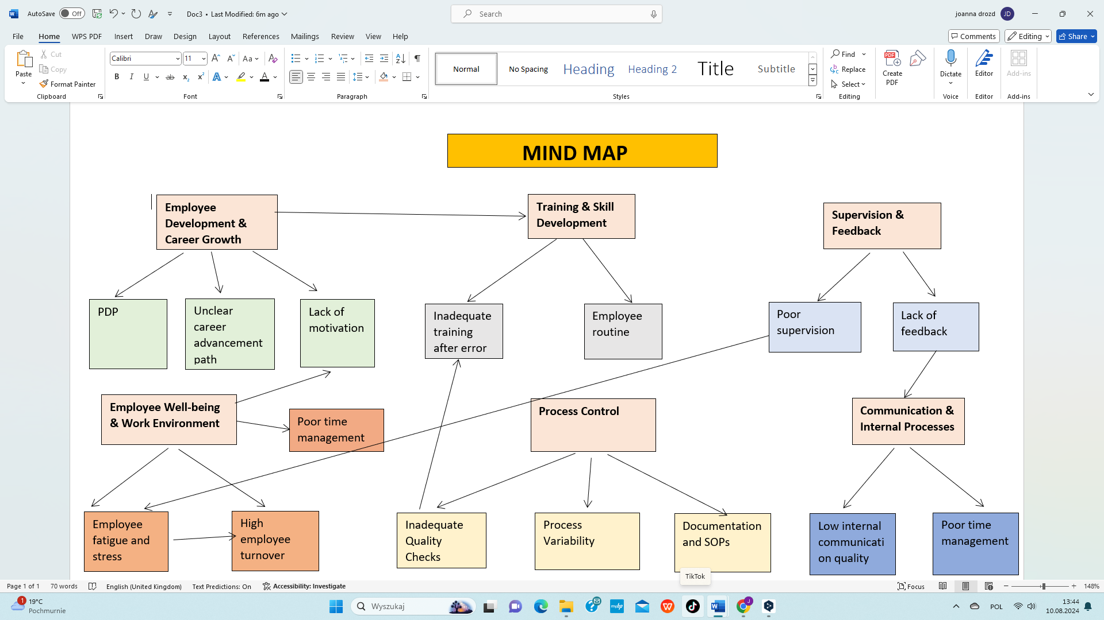

3.3 "5 Whys" analysis

The "5 Whys" method is a simple but effective quality management and problem-solving tool. Its goal is to identify the root cause of a problem by repeatedly asking the question "why." This helps to uncover the symptoms of the problem and the deep, hidden sources that are the actual cause.

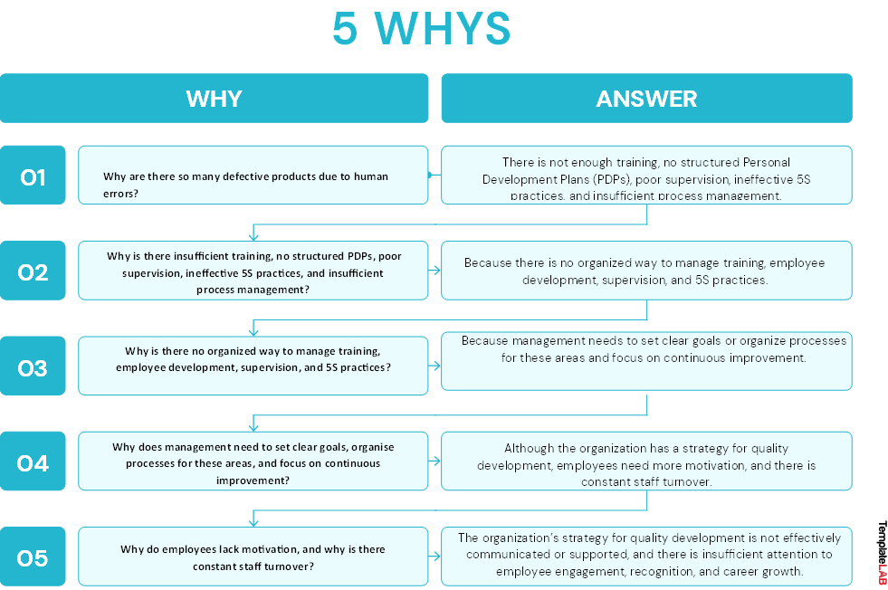

3.4 The Fishbone diagram

The Fishbone diagram, also known as the Ishikawa diagram, helps identify the root causes of problems. Named after Japanese statistician Kaoru Ishikawa, this tool became popular in the 1960s (Juran, 1999). It visually shows the relationship between an effect and its causes, making it a cause-and-effect diagram (Watson, 2004).
The diagram's structure resembles a fish's skeleton, with a mainline for the effect and branches for causes and sub-causes. This setup helps teams systematically analyse problems, encourages group input, and highlights areas needing more data.
The diagram can include qualitative and quantitative details and helps assess risks and set priorities for further analysis.
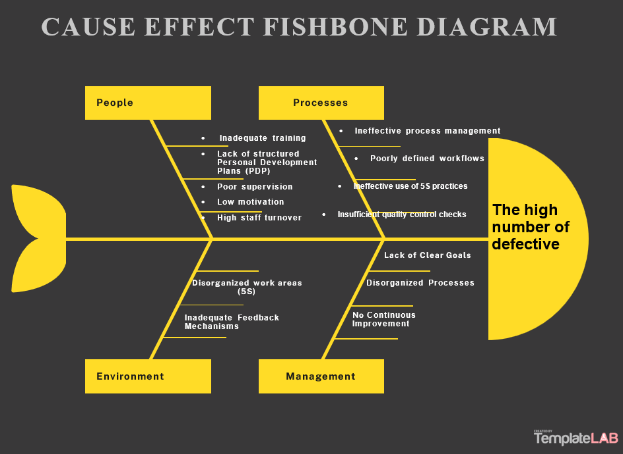
The problem analysis shows that several connected issues are causing inconsistent quality, frequent mistakes, and high employee turnover. More structured Personal Development Plans (PDP), including specific training on technical skills, soft skills, etc., and better supervision are needed. This leaves employees unprepared and unsupported, leading to errors, uneven work quality, and dissatisfaction that drives many to go. High workloads and poorly organised workspaces due to poorly implemented 5S practices worsen things, causing disorganisation and reducing productivity.
Management is a critical factor in this problem. With clear goals, good planning, and efforts for continuous improvement, the organisation can fix these issues. There needs to be more communication between employees and management and more resources. This leads to a scattered approach to managing quality and contributes to the high turnover rate. However, with the right strategies and resources, management can play a pivotal role in resolving these issues.
By implementing a comprehensive plan that focuses on employee development, improved training and supervision, better resource utilisation, more robust management practices, proper implementation of 5S, and strategies to reduce turnover, the organisation can significantly enhance quality, reduce errors, and retain more employees. See Appendix 1 for further details on how the organisation can use 5S to enhance quality and reduce errors.

4. Strategic Solutions for Enhancing Quality and Reducing Errors

Implementing a range of targeted solutions is essential to addressing the issues of inconsistent quality, frequent human errors, and high employee turnover. The following table outlines various strategies designed to tackle these challenges effectively by focusing on key areas such as employee development, training, and management practices.

Category | Solution | Description | Resources Needed
Employee Development | Implement Structured PDPs | Develop Personal Development Plans for all employees, outlining goals, skills, and career progression to improve job satisfaction and reduce turnover. | HR support, time for regular reviews, manager involvement
Training & Supervision | Enhance Training Programs | Offer comprehensive training, including onboarding, ongoing skill development, and cross-training to reduce errors and dependency on specific individuals. | Training materials, trainers, time allocation for training sessions
Supervision & Feedback | Strengthen Supervision & Feedback | Increase supervisor involvement and establish regular feedback loops to guide employees, reduce errors, and improve retention. | Supervisor training, feedback collection tools, performance review system
Workload Management | Optimize Workload Distribution | Redistribute tasks to balance workloads, reducing stress, errors, and turnover, and improving work quality. | Workflow analysis, task management tools, input from team leaders
5S Implementation | Improve 5S Practices | Fully implement the 5S methodology to organize workspaces, enhance efficiency, and reduce errors, contributing to employee satisfaction and lower turnover. | Training on 5S principles, time for organizing workspaces, commitment from staff
Management Practices | Set Clear Goals & Strategic Plans | Define clear, measurable goals and strategic plans to align processes, improve focus, and enhance job satisfaction, reducing turnover. | Management workshops, strategic planning sessions, communication tools
Resource Allocation | Allocate Sufficient Resources | Provide necessary tools, technology, and time for training and work execution to reduce frustration and turnover. | Budget allocation for tools and technology, resource gap assessment, prioritization of resource distribution
Communication | Enhance Communication Channels | Improve internal communication with regular meetings, feedback sessions, and transparency to foster inclusivity and reduce turnover. | Communication platforms, time for regular meetings, training on effective communication
Continuous Improvement | Implement Continuous Improvement Programs | Introduce Lean or Six Sigma methodologies to identify inefficiencies, reduce errors, and create a more engaging work environment, lowering turnover. | Training in continuous improvement, dedicated improvement teams, monitoring tools
Employee Retention | Develop Employee Retention Strategies | Create programs focused on engagement, recognition, and career growth to retain talent and reduce high turnover rates. | HR involvement, budget for incentives and rewards, management support
Quality Control |  | Strengthen quality control measures by implementing stricter inspection processes, utilizing statistical process control (SPC), and regular audits to ensure consistent product quality. | Quality control tools, training for quality inspectors, and resources for regular audits and inspections
  Improve Quality Control Systems

This table provides a clear overview of the potential solutions, highlighting their benefits and challenges to aid in decision-making.

5. Evaluation of Solutions Using Decision-Making Techniques

5.1 Grid Analysis

To effectively implement proposed solutions, it is essential to use tools that help set priorities. One helpful approach is Grid analysis, which analyses different options based on cost, effectiveness, feasibility, time required, and how sustainable they are. This method provides a balanced view by clearly defining which solutions are the most practical and likely to work well. By using this method, organisations can make sound decisions that align with their goals and increase their chances of success (Bensla, 2023).

Factors: | Cost | Effectiveness | Feasibility | Timeframe | Sustainability | Total
Weights: | 4 | 5 | 1 | 4 | 3
Implement Structured PDPs | 4  16 | 5  25 | 4  4 | 5  20 | 4  12 | 22  77
Improve 5S Practices | 4  16 | 4  20 | 4  4 | 5  20 | 5  15 | 22  75
Develop Employee Retention Strategies | 5  20 | 5  25 | 3  3 | 3  12 | 5  15 | 20  72
Strengthen Supervision & Feedback | 3  12 | 5  25 | 4  4 | 4  16 | 3  9 | 19  66
Enhance Communication Channels | 2  8 | 4  20 | 5  5 | 3  12 | 4  12 | 18  57
Implement Continuous Improvement | 4  16 | 5  25 | 3  3 | 3  12 | 4  12 | 19  68
Set Clear Goals & Strategic Plans | 3  12 | 5  25 | 4  4 | 3  12 | 4  12 | 18  65
Optimize Workload Distribution | 2  8 | 4  20 | 5  5 | 3  12 | 4  12 | 18  57
Enhance Training Programs | 4  16 | 5  25 | 4  4 | 4  16 | 4  12 | 21  73
Improve Quality Control Systems | 4  16 | 5  25 | 4  4 | 4  16 | 4  12 | 21  73
Allocate Sufficient Resources | 3  12 | 4  20 | 4  4 | 3  12 | 3  9 | 18  57

Scoring Key
- Cost: 0 (very high cost) to 5 (very low cost)
- Effectiveness: 0 (very ineffective) to 5 (very effective)
- Feasibility: 0 (very difficult to implement) to 5 (very easy to implement)
- Timeframe: 0 (very long time to implement) to 5 (immediate or short-term implementation)
- Sustainability: 0 (not sustainable) to 5 (highly sustainable)

Summary of the Grid Analysis

A Grid Analysis was conducted to evaluate several critical initiatives to reduce human errors during production. Each initiative was assessed based on cost, effectiveness, feasibility, timeframe, and sustainability. The following actions received the highest scores:
- Implementation of Structured Personal Development Plans (PDPs) – 77
- Improvement of 5S Practices – 75
- Enhancement of Training Programmes – 73
- Improvement of Quality Control Systems – 73
5. Development of Employee Retention Strategies – 72

These initiatives are closely related and can be integrated to maximise their effectiveness. For example, PDPs can be linked to training programmes and quality control systems, providing a structured approach to developing skills and reducing errors. Similarly, 5S practices can be improved into PDPs, ensuring that workplace organisation is part of each employee's development. Together, these top-scoring initiatives form a comprehensive strategy to reduce human errors in production significantly (Stobierski, 2019).

5.2 Cost – Benefit Analysis and Ratios

List all the costs:

 | Year 1 | Year 2 | Year 3 | Total Cost
  Cost Factor
Structured PDPs, Retention, and Training
Development Costs | £15,000 | £5,000 |  | £25,000
  £5,000
Training Costs | £12,000 | £8,000 | £8,000 | £28,000
Communication Costs | £4,000 | £2,000 | £2,000 | £8,000
Monitoring and Evaluation Costs | £5,000 | £3,000 | £3,000 | £11,000
Employee Turnover Costs (30 per year) | £150,000 | £150,000 | £150,000 | £450,000
Total | £186,000 | £168,000 | £168,000 | £522,000
Improvement of 5S Practices
Training Costs | £5,000 | £3,000 | £3,000 | £11,000
Implementation Costs | £7,000 | £4,000 | £3,000 | £14,000
Maintenance Costs | £3,000 | £3,000 | £3,000 | £9,000
Total | £15,000 | £10,000 | £9,000 | £34,000

Overall, Total Estimated Costs Over Three Years: £ 556,000
Explanation:

- Development Costs: Initial costs include creating and establishing Personal Development Plans (PDPs) and retention strategies, which will be updated periodically in subsequent years.
- Training Costs: Costs cover initial and continuous training for employees to improve skills and reduce errors, along with specific training for 5S practices.
- Communication Costs: These include the development and dissemination of materials to communicate new practices, PDPs, and training programs to employees.
- Monitoring and Evaluation Costs: To track the effectiveness of the PDPs and training programs and to assess progress regularly.
- Implementation Costs: For 5S practices, this includes setting up the necessary infrastructure and initial rollout.
- Maintenance Costs: Regular reviews and updates to the 5S practices are necessary to ensure continued effectiveness and adherence.
- Employee Turnover Costs: With a recruitment cost of £2,500 per employee (10% of an average £25,000 salary) and a training cost of £2,500 per employee, the total incremental cost per employee is £5,000. Replacing 30 employees annually results in a total cost of £150,000 annually. These employees are sourced through an agency, and the cost includes all expenses associated with bringing new agency staff up to speed and ensuring they are productive as quickly as possible. Reducing these turnover costs is crucial for improving profitability and operational stability.

List all the Benefits:

Benefit Factor | Year 1 | Year 2 | Year 3 | Total Benefit
Reduced Errors | £40,000 | £45,000 | £50,000 | £135,000
Improved Quality | £25,000 | £30,000 | £35,000 | £90,000
Increased Efficiency | £20,000 | £25,000 | £30,000 | £75,000
Employee Retention | £200,000 | £200,000 | £200,000 | £600,000
Customer Satisfaction | £15,000 | £20,000 | £25,000 | £60,000
Total | £300,000 | £320,000 | £ 340,000 | £ 960,000

Total Benefits Over Three Years: £ 960,000
Net Benefits Over Three Years: £404,000

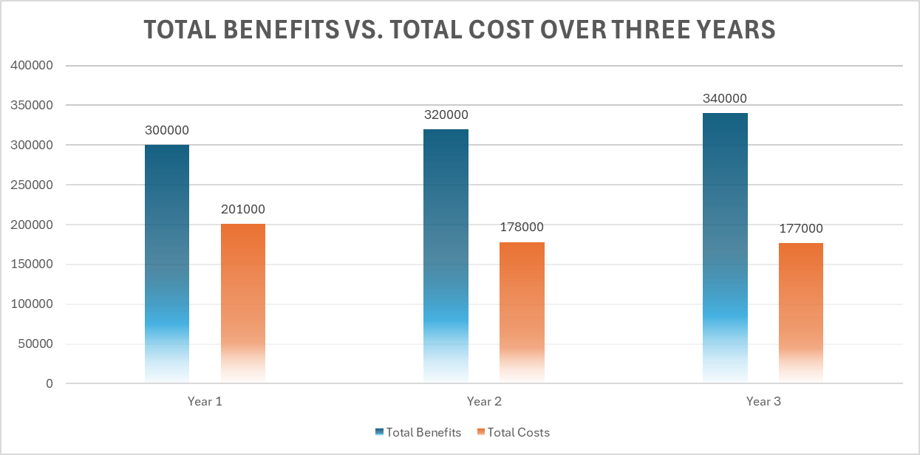
RATIO Analysis:
Investment to Benefit Ratio:
Total Benefits/Total Costs = £960,000 / £556,000 ≈ 1.73

The investment-to-benefit ratio of 1.73 demonstrates that for every £1 invested, the company gains £1.73 in return. This strong ratio indicates a highly profitable venture, underscoring the likelihood of substantial financial returns. The projected benefits from the proposed strategies are expected to be significant, reinforcing the soundness of the investment decision and its potential to deliver considerable value to the company.
Conclusion:
The best option is to Combine Structured Personal Development Plans (PDPs), 5S Practices, Training Programs, and Employee Retention Strategies. This mix works well because it balances effectiveness, sustainability, and feasibility, helping the organisation get a good return on investment. It focuses on developing employees and improving the work environment, which reduces mistakes, raises quality, and boosts overall efficiency.
Adding Employee Retention strategies is critical because it not only supports employee growth and a well-organised workplace but also cuts down on the costs of high staff turnover. Keeping experienced employees helps maintain stability, strengthens organisational knowledge, and keeps morale and engagement high, leading to better performance.
While this approach might not be the cheapest, it is the most thorough and offers the best long-term benefits. By investing in these top initiatives and focusing on retaining talent, the organisation can achieve significant gains in performance, quality, efficiency, and employee retention, all essential for long-term success.

6. Develop a detailed plan for implementing the solution

Action Plan
Three-Year Action Plan
Wide Improvement Project
Period: 2024-2026
OBJECTIVES | TASKS | SUCCESS CRITERIA | TIME FRAME | RESOURCES
1. Implement Structured PDPs | - Design and document PDP templates  - Roll out training on PDP usage | - All employees have a PDP in place  - Positive feedback from employees | Phase 1: Design by Q4 2024  Phase 2: Implement by Q2 2025  Review: Annually | HR Department  Training resources
2. Improve Quality Control Processes | - Review and redesign QC processes  - Train operators on new QC procedures | - Reduced error rates  - Increased operator compliance with QC standards | Phase 1: Review by Q2 2025  Phase 2: Implement by Q4 2025  Ongoing: 2026 | Quality Control Team  Operations Team  Training materials
3. Enhance Employee Retention Strategies | - Review current retention strategies  - Implement new incentives | - Reduced employee turnover  - Increased job satisfaction in surveys | Phase 1: Strategy by Q3 2025  Phase 2: Implement by Q1 2026  Review: Annually | HR Department  Employee Survey Tools
4. Integrate 5S Practices | - Conduct 5S training sessions  - Redesign workspaces according to 5S | - Improved workplace organization  - Regular audits show sustained 5S practices | By: November 15, 2024 | Operations Team  External 5S Experts  Training Materials

Phase 1 involves planning, designing, and reviewing the existing practices and systems, which will typically be completed within the first year (2024-2025).
Phase 2 includes implementing the new strategies and processes. This will occur in the second year (2025-2026), ensuring that changes are effectively embedded within the organisation.
Ongoing Review and Monitoring: Throughout 2026, there will be annual reviews to monitor the success and effectiveness of the implemented changes. This includes evaluating the effectiveness of PDPs, QC processes, and retention strategies and adjusting as needed.
Short-Term Objective: The 5S Practices will be completed by November 15, 2024, due to their nature as a quick, impactful improvement.
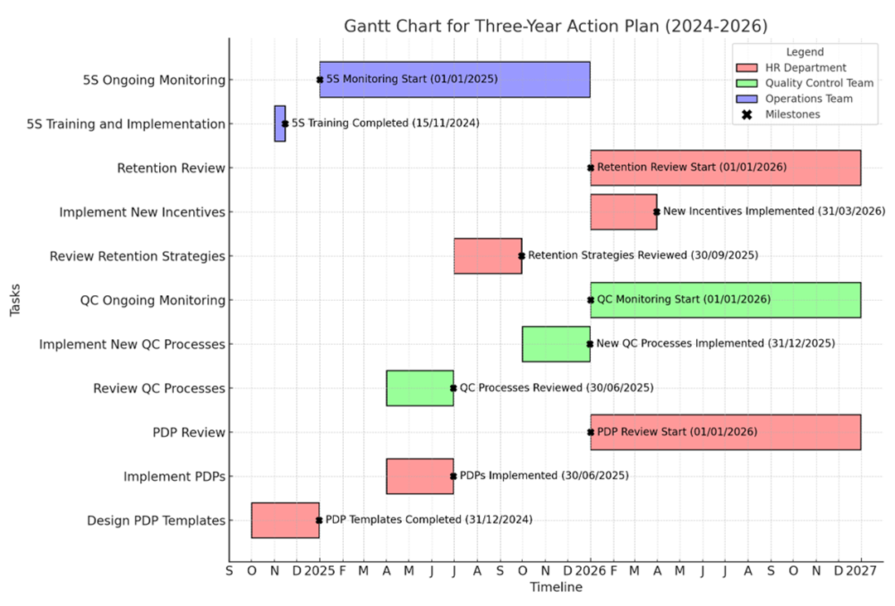

The milestones:
- Designing PDP Templates (Q4 2024) - Deadline: 31/12/2024.
- Implementation of PDPs (Q2 2025) - Deadline: 30/06/2025.
- Review of QC Processes (Q2 2025) - Deadline: 30/06/2025.
- Implementation of New QC Processes (Q4 2025) - Deadline: 31/12/2025.
- Review of Retention Strategies (Q3 2025) - Deadline: 30/09/2025.
- Implementation of New Incentives (Q1 2026) - Deadline: 31/03/2026.
- Completion of 5S Practices (November 15, 2024) - Deadline: 15/11/2024.
Communication and Milestone Monitoring Plan (2024-2026)
Milestone | Meeting Objective | Meeting Date | Participants | Communication Channel | Responsible Party
Designing PDP Templates  Deadline: 31/12/2024 | Final review to ensure PDP templates are completed as planned. | 20/12/2024 | HR Team, Management | In-person | HR Department
Implementation of PDPs  Deadline: 30/06/2025 | Mid-implementation checks to ensure smooth rollout and address any issues | 15/06/2025 | HR Team, Department Heads | In-person | HR Department, Training Team
Review of QC Processes  Deadline: 30/06/2025 | Review meeting to assess the findings and plan for implementation of new QC processes | 25/06/2025 | QC Team, Operations, Management | In-person | Quality Control Team
Implementation of New QC Processes  Deadline: 31/12/2025 | Pre-launch meeting to confirm readiness for new QC processes. | 15/12/2025 | QC Team, Operations, Management | In-person | Quality Control Team, Operations Team
Review of Retention Strategies  Deadline: 30/09/2025 | Final review to evaluate current strategies and confirm new retention strategies. | 20/09/2025 | HR Team, Management | In-person | HR Department
Implementation of New Incentives  Deadline: 31/03/2026 | Pre-launch meeting to ensure new incentive programs are ready for implementation. | 20/03/2026 | HR Team, Management | In-person | HR Department
Completion of 5S Practices  Deadline: 15/11/2024 | Final review meeting to confirm the completion and effectiveness of 5S practices. |  | Operations Team, 5S Experts | In-person | Operations Team, 5S Experts
  10/11/2024
This Communication and Milestone Monitoring Plan outlines a series of meetings scheduled between November 15, 2024, and March 31, 2026, to ensure timely progress and successful completion of key project milestones. This approach ensures effective communication, timely interventions, and smooth implementation across all project phases.

7.Communicate the plan to relevant stakeholders

A stakeholder communications plan ensures stakeholders are involved and informed throughout every project step. It involves identifying the key stakeholders, determining what information needs to be shared with them, why it is essential, and how frequently communication should occur. The plan also includes selecting the most effective communication channels to reach stakeholders and establishing ways to gather their feedback to support the project's success (Anderson,2023).

Identifying Stakeholders

Internal Stakeholders |  | External Stakeholders:
WHO | WHY | WHO | WHY
Senior Management | Senior management must be informed to ensure alignment with the company’s strategic goals and approve budgets and resources. Their support is crucial for the successful implementation of the plan. | Customers | Improved quality and efficiency will benefit customers. Keeping them informed about ongoing improvements will enhance their satisfaction and trust in the company.
HR Department | HR is responsible for developing and implementing the Structured PDPs, Employee Retention Strategies, and training programs. Their involvement is critical to ensuring the effective execution of these initiatives. | Suppliers | Any changes in quality control or operational processes might affect suppliers. They must be informed to ensure their services align with the new standards.
Operations Team | This team will be directly involved in implementing and maintaining the 5S practices. They need to be informed to prepare for changes in processes and workflows.
Employees | Changes in training, processes, and systems directly impact employees. Keeping them informed ensures they are prepared for changes and can contribute effectively.
Quality Control Team | They will be responsible for improving the quality control systems. Their understanding and input are essential to the successful update and implementation of these processes.

Influence–Interest Matrix
The Influence–Interest Matrix is a tool for categorising stakeholders based on their level of influence over a project and their level of interest. This categorisation helps determine each stakeholder group's appropriate communication and engagement strategies.

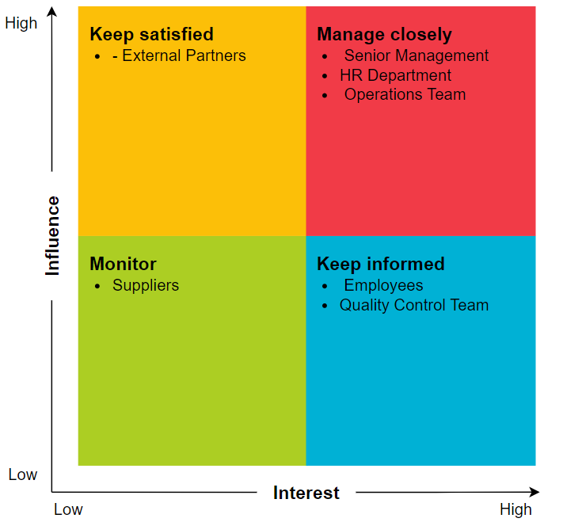

Communications Plan
Stakeholder Group | Why (Expectations) | What (Key Messages) | How (Channel) | When | Who
Senior Management | Ensure alignment with strategic goals, approve budgets and resources. | Progress updates, resource needs, potential risks, and changes. | Face-to-face meetings, email | Bi-weekly meetings, Quarterly reports | Project Manager
HR Department | Develop and implement PDPs, Retention Strategies, and Training Programs. | Training progress, employee feedback, development needs. | Internal meetings, email | Weekly status reports | HR Manager
Operations Team | Implement and maintain 5S practices. | Process changes, training schedules, ongoing support. | Meetings, training sessions, email | Weekly updates | Operations Manager
Quality Control Team | Responsible for improving Quality Control Systems. | System upgrades, timelines, training updates. | Technical documentation, email, meetings | Bi-weekly meetings | Quality Control Manager
Employees | Directly impacted by changes in training, processes, and systems. | New processes, training schedules, expectations. | Meetings, internal newsletters, email | Monthly or as changes occur | HR Manager
Customers | Benefit from improved quality and efficiency. | Product improvements, timelines, impacts. | Newsletters, emails, customer portal | End of each major phase (quarterly) | Marketing Manager
Suppliers | Align services with new operational and quality control standards. | Changes affecting supply requirements. | Email, formal letters, vendor meetings | Quarterly updates or as needed | Procurement Manager

8. Evaluation of monitoring and review techniques to ensure successful implementation of the solution.

Good project management needs robust monitoring and review techniques to be successful. These techniques help track the project, find problems early, and make changes to fix issues. Below is a summary of the essential methods to achieve this:
Technique | Description | Actions
Gantt Chart Monitoring | Using a Gantt chart to track project progress. | - Regular Progress  Checks: Compare actual progress with the plan (weekly or bi-weekly).  -Milestone Tracking: Watch key milestones and act if needed.
Action Plan Monitoring | Checking that tasks in the action plan are completed on time. | - Task Completion Reviews: Make sure tasks are finished as planned.  - Responsibility Tracking: Ensure people or teams meet their deadlines by getting regular updates.
Communication Plan Monitoring | Ensuring good communication with stakeholders. | - Feedback Loops: Get regular feedback from stakeholders to spot issues early.  - Adjustments Based on Feedback: Change the plan or resources if needed based on feedback.
Milestone Reviews | Formal review at each key point in the project. | - Scheduled Reviews: Compare planned and actual progress with key stakeholders.  - Preventive Measures: Take early actions to avoid missing future milestones.
Continuous Monitoring and Adaptation | Ongoing tracking of the project. | - Real-Time Monitoring: Use software or meetings to track the project regularly.  - Real-Time Updates: Use tools that show real-time updates on tasks and resources.

In summary, regular monitoring of the Gantt chart, action plan, and communication plan is essential to keeping the project on track. By reviewing milestones and adjusting in real time, you can manage risks and ensure the success of the project. Monitoring progress at each stage is critical because it is easier to resolve issues early on. Including milestones helps to check if the project is on track and allows for quick correction of delays. This approach ensures that the project achieves its goals on time.

9. Conclusion

To summarise, the significant quantity of manufacturing faults, with 65% attributed to human error, clearly highlights the necessity for improved organisational tactics. An optimal approach involves integrating structured personal development plans (PDPs), 5S principles, training programs, and staff retention tactics. This strategy will mitigate mistakes, enhance product quality, and optimise efficiency. An organisation may effectively reduce the likelihood of errors by prioritising staff growth and fostering a more organised work setting.

Allocating additional resources to these areas at the outset may be necessary, but the potential long-term advantages are substantial. By closely monitoring the progress and making necessary adjustments to the plans, the organisation can guarantee that it stays on course to achieve its objectives. Implementing this plan will result in improved productivity, reduced mistakes, and enhanced output quality, enabling the organisation to sustain a competitive edge in the market.

10. Recommendations

According to Crail (2024), understanding why employees leave is critical to developing an effective retention strategy. Offboarding, the process of managing the employee's departure, plays a vital role. Not only does it ensure a smooth separation, but it also provides valuable insights into why the employee decided to leave. Key reasons often include insufficient pay, overworked, a lack of development opportunities, poor work-life balance, dissatisfaction with management or company culture, and more attractive job offers elsewhere.
Herzberg's two-factor theory offers further insight into employee retention by categorising factors as "hygiene" and "motivators". Hygienic factors, such as occupational safety, remuneration and working conditions, prevent dissatisfaction but do not necessarily motivate workers. Motivators such as responsibility, recognition and development opportunities increase job satisfaction and encourage employees to commit themselves.
To improve retention, the company should:
- Offer a competitive salary: To retain talents, provide wages that reflect the cost of living, experience, and professional responsibilities.
- Promote flexible working hours: Give employees the freedom to choose working hours, increasing productivity and reducing burnout.
- Promote work-life balance: Encourage work-life balance to improve the overall well-being of employees.
- Appreciate and Reward Employees: Regularly appraise and reward employees' financial and social efforts.
- Build a positive workplace culture: Cultivate a diverse, inclusive, and engaging company culture that employees want to be part of.
- Strengthen employee engagement: Actively involve employees in company decisions and create an environment where they feel valued.
- Emphasis on teamwork: Encourage department collaboration to strengthen ties and increase collective productivity.
- Prevent occupational burning: Solve workload problems and ensure fair treatment to reduce the risk of employee burnout. Promote well-being: Provide health care and sick leave and maintain a safe, healthy working environment.
- Invest in career development: Provide opportunities for further education and skills development.
- Practice effective management: Managers should act as trainers, providing support and autonomy, not micromanagement.
- Manage your departure well: Recognise when it is time for your employees to leave and ensure a smooth, positive process (Crail, 2024).

11. References

- Anderson, L. (2023, October 27). How to create an effective stakeholder communication plan. Forbes. https://www.forbes.com/councils/forbesagencycouncil/2023/10/27/how-to-create-an-effective-stakeholder-communication-plan/
- Bensla, A. (2023, February 22). Decision making grids: 7 steps to create a grid and reach your potential. Risely. https://www.risely.me/decision-making-grids/
- Combine group brainstorming with online or individual sessions for better idea selection (Brown & Paulus, 2002).
- Crail, C. (2024, May 10). 13 Effective Employee Retention Strategies For 2024. Forbes. Edited by L. Howard. Retrieved from https://www.forbes.com/uk/advisor/business/employee-retention-strategies/
- Dudek-Burlikowska, M. (2006). Quality research methods as a factor of improvement of preproduction sphere. Journal of Achievements in Materials and Manufacturing Engineering, 18(1-2), 435-438.
- Funke, J. (1991). Solving complex problems: Exploration and control of complex systems. W R. J. Sternberg & P. A. Frensch (Red.), Complex Problem Solving: Principles and Mechanisms (ss. 185–222). Lawrence Erlbaum Associates.
- Funke, J. (2012). Complex problem solving. W N. M. Seel (Red.), Encyclopedia of the Sciences of Learning (ss. 682–685). Springer. https://ssrn.com/abstract=2233373
- Gupta, S., & Jain, S. K. (2014). The 5S and kaizen concept for overall improvement of the organisation: A case study. International Journal of Lean Enterprise Research, 1(1), 22-40. https://doi.org/10.1504/IJLER.2014.062280
- Halford, G. S., Wilson, W. H., & Phillips, S. (1998). Processing capacity defined by relational complexity: Implications for comparative, developmental, and cognitive psychology. Behavioral and Brain Sciences, 21(6), 803–864. https://doi.org/10.1017/S0140525X98001769
- Harrington, H. J. (2000). Business process improvement: The breakthrough strategy for total quality, productivity, and competitiveness. McGraw-Hill.
- Huntington, C. (n.d.). Brainstorming: Definition, examples, & strategies. Berkeley Well-Being Institute. https://www.berkeleywellbeing.com/brainstorming.html
- Ilie, G., & Ciocoiu, C. N. (2010). Application of fishbone diagram to determine the risk of an event with multiple causes. Management research and practice, 2(1), 1-20.
- Juran, J. M. (1999). Juran's quality handbook (5th ed.). McGraw-Hill.
- Osborn, A. F. (2012). Applied imagination: Principles and procedures of creative writing. Read Books Ltd.
- Peterson, J., & Smith, R. (2001). The 5S pocket guide. Quality Resources.
- Phillips, S. (1997). Measuring relational complexity in oddity discrimination tasks. Noetica, 3(1), 1–14.
- Quesada, J., Kintsch, W., & Gomez, E. (2005). Complex problem-solving: A field in search of a definition? Theoretical Issues in Ergonomics Science, 6(1), 5–33. https://doi.org/10.1080/14639220512331311553
- Stobierski, T. (2019, September 5). How to do a cost-benefit analysis & why it’s important. Harvard Business School. https://www.hbs.edu/
- TemplateLab. (n.d.). Fishbone diagram templates. TemplateLab. Retrieved July 30, 2024, from https://www.templatelab.com/fishbone-diagram-templates/
- VanLehn, K. (1989). Problem solving and cognitive skill. W M. I. Posner (Red.), Foundations of Cognitive Science (ss. 527–579). MIT Press.
- Watson, G. (2004). The legacy of Ishikawa. Quality Progress, 37(4), 54-57.

Appendix 1

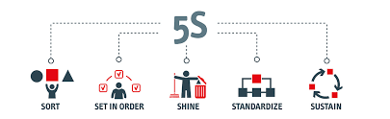
Recommendations for Optimising Workplace Organisation Using 5S.
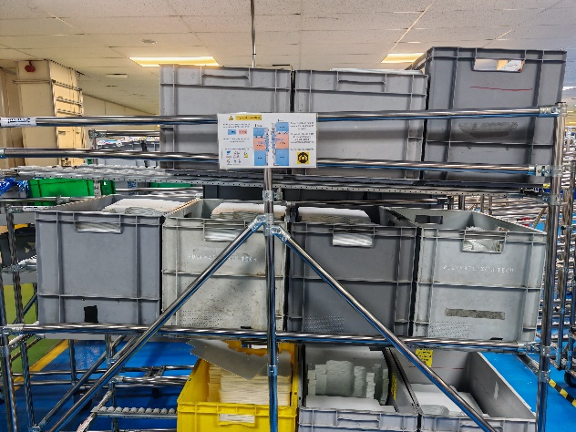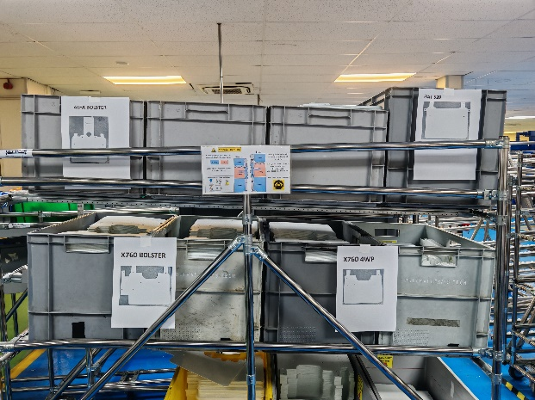
The 5S methodology is a systematic approach to improving workplace organisation and operational efficiency. Implementing this method can significantly reduce errors caused by human factors, such as misidentification and mishandling of components. Above are detailed recommendations for aligning my workplace practices with 5S principles, supported by visual evidence:
Seiri (sorting):
Recommendation: Conduct thorough work area sorting to eliminate unnecessary items. During this process, identify rarely used components or tools and remove or move them to a designated storage area. This will reduce clutter, and the likelihood of errors caused by misplacement or confusion (Peterson et al., 2001; Harrington, 2000).
Current Problem: As seen in the first image, the work area contains many flexible mats that must be marked, increasing the risk of misuse.
Seiton (systematic organisation):
Recommendation: Implement systematic organisation, ensuring all components, including flexible mats, are clearly labelled with distinct identifiers. Implement colour-coded labels or markings to distinguish similar components easily. This step is crucial to prevent errors such as confusion between different types of mats (Peterson et al., 2001; Dudek-Burlikowska, 2006).
Current issue: The first image highlights the lack of clear labelling, which leads to potential human errors, such as using the wrong flexible mat for a specific task. The second image shows an improved organisation that uses labels to make it easier to distinguish different components.
Seiso (Cleaning):
Recommendation: Maintain a clean, tidy work environment by following regular cleaning schedules. A clean workspace increases safety, helps maintain label visibility, and ensures that all components are stored in designated areas, reducing the risk of errors (Peterson et al., 2001; Harrington, 2000).
Current Issue: A cluttered workspace, as seen in the first image, can obscure labels or lead to the accumulation of unlabeled items, contributing to errors.
Seiketsu (standardisation):
Recommendation: Standardise labelling and organisation practices across all workstations. Develop and enforce standard operating procedures (SOPs) for placing and labelling all components, ensuring consistency throughout the facility. Regular audits should be conducted to ensure compliance with these standards (Peterson et al., 2001).
Current Issue: Inconsistent labelling practices, as shown in the first image, indicate the need for standardisation. The second image shows an example of a properly organised and labelled area that should be standard at all workstations.
Shitsuke (discipline):
Recommendation: Cultivate employee discipline through ongoing training and reinforcement of 5S principles. Implement a system of regular checks and incentives to ensure adherence to established standards, supporting a culture of continuous improvement (Peterson et al., 2001; Dudek-Burlikowska, 2006).
Current problem: The discrepancy between the two images suggests that the discipline in maintaining 5S standards may need to be more consistent. Continuous training and reinforcement are essential to sustain improvements.
Conclusions
By rigorously applying the 5S methodology, we can significantly reduce component misidentification errors and improve our production processes' overall efficiency and safety. The transition from the state shown in the first image to the state shown in the second image illustrates the positive impact of proper labelling and systematic organisation. Adopting these practices throughout your facility will improve product quality, increase employee morale, and job satisfaction.

