independent Project Proposal – “Developing an Educational Game for Teaching Social Situations and skills to Younger Players"
Charlie Keirl (2103411) BCS Applied Computing

Contents
1. Introduction 2
1.1 Context to the Project 2
1.2 Aim and Objectives 2
1.2.1 Project Aim 2
1.2.2 Research Objectives 2
2. Literature Review 3
2.1 Education and Video Games 3
2.2 Social Skills Development within Children 3
3. Project Design 4
3.1 The Concept 4

Introduction

1.1 Context to the Project
When it comes to video games, the majority of us have at least played one in our lifetime, whether that be a big AAA game from a popular franchise like Assassin’s Creed or something as simple as the mobile game Candy Crush. Since their rise in popularity in the 1980s, video games have become a very important part in a lot of people's day-to-day lives and because of this, there is a small section within the market for games to help educate players on skills, methods and concepts.
And this small section within the market is where I am going to lay down my project. I am going to create a small game that will teach young people some basic social skills to help them develop these skills early on to help prepare them for their future. At first, I considered developing a game that would teach players some basic STEM skills such as mathematics and science however, there are not so many games that teach these social skills (such as thoughts and feelings) compared to the number of games that teach some of these STEM skills.

1.2 Aim and Objectives

Project Aim
The aim of this project is to design and create an educational card-based video game to help develop the early on social skills of younger players by presenting them with certain social situations and teaching them how to navigate through them.

Research Objectives
- To analyse key concepts and social skills that are needed to develop a child’s ability to understand social situations and how to react when presented with them by studying literature based on childhood development of these skills as well as understanding why this type of game is needed within today’s market.
- To design and develop a card-based game that will help to develop these skills by incorporating them into the gameplay by making the players to think about the situation and how they would react to them themselves if they were to come across them in real life.
- To design and implement a user interface that is suitable for players between the ages of 3 and 6 to use and understand as well as simple enough game mechanics so that they can play the game without struggling to understand what they need to do.
- To evaluate the effectiveness of the game by playtesting it on young players and seeing if they understand why they have chosen the options within the game.

Literature Review

2.1 Education and Video Games
When we think about the term “video games”, education is not usually the first thing that comes to people’s minds. However, video games and education have a lot more in common than you think. There are already many examples of video games that are considered to have underlying educational properties such as Portal (logic, physics and problem-solving skills), Kerbal Space Program (Physics, mathematics and basic aerospace engineering) and even Minecraft (creativity, problem-solving and even STEM subjects in the Minecraft Education edition)[1]. There is also a proven link between playing video games and cognitive skills development, depending on the video game of course, and there are studies to prove this.
One of these example games was created by Bruce M. McLaren and his team who designed a game called “Decimal Point Amusement Park” which intended to teach children how to solve decimal point problems. They created this game to test whether or not teaching children through the medium of video games was possible.[2] After asking set A to play their game, they asked set B to solve the same math problems however in a different format, rather than through the medium of game. They found that set A showed a significant improvement in their ability to solve these problems on both an immediate test (d = 0.4) and a delayed (d = 0.4) test than group B could.[2] They also showed that group A had some enjoyment playing the game, which could indicate that the children are more likely to play that game again, strengthening their mathematical skills once more.[2]
Another study was undertaken which was to find out if an educational video game impacted the mathematical skills of primary school children in grades 4, 5 and 6 compared to traditional learning methods in six schools in Riyadh, Saudi Arabia.[3] Just like the last paper, the team took two sets of children, one with the game and one without. While the pre-test results showed no significant differences between the two groups, the post-test results revealed that those who played the game scored significantly higher, with those in fourth grade scoring 24.56 compared to 23.73, fifth grade 25.34 compared to 24.17, and sixth grade 24.92 compared to 23.61.[3] This indicates that although video games may not replace traditional teaching, they can be an effective tool to enhance engagement and improve learning outcomes.

2.2 Social Skills Development within Children
There have also been studies on how children develop social skills at a young age. As they are children, these types of skills need to be taught to ensure they have a good upbringing and promising future.
One study showed that after giving children a question containing 69 items all based around criticism, respect, solving problems, right and responsibilities and tolerating differences, there was a clear difference in how each question was answered by different types of children (gender, urban and rural schools and year group differences).[4] The results showed that boys scored higher in accepting criticism and accepting rights and responsibilities whereas girls scored better in having better tolerance in differences.[4] There was also a difference between urban and rural schools as students from urban schools performed better in accepting criticism, showing respect, solving problems and tolerance.[4] This clearly shows that there is a gap in the school education system when it comes to teaching children about social situations.
However, one of the major factors in lack of social skills development is those wo have been diagnosed (or undiagnosed in some cases) with neurodivergences such as ADHD (Attention Deficit Hyperactivity Disorder) and ASD (Autism Spectrum Disorders). These types of diagnosis’ can severely affect how those children understand, process and develop social situations and skills.
Using the Matson Evaluation of Social Skills for Youngsters-II (a questionnaire based tool that helps to analyse a child’s social behaviours and adaptive skills), one study found that both children with ADHD and ASD had difficulties in social skill development.[5] Between the ages of 6 and 9, children with ASD had significant deficits in their adaptive social skills than those with ADHD or neurotypical children whereas those with ADHD had trouble in how they can apply their social skills, even if they already have them.[5] Again, a clear sign something is missing to help solidify these skills for both those with ADHD and ASD.
And I believe that creating a game that focuses on helping solidify these skills is a great way to fill that gap in the market.

Project Design

3.1 The Concept
The game will be called “Social Shuffle”, a card-based video game in which players are presented with a relatable, age-appropriate social scenario and they would then play a card they have within their hand that corresponds to said scenario. For example, one scenario might be that Tom has taken a toy away from Jenny without asking her first. The game would then ask the user how they think that makes Jenny feel. From here, the player will then have a look at what cards they have in their hand (the cards will have emotions on them) and they will then have to play the correct card. In our example, they could put the card “Sad” down which would be correct, at least compared to putting down excited.
The game is to help young players between the ages of 3 and 6 to be able to develop these social skills which will hopefully help them in the future, especially if they come into these social scenarios in real life.
The game itself will be created using Unity Personal (the free version of Unity), a game engine in which a lot of modern games are made. This type of game engine is easy to use and understand and can have many useful features to use when creating this game. The methodology I have decided to use is Agile. This would allow me to create prototypes of the game and do regular testing to ensure it works as intended. It also allows me to create a plan for timeframes when creating this game to ensure that I stay on track and have the project ready for when I need it to be.
Below is a Gantt Chart I have created to help document and structure the process in which the game is designed. This chart will help me to plan and schedule tasks and show me how long I have left to complete a certain task. It will also help to motivate myself to complete a task before the deadline.
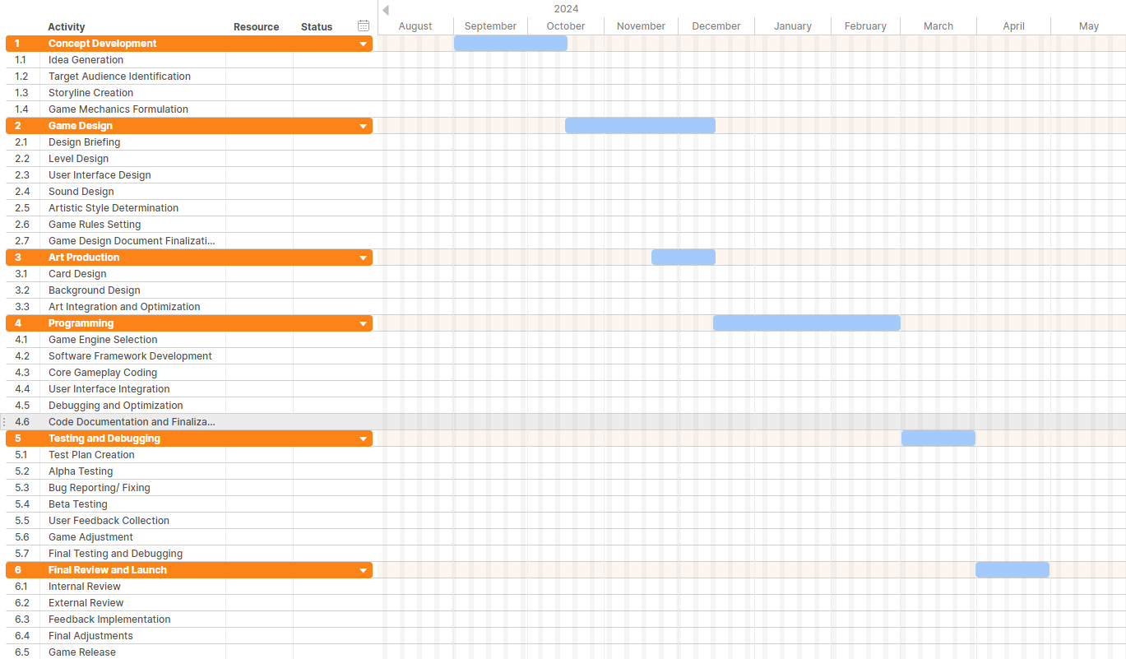

References
[1] Anonymous (). 13 (Secretly) Educational Video Games That Kids Will Actually Like. Available: https://www.cnet.com/tech/gaming/13-secretly-educational-video-games-that-kids-will-actually-like/.
[2] McLaren, B. M., Adams, D. M., Mayer, R. E., & Forlizzi, J. McLaren, B. M., Adams, D. M., Mayer, R. E., & Forlizzi, J. A computer-based game that promotes mathematics
learning more than a conventional approach. A computer-based game that promotes mathematics
learning more than a conventional approach. 2017. Available: https://www.cs.cmu.edu/~bmclaren/pubs/McLarenEtAl-EdGamesVsProblemSolving-IJGBL2017.pdf.
[3] A. R. Baig and A. Alotaibi. A. R. Baig and A. Alotaibi. Effect of curriculum-based video games on students’
performance. Effect of curriculum-based video games on students’
performance. 2020. Available: file:///C:/Users/chuck/Downloads/article_218423.pdf.
[4] T. Rashid. T. Rashid. Development of social skills among children at
elementary level. Development of social skills among children at
elementary level. 2010. Available: https://pu.edu.pk/images/journal/pesr/PDF-FILES/5-Social%20Skills%20among%20Children%20at%20Elementary%20Level.pdf.
[5] Paige E. Cervantes , Johnny L. Matson, Hilary L. Adams, Lindsey W. Williams, Rachel L. Goldin, Jina Jang. Paige E. Cervantes , Johnny L. Matson, Hilary L. Adams, Lindsey W. Williams, Rachel L. Goldin, Jina Jang. Comparing social skill profiles of children with autism
spectrum disorders versus children with attention deficit
hyperactivity disorder: Where the deficits lie. Comparing social skill profiles of children with autism
spectrum disorders versus children with attention deficit
hyperactivity disorder: Where the deficits lie. 2013. Available: https://pdf.sciencedirectassets.com/273587/1-s2.0-S1750946713X00078/1-s2.0-S1750946713001104/main.pdf?X-Amz-Security-Token=IQoJb3JpZ2luX2VjEAkaCXVzLWVhc3QtMSJIMEYCIQDHNaYzFWSEVgN16XcRbjGNz3wDhs0aPNTOI9lLDUAmAQIhALxbqCQuLSTXcFMogEgCQ3FxsDRVZTAp01DlkdAoU6%2FLKrIFCHIQBRoMMDU5MDAzNTQ2ODY1Igw9jvvYNbn0FwxLT1QqjwU41uUBFsfcHjlTR2cMvP2BjlyDeaHxjNhWAjkX1wihxZfDTbiC3vplZcR9nQVy7nYUqc4MRaGR5%2F0i%2FZv%2BN5rOGb6XhCnFwo0VInaAjqdoBuKjgx1DQcNvedt4R7QWH3yWMtAT%2BQ5%2BDJu1YJlfuFolDJQi5Ll3Im%2BCtAe9AlVXW6MGZEf4CWhFRgC69Py4Yx%2F9MMkvch2FEhx0eGc8JOP2tj%2FvagwPHe%2FiHsJ6NGHdHbYF15OGB%2FLrmIx0P3MvCwAvZW7P0DqVyzhhz7YBwrD%2Fuxz2c4f9%2Frq9EOuAn5KvIB9DsBnufUELIuqlhYtEY%2FXkv9h28WUYkzLC1S19Du1lfzC%2FY0yV1QfTSFdLzQPqCMagW2dDBU5yJJM0awEf6P49usaN3kRn6%2FfO9TCf1PZMPoH5LdLUER8DfYf8NEc8UunN1wztc6pFRaTi%2BoxAbOVZ4%2Bce2%2BhfK6VwgfM9iyLSYRrRuNe9XLyIjEkJibBHrABFAWcB9pDUqbwezRjDdssHfNafajLnht7g2uGuk%2FgewzVrchfEMcQHChbPwi9Y8Ony012JHEJKTmIfFiRadnhfM5PeyYkf7g4nw%2Fq8X3Z78pfoRNSdcDmTo4y08SRFzYeN%2F2KK5Sb4GWzVUMbBPFSSuh427rRg9ptf7XGtmeEJy9V9LKf%2B0PgHLDZj%2F%2FPFbNviKqqklehI0V6nOBExnPmd%2BLva9SoCIlV7Fdg3jCjC9CHHD7iXbtQFVy91%2B86oKepYeR6nV7qy6W5P2%2FYVbr23of9fW9YdAwZMCJKeIyA9Zk%2FZCzejEPDB4YTHc4LoH19Yy9IUNlrRJP8VclVMhW3VEVRWLENHfyQgMkC0cd4DZz4F4bxpn8%2FBWorbSGw%2BMO6J07gGOrABHUQKO75j1lKvmE6fWsOSNuFLxFXlko2XCyDSkrkFxDJBdVA10BMJKLnd%2B8fZeTccYYNW4rdeI1NU8xoMVqdIbCedUvpWVxA4dCU1pU7X4BbeKs1Q62EsTuiEuY0GZd72nE%2FY3zYWX58p%2BA8h%2BgKNgmCeN9fZ1Tph3X8xpkDBHaf8VzVsc8XkQgcU0Yz%2F%2FHGVCfgPWwkT71eEAk%2Beoda5SdZtFwm1Z52SvjxKu3vCG7c%3D&X-Amz-Algorithm=AWS4-HMAC-SHA256&X-Amz-Date=20241020T103551Z&X-Amz-SignedHeaders=host&X-Amz-Expires=300&X-Amz-Credential=ASIAQ3PHCVTYSLSNYF3C%2F20241020%2Fus-east-1%2Fs3%2Faws4_request&X-Amz-Signature=c627ceec97973a194f3a373570c742a90fdbfbe912d4b91a92e694b76077c275&hash=17123d8a3213f31eaa63f693f9ca61207470c2cefdab253d1e219be1cee77b27&host=68042c943591013ac2b2430a89b270f6af2c76d8dfd086a07176afe7c76c2c61&pii=S1750946713001104&tid=spdf-6c6906a6-9dbf-4ff8-ad14-54dfedaa67f4&sid=05c0640933fa6142d82a7004d32f563cb4cfgxrqb&type=client&tsoh=d3d3LnNjaWVuY2VkaXJlY3QuY29t&ua=01045b04525a56065305&rr=8d585d0c3d75412d&cc=gb.

