
  - The strategic analysis of Volkswagen in the Chinese market
Student: Qu Jiangying
Student ID number: 2001788
Programme: MBA
Module: Strategic management
Module code: BMMB7013
Professor: Glenn Behenna

Executive Summary
Volkswagen, perceived as the leading automobile manufacturer and distributor over the world, has maintained the first position in terms of the Chinese automobile market. However, the Chinese automobile market has been featured with an extremely high level of dynamism, uncertainties, and complexities, these environmental shifts are out of control of Volkswagen but have important implications on Volkswagen’s future strategic formulation and implementation.
The analysis on the macro level strategy, through the framework of PESTEL, indicates the supportive political environment in China, the changing demographics featured by the emergence of urban young consumers with higher consumption power and distinct pursuit of product/service heterogeneity, the awareness in environmental protection, the mainstream trend of automobile intelligence, connectivity, and electrification. The micro-level analysis, through Porter’s five forces, reveals the picture of high competition, high threats of new entrants, high bargain power of buyers, and high threats of substitutes. The hybrid strategy insisted by Volkswagen can secure its future competitive advantage due to the high homogeneity of the whole industry, and the small profit margin of the whole industry. The report further analyses the internal environment of Volkswagen, through VRIO analysis and SWOT analysis, indicating Volkswagen’s resources and capabilities in R&D, production chain, and supply chain. In an era of personalization, the report further concludes that Volkswagen should be transformed into a software-centred, customer-oriented mobility service provider to acquire and remain differentiated in their future competition.

Table of contents
Executive Summary
1. Introduction 1
2. The analysis of Volkswagen’s competitive environment 3
2.1 Macro environment analysis 4
2.2 Micro environment analysis 11
2.3 Internal environment analysis 15
3. Strategic analysis of Volkswagen 18
4. Conclusion 21
5. Recommendations 22
References 24

Introduction
Volkswagen AG (as the Company, the Group or Volkswagen), based in Germany and founded in 1937, with the previous mission to mass-produce a low-priced people’s car, has been one of the largest manufacturers in the whole world (Volkswagen, 2021b). The business of Volkswagen consists of two distinct divisions, including the automobile division and the financial service division (see Figure 1). So far, the geographical presence of Volkswagen can be found in regions including Europe, Asia Pacific, North and South America, and the Middle East (MarketLine Intelligence Center, 2021). Among these, Europe is the biggest market, and Asia-pacific is the second-largest market of the group.
In the financial year ended on the 31st December, Volkswagen reported a total sales revenue of EURO 222,884 million, recording an astonishing decrease of 11.8% over the fiscal year of 2019 (Volkswagen, 2021a). Accordingly, the operating margin was 4.3%, compared to 6.7% over the fiscal year of 2019 (Volkswagen, 2021a). The sudden outbreak of the covid-19 pandemic is the major culprit behind the declining financial performance, resulting in lower figures in terms of unit sales, sales revenues, and profits throughout the group. It is believed that as covid-19 is under control in the future, the future financial performance of Volkswagen would soon catch up. A deeper dive into the financial performance and the strategic orientation of the Group indicates its ambition to expand its businesses in the Chinese market. Specifically, the automobile market in Europe is getting to the saturation point, with the growth cannot being further driven by the demand of the public. On the other hand, the Chinese market, with emerging demands, has been perceived as a market of huge untapped opportunities for Volkswagen. China is by far the world's largest, most important, and most profitable automotive market, not only selling 26 million vehicles in 2019 but also quickly rejuvenating the market after the new crown epidemic (Chen, Lawell and Wang, 2020). Despite the recession accelerated by the outbreak of the covid-19 epidemic, China remains the world's largest automotive market, with 25.76 million passenger and commercial vehicles sold in 2020 (KPMG, 2020). The Chinese automotive market has long been a cornerstone of the growth strategies of global automakers and, more importantly, a key to business success in the long term. Western carmakers, who early on established themselves through joint ventures with Chinese OEMs, are now relying on the impressive and upward trending performance of the Chinese market (Chen, 2017). Therefore, the present report aims to provide some implications for the future strategic alignment for Volkswagen in the Chines market.
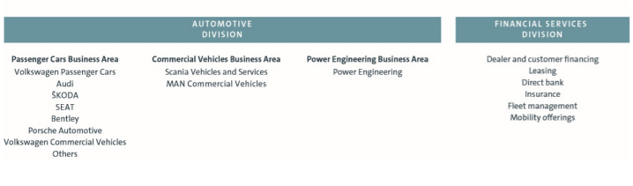
Figure 1. Volkswagen Group Structure
Source: (Volkswagen, 2021a)
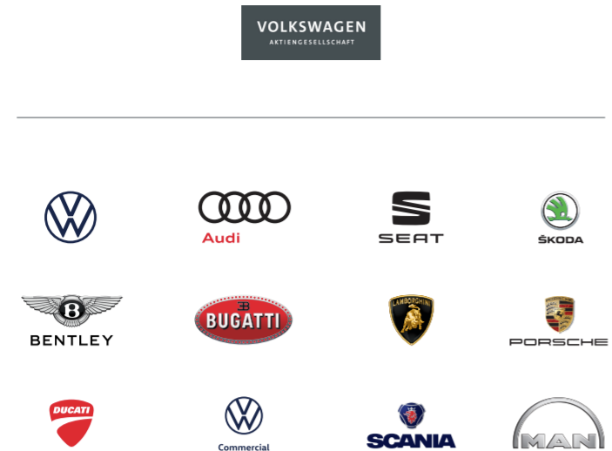
Figure 2. Brands under Volkswagen Group
Source: (Volkswagen, 2021a)

The analysis of Volkswagen’s competitive environment
Defined by Pearce et al. (2000), an external environment comprises a wide range of factors that are outside the control of the specific organization but affect it to some extent. The study on the macro environment is the very first step to identify all possible opportunities and threats that may impact Volkswagen’s future operation in the Chinese market. The most widely used technique to perform the macro environment is the PESTEL framework, an acronym for political, economic, social, technological, environmental, and legal factors. The next level of environment analysis involves the analysis of the microenvironment, which covers the trends and events that affect the set of firms within the whole automobile industry, and it is normally completed through the use of Porter’s five forces that determines the competitiveness, attractiveness and business landscape of a specific industry. After a comprehensive investigation of the macro and micro environment, it is also highly necessary to conduct an analysis of Volkswagen’s internal environment to see if there is a strategic fit between the internal environment and external environment. The strategic management tools used in the analysis of the internal environment is the VRIO model and SWOT model.

Macro environment analysis

Political factors
The issuance of the "Eleventh Five-Year Plan for the Development of China's Automotive Industry" and the successive introduction of related policies have signified that China's automotive industry is gradually becoming standardised and legalised (Wei et al., 2020). In addition, the introduction of the "Used Car Circulation Management Method" has also introduced competition into the used car market (Li, 2020). The introduction of this method has greatly simplified the used car trading process and the whole market is moving in a better direction. At the same time, in recent years, the state has also issued a series of import tariffs and other related policies, all of which have provided a good opportunity and environment for the development of domestic vehicles. During the "12th Five-Year Plan" period, the task of increasing the share of independent brands to more than 50% of the domestic market has been completed, and China is transforming from a large automobile country to a strong one, with the whole automobile industry and related industries achieving coordinated development (Jiang and Lu, 2018). In order to accelerate the construction of ecological civilisation, the new energy vehicle industry is one of the key directions for future development in the national 14th Five-Year Plan (Kendall, 2018). The country will increase or update the existing urban bus, rental, storage and logistics distribution industry vehicles from 2021 onwards in key areas such as ecological conservation, pollution prevention and control, and the proportion of new energy vehicles will be no less than 80%.

Economic
Since 2019, global economic growth has continued to slow. The world economy grew at a rate of 2.3% in 2019 and was even harder hit by the global pandemic impact of the covid-19 epidemic in 2020, with the economy suffering negative growth (The World Bank, 2021b). Fortunately, China has taken full advantage of its system and has been the first in the world to turn the situation around through a series of means, becoming the only major country among the world's major economies to achieve positive economic growth (The World Bank, 2021a). It now appears that China will remain the main driver of global economic growth in the long term. Data show that in 2020, China's per capita disposable income reaches RMB 32,189, an increase of 4.7 per cent year-on-year, and the per capita income of China's residents in 2020 has doubled compared to 2010 (Bloomberg, 2021). The growth in national income has pushed car consumption to continue to heat up. Despite the impact of the new crown pneumonia epidemic and the major difficulties faced by the auto industry, it still showed great resilience in its development. With favourable conditions such as national and local policy support and recovery in consumer demand, the auto industry's market performance far exceeded expectations and led the world.
In 2020, car ownership per 100 households of Chinese residents increased by 5.2% year-on-year to reaching 37.1 vehicles (KPMG, 2020). China's economic development has gradually shifted to a stage of high-quality development. Although the growth rate of GDP has slowed down, on the basis of adhering to the general keynote of "seeking progress in a stable manner", the proportion of residents' income has increased and the "six stabilisations" and "six guarantees" have achieved remarkable results (The World Bank, 2021a). The "Six Stabilisations" and "Six Guarantees" have achieved remarkable results, and the purchasing power of residents has increased significantly. In the future, China's 400 million or so middle-income group will continue to promote the upgrading of automobile consumption, and the strong impetus of market demand will also prompt the rapid development of automotive enterprises (Accenture, 2021b). However, it must also be soberly recognized that, influenced by factors such as economic and trade frictions, epidemic impact and ecological and environmental protection, Volkswagen must always keep its strategic thinking clear, proactively seek changes and actively respond to the unpredictable market environment with solid and profound accumulation and flexible strategies.
At the same time, the domestic new energy industry started early, and after more than ten years of continuous development since the birth of the "863" electric vehicle major special project in 2001, the sales scale has exceeded the 1 million units/year mark, with an average annual growth rate of more than 80% (Roland Berger, 2021). From a global perspective, domestic new energy vehicle sales account for nearly 50% of the world's total, and have been the world's number one for five consecutive years, making it the undisputed leader in the new energy industry.
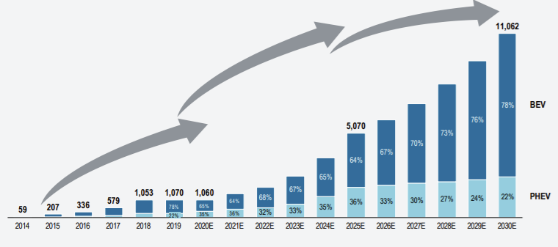
Figure 3. The projection of the new energy vehicles sales
Source: (Roland Berger, 2021)

Social
The world's largest population is one of the most important factors for the survival and prosperity of our many automotive industries. In addition to the size of the population, another point that is incomparable to other countries with large populations is the urbanisation process that has been accelerating with the rapid development of China's economy. According to Guan et al. (2018), by the end of 2022, the urbanisation rate of China's resident population will have exceeded 60%. This is very impressive for a country with a population of over 1.4 billion. On the other hand, the liberalisation of the comprehensive "two-child" policy will also largely affect the demand for cars (Huang et al., 2019). People are gradually shifting from a focus on the basic function of transportation to a higher demand for space and comfort.
China is still the largest developing country in the world. Compared to the old capitalist developed countries, only 40 years have passed since the reform and opening up of China, and the majority of the middle and upper-income groups at this stage have not accumulated wealth for too long. Housing and vehicles are still generally regarded as important symbols of wealth and status in society, and vanity and comparison behaviours are still widespread. Therefore, as the number of middle and high-income groups continues to increase, people's demand for cars, as well as the need to purchase more high-end cars, will also continue to grow (Chen and Goodman, 2013). In 2020 China officially declared the eradication of absolute poverty for the first time in its history, having successfully achieved the ambitious goal of building a moderately prosperous society in all aspects (The World Bank, 2021a). Against this backdrop, the implementation of the rural revitalisation strategy has been accelerated and the gap between urban and rural areas has been further narrowed, all of which provide extremely favourable prerequisites for the rapid development of the automotive industry.
At the same time, the user consumption has structured has changed, with youthfulness, femininity and sinking becoming key trends, and consumer preferences are more focused on digitalisation, intelligence, personalisation and experience, placing higher demands on products and services; the gradual maturation of new models such as shared mobility, net-contracting and autonomous driving technology has had a profound impact on car demand; there has been no significant relaxation of policies in cities with high line licence and traffic restrictions, and policy tools will be used very cautiously (Zhang, 2019).

Technology
The intelligent and connected cars are the start button for the digital transformation of the whole auto manufacturing industry, from empowering the improvement of product power, to empowering the value mining of the auto after-market, to empowering product development and collaborative innovation of the whole value chain, becoming the "new four" (electrification, intelligence, networking and sharing) trend of the auto industry (Bian and Li, 2018). The industrial ecology of intelligent and interconnected networked vehicles is an ecosystem of high complexity and uncertainty, with participants including vehicle manufacturers, high-tech companies, suppliers and the government. Among the ecological participants, vehicle manufacturers, as the ultimate integrator, need to bring together all the players, including software and hardware, functional and ecological service providers, to complete the delivery from complete vehicle manufacturing to long-term travel services (Ullah, Zhang and Ahmed, 2021). Also, the development of interconnectivity and intelligence of automobiles has been based on the development of electric automobiles. The modernisation of new energy vehicle platforms will drive the implementation of connected and intelligent cars.

Environmental
China is currently facing serious environmental challenges, one of which is the hazy weather that appeared in many Chinese cities in 2013. The serious environmental pollution problems represented by the haze threaten to shake the implementation and outcomes of development plans, erode public confidence and trust in the government, affect people's quality of life and reduce the level of ecological services needed for social development (Chen and Lees, 2018). Although China's investment in environmental protection has continued to increase, it is still not sufficient to arrest the deterioration and achieve sustained improvements in environmental quality. Both the development model and the new problems that have emerged during the transition period, as well as climate change and increasing domestic consumption pressures, are sounding new alarm bells(Li and Shapiro, 2020). Environmentalism is gradually rising, gradually abandoning highly-polluting traditional fuel vehicles; and new energy vehicle companies such as Tesla have achieved a good educational effect on users, with consumer acceptance of new energy and willingness to buy rising (Lo, 2020). With the future approaching, the ever-changing new energy vehicle market over the past few years has gradually emerged as demand-driven. Today, consumers are more in favour of sustainable and environmentally friendly lifestyles. This has become even more pronounced due to the epidemic, as consumers are increasingly looking for eco-friendly features in all price ranges, especially in China.

Legal
Strengthening the protection of intellectual property rights is an inherent need for China to transform and upgrade itself and move towards high-quality development, an inevitable requirement for promoting the "administrative and service" reform and shaping a good business environment, as well as a practical need for China to expand its opening-up and integrate into the world economy (Brander, Cui and Vertinsky, 2017). The Opinions on Strengthening the Protection of Intellectual Property Rights have made overall arrangements and specific requirements for the "strict protection" of intellectual property rights, reflecting China's firm stance and clear attitude of strictly protecting intellectual property rights in accordance with the law in the new era, which is essential for stimulating social innovation, creating a fair and competitive market environment and a world-class business environment, and accelerating the construction of a strong intellectual property country (Fang, Lerner and Wu, 2017; Gao, 2021). It is of great significance to stimulate social innovation, create a fair and competitive market environment and a world-class business environment, and accelerate the construction of a strong intellectual property right framework.

Micro environment analysis

Bargaining power of suppliers
The component suppliers from the international marketplace have established factories in the Chinese market, and the competition between suppliers are getting intense as most domestic automobile manufacturers do not have sufficient capabilities in developing their own production chain for components. However, leading automobile manufacturers such as Volkswagen, have formulated a long-term cooperation with suppliers with an integrated progress of procurement and logistics ecosystem. For instance, in 2015, Volkswagen started to try to market its parts business in China, setting up four parts companies one after another (Volkswagen, 2021a). Therefore, most of Volkswagen's components are based on independent research and development.

Bargaining power of buyers
With the prosperous growth of the national economy, China's national income has increased significantly, affording consumers with higher spending power on non-necessities. As China's urbanisation level continues to advance, the urban population will still maintain a relatively rapid growth, and China's GDP per capita continues to grow rapidly, all of which will support the future development of the automobile market. Consumers tend to be more mature and rational: China's consumers' purchasing behaviour towards passenger cars has also become more mature and rational with the continuous development of the auto market. Consumers have changed from being concerned with price and grandeur to being more concerned with value for money, quality, brand and after-sales service, and have also become more sensitive to price (Zhang, 2019). Also, regardless the traditional vehicle or electric vehicles, there are extensive choices, domestic and international, provided to Chinese consumers without any switch costs. Therefore, the bargaining power of buyers is evaluated to be higher.

Threats from new entrants
The automotive market in China has always remained very competitive, but there are also high barriers to entry, and of course the industry profit margins in the automotive sector are very substantial. Attracted by such high profit margins, the major domestic car companies have begun a race to expand their production capacity. For example, FAW-Volkswagen, Dongfeng Nissan, Dongfeng Honda, some of the SAIC Group's car companies and so on have all made development plans to expand their production capacity in recent years, and new plants of considerable scale are in the process of construction (McKinsey, 2021). These potential capacities will intensify competition in the existing market. A large number of private companies with extensive experience in the competitive market have completed the accumulation of original capital with the support of the market economy (Wang, Chen and Huang, 2021). A good example of this is BYD Auto, which is now one of the better-developed automotive companies. It is likely that more private companies will enter this field of car production in the future and will be able to occupy a place in the car market thanks to new technologies or systems and other advantages.
The threats of new entrants in the electronic vehicle sector are especially intensive. The domestic brands such as NIO, Xpeng has exceled superior capabilities’ in developing value-added software, and international brands such as Tesco has accumulated much more reputation in China (McKinsey, 2021). Given the extensive positive outlooking on the future Chinese prospects, there are more innovative start-up wants to take a slice of pie, and increasingly traditional automobile has made the electrification as their strategic priority. Therefore, the threats of new entrants are estimated to be high.

Threats of substitutes
In recent years, the new transportation represented by shared bicycles, online bicycles, hitchhiking, electric balance bicycles, rail trams, etc. has flourished, and people's way of travel has quietly changed, stopping as they go, environmental protection and saving, green travel, which not only reduces transportation costs, but also makes better use of resource saving (McKinsey, 2021). As the major online platforms continue to compete, optimise, regulate and improve services, most of the wait-and-see people who do not have a strong demand for cars will choose the meaningful way to travel. On the other hand, the new mode of travel has greatly increased the scope of people's activities. First- and second-tier cities are congested with traffic during peak commuting periods and travel long distances, in order to alleviate the travel pain points, some people will choose carpooling travel methods (Zhang, 2019). For shorter distances, such as within two or three kilometres, people will choose to share bicycles, which are easy to park and help with fitness. This new way of travelling greatly increases people's range of motion compared to driving and walking, and are featured by higher level of affordability and environmental friendliness. Therefore, threats of substitutes is estimated to be high.

Existing competition
Although competitors within the industry may pose a certain degree of threat to enterprises, suitable competitors can help enterprises strengthen their competitive position, so competition within the industry is not always harmful to enterprises, but also some competition is beneficial (Automotive News, 2021). After China's auto market became the world's largest, the growth rate of auto sales has also remained the highest in the world, such a "big piece of cake" has made many auto enterprises, especially multinational auto enterprises covet (KPMG, 2020). The Chinese auto market has become a battleground for major domestic and foreign auto manufacturers, and the competition for the market has been fierce, with China's auto market showing the characteristics of many, small and scattered competitive enterprises in recent years. At present, there are more than a hundred domestic vehicle manufacturers, more than the total number of European, American and Japanese vehicle manufacturers. The number is large, but as mentioned earlier, the industry is not highly concentrated and most automotive enterprises are at a relatively small scale. Differentiation of automotive companies is currently the main means of competition.
Although Volkswagen has been dominated the Chinese traditional vehicle market, its market position in the electric vehicle sector has lagged behind the domestic brands and other international brands with early mover advantages and more digital capabilities.
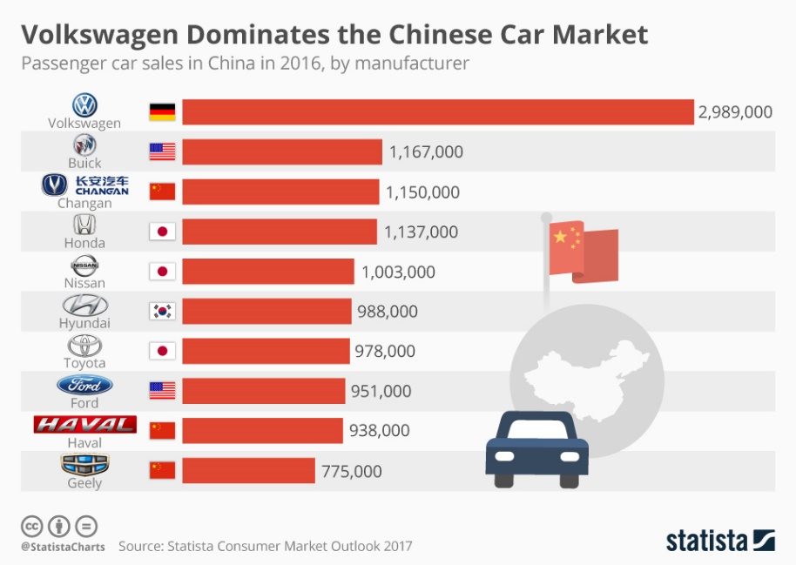
Figure 4: Automobile market in China
Source: (Statista, 2020)
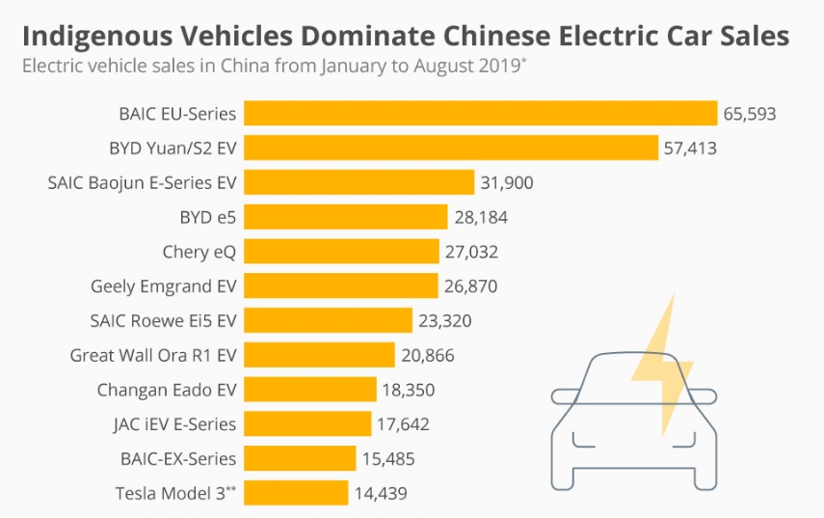
Figure 5. Electric Car Sales in China
Source: (Statista, 2020)

Internal environment analysis
Table 1. VRIO analysis
Source: own summary based on (Zhang, 2019; KPMG, 2020; Accenture, 2021a; Volkswagen, 2021a)

Table 2. SWOT analysis
Source: own summary based on (Bloomberg, 2021; MarketLine Intelligence Center, 2021; Volkswagen, 2021a)

Strategic analysis of Volkswagen
First of all, the competition in car sales prices in the Chinese market is very fierce. Before 2010, before the expiry of the government's policy on car purchase tax incentives, the prices in China's car market were very firm and discounted models were very rare (Qian and Soopramanien, 2014). However, in 2010, along with the expiry and withdrawal of the state's stimulating policies on car consumption, the sales of the car market also showed signs of decline, and various car manufacturers began to reduce prices in an attempt to compete for the market through price wars, and the situation of selling cars at a price increase no longer existed (Barwick, Cao and Li, 2021). In 2011, against the backdrop of increased monetary liquidity, the auto market saw a very prosperous scene and continued to grow at a high rate (Li, Xiao and Liu, 2015). At present, the auto market is beginning to diverge, accompanied by the acceleration of new models and technologies of joint venture branded cars being pushed into the market, as well as the continuous downward movement of auto sales prices, resulting in the lower priced domestic independent branded car market being continuously squeezed and market share beginning to shrink (Iguchi, 2020). Although the car market has been divided, the competition between joint venture brands and joint venture brands, and between independent brands and independent brands is still extremely fierce. China's policy on small displacement and energy-saving and environmentally friendly cars is encouraged, and various car manufacturers are striving to meet the requirements of energy saving and emission reduction by competing for the market of models with a displacement of 1.6 litres or less, and FAW-Volkswagen's Sprint, Bolai and New Jetta are in this displacement (Li et al., 2020). In terms of data, models in this range account for more than 75% of annual car sales, and the position that such models occupy in the car market is evident.
With the maturity and rationality of car consumption in China, quality and branding, as well as the convenience of after-sales service, are important considerations when people consider buying a car. The convenience, availability, accessibility, and service attitude of after-sales service all influence people's experience of after-sales service, and the satisfaction formed by this experience will become a kind of word-of-mouth and an intangible competitiveness of the company, and become one of the important factors to promote re-sale (Xiao, 2019). Whether or not the after-sales service is of high quality determines the brand effect of the company and its long-term development. This thoughtful and perfect service can cultivate consumer loyalty and form a word-of-mouth that can make old customers create new ones. A set of data shows that the satisfaction of customers who "will definitely" recommend the car brand they use to the people around them should reach more than 42%, while 21% of them said they "will definitely" buy the brand again (Accenture, 2021a). For brands with lower after-sales satisfaction, only 16% and 4% of customers would "definitely" recommend someone around them to buy or buy the car themselves again. The rapid growth of the car market over the years has led to a record high in car ownership in China, but the after-sales service capability has not kept pace with this development, and the service system is relatively lagging behind, which has led to a surge in consumer complaints about after-sales service (Accenture, 2021a).
Chinese consumers have become very accustomed to the rapid advancement of technology, and technological innovation through software development has been a crucial competitive edge for automobile brands to get rid of vicious competition (Reuters, 2019). When higher quality or newer technology cars enter the market, lower quality or low technology cars need to lower their prices if they want to secure market share, or even be abandoned by car manufacturers or eliminated from the market, which is the competitive process of price gaming for car products in the market. If a car manufacturer can be the first to launch a new product with advanced technology, aided by marketing and brand culture, then it is likely to effectively avoid price fighting with other car companies and gain better profit margins. The value-added services through automobile embedded software can be exploited as an effective mean to differentiate services from the mass homogeneous offers, and this is highly important in the era when the personalization is pursued by the emerging young generation consumers in China (Deloitte, 2021). Over the past decade, China has grown rapidly to become the world's largest electric vehicle market. In terms of industry, technology and business models, China's electric vehicle models are gradually entering the world market, China has the leading mass-produced power battery technology and continues to innovate, and is one of the most active regions in the world in terms of innovation in electric mobility business models (KPMG, 2020). The orientation in the electric vehicles segment should be incorporated in Volkswagen’s future strategy, together with the concept of software-defined vehicles.
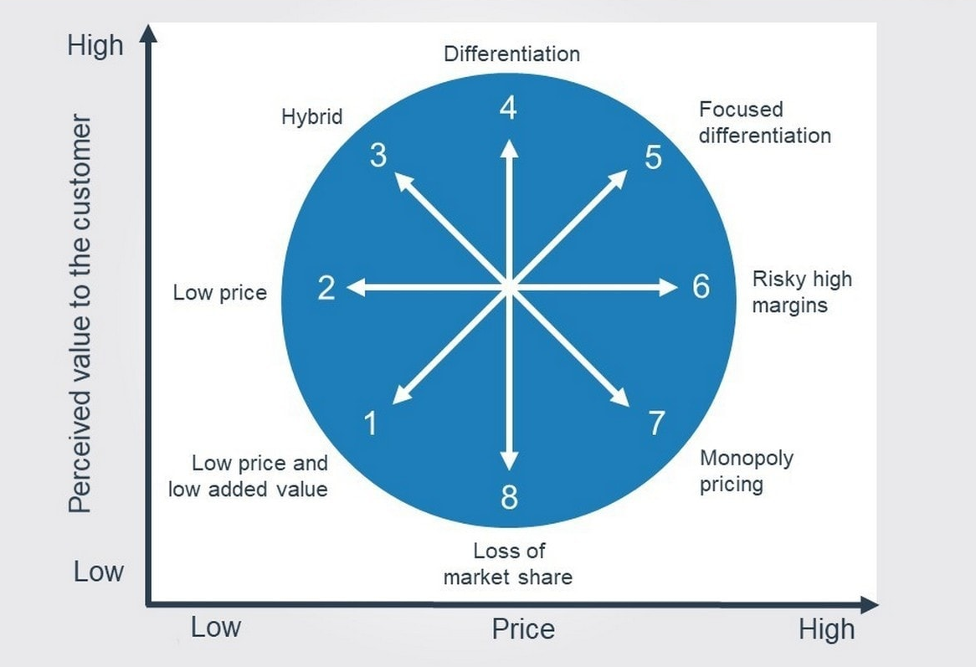
Figure 6. Bowman’s strategy clock
Source: (Henry, 2021)
Bowman’s strategy clock indicates there are eight strategies to compete indicated in the above figure, and the clock shows the pricing range of a product/service matched against the perceived value to the customers. In order for a specific strategy to be competitive, the two dimensions must be carefully evaluated and determined. The market position of Volkswagen has been secured by the Hybrid strategy with moderate pricing range but higher perceived value to the customers. The above analysis indicates the strategy has been imitated by other international and domestic brands with even more affordable offerings, resulting in a narrowed profit margin for the automobile manufacturers in the Chinese market. Under the circumstance, the differentiation strategy, with a focus on electric, intelligent, and interconnected automobiles to the Chinese customers to attract the young generation of Chinese consumers who have strong preferences for heterogenous offerings.

Conclusion
The report, using Volkswagen as a research object and China as a target market, develop a strategic analysis for Volkswagen. The macro environment analysis indicates the major trends of the sharp rise of electric vehicles (due to the political supports from the government, and the prevalence of environmentalism in China), the emphasis of intelligence and connectivity in the automobiles; the micro environmental analysis reveals the high level of competition through homogenous products offerings. The Internal analysis through VRIO and SWOT indicates Volkswagen’s strong capabilities in R&D, as well as supply and production chain analysis. Therefore, it can be concluded the hybrid strategy which is more oriented by offering a wide range of automobile products at relatively affordable prices. The shrinked profit margin and the changing external environment indicates an strategic transformation is required to sustain future competitive advantage of Volkswagen, through an more electric, software- centred, and customer-centred automobile offerings.

Recommendations
- Volkswagen needs to accelerate its transformation into a software-driven mobile mobility service provider. the Group can focus on a platform-based strategy to create synergies and economies of scale, and create new sources of profit. Based on developments in software and electric vehicle technology, the evolution of Volkswagen should be towards safer, smarter and ultimately environmental friendlier vehicle products. For the Volkswagen Group, this means that technology development, transformation acceleration and scaling up will be more important than ever.
- Data insights and data analytics using various information technologies will be a new source of value generation for OEMs - from predictive maintenance to location-based services. OEMs will need the right capabilities to manage big data flows and proactively deliver new services, while, at the same time, engaging in collaboration within an ecosystem of partners. Intangible services is the cornerstone of the after-sales service transformation. It depicts an immersive experience enabled by the full integration of online and offline touchpoints, where Volkswagen uses intangible services to engage with consumers on an ongoing basis at home, at the repair station or dealership service point, or in the car.
- In the traditional automotive development model, the development cycle can take 3-5 years. Once a product has been sold, it is difficult to update the product's functional features. This iteration rate and development model is far from being able to meet the dynamic market demands. The shift in value in the industry requires companies to focus on and strengthen their software development and integration capabilities, in addition to their existing hardware development capabilities. By taking a cue from the consumer electronics industry, Volkswagen should embark on a software-defined model- continuously injecting new features into products throughout their lifecycle to keep them competitive and dynamic. VW should be more proactive in reaching out beyond the boundaries of the industry to connect the car to the rest of the external ecosystem to reach and partner with other stakeholders who can provide technological supports for their software-oriented strategic initiative, and to secure differentiation and personalization through value added services.

References
- Accenture (2021a) China Automotive Aftersales Market. Available at: https://www.accenture.com/cn-en/insight-china-auto-aftersale-market (Accessed: 14 December 2021).
- Accenture (2021b) ‘COVID-19: Restarting the Chinese Automotive Industry ’.
- Automotive News (2021) Chinese auto brands accelerate market share gains amid chip shortage . Available at: https://www.autonews.com/china-commentary/chinese-auto-brands-accelerate-market-share-gains-amid-chip-shortage (Accessed: 14 December 2021).
- Barwick, P. J., Cao, S. and Li, S. (2021) ‘Local protectionism, market structure, and social welfare: China’s automobile market’, American Economic Journal: Economic Policy, 13(4), pp. 112–151.
- Bian, M. and Li, K. (2018) ‘Strategic Analysis on Establishing an Automobile Power in China Based on Intelligent & Connected Vehicles’, Strategic Study of Chinese Academy of Engineering, 20(1), pp. 52–58.
- Bloomberg (2021) Covid Outbreak: China’s Economy Weakens as Consumers Turn Wary . Available at: https://www.bloomberg.com/news/articles/2021-09-15/china-s-economy-weakens-as-consumers-turn-wary-amid-outbreak (Accessed: 14 December 2021).
- Brander, J. A., Cui, V. and Vertinsky, I. (2017) ‘China and intellectual property rights: A challenge to the rule of law’, Journal of International Business Studies, 48(7), pp. 908–921.
- Chen, G. C. and Lees, C. (2018) ‘The new, green, urbanization in China: Between authoritarian environmentalism and decentralization’, Chinese Political Science Review, 3(2), pp. 212–231.
- Chen, J. (2017) ‘The Chinese automobile market and the strategies of European, American, Japanese, Korean and Chinese auto makers’, International Relations, 5(5), pp. 241–257.
- Chen, M. and Goodman, D. S. G. (2013) Middle class China: Identity and behaviour, Middle Class China: Identity and Behaviour. doi: 10.4337/9781781005712.
- Chen, Y., Lawell, C.-Y. C. L. and Wang, Y. (2020) ‘The Chinese automobile industry and government policy’, Research in Transportation Economics, 84, p. 100849.
- Deloitte (2021) Software-Defined Vehicles – A Forthcoming Industrial Evolution. Available at: https://www2.deloitte.com/cn/en/pages/consumer-business/articles/software-defined-cars-industrial-revolution-on-the-arrow.html (Accessed: 14 December 2021).
- Fang, L. H., Lerner, J. and Wu, C. (2017) ‘Intellectual property rights protection, ownership, and innovation: Evidence from China’, The Review of Financial Studies, 30(7), pp. 2446–2477.
- Gao, X. (2021) ‘The impact of density, distance and division on intellectual property rights protection: the case of Huaihai Economic Zone, China’, International Journal of Urban Sciences, 25(2), pp. 208–232.
- Guan, X. et al. (2018) ‘Assessment on the urbanization strategy in China: Achievements, challenges and reflections’, Habitat International, 71, pp. 97–109.
- Henry, A. (2021) Understanding strategic management. Oxford University Press.
- Huang, J. et al. (2019) ‘Effect of fertility policy changes on the population structure and economy of China: from the perspective of the shared socioeconomic pathways’, Earth’s Future, 7(3), pp. 250–265.
- Iguchi, M. (2020) ‘Regulatory convergence and policy diffusion in automobile emission standards: Cases of China and India’, in Sustainability and the Automobile Industry in Asia. Routledge, pp. 42–58.
- Jiang, H. and Lu, F. (2018) ‘To be friends, not competitors: A story different from Tesla driving the Chinese automobile industry’, Management and Organization Review, 14(3), pp. 491–499.
- Kendall, M. (2018) ‘Fuel cell development for New Energy Vehicles (NEVs) and clean air in China’, Progress in Natural Science: Materials International, 28(2), pp. 113–120.
- KPMG (2020) ‘What COVID-19 means for the car industry in China ’. Available at: https://home.kpmg/sk/en/home/insights/2020/04/what-covid-19-means-for-china-car-industry.html (Accessed: 14 December 2021).
- Li, J. (2020) ‘Charging Chinese future: the roadmap of China’s policy for new energy automotive industry’, International Journal of Hydrogen Energy, 45(20), pp. 11409–11423.
- Li, S., Xiao, J. and Liu, Y. (2015) ‘The price evolution in China’s automobile market’, Journal of Economics & Management Strategy, 24(4), pp. 786–810.
- Li, W. et al. (2020) ‘Public preference for electric vehicle incentive policies in China: a conjoint analysis’, International journal of environmental research and public health, 17(1), p. 318.
- Li, Y. and Shapiro, J. (2020) China goes Green: coercive environmentalism for a troubled planet. John Wiley & Sons.
- Lo, K. (2020) ‘Ecological civilization, authoritarian environmentalism, and the eco-politics of extractive governance in China’, The Extractive Industries and Society, 7(3), pp. 1029–1035.
- MarketLine Intelligence Center (2021) Volkswagen AG - Overview. Available at: https://advantage-marketline-com.uoelibrary.idm.oclc.org/Company/Summary/volkswagen_ag (Accessed: 14 December 2021).
- McKinsey (2021) The race to win: The Chinese automotive market in post-pandemic China . Available at: https://www.mckinsey.com/industries/automotive-and-assembly/our-insights/the-race-to-win-how-automakers-can-succeed-in-a-post-pandemic-china (Accessed: 14 December 2021).
- Pearce, J. A., Robinson, R. B. and Subramanian, R. (2000) Strategic management: Formulation, implementation, and control. Irwin/McGraw-Hill Columbus, OH.
- Qian, L. and Soopramanien, D. (2014) ‘Using diffusion models to forecast market size in emerging markets with applications to the Chinese car market’, Journal of Business Research, 67(6), pp. 1226–1232.
- Reuters (2019) VW says China to become global software development hub to autonomous tech. Available at: https://www.reuters.com/article/us-autoshow-shanghai-volkswagen-software-idUSKCN1RR16S (Accessed: 14 December 2021).
- Roland Berger (2021) White paper on China’s new energy vehicle supply chain in 2020.
- Statista (2020) Automotive manufacturing industry in China - statistics & facts. Available at: https://www.statista.com/topics/1050/automobile-manufacturing-in-china/ (Accessed: 14 December 2021).
- The World Bank (2021a) China Economic Update - June 2021. Available at: https://www.worldbank.org/en/country/china/publication/china-economic-update-june-2021 (Accessed: 14 December 2021).
- The World Bank (2021b) Global Economic Prospects: The Global Economy: on Track for Strong but Uneven Growth as COVID-19 Still Weighs. Available at: https://www.worldbank.org/en/news/feature/2021/06/08/the-global-economy-on-track-for-strong-but-uneven-growth-as-covid-19-still-weighs (Accessed: 14 December 2021).
- Ullah, A., Zhang, Q. and Ahmed, M. (2021) ‘The impact of smart connectivity features on customer engagement in electric vehicles’, Sustainable Production and Consumption, 26, pp. 203–212.
- Volkswagen (2021a) The future on hand: annual report 2020.
- Volkswagen (2021b) Volkswagen Group - About us. Available at: https://www.volkswagenag.com/en/group.html.
- Wang, S., Chen, G. and Huang, D. (2021) ‘Can the New Energy Vehicle Pilot Policy Achieve Green Innovation and Emission Reduction?:A Difference-in-Differences Analysis on the Evaluation of China's New Energy Fiscal Subsidy Policy’, Sustainability, 13(15), p. 8643.
- Wei, Y. et al. (2020) ‘Research on structural dynamics in Chinese automobile standard citation network’, Neural Computing and Applications, 32(1), pp. 31–39.
- Xiao, M. (2019) ‘Annual report on the trend of automobile consumption in China (2012)’, in Development of a society on wheels. Springer, pp. 285–307.
- Zhang, J. (2019) Driving toward Modernity: Cars and the Lives of the Middle Class in Contemporary China. Cornell University Press.

