Assignment Title: International Marketing
Programme: MBA
Module: International Marketing
Module code: LCMB7006
Name: Yogesh Sain
Student ID: 2221521

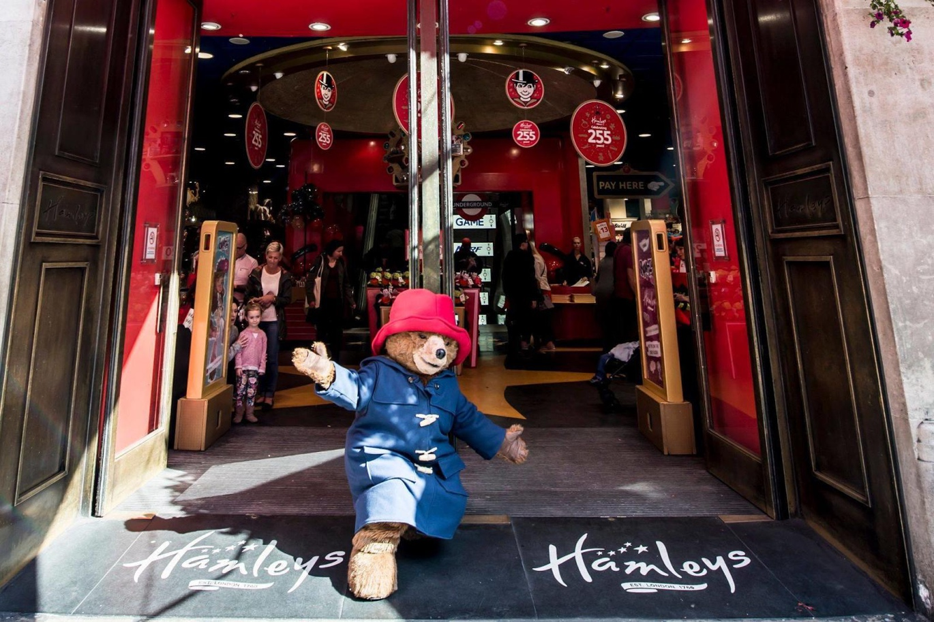
INTRODUCTION
Hamleys, the best toy store in the world, is a historic toy store with a storied past in London. With toys that have been around for more than 260 years, the Hamleys brand is synonymous with the magic and entertainment they provide.

History

Hamleys was first established in Holborn, London, in 1760 by William Hamley as a small toy shop known as "Noah's Ark." Before finally settling in its current flagship location on Regent Street in 1881, the store underwent several expansions and moves over the years.

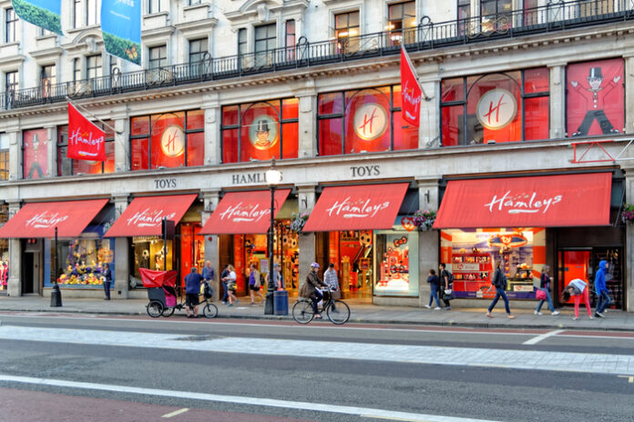
Fascinating history and legacy of Hamleys
As a representation of joy, wonder, and adventure, Hamleys continues to be a significant and well-liked toy retailer. Hamleys has a rich history, enchanting in-store experiences, a wide range of products to choose from, and a dedication to customer satisfaction, making it a beloved destination for toy lovers of all ages.
The Regent Street flagship of Hamleys has earned a reputation as a must-see destination for toy enthusiasts worldwide. It is one of the biggest toy stores in the world, with a total area of 54,000 square feet spread across seven floors. Customers are given an extraordinary experience that goes above and beyond typical shopping when they visit the store. For people of all ages, each floor has been carefully curated to offer engaging and interactive experiences. Every child's imagination and interests are catered to by the wide selection of toys, games, puzzles, dolls, action figures, and plush toys available at Hamleys. Hamleys has established a reputation as a distinctive and sought-after toy retailer by working with renowned toy manufacturers to offer unique and limited-edition items that are only available in their stores. Playfulness and captivating presentations make toys come to life during in-store toy demonstrations, which produce a magical atmosphere. Hamleys takes great pride in providing outstanding customer service, and their helpful staff, referred to as "Hamleys Helpers," is always on hand to help and make sure a pleasant shopping experience. Hamley's has opened stores in numerous cities around the world, though its Regent Street location continues to serve as its flagship. The shopping experience is made more exciting and entertaining by the numerous events and performances that Hamley's hosts throughout the year. Hamleys has persisted as a beloved toy retailer that enthralls kids and adults of all generations thanks to its capacity to adapt to shifting trends while keeping a focus on imagination, creativity, and play.

Hamleys' business goals and objectives
As a well-known toy shop, Hamleys is driven by a thorough set of aims and objectives that support its strategic orientation. As the cornerstone of its growth plan, increasing sales and producing money is a top priority. To provide a comprehensive approach to income production, this means setting exact revenue targets and developing methods to improve sales across both physical and online channels. Alongside this, Hamleys aims to increase its market share in the toy and entertainment industries. This goal is motivated by a comprehensive strategy that includes expanded geographic reach, diverse product offers, and effective marketing strategies. Hamleys wants to solidify its position in a few markets and geographic areas to gain a larger market share. The goal of increasing brand awareness is essential to its long-term success. Hamleys understands the value of building a strong brand identification and strives to become a household name associated with premium toys and entertainment products. This endeavour to develop a brand is consistent with the company's goal of securing client loyalty and satisfaction. Hamleys strives to not only delight its consumers but also foster their enduring devotion by offering first-rate customer service, premium goods, and amazing shopping experiences.
Hamleys' objectives likewise put efficiency and effectiveness first. The goal is to improve operational effectiveness, which includes tactics to boost revenue while preserving product quality. Hamleys works to achieve this balance through economical procedures, streamlined supply chain operations, and improved inventory management. The business also acknowledges the panorama of digital transformation and seeks to embrace innovation in its goods and customer experiences. Hamleys strives to improve its offerings and adjust to the changing preferences of its tech-savvy clientele by staying on the cutting edge of digital trends. By incorporating sustainable practises into its operations, Hamleys also takes on a broader corporate duty. The business is driven to link its business practises with social and environmental responsibility to reduce its impact on the environment and positively impact the communities in which it operates. Growth tools include strategic alliances and collaborations. Hamleys wants to broaden its product line, increase client base, and increase brand visibility. To do this, it has partnered with brands, producers, and entertainment companies.
Growth tools include strategic alliances and collaborations. Hamleys wants to broaden its product line, increase client base, and increase brand visibility. To do this, it has partnered with brands, producers, and entertainment companies. Additionally, a global expansion is coming. Through the opening of additional stores or online platforms in other nations, Hamleys sees chances to reach out to new demographics and geographic areas.Continuous innovation and growth are important components of the Hamleys DNA. In order to stimulate innovation and outperform rivals in the rapidly changing toy business, the company promotes a culture of creativity and improvement throughout the entire organisation. Fundamentally, these goals direct Hamleys' operational, marketing, and strategic decisions. Hamleys aspires to keep its position as a top toy retailer by continuously adjusting to market realities and satisfying the changing needs of its wide client base. Hamleys' commitment to growth and excellence serves as its foundation.

MISSION, VISION, AND VALUES
- Hamleys' brand strategy centers on providing a magical and engrossing experience for kids and families, both in-store and online. They provide a vast selection of top-notch toys, games, and entertainment products to establish themselves as the ultimate toy destination.
- Story of the Brand: Hamleys is one of the oldest and most renowned toy retailers in the world. It was established in London in 1760. It has a long history of bringing happiness and entertainment to kids through its renowned flagship store on Regent Street and other locations around the world.
- To "create moments of joy by providing children with magical experiences and exceptional toy products," as stated in Hamleys' mission statement.
- Vision: Hamleys' vision is to "be the most loved and respected toy brand globally," consistently outperforming expectations of customers and cultivating enduring loyalty.
- Hamleys' core values include offering outstanding customer service, supporting creativity and innovation, encouraging imagination, and upholding a dedication to quality and safety standards.

Hamleys: Indian Billionaire Mukesh Ambani's Reliance Industries Acquires Hamleys: A Strategic Move in the Global Retail Landscape
In a significant step, Indian billionaire Mukesh Ambani's Reliance Industries purchased the famed brand from British toy store Hamleys for £68 million. In the past seven years, Hamleys has undergone three ownership transitions. The main operation of Hamleys, which consists of 167 locations across 18 countries, is included in the acquisition from Hong Kong-based C Banner International. The deal, which is a result of Ambani's plan to take advantage of the global retail sector, comes as Hamleys faces difficulties in the UK consumer market.
After being purchased by C Banner in 2015 for £100 million, the most recent transaction shows a considerable price decrease, which is indicative of the competitive UK retail market. Following a restructuring effort, Hamleys demonstrated a spectacular turnaround, going from a deficit of £11.2 million to a post-tax profit of £2.4 million in 2018. Sales for the business, nevertheless, fell somewhat from £66 million in 2017 to £63 million in 2018.
Hamleys has faced its own set of difficulties, albeit displaying some perseverance in the face of obstacles like Amazon's rivalry. These include difficulties with its franchise operations in South Africa and problems with business rates at its famous Regent Street site. The acquisition by Ambani fits in perfectly with his overall strategy for company expansion, as Reliance Industries seeks to increase its market share in both retail and digital services. Hamleys will now be a part of Reliance Brands, a Reliance Industries company, after this acquisition.
William Hamley established Hamleys in 1760 as a single shop called Noah's Ark. Over the course of its existence, its ownership has changed multiple times, frequently under foreign corporations. After months of rumours that the beloved toy business would be sold, Mukesh Ambani has acquired Hamleys. Beyond its wholly owned stores in the UK and China, Hamleys runs 128 franchised locations, with 71 of them located in India thanks to a 2008 deal with Reliance. This acquisition is a part of Reliance's strategy plan to diversify its revenue streams by expanding its consumer-focused business portfolio.

Transforming Retail: The Power of Immersive Experiences and Strategic Partnerships
The value of offering immersive experiences has risen above the conventional concentration only on price in the contemporary retail environment. Even while internet shopping is still a popular choice, the effects of COVID-19 and lockout measures have increased consumers' need for entertainment and experiences. Many consumers have changed what was formerly motivated by need during the pandemic into a deliberate choice. As a result, merchants are pressured to make their stores more than just places to buy and take on the role of places that provide excitement, engagement, and entertainment.
Hamleys and LEGO are good examples of this change because they support the "retailtainment" paradigm. The merger of retail and entertainment is best exemplified by Hamleys' avant-garde immersive concept at Westfield London, which includes interactive features including an indoor slide, dessert boutique, Nerf target practise area and Playmobil play zone. Hamleys increases its expansion plans and can charge more for its products by improving the shopping experience. The plan is clear from the company's revenue records, which show that in 2021, global revenue, which includes both product sales and franchise income, was £5.214 million. Hamleys showed resiliency in the face of closure issues by making investments in unique in-store experiences.
By enlarging its flagship location in London, LEGO similarly tapped into this trend and built a huge retail area that highlighted British culture with individualised experiences and interactive zones. These retailtainment initiatives set stores apart and make them popular travel destinations. More than a fifth of U.S. consumers specifically mention this choice, indicating that consumer preferences are shifting towards valuing in-store experiences that promote community connections. Additionally, the popularity of offline product trials among Chinese consumers and the perception that British people miss shopping as a leisure activity highlight the value of experiential retail.
The change of the retail market needs a focus on differentiation and teaming up with other businesses to improve experiences. Retailers must modify their pricing tactics to remain competitive with online behemoths like Amazon as consumers' discretionary spending changes in response to the economy. The challenge is in adapting to consumers' shifting preferences, utilising technology to increase accessibility, and keeping up innovation to keep their interest. The necessity is clear: in the new retail era, retailers who embrace immersive experiences and strategic collaborations will prosper. Examples of this paradigm shift in action are the interactive Playbill and Nerf stations in Hamleys' new shop.

Micro & Macro -Environment Analysis: UK & US
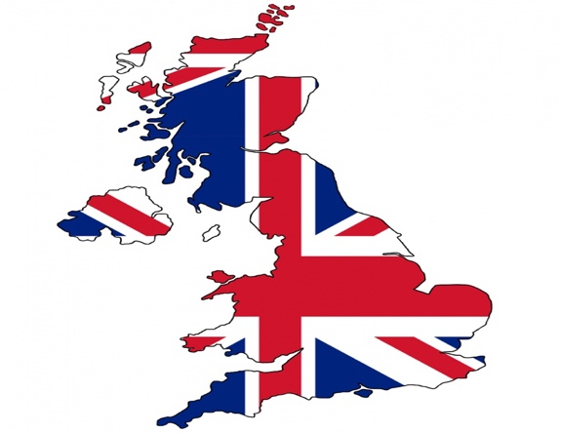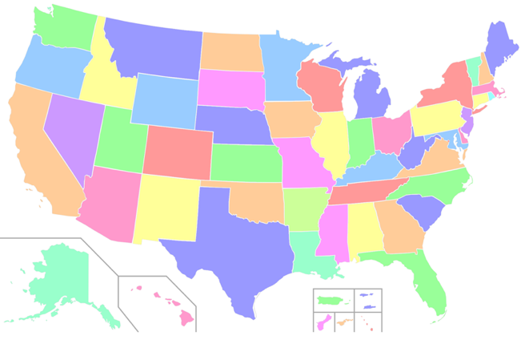
Microenvironment Analysis UK Region
Key Factors | Strategic Considerations
Consumers | Tailor offerings for parents, grandparents, and gift buyers, address diverse preferences and demographics, stay attuned to evolving consumer demands
Competitors | Analyse competition levels in both physical and online markets, differentiate from traditional toy retailers, Strategize against e-commerce giants
Suppliers | Establish reliable connections with toy distributors and manufacturers, Ensure competitive pricing and quality control, Curate a diverse range of appealing products
Intermediaries | Cultivate collaborations with wholesalers, distributors, and agents, Enhance customer outreach and distribution channels
Stakeholders | Manage relationships with investors, employees, local communities, and regulatory bodies, Foster a supportive ecosystem and compliance
Internal Resources | Assess financial capabilities, utilize skilled workforce effectively, optimize marketing, sales plans, and operational efficiency, Leverage internal strengths for competitive advantage
Hamleys uses a strategic approach to negotiate the complex toy market landscape and the several important aspects that influence its operations and expansion. Hamleys first acknowledges the diversity of its customer base in the UK, which includes parents, grandparents, and gift purchasers, by adjusting its goods to suit their specific needs, preferences, and demographics. Hamleys will continue to be aware of the changing preferences and needs of its target market thanks to this customer-centered strategy. Hamleys carefully examines the market to determine the degree of competition in the UK, which results in a rigorous assessment of the competitive environment. It challenges established toy sellers like The Entertainer and Smyths in physical stores while also recognising the ubiquitous influence of e-commerce behemoths like Amazon and eBay, who are important rivals in the online toy sector. This thorough analysis helps Hamleys come up with plans for carving out a unique niche among rivals. Regarding suppliers, Hamleys is dedicated to forging strong ties with toy distributors and producers. This means actively interacting with local and international toy suppliers to curate a varied and enticing variety of products in addition to maintaining a stable supply chain, competitive pricing, and strict quality control.
These initiatives highlight Hamleys' dedication to providing a broad selection of toys that cater to various consumer tastes. Hamleys' distribution strategy heavily relies on partnerships and collaborations with middlemen. Hamleys expands its client reach and enables the creation of effective distribution channels by researching and fostering relationships with wholesalers, distributors, and agents. These middlemen aid in bridging the gap between Hamleys and its customers, resulting in a seamless supply of the company's goods.
The management of stakeholder relationships continues to be essential to Hamleys' operations. Stakeholders including investors, employees, local communities, and regulatory organisations are recognised for their importance. By fostering these connections, Hamleys creates a favourable environment that supports its goals and encourages adherence to the law.

Macroenvironment Analysis UK region

Factor | Description
Demographic Factors | Population size, age distribution, families with children
Economic Factors | GDP growth, inflation, unemployment, consumer confidence, disposable income
Socio-Cultural Factors | Cultural trends, educational toy demand, parenting philosophies
Technical Factors | E-commerce adoption, online toy sales, interactive and STEM-focused toys
Environmental Factors | Eco-friendly products, sustainable materials, compliance with environmental laws
Legal Aspects | Intellectual property protection, toy safety regulations, labelling compliance
Political Aspects | Import/export regulations, trade agreements, political stability
Hamleys' strategy decisions are delicately woven with a mosaic of various aspects in the complex tapestry of the UK toy market. Toy choices that change as kids become older are greatly influenced by demographic dynamics, which span the broad fields of population size, age distribution, and familial makeups. Consumer accessibility to toys is influenced by several economic undercurrents, such as the ebb and flow of GDP growth, inflation rates, unemployment rates, consumer confidence, and disposable income levels. The demand for educational toys is defined by the reverberation of socio-cultural harmonies, which reverberates through the world of cultural trends and preferences, tracing the trajectory of toy businesses' acceptability within the UK market. The distinctive cadence of parenting ideologies and techniques further reverberates within. The backdrop of political stability further tempers this composition, shaping the harmonious rhythm of Hamleys' operations within the UK's political landscape. Together, these interwoven factors converge to create a unique and dynamic symphony that guides Hamleys' strategic direction within the multifaceted realm of the UK toy market. Hamleys' strategy considerations are carefully woven into the complex fabric of the UK toy market with a mosaic of several components. Toy choices that change as children become older are mostly influenced by demographic dynamics, which cover a wide range of factors including population size, age distribution, and familial makeups. The availability of toys for consumers is influenced by a variety of economic factors, such as the ebb and flow of the GDP, inflation, unemployment, consumer confidence, and disposable income levels. The desire for educational toys and the trajectory of toy businesses' acceptance within the fabric of the UK market are both defined by the resonance of socio-cultural harmonies, which resonate through the domain of cultural trends and preferences. The distinctive cadence of parenting ideologies and methods is echoed inside and goes on to further

Microenvironment Analysis, US Region:

Factors | UK Toy Market | US Toy Market
Consumers | Demographics, age groups, family preferences | Demographics, parental preferences
Competitors | The Entertainer, Smyths, Amazon, eBay | Toys "R" Us, Walmart, Amazon, Target
Suppliers | Domestic and international sources | Domestic and international sources
Intermediaries | Wholesalers, distributors, agents | Wholesalers, distributors, agents
Stakeholders | Investors, employees, local communities | Investors, employees, local communities
Internal Resources | Financial resources, skilled workforce | Financial resources, experienced staff
 | Marketing and sales strategies | Marketing and sales strategies
 | Operational efficiency | Operational efficiency
Hamleys demonstrates strategic sophistication in handling a wide range of important aspects in the always changing environments of both the UK and US toy marketplaces. Hamleys tailors its strategies to connect with the unique market dynamics by comprehending the different consumer preferences and demographics as well as the competition landscape. Hamleys faces a wide range of competitors in both marketplaces, from traditional retailers to e-commerce behemoths, needing creative differentiating techniques. Hamleys' capacity to provide extraordinary experiences and maintain its market presence is further shaped by the complex web of suppliers, intermediaries, stakeholders, and internal resources. Hamleys maintains a constant focus on quality, sustainability, and customer pleasure even as it adjusts to shifting sociocultural and technological trends. This all-encompassing strategy highlights Hamleys' skill in utilising the nuances of the toy business to inform its choices and actions, securing its position as a leading toy shop on both sides of the Atlantic
Macroenvironment Analysis, US Region:

Demographic Factors | Population size, age distribution, and family composition impact toy preferences and target consumer segments.
Economic Aspects | GDP growth, inflation, unemployment, and disposable income levels determine consumer purchasing power.
Socio-cultural | Cultural trends, demand for interactive toys, and parenting practices shape toy preferences and trends.
Technical Factors | E-commerce growth, technological advancements, and innovation influence retail strategies and consumer behavior.
Environmental | Growing eco-consciousness drives demand for sustainable toys, necessitating adherence to environmental norms.
Legal Considerations | Intellectual property protection, toy safety regulations, and compliance with legal standards are vital.
Political Aspects | Political stability, trade agreements, and governmental policies impact trade, import/export, and operations.

The US toy market is shaped by a complex web of interrelated variables, each of which has an impact on Hamleys' business practises. Population makeup, age groupings, and family structures all affect changing toy choices, hence demographic factors are crucial. Toy affordability is strongly impacted by economic factors such as GDP growth, inflation, unemployment, and consumer confidence. Choices are greatly influenced by socio-cultural trends, which represent consumer demand for interactive or collectible toys. Additionally, parenting techniques and perspectives on learning and play influence shopping choices. Consumer behaviour is changed by the rise in e-commerce and technical breakthroughs like virtual reality. Demand for eco-friendly toys is fueled by environmental awareness, necessitating conformity to US environmental legislation. Legal considerations protect intellectual property and guarantee adherence to strict toy safety standards. Trade agreements are steered by political stability, which also has an impact on company operations. Hamleys develops solutions in this complex environment that connect with US consumers, adhere to legal requirements, and consider shifting socio-cultural trends and market dynamics.

Brief Analysis analysis of both Hamley's micro- and macro-environment in the UK and the US.

Differences | Unique points
Consumers analysis | Focus on parents, grandparents and gift buyer.
Competitive landscape | Rivals like the entertainer, Smith’s competitive online on Amazon and eBay
Supply relations | Reliable supply chain, global supplier in directions
Intermediaries | Collaborations with wholesalers, distribution agents,
Stakeholder Management | Engaging with investors employees, community is regulators
Internal resources | Financial strength, skilled workforce marketing plans,
Macro Environment | Demographic, economic, social, cultural, technological environmental factors,

SIMILARITIES | Unique Points
Consumer focus | Based on Demographics and trends
Competitor Awareness | Understanding rivals, market competitiveness
External Factors | Recognizing impact of external factors on operations

As a well-known toy retailer in the UK, Hamleys deals with a variety of difficulties and opportunities. The division of diverse factors, such as customers, rivals, suppliers, intermediaries, stakeholders, and internal resources, exemplifies the comprehensive strategy that Hamleys must use to compete in a competitive market. The macro-environment study also emphasises the necessity to take into account cultural preferences, economic situations, demographic changes, technological developments, and environmental issues. These variables interact to create the business model for Hamleys.

Directional Development Strategy
The Ansoff Matrix can be used for Hamley's targeted development strategy in the US and UK markets. The Ansoff Matrix offers four strategic growth options based on market penetration, market development, product development and diversification. Let's consider possible strategies in each market.

For the US market:

1. Market Penetration: Hamleys can focus on increasing market share by increasing marketing efforts, expanding distribution channels and capturing a larger portion of the existing toy market. This strategy may include advertising campaigns, loyalty programs, and partnerships with other retailers. 2. Market Development: Hamleys can drive market development by identifying new customer segments or geographies within the United States where it can launch its brand and expand its presence. This may include opening new stores in untapped markets or using online platforms to reach customers in previously untapped territories.

3. Product Development: Hamleys may consider introducing new and innovative toy products or expanding existing product lines to meet the evolving tastes and needs of our US customers. This includes working with toy makers and using our unique design skills to create our own products.

4. Diversification: Hamleys may explore a diversification strategy by expanding into related areas outside the traditional toy market. This could include entering the children's entertainment industry, such as working with movie studios to develop branded merchandise and developing interactive experiences in stores.

For the UK market:

1. Market Penetration: As in the US market, Hamleys can focus on increasing its market share in the UK by running aggressive marketing campaigns, strengthening its customer loyalty program and further expanding its distribution channels across the country. Masu.

2. Market development: Hamley can drive market development in the UK by identifying new regions and demographics that are currently underserved for toy shopping. This could include opening smaller stores in suburban areas or targeting specific age groups or interests that may not be well served by existing competitors.

3. Product Development: Hamleys may continue to innovate and introduce new toy products or add unique features to existing product lines. This strategy includes continuously monitoring market trends, conducting market research and working with toy manufacturers to anticipate customer demand.

4. Diversification: Similar to the US market, Hamleys may consider a diversification strategy in the UK by expanding into complementary areas such as children's clothing and educational products. To do this, the company must use its brand reputation and customer trust to open up new market segments. It is important for Hamleys to carefully evaluate these strategic options based on market research, customer insights, competitive analysis and financial feasibility. The strategy chosen must be aligned with the company's capabilities, resources and long-term goals to ensure successful growth in both the US and UK markets.

PESTLE Analysis of the UK & US Market:

FACTORS | UK MARKET | US MARKET
POLITICAL | Favourable climate due to political stability | Influential trade policies and regulation
ECONOMIC | Consumer spending linked to growth stability | Consumer affordability, tax and interest rates
SOCIO-CULTURAL | Shifting demographics, changing ideas | Altered family structures, diverse demand
TECHNOLOGICAL | E-commerce expansion, tech integrated toys | Digitalization, tech driven retail
ENVIRONMENT | Growing sustainability concerning regulation | Eco-friendly materials, environmental laws
LEGAL | UK toy safety laws, IP protection | US toy safety standards, IP safeguarding
Analysis:
Significant parallels and contrasts between the US and UK markets are revealed by the PESTLE analysis:
Similarities:
- Political: Political stability influences business climates and trade relations, which benefits both markets.
- Economic: Taxes, interest rates, inflation, and economic development and stability all have an impact on consumer spending in both markets.
- Socio-Cultural: Shifts in consumer choices and market dynamics are influenced by shifting demographics and ideals.
- Environmental: As environmental concerns grow, both markets are seeing demands for environmentally responsible practises and adherence to laws.
- Legal: For both markets, strict toy safety regulations and intellectual property protection are essential.

Differences:

- Although technology has an impact on both markets, the UK places more emphasis on e-commerce while the US places more emphasis on toys that integrate technology and online shopping.
- Socio-culturally, the US market places a strong emphasis on variety and digital play in toys, whilst the UK market exhibits a growing preference for environmentally friendly or educational toys.
- Environmental: Environmental regulations and trends vary by market, affecting the manufacture and packaging of toys.

Conclusion:

Based on the PESTLE analysis, the overall assessment is that the factors are generally favourable for the toy industry in both the UK and US markets. The political stability, strong economic growth, changing sociocultural dynamics, technological advancements, environmental awareness, and robust legal frameworks all contribute to a supportive business environment.

In terms of the Hoisted model and cultural differences between the UK and US, there are a few notable distinctions. The UK tends to have a lower power distance, indicating a preference for equality and fairness, while the US has a moderate power distance, maintaining hierarchy but providing opportunities for upward mobility.

Regarding individualism and collectivism, the UK exhibits moderate levels of individualism, balancing individual and social interests, while the US has high individualism, emphasising individual achievement and independence.

In terms of avoiding uncertainty, the UK has low uncertainty avoidance, promoting ambiguity and tolerance for change, whereas the US exhibits moderate uncertainty avoidance, characterised by a tendency to seek structure and rules.

In terms of long-term orientation, the UK is slightly more focused on long-term goals, valuing perseverance and tradition, while the US is slightly less long-term oriented, prioritising immediate results and adaptability.

Lastly, in terms of patience and restraint, the UK is moderately extravagant, valuing leisure and pleasure, while the US also displays a moderately extravagant style but emphasises personal freedom and enjoyment.

Hamley's UK vs US: Contrast in Marketing Strategies

Due to differences in market conditions and consumer behaviour, Hamleys' marketing strategies in the US and the UK are different. These tactics can be contrasted by using the STP framework (Segmentation, Targeting, and Positioning), the 4Ps marketing mix (Product, Price, Place, and Promotion), and the idea of Directional Development. Both marketplaces target families, parents looking for educational toys, and toy collectors when it comes to STP audience segmentation. However, while the UK flagship store serves both locals and visitors, the US shops predominantly target those who live in major cities. Hamleys UK positions itself as the "finest toy store in the world," highlighting its extensive history, in-store experiences, and distinctive products. This strategy aims to stir up feelings of wonder and nostalgia. The luxury toy retailer Hamleys US, on the other hand, prides itself on offering unique and cutting-edge toys to give customers a pleasurable and memorable shopping experience. Both markets place a strong emphasis on high-end, branded toys and limited-edition goods when looking at the 4Ps marketing mix. Both companies have similar pricing policies, selling high-quality goods at competitive prices. The US combines e-commerce with physical stores in strategic cities while the UK relies on its flagship store and online platform, potentially expanding their reach through partnerships. Similar promotion tactics include in-store events, partnerships, and online marketing. Both markets use these strategies to successfully connect with their target audience. Given that Hamleys focuses on horizontal growth, directional development is crucial for them. To do this, new items must be introduced, entertainment businesses must be partnered with, and the in-store experience must be improved. businesses can adjust to shifting consumer tastes and market dynamics thanks to this strategy, which also ensures that businesses stay inventive and competitive. In essence, Hamleys customises its marketing approaches for each country in order to take use of its advantages and adjust to the specific requirements of the US and UK toy industries.

Brief contrast in Marketing Strategies: Hamleys UK vs US
By launching new items, collaborating with entertainment firms, and improving the in-store experience, Hamleys focuses on horizontal development. They modify their tactics in response to shifting consumer preferences and market realities.

Marketing Mix strategy
Product | Upscale toys, limited-edition items | Premium toys, limited editions
Price | Variety of price points, some premiums | Premium goods at reasonable prices
Place | Physical stores, online platform | Physical stores, e-commerce
Promotion | Seasonal campaigns, events, collaborations | In-store events, digital marketing

Conclusion:
Hamleys' marketing approaches in the US and the UK show some parallels as well as differences. While both markets use comparable segmentation criteria, they take slightly different positions, putting more emphasis on premium innovation in the US and history and nostalgia in the UK. The 4Ps marketing mix shows similarities in product diversity and price tactics, but the promotional strategies change to fit the characteristics of each market. Directional development is still a recurring theme, demonstrating Hamleys' dedication to ongoing innovation and adaptation to maintain its competitiveness and meet shifting customer demands. The contrast in approaches shows how well Hamleys can adapt their strategy to the particular traits and requirements of each market.

Porter's Five Forces
Hamleys' application of Porter's Five Forces Analysis to the toy marketplaces in the US and the UK yields valuable insights into the regional competitive dynamics.

- First off, both markets evaluate the threat of new entrants as being mild. This is linked to the UK's current competitive environment, iconic brand recognition of Hamleys, and high entrance barriers. In the same way, the position of Hamleys as a well-known brand, the competitive environment, and potential barriers to entry contribute to the moderate threat in the US.

- Second, both marketplaces show comparable developments when supplier bargaining power is considered. Supplier sway is evaluated as moderate to low, however Hamleys' size and reputation may provide it considerable negotiating strength.

- Buyer bargaining power, the third force, also exhibits similarities. Due to the well-established brand reputation and distinctive product offers of Hamleys, the UK and US markets both show modest buyer bargaining power.

- Regarding the threat of substitutes, the analysis confirms conclusions that were found in both markets. The varied and distinctive toy assortment of Hamleys helps to mitigate the moderate threat of substitutes in the UK, while the novelty of Hamleys' toys also helps to mitigate the moderate substitute threat in the US market.

A high amount of competitiveness may be seen in both the US and UK markets, according to the competitive rivalry force. This enthusiasm is fueled in the UK by well-known rivals like The Entertainer and Smyths. Similar to this, the US has intense competition due to the presence of numerous well-known toy retailers.

Porter's Five Forces | UK Toy Market | US Toy Market
Threat of New Entrants | Moderate due to competition and entry barriers | Like the UK, moderate threat
Bargaining Power of Suppliers | Moderate to low, size and reputation | Like the UK, moderate to low
Bargaining Power of Buyers | Moderate, strong brand mitigates | Like the UK, moderate buyer power
Threat of Substitutes | Moderate, diverse toy range reduces threat | Like the UK, moderate threat
Competitive Rivalry | High due to strong competitors (The Entertainer, Smyths) | Like the UK, high rivalry

Analysis shows that the US and UK markets have a relatively moderate to low threat of new entrants. In the UK, this is largely due to the current competitive environment and Hamleys' iconic brand recognition making it difficult for new players to establish themselves. Additionally, high barriers to entry, such as the need for large capital investments and the need to build strong distribution networks, increase the moderate threat level. Also, in the US market, Hamleys' presence as a well-known brand, combined with a competitive environment and potential barriers to entry, poses a moderate threat to new entrants.
Supplier bargaining power is rated as moderate to low in both markets. Hamleys' size and reputation allow it to exert significant influence and secure favorable terms in negotiations with suppliers. Moderate to low bargaining power for this supplier indicates that the supplier may have limited ability to dictate terms or raise prices significantly.
In terms of buyer bargaining power, Hamleys has moderate bargaining power in both the UK and US markets. This is due to Hamleys' established brand reputation and ability to offer unique and distinctive toy products. Hamleys' strong brand recognition and high customer loyalty give it a strong bargaining position in negotiations with buyers, but it limits its ability to exert significant pressure or obtain significant discounts. I'm here. This analysis presents a moderate threat from substitutes in both the US and UK markets. In the UK, Hamleys' diverse and unique toy offering helps mitigate the threat of substitution as customers are drawn to the brand's exclusive and unrivaled product range. Even in the United States, the novelty and uniqueness of Hamleys toys make customers less likely to choose alternative products. These factors suggest that while some substitution is possible, the overall threat level remains moderate.
Finally, competitiveness in both markets is rated as high. In the UK, increased competition from high-profile rivals such as The Entertainer and Smyths poses significant challenges for Hamleys in terms of market share and differentiation. In the United States, too, there are many well-known toy retailers, and the competitive environment is intensifying. This high level of competitiveness demonstrates the need for continuous innovation, aggressive marketing strategies and strong brand positioning to maintain and grow market share.
In summary, the US and UK markets are characterized by medium to low threat from new entrants, medium to low bargaining power of suppliers, low bargaining power of buyers, and medium threat from substitutes. and has a high level of competitiveness.

SWOT analysis for Hamleys in the UK and US toy markets:
Strengths come from Hamleys' legendary brand reputation as a symbol of excellence and originality that attracts discerning customers looking for outstanding toys. The wide-ranging and diverse product selection appeals to a wide variety of age groups and interests. Hamleys stands out for its selection of rare and sought-after toys, which enthrals both collectors and enthusiasts. Additionally, Hamleys' in-store experience, which combines enchantment and involvement, strengthens client loyalty.
However, several flaws are apparent. Certain client segments may find it difficult to access unique toys from Hamleys because of their high price tags. Although the brand is powerful, compared to online behemoths, its reach may be constrained by its physical retail footprint. The competitive environment makes it difficult for Hamleys to stand out from the crowd, especially in the vibrant US market.
Opportunities abound for Hamleys to maximise its advantages. E-commerce provides a huge space for growth, in keeping with the expanding trend of online buying. A niche can be created by concentrating on educational toys in response to the desire for STEM and learning-oriented items. Collaborations with well-known brands or entertainment organisations may allow for the sale of unique goods, increasing customer foot traffic and brand recognition.
However, the study reveals some threats that demand attention. Both physical and online competition is fierce and necessitates strategic differentiation. The necessity for adaptability is highlighted by the frequently changing tides of customer tastes, which are impacted by trends and international events. In difficult economic times, economic fluctuations, an uncontrolled element, might affect discretionary expenditure on goods like toys.
Strengths | Weaknesses
Strong Brand | Premium Pricing
Extensive Selection | Limited Presence
Exclusive Offerings | Competitive Pressure
In-Store Experience

Opportunities | Threats
E-Commerce Expansion | Intense Competition
Educational Focus | Changing Consumer Preferences
Partnerships | Economic Fluctuations

The SWOT analysis highlights Hamleys' location at the nexus of opportunities and challenges in its conclusion. The brand's historical importance, distinctive products, and experiential appeal lay the groundwork for success. As Hamleys negotiates the complex terrain of both the UK and US toy sectors, minimising weaknesses, seizing opportunities, and coming up with plans to deal with threats will be crucial.

RECOMMENDATION AND CONCLUSION
In conclusion, a thorough awareness of market dynamics, consumer behaviour, and competitive landscapes can be shown in the analysis of Hamleys' operations and strategies within the UK and US toy sectors. Hamleys successfully targets different consumer segments in both markets with their offers through segmentation, targeting, and positioning techniques. The company's premium positioning is aligned with the 4Ps marketing mix and directed development places a strong emphasis on ongoing innovation to maintain relevance.
Hamleys can develop strategies that capitalise on its advantages and counter risks because to Porter's Five Forces analysis, which highlights the competitive forces influencing the company's operational environment. Additionally, the SWOT analysis aids in strategic decision-making by giving a comprehensive picture of Hamleys' internal strengths and weaknesses, external opportunities, and threats.
By considering macro-environmental factors, such as Hofstede's idea of cultural dimensions, which informs marketing tactics and acknowledges cultural nuances, Hamleys' approach is strengthened. This strategy has a lot to offer in terms of cultural adaptability, consumer interaction, and strategic alignment, but there could also be negatives because it is oversimplified and lacks depth. By adjusting to ownership changes and shifting consumer preferences, Hamleys has demonstrated its tenacity and adaptability, according to marketing and business performance criteria. In keeping with the trend of consumers seeking entertainment outside of traditional retail, it deliberately emphasises experiential retail with in-store immersive concepts. Hamleys has been able to sustain its profitable brand reputation thanks to these approaches.
The mix of many frameworks, including STP, 4Ps, Porter's Five Forces, and macro-environment analysis, clearly gives Hamleys a complete arsenal for strategic decision-making when assessing the effectiveness of the strategy. Its strategy is enhanced by taking into account cultural aspects, which increases client receptivity and loyalty. However, monitoring indicators like sales growth, customer retention, and brand awareness in both the UK and US markets would provide empirical evidence of the approach's impact, helping to further prove its efficacy. In conclusion, Hamleys' chosen strategy integrates theoretical frameworks and practical knowledge to help it traverse the challenging and cutthroat toy industries of the UK and US. By adopting this strategy and enhancing it over time with empirical study, Hamleys can continue to be a prestigious toy business and successfully adjust to changing consumer expectations.
Furthermore, the use of the selected strategy demonstrates Hamleys' dedication to keeping up with the dynamic business environment. Hamleys is able to provide individualised experiences due to the alignment of its segmentation and targeting techniques and a solid awareness of customer preferences. The mild threat of new entrants resulting from its iconic brand and strong entry barriers supports this customer-centric strategy. Hamleys' negotiating position is greatly improved by the analysis of buyer and supplier bargaining power, which also aids in improving its pricing and procurement methods.
The SWOT analysis underlines Hamleys' advantages in terms of its well-known brand and special products, which are complimented by its emphasis on educational toys and growing online presence. This highlights Hamleys' flexibility and strategic focus on digital innovation, which mirror the evolving retail landscape.
Regarding agreement with the methodology, it is obvious that Hamleys' multidimensional strategy is well adapted to address the complexity of the toy marketplaces in both the UK and the US. Hamleys is able to traverse not just the competitive landscape but also cultural nuances, client preferences, and market trends thanks to the combination of theoretical frameworks and practical insights. The method is flexible, enabling Hamleys to seize chances while reducing risks, and its performance indicators and ongoing significance in the toy market are proof of its constancy in brand positioning.
In conclusion, Hamleys has a solid strategy to succeed in the UK and US toy sectors thanks to the integration of thorough analysis, marketing plans, and cultural understanding. The effectiveness of the method can be strengthened further by a sustained dedication to tracking performance metrics, encouraging innovation, and adjusting strategies in response to shifting market circumstances. By adopting this strategy and always adjusting to the ever-changing business environment, Hamleys is well-positioned to sustain its reputation as an iconic toy retailer.

References:

Hamleys. (n.d.). About us. https://www.hamleys.com/explore-our-world.

Reliance Industries Limited. (2023). Press Releases. https://www.ril.com/TheRelianceStory.aspx

International Marketing" by Terence A. Shimp

Global Marketing Management: Planning and Organization" by Masaaki Kotabe and Kristiaan Helsen

www.linkedin.com. (n.d.). Anil Agarwal on LinkedIn: #hamleys #marketing #strategy | 25 comments. [online] Available at: https://www.linkedin.com/posts/anil-agarwal-1a7b7541_hamleys-marketing-strategy-activity-7095287901550243841-GVC8 .
‌
Global Toy News. (2023). Hamleys Gears Up to Build on ‘Experiential Retail’. [online] Available at: https://globaltoynews.com/2023/01/25/hamleys-gears-up-to-build-on-experiential-retail/
‌
Butler, S. (2014). Hamleys toystore eyes expansion into US market. The Guardian. [online] 28 Nov. Available at: https://www.theguardian.com/business/2014/nov/28/hamleys-toystore-united-states-expansion-stores ‌

MarketLine. Toys and Games Retail in the United Kingdom (UK) – Market Summary, Competitive Analysis and Forecast to 2025.

MarketLine. Toys and Games Retail in the United States of America (USA) – Market Summary, Competitive Analysis and Forecast to 2025.

Kotler, P., Keller, K. L., Brady, M., Goodman, M., & Hansen, T. (2021). Marketing management. Pearson.

Hofstede, G. Culture's consequences: International differences in work-related values.

Sage Porter, M. E. . How competitive forces shape strategy. Harvard Business Review, 57(2), 137-145.

www.instagram.com. (n.d.). Hamleys Toy Shop (@hamleysofficial) • Instagram photos and videos. [online] Available at: https://www.instagram.com/hamleysofficial/?hl=en

Contributor (2018). Hamleys looks to Asia for international growth - Retail in Asia. [online] Retail in Asia - The one-stop source for retail intelligence in Asia. Available at: https://retailinasia.com/in-markets/hamleys-looks-to-asia-for-international-growth/

Statista. (n.d.). Toys & Games - United States | Statista Market Forecast. [online] Available at: https://www.statista.com/outlook/cmo/toys-hobby/toys-games/united-states.
‌
Marketing91. (2017). Top 10 Toy companies in the world in 2017 - Best Toy companies. [online] Available at: https://www.marketing91.com/top-toy-companies-in-world/.

‌Keegan, W.J. and Schlegelmilch, B.B. (2001). Global marketing management : a European perspective. Harlow (England): Financial Times/Prentice Hall.
Hamleys ‘Hamleys. More than a toy shop’ by VCCP. (2022). Campaign. [online] 14 Dec. Available at: https://www.campaignlive.co.uk/article/hamleys-hamleys-toy-shop-vccp/1808046

