Student name: Agnieszka Janina Wilkosz

Student ID number: 2115098

Programme: BA (Hons) Management and Leadership – Skills for the Workplace

Module: Leading and implementing workplace change

Module code: BMSW6103

Lecturer: Prof Dennis Pepple

Assignment Title: Change management portfolio.

Table of Contents
Introduction 3
Culture's Influence on Communication, Negotiation, and Feedback. 4
Communication 8
Negotiations 10
Feedback 12
Ethnocentric and Polycentric Models in People Management. 15
Validating the Lewis Model through an Interview 21
Conclusion and recommendations 25
Recommendations 25
References 26
Appendix 30
Appendix 1- Interview 30

Introduction

Many differences between domestic and international work are due to social and cultural issues arising from the different traditions, culture and religions of the peoples and nations in which the work is located (Moore, 2010).
As the global economy develops, more domestic enterprises establish contacts with companies in other countries. A certain degree of approach uniformity is expected because companies have the same goals. Although certain concepts may be familiar, they are perceived differently in different cultures and countries, leading to misunderstandings regarding operational management and communication (Lewis, 2021).

The following report will focus on Energy Power, which was recently acquired by Universal Elect Plc in the UK by the United Arab Emirates. Various UK and UAE departments will work together to ensure a smooth takeover in the UK.

The report will present change management in various cultures. In this context, the Lewis model will critically present how culture can influence communication, negotiation, and feedback practices between the UK and the UAE. In the next paragraph, ethnocentric and polycentric models will be presented, focusing on their application in various areas of people management. To verify the theories discussed, an interview will be conducted with a classmate from a different culture, and then the conclusions will be presented.

Culture's Influence on Communication, Negotiation, and Feedback.

Culture, whether social or organizational, is a ubiquitous phenomenon. People usually act unconsciously based on cultural values and practices (Moradkhan, 2012). There are many layers of culture, which can be established at national, regional, gender, generation, social class, and organizational levels. Diverse institutions characterise countries, including government bodies, regulatory frameworks, legal systems, associations, businesses, religious communities, educational systems, and family structures. Cultural differences are visible within this institutional framework, and these differences are evident in the language, religion, and environmental factors of the United Kingdom (UK) and the United Arab Emirates (UAE). (Moore, 2010).
There are countless definitions of "culture" (Fadol, 2013).

One of them is:

"A culture is the total socially acquired life-way or life-style of a group of people. It consists of the patterned, repetitive ways of thinking, feeling, and acting that are characteristic of the members of a particular society or segment- of a society" (Birukou, 2013, p5).

Another one is saying,

"Culture describes the whole of an individual's learned behaviours, thoughts and perceptions that have been transmitted throughout generations from institutions, organizations, or group membership" (Rasmussen, 2014, p18).

Despite differences in the definitions of the word culture, they all have a common denominator: a set of values, norms, traditions, customs, and beliefs that a specific group share.
Culture, whether social or organizational, is a ubiquitous phenomenon. Usually, people act unconsciously, by their cultural values and practices (Moradkhan, 2012)

In the global economy, with such an increase in the role of information technology in global communication, more domestic enterprises establish contact with companies in other countries. A somewhat uniform approach is then expected because the companies have a common goal. However, while certain concepts may be familiar, employees perceive them very differently depending on the culture in which they live and work. It can lead to misunderstandings regarding operational management and communication (Lewis, 2021). Many differences between domestic and international work are due to social and cultural issues resulting from the different traditions of the peoples and nations in which the work is located. Culture, and more importantly, cultural differences can potentially impact work (Moore, 2010).

The impact of culture on communication, negotiations and feedback was considered using the Lewis model, which proposes the division of cultural categories into linear active, multi active and reactive as show image 1 below (Lewis, 2019).

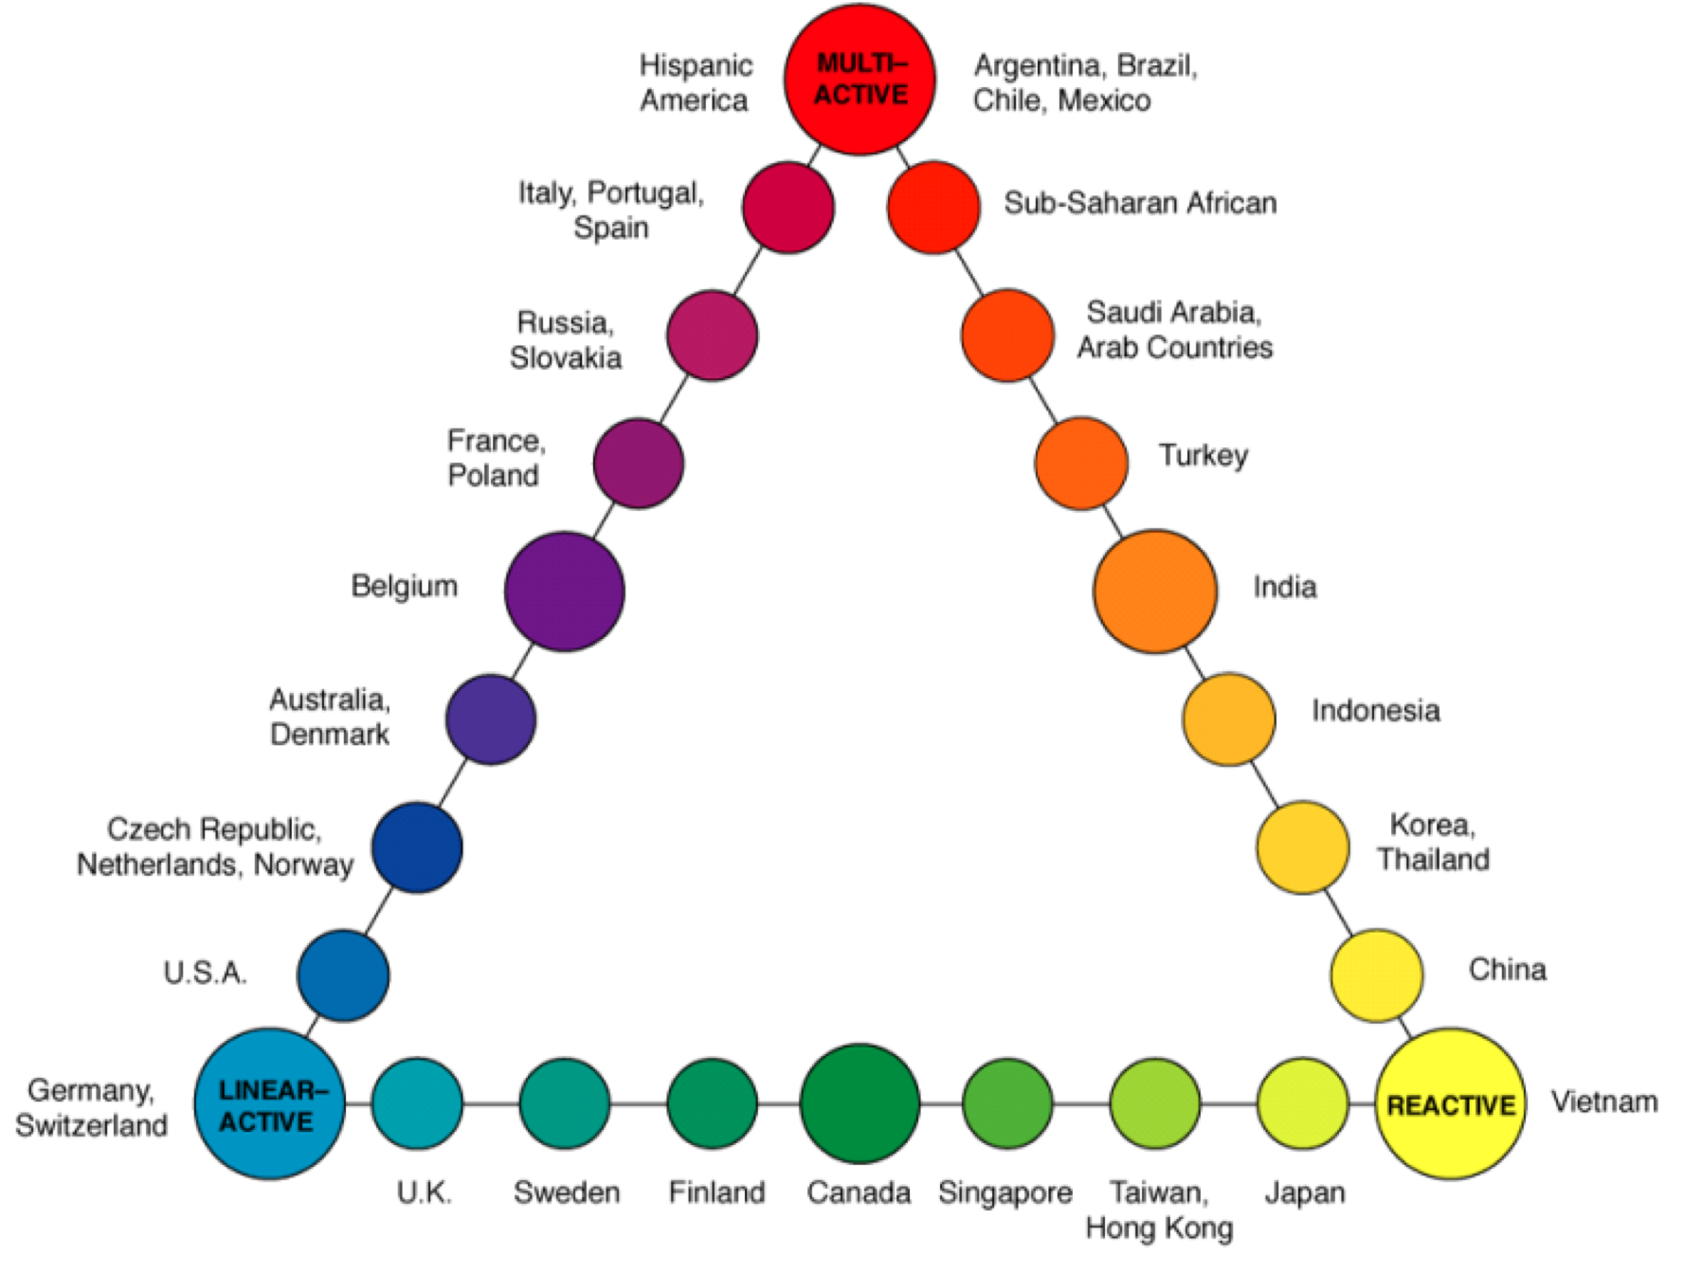
Image 1 Cultural Types: The Lewis Model. (Source: Bačík, 2018)

Richard D. Lewis shows in his model how different cultures are programmed to perceive the world differently and adopt different behaviors. It focuses on values and communication and their impact on behavior, especially in professional life (Marufuji, 2019).

The culture of the UAE is a combination of original Arabic and Islamic cultures and Western styles. Western influence partly arose due to British colonization of the region, which ended in 1970. The United Arab Emirates has a multinational population, with almost 80% of its citizens abroad coming from different nationalities. A typical organization in the UAE may consist of various people from any country (AlMazrouei, 2014).

In every large organization in the United Arab Emirates, employees have 40 nationalities, so the mixture of cultures causes intercultural misunderstandings, tensions, sometimes conflicts and often inefficiency. These problems result from language differences, low levels of interpersonal trust or misunderstanding of values. These problems may also arise during a takeover in the UK (Hills, 2013).
The Lewis model itself should be approached critically because, as the information above shows, countries do not consist of one nation. Culture is not limited by national borders. Cultural diversity can occur both within one country and between nations. Therefore, countries do not have a pure culture, instead they have a mixture of different cultures and people who are usually hybrids. A hybrid consists of two different elements or is mixed. Therefore, a hybrid can be viewed as a person who simultaneously belongs to different cultural groups. Therefore, hybridization of management styles or practices must be taken into account (Hienz, 2018).

Some national cultures are reluctant to learn about others, especially the world's largest economies: the United States, Japan, Germany, United Kingdom, and France. These countries have shown insensitivity in their approach to intercultural issues. UK assumed it could indefinitely continue the path of an Empire in which the English language is used, with one policy, one supreme authority, one educational system, one code of ethics and one way of doing business (Lewis, 2018).

Westerners and Arabs have very different views on what is good and evil, logical, and illogical, acceptable, and unacceptable. They live in two different worlds, each organized in its way.
The West separates church from state. Most Islamic countries do not do this; religion strongly influences social behaviour, politics, and business. Most Western countries have managed to ensure equality between men and women. Arabs believe both genders have very different personalities and roles (Lewis, 2018).

Cultural differences may play a role in working together as the expectations of Arab and British employees may differ (Rees-Caldwell, 2013). In England, it is described as linear-active, while the United Arab Emirates is considered more multi-active (Lewis, 2018). For example, monochronic cultures such as the UK encourage a time-structured approach to life based on preparation and planning. In contrast, polychronic cultures, such as the Arab world, encourage simultaneous work and spontaneity (Rees-Caldwell, 2013). The set of differences between monochronic, and polychronic cultures is presented in Image 2.

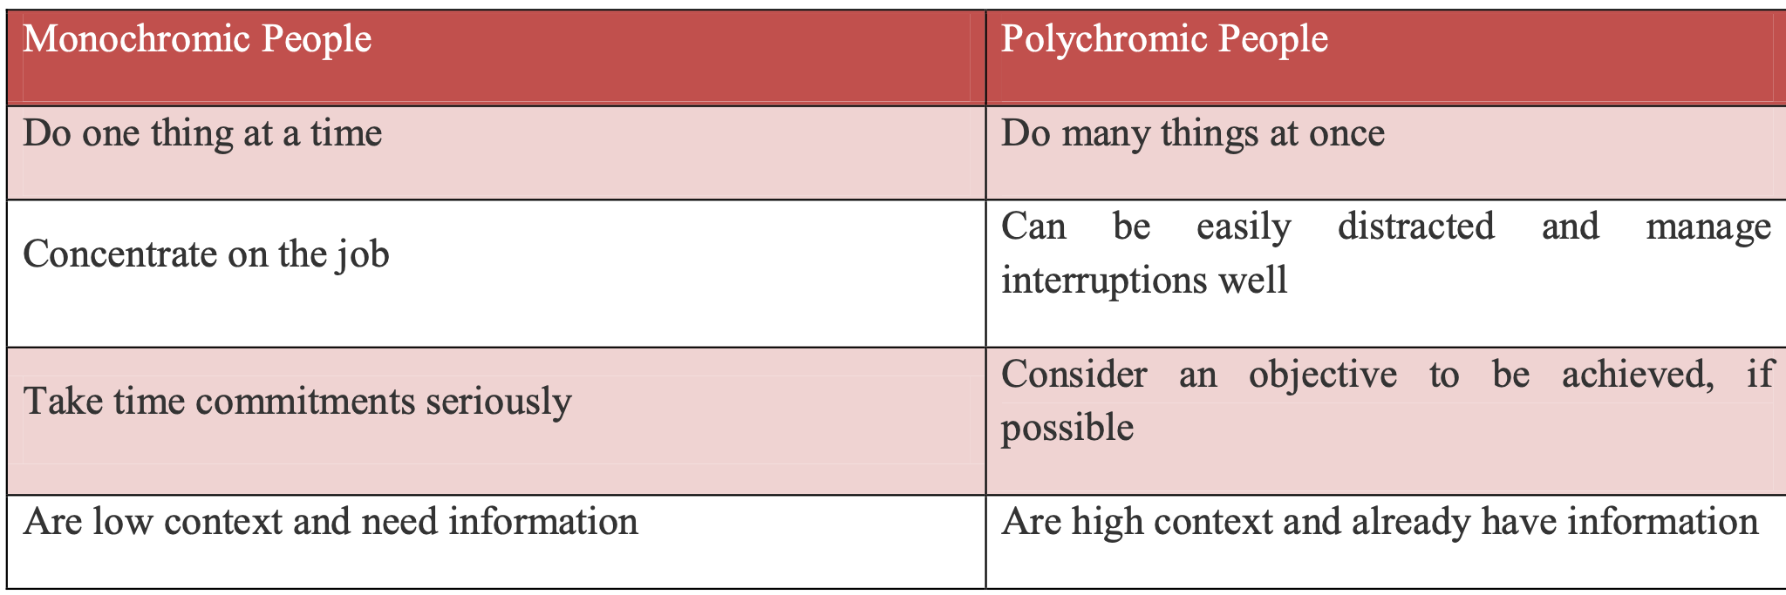
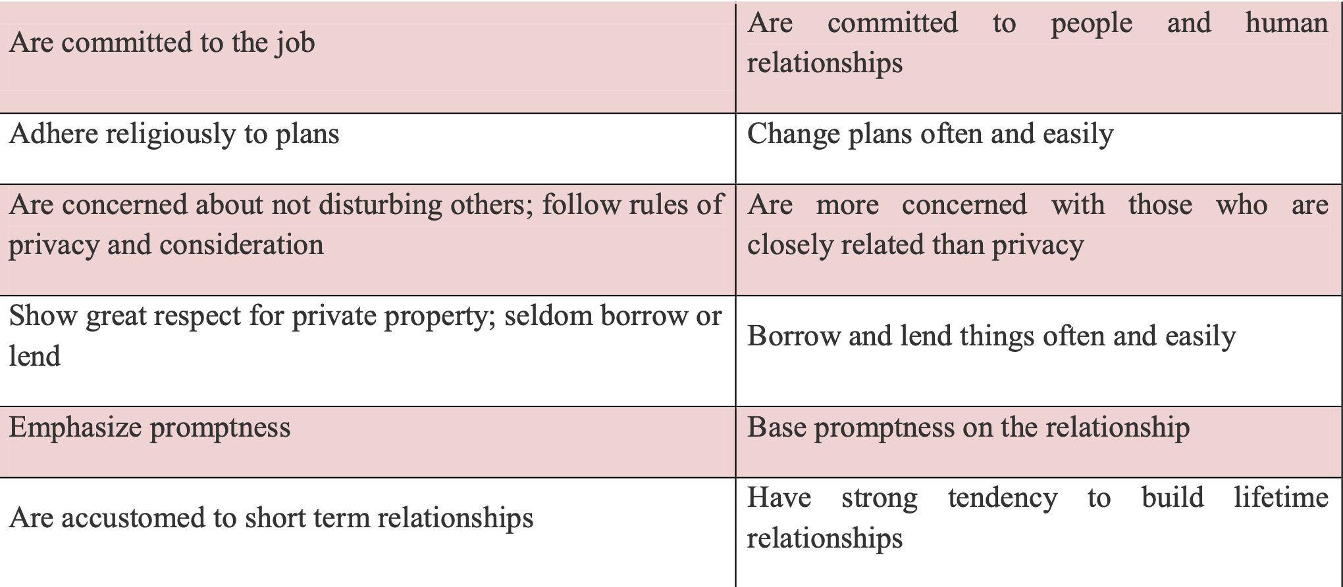
Image 2 Differences between monochronic, and polychronic cultures.
(Source: Muhammad, 2011).

Communication

There is a strong interdependence between culture and communication. Communication and culture influence each other (Henze, 2009).
Communication is a two-way process involving the speaker's communication skills and the interlocutor's listening habits. Just as different cultures do not use speech in the same way, they also do not listen in the same way. What leads to low-level communication is that citizens of each city use language and speech differently (Lewis, 2018).
People with different speaking styles and nationalities using the language inevitably lead to misunderstandings. English people may distrust Arabs because they sound emotional, loud, or prone to exaggeration (Lewis, 2018).
The British and the Arabs come from different worlds, so communication will not occur naturally. The requirements of the Muslim religion further complicate the exchange of views. However, Arabs are used to dealing with foreigners and are happy to forgive them for not behaving like Arabs. It is virtually impossible for multi-active people, especially Arabs, to behave like British people. Communication In the UK, known as linear-active, communication is usually direct, clear, and focused on the task. In turn, the United Arab Emirates, as a multi-active country, values relationships and often uses indirect communication. Cultural differences in communication styles can lead to misunderstandings and misinterpretations during the acquisition process. For example, British counterparts may perceive UAE colleagues as too indirect or vague, while Emiratis may perceive British communication as too direct or transactional. Especially since the English will use their language when communicating - English is the second language of the Arabs. This cultural discrepancy can lead to misunderstandings and misinterpretations during an acquisition. Strategies such as cross-cultural training and clear communication protocols can alleviate these challenges (Lewis, 2018).
The main language spoken in the UK is English, which has become the most popular second language in the world. English as a common language can become a disadvantage due to the inability to truly communicate with other cultures. To reduce language barriers during the transfer, you can consider language courses in the UAE, such as English and Arabic language courses in the UK. In matters of the highest importance, a company may consider hiring translators to ensure everything said is understood. Cultural dimensions such as hierarchy and power distance influence communication between the UK and the UAE. The UK is typically characterized by lower power distance, where hierarchies are flatter, and individuals feel more comfortable expressing their opinions or criticizing a superior. In contrast, the United Arab Emirates is characterized by greater power distance, respect for authority and a more organized hierarchical order. Managers prefer employees to agree with them, even if they are wrong (Rees-Caldwell, 2010).
The image 3 shows the listening habits of Arabs and English people. Reconciliation is also an essential element in effective communication (Henze, 2009).

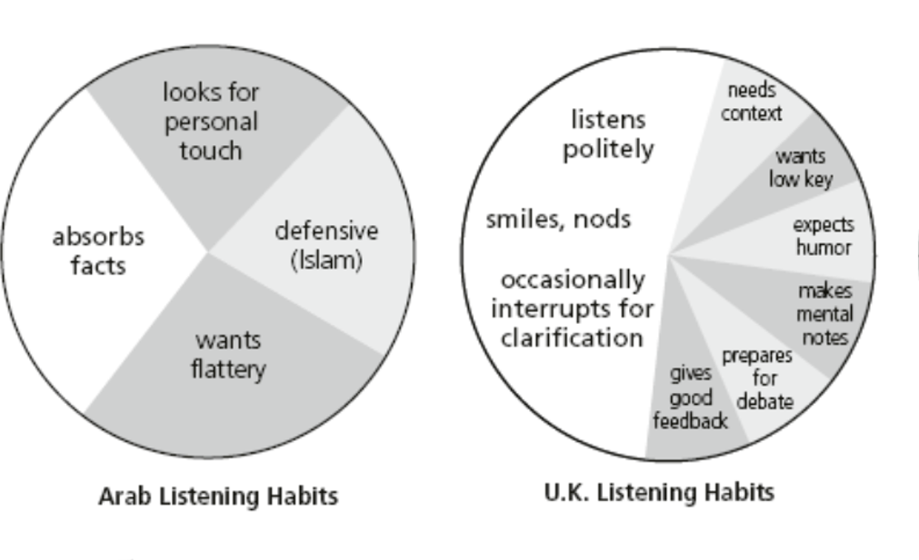
Image 3 Listening Habits (Source: Lewis, 2018).

Negotiations

Research shows that frustration can arise between people from monochronic and polychronic cultures, especially during negotiations (Rees-Caldwell, 2013). When communicating or negotiating, the English rely on understatements and reservations. At first, they award points to their opponent to lighten the mood, but their tone shows they are right. They know how to be vague to maintain politeness or avoid confrontation and are adept at hesitating when they want to put things off. In British English, people often strive for elegantly polite conversation to show respect for their interlocutor (Lewis, 2018). The emphasis on punctuality may frustrate Arab workers, and conversely, a British worker may frustrate a more relaxed approach to time management. British managers willingly listen to the opinions of their employees, even if they have different opinions. Arab managers prefer employees to agree with them.

British managers spend much time on strategic planning, a practice less popular among their Arab counterparts due to cultural reasons. Arab management strategies typically prioritize short-term plans, often lasting a week or less, allowing for flexibility in unforeseen circumstances. Despite the perception of limited planning in Arab culture, delegating planning tasks to experts is preferred. In Arab societies, interpersonal connections and verbal commitments are of paramount importance. On the other hand, British managers emphasize detailed contractual arrangements to ensure transparency and accountability (Rees-Caldwell, 2013). It is worth noting that British women stand out in international forums thanks to their composed demeanour and eloquent communication skills, often outshining their male counterparts. However, their dominance in an English-dominant environment may inadvertently promote linguistic superiority. Therefore, there may be conflicts between Arabs and English, but considering that English is the first language of British people, they will have an advantage over Arabs (Lewis, 2018).
At business meetings, British people initially behave formally. Then, they become very informal. The British like to present themselves as family-oriented people, so they talk about children, and holidays during and between meetings. Humour is essential in UK business sessions. British managers may use humour (especially irony and sarcasm) to ridicule an opponent or showing opposition or contempt.
During meetings, British managers try to show that they are guided by reason, compromise, and common sense. However, even in the absence of a dispute, the British rarely make a final decision on the first meeting; they do not like rushing, so during negotiations, they may extend the time and number of meetings. The British rarely openly oppose the other side's proposals. Agree if possible British negotiators have a unique blend of charm, ambiguity, humour, understatement, and seemingly practical reasoning, maintaining a pleasant demeanour while subtly emphasizing their position over extended periods. They skillfully conceal their emergency position until disclosure is necessary. British companies' representatives use their respected reputation, size, and financial capabilities to strengthen their negotiating position. In contrast, Western negotiators rely on logical deductions, while Arab counterparts emphasize personalized appeals and sustained persuasion tactics. Arabs typically maintain closer physical proximity during negotiations, often engaging in frequent touching and close breathing, reflecting the importance of interpersonal connections. Negotiations are central to many, if not most, meetings, emphasizing their crucial role in business interactions. When people from different cultures are involved, cultural characteristics will determine or influence each side's approach. It can be said that citizens of different cultures negotiate in entirely different ways (Lewis, 2018).
The negotiation style in the UK is often competitive and task-oriented, while in the UAE it tends towards a more relationship-oriented approach. This may lead to conflicts and longer time to make a decision.

Feedback

The feedback culture in the UK tends to be straightforward and constructive, whereas in the UAE feedback may be more implicit and given in the context of a relationship. as picture 1 shows, the English give good feedback, while the Arabs expect flattery. Just like in communication, also in feedback, Arab managers expect to agree with what they say, they do not want to hear criticism. Listening to feedback from Arabs, especially negative ones, may be negatively perceived. also, constructive feedback means allowing the other side to express their opinion, which may be problematic for Arabs. Culture will influence feedback in the UK and UAE. In the British linear-active culture, feedback is usually immediate, clear, and results-focused. In contrast, the multi-active culture in the UAE values harmony and may prioritize hidden or indirect feedback to protect interpersonal relationships.
These cultural differences can impact how feedback is given and received between teams. For example, British managers may perceive employees from the United Arab Emirates as resistant to feedback or hypersensitive to direct criticism. And workers in the UAE may feel uncomfortable sharing honest feedback with British colleagues for fear of causing misunderstandings.
Creating a culture of feedback regarding the application of both cultures is essential. Due to significant cultural differences, the company should consider providing the possibility of anonymously providing feedback to avoid uncomfortable situations, misunderstandings, or conflicts (Lewis, 2018).

The main differences between Arabs (multi-active) and English (interactive) are presented in the image 4 below, which will perfectly summarize the differences between the two cultures.

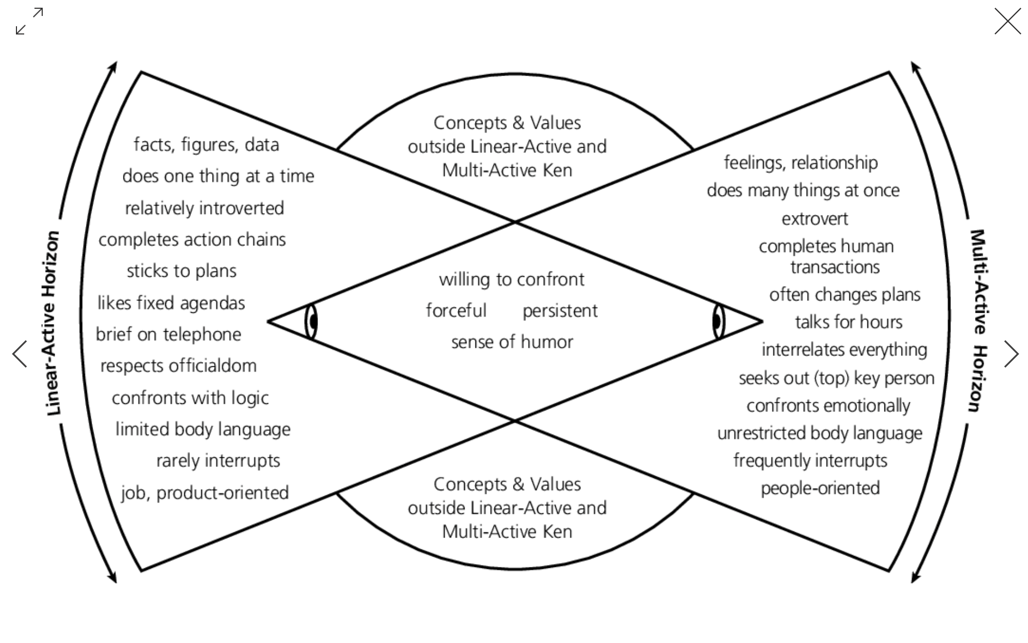
Image 4 The main differences between multi-active and inter-active culture (Source: Lewis, 2018).

Understanding the communication styles of different cultures can helps communicate more effectively. By adapting communication strategies based on the Lewis Model, managers can prevent misunderstandings and build relationships with customers, partners, and employees from different cultural backgrounds. However, it should be remembered that in the case of the United Arab Emirates and United Kingdom, the company will not employ only English or Arabs, so the communication process itself based on the Lewis model may not be effective.

In international business, negotiations involve parties from different cultures. Lewis' model helps managers adapt negotiation strategies based on cultural communication styles, increasing the likelihood of reaching a successful agreement. However, as in the case of communication, Lewis' model does not take into account immigrants who live both in the United Arab Emirates and in England.
The same situation applies to feedback - the Lewis model can help in providing feedback effectively, but you should also remember about the gaps in the model. Otherwise, in negotiation communication or feedback, cultural differences can sometimes lead to conflicts.

In international companies, it is worth not only focusing on the Lewis model but also considering Hofstede's Model - Geert Hofstede's Cultural Dimensions Model focuses on six cultural dimensions that provide a comprehensive framework for understanding cultural differences between countries. These dimensions include various aspects such as power distance, individualism, masculinity, uncertainty avoidance, long-term orientation, and indulgence. Geert Hofstede's Cultural Dimensions Model offers a comprehensive framework for understanding cultural differences among various dimensions (Muhammad, 2011). Richard D. Lewis's Model provides insight primarily into communication styles and behaviour in various cultural contexts. The Lewis model is mainly used to understand communication patterns and provides a simplified framework compared to the Hofstede model (Lewis, 2018).

Diversity increases creativity, innovation, and better decision-making in organizations. By bringing together people with different backgrounds, perspectives, and experiences, organizations can tap into a wealth of ideas and insights, leading to innovative solutions and higher-quality decisions. Moreover, diversity stimulates complex thinking among employees, contributing to economic growth and competitiveness. Therefore, effective diversity management is crucial to a company's success in today's business environment (Marufuji, 2019).

Ethnocentric and Polycentric Models in People Management.

Globalisation, technological progress, and business competition have resulted in the need for business organisations to internationalise their business activities. Trade agreements and the opening of economies support international trade. Increased organisational size and geographic dispersion create countless management challenges for executives (Kiuna, 2013).
Company culture is shaped by both internal and external factors. Internally, it is influenced by the organization's employees, management practices, and leadership style. Externally, factors such as competition, the legal framework and the broader socioeconomic environment also play a significant role in defining the culture of an organization (Bačík, 2018). Doing business in a culturally distant country is complicated because the company is culturally distant from the potential partner, and the risk of inconsistency between its respective practices, policies, and procedures increases, significantly complicating the coordination process. It can be a severe problem during a takeover. (Montagna, 2023). International business cooperates with people and organisations of different nationalities. As in the case of the United Emirates takeover in England, workers must cooperate with different nationalities. An essential aspect of international business involves people from different countries with different cultures, experiences, and expectations. This diversity and expectations challenge international business management (Kiuna, 2013).
The EPG model, developed by Perlmutter in 1969, is an international business framework enabling the study of three different cultural orientations: ethnocentric, polycentric, and geocentric. Companies use the EPG model to create a strategic profile of organisational centricity (Morcos, 2018).

In international business, approaches to human resources management in international companies often focus on ethnocentric and polycentric models. These models represent contrasting philosophies regarding standardising or adapting HR practices in different national contexts. In the context of Energy Power's acquisition of Universal Elect Plc between the UK and the UAE, understanding these models is key to successfully integrating and managing staff from different cultural backgrounds.

Corporations' management style encompasses their approach to conducting business, exercising authority, and leading their employees to achieve domestic and global goals. In the context of international operations, companies often adopt a variety of management styles tailored to optimize their profits and health in foreign markets. Sometimes, national considerations influence the choice of management style, and in other cases, companies stick to their strategies, implementing them universally across all subsidiaries.
The coherence of organizational culture and marketing strategy is most important for effective market functioning. Ensuring alignment between these elements enables organizations to successfully, sustainably navigate markets, and grow (Sherry, 2021).
Choosing an internationalisation strategy is essential because it provides each employee with the information needed to interact with other cultures and shows what the employee can do and how he should do it by the strategy. For multinational companies, international assignments are an integral part of their strategy. If an organisation lacks a clear strategy or is unknown, employees lack orientation in intercultural situations, which causes participants to create their ideas about how they should behave (Henze, 2009). Each company will be characterised by a certain degree of ethnocentrism and polycentrism, but one will be perceived as dominant (Mosbah, 2019).

According to the ethnocentric orientation, fundamental decisions are made at the headquarters, and foreign subsidiaries have little autonomy (Isidor, 2011). The ethnocentric perspective signals distance and familiarity and is characterised by low trust (Michailova, 2001).1) The ethnocentric attitude is characterised by the fact that the leading managers in the headquarters and the subsidiaries come from the home country. The flow of communication and information consists of orders and commands from the headquarters to the subsidiaries, and the power and decision-making process dominates at the headquarters. The organisation is complex in the headquarters but simple in the subsidiaries (Mosbah, 2019). The relationship between headquarters and subsidiaries in ethnocentric companies can be characterised as hierarchical. The role of subsidiaries is to implement the strategy formulated by the headquarters (Carlsson-Wall, 2017).

In a polycentric orientation, the headquarters views foreign subsidiaries as separate domestic entities, granting them considerable autonomy (Isidor, 2011). This approach starkly contrasts ethnocentrism, which recognizes and accepts diversity between countries while trusting local individuals to navigate and address country-specific dynamics. In a polycentric company, there is limited communication between headquarters and subsidiaries, reflecting their independence. Therefore, decision-making powers at the headquarters are minimal (Mosbah, 2019). The primary role of the headquarters in this model is to support a sense of organizational cohesion and belonging (Carlsson-Wall, 2017). The image 5 below summarises the differences between the polycentric and ethnocentric models.

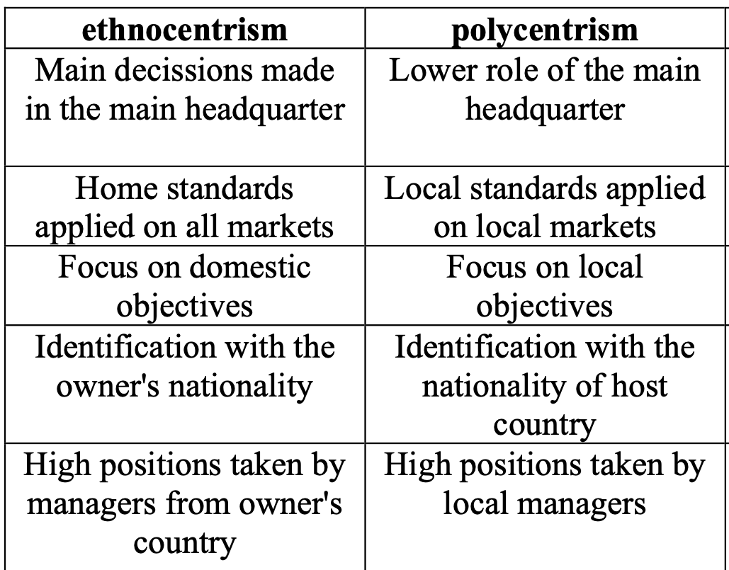

Image 5 Summarises the differences between the polycentric and ethnocentric models (Source: Drachal, 2014)

Also, the polycentric and ethnocentric models differ greatly in the company structure. In the ethnocentric approach, all managers come from the founding country, and in the adopted countries, only assistants are selected to contact the headquarters, but the main managers come from the acquiring country. However, in the polycentric approach, managers in the acquired country are of local origin (Rao, 2021). The above organization structure diagrams are presented in the image 6 below.

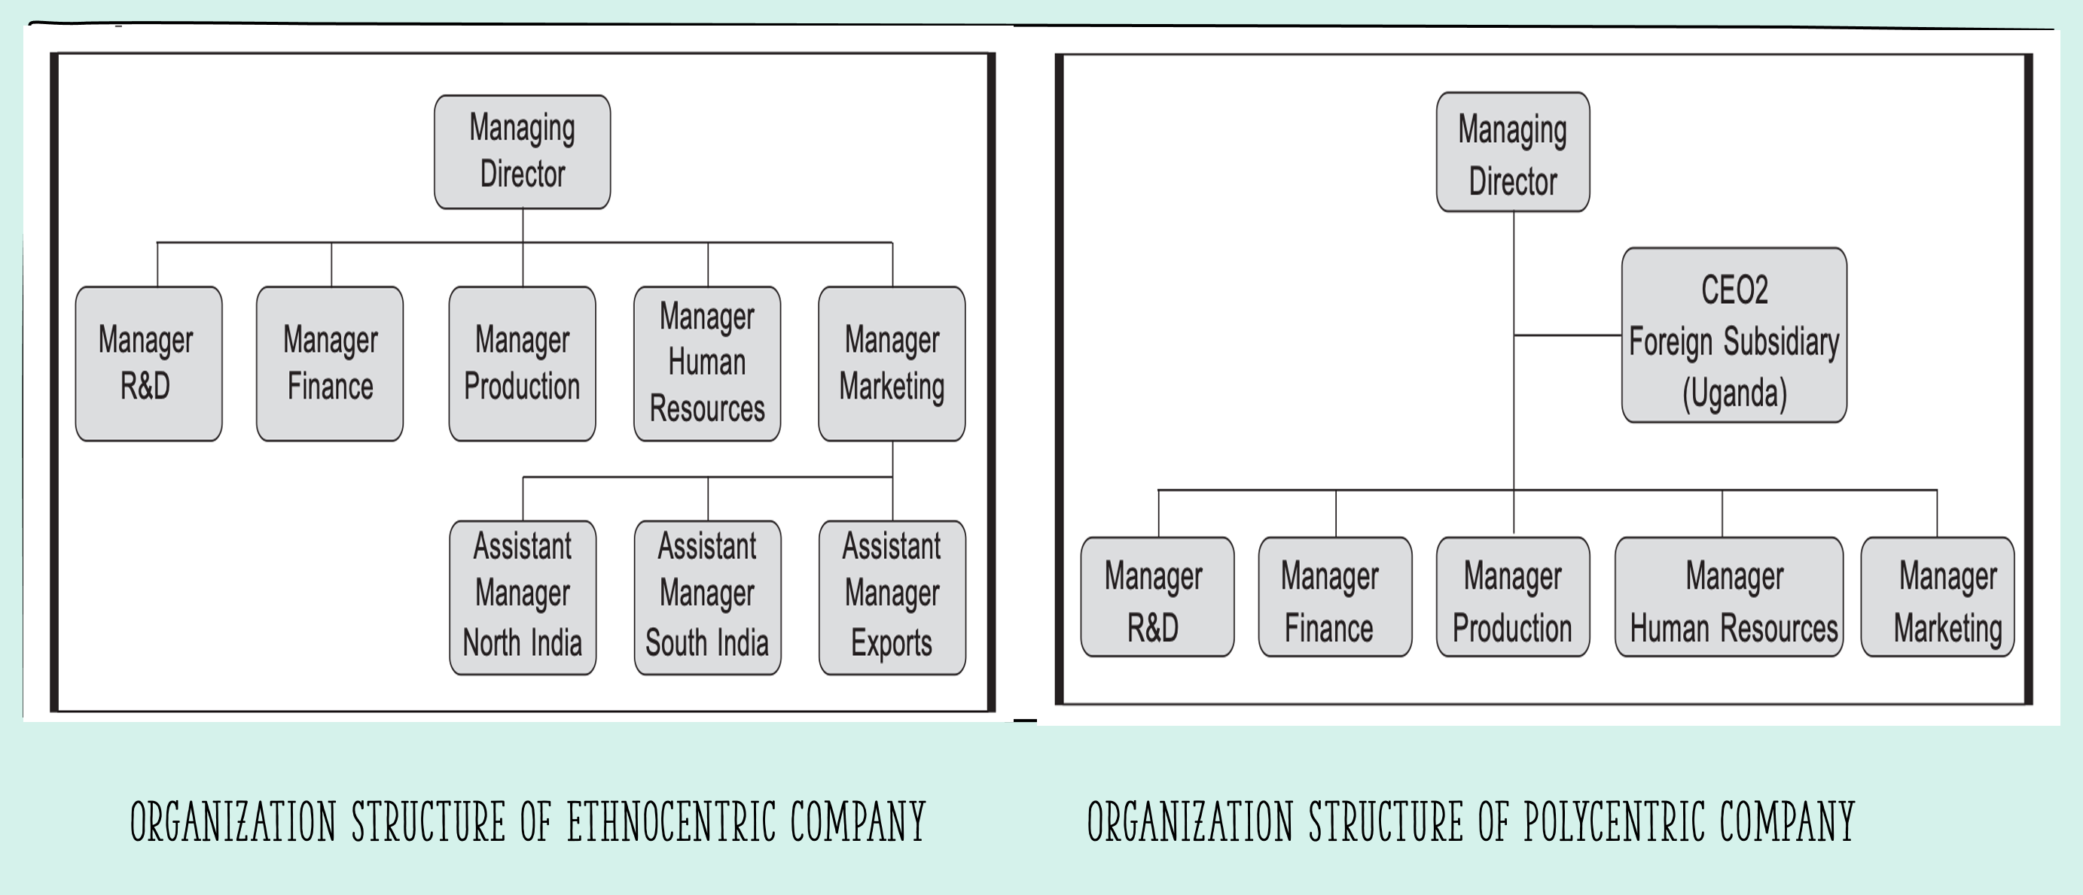
Image 6 Organization structure diagrams (Source: Rao, 2021)

People spend more than half of their lives at work, and their well-being should be the main goal of employers because subjective well-being has been shown to be interrelated with productivity. Satisfied employees are more productive. Therefore, during the acquisition, the United Arab Emirates should consider the countries' significant cultural differences, which were presented in the first chapter of this report (Mosanya, 2022). The ethnocentric and polycentric approaches differ significantly.

Sovereign governments pass and implement laws and formulate and implement policies and regulations. Multinational companies should comply with these laws, rules, and regulations. As the United Arab Emirates takes over a company in England, it will be obliged to comply with the rules and laws in force in that country. Therefore, they cannot implement 100% ethnocentric or polycentric policies.
due to social and cultural factors influencing international business. These factors include a person's attitude towards work, wealth, family, marriage, religion, education, ethics, interpersonal relationships, and social responsibility (Rao, 2021). Most international organizations start with an ethnocentric strategy and evolve into polycentric ones (Henze, 2009).
During an acquisition, a company should centralize decision-making. It means that it should
focus on an ethnocentric approach, i.e. decision-making power belongs primarily to the headquarters, and the branch in England will have little autonomy. It can help ensure consistency and alignment with the parent company's goals and strategies. However, locally, the company should be empowered to make independent decisions regarding human resources, considering local regulations, cultural norms, and market conditions. It promotes flexibility and the ability to respond to local needs. Ethnocentric policies aim to improve coordination, control, and communication among individuals. In the recruitment process, on the one hand, the company should consider the polycentric model, especially when hiring rank-and-file employees and lower-level managers, while when hiring higher-level managers, it should consider the ethnocentric model (Henze, 2009)
Research shows that the excessive employment of local managers in foreign subsidiaries in Japan has led to the isolation of these companies' subsidiaries because these managers spoke little English. Branch managers may focus on local activities and resist following orders from headquarters, especially when the interests of the headquarters and branches are divergent. Therefore, the headquarters must have a certain degree of control and, when recruiting, consider the knowledge and knowledge of local employee policies, laws, and regulations. They must also have representatives from their local area who will have complete control.
The UAE and England will have to decide what language they will use during the takeover. In this case, they will have to consider a polycentric policy in the English seat, where the official language is English. When emigrants from their country of origin dominate the boards of subsidiaries, the pressure on communication increases. Managers working abroad may have poor knowledge of English.
However, strengthening the native language - Arabic - in the English company headquarters is not the best solution, as it may have a negative impact on employees and the communication process. It is best if the company considers sending experts who speak English at a high level but can also communicate with the headquarters in Arabic (Van 2010). However, human resource practices need to be adapted based on the host country's culture because most of the employees will come from that country. Therefore, the UAE cannot impose all its practices and rules in the UK that apply in the UAE (Rao, 2021).
Researchers have found that companies that consistently use an ethnocentric orientation benefit from both a global strategy and local operations. Moreover, ethnocentric companies may experience slow growth due to their inability to adapt their activities to the market's specifics (Morcos, 2018).

Although polycentrism has found significant applications, it may be ineffective in the context of knowledge flow and exchange. In polycentrism, organizations assume that only local managers understand the local market, which makes knowledge exchange difficult. Moreover, the headquarters' lack of strict control allows for excessive freedom, which may escalate disorder and a lack of coordination between departments. Local managers may also be reluctant to follow headquarters' recommendations (Morcos, 2018).

In the ethnocentric model, standardizing HR principles such as recruitment, training, remuneration and performance evaluation are formulated at the headquarters and implemented uniformly in all subsidiaries. When acquiring a business in the UK, a company should focus more on a polycentric model where HR policies and practices are tailored to reflect each subsidiary's operating environment's unique cultural, legal and economic factors. It promotes employee engagement and increases organizational efficiency. Remuneration may be unified both in the headquarters and the host country if the remuneration complies with English law- equal to the required minimum rate (Sherry, 2021).

Orientations have individual advantages and disadvantages related to organizational performance (Morcos, 2018). Both management styles have advantages and disadvantages. The advantages of the ethnocentric orientation are a simple organizational structure, simplicity of information flow and simplicity of internal control. The dominance of national culture can create rigidity and hinder adaptation in subsidiaries, contributing to reduced efficiency. Although a polycentric approach provides subsidiaries with autonomy and flexibility, communication deficiencies can accelerate disorder and limit expansion, and local managers resist headquarters directives (Sherry, 2021).

Validating the Lewis Model through an Interview

"Culture gives people a sense of who they are, of belonging, of how they should behave, and of what they should be doing. Culture impacts behavior, morale, and productivity at work, and includes values and patterns that influence " (Moran, 2010).

Richard D. Lewis's model focuses on values and communication and their impact on behaviour, especially professionally. It is based on three categories: linear-active, multi-active, and reactive (Marufuji, 2019). Lewis also places each culture of the world in individual categories (5 golden rules models of cultural dimensions, n.d.). Overall, Lewis' goal was to create a culture category to prevent misunderstanding and predict the behaviour and reactions of different cultures (Niemi, 2019).
To verify Lewis' model, an interview was conducted with a classmate from the University, and a series of questions were asked.

Characteristics of the person taking part in the interview:
Woman, over 30, born and raised in England. So, according to the Lewis model, it belongs to the linear-active group. The family (father) comes from the Caribbean. The interview focused on the aspects included in Lewis's model presented image 7 below.

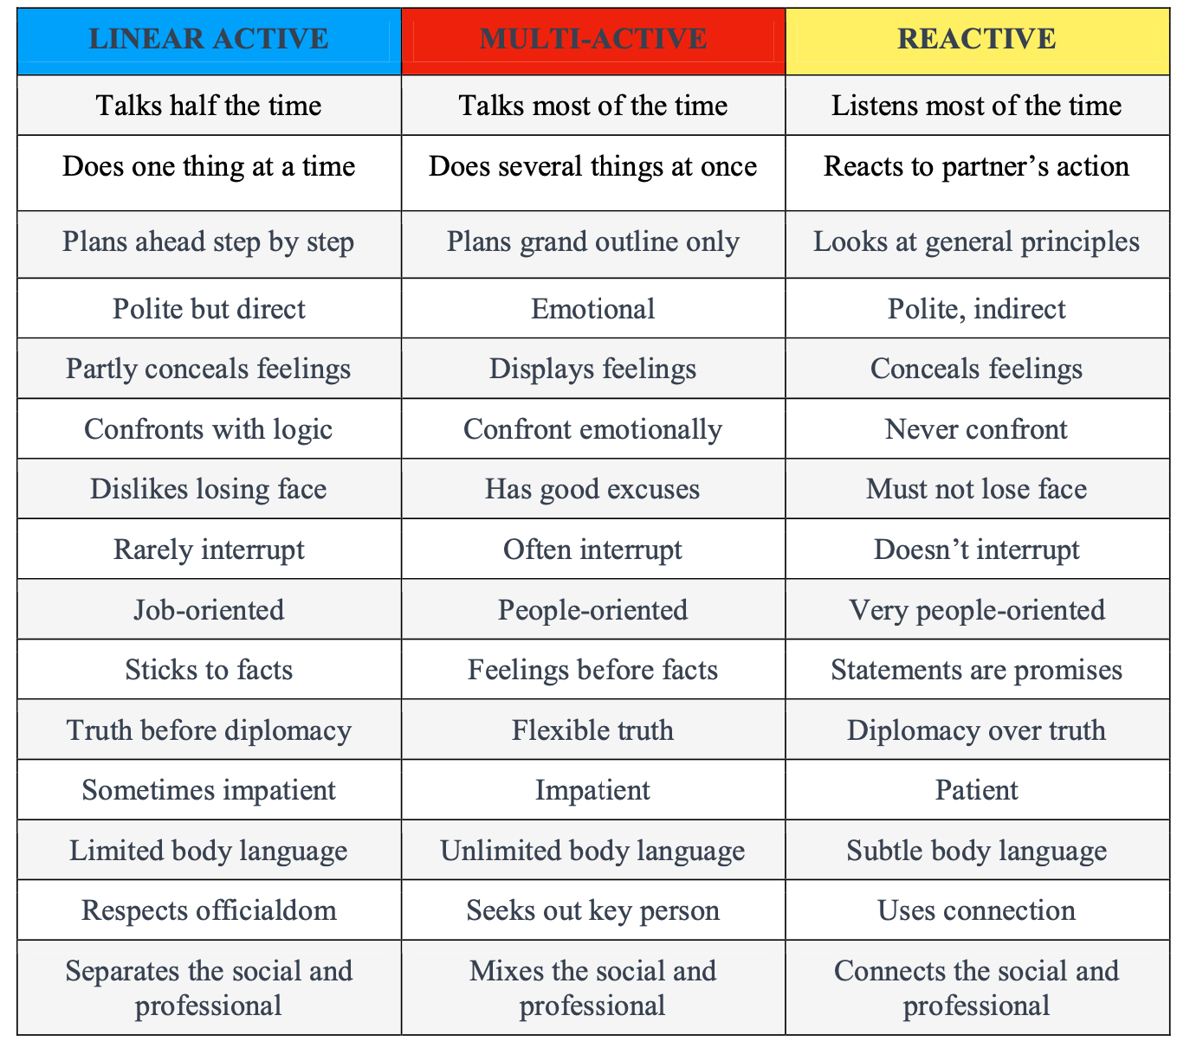
Image 7 Culture Types (Source: Addina, 2024).

People belonging to the linear-active group are task-oriented, stick to a plan and have a linear or, according to Hall, monochronic perception of time. They are punctual, rarely interrupt others in conversations, and are characterized by a lack of open displays of emotions (Niemi, 2019).
The main purpose of this interview was to show whether Lewis's categorization of culture by country fits personality. Do linear active people always have specific characteristics and behaviours, as Lewis defines them?
Following the questions and answers posted in the Appendixes, most answers agree with Lewis's assumptions. For example, they may focus on one task at a time or prefer to be well-organized and have a plan. However, there are those whose answers show incompatibility with the Lewis model. Question number 8:

Regarding emotional expression, do you tend to partially hide your feelings, especially in professional or formal contexts? How does this affect your interpersonal interactions?

Answer: I am very happy to express emotions to an extent. I think it helps with interactions to be open rather than reserved.

It means that the interviewee should belong to a multi-active group. It shows that "Culture is dynamic. Cultures change...but slowly" (Moran, 2010, p. 10). In Lewis’s model, there is a static view of cultures; cultures are not static; they evolve and change over time under various influences. Only 10% of the 191 nations have ethnically or racially homogeneous people. Many people leave their home countries to travel, work abroad, or escape as refugees. In countries that accept immigrants, communities are reconfigured and are strained by vast waves of immigrants (Moran, 2010). As of the year ending June 2021, people born outside the UK represented an estimated 14.5% of the UK population, or 9.6 million people (Vargas-Silva, 2022). It shows that there are many immigrants in England, and this certainly has an impact on the culture. In 2020/21, approximately 696,000 Polish citizens lived in the UK, the largest non-UK population (Statista,2024). According to the Lewis model, the flat belongs to the multi-active group. The person from the interview had contact with people born outside England during studies and work. It could have influenced deviations from the Lewsia Model. National borders do not limit culture. Cultural diversity can occur both within one country and between nations. Therefore, countries do not have pure culture; they have a mixture of different cultures and people (Hienz, 2018). People are complex, and their reactions, behaviours, and communication styles can be influenced by various factors beyond their cultural background. Lewis himself stated that it is difficult to define the culture of a nation accurately due to different cultures, which may cause some exceptions to the generalizations that may arise (AbuZaher, 2015).
Certain concessions must be considered when considering the division of Lewis into three groups. The culture described is always the culture of the mainstream majority and, of course, cannot include all minorities and subcultures present in every cultural space (5 golden rules models of cultural dimensions, n.d.). Taking the example of the UK, a large part of which are immigrants, how people behave will often not match Lewis's model. Because at school, at university, and in a place of work, different cultures will cooperate. The model itself would have a great application if there were people of only one nationality in each place and they did not have much contact with other cultures, which could lead to changes in behaviour.
same question number 7

In your social and professional environment, do you tend to distinguish between your personal and professional life or combine the two worlds to some extent?

Answer: I can combine both worlds.

It shows that the person from the interview belongs to the reactive group this time.

It shows that when interviewing one person out of 10 questions, eight answers coincide with the Lewis Model, and two are entirely inconsistent, so 20%.
Lewis' model was developed in the 1990s and presented in the book "When Cultures Collide" in 1996. It won the American Book of the Month award in 1997. After visiting 135 countries and working in over 20 of them, Lewis concluded that people can be divided into three clear categories, not based on nationality or religion, but on behaviour (Anon, 2015). As seen from the interview, many statements in the model are still valid. However, due to the fact that 28 years have passed since the model was developed years and the development of technology, the Internet and globalization have undergone significant development, which has influenced the change in people's behaviour and their culture. The model does not consider the changes; it only presents rigid behaviours that people should distinguish from different groups. The model also does not consider age, educational or gender differences. Probably the same questions asked to a person of the opposite sex, with a different level of education, the answers could differ significantly. The model does not consider the influence of other cultures on changes in behaviour at a given moment of immigration. The model needs to consider the mixing of cultures, and nowadays, many people come from culturally mixed births. Lewis put a lot of work and efforts into creating the model, but with the passage of time and significant progress that is not reflected in the model will increasingly show its flaws. One should be remembered, "We can test theories, but can never verify them, because there is always the possibility that one day, they will turn out to be false" (Lewis, 1998, p. 258).

Conclusion and recommendations

In summary, conducting the acquisition of Universal Elect Plc by Energy Power in the UK and UAE requires a deep understanding of cultural influences on communication, negotiations, and feedback. Lewis's model provides a valuable framework for understanding the enormous cultural differences between Arabs and English. Additionally, the choice between an ethnocentric or polycentric approach to people management during a takeover should be carefully considered, integrating the strengths of both models. Both models have many advantages and disadvantages, so adapting the model to the conditions prevailing in the company during a takeover is essential. For a company's growth and smooth operation, it is impossible to choose one management model. In the paper's final section, the interview findings highlighted the practical application and validity of Lewis' model in real-life scenarios. The interview showed that the answers overlap 80% with the Lewis model, but 20% differ from what is stated in the model. Even though the model was created 28 years ago, it still works well, but it has many flaws that should be remembered.

Recommendations

During the takeover, it is recommended that comprehensive cross-cultural training be conducted so that UAE and UK employees can understand each other's different cultures better. Taring should focus on increasing cultural awareness, communication skills and conflict resolution techniques.
Clear communication channels should be established so that the headquarters and the host company have the best possible level of communication. However, it is necessary to remember the language barrier, so it is recommended that people in the highest positions be fluent in both English and Arabic, reducing misunderstandings.
In people management strategies, combining ethnocentric and polycentric elements is recommended. However, constant evaluation is recommended to adjust.
Management practices to change cultural dynamics. Often, the company has an extensive ethnocentric practice, but over time, with increasing trust, the company begins to transform the management model into a polycentric one. Therefore, it should be constantly monitored to prevent hindering the company's development.
The company should consider implementing regular feedback. This will allow it to obtain information from employees about their experiences with cross-cultural interactions during the takeover. Using this feedback, the company will be able to identify challenges, solve problems, and improve cross-cultural communication and cooperation. It is important to remember cultural differences and, in Arabic culture, focus on anonymous surveys to make it easier for the employee to express an honest opinion.
By adopting a culturally sensitive and adaptive approach, a company can facilitate a smooth and successful acquisition by leveraging the strengths of both organizational cultures. However, due to the significant cultural differences between countries, the company must be ready for numerous conflicts that can significantly complicate work, so training in conflict resolution at the international level is recommended.

References

- AbuZaher, S.A., 2015. The Impact of National Culture on the Success of construction Projects (Doctoral dissertation, The British University in Dubai (BUiD)).
- Addina, N., Corresponding, H. and Putra Pratama, A. (2024). Exploration of Indonesia’s Character Communication Approach: The Lewis Culture Model. International Journal of Business and Management Invention (IJBMI) ISSN, [online] 13, pp.14–21. doi:https://doi.org/10.35629/8028-13021421.
- AlMazrouei, H. and J. Pech, R. (2014). Expatriates in the UAE: advance training eases cultural adjustments. Journal of Business Strategy, 35(3) , pp.47-54
- Anon. (2015). The Lewis Model – Dimensions of Behaviour - Cross Culture. [online] Available at: https://www.crossculture.com/the-lewis-model-dimensions-of-behaviour/#:~:text=The%20Lewis%20Model%20is%20the [Accessed Date].
- Bačík, R. and Turáková, A. (2018). The analysis of culture differences defined in Lewis’s model and impact on corporate culture. Journal of Global Science, [Online] Available at: http://www.jogsc.com/pdf/2018/2/theanalysis.pdf [Accessed 14 Mar]
- Birukou, A., Blanzieri, E., Giorgini, P. and Giunchiglia, F. (2013). A formal definition of culture. Models for intercultural collaboration and negotiation, pp.1-26.
- Carlsson-Wall, M.A.R.T.I.N. and Strömsten, T. (2017). Robotisation of Accounting in Multi-National Companies: Early Challenges and Links to Strategy. In Andersson, P., Movin, S., Mähring, M., Teigland, R., & Wennberg, K. (Eds.), [Include Title of Book or Conference Proceedings], p. 175.
- Cross Culture. (2015). The Lewis Model – Dimensions of Behaviour. [online] Crossculture.com. Available at: https://www.crossculture.com/the-lewis-model-dimensions-of-behaviour/ [Accessed 16 Mar. 2024].
- Drachal, K. (2014) What do we know from Eprg Model?, Core. Available at: https://core.ac.uk/download/pdf/236086061.pdf [Accessed: 21 March 2024].
- Henze, Y. (2009). Challenges and limitations of intercultural training for inpatriates in German multinationals - A case study. [online] Available at: https://core.ac.uk/download/pdf/40044191.pdf [Accessed 16 Mar. 2024].
- Henze, Y. (2009). CHALLENGES AND LIMITATIONS OF INTERCULTURAL TRAINING FOR INPATRIATES IN GERMAN MULTINATIONALS -A CASE STUDY. [online] Available at: https://core.ac.uk/download/pdf/40044191.pdf [Accessed 16 Mar. 2024]
- Hienz, N., & Engelhart, L. (2018). Management of a Cross Cultural Workforce: Case Study at Luleå Tekniska Universitet. Business Administration, bachelor's level. [online] Available at: https://www.diva-portal.org/smash/get/diva2:1241635/FULLTEXT01.pdf [Accessed Date].
- Hills, R.C. and Atkins, P.W. (2013). Cultural identity and convergence on western attitudes and beliefs in the United Arab Emirates. International Journal of Cross Cultural Management, 13(2), pp.193-213.
- Intercultural awareness and intercultural competence: 5 golden rules models of cultural dimensions. (n.d.). [online] Available at: https://www.cpv.org/documents/10180/361603/MODELS+OF+CULTURAL+DIMENSIONS.pdf/3617c969-8500-49d3-b67c-7e750db895de [Accessed 15 Mar. 2024].
- Isidor, R., Schwens, C. and Kabst, R. (2011). Human resource management and early internationalization: is there a leap-frogging in international staffing?. The International Journal of Human Resource Management, 22(10), pp.2167-2184.
- Kiuna, N.W. (2013). The EPRG (ethnocentric Polycentric Regiocentric Geocentric) model applied to KCB Bank Group as a multinational corporation (Doctoral dissertation, University of Nairobi,).
- Lewis, D., 1998. How useful a concept is organizational culture?. Strategic Change, 7(5), pp.251-26
- Lewis, R.D. (2018). When Cultures Collide: Leading Across Cultures. London; Boston: Nicholas Brealey Publishing.
- Lewis, R.D. (2019). The cultural imperative: Global trends in the 21st century. Training Language and Culture, [online] 3(3), pp. 8–20. doi:https://doi.org/10.29366/2019tlc.3.3.1.
- Lewis, R.D. (2021). Organizational culture-a fallacy? TLC Journal, 5(1).
- Marufuji, H. (2019). An investigation on the role of a gender-free feminine style on multicultural team leadership. [online] Available at: https://pure.manchester.ac.uk/ws/portalfiles/portal/248799854/FULL_TEXT.PDF [Accessed 12 Mar. 2024].
- Michailova, S. and Hollinshead, G. (2001), June. Western management training in the ‘new’Europe beyond ethnocentric coherence and polycentric ambiguity. In Paper submitted to the Second International Conference on Critical Management Studies, University of Manchester, UK
- Montagna, E. (2023). Cross-Cultural Communication in Business: The Impact of Cross-Cultural Communication from A Marketing and Advertising Perspective. International Journal of Business & Management Studies, [online] 04(05), pp.1–15. doi:https://doi.org/10.56734/ijbms.v4n5a1.
- Moore, S. and Elmualim, A. (2010). Culture and its impact on British construction professionals practicing in the United Arab Emirates (Doctoral dissertation, Association of Researchers for Construction Man).
- MORADKHAN, E. (2012). National Culture and Leadership in the United Arab Emirates (UAE) (Doctoral dissertation, The British University in Dubai (BUiD)
- Morcos, P. (2018). Effective Organizational Culture Strategies for a Firm Operating in Foreign Countries. [online] Available at: https://scholarworks.waldenu.edu/cgi/viewcontent.cgi?article=7033&context=dissertations [Accessed 12 Mar. 2024].
- Mosanya, M., 2022. Global mindset as a predictor of life satisfaction of non-Western multicultural individuals: The mediational role of self-efficacy. Edukacja Ekonomistów i Menedżerów, 63(1).
- Mosbah, A., Alharbi, J., Fetais, A. and Alkandi, I. (2019). The role of the manager in the Middle East: An empirical study of multinational companies. Global Business Review, 20(4), pp.887-900.
- Muhammad, H., Shaiq, A., Khalid, S., Akram, A., & Bakhtiar, A. (2011). Why not everybody loves Hofstede? What are the alternative approaches to study of culture? [Online], 3(6). Available at: https://core.ac.uk/download/pdf/234624093.pdf [Accessed 15 Mar. 2024].
- Radovan Bačík and Turáková, A. (2018). The analysis of culture differences defined in Lewis’s model and impact on corporate culture. [online] Journal of Global Science, Online, pp.2453–756. Available at: http://www.jogsc.com/pdf/2018/2/theanalysis.pdf.
- Rao, S., 2021. International Business Environment. Himalaya Publishing Hous
- Rasmussen, H.N. and Lavish, L. (2014). Broad definitions of culture in the field of multicultural psychology. Perspectives on the intersection of multiculturalism and positive psychology, pp.17-30
- Rees-Caldwell, K. and Pinnington, A.H. (2013). National culture differences in project management: Comparing British and Arab project managers' perceptions of different planning areas. International Journal of Project Management, 31(2), pp.212-227.
- Sherry, A. (2021). Management Styles of Multinational Corporations and PepsiCo Orientation in the Lebanese Market. Management Studies and Economic Systems, 6(4-3), pp.101–107. doi:https://doi.org/10.12816/0059998.
- Statista. (2024). Non-British population UK 2021. [online] Available at: https://www.statista.com/statistics/759859/non-british-population-in-united-kingdom-by-nationality/#:~:text=In%202020%2F21%20there%20were.
- Van den Born, F. and Peltokorpi, V., 2010. Language policies and communication in multinational companies: Alignment with strategic orientation and human resource management practices. The Journal of Business Communication (1973), 47(2), pp.97-118.
- Vargas-Silva, C. and Rienzo, C. (2022). Migrants in the UK: An overview. [online] Migration Observatory. Available at: https://migrationobservatory.ox.ac.uk/resources/briefings/migrants-in-the-uk-an-overview/ [Accessed 15 Mar. 2024].
- Yasin Fadol, Y. and Sandhu, M.A. (2013). The role of trust on the performance of strategic alliances in a cross-cultural context: A study of the UAE. Benchmarking: An International Journal, 20(1), pp.106-128

Appendix

Appendix 1- Interview

Considering the Lewis model and cross-culture negotiation types, England belongs to the linear active group. Below, a series of questions and answers will be presented to someone from England to check whether this person's personality matches what Model Lewis presents.

Questions:
1) During a conversation, do you talk all the time, or do you let the other person talk half the time?
Answer: Let the other person talk half the time.
2) In your experience, do you prefer to focus on one task at a time, carefully planning and executing each step, or are you more comfortable multitasking?
Answer: Focusing on one task at a time.
3) When planning a holiday, for example, do you create the entire plan step by step, emphasizing thorough preparation and organization, or do you prefer spontaneity?
Answer: I prefer to be well-organised and have a plan in place.
4) Are you generally polite but direct when expressing your thoughts and opinions?
Answer: Yes, I would say so.
5) How do you usually react in situations requiring quick action or decision? Are you sometimes impatient and prefer a quick solution to long-term considerations?
Answer: Depending on situation, I can be impatient.
6) Can you describe the role of body language in your communication? Do you tend to use limited body language, relying more on verbal expression?
Answer: Rely more on verbal expression.
7) In your social and professional environment, do you tend to distinguish between your personal and professional life or combine the two worlds to some extent?
Answer: I can combine both worlds.
8) Regarding emotional expression, do you tend to partially hide your feelings, especially in professional or formal contexts? How does this affect your interpersonal interactions?
Answer: I am very happy to express emotions to an extent, I think it helps with interactions to be open rather than reserved.
9) When presenting information or making decisions, do you rely primarily on facts and evidence, prioritizing accuracy, and reliability over other considerations?
Answer: Prefer to base decisions on the facts and evidence.
10) Do you rarely interrupt others, allowing each person to speak without interruption, or will you interrupt people during a conversation?
Answer: Allow people to speak.
11) Have you had contact with people born outside the UK? With what nationalities?
Answer: Yes, I had contact with other nationalities at school, at university and at work. These were mainly people from Poland, Romania, India and Nigeria.

