

Material Selection Report & GD&T Drawings

Oliver Moss
2204624

Module Code: ACHA4001
Submission Deadline: Sunday 19th March 2023 (22:00)
Submission Date: Sunday 19th March 2023 (20:30)
Word Count: 2,283
Lecturer: Dr K A Tudor
1. Contents
1. Contents…………………………………………………………………..1
2. Introduction………………………………………………………………3
3. Material Properties……………………………………………………….4
4. Material Selection………………………………………………………..6
4.1. Important Requirements……………………………………………..6
4.2. Material Charts………………………………………………………7
5. Manufacturing Process………………………………………………….10
5.1. What is Manufacturing?……………………………………………10
5.2. Type of Production…………………………………………………10
5.3. Casting……………………………………………………………...11
5.4. Forging……………………………………………………………..12
5.4.1. Cold Forging………………………………………………13
5.4.2. Hot Forging………………………………………………..13
5.4. Best Manufacturing Process………………………………………..14
6. Conclusion…………………………………………………………………..15
7. References…………………………………………………………………..16

Figure 1 - Stress-Strain Graph, (An Introduction to the Mechanics of Elastic and Plastic Deformation of Solids and Structural Materials, 1997)…………………7
Figure 2 - Permanent Deformation (An Introduction to the Mechanics of Elastic and Plastic Deformation of Solids and Structural Materials, 1997)…………….7
Figure 3 - Stress-Strain of Multiple Metals (An Introduction to the Mechanics of Elastic and Plastic Deformation of Solids and Structural Materials, 1997)…….7
Figure 4 - Material Bar Chart (Materials Selection in Mechanical Design, Pg57, 2016)…………………………………………………………………………….8
Figure 5 - Material Chart (Materials Selection in Mechanical Design, Pg58, 2016)…………………………………………………………………………….8
Figure 6 - Technology Manufacturing (Razin Sazzad Molla, 2018)…………..10
Figure 7 - Economy Manufacturing (Razin Sazzad Molla, 2018)……………..10
Figure 8 - Sand Casting (Materials Selection in Mechanical Design, Pg221, 2016)…………………………………………………………………………...11
Figure 9 - Die Casting (Materials Selection in Mechanical Design, Pg221, 2016)…………………………………………………………………………...11
Figure 10 - Investment Casting - (Materials Selection in Mechanical Design, Pg221, 2016)…………………………………………………………………...12
Figure 11 - Casting Defects (Mishra. P, 2020)………………………………...12
Figure 12 - Forging (Materials Selection in Mechanical Design, Pg221, 2016)…………………………………………………………………………...13
Table 1 – (Ferrari, 2023)………………………………………………………...3
Table 2 - Type of Production…………………………………………………..11
Table 3 - Types of Casting……………………………………………………..12
Table 4 - Forging Temperatures (Wikipedia, 2022)…………………………...14

2. Introduction
The piston in an engine is a crucial part to the performance of that engine and this is why deciding on the piston’s features are a crucial so that it is the best fit for its purpose. These features like the material and manufacturing process are what will be outlined in this report, which is based on Ferrari’s F2002, Tipo 051 engine which was used in the 2002 formula one world championship and helped Ferrari win the constructures championship along with both Ferrari drivers, Michael Schumacher and Rubens Barrichello, getting 1st and 2nd in the drivers’ championship respectively and giving Michael Schumacher his 5th world drivers’ championship. Ferrari, 2023 has data for the Tipo 051 engine as shown in table 1.
Engine Configuration | 90° V10
Weight | 95Kg
Bore | 96mm
Stroke | 41.4mm
Displacement | 2996.62cc
Compression Ratio | 12.6 : 1
Max Revolutions | 17,800rpm
Max Power | 614Kw (835hp)
Power per Litre | 279hp/L
Valves per Cylinder | 4
Table 1 – (Ferrari, 2023)
3. Material Properties
An important part of a piston is the properties that the material possesses which makes it the most suitable choice. A material has 3 types of properties which are;
- Mechanical Properties - How a material reacts when a load is applied onto it. Examples:
- Torsion  - Tension | - Bending  - Impact Strength | - Fatigue  - Compression | - Hardness  - Malleability
- Physical Properties - How the material can affect or assist the manufacturing process. Examples:
- Electrical conductivity
E.g., Electro-Discharge Machining (EDM) can only be done on materials that conduct electricity.
- Thermal Conductivity
E.g., Welding requires the material to be able to conduct temperature so that it will melt at high temperatures.
- Chemical Properties - How the material’s properties can cause chemical reactions. Examples:
- Corrosion Resistance | - Reactivity | - Flammability

The Tipo 051 engine is used for motorsport racing so the main aim is for the engine to perform at its best capabilities. This means that the material properties that would be important for its performance would be;
Fatigue: The piston will have to endure the repeated strain caused by the large load being applied to it and not cause any breaks in the material. However, even though the piston experiences a repeating large force, it may not have to last as long as a road car for example as a new engine is produced each season.
Impact Strength: There would have to be a high impact strength of the engine as there is a large torque pushing the piston up the cylinder. The torque for the Tipo 051 engine can be calculated by using data from table 1;
$Power\left(P\right)=\frac{2π×Torque\left(T\right)×Engine Speed\left(N\right)}{60}$ so $T=\frac{60×P}{2π×N}$
$$∴T=\frac{60×(614×{10}^{3})}{2π×17800}=329.4Nm$$
Flammability: It is crucial that no part of the piston can be flammable as the piston is used to create explosions. So, a material with a high melting point, as well as non-flammable, is desired so that the piston doesn’t deform.
Thermal Conductivity: Continuing from the point before, a low thermal conductivity means a higher melting point which is crucial as the cylinder can have temperatures up to 2600°C. Also, if the material has a lower temperature it allows for a greater load on the material which is desirable. However, some may argue that this can affect the manufacturing process of the piston which is further analysed in chapter 5, Manufacturing Process.
Density: This is the mass per unit of volume and for a formula 1 car a low-density material is favourable as it results in a lower mass so a more lightweight piston because $Mass\left(M\right)=Density(ρ)×Volume(V)$. This is beneficial because a formula 1 car aims to be as lightweight as possible because acceleration increases due to the equation $Acceleration\left(a\right)=\frac{Force (F)}{Mass (M)}$.

4. Material Selection
There are over 200,000 different materials in the world so picking the perfect material can be hard but there are certain steps that can be taken to assist the selection process.
4.1. Important Requirements
Firstly, outlining the important requirements the material must possess can help rank materials in each subgroup as Academic Gain Tutorials, 2019, shown.
Performance Requirements: This refers to how well a material performs due to certain external factors which are common to occur. For a piston, it will be under a lot of force and shouldn’t break or fracture and fail.
Material Reliability: This helps to understand how reliable a material is by looking at the probability of it remaining functional and not failing. This is important but not crucial as a Formula 1 piston only needs to last a short time but with high loads applied onto it.
Physical Attributes: This looks at the physical factors and how it benefits or hinders the material’s performance. Size and density are important for a formula 1 piston as less size or a smaller density results in less weight so a lighter car. Also, a smaller size will need less space so the car could be more aerodynamic.
Environmental Conditions: How the material performs in the environment that it operates in. A formula 1 piston operates amongst high temperatures and fuel with many chemicals in, so the piston must not react with the fuel and cause a chemical reaction like corroding.
Expenditure: This outlines, how much it would cost to acquire and use the material. It is important to note that, even though spending less money is preferred, it may not be important as Formula 1 teams have a larger budget and are willing to spend high amounts for the best performances.
4.2. Materials Charts
The Young’s Modulus of a material is a value given to it based upon how much a material’s dimensions change when a force is applied to it and a graph can be made of stress against strain as figure 1 shows. This is a constant value up to a material’s elastic limit where Hooke’s Law is no longer applied.
$Stress/σ=\frac{Force Applied/F}{Area/A}$ $Strain/ε=\frac{Change in Length/∆L}{Original Length/L}$
$$Young^{'}s Modulus/E=\frac{σ}{ε}=\frac{FL}{A∆L}$$
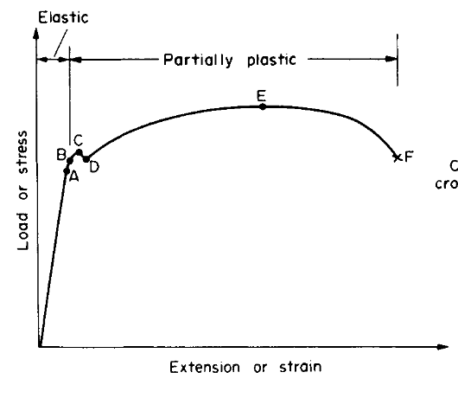
- Limit of Proportionality
- Elastic Limit
- Upper Yield Stress point
- Lower Yield Stress point
- Ultimate Stress Point
- Breaking Point

Figure 1 - Stress-Strain Graph (An Introduction to the Mechanics of Elastic and Plastic Deformation of Solids and Structural Materials, 1997)

Figure 2 shows that once a material passes its elastic limit it is permanently deformed and will not go back to its original shape. This is because when there is no force applied (stress) there is still a change in length. This means that the area shaded is the work done/energy lost due to the material going past its elastic limit.
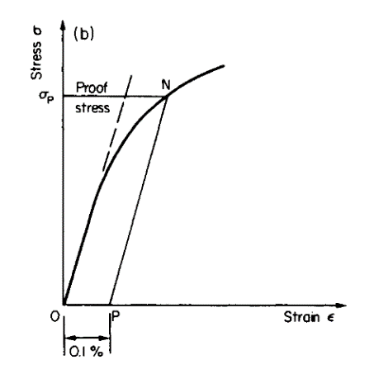
Figure 2 - Permanent Deformation (An Introduction to the Mechanics of Elastic and Plastic Deformation of Solids and Structural Materials, 1997)
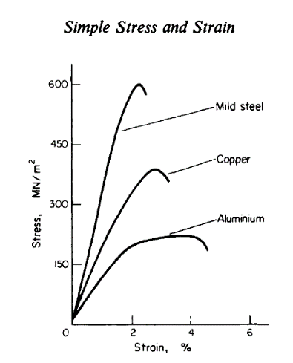
Figure 3 - Stress-Strain of Multiple Metals (An Introduction to the Mechanics of Elastic and Plastic Deformation of Solids and Structural Materials, 1997)

Another useful tool to help select the right material is by using a material bar chart (Figure 4) or a material chart (Figure 5) to better understand what types of materials suit certain requirements. (Ashby. 2017. Materials selection in mechanical design. (Fifth edition). Butterworth-Heinemann.)

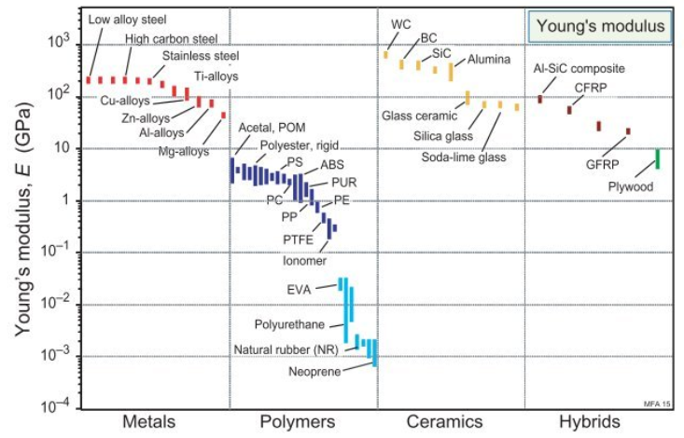
Example of a minimum Young’s Modulus value
Figure 4 - Material Bar Chart (Materials Selection in Mechanical Design, Pg57, 2016)
Figure 4 shows a material bar chart where all different types of materials are plotted depending on the material’s Young’s Modulus which is a measure of a material’s change in dimensions when a force is applied to it. This bar chart is useful as for a formula 1 piston a high young’s modulus value is desired as it means a large amount of force is needed to extend or compress the material. Therefore, a line can be drawn horizontally across the graph where the minimum young’s modulus value is, as figure 3 shows, and any material below that value can be excluded like polymers as they are too elastic.
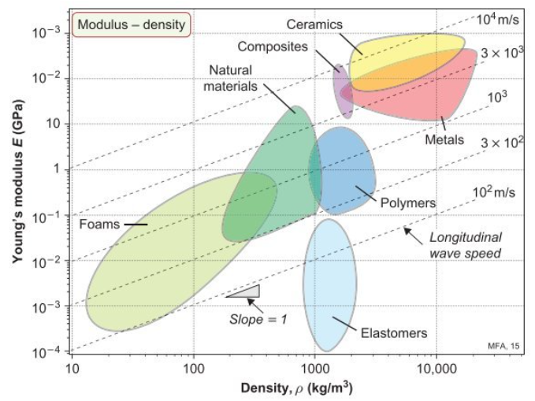
Example of a minimum Young’s Modulus value
Figure 5 - Material Chart (Materials Selection in Mechanical Design, Pg58, 2016)

Material charts are helpful as it allows materials to be analysed off 2 important properties which figure 5 shows. This is because materials can be plotted depending on Density, ρ and the Young’s Modulus value, E. A perfect Formula 1 piston would have a high Young’s Modulus value and a low density however the graph shows a positive linear relationship so it may be hard to find the perfect point. A line can be drawn again at the minimum Young’s Modulus value and then materials can be selected depending on their density. For this example, there is a natural material that has a low density and a suitable Young’s Modulus value however some may argue the value is too close to the minimum and a metal be more applicable as, even though the material is denser, it has a higher Young’s Modulus value.
Overall, the best material for a Formula 1 engine like the Tipo 051 would be a metal. This is because there is a point on figure 4 where the metal has a similar density and Young’s Modulus as a composite but metal is a lot stronger than a composite material as they are very brittle. Similarly, a metal is better than a ceramic material as, even though it has a larger Young’s Modulus, it is also very brittle.
5. Manufacturing Process
5.1. What is Manufacturing?
Manufacturing is the process of using raw materials and converting them into a product. There is both a technological and economical side to manufacturing where technological is the changing of raw materials to a product to suit a need or want in society whereas the economical side to manufacturing is based upon “adding value” to a material by transforming it into a product that satisfies customers. However, for a motorsport team like Ferrari F1, added value is not of importance as these parts, like pistons, are not being manufactured in bulk to be sold to customers and profit off.
Technology Manufacturing | Economic Manufacturing
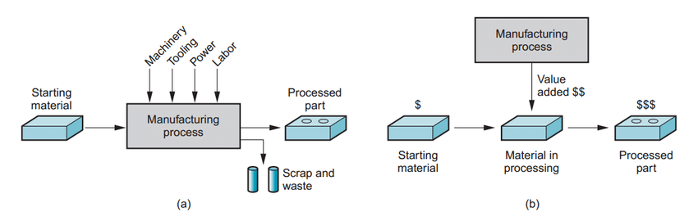  Figure 6 - Technology Manufacturing (Razin Sazzad Molla, 2018) | Figure 7 - Economy Manufacturing (Razin Sazzad Molla, 2018)

5.2. Type of Production
Types of Production | Definition | Examples | No. of Units
Project | When a large specialised product is produced and all materials and workers are brought to it. | - Houses  - Aircrafts  - Ships  - Bridges | 1 – 10
Job | Producing unique, high-quality products on a low volume. | - Motorsport components  - Tailored suits  - Custom Cakes | 10 – 100
Batch | Where a bunch of products are produced at a time | - Bakery  - Clothing  - Newspapers | 100 – 10,000
Mass | A continuous flow of products are made often using assembly lines and machinery meaning large quantities are produced at low unit costs. | - Drinks Bottles  - Cars  - Canned Goods  - Toys | 10,000+
Table 2 - Type of Production
5.3. Casting
Casting is one way a metal can be created into a product. It is the process of pouring molten metal into a mould and waiting for it to then cool down and solidify and then breaking the mould away to leave a product alone. Casting can be done in different ways as table 3 shows.
Types of Casting | How it Works | Advantages | Disadvantages
Sand Casting  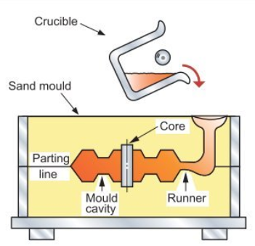  Figure 8 - Sand Casting (Materials Selection in Mechanical Design, Pg221, 2016) | The desired shape is split in half and then each side is pressed into sand to reveal 2 different imprints. Then one is placed on top of the other and molten metal is then poured into the sand. It is then left to cool and the sand is broken away. | - Can build products with detailed and complex cores  - Any ferrous or non-ferrous material can be used  - Low cost | - Requires finishing  - Isn’t very accurate so may struggle with tight tolerances  - Slag from sand ending up in the material
Die Casting  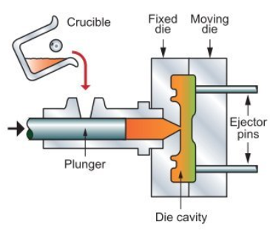  Figure 9 - Die Casting (Materials Selection in Mechanical Design, Pg221, 2016) | Molten metal is poured in between 2 moulds, called dies, and then forced together under pressure. Then the material is taken out and the process is repeated | - Has good accuracy and surface finish  - High productivity so low cost per unit when production is high | - Only suitable for low melting point metals  - High cost to buy dies  - Large products can’t be casted
Investment Casting  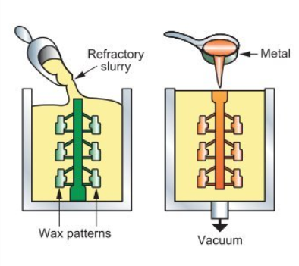  Figure 10 - Investment Casting - (Materials Selection in Mechanical Design, Pg221, 2016) | Firstly, an exact replica of the casting is made out of wax or foam using injection moulding which is the same as die casting but for molten plastic. Multiple wax replicas are then placed together forming a “tree” which is then covered in ceramic, dried off and repeated many times. Next, the wax is melted out of the ceramic and molten metal is poured into the ceramic “tree”. Once cooled the ceramic shell is then broken away. | - Different castings can be made at the same time as there can be different moulds on one “tree”.  - Can produce highly accurate products with small tolerances.  - Can be used on very complex-shaped casts | - Can be a long process from start to finish  - Expensive compared to other castings
Table 3 - Types of Casting
One problem with casting is that it can cause many defects in products as figure 11 shows.
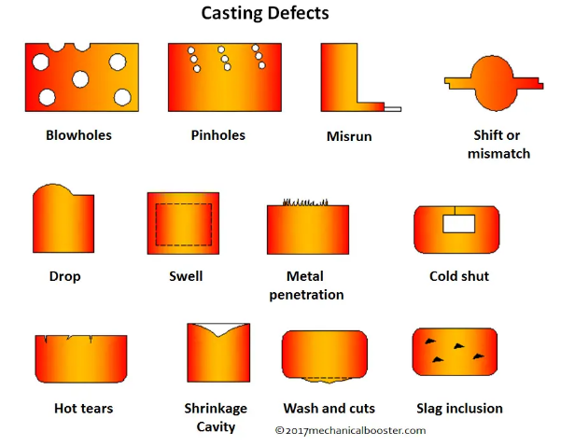
Figure 11 - Casting Defects (Mishra. P, 2020)

5.4. Forging
Forging is another manufacturing process by which a material is placed between 2 dies (moulds) and forced together as figure 12 shows. This can either be done using hot forging or cold forging, but it is important to note after the forging process there is excess material which has to be removed so finishing is required after.
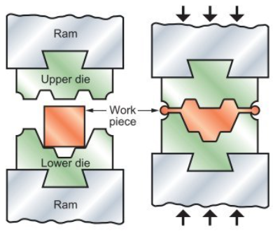
Figure 12 – Forging (Materials Selection in Mechanical Design, Pg221, 2016)
5.4.1 Cold Forging
This is when forging is done at around room temperature so more pressure is needed to forge the material into the dies.
Advantages:
- Greater precision
- Good surface finish so finishing work isn’t required
- Saves energy as the material doesn’t need to be heated up
- Won’t change shape due to thermal changes
Disadvantages:
- Forging pressures need to be higher
- Could break part being forged or the Dies which are expensive to replace
- Only works on certain materials as some may break
5.4.2. Hot Forging
This is when the material is heated up first to a point called the forging temperature where it is soft and elastic but is not past its melting point meaning it can be forced between 2 dies with less force to match the mould. The forging temperature of a material is dependent on its components and table 4 shows some examples of forging temperatures. The forged part must then be heat treated after as there is stress in the part due to the heating up process.
Advantages:
- Easier to deform the material
- Less force is required to forge material
- Dies have a longer time being used
Disadvantages:
- Leaves a poor surface finish so more finishing work is required compared to cold forging
- Less accurate due to oxidisation
- Part requires heat treatment after
- Longer production process
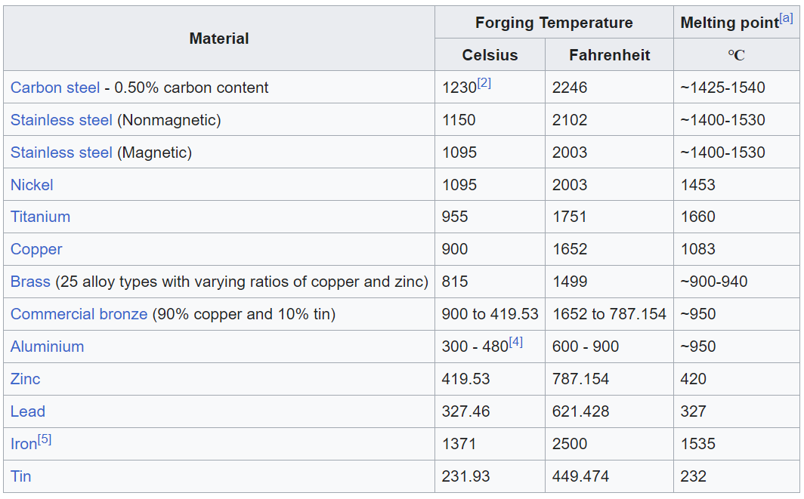
Table 4 - Forging Temperatures (Wikipedia, 2022)
5.5. Best Manufacturing Process
In conclusion, for a formula 1 piston where high quality is the most important factor throughout the whole process the best production process would be job production as each part is made at the highest quality and demand is low as only a collection of pistons is required per season. Having job production means that staff require a high skill level so there is a larger labour cost however that isn’t too important for a formula 1 team like Ferrari. In addition to job production, the best manufacturing process would be hot forging as it is arguably better than cold forging and a lot better than casting. This is because, compared to casting, forging prevents defects due to reshaping the material and less chance of sagging due to sand in the material. As well as that forging is a lot more accurate, takes less time to complete and leaves a better finish.
6. Conclusion
Overall, this report has aimed to show all the important properties that are considered when producing a formula 1 piston for an engine like the Ferrari’s F2002, Tipo 051 engine. The best material to use would be aluminium instead of steel as, even though steel has a larger Young’s Modulus, aluminium is considerably less dense with a density of 2710Kg/m³ compared to the density of steel, 7500Kg/m³ – 8000Kg/m³. Also, looking at table 4, steel has a higher melting point and forging temperature which is useful in a piston as the cylinder can have temperatures up to 2600°C so the metal will not soften and change shape however having a very high forging temperature means a lot more energy is needed to heat up the steel when doing hot forging compared to aluminium. Therefore, aluminium is better as it has a lot lower forging temperature so easier to forge and less of a drop in melting points. As well as outlining the best material to use, this report shows that the piston should be technologically manufactured in a job production process and produced by hot forging the aluminium.

7. References

Academic Gain Tutorials. Selection Criteria of Engineering materials. 2019. https://www.youtube.com/watch?v=W2NTYg6fZY0&t=1s. Accessed 15th March 2023).

Ferrari. (2023). F2002. https://www.ferrari.com/en-EN/formula1/f2002. (Accessed 3th March 2023).

Silodrome Gasoline Culture. (2019). For Sale: A Ferrari Tipo 051 V10 Formula 1 Engine – 900 BHP. https://silodrome.com/ferrari-tipo-051-v10-f1-engine/. (Accessed 12th March 2023).

MAHLE International GmbH. (2016). Pistons and Engine Testing. Atz/Mtz-Fachbuch. (2nd edition). Berlin. Springer Vieweg. Pg 3-7, 59-83.

Ashby, Michael F. (2016). Material Selection in Mechanical Design. 5th edition. Oxford. Butterworth-Heinemann. Pg 1-144.

Molla, R.S. (2018). A study on Manufacturing of Deformed Bar (G 60-400W) at Elite Iron and Steel Industries. Montana State University. Pg 6-10.

Dr Kerry Tudor. (2023). ACHA4001_Sem2_2023_Lecture 1 – Lecture 7. Semester 2 – Design and Tolerancing. University of Wales Trinity Saint David.

Hearn, E.J. (1997). An introduction to the mechanics of elastic and plastic deformation of solids and structural materials. (3rd edition). Oxford. Butterworth-Heinemann. Pg 1-10.

Mishra, P. (2020). What is Casting Defects – Types, Causes and Remedies?. Mechanical Booster.

Wikipedia. (2022). Forging Temperature. https://en.wikipedia.org/wiki/Forging_temperature. (Accessed 17th March 2023)

